**Appendix 1: Figures and Tables**

**Appendix Figure I:** Prohibition Counties have Higher Population and Farm Values

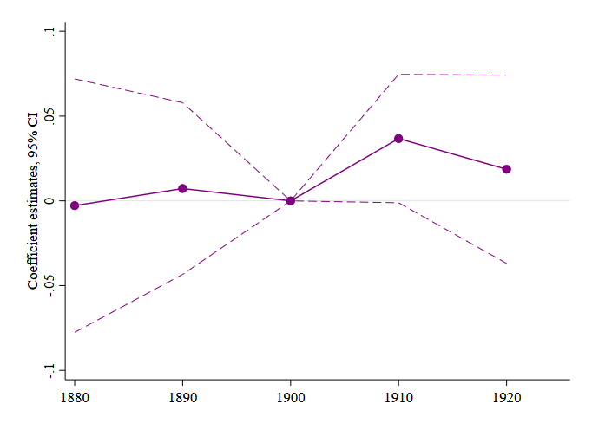

(a) Log Population

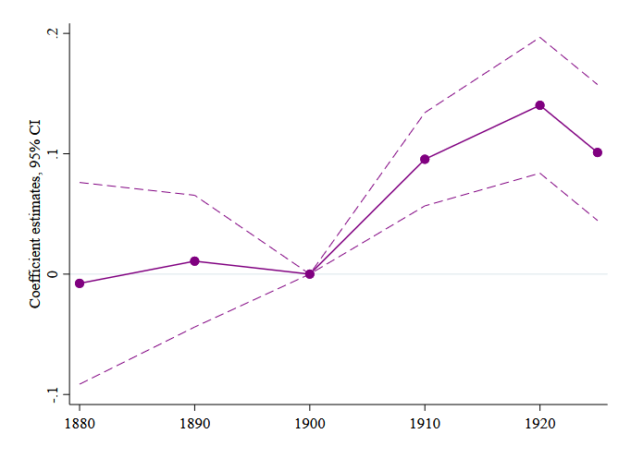

(b) Log Farm Value per Acre

*Notes*: The graphs show the effect of Prohibition on population and farm values per county acre by year. Each graph shows the coefficients *β* with 95 percent confidence intervals from the event study specification (equation (2)). We regress the outcome on an indicator variable for being an early adopted interacted with year dummies, deciles of the share of population belonging to denominations in favor of Prohibition in 1890 interacted with year dummies, baseline controls interacted with year dummies, county fixed effects and state-year fixed effects (equation (2)). Baseline controls are log population, share urban, share white, and share male, all measured in 1880. Population regressions do not control for baseline population. The sample excludes urban counties and counties that adopted Prohibition before 1899, and is restricted to counties for which the outcome is never missing. All regressions are estimated by OLS. Standard errors are clustered at the county level. 1880 data features substantial county boundary changes leading to some large changes in population and demographics from 1880 to 1890, so while we show this for robustness, our preferred specifications focus on the 1890-1925 time period.

*Sources:* Population is from the Population Census 1880-1920. Farm values are from the Census of Agriculture 1880-1925. Prohibition adoption data is from Sechrist (2012). Share in denominations in favor of Prohibition is from the 1890 Census of Religious Bodies. Baseline demographic controls are from the 1880 Population Census. See Appendix Table I for more details.

**Appendix Figure II:** Heterogeneous Effects by Share of County that is Rural

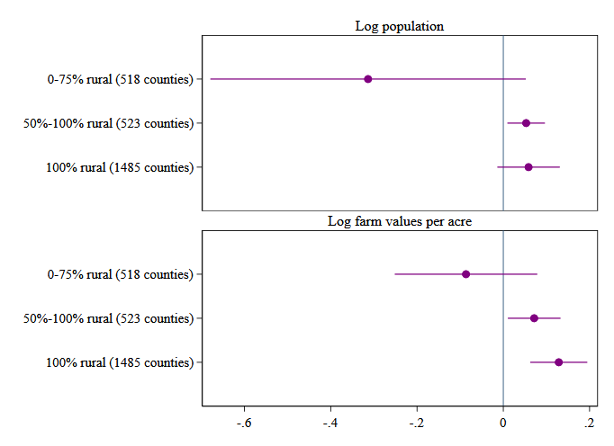

*Notes*: The graph shows heterogeneous effects of Prohibition on population and farm values per county acre by share of county that is rural. The coefficients are estimated in separate regressions. We regress the outcome on an indicator variable for being an early adopted interacted with year dummies, deciles of the share of population belonging to denominations in favor of Prohibition in 1890 interacted with year dummies, baseline controls interacted with year dummies, county fixed effects and state-year fixed effects (equation (2)). Baseline controls are log population, share urban, share white, share male, share 1st and 2nd generation immigrant and share 1st generation immigrant, all measured in 1890. Population regressions do not control for baseline population. The sample excludes urban counties and counties that adopted Prohibition before 1899, and is restricted to counties for which the outcome is never missing. All regressions are estimated by OLS. Standard errors are clustered at the county level.

*Sources:* Population is from the Population Census 1890-1910. Farm values are from the Census of Agriculture 1890-1910. Prohibition adoption data is from Sechrist (2012). Share in denominations in favor of Prohibition is from the 1890 Census of Religious Bodies. Baseline demographic controls are from the 1890 Population Census. See Appendix Table I for more details.

**Appendix Figure III:** Prohibition Counties have Higher Productivity

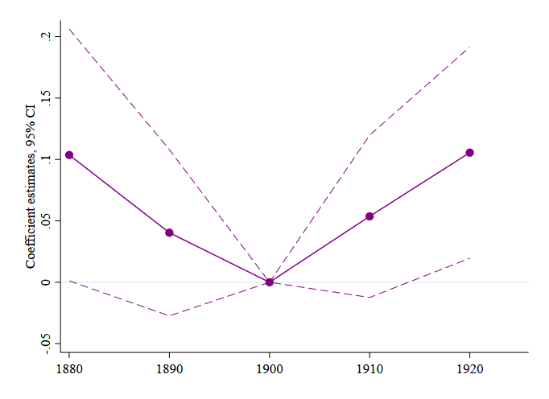

(a) Log productivity

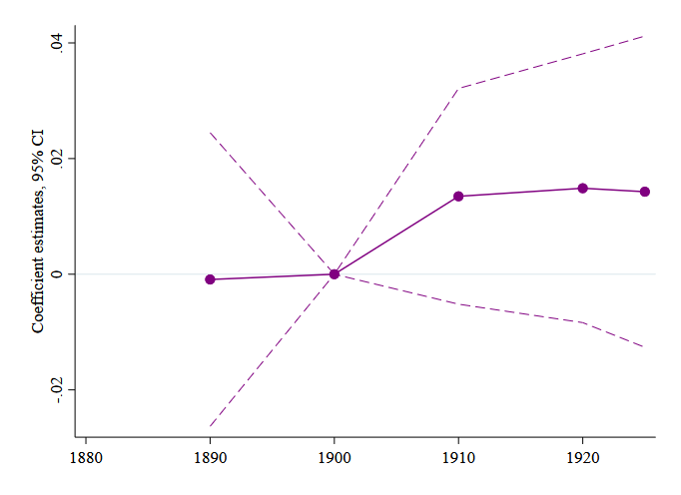

(c) Share of land in farms

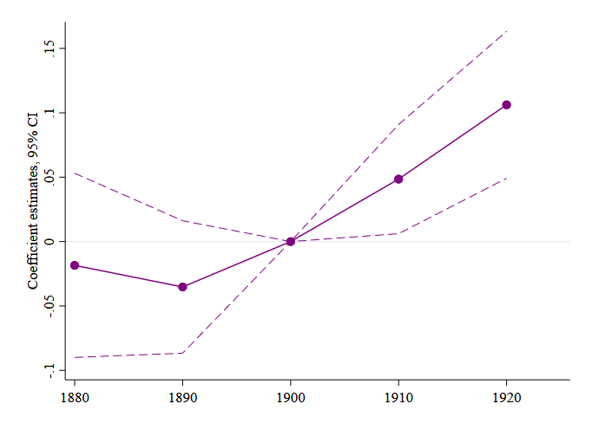

(b) Log implements per capita

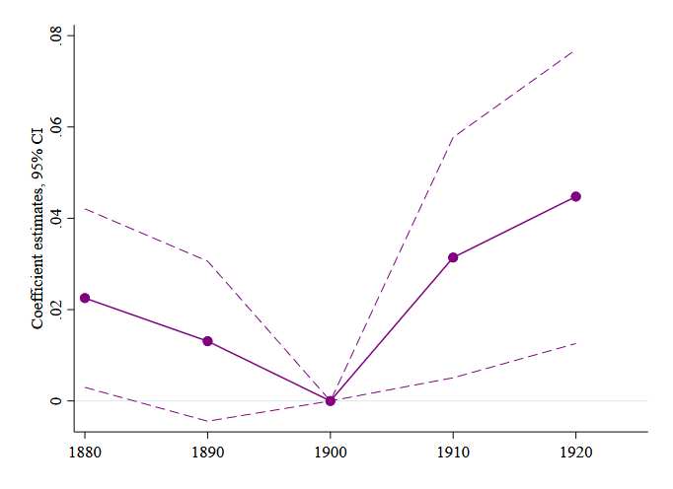

(d) Banks per 1,000 people

*Notes*: The graphs show the effect of Prohibition on productivity, investments, and banks per capita by year. Each graph shows the coefficients *β* with 95 percent confidence intervals from the event study specification (equation (2)). Productivity is defined as log output for the five major crops (corn, cotton, oats, tobacco, and wheat) times 1910 prices per capita. We regress the outcome on an indicator variable for being an early adopted interacted with year dummies, deciles of the share of population belonging to denominations in favor of Prohibition in 1890 interacted with year dummies, baseline controls interacted with year dummies, county fixed effects and state-year fixed effects (equation (2)). Baseline controls are log population, share urban, share white, and share male, all measured in 1880. The sample excludes urban counties and counties that adopted Prohibition before 1899, and is restricted to counties for which the outcome is never missing. All regressions are estimated by OLS. Standard errors are clustered at the county level. 1880 data features substantial county boundary changes leading to some large changes in population and demographics from 1880 to 1890, so while we show this for robustness, our preferred specifications focus on the 1890-1925 time period.

*Sources:* Productivity, implements per capital, and share of land in farms are from the Census of Agriculture 1880-1925. Banks data are from Jaremski and Fishback (2018). Prohibition adoption data is from Sechrist (2012). Share in denominations in favor of Prohibition is from the 1890 Census of Religious Bodies. Baseline demographic controls are from the 1880 Population Census. See Appendix Table I for more details.

**Appendix Figure IV:** Effect of Prohibition on Employment Shares

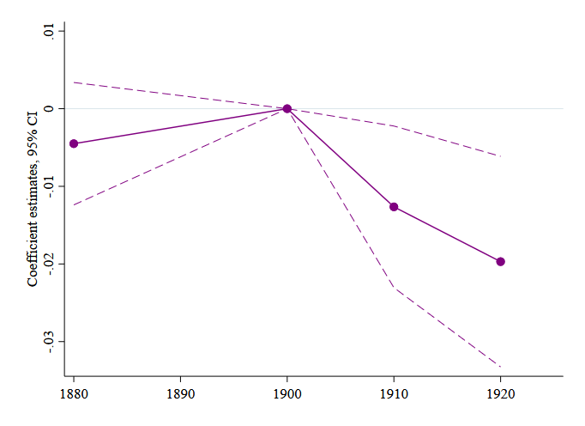

(a) Share of males 15-60 in agriculture

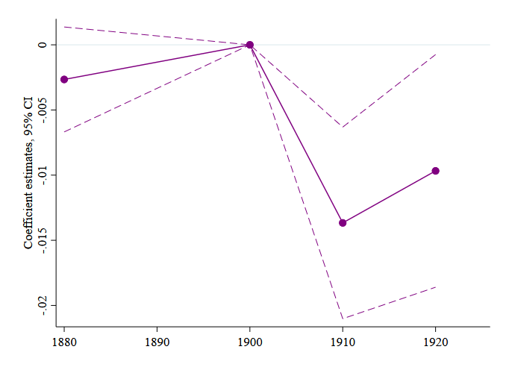

(c) Share of males 15-60 who are laborers

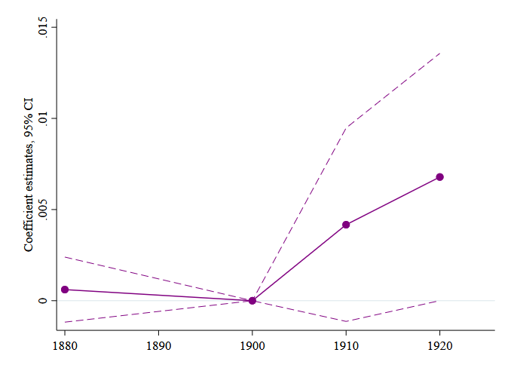

(e) Share of males 15-60 in manufacturing

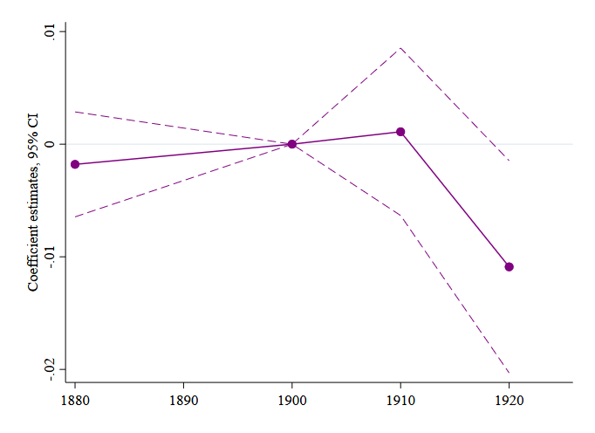

(b) Share of males 15-60 who are farmers

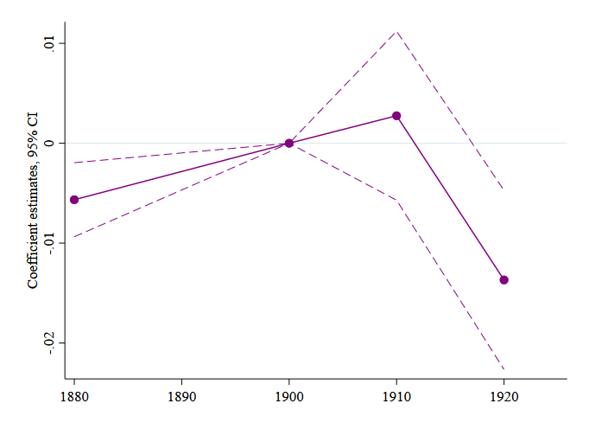

(d) Share of males 15-60 who are employed

*Notes*: The graphs show the effect of Prohibition on employment shares by year. Each graph shows the coefficients *β* with 95 percent confidence intervals from the event study specification (equation (2)). All outcomes are calculated from a 25 percent sample of the Population Census 1880-1920. We regress the outcome on an indicator variable for being an early adopted interacted with year dummies, deciles of the share of population belonging to denominations in favor of Prohibition in 1890 interacted with year dummies, baseline controls interacted with year dummies, county fixed effects and state-year fixed effects (equation (2)). Baseline controls are log population, share urban, share white, and share male, all measured in 1880. The sample excludes urban counties and counties that adopted Prohibition before 1899, and is restricted to counties for which the outcome is never missing. All regressions are estimated by OLS. Standard errors are clustered at the county level. 1880 data features substantial county boundary changes leading to some large changes in population and demographics from 1880 to 1890, so while we show this for robustness, our preferred specifications focus on the 1890-1925 time period.

*Sources:* All outcomes are calculated from a 25 percent sample of the Population Census 1880 and 1900-1920. Prohibition adoption data is from Sechrist (2012). Share in denominations in favor of Prohibition is from the 1890 Census of Religious Bodies. Baseline demographic controls are from the 1890 Population Census. See Appendix Table I for more details.

**Appendix Figure V:** Effect of Prohibition on Sorting

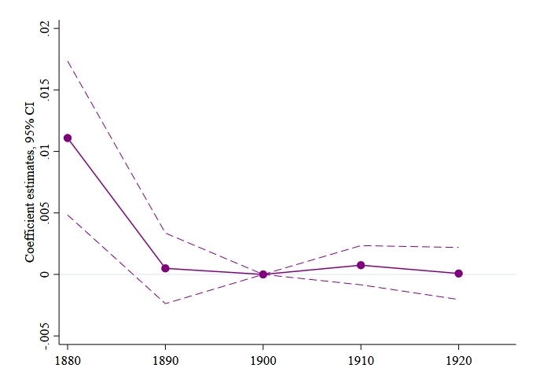

(a) Share male

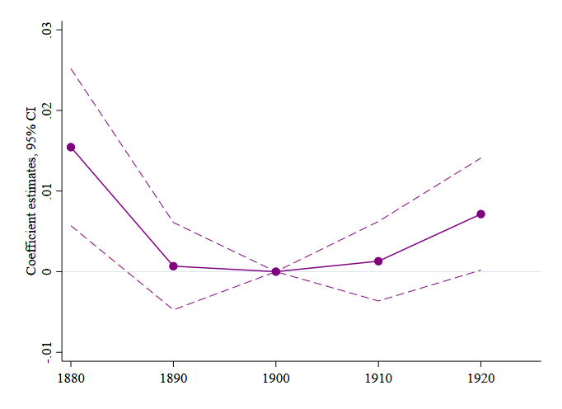(c) Share 1st and 2nd generation immigrant

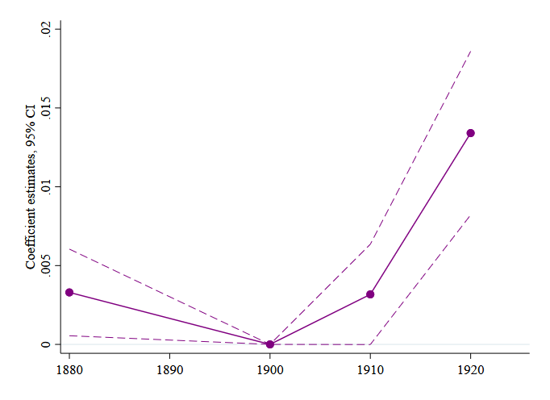(e) Share German, Irish, and Italian immigrant

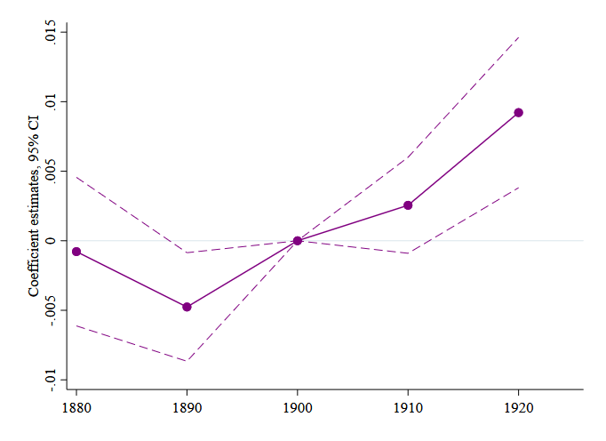(b) Share African-American

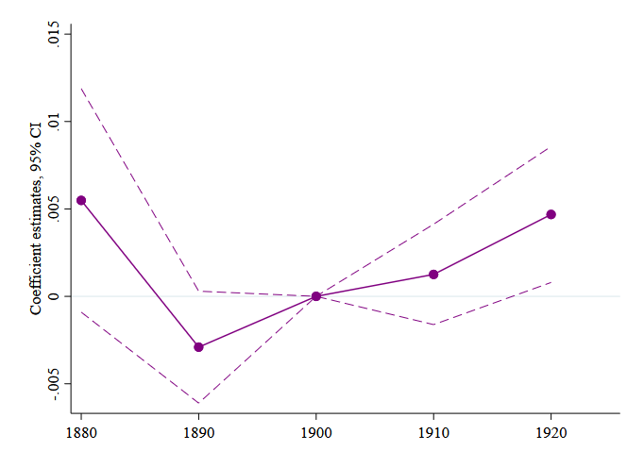

(d) Share 1st generation immigrant

*Notes*: The graphs show the effect of Prohibition on sorting by year. Each graph shows the coefficients *β* with 95 percent confidence intervals from the event study specification (equation (2)). We regress the outcome on an indicator variable for being an early adopted interacted with year dummies, deciles of the share of population belonging to denominations in favor of Prohibition in 1890 interacted with year dummies, baseline controls interacted with year dummies, county fixed effects and state-year fixed effects (equation (2)). Baseline controls are log population, share urban, share white, and share male, all measured in 1880. In regressions including one of the outcomes, we omit the respective control. The sample excludes urban counties and counties that adopted Prohibition before 1899, and is restricted to counties for which the outcome is never missing. All regressions are estimated by OLS. Standard errors are clustered at the county level. 1880 data features substantial county boundary changes leading to some large changes in population and demographics from 1880 to 1890, so while we show this for robustness, our preferred specifications focus on the 1890-1925 time period.

*Sources:* All outcomes are from the Population Census 1880-1920, with the exception of share German, Irish and Italian immigrants that is calculated from a 25 percent sample of the Population Census 1880 and 1900-1920. Prohibition adoption data is from Sechrist (2012). Share in denominations in favor of Prohibition is from the 1890 Census of Religious Bodies. Baseline demographic controls are from the 1890 Population Census. See Appendix Table I for more details.

**Appendix Table I:** Variables Definitions and Sources



**Appendix Table II:** Effect of Prohibition on Population and Farm Values, Adding One Control at the Time

|  |  |  |  |  |  |  |  |
| --- | --- | --- | --- | --- | --- | --- | --- |
|  |  |  |  |  |  |  |  |
|  | (1) | (2) | (3) | (4) | (5) | (6) | (7) |
| Additionally controls for… | - | Log population | Share urban | Share male | Share white | Share 1st gen imm | Share 1st and 2nd gen imm |
|  |  |  |  |  |  |  |  |
| Panel A: Effect on log population | | | | | | | |
|  |  |  |  |  |  |  |  |
| Early adopter * 1910 | 0.113*** | - | 0.114*** | 0.094*** | 0.075*** | 0.060** | 0.064*** |
|  | (0.027) | - | (0.027) | (0.025) | (0.025) | (0.025) | (0.025) |
|  | [0.037] | - | [0.037] | [0.030] | [0.028] | [0.026] | [0.027] |
| *N* | 6945 | - | 6945 | 6945 | 6945 | 6945 | 6945 |
| Clusters | 2315 | - | 2315 | 2315 | 2315 | 2315 | 2315 |
|  |  |  |  |  |  |  |  |
| Panel B: Effect on log farm values per acre | | | | | | | |
|  |  |  |  |  |  |  |  |
| Early adopter * 1910 | 0.209*** | 0.120*** | 0.124*** | 0.126*** | 0.126*** | 0.120*** | 0.107*** |
|  | (0.029) | (0.025) | (0.024) | (0.024) | (0.024) | (0.024) | (0.024) |
|  | [0.040] | [0.029] | [0.029] | [0.028] | [0.028] | [0.028] | [0.028] |
| *N* | 6906 | 6906 | 6906 | 6906 | 6906 | 6906 | 6906 |
| Clusters | 2302 | 2302 | 2302 | 2302 | 2302 | 2302 | 2302 |
| County fixed effects | yes | yes | yes | yes | yes | yes | yes |
| State-year fixed effects | yes | yes | yes | yes | yes | yes | yes |
| Controls for baseline religiosity | yes | yes | yes | yes | yes | yes | yes |
| Controls for baseline demographics | yes | yes | yes | yes | yes | yes | yes |

*Notes*: The table shows the effect of Prohibition on population and farm values per county acre, adding one set of baseline controls at the time. We regress the outcome on an indicator variable for being an early adopted interacted with an indicator variable for the post period, deciles of the share of population belonging to denominations in favor of Prohibition in 1890 interacted with year dummies, county fixed effects and state-year fixed effects (equation (1)). The baseline controls we include incrementally are population, share urban, share white, share male, share 1st and 2nd generation immigrant and share 1st generation immigrant, all measured in 1890. Population regressions do not control for baseline population. The sample excludes urban counties and counties that adopted Prohibition before 1899, and is restricted to counties for which the outcome is never missing. All regressions are estimated by OLS. Standard errors clustered at the county level are in parentheses and Conley standard errors are in brackets. *** p<0.01, ** p<0.05, * p<0.1.

*Sources:* Population is from the Population Census 1890-1910. Farm values are from the Census of Agriculture 1890-1910. Prohibition adoption data is from Sechrist (2012). Share in denominations in favor of Prohibition is from the 1890 Census of Religious Bodies. Baseline demographic controls are from the 1890 Population Census. See Appendix Table I for more details.

**Appendix Table III:** Effect of Prohibition on Population and Farm Values, Spillovers

|  |  |
| --- | --- |
|  |  |
|  | (1) |
|  |  |
| Panel A: Effect on log population | |
|  |  |
| Early adopter * 1910 | 0.086*** |
|  | (0.032) |
|  | [0.035] |
| *N* | 6501 |
| Clusters | 2167 |
|  |  |
| Panel B: Effect on log farm values per acre | |
|  |  |
| Early adopter * 1910 | 0.138*** |
|  | (0.029) |
|  | [0.035] |
|  |  |
| *N* | 6462 |
| Clusters | 2154 |
| County fixed effects | yes |
| State-year fixed effects | yes |
| Controls for baseline religiosity | yes |
| Controls for baseline demographics | yes |
|  |  |

Notes: The table shows that the effect of Prohibition on population and farm values per county acre is robust to dropping counties for which the majority of the neighbors are early adopters. We regress the outcome on an indicator variable for being an early adopted interacted with an indicator variable for the post period, an indicator variable for being the neighbor of an early adopted interacted with an indicator variable for the post period, deciles of the share of population belonging to denominations in favor of Prohibition in 1890 interacted with year dummies, baseline controls interacted with year dummies, county fixed effects and state-year fixed effects (equation (1)). Baseline controls are log population, share urban, share white, share male, share 1st and 2nd generation immigrant and share 1st generation immigrant, all measured in 1890. Population regressions do not control for baseline population. The sample excludes urban counties and counties that adopted Prohibition before 1899, and is restricted to counties for which the outcome is never missing. All regressions are estimated by OLS. Standard errors clustered at the county level are in parentheses and Conley standard errors are in brackets. *** p<0.01, ** p<0.05, * p<0.1.

*Sources:* Population is from the Population Census 1890-1910. Farm values are from the Census of Agriculture 1890-1910. Prohibition adoption data is from Sechrist (2012). Share in denominations in favor of Prohibition is from the 1890 Census of Religious Bodies. Baseline demographic controls are from the 1890 Population Census. See Appendix Table I for more details.

**Appendix Table IV:** Robustness of the Effect of Prohibition on Productivity

|  |  |  |
| --- | --- | --- |
|  |  |  |
|  | (1) | (2) |
| Dependent variable | Log productivity, no corn | Log productivity, 1900 prices |
|  |  |  |
| Early adopter * 1910 | 0.194*** | 0.089** |
|  | (0.059) | (0.037) |
|  | [0.070] | [0.043] |
| *N* | 6759 | 6840 |
| Clusters | 2253 | 2280 |
| Outcome mean | 2.726 | 2.867 |
| County fixed effects | yes | yes |
| State-year fixed effects | yes | yes |
| Controls for baseline religiosity | yes | yes |
| Controls for baseline demographics | yes | yes |
|  |  |  |

*Notes*: The table shows that the effect of Prohibition on productivity is robust to how productivity is defined. In column (1), productivity is defined as log output for the five major crops excluding corn times 1910 prices per capita. In column (2), productivity is defined as log output for the top five crops times 1900 prices per capita. The five major crops are corn, cotton, oats, tobacco, and wheat. We regress the outcome on an indicator variable for being an early adopted interacted with an indicator variable for the post period, deciles of the share of population belonging to denominations in favor of Prohibition in 1890 interacted with year dummies, baseline controls interacted with year dummies, county fixed effects and state-year fixed effects (equation (1)). Baseline controls are log population, share urban, share white, share male, share 1st and 2nd generation immigrant and share 1st generation immigrant, all measured in 1890. The sample excludes urban counties and counties that adopted Prohibition before 1899, and is restricted to counties for which the outcome is never missing. All regressions are estimated by OLS. Standard errors clustered at the county level are in parentheses and Conley standard errors are in brackets. *** p<0.01, ** p<0.05, * p<0.1.

*Sources:* Productivity is from the Census of Agriculture 1890-1910. Prohibition adoption data is from Sechrist (2012). Share in denominations in favor of Prohibition is from the 1890 Census of Religious Bodies. Baseline demographic controls are from the 1890 Population Census. See Appendix Table I for more details.

# Appendix 2: Model

In this appendix, we present a stylized model to illustrate the economic forces that we believe are driving the empirical results we present in this paper. The model is of a single county and captures production and the choice of where to live. It includes a somewhat novel agglomeration mechanism.[1]

In our model, there are several types *j* of agents *i* that differ in their mobility and their amenity preferences. There is a bank that provides capital at rate *r* and imposes a land collateral constraint.

Agents have preferences over consumption and amenities. Utility is given by

$$c+a_{j}+ϵ_{i,j }$$

where *aj* is the preference for the amenity by group *j* and $ϵ_{i,j}$ is an idiosynchratic preference parameter for person *i*, although the distribution of such parameter may depend on *j*. $ϵ_{i,j}$ is an i.i.d. draw from a Frechet distribution with shape parameter $1/μ_{j}$. Everyone has an outside option to live in a much bigger region outside the county with utility ${\overline{u}}_{j}+ϵ_{j,k}$  where $ϵ_{j,k}$ is also drawn from the same Frechet distribution. Population of group *j* is therefore given by

$$N_{j}={\overline{N}}_{j}\frac{{\left(c+a_{j}\right)}^{μ_{j}}}{{\left(c+a_{j}\right)}^{μ_{j}}+{\overline{u}}_{j}^{μ_{j}}}$$

where ${\overline{N}}_{j}$ is the total population of type $j$. The fact that the other region is much larger implies that ${\overline{u}}_{j}$ is much larger than $c+a_{j}$ and that the equation is well-approximated by

$$N_{j}={\overline{N}}_{i,j}{\left(c+a_{j}\right)}^{μ_{j}}$$

for a constant ${\overline{N}}_{i,j}$.

To produce goods, agents combine their labor, which is supplied inelastically with 1 unit, 1 unit of land, and capital. The production function is a Leontieff nested within a Cobb-Douglass for tractability:

$$y=Ak^{α}{\min\left\{n,l\right\}}^{1-α}$$

where *n* is labor and *l* is land, and $α∈(0,1)$.

Total land demand is therefore $L=\left(\sum_{j}{N_{j}}\right)$. Combining that with the demand to live in the location,

$$L=N=\left(\sum_{j}{{\overline{N}}_{i,j}{\left(c+a_{j}\right)}^{μ_{j}}}\right)$$

This defines a “migration curve,” an upward sloping relationship between *c* and *L* or *N*. The agent consumes their production, minus what they pay out for land and capital:

$$c=Ak^{α}-p-rk$$

They are also subject to a capital constraint that $rk≤ϕp$.

Land *L* is supplied elastically with elasticity $1/σ$:

|  |  |
| --- | --- |
| $$p=\overline{p}L^{σ}$$ | (3) |

where $\overline{p}$ is a constant.

Assume the capital constraint is tight enough so as to be binding, and then substitute in the land supply curve:

|  |  |
| --- | --- |
| $$c=A{\left(\frac{ϕ}{r}\overline{p}L^{σ} \right)}^{α}-\left(1+ϕ\right)\overline{p}L^{σ}$$ | (4) |

This “production curve” is non-monotonic: at low values, it is increasing in *L*, but at high values, it is decreasing in *L*. The increasing part represents an agglomeration force that comes from the banks’ capital constraint.[2]

Using equations (3) and (4), we illustrate the equilibrium in Appendix Figure VI. The equilibrium of this model is found at the intersection of the two lines. When the amenity value increases, the line representing equation (3) shifts to the right. If it is on the upward-sloping portion of the equation (4) line, consumption increases in response because the workers are able to invest more heavily in capital.

This model explains the mechanism through which we think our empirical results are best understood. As we will show in the data, an increase in amenities for any group raises population, land prices, capital, and output per capita. This comes through an agglomeration force based on collateral constraints of banks.

Note that the amenity does not have to be valued by every group to increase consumption of every group. So even if the amenity only matters to some of the groups, it can still increase population of all groups. If the mobility parameter $μ_{j}$ is high enough for the group that does not value the amenity, they might still have more people move in in response.

Finally, the model allows us to think about how the effects of an amenity might change, based on local characteristics. First, we can interpret a larger banking sector as a higher $ϕ$ or a lower *r*. Either way, the line (4) becomes more steep in the relevant section. So the increases in population, consumption, and prices are all larger.

Second, we can interpret more railroads or more nearby dry counties as an increase in $μ$, making line (3) flatter. So a shift in the line would have a larger effect on population, consumption, and prices. As drawn in the graph, when we change the slope of (3), an amenity shift still moves the curve downward by the same level-shift. Therefore the new equilibrium will be further up line (4).

The model also features a financial accelerator in response to a productivity shock. An increase in productivity *A* relaxes the collateral constraint and increases capital and output because people migrate in, raising prices. An implication of this accelerator is that an increase in sobriety at work might have similar comparative statics as an amenity increase. We have to rely on our auxiliary results in the main text to argue in favor of our amenity channel.

**Appendix Figure VI:** Migration (Blue) and Production (Magenta) Curves, with an Amenity Change (Dashed)

*c*

(4)

(3)

*L*

1. While there is empirical evidence that higher land prices cause higher productivity and investment (Chaney et al. 2012; Bahaj et al. 2020), we are not aware of such a force ever being considered as the basis for agglomeration.
2. It is not critical that the worker owns the land or rents the capital. A landowner hiring labor at competitive rates would pay wages that fund the consumption in equation (4).