Appendix A
Descriptive Statistics and Regression Tables for Main Results

Table A1: Descriptive Statistics
 | (1) | (2) | (3) | (4) | (5)
 | No. | Mean | St. dev. | Min | Max
Main treatment variable:  Electricity grid access, Western Line (Dummy=1) | 9,948 | 0.024 | 0.15 | 0 | 1
Main outcome variables:  Log(1+Total Strikes) | 9,948 | 11 | 39 | 0 | 498
Log(1+Offensive Strikes) | 9,948 | 7.2 | 31 | 0 | 463
Log(1+Defensive Strikes) | 9,948 | 1.8 | 14 | 0 | 264
Log(1+No. of striking workers) | 7,461 | 52 | 150 | 0 | 1,242
Control variables:  Electricity, outside Western Line (Dummy=1) | 9,948 | 0.15 | 0.36 | 0 | 1
Railroad (Dummy=1) | 9,948 | 0.48 | 0.5 | 0 | 1
Log(1+Labor Force) | 7,461 | 587 | 102 | 0 | 1,116
1. Elite (%) | 7,410 | 1.1 | 1 | 0 | 18
2. White collar (%) | 7,410 | 5.6 | 4 | 0 | 49
3. Foremen (%) | 7,410 | 1.9 | 1.9 | 0 | 16
4. Medium skilled (%) | 7,410 | 7.3 | 4.3 | 0 | 47
5. Farmers (%) | 7,410 | 32 | 15 | 0 | 89
6. Lower skilled (%) | 7,410 | 9.7 | 8.7 | 0 | 79
7. Unskilled (%) | 7,410 | 43 | 11 | 1.1 | 93
Note: This table shows descriptive statistics for the variables included in the main regression. For easy of interpretation, all strike outcome variables and the control variable measuring the size of the labor force has been scaled by 100. The columns present the following statistics: (1) number of observations, (2) mean value (3) standard deviation, (4) minimum observed value and (5) maximum observed value.

Table A2: Main Results with Check for Pre-Trends
 | (1) | (2) | (3) | (4)
Dependent Variable: | Log(1+Total Strikes) | Log(1+Offensive Strikes) | Log(1+Defensive Strikes) | Log(1+No. of striking workers)
Electricity grid access, Western Line (Dummy=1) | 11.9** | 12.1** | 2.3 | 35.0*
 | (4.087) | (4.052) | (1.546) | (16.480)
 | (4.559)** | (4.597)** | (1.748) | (16.21)*
Pre-Trend: Electricity grid access, t−1 Western Line (Dummy=1) | 1.3 | 3.3 | -1.7 | -11.4
 | (2.535) | (2.378) | (1.094) | (12.763)
 | (2.855) | (2.903) | (1.603) | (13.01)
Mean dependent variable | 12.0 | 8.0 | 2.2 | 51.5
St. dev. dependent variable | 42.7 | 34.2 | 14.3 | 159.8
Controls | Yes | Yes | Yes | Yes
Parish FE | Yes | Yes | Yes | Yes
Year FE | Yes | Yes | Yes | Yes
County × Year FE | Yes | Yes | Yes | Yes
Observations | 7,410 | 7,410 | 7,410 | 7,410
No. of parishes | 2,470 | 2,470 | 2,470 | 2,470
Note: This table shows results for the treatment and pre-treatment period from access to the Western Line electricity grid on the four main outcome variables. Robust standard errors clustered at the parish level are given in parentheses. *** p < 0.001, ** p < 0.01, * p < 0.05. Standard errors adjusted for spatial autocorrelation in italics, computed using Conley’s method assuming linear decay and cut off at 100 km.

Table A3: Regression Results for Change in Occupational Groups’ Shares
 | (1) | (2) | (3) | (4) | (5) | (6) | (7)
 | Elite | White collar | Foremen | Med. skilled | Farmers | Low skilled | Unskilled
Electricity grid access, Western Line (Dummy=1) | 0.1 | 0.6 | 0.0 | 1.4* | -2.5** | 1.4 | -1.0
 | (0.119) | (0.377) | (0.294) | (0.574) | (0.917) | (0.831) | (1.162)
 | (0.106) | (0.380) | (0.219) | (0.529)* | (0.530)*** | (0.513)** | (0.874)
Mean dependent variable | 1.1 | 6.2 | 2.2 | 7.7 | 31.1 | 10.9 | 40.8
St. dev. dependent variable | 1.1 | 4.2 | 2.0 | 4.4 | 15.0 | 9.3 | 11.1
Controls | Yes | Yes | Yes | Yes | Yes | Yes | Yes
Parish FE | Yes | Yes | Yes | Yes | Yes | Yes | Yes
Year FE | Yes | Yes | Yes | Yes | Yes | Yes | Yes
County × Year FE | Yes | Yes | Yes | Yes | Yes | Yes | Yes
Observations | 4,931 | 4,931 | 4,931 | 4,931 | 4,931 | 4,931 | 4,931
No. of parishes | 2,470 | 2,470 | 2,470 | 2,470 | 2,470 | 2,470 | 2,470
Note: This table shows results for the impact of access to the Western Line electricity grid on occupational groups’ share of employment. Robust standard errors clustered at the parish level are given in parentheses. *** p < 0.001, ** p < 0.01, * p < 0.05. Standard errors adjusted for spatial autocorrelation in italics, computed using Conley’s method assuming linear decay and cut off at 100 km.

Table A4: Regression Results for Strikes by Sector

Agriculture Industry and services
 | (1) | (2) | (3) | (4) | (5) | (6)
 | All | Offensive | Defensive | All | Offensive | Defensive
Electricity grid access, Western Line (Dummy=1) | 1.1 | 0.8 | -0.3 | 9.9** | 8.2* | 3.3*
 | (1.397) | (1.058) | (0.231) | (3.282) | (3.234) | (1.294)
 | (1.159) | (1.023) | (0.230) | (3.594)** | (3.265) | (1.718)
Mean dependent variable | 1.0 | 0.6 | 0.1 | 12.2 | 8.9 | 2.4
St. dev. dependent variable | 9.3 | 7.2 | 2.5 | 41.5 | 34.1 | 15.1
Controls | Yes | Yes | Yes | Yes | Yes | Yes
Parish FE | Yes | Yes | Yes | Yes | Yes | Yes
Year FE | Yes | Yes | Yes | Yes | Yes | Yes
County × Year FE | Yes | Yes | Yes | Yes | Yes | Yes
Observations | 7,410 | 7,410 | 7,410 | 7,410 | 7,410 | 7,410
No. of parishes | 2,470 | 2,470 | 2,470 | 2,470 | 2,470 | 2,470
Note: This table shows results for the impact of access to the Western Line electricity grid on strikes divided between agricultural and non-agricultural activities. Robust standard errors clustered at the parish level are given in parentheses. *** p < 0.001, ** p < 0.01, * p < 0.05. Standard errors adjusted for spatial autocorrelation in italics, computed using Conley’s method assuming linear decay and cut off at 100 km.

Table A5: Regression Results for Strikes by Type of Parish: Non-Industrial/Industrial
 | (1) | (2) | (3)
 | All strikes | Offensive | Defensive
Electricity grid access, Western Line (Dummy=1) | 0.8 | 1.5 | 0.1
 | (2.607) | (2.397) | (0.543)
 | (2.206) | (1.769) | (0.584)
Electricity grid access, Western Line (Dummy=1) × | 17.8*** | 15.4** | 5.6**
Industrial parish (Dummy=1) | (5.067) | (5.128) | (2.147)
 | (5.461)** | (4.693)** | (2.487)*
Mean dependent variable | 12.0 | 8.0 | 2.2
St. dev. dependent variable | 42.7 | 34.2 | 14.3
Controls | Yes | Yes | Yes
Parish FE | Yes | Yes | Yes
Year FE | Yes | Yes | Yes
County × Year FE | Yes | Yes | Yes
Observations | 7,401 | 7,401 | 7,401
No. of parishes | 2,470 | 2,470 | 2,470
Note: This tables shows results of interacting Western Line electricity grid access with an indicator for whether a parish is non-industrial or industrial. Industrial parishes are the 50 percent of parishes with the highest share of industry in total employment in 1900. Standard errors clustered at the parish level. Robust standard errors clustered at the parish level are given in parentheses. *** p < 0.001, ** p < 0.01, * p < 0.05. Standard errors adjusted for spatial autocorrelation in italics, computed using Conley’s method assuming linear decay and cut off at 100 km.

Appendix B Additional Results

Table A6: Results with Strikes Aggregated over a Five-Year Period
 | (1) | (2) | (3) | (4)
Dependent Variable: | Log(1+Total Strikes) | Log(1+Offensive Strikes) | Log(1+Defensive Strikes) | Log(1+No. of striking workers)
Electricity grid access, Western Line (Dummy=1) | 11.92*** | 8.070** | 7.608** | 43.61***
 | (3.325) | (3.068) | (2.320) | (11.87)
 | (3.153)*** | (2.817)** | (2.596)** | (10.73)***
Mean dependent variable | 17.5 | 11.7 | 4.4 | 67.0
St. dev. dependent variable | 50.7 | 39.7 | 22.6 | 170.5
Controls | Yes | Yes | Yes | Yes
Parish FE | Yes | Yes | Yes | Yes
Year FE | Yes | Yes | Yes | Yes
County X Year FE | Yes | Yes | Yes | Yes
Observations | 7,410 | 7,410 | 7,410 | 7,410
No. of parishes | 2,470 | 2,470 | 2,470 | 2,470
Note: This table shows results when estimating the effect of access to the Western Line electricity grid on the four main outcome variables when aggregating strikes over a five-year period following the observation year. Standard errors clustered at the parish level. *** p < 0.001, ** p < 0.01, * p < 0.05. Standard errors adjusted for spatial autocorrelation in italics, computed using Conley’s method assuming linear decay and cut off at 100 km.

Table A7: Effect on Offensive Strikes when Including Strikes for Other Causes
 | (1)
Dependent Variable: | Log(1+Offensive+other strikes)
Electricity grid access, Western line (Dummy=1) | 10.68**  (3.019)  (3.822)**
Mean dependent variable | 10.0
St. dev. dependent variable | 37.0
Controls | Yes
Parish FE | Yes
Year FE | Yes
County X Year FE | Yes
Observations | 7,410
No. of parishes | 2,470
Note: This table shows results of estimating the effect of access to the Western Line electricity grid on offensive strikes when including strikes for other causes. *** p < 0.001, ** p < 0.01, * p < 0.05. Standard errors adjusted for spatial autocorrelation in italics, computed using Conley’s method assuming linear decay and cut off at 100 km.

Table A8: Results with Regression Weighted by Parish Population
 | (1) | (2) | (3) | (4)
Dependent Variable: | Log(1+Total Strikes) | Log(1+Offensive Strikes) | Log(1+Defensive Strikes) | Log(1+No. of striking workers)
Electricity grid access, Western Line (Dummy=1) | 29.949* | 42.336* | 18.423** | 38.329
 | (13.282) | (17.061) | (6.676) | (24.537)
 | (14.75)* | (18.18)* | (6.70)** | (22.54)
Mean dependent variable | 51.0 | 36.4 | 14.3 | 156.6
St. dev. dependent variable | 99.0 | 81.2 | 43.5 | 260.2
Controls | Yes | Yes | Yes | Yes
Parish FE | Yes | Yes | Yes | Yes
Year FE | Yes | Yes | Yes | Yes
County X Year FE | Yes | Yes | Yes | Yes
Observations | 7,401 | 7,401 | 7,401 | 7,401
No. of parishes | 2,470 | 2,470 | 2,470 | 2,470
Note: This table shows results when estimating the effect of access to the Western Line electricity grid on the four main outcome variables when weighting the regression by parish population in 1900. *** p < 0.001, ** p < 0.01, * p < 0.05. Standard errors adjusted for spatial autocorrelation in italics, computed using Conley’s method assuming linear decay and cut off at 100 km.

Table A9: Results with Strikes Measured as a Dichotomous Dummy Variable
 | (1) | (2) | (3)
Dependent Variable: | Total Strikes (Dummy=1) | Offensive Strikes (Dummy=1) | Defensive Strikes (Dummy=1)
Electricity grid access, Western line (Dummy=1) | 0.083** | 0.059* | 0.036*
 | (0.028) | (0.027) | (0.017)
 | (0.027)** | (0.025)* | (0.021)
Mean dependent variable | 0.11 | 0.08 | 0.03
St. dev. dependent variable | 0.32 | 0.28 | 0.16
Controls | Yes | Yes | Yes
Parish FE | Yes | Yes | Yes
Year FE | Yes | Yes | Yes
County X Year FE | Yes | Yes | Yes
Observations | 7,410 | 7,410 | 7,410
No. of parishes | 2,470 | 2,470 | 2,470
Note: This table shows results of estimating the effect of access to the Western Line electricity grid when strikes are measured as a dichotomous dummy variable taking the value 1 if any strike took place and 0 otherwise. *** p < 0.001, ** p < 0.01, * p < 0.05. Standard errors adjusted for spatial autocorrelation in italics, computed using Conley’s method assuming linear decay and cut off at 100 km.

Table A10: Regression Results for Strikes by Sector, with Industry and Services Separately
 |  | Agriculture |  |  | Industry |  |  | Services
 | (1) | (2) | (3) | (4) | (5) | (6) | (7) | (8) | (9)
 | All | Offensive | Defensive | All | Offensive | Defensive | All | Offensive | Defensive
Electricity grid access, Western line (Dummy=1) | 1.1 | 0.8 | -0.3 | 6.8* | 4.7 | 1.8 | 7.2* | 7.1* | 1.7*
 | (1.397) | (1.058) | (0.231) | (2.791) | (2.726) | (1.263) | (2.883) | (2.741) | (0.841)
 | (1.159) | (1.023) | (0.230) | (2.504)** | (2.429) | (1.388) | (3.747) | (3.180)* | (0.969)
Mean dependent variable | 1.0 | 0.6 | 0.1 | 9.7 | 6.8 | 2.0 | 4.7 | 3.5 | 0.5
St. dev. dependent variable | 9.3 | 7.2 | 2.5 | 35.6 | 28.6 | 13.6 | 24.6 | 20.2 | 6.5
Controls | Yes | Yes | Yes | Yes | Yes | Yes | Yes | Yes | Yes
Parish FE | Yes | Yes | Yes | Yes | Yes | Yes | Yes | Yes | Yes
Year FE | Yes | Yes | Yes | Yes | Yes | Yes | Yes | Yes | Yes
County × Year FE | Yes | Yes | Yes | Yes | Yes | Yes | Yes | Yes | Yes
Observations | 7,410 | 7,410 | 7,410 | 7,410 | 7,410 | 7,410 | 7,410 | 7,410 | 7,410
No. of parishes | 2,470 | 2,470 | 2,470 | 2,470 | 2,470 | 2,470 | 2,470 | 2,470 | 2,470
Note: This table shows results for the impact of access to the Western Line electricity grid on strikes divided between agricultural and non-agricultural activities. Robust standard errors clustered at the parish level are given in parentheses. *** p < 0.001, ** p < 0.01, * p < 0.05. Standard errors adjusted for spatial autocorrelation in italics, computed using Conley’s method assuming linear decay and cut off at 100 km.

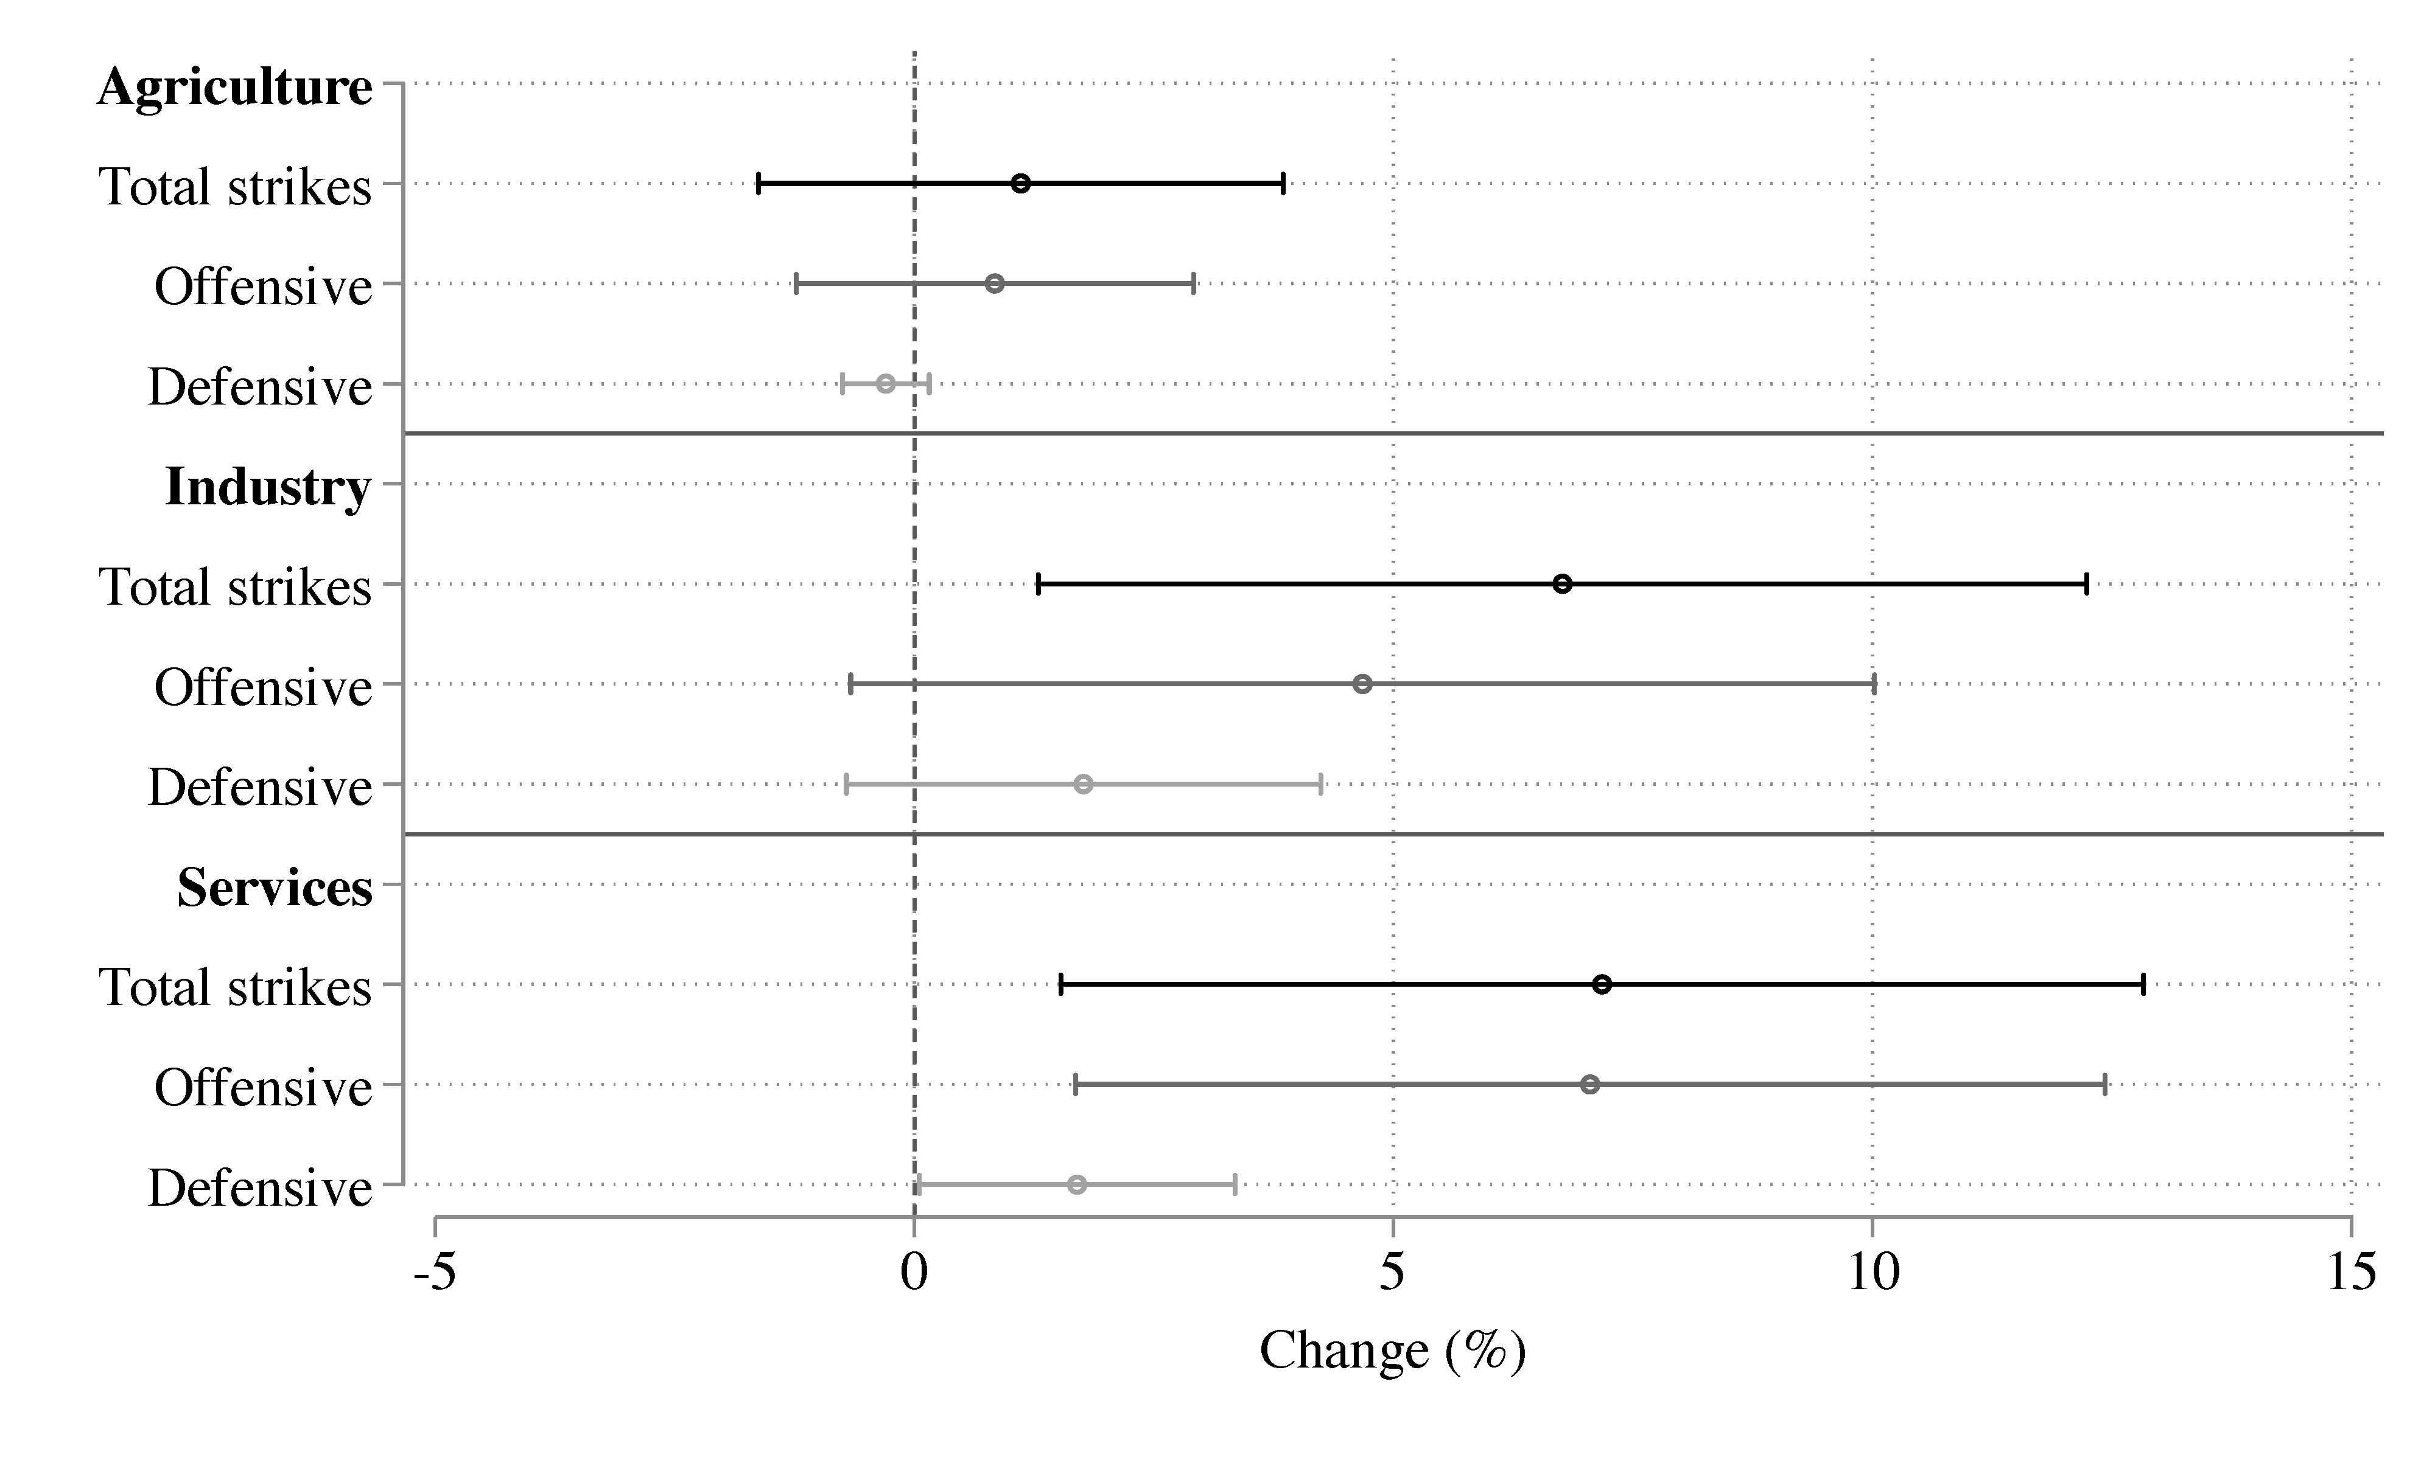Figure A1: Regression Results for Strikes by Sector, Industry and Services Separately
Note: This figure shows point estimates and 95% confidence intervals for the impact of a parish’s gaining access to the Western Line electricity grid on the increase in the number of strikes by sector, with a division between industry and services.
Standard errors are clustered at the parish level. The full regression table can be found in Table A4 of Appendix A.

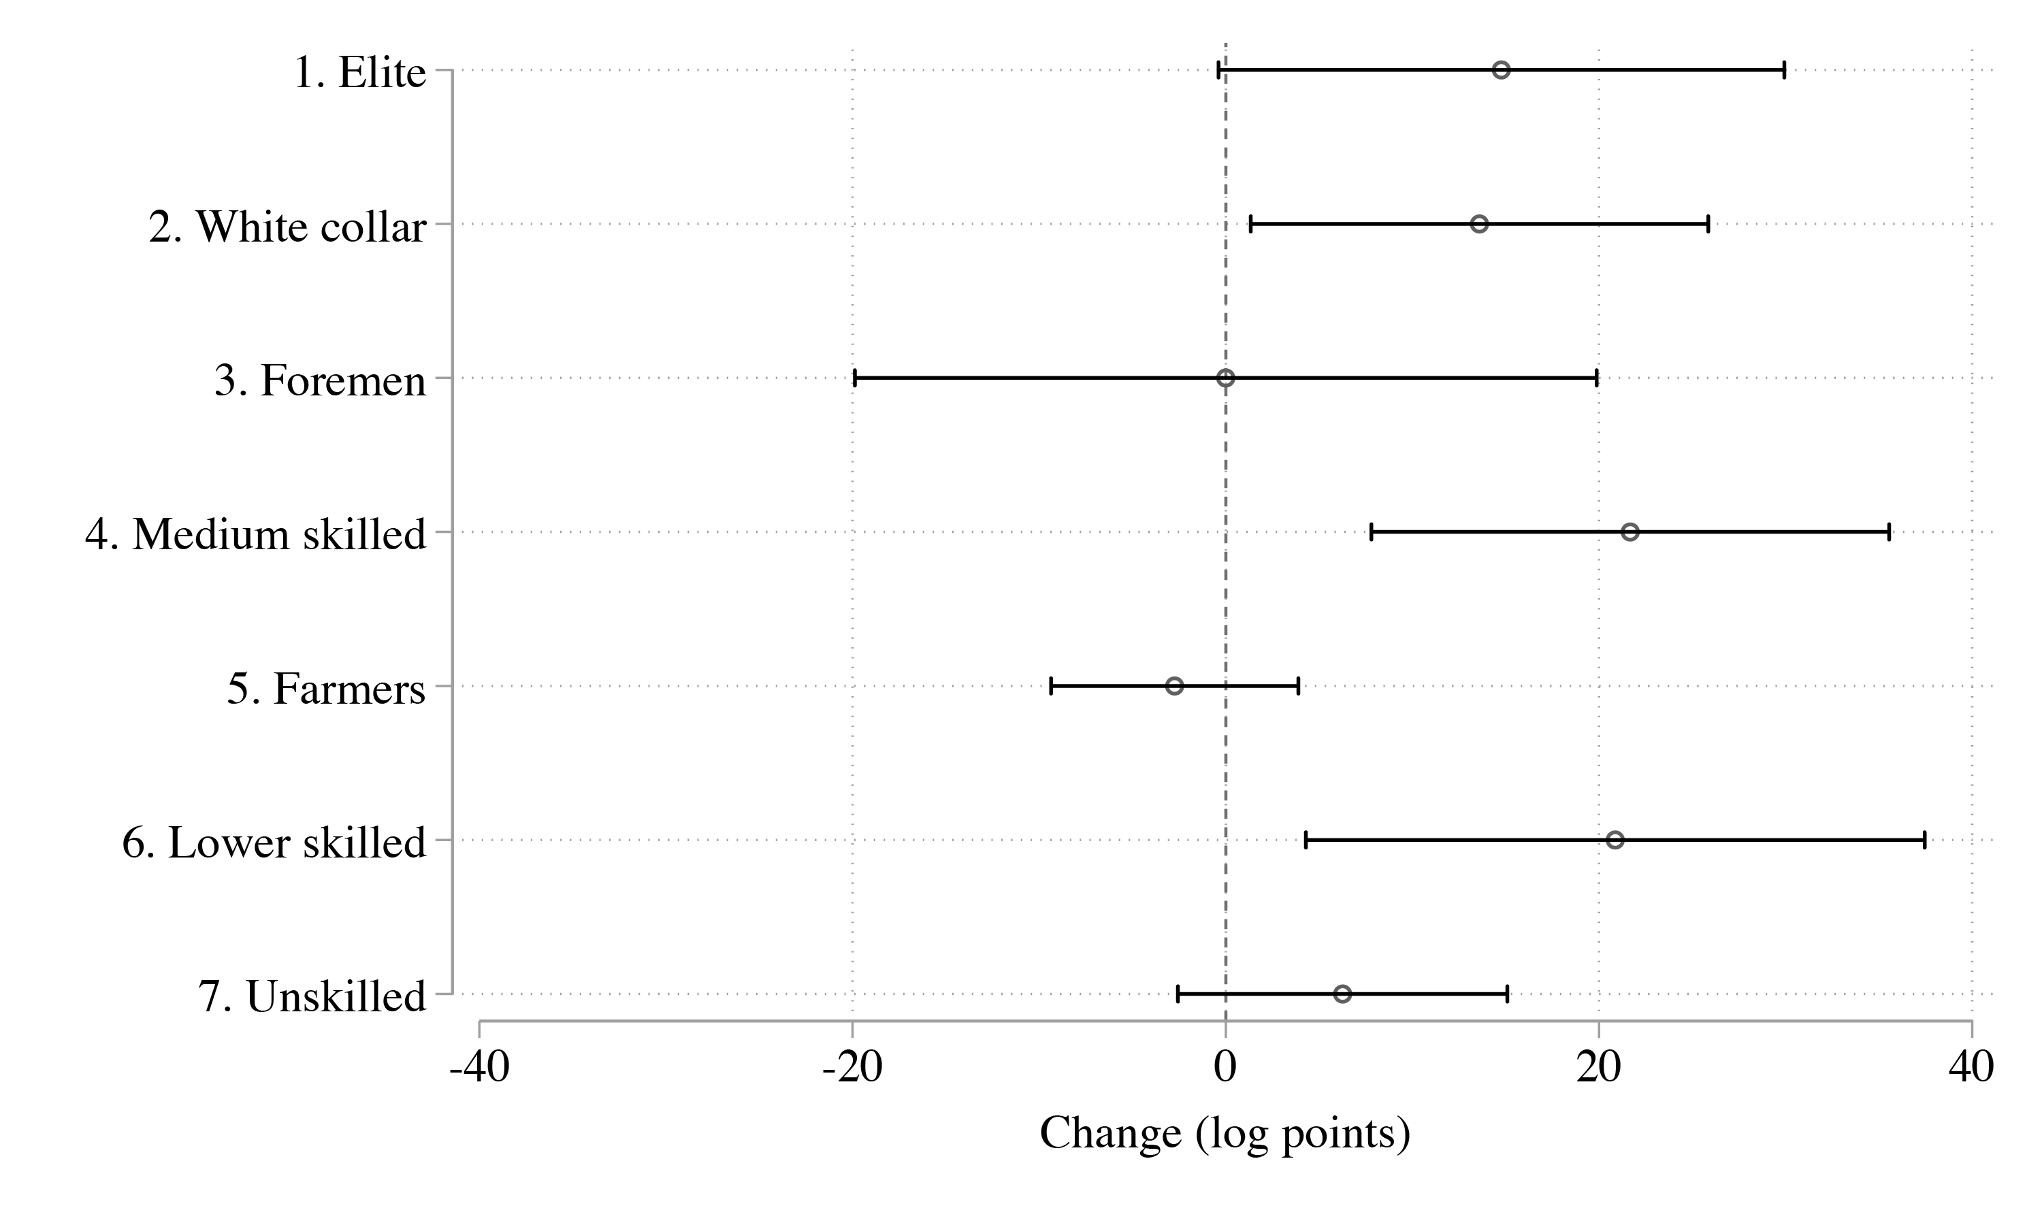Figure A2: Regression Results for Absolute Growth of Occupational Groups
Note: This figure shows point estimates and 95% confidence intervals for the impact of a parish’s gaining access to the Western Line electricity grid on the growth of employment by skill group. Standard errors clustered at the parish level. The full regression tables can be found in Table A11 of Appendix A.

Table A11: Regression Results for Absolute Growth of Occupational Groups
 | (1) | (2) | (3) | (4) | (5) | (6) | (7)
 | Elite | White collar | Foremen | Med. skilled | Farmers | Low skilled | Unskilled
Electricity grid access, Western Line (Dummy=1) | 14.8 | 13.6* | 0.0 | 21.7** | -2.7 | 20.9* | 6.3
 | (7.738) | (6.253) | (10.142) | (7.078) | (3.386) | (8.459) | (4.502)
 | (6.866)* | (7.181) | (6.120) | (5.574)*** | (2.438) | (3.159)*** | (5.881)
Mean dependent variable | 152.2 | 312.0 | 201.7 | 332.6 | 460.4 | 352.5 | 505.0
St. dev. dependent variable | 107.1 | 118.1 | 122.5 | 119.1 | 92.6 | 138.1 | 93.9
Controls | Yes | Yes | Yes | Yes | Yes | Yes | Yes
Parish FE | Yes | Yes | Yes | Yes | Yes | Yes | Yes
Year FE | Yes | Yes | Yes | Yes | Yes | Yes | Yes
County × Year FE | Yes | Yes | Yes | Yes | Yes | Yes | Yes
Observations | 4,931 | 4,931 | 4,931 | 4,931 | 4,931 | 4,931 | 4,931
No. of parishes | 2,470 | 2,470 | 2,470 | 2,470 | 2,470 | 2,470 | 2,470
Note: This table shows results for the impact of access to the Western Line electricity grid on the increase in the number of strikes by sector, with a division between industry and services. Robust standard errors clustered at the parish level are given in parentheses. *** p < 0.001, ** p < 0.01, * p < 0.05. Standard errors adjusted for spatial autocorrelation in italics, computed using Conley’s method assuming linear decay and cut off at 100 km.

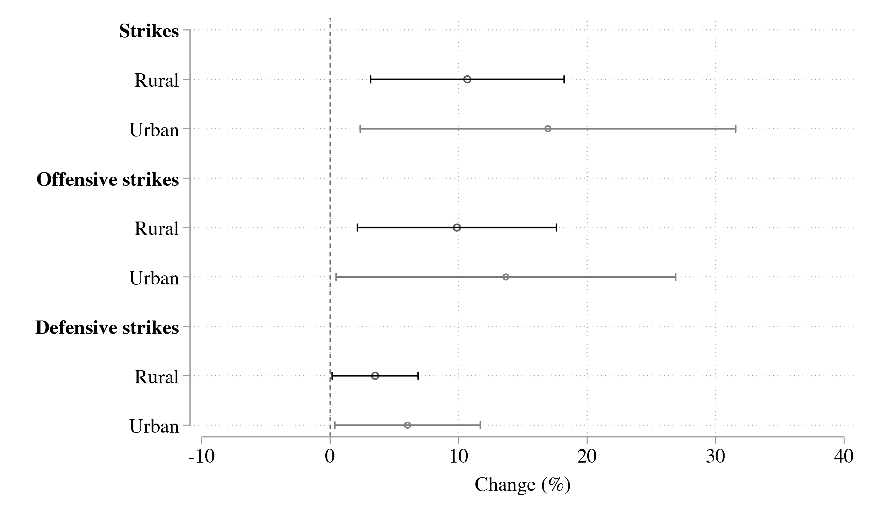Figure A3: Results for Strikes by Type of Parish: Rural/Urban
Note: This figure shows results of interacting Western Line electricity grid access with an indicator for whether a parish is rural or urban. Urban parishes are defined as the 50 percent of parishes with the highest population density in 1900. Standard errors clustered at the parish level. The corresponding regression tables are found in Table A12 of Appendix A.

Table A12: Regression Results for Strikes by Type of Parish: Rural/Urban
 | (1) | (2) | (3)
 | All strikes | Offensive | Defensive
Electricity grid access, Western Line (Dummy=1) | 10.4** | 9.7* | 3.4*
 | (3.830) | (3.944) | (1.702)
 | (4.294)** | (4.245)* | (2.038)*
Electricity grid access, Western Line (Dummy=1) × | 2.7 | 1.0 | 0.2
Urban parish (Dummy=1) | (8.425) | (7.847) | (2.966)
 | (8.010) | (7.649) | (2.220)
Mean dependent variable | 12.0 | 8.0 | 2.2
St. dev. dependent variable | 42.7 | 34.2 | 14.3
Controls | Yes | Yes | Yes
Parish FE | Yes | Yes | Yes
Year FE | Yes | Yes | Yes
County × Year FE | Yes | Yes | Yes
Observations | 7,401 | 7,401 | 7,401
No. of parishes | 2,470 | 2,470 | 2,470
Note: This tables shows results of interacting Western Line electricity grid access with an indicator for whether a parish is rural or urban. Urban parishes are the 50 percent of parishes with the highest population density in 1900. Standard errors clustered at the parish level. *** p < 0.001, ** p < 0.01, * p < 0.05. Standard errors adjusted for spatial autocorrelation in italics, computed using Conley’s method assuming linear decay and cut off at 100 km.

Appendix C Occupational Classification
We have used an abbreviated version of the HISCLASS scheme to denote the level of skills embedded in different occupations. The HICLASS scheme, introduced in van Leeuwen and Maas (2011), builds on the Historical International Standard of Classification of Occupations (HISCO), where historical occupations are coded into six-digit codes indicating one of 1,600 possible unit groups (van Leeuwen et al., 2002). Examples of six-digit codes include 02220 “Building Construction Engineer” and 61110 “General Farmer.” HISCO also allows the coding of three additional variables: Status, Relation, and Product. The most relevant for social class analysis is the Status variable, which provides details on ownership, stages in an artisan’s career, and whether someone is a principal or subordinate, information which is sometimes indicated in the original occupational strings but does appear in the occupational code itself. HISCLASS uses the HISCO codes together with the Status variable to sort each occupational unit group into one of twelve social classes. The twelve groups are shown in Table A13.
The HISCLASS scheme is based on three levels of differentiation: between manual and non-manual work, between levels of skill, and whether the occupation involves a supervisory role. Groups one through five are all non-manual. Within this set of non-manual classes, members of the first group, “Higher managers,” have a higher level of skill than, for example, those of the fifth group, “Lower clerical and sales personnel.” Those in the first group, “Higher managers,” have, in turn, a higher status than the second group of “Higher professional,” since even though they are both considered highly skilled, the position of the former also involves a supervisory role. As a corollary, among manual workers, “foremen,” since they also have a supervisory role, are given a higher social status than medium, lower and unskilled manual workers. While the HISCLASS scale running from one to twelve is nominal, it can be read as a ranking where “Higher managers” have the highest social status and “Unskilled workers” the lowest. An exception to this rule is “Farmers and fishermen,” which constitute their own social class. The occupations included in this group involve persons holding a wide range of skills and exercising a wide range of degrees of supervision. The scheme also divides low skilled and unskilled workers between the primary sector and the rest of the economy. This means that a move in the ranking from group nine, “Low-skilled workers,” to group ten, “Low-skilled farm workers,” does not mean a drop in social status, but rather a change of sector.
For our empirical analysis, we used an abbreviated version of the system, where we aggregated categories to arrive at seven groups. This classification is also displayed in Table A13. Since we are mainly interested in the skill dimension of social class, we have aggregated groups one and two into the elite, and three, four, and five into white collar workers. These middle class groups were very small in Sweden at the beginning of the twentieth century, so the number of people coded into any of these two groups is very small even after this aggregation. Because of the focus on skills, we also aggregated into one the two groups of low-skilled workers, who were in the original scheme split between the primary sector and the other sectors, and we do the same for unskilled workers.

Table A13: Occupational Classification Schemes: HISCLASS and our abbreviated categorization

HISCLASS Abbreviated
Number | Title | Number | Title
1 | Higher managers | 1 | Elite
2 | Higher professionals
3 | Lower managers | 2 | White collar
4 | Lower professionals, clerical and sales personnel
5 | Lower clerical and sales personnel
6 | Foremen | 3 | Foremen
7 | Medium-skilled workers | 4 | Medium-skilled workers
8 | Farmers and fishermen | 5 | Farmers and fishermen
9 | Low-skilled workers | 6 | Low-skilled workers
10 | Low-skilled farm workers
11 | Unskilled workers | 7 | Unskilled workers
12 | Unskilled farm workers

