Online Appendix

Tariffs and Trees: The Effects of the
Austro-Hungarian Customs Union on
Specialization and Land-Use Change

Jennifer Alix-Garcia, Sarah Walker, Volker Radeloff, and Jacek Kozak

Appendix A Additional Summary Table

Table A1
Summary Statistics of Variables Used in Analysis
 | Mean | SD | Min. | Max.
Crops (0/1) | 0.358 | 0.479 | 0.000 | 1.000
Pasture (0/1) | 0.181 | 0.385 | 0.000 | 1.000
Wetlands (0/1) | 0.012 | 0.110 | 0.000 | 1.000
Forest/grasslands (0/1) | 0.354 | 0.478 | 0.000 | 1.000
Urban (0/1) | 0.012 | 0.109 | 0.000 | 1.000
Ruggedness index | 0.837 | 0.665 | 0.000 | 3.093
Km to nearest city | 17.864 | 11.143 | 0.022 | 80.520
Km to nearest river | 43.157 | 28.737 | 0.001 | 137.848
No ag. limitations (0/1) | 0.678 | 0.467 | 0.000 | 1.000
Approx. population density | 53.095 | 46.742 | 20.424 | 3978.750
Observations | 81,407

Source: Author’s calculations using dataset described in Data and Methodology section.

Appendix B Alternative Discontinuity Window Results
48

Table B2
Impacts of customs union within Hungary
40 kilometer discontinuity, only districts with time variation
 |  | Dependent Variable
 |  | Crops |  |  |  | Pasture |  |  | Forest
 |  | (1) |  | (2) |  | (3) |  | (4) | (5) |  | (6)
Post customs union |  | 0.028 |  | 0.050 |  | –0.042 |  | –0.054 | –0.001 |  | 0.009
 |  | (0.062) |  | (0.051) |  | (0.062) |  | (0.050) | (0.073) |  | (0.027)
 |  | [–0.209, 0.158] |  | [–0.095, 0.139] |  | [–0.274, 0.121] |  | [–0.236, 0.075] | [–0.096, 0.294] |  | [–0.017, 0.162]
Years since 1850 x post union |  | 0.046* |  | 0.049** |  | –0.001 |  | –0.007 | –0.050** |  | –0.039***
 |  | (0.022) |  | (0.017) |  | (0.013) |  | (0.012) | (0.019) |  | (0.011)
 |  | [–0.006, 0.135] |  | [0.028, 0.078] |  | [–0.021, 0.040] |  | [–0.034, 0.016] | [–0.141, –0.025] |  | [–0.059, –0.019]
Other covariates |  | No |  | Yes |  | No |  | Yes | No |  | Yes
District FE |  | Yes |  | Yes |  | Yes |  | Yes | Yes |  | Yes
Observations |  | 7,618 |  | 7,618 |  | 7,618 |  | 7,618 | 7,618 |  | 7,618
R² 0.010 | 0.010 |  | 0.049 |  |  | 0.004 | 0.018 |  | 0.019 | 0.125
δ |  | 9.146 |  | 49.346 |  | –0.824 |  | –2.618 | 12.550 |  | 6.332
N districts |  | 10 |  | 10 |  | 10 |  | 10 | 10 |  | 10
* p< 0.10, ** p<0.05, *** p < 0.01.
Unit of observation is the point. Standard errors are in parentheses and are clustered at the district level. These are partial results using the sample within 40 km of a mapping border. All estimates include years since 1850, a quadratic of distance to discontinuity, and ln(km to border with Austria). Other covariates include ruggedness, an indicator for agricultural soil, proximity to city, and proximity to river. Ninety-five percent wild bootstrap clustered CIs in [].
Sources: Authors’ calculations using dataset described in Data and Methodology.

Table B3

Impacts of customs union within Hungary 30-kilometer discontinuity
 | Dependent Variable
 | Crops |  | Pasture |  | Forest
 | (1) | (2) | (3) | (4) | (5) | (6)
Post customs union | 0.031 | 0.051 | –0.058 | –0.061 | 0.013 | 0.016
 | (0.058) | (0.043) | (0.049) | (0.045) | (0.070) | (0.039)
Years since 1850 x post union | 0.041** | 0.038** | –0.003 | –0.008 | –0.040** | –0.025*
 | (0.020) | (0.016) | (0.011) | (0.012) | (0.018) | (0.014)
Other covariates | No | Yes | No | Yes | No | Yes
District FE | Yes | Yes | Yes | Yes | Yes | Yes
Observations | 8,186 | 8,186 | 8,186 | 8,186 | 8,186 | 8,186
R² | 0.009 | 0.054 | 0.002 | 0.013 | 0.013 | 0.122
N districts | 23 | 23 | 23 | 23 | 23 | 23
* p< 0.10, ** p<0.05, *** p < 0.01.
Unit of observation is the point. Standard errors are in parentheses and are clustered at the district level. These are partial results using the sample within 30 km of a mapping border. All estimates include years since 1850, a quadratic of distance to discontinuity, and ln(km to border with Austria). Other covariates include ruggedness, an indicator for agricultural soil, proximity to city, and proximity to river.
Sources: Authors’ calculations using dataset described in Data and Methodology.

Table B4

Impacts of customs union within Hungary 20-kilometer discontinuity
 | Dependent Variable
 | Crops |  | Pasture |  | Forest
 | (1) | (2) | (3) | (4) | (5) | (6)
Post customs union | 0.031 | 0.057 | –0.055 | –0.072 | 0.010 | 0.014
 | (0.067) | (0.046) | (0.033) | (0.041) | (0.068) | (0.038)
Years since 1850 x post union | 0.042* | 0.045** | –0.005 | –0.014 | –0.042* | –0.031*
 | (0.023) | (0.017) | (0.011) | (0.013) | (0.022) | (0.015)
Other covariates | No | Yes | No | Yes | No | Yes
District FE | Yes | Yes | Yes | Yes | Yes | Yes
Observations | 5,772 | 5,772 | 5,772 | 5,772 | 5,772 | 5,772
R² | 0.011 | 0.053 | 0.002 | 0.016 | 0.014 | 0.122
N districts | 18 | 18 | 18 | 18 | 18 | 18
* p< 0.10, ** p<0.05, *** p < 0.01.
Unit of observation is the point. Standard errors are in parentheses and are clustered at the district level. These are partial results using the sample within 20 km of a mapping border. All estimates include years since 1850, a quadratic of distance to discontinuity, and ln(km to border with Austria). Other covariates include ruggedness, an indicator for agricultural soil, proximity to city, and proximity to river.
Sources: Authors’ calculations using dataset described in Data and Methodology.

Appendix C Results Including District Time Trends

Table C5

Impacts of customs union within Hungary with district by year trends
 | Dependent Variable
 | Crops |  | Pasture |  | Forest
 | (1) | (2) | (3) | (4) | (5) | (6)
Post customs union | 0.033 | 0.004 | –0.029 | –0.067 | –0.029 | 0.063
 | (0.055) | (0.100) | (0.049) | (0.044) | (0.068) | (0.071)
Years since 1850 x post union | 0.035* | 0.053** | 0.005 | –0.018 | –0.040** | –0.030*
 | (0.017) | (0.020) | (0.010) | (0.014) | (0.015) | (0.016)
Other covariates | No | Yes | No | Yes | No | Yes
District FE | Yes | Yes | Yes | Yes | Yes | Yes
Observations | 10,356 | 10,356 | 10,356 | 10,356 | 10,356 | 10,356
R² | 0.007 | 0.054 | 0.003 | 0.024 | 0.014 | 0.132
N districts | 23 | 23 | 23 | 23 | 23 | 23
* p< 0.10, ** p<0.05, *** p < 0.01.
Unit of observation is the point. Standard errors are in parentheses and are clustered at the district level. These are partial results using the sample within 40 km of a mapping border. All estimates include years since 1850, a quadratic of distance to discontinuity, and ln(km to border with Austria). Other covariates include ruggedness, an indicator for agricultural soil, proximity to city, and proximity to river.
Sources: Authors’ calculations using dataset described in Data and Methodology.

Table C6

Impacts of customs union within Hungary
with district BY YEAR trends and using sample
with within-district variation in treatment
 | Dependent Variable
 | Crops |  | Pasture |  | Forest
 | (1) | (2) | (3) | (4) | (5) | (6)
Post customs union | 0.028 | 0.004 | –0.042 | –0.066 | –0.001 | 0.059
 | (0.062) | (0.101) | (0.062) | (0.043) | (0.073) | (0.073)
Years since 1850 x post union | 0.046* | 0.055** | –0.001 | –0.018 | –0.050** | –0.032*
 | (0.022) | (0.020) | (0.013) | (0.014) | (0.019) | (0.017)
Other covariates | No | Yes | No | Yes | No | Yes
District FE | Yes | Yes | Yes | Yes | Yes | Yes
Observations | 7,618 | 7,618 | 7,618 | 7,618 | 7,618 | 7,618
R² | 0.010 | 0.052 | 0.004 | 0.023 | 0.019 | 0.127
N districts | 10 | 10 | 10 | 10 | 10 | 10
* p< 0.10, ** p<0.05, *** p < 0.01.
Unit of observation is the point. Standard errors are in parentheses and are clustered at the district level. These are partial results using the sample within 40 km of a mapping border. All estimates include years since 1850, a quadratic of distance to discontinuity, and ln(km to border with Austria). Other covariates include ruggedness, an indicator for agricultural soil, proximity to city, and proximity to river.
Sources: Authors’ calculations using dataset described in Data and Methodology.

Appendix D Results Including Population Density

Table D7

Impacts of customs union in Hungary, including population
 | Dependent Variable
 | Crops |  | Pasture |  | Forest
 | (1) | (2) | (3) | (4) | (5) | (6)
Post customs union | 0.050 | 0.036 | –0.014 | –0.037 | –0.064 | –0.005
 | (0.059) | (0.049) | (0.049) | (0.044) | (0.064) | (0.037)
Years since 1850 x post union | 0.030 | 0.029* | 0.001 | –0.005 | –0.031* | –0.018
 | (0.018) | (0.015) | (0.010) | (0.010) | (0.016) | (0.013)
Other covariates | No | Yes | No | Yes | No | Yes
District FE | Yes | Yes | Yes | Yes | Yes | Yes
Observations | 10,356 | 10,356 | 10,356 | 10,356 | 10,356 | 10,356
R² | 0.008 | 0.048 | 0.004 | 0.018 | 0.017 | 0.126
N districts | 23 | 23 | 23 | 23 | 23 | 23
* p< 0.10, ** p<0.05, *** p < 0.01.
Unit of observation is the point. Standard errors are in parentheses and are clustered at the district level. These are partial results using the sample within 40 km of a mapping border. All estimates include ln(population density), years since 1850, a quadratic of distance to discontinuity, and ln(km to border with Austria). Other covariates include ruggedness, an indicator for agricultural soil, proximity to city, and proximity to river.
Sources: Authors’ calculations using dataset described in Data and Methodology.

Table D8

Impacts of customs union within Hungary – 40 kilometer discontinuity, only districts with time variation, including population density
 | Dependent Variable
 | Crops |  | Pasture |  | Forest
 | (1) | (2) | (3) | (4) | (5) | (6)
Post customs union | 0.047 | 0.059 | –0.027 | –0.045 | –0.037 | –0.008
 | (0.067) | (0.058) | (0.063) | (0.053) | (0.068) | (0.030)
Years since 1850 x post union | 0.042* | 0.047** | –0.004 | –0.008 | –0.043* | –0.036**
 | (0.022) | (0.017) | (0.012) | (0.012) | (0.019) | (0.013)
Other covariates | No | Yes | No | Yes | No | Yes
District FE | Yes | Yes | Yes | Yes | Yes | Yes
Observations | 7,618 | 7,618 | 7,618 | 7,618 | 7,618 | 7,618
R² | 0.010 | 0.049 | 0.005 | 0.018 | 0.022 | 0.126
N districts | 10 | 10 | 10 | 10 | 10 | 10
* p< 0.10, ** p<0.05, *** p < 0.01.
Unit of observation is the point. Standard errors are in parentheses and are clustered at the district level. These are partial results using the sample within 40 km of a mapping border. All estimates include ln(population density), years since 1850, a quadratic of distance to discontinuity, and ln(km to border with Austria). Other covariates include ruggedness, an indicator for agricultural soil, proximity to city, and proximity to river.
Sources: Authors’ calculations using dataset described in Data and Methodology.

Table D9

Impact of customs union by distance to Austro-Hungarian border, with population density
 | Dependent Variable
 | Crops | Pasture | Forest
 | (1) | (2) | (3)
Post customs union | –0.014 | –0.071 | 0.079*
 | (0.053) | (0.044) | (0.041)
Post union x border proximity | 4.200** | 3.418*** | –7.461**
 | (1.957) | (0.659) | (2.687)
Years since 1850 x post union | 0.041** | 0.005 | –0.039***
 | (0.018) | (0.010) | (0.014)
Post union x year x border proximity | –1.137* | –1.022*** | 2.094**
 | (0.579) | (0.173) | (0.780)
Other covariates | Yes | Yes | Yes
District FE | Yes | Yes | Yes
Observations | 10,356 | 10,356 | 10,356
R² | 0.049 | 0.019 | 0.129
N districts | 23 | 23 | 23
* p< 0.10, ** p<0.05, *** p < 0.01.
Unit of observation is the point. Standard errors are in parentheses and are clustered at the district level. These are partial results using the sample within 40 km of a mapping border. Other covariates include ruggedness, an indicator for agricultural soil, proximity to city, a quadratic for distance to discontinuity, proximity to river, ln(population density), and years since 1850. Border proximity is measured as 1/km to border.
Sources: Authors’ calculations using dataset described in Data and Methodology.

Appendix E: Additional Figures

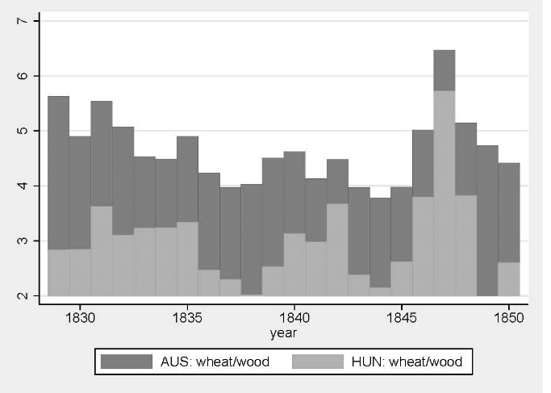

Figure E1

Relative Prices

Source: Tafeln zur Statistik der Österreichischen Monarchie (1828–1865).

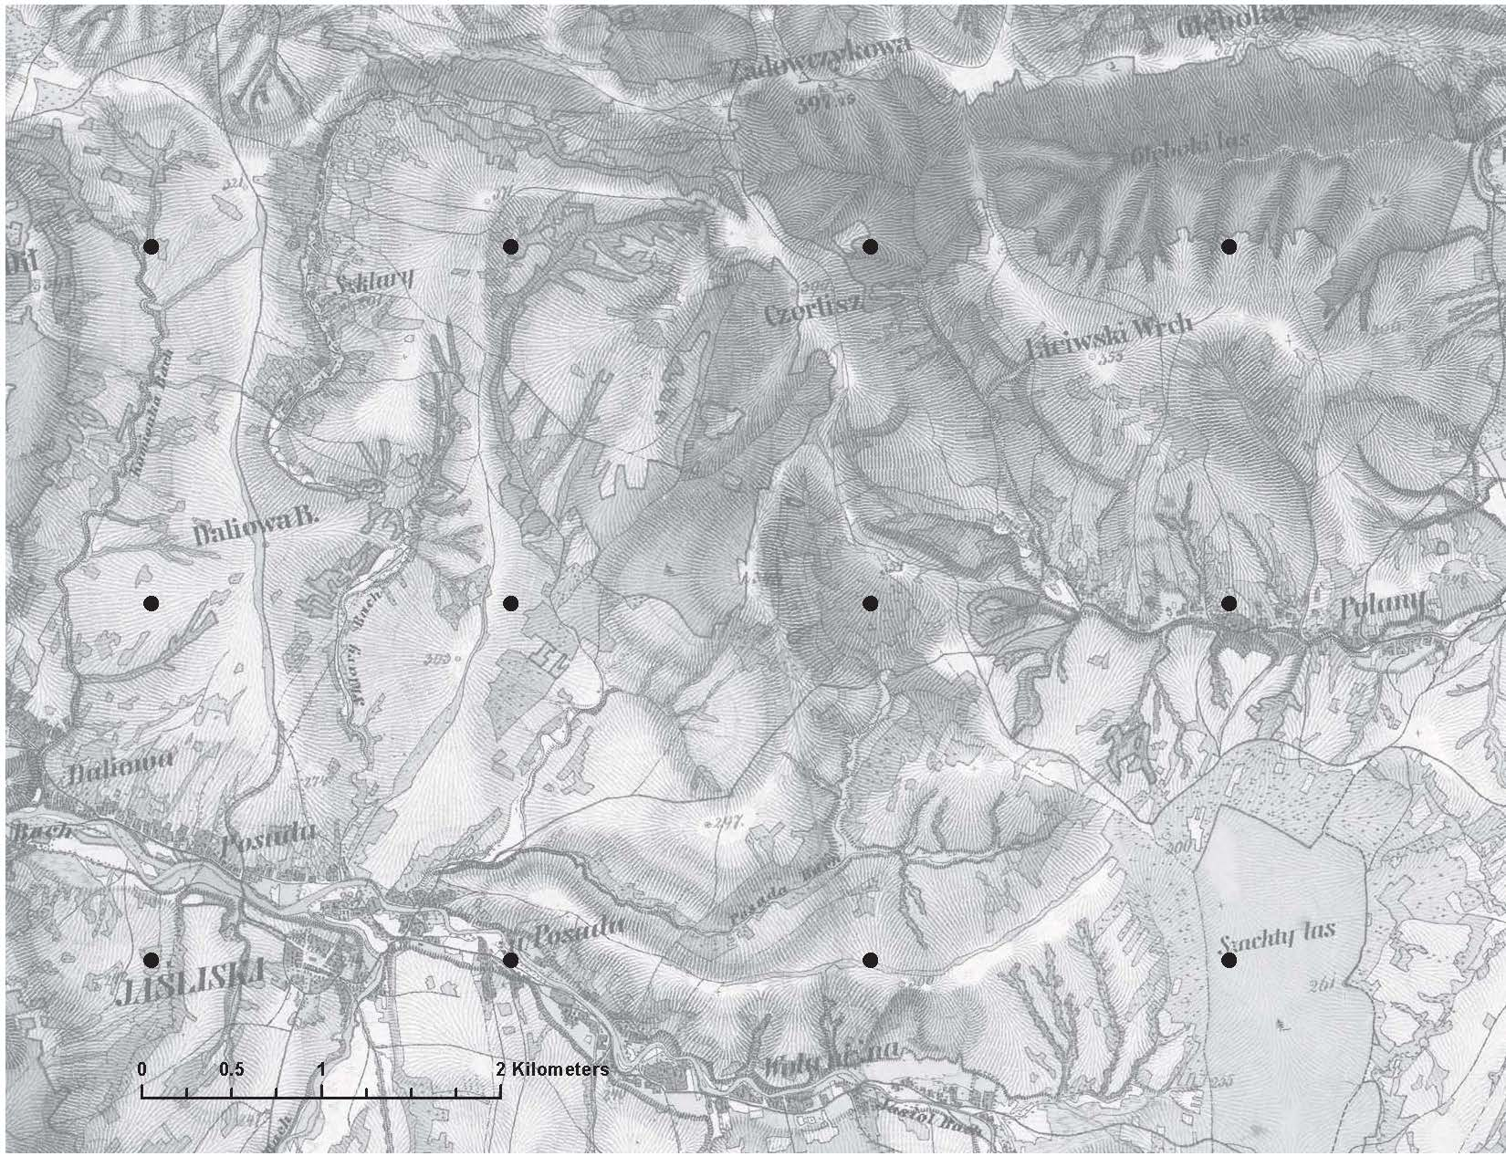

Figure E2

Historic map and sampled points

Source: The underlying map comes from section 11, west column XI of the Habsburg Second Military Survey (Timár et al. 2006) and covers what are now the southern areas around Krosno County Poland. The black circles represent the sampled points that comprise our dataset.

Density
.02 .04 .06
.08

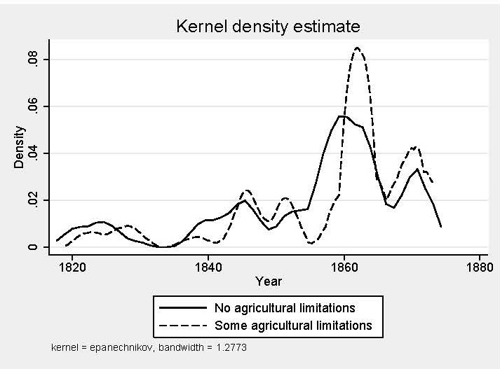

Figure E3

Mapping years and agricultural limitations

The figure shows the density of land mapped over time with no agricultural limitations (solid line) and with some agricultural limitations (dotted line).

Sources: Authors’ calculations using ESDB (2004) and Timár et al. (2006) historical maps.

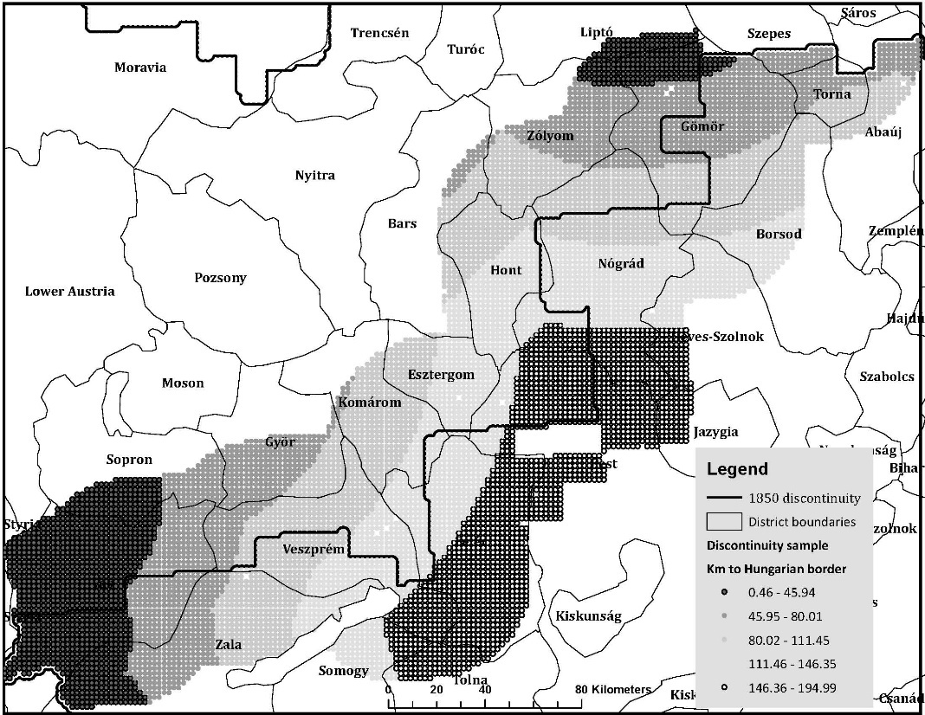

Figure E4

Sample for within-Hungary discontinuity estimation

Source: Authors' calculations using Timár et al. (2006) historical maps.

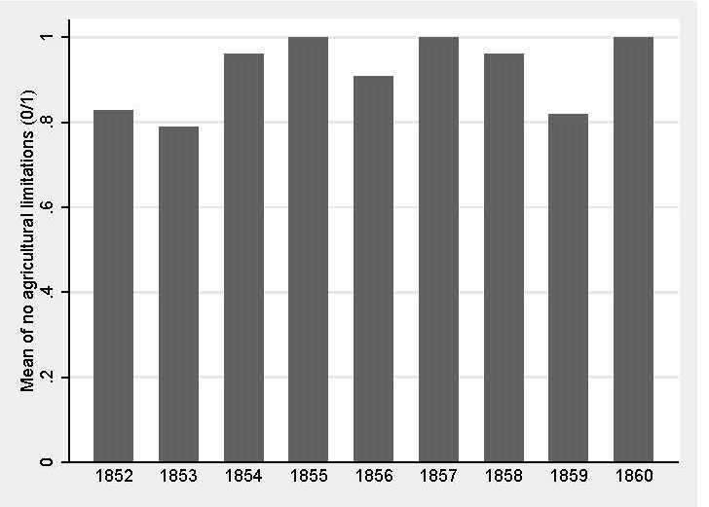

Figure E5

Inherent agricultural productivity by year

This graph uses the subsample of land in agricultural use after 1850 within the discontinuity window of 40 kilometers.

Sources: Authors’ calculations using ESDB (2004) and Timár et al. (2006) historical maps.

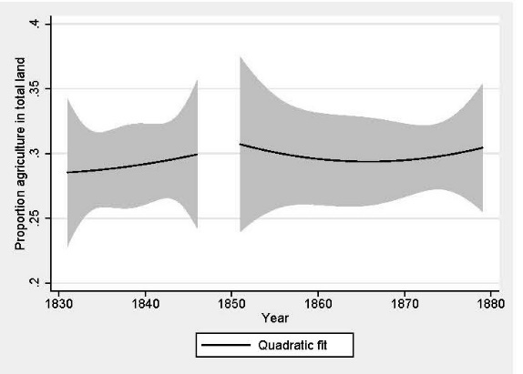 | 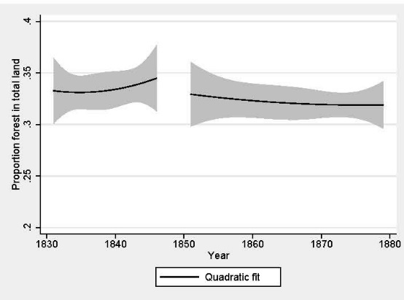
- Austria – Crops | - Austria – Forest
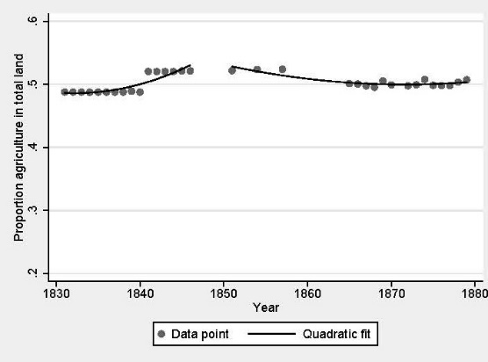 | 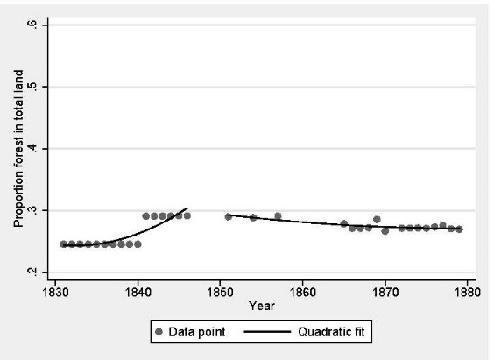
- Moravia – Crops | - Moravia – Forest
Figure E6
Trends in crop fields and forested area as a percent of total land: 1831–1880
Estimates are simple OLS quadratic fit regressions using data from Habsburg statistical yearbooks.
Source: See text for specific sources.

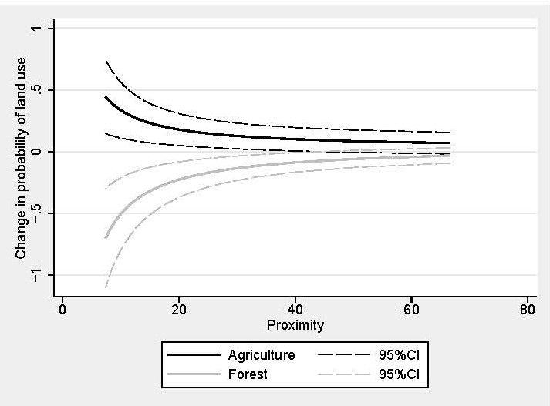

Figure E7

Marginal effects of distance to border on land-use after 1850

Marginal effects and 95 percent confidence intervals calculated from estimates in columns (1) and (3) in Table 6. Black lines are for agriculture, and gray for forest. Marginal effects for pasture are not shown.

Source: Authors’ calculations.

