Online Appendix
The Harvester Judgement and Wages Set
by Victorian Special Boards

The Special Boards were explicitly instructed to consider market factors when setting minimum wages. To address the possibility of endogeneity due to unobserved market factors influencing the rates set by Special Boards, we use an instrumental variable identification strategy. Our instrument derives from the 1907 Sunshine Harvester Judgement (Australia 2CAR1). In his decision, Justice H. B. Higgins ruled that employers had an obligation to meet “the normal needs of an average employee” defined by the “fair and reasonable” wage of 42s per week. While this decision only directly applied to firms which operated in more than one state and thus were covered by Federal arbitration, there exists a literature in Australian industrial relations arguing that the Victorian Special Boards used the Harvester standard as a benchmark when issuing their own determinations. Hammond noted that “the standard set up in this case has steadily served as the precedent in other cases … [and] has generally been accepted by other courts in Australasia and even to some extent by wages boards” (Hammond 1913, p. 268). Later scholars have generally come to similar conclusions. P. G. McCarthy noted, “For most of the unskilled, adverse labour market conditions caused wages to stick at a level markedly lower than the Harvester standard [prior to 1907]. ... [M]ost … boards were concerned primarily with skilled or semiskilled workers” (McCarthy 1968, p. 123). McCarthy saw the Harvester ruling as the beginning of a change in approach to wage setting by the Special Boards, noting that after 1907, “The process was first for boards to apply a 36s to 42s a week standard for work done by full laborers, and later to gradually draw sub-laboring grades of work done by adult males up to the lower figure of 36s. The last stage was to lift all up to the Harvester standard wage of 42s” (McCarthy 1968, p. 128).
This discussion implies that between 1906 and 1907 there would have been a change in the nature of minimum wage setting for trades with minimum wages under 42s per week. We capture this change in our regressions using the interaction of time period (after Harvester, that is t > 1907 = 1) and [Max (0, 42 – lagged minimum)] as an instrument for the change in the minimum wage. The instrument measures the wage increase needed to bring the minimum rate to the Harvester standard. Minimum rates already at or above the Harvester standard needed no further increase to reach this level, so in these cases our instrument takes on a value of zero. Prior to 1907, the Harvester ruling could not have affected the reasoning of the Special Boards. In these cases our instrument also takes on a value of zero. Crucially, this instrument is exogenous to either wages or employment, as the 42s level was determined based on the needs of the average adult male worker, not on market factors affecting the demand for labor. The Harvester standard did not apply to women or youths, and thus we do not consider these workers in our IV regressions.
To address the validity of this instrument, we examine changes in Special Board minimum wage determinations after 1907, compared to those issued earlier. A simple inspection of all judgements (issued across occupations, rather than trades) from 1907 onwards shows that the Special Boards did not fully adopt the Harvester standard. Approximately 6.1 percent of new determinations between 1907 and 1913 were less than 42s. Minimum rates of exactly 42s were relatively rare, averaging about 5 percent of new determinations between 1907 and 1913, and only exceeding 10 percent in 1909. The number of determinations at 45s exceeded the number at 42s over this period. However, even though there remained minimum rates below the Harvester standard and there was relatively little clustering at exactly 42s, it is nevertheless possible that the Special Boards focused increasingly on raising the lowest wages following the Harvester case. Figure A1 shows the proportion of workers employed in trades for which the lowest and median minimum wages were less than the Harvester standard. It is evident that there was a steep drop in the proportion of workers in trades with minimum rates below 42s between 1906 and 1907 followed by a gradual further decline thereafter.
As a further test of the effect of the Harvester standard on Victorian minimum wages, we examine the relationship between our instrument and individual determinations using the full set of occupation-level minimum wages from the WFSB Appendix. We regress the percentage change in the nominal minimum wage on 1) Max (42 – lagged minimum, 0) and 2) Max (42 – lagged minimum, 0)*after Harvester. We also include a time trend and year dummies as control variables in two specifications. In each specification we include Special Board fixed effects. The results are presented in Table A1. The regressions show that the Harvester Judgement had a strong effect on the Special Boards. Prior to the Harvester Judgement, there was a significant negative relationship between Max (42 – lagged minimum, 0) and the percentage increase in the minimum rate. In other words, the lowest skilled workers received the lowest increases in minimum rates. After the Harvester Judgement, there was a significant positive relationship. Some idea of the magnitude of this effect can be obtained by examining the predicted values of the regression at different initial minimum rates. For example, the first specification implies that the predicted increase in the minimum wage for an occupation with a minimum wage of 42s or more was 1.59 percent per year over the entire period. By contrast, the predicted increase for an occupation with a minimum wage of 35s was 0.08 percent per year between 1900 and 1906 and 5.21 percent per year from 1907. These differences are quantitatively large and strongly statistically significant, thus suggesting a large, exogenous change in wage setting policy from 1907.
The exclusion restriction for the suitability of a potential instrument is that there is no plausible channel by which it affects the dependent variable in the main regression, other than through the correlation with the independent variable of interest. There is no formal test for this restriction, but it appears to have been met in practice. Although the Sunshine Harvester case is widely viewed as the most important decision in Australian industrial relations history, this is because of the switch from state-level to federal-level minimum wage setting a decade after the period of our study. The direct impact of the decision on our sample was negligible. The CCA did not cover any workers in our sample and only covered relatively few workers state-wide before the 1920s and so had little direct or indirect market-based effects on wages in our sample.

REFERENCES

Hammond, M. B. “Judicial Interpretation of the Minimum Wage in Australia.” American Economic Review 3, no. 2 (1913): 259–86.

McCarthy, P. G. “Victorian Wages Boards: Their Origins and the Doctrine of the Living Wage.” Journal of Industrial Relations 10, no. 2 (1968): 116–34.

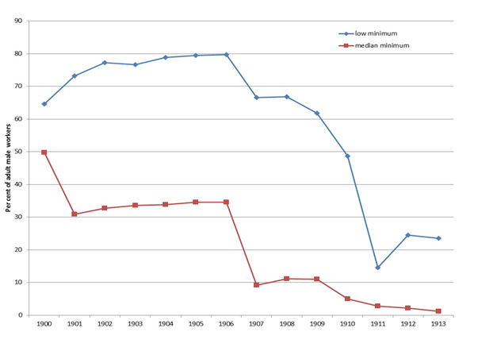
Figure A1
Percent of Adult Male Workers in Trades with Minimum Rates Under 42s per Week

Source: Victoria, Report of the Chief Inspector.

Table A1
Determinants of Occupation-Level Adult Male Minimum Wage Rates
 | (1) | (2) | (3)
Max (42– lagged minimum, 0) | –0.215***  (-5.90) | –0.092**  (2.45) | –0.092**  (2.46)
Max (42 – lagged minimum, 0)*  after Harvester | 0.732***  (17.56) | 0.617***  (14.54) | 0.639***  (14.68)
Year |  | –0.290***  (11.87)
Year Dummies | No | No | Yes
Constant | 1.587***  (20.53) | –1.061***  (4.50) | –0.086  (0.21)
F | 168.50*** | 161.54*** | 50.74***
Adjusted R² | 0.093 | 0.111 | 0.136
N | 7,100 | 7,100 | 7,100
Notes: Dependent variable is the percentage change in the real minimum wage rate, at the occupation level. All regressions contain occupation-level fixed effects. Other notes are the same as Table 2.
Source: Victoria, Report of the Chief Inspector.

We do not attempt to instrument for the highest minimum rate, as this was over 42s in virtually all trades after 1907.

