Online Appendix: Import Prices

In this article we rely on a single import price index to derive the terms of trade for all African countries and regions in our sample. This import price index from Brian R. Mitchell (1988, pp. 526–28) is based on a comprehensive set of products—the prices of which are observed in the United Kingdom—that are shipped to the British colonies and possessions as well as its other trading partners. The main benefit of relying on this common import price index is that the resulting terms of trade series are consistent with the earlier work of Jeffrey G. Williamson (2011), making a direct comparison of the relative size and duration of the terms of trade boom between Africa and the other “peripheral” countries possible (see Figure 6).
Potential concerns with the use of Mitchell’s import price index are that: (1) the mix of goods shipped to the full range of Britain’s trading partners (including developed countries) may not be representative for the flow of goods sent from the United Kingdom to Africa; (2) the prices of imported goods as observed in Africa may deviate from the prices observed in the United Kingdom; (3) the import price index based on British prices and goods may not be representative for the goods shipped from France to its colonies and possessions. As we will illustrate later, none of these issues appear to have a structural or pronounced effect on the resulting import price index.
To test the representativeness of the import price index by Mitchell, we reconstructed a new price index for the Gambia, Gold Coast and Sierra Leone. For these three British colonies we have reliable data, from 1853 onwards, of the flow and composition of goods shipped from the United Kingdom as well as African price series for the key import items. We derived the value shares of imports from the Annual Statement of Trade and Navigation of the United Kingdom, the prices observed at the African coast are from the Blue Books and the Statistical Abstract for the Several Colonial and Other Possessions, and—for those products where no African prices are available—we used the British export prices from the Statistical Abstract for the United Kingdom. Table A.1 summarizes the value shares of 13 key imported goods which together cover more than 75 percent of the total value of imports into the Gold Coast, Gambia, and Sierra Leone over the period 1853–1902.
Table A.1 shows that the import shares for British West Africa did indeed deviate from the overall export mix of the United Kingdom.
Table A.1
VALUE SHARES OF KEY IMPORTS INTO BRITISH WEST AFRICA,
1853–1902 (Percent)
Product | Imports into |  | Exports from
 | Gold Coast | Gambia and Sierra Leone | the United Kingdom
Rice | 1.0 | 11.3 | 0.5
Beer | 0.4 | 1.4 | 0.7
Spirits | 0.7 | 1.4 | 0.6
Tobacco | 1.0 | 3.3 | 0.2
Gunpowder | 2.8 | 4.8 | 0.1
Wooden goods | 3.1 | 0.3 | 0.1
Silk goods | 1.3 | ... | 0.7
Cotton goods | 54.8 | 52.1 | 22.2
Apparel and slops | 2.5 | 5.8 | 1.4
Beads | 1.6 | 1.0 | ...
Iron | 1.6 | 4.2 | 8.5
Brass | 2.4 | ... | 0.1
Firearms | 1.7 | 6.3 | 0.2
Other | 25.0 | 8.0 | 64.6
TOTAL | 100.0 | 100.0 | 100.0
Notes: Items listed as “…” are not mentioned in the primary source.
Sources: For Gold Coast, Gambia, and Sierra Leone: Annual Statement of Trade and Navigation of the United Kingdom (1856, 1861, 1866, 1871, 1876, 1881, 1887, 1892, 1897, 1902); for the United Kingdom: Statistical Abstract for the United Kingdom in each of the last 15 years (1868, 1874, 1887, 1898, 1903).

All three African countries predominantly imported cotton goods, but tobacco, gunpowder, and firearms also made up a sizable share of the value of West African imports. Cotton cloth was a major export item for the United Kingdom, but a substantial share of British exports remains uncovered by these 13 items. Important items such as machinery, woolen goods, and processed food were scarcely imported into Africa.
To see whether the divergent import mix for British West Africa affects the import price index as well, we combine the average value shares for each decade with annual price indices for these 13 items. Unfortunately, no reliable set of African prices was available for cotton goods, wooden goods, and brass. For these items we relied on British export prices instead. Figure A.1 compares the new, country-specific import price indices to the original index by Mitchell.

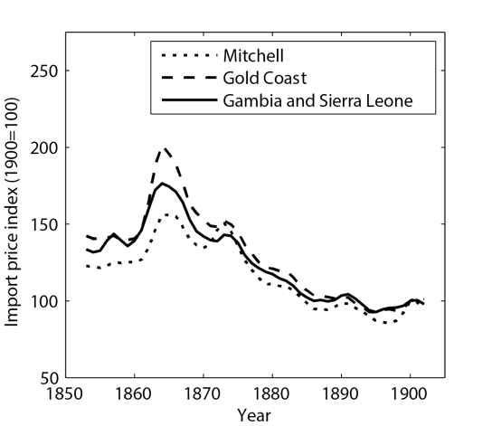 | 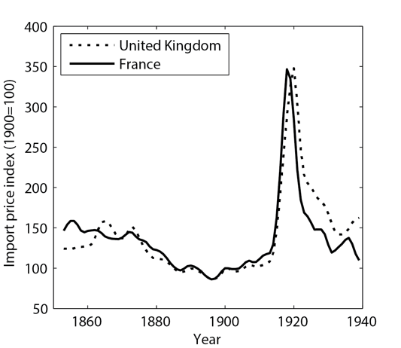
Figure A.1
IMPORT PRICE INDICES COMPARED, 1853–1939

Notes: French import price index converted to pounds using quoted exchange rates. Import price indices for United Kingdom and France refer to the price of goods shipped from these respective countries to their trading partners and colonies (so technically export price indices). Maintained reference to “import” to retain consistency with main text which views trade from the perspective of African countries.
Sources: [left-hand pane] Mitchell (1988, pp. 526–28); Gold Coast, Gambia, and Sierra Leone, value shares see Table A.1; African prices Blue Books (various issues), and Statistical Abstract for the Several Colonial and Other Possessions (1865, 1874, 1885, 1891, 1895, 1906); British prices Statistical Abstract for the United Kingdom in each of the last 15 years (1868, 1874, 1887, 1898, 1903). [right-hand pane] United Kingdom from Mitchell (1988, pp. 526–28); France from Mitchell (2007). Exchange rates from Mitchell (1988, pp. 700–03).

The left-hand pane of Figure A.1 clearly shows that the original index by Mitchell is a good proxy for the price development of imported goods into British West Africa. Between 1853 and the peak of the terms-of-trade boom (1884), the country-specific indices show a slightly greater decline in import prices: –0.87 and–0.82 versus Mitchell’s –0.68 percent per annum. The use of these import prices would thus increase the rate of growth of the terms of trade by between 0.14 and 0.19 percentage points per annum for this period. The more pronounced peak in import prices during the early 1860s in the result of rising prices for cotton during the American Civil War which weigh heavily in the West-African import mix (see Table A.1).
The right-hand pane of Figure A.1 compares the price index of British commodities to an index of French commodities being traded with the rest of the world. To make both series comparable we converted the French prices into British pounds using quoted exchange rates (Mitchell 1988, pp. 700–703). Again the original, British index by Mitchell appears to be a good proxy for the price development of imported goods into Africa.
REFERENCES

Board of Trade. Annual Statement of the Trade and Navigation of the United Kingdom with Foreign Countries and British Possessions. London: Eyre and Spottiswoode (1856, 1861, 1866, 1871, 1876, 1881, 1887, 1892, 1897, 1902).
______. Statistical Abstract for the United Kingdom in each of the Last 15 Years. London: Eyre and Spottiswoode (1868, 1874, 1887, 1898, 1903).
______. Statistical Abstract for the Several Colonial and Other Possessions of the United Kingdom. London: Eyre and Spottiswoode, 1 (1865); 10 (1874); 20 (1885); 28 (1891); 32 (1895).
______. Statistical Abstract for the Several British Colonies, Possessions, and Protectorates. London: His Majesty’s Stationery Office, 43 (1906).
British Foreign and Commonwealth Office. Blue Book for the Gambia. London: Government Printer, 1828–1849; 1851–1939.
______. Blue Book for the Gold Coast. London: Government Printer, 1846–1861; 1867–1939.
______. Blue Book for Sierra Leone. London: Government Printer, 1819–1939.
Mitchell, Brian R. British Historical Statistics. Cambridge: Cambridge University Press, 1988.
______. International Historical Statistics: Europe 1750–2005. Basingstroke: Palgrave Macmillan, 2007.
Williamson, Jeffrey G. Trade and Poverty: When the Third World Fell Behind. Cambridge, MA: MIT Press, 2011.

Either price data was absent or, in the case of cotton goods, the units (that is, yards or packages), description and quality changed frequently and were irreconcilable between the years in our sample.

