*Online Appendix*

*America’s First Great Moderation*

Table A1

MARKOV-REGIME SWITCHING MODELS FOR KEY IP COMPONENTS, 1792–1914

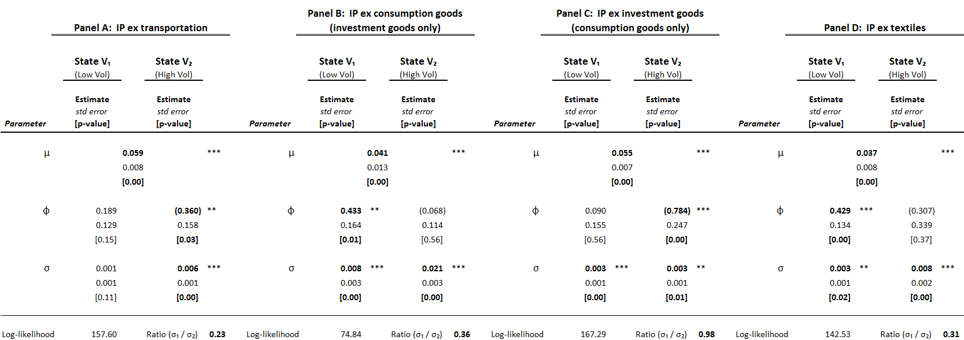

\* = Significant at the 10 percent level.

\*\* = Significant at the 5 percent level.

\*\*\* = Significant at the 1 percent level.

*Sources*: Authors’ calculations and the output from the vector autoregressions.

Table A2

GRANGER-CAUSALITY TESTS-IP SECTORS VERSUS ALL OTHER IP

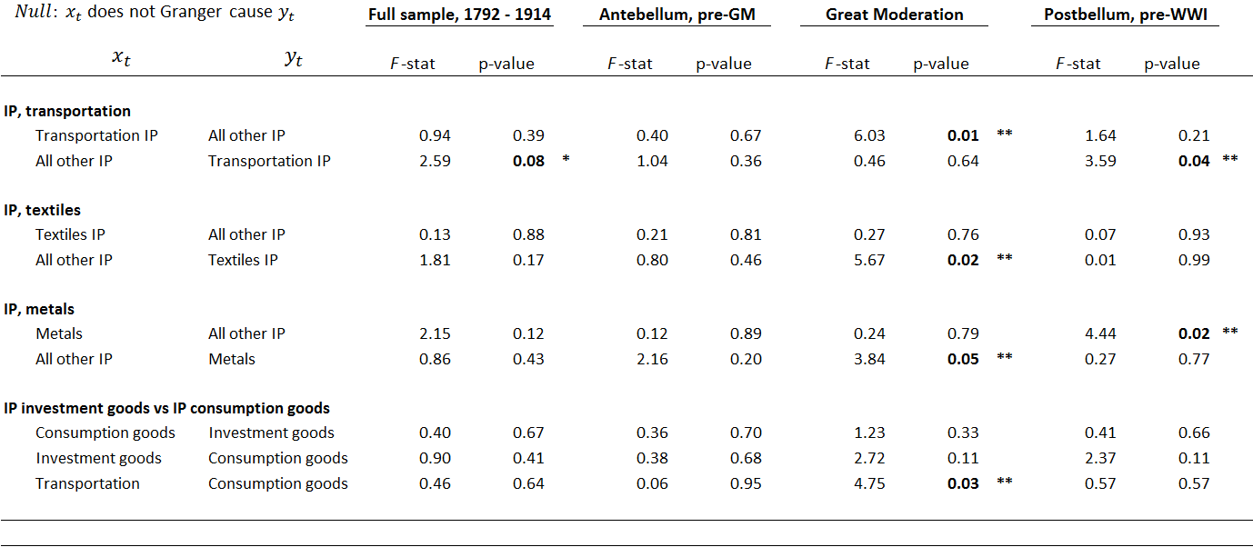

\* = Significant at the 10 percent level.

\*\* = Significant at the 5 percent level.

\*\*\* = Significant at the 1 percent level.

*Notes*: VAR Granger-causality tests employ two lags for all series in all samples. “Great Moderation” sample ends in 1858 (rather than 1856) to account for the two-year lag. The post-bellum period begins in 1870 to remove the immediate effects of the end of the Civil War. The results for IP metals in the “Antebellum, pre-GM” sample begin in 1830 since the IP metals index begins in 1827 and the test requires two lags.

*Sources*: Authors’ calculations and the output from the vector autoregressions.

Table A3

GRANGER-CAUSALITY TESTS-ALTERNATIVE FACTORS ON IP INDICES



\* = Significant at the 10 percent level.

\*\* = Significant at the 5 percent level.

\*\*\* = Significant at the 1 percent level.

*Sources*: Authors’ calculations and the output from the vector autoregresions.