Online Appendix
APPENDIX 1: BRITISH, FOREIGN AND COLONIAL LIQUIDITY INDICATORS

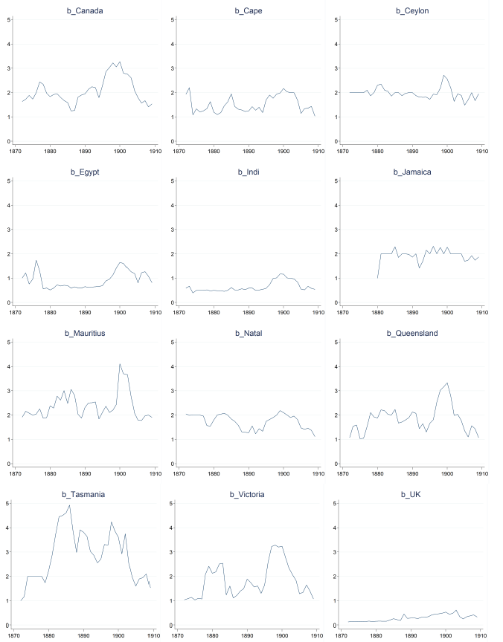

Figure A1
COLONIAL LIQUIDITY INDICATORS (RATIO OF CLOSING QUOTATIONS BRACKET TO BOND PRICE; MEAN BY COUNTRY AND YEAR)
Source: Author’s database as collected from the Official List.
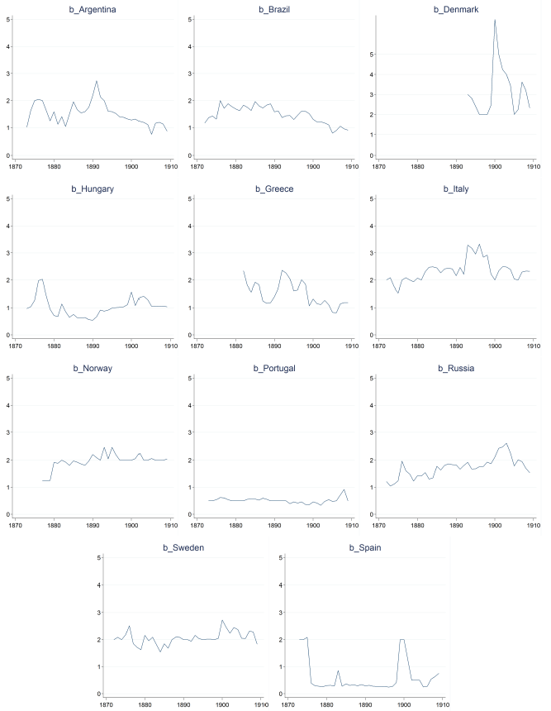

Figure A2
SOVEREIGN LIQUIDITY INDICATORS (RATIO OF CLOSING QUOTATIONS BRACKET TO BOND PRICE; MEAN BY COUNTRY AND YEAR)
Source: Author’s database as collected from the Official List.

APPENDIX 2: SAMPLE, DATA AND SOURCES

Our sample draws from a novel hand-picked database of government bond quotations from the London Stock Exchange covering the 1872–1909 period. We originally collected the entire universe of quoted sovereign and colonial bonds at monthly frequency (the last trading day of the month) in the London Daily Stock and Shares List (“Official List”), a leading financial publication (Michie 1999). However, the main tests of this paper exploit only yearly prices (using the month of December data) for a subset of countries and abstracts from the 1872–1880 years. This is because we additionally use credit risk proxies drawn from the Global Finance Database (http://eh.net/database/global-finance/), which draws on Flandreau and Zumer (2004) and Accominotti, Flandreau, and Rezzik (2011). This dataset covers the 1880–1909 period at yearly frequency for a number of countries in our database. The colonies included in the Global Finance Database are Canada, Cape of Good Hope, Ceylon, Egypt, India, Jamaica, Mauritius, New South Wales, New Zealand, Natal, Queensland, South Australia, Tasmania, Victoria, and Western Australia. The sovereigns are Argentina, Brazil, Denmark, Greece, Hungary, Italy, Norway, Portugal, Russia, Spain, and Sweden.
In contrast, results in Tables A.1 to A.4 exploit the whole sample of countries and years at monthly frequencies. In both cases, we excluded the bonds of countries in default by using the corresponding proxy in Flandreau and Zumer (2004). We also excluded sovereign bonds denominated in currencies other than Sterling. Finally, we removed those bonds for which we observed less than 12 data points.
We measure the yield on a bond i issued by country c using a standard coupon-yield formula such as:
$${Yield}_{i,c,t}=\frac{{Coupon}_{i,c}}{{Price}_{i,c,t}}.$$ | (A.1)

Since the Official List only provides upper and lower price brackets (see discussion in Section 3), we approximate Price_{i,c,t} by:

$${Price}_{i,c,t}=\frac{1}{2}\left({Upper Price}_{i,c,t}+{Lower Price}_{i,c,t}\right).$$ | (A.2)

Data for coupon and lower and upper prices come from our database, as collected from the Official List. To control for changes in long-term risk-free interest rates, we measure Yield_{i,c,t} in excess of the yield on British Consols. An incidental difficulty in that respect is that the British issues considered as benchmark long-term risk-free bond by investors has changed over time due to conversion threats. To identify the correct benchmark Consol at each t, we follow Klovland (1994). This implies successively using the 3 percent Consol (1872m1–1880m12), the New 2.5 percent (1881m1–1884m12), the Childers 2.5 percent (1885m1–1888m12), and the Goschen 2.75/2.5 percent Consol (1889m1–1909m12).
To proxy for issuers’ credit risk, Flandreau and Zumer (2004) recommend using the debt service-to-revenue ratio. They show that it is a strong predictor of default risk and that it was also a variable of choice to inform contemporary opinion. We thus measure credit risk as follows (the data to construct this ratio is taken from the Global Finance Database):

$${Credit}_{c,t}=\frac{{Interest Service}_{c,t}}{{Government Revenue}_{c,t}}$$ | (A.3)
A bond’s Age is measured by the (log) number of years since the bond was issued. We prefer this measure to the more usual time-to-redemption since the latter can be observed only imperfectly owing to missing information or redemption clauses. We draw information on issuance year and month from the Official List (where available) or Burdett’s (otherwise). This leaves us with a few missing observations, which explains why the number of observations is slightly smaller when the regressions include Age. Bonds’ Volume is measured by the (log) outstanding amount, as collected from the Official List at the beginning of each year (for the month of January). We prefer the outstanding amount to the initial amount (also displayed in the Official List) because a large number of bonds were redeemed gradually during their lifetime, for instance via the operations of a sinking fund.

APPENDIX 3: A PORTFOLIO APPROACH

In this Appendix, we develop a portfolio approach to measure liquidity risk pricing similar to Alquist (2010) so as to deconstruct the differences between his approach and ours and demonstrate that the point of departure is his (in our view incorrect) assumption that colonial and foreign debt markets were “integrated.” We argue they were not and that this explains the differences between the two sets of results. In what follows we first discuss differences in methodologies, then differences in datasets and finally discuss the insights one can glean from applying an arbitrage pricing approach to our dataset.

Foreign and Colonial Debt Markets Were Not Integrated

Let us start by explaining differences in modeling. Alquist’s model is an application of the Arbitrage Pricing Theory (APT), a widespread approach in finance. According to APT, investors do not price individual bond characteristics (as we assume in this article) because the latter can always be diversified away within an investment portfolio. In contrast, they do price the sensitivity of individual bonds to market-wide risks (or “factors”), which by definition cannot be diversified away. To test the model empirically, Alquist regresses time-series of bond prices on a set of five such time varying factors:

$${Return}_{p,t}=α+β_{1}∙{Liq}_{t}+β_{2}∙{Credit}_{t}+β_{3}∙{Term}_{t}+β_{4}∙{Market}_{t}+ε_{p,t}.$$ | (A.4)

Liq_{t} is the average of individual closing quotations (called by Alquist bid-ask spread) at each time t, over the universe of all bonds. Technically, Alquist’s regression uses the “shock” component of Liq_{t}, measured by the residuals of a second-order autoregressive (AR(2)) model of Liq_{t}. Credit_{t} comprises two different measures of aggregate credit risk. They correspond to the return differentials between portfolios made of bonds of both colonial and sovereign issuers sorted at the beginning of each year according to each countries’ debt level and export-to-GDP ratio, respectively, which Alquist takes from Flandreau and Zumer (2004) and Accominotti, Flandreau, and Rezzik (2011). Term_{t} measures the aggregate risk of changes in interest rates, as measured by the return on British Consols net of the return on 30-days bankers’ bills. Market_{t} measures changes in aggregate stock returns, as measured by an average of stock prices collected by Alquist.
On the left-hand side, returns are measured net of the return on a one-month bill, which Alquist considers to be the benchmark risk-free rate. As the subscript indicates, returns are not measured at the level of an individual bond, but rather at the level of a portfolio of bonds. Specifically, Return_{p,t} is the average return (the average change in bond prices) on a given portfolio p. Individual bonds are sorted at the beginning of each year into ten portfolios according to their liquidity, proxied by their individual bonds’ closing quotations.
While our econometric strategy differs from Alquist’s, both are really based on the very same intuition. To see this, let us make the following thought experiment. Consider a market-wide evaporation of liquidity, reflected in a sudden increase in the set of all individual securities’ liquidity indicators. In our own main equation 2, this adverse shock will cause individual bond prices to go down (equivalently, will cause yields to rise) because our model predicts that lower liquidity depresses bond prices. In terms of portfolio returns now, the inference is that illiquidity shocks have a negative impact on bond prices (they go down), and thus on returns. Formally, the loading β for an illiquidity factor should be negative and significant. This is exactly what Alquist finds in results obtained with the entire population of bonds, as can be seen from his Tables 1 and 2. Just keep in mind that since his model is specified in terms of liquidity rather than illiquidity shocks (illiquidity multiplied by –1), his results are simply the opposite, a positive and significant β (an amelioration of liquidity boosting bond prices).
Now, here comes the crucial difference between the two approaches. To measure Liq_{t}, Alquist starts with the same individual colonial and sovereign closing quotations brackets from the Official List we use in our workhorse regression framework. But he then averages all of these individual measures at each time t to form one time-series indicator of market-wide liquidity. (Alquist’s measure is thus a kind of average of the two measures we show in Figure 3.) Alquist’s central result is that colonial and sovereign bond prices (pooled together) react positively to changes in this index of market liquidity. Notwithstanding the different approach, the logic of the test is consistent with ours: it asks whether an improvement in market-wide liquidity (a narrowing of closing quotations in our framework, and a decrease in his index) lifts up bond prices (decreases bond yields in our framework, and increases returns in his model).
With this approach, Alquist’s finds that the significance of liquidity vanishes when his regression (A.4) is applied to colonial bonds only. Since colonial bonds do not react to this “aggregate liquidity,” Alquist concludes that the colonials were “immune” to illiquidity problems. This is where our conclusions strongly differ. We argue that this inference is incorrect, because it relies on a mis-measurement of “market liquidity.” At stake is not the definition of “liquidity” but the delineation of “markets.” As said, Alquist’s Liq_{t} amalgamates colonies and sovereign. This amounts to assuming that there was one unique “market” and thus one unique measure of “market liquidity.” This is not an innocuous assumption: as we saw in Figure 3, average liquidity indicators for sovereigns and colonies exhibited long phases of decoupling, most strikingly during episodes of sovereign debt turmoil. Since Alquist’s liquidity factor is an average, it will effectively be driven by sovereign turbulences during times of sovereign distress. To be very concrete, Alquist assumes that investors in the bonds of the colony of Victoria—a very safe, but illiquid investment—should react to woes in Turkish bonds—a highly risky, yet very liquid investment. We think this is unwarranted. Because they were originated and held by different agents, colonial returns ought to have reacted to changes in colonial market liquidity, and sovereign returns to changes in sovereign liquidity. Assuming otherwise is unjustified, and can lead to erroneous conclusions.
To show this, Tables A.1 and A.2 replicate Alquist’s approach, but for one dimension: we measure market liquidity (Liq_{t}) separately for colonial and sovereigns, by taking the average bid-ask of the respective groups at each t. As can be seen from the tables, results are now consistent with our own results. In particular, Table A.1 shows that the return on colonial bonds is now sensitive to the colonial market liquidity factor for all five portfolios (increases in illiquidity depressing returns). Furthermore, our model’s R² is between two and ten times higher than reported in Alquist’s “colonial” regression (depending on the portfolio). Taken together, results underscore that, as argued in the text, colonial and sovereign markets were very different. Colonial bonds were not at all “immune” to market liquidity shocks. Instead, they logically reacted to liquidity in the colonial market but not in the sovereign one.

Differences in Data

We have argued on the basis of results in Tables A.1 and A.2 that the difference between our results and Alquist’s is due to a divergence in the definition of markets, rather than in econometric models. We now investigate whether differences in datasets also play a role.
Alquist’s sample covers both a smaller period (1872–1907, against 1872–1909 for our full sample and 1880–1909 for the sample used in our results in the main text) and a smaller cross-section of bonds. As he explains in his article Alquist collected bond prices from a secondary source (a periodic called The Money Market Review), which reported a subset only of the quotations in the Official List (our source). Since we do not have his dataset, we cannot elaborate further on differences in coverage. But since Alquist kindly shared his colonial portfolios, we could observe that his colonial data has a lot of missing values in the earlier years of the sample. Upon inspection, our coverage seems more comprehensive, especially for colonial bonds and in earlier parts of the period of study.
Given the limited information on his data, we can only make indirect inferences about the role of dataset differences. Bearing this caveat in mind, one first informative exercise is to apply Alquist’s (i) econometric model and (ii) definition of markets to our data, and see whether we can replicate his key result—the importance of pooled “market liquidity” for the pooled colonial-sovereign sample. Specifically, we sort sovereign and colonial bonds for the 1872–1907 period into 10 portfolios according to their bid-ask spread (from most illiquid to most liquid). To measure the “market liquidity” factor, we take the shock component of the average bid-ask spread across all bonds (both colonial and sovereign) at each t (we have done this separately for colonials and sovereigns in Tables A.1 and A.2). The results in Table A.3 show that we can retrieve the essence of Alquist’s result: the “market liquidity” factor shows a positive and significant correlation with portfolio returns for each portfolio. Moreover, as in Alquist, we find that the less liquid the portfolio, the stronger the effect (e.g., 0.01 for the most illiquid portfolio and 0.002 for the most liquid one).
The other important result in Alquist is that the “market liquidity” factor is not significant in his panel of colonials. Perhaps it is just that his colonial data is too scarce? To find out, we run a “horse race” between our and Alquist’s definitions of market liquidity. We sort our colonial data for the 1872–1907 period into five portfolios (as in Table A.1). We next introduce two liquidity factors. The first is Alquist’s market liquidity factor, measured with our own data, that is, the shock component of the average bid-ask spread for the pooled colonial-sovereign sample (as in Table A.3). The second is our colonial-only liquidity factor, that is, the shock component of the average bid-ask spread for colonial sample (as in Table A.1). The results are shown in Table A.4. Only the latter factor (our colonial-only liquidity factor) is significantly correlated with colonial returns. By contrast, like in Alquist, the pooled liquidity factor is irrelevant for colonial returns. In other words, the liquidity of the combined sovereign and colonial market does not matter for colonial returns, but the colonial market liquidity does. Taken together, the results in this section suggest that our divergence with Alquist stems from different assumptions regarding market structures, not from different econometric methodology or data. We argue that the colonial and sovereign debt markets were segmented. This makes sense from historical evidence (different intermediaries and operation) and economic logic (different asymmetries of information). The previous statistical evidence also supports this view.

REFERENCES

Accominotti, Olivier, Marc Flandreau, and Riad Rezzik. “The Spread of Empire: Clio and the Measurement of Colonial Borrowing Costs.” Economic History Review 64, no. 2 (2011): 385–407.
Alquist, Ron. “How Important Is Liquidity Risk for Sovereign Bond Risk Premia? Evidence from the London Stock Exchange.” Journal of International Economics 82, no. 2 (2010): 219–29.
Burdett's Official Intelligence, various issues.
Flandreau, Marc, and Frederic Zumer. The Making of Global Finance 1880–1913. Paris: OECD Publishing, 2004.
Klovland, Jan Tore. “Pitfalls in the Estimation of the Yield on British Consols, 1850–1914.” The Journal of Economic History 54, no. 1 (1994): 164–87.
London Daily Stock and Share List. London: Couchman, 1872–1899.
London Stock Exchange Daily Official List. London: Couchman, 1899–1910.
Michie, Ranald C. The London Stock Exchange: A History. Oxford: Oxford University Press, 1999.

Table A.1
COLONIAL RETURNS 1872–1909; BID-ASK-SORTED PORTFOLIOS

 | (1) | (2) | (3) | (4) | (5) | (6)
Portfolio: | Illiquid | 2 | 3 | 4 | Liquid | IML
Liquidity (Colonial) | 0.001*** | 0.001*** | 0.001*** | 0.001** | 0.002*** | –0.001***
 | (3.08) | (2.77) | (2.69) | (2.28) | (4.95) | (–3.93)
Credit (Export) | –0.007 | 0.001 | –0.018 | –0.028 | –0.045** | 0.036**
 | (–0.49) | (0.08) | (–1.35) | (–1.51) | (–2.11) | (2.11)
Credit (Deficit) | –0.038** | –0.029 | –0.042** | –0.028 | –0.029 | –0.0051
 | (–2.53) | (1.52) | (–2.58) | (–1.21) | (–1.38) | (–0.27)
Term | 0.200*** | 0.211*** | 0.152*** | 0.233*** | 0.205*** | –0.005
 | (7.27) | (6.19) | (5.43) | (6.76) | (5.63) | (–0.16)
Market | 0.071*** | 0.098*** | 0.081*** | 0.074*** | 0.082*** | –0.011
 | (4.39) | (4.58) | (4.60) | (3.44) | (3.63) | (0.58)
Constant | 0.002*** | 0.001*** | 0.001*** | 0.001*** | 0.0006* | 0.001***
 | (9.65) | (5.57) | (6.30) | (5.29) | (1.87) | (5.63)
N | 431 | 429 | 430 | 430 | 429 | 428
R² | 0.295 | 0.252 | 0.227 | 0.229 | 0.260 | 0.0655
* = Significant at the 10 percent level.
**= Significant at the 5 percent level.
*** = Significant at the 1 percent level.
Notes: This table shows results of a time-series OLS regression of average returns on five portfolios of colonial bonds against five aggregate risk factors. Returns are measured in excess of the return on the one-month Bill rate. Portfolios are assembled at the beginning of each year by sorting bonds into five groups depending on their bid-ask spread. IML is the return on an investment long in the Illiquid portfolio and short in the Liquid portfolio. Liquidity (Colonial) is the average bid-ask spread in colonial bonds. Credit (Export) and Credit (Deficit) correspond to the return differential between portfolios of most and least credit worthy issuers ranked in three groups using the export-to-GDP and deficit-to-GDP ratio, respectively. Term corresponds to the return differential between British Consols and the bills rate. Market corresponds to average stock market return (from Alquist (2010)).
Source: Author’s database as collected from the Official List.

Table A.2
SOVEREIGN RETURNS 1872–1909; BID-ASK-SORTED PORTFOLIOS

 | (1) | (2) | (3) | (4) | (5) | (6)
Portfolio: | Illiquid | 2 | 3 | 4 | Liquid | IML
Liquidity (Sovereign) | 0.013*** | 0.006*** | 0.007*** | 0.008*** | 0.006*** | 0.008*
 | (3.35) | (2.71) | (5.05) | (3.84) | (5.42) | (1.91)
Credit (Export) | –0.250 | –0.063 | –0.011 | –0.043 | –0.036** | –0.215
 | (–1.40) | (–1.08) | (–0.24) | (–1.16) | (–0.70) | (–1.28)
Credit (Deficit) | –0.277* | –0.179*** | –0.175*** | 0.0109 | 0.0212 | –0.296**
 | (–1.91) | (–3.08) | (–4.26) | (0.23) | (0.40) | (–2.14)
Term | 0.301 | 0.164* | 0.266*** | 0.226*** | 0.181* | 0.0913*
 | (1.19) | (1.73) | (3.77) | (2.73) | (1.81) | (0.36)
Market | –0.140 | 0.442*** | 0.183*** | 0.282*** | 0.254*** | –0.383
 | (–0.22) | (3.61) | (3.74) | (5.01) | (3.74) | (–0.60)
Constant | 0.010** | 0.0018* | 0.001 | 0.004*** | 0.002** | 0.008*
 | (2.31) | (1.74) | (1.10) | (5.52) | (2.53) | (1.83)
N | 430 | 429 | 430 | 429 | 430 | 429
R² | 0.043 | 0.218 | 0.380 | 0.374 | 0.226 | 0.0175
* = Significant at the 10 percent level.
**= Significant at the 5 percent level.
*** = Significant at the 1 percent level.
Notes: This table shows results of a time-series OLS regression of average returns on five portfolios of sovereign bonds against five aggregate risk factors. Returns are measured in excess of the return on the one-month Bill rate. Portfolios are assembled at the beginning of each year by sorting bonds into five groups depending on their bid-ask spread. IML is the return on an investment long in the Illiquid portfolio and short in the Liquid portfolio. Liquidity (Sovereign) is the average bid-ask spread in sovereign bonds. Default (Export) and Default (Deficit) correspond to the return differential between portfolios of most and least credit worthy issuers ranked in three groups using the export-to-GDP and deficit-to-GDP ratio, respectively. Term corresponds to the return differential between British Consols and the bills rate. Market corresponds to average stock market return (from Alquist (2010)).
Source: Author’s database as collected from the Official List.

Table A.3
POOLED SOVEREIGN AND COLONIAL RETURNS 1872–1907; BID-ASK-SORTED PORTFOLIOS

 | (1) | (2) | (3) | (4) | (5) | (6) | (7) | (8) | (9) | (10) | (11)
Portfolio: | Illiquid | 2 | 3 | 4 | 5 | 6 | 7 | 8 | 9 | Liquid | IML
Liquidity (Pooled) | 0.01** | 0.008*** | 0.003*** | 0.006*** | 0.003** | 0.004*** | 0.002*** | 0.002*** | 0.002*** | 0.002*** | 0.006
 | (0.0038) | (0.0011) | (0.0012) | (0.0011) | (0.0018) | (0.0006) | (0.0005) | (0.0005) | (0.0008) | (0.0008) | (0.0037)
Credit (Export) | –0.13 | –0.05 | –0.02 | 0.03 | 0.01 | 0.01 | –0.00 | –0.03 | –0.05 | –0.00 | –0.13
 | (0.12) | (0.041) | (0.042) | (0.027) | (0.022) | (0.020) | (0.017) | (0.025) | (0.031) | (0.033) | (0.12)
Credit (Deficit) | –0.23** | –0.14*** | –0.15*** | –0.12*** | –0.02 | –0.03 | –0.02 | –0.10*** | –0.02 | 0.02 | –0.24**
 | (0.11) | (0.047) | (0.044) | (0.032) | (0.023) | (0.020) | (0.024) | (0.028) | (0.032) | (0.043) | (0.11)
Term | 0.35* | 0.33*** | 0.25*** | 0.28*** | 0.23*** | 0.18*** | 0.22*** | 0.26*** | 0.26*** | 0.16** | 0.19
 | (0.20) | (0.079) | (0.074) | (0.067) | (0.044) | (0.031) | (0.040) | (0.064) | (0.060) | (0.072) | (0.21)
Market | –0.08 | 0.22*** | 0.31*** | 0.19*** | 0.12*** | 0.11*** | 0.11*** | 0.18*** | 0.21*** | 0.25*** | –0.33
 | (0.47) | (0.047) | (0.063) | (0.050) | (0.036) | (0.023) | (0.029) | (0.036) | (0.041) | (0.045) | (0.48)
Constant | 0.01** | 0.00*** | 0.00* | 0.00** | 0.00** | 0.00*** | 0.00*** | 0.00*** | 0.00*** | 0.00*** | 0.01
 | (0.0032) | (0.0006) | (0.0007) | (0.0005) | (0.0004) | (0.0003) | (0.0004) | (0.0004) | (0.0005) | (0.0006) | (0.003)
N | 431 | 430 | 430 | 431 | 431 | 431 | 431 | 429 | 430 | 430 | 429
R² | 0.02 | 0.20 | 0.26 | 0.22 | 0.28 | 0.19 | 0.18 | 0.22 | 0.20 | 0.16 | 0.01
* = Significant at the 10 percent level.
**= Significant at the 5 percent level.
*** = Significant at the 1 percent level.
Notes: This table shows results of a time-series OLS regression of average returns on ten portfolios of sovereign and colonial bonds against five aggregate risk factors. Returns are measured in excess of the return on the one-month Bill rate. Portfolios are assembled at the beginning of each year by sorting bonds into ten groups depending on their bid-ask spread. IML is the return on an investment long in the Illiquid portfolio and short in the Liquid portfolio. Liquidity (Pooled) is the residual from an AR(2) model of the average bid-ask spread in sovereign and colonial bonds. Default (Export) and Default (Deficit) correspond to the return differential between portfolios of most and least credit worthy issuers ranked in three groups using the export-to-GDP and deficit-to-GDP ratio, respectively. Term corresponds to the return differential between British Consols and the bills rate. Market corresponds to average stock market return (from Alquist (2010)) .
Source: Author’s database as collected from the Official List.

Table A.4
COLONIAL RETURNS 1872–1907; BID-ASK-SORTED PORTFOLIOS

 | (1) | (2) | (3) | (4) | (5) | (6)
 | Illiquid | 2 | 3 | 4 | Liquid | IML
Liquidity (Colonial) | 0.0006** | 0.0006** | 0.0005** | 0.0008** | 0.001*** | –0.0009***
 | (0.00) | (0.00) | (0.00) | (0.00) | (0.00) | (0.00)
Liquidity (Pooled) | 0.0003 | 0.0004 | 0.0003 | 0.0003 | 0.0008** | –0.0005**
 | (0.00) | (0.00) | (0.00) | (0.00) | (0.00) | (0.00)
Credit (Export) | –0.01 | 0.00 | –0.02 | –0.02 | –0.05** | 0.04**
 | (0.01) | (0.02) | (0.01) | (0.02) | (0.02) | (0.02)
Credit (Deficit) | –0.03** | –0.03 | –0.04** | –0.04* | –0.03 | –0.01
 | (0.01) | (0.02) | (0.02) | (0.02) | (0.02) | (0.02)
Term | 0.20*** | 0.21*** | 0.15*** | 0.23*** | 0.20*** | –0.00
 | (0.03) | (0.03) | (0.03) | (0.03) | (0.04) | (0.03)
Market | 0.07*** | 0.09*** | 0.08*** | 0.08*** | 0.07*** | –0.01
 | (0.02) | (0.02) | (0.02) | (0.02) | (0.02) | (0.02)
Constant | 0.00*** | 0.00*** | 0.00*** | 0.00*** | 0.00** | 0.00***
 | (0.00) | (0.00) | (0.00) | (0.00) | (0.00) | (0.00)
N | 430 | 429 | 430 | 429 | 429 | 428
R2 | 0.30 | 0.26 | 0.23 | 0.24 | 0.27 | 0.07
* = Significant at the 10 percent level.
**= Significant at the 5 percent level.
*** = Significant at the 1 percent level.
Notes: This table shows results of a time-series OLS regression of average returns on five portfolios of colonial bonds against six aggregate risk factors. Returns are measured in excess of the return on the one-month Bill rate. Portfolios are assembled at the beginning of each year by sorting bonds into five groups depending on their bid-ask spread. IML is the return on an investment long in the Illiquid portfolio and short in the Liquid portfolio. Liquidity (Pooled) is the residual from an AR(2) model of the average bid-ask spread in sovereign and colonial bonds. Liquidity (Colonial) is the residual from an AR(2) model of the average bid-ask spread in colonial bonds. Default (Export) and Default (Deficit) correspond to the return differential between portfolios of most and least credit worthy issuers ranked in three groups using the export-to-GDP and deficit-to-GDP ratio, respectively. Term corresponds to the return differential between British Consols and the bills rate. Market corresponds to average stock market return (from Alquist (2010)) .
Source: Author’s database as collected from the Official List.

Ron Alquist kindly shared his market factors. We thus use his market and term factors (which we had not collected ourselves). Alquist collected data at a 28-day frequency. We therefore converted his market factor to a 30-days equivalent using a simple linear approximation.

