### *Online Appendix*

### Appendix 1: Deriving the Segregation Measure

Construction of the measure begins by identifying neighbors in the census. The complete set of household heads in the census is sorted by reel number, microfilm sequence number, page number, and line number. This orders the household heads by the order in which they appear on the original census manuscript pages, meaning that adjacent households appear next to one another. There are two different methods for identifying each household head’s next-door neighbors. The first is to simply define the next-door neighbors as the household head appearing before the individual on the census manuscript page and the household head appearing after the individual on the census manuscript page. An individual that is either the first or last household head on a particular census page will only have one next-door neighbor identified using this method.

To allow for the next-door neighbor appearing on either the previous or next census page and to account for the possibility that two different streets are covered on the same census manuscript page, an alternative method for identifying neighbors is also used that relies on street name rather than census manuscript page. In this alternative measure next-door neighbors are now identified by looking at the observations directly before and after the household head in question and declaring them next-door neighbors if and only if the street name matches the street name of the individual of interest (and the street name must be given, two blank street names are not considered a match). This approach has the advantage of finding the last household head on the previous page if an individual is the first household head on his census manuscript page or the first household head on the next page if the individual was the last household head on a manuscript page. However, the number of observations is reduced substantially relative to the first method because many individuals have no street name given. Few roads had names in historical census records. This is particularly true in rural areas.

Once next-door neighbors are identified, an indicator variable is constructed that equals one if the individual has a next-door neighbor of a different race and zero if both next-door neighbors are of the same race as the household head.[1]1 Two versions of this indicator variable are constructed, one in which all observations are used and one in which only those observations for which both next-door neighbors are observed are used. This latter version reduces the sample size but, for the remaining individuals, gives a more accurate measure of the percentage of individuals with a neighbor of a different race.

Formally, we begin with the following:

* $b_{all}$: the total number of black household heads in the area
* $n_{b,B=1}$: the number of black household heads in the area with two observed neighbors
* $n_{b,B=0}$: the number of black household heads in the area with one observed neighbor
* $x_{b}$: the number of black household heads in the area with a neighbor of a different race

The equivalent variables for the set of white household heads are similarly defined. These components, by themselves, can be used to derive new measures of social interaction between races. For example, using the measures above one can calculate the share of households with an opposite race neighbor.

Given these measures, the basic measure of segregation is calculated as the distance the area is between the two extremes of complete segregation and the case where neighbor’s race is entirely independent of an individual’s own race.[2]2 There are a total of four versions of the segregation measure. Each of these measures corresponds to one of the two different methods of defining next-door neighbors (whether the specific street of residence is identified on the census manuscript form) and whether all individuals with a neighbor present are included or only those individuals with both neighbors identified are used.

In the case of random neighbors, the number of black residents with at least one white neighbor will be a function of the fraction of black households relative to all households. In particular, the probability that any given neighbor of a black household will be black will be $\frac{b_{all}-1}{\left(b_{all}-1\right)+w_{all}}$. The probability that the second neighbor will be black if the first neighbor is black will then be $\frac{b_{all}-2}{b_{all}-2+w_{all}}$. The probability that a black household head will have at least one white neighbor can be written as a function of these probabilities by expressing it as:

|  |  |
| --- | --- |
| $$p\left(white neighbor\right)=1-(\frac{b_{all}-1}{b_{all}-1+w_{all}})(\frac{b_{all}-2}{b_{all}-2+w_{all}})$$ | (1) |

where the second term comes from the assumption that the races of adjacent neighbors are uncorrelated, a reasonable assumption given that we are considering randomly located neighbors. The expected value of $x_{b}$ under random assignment of neighbors would then be:

|  |  |
| --- | --- |
| $$E\left(\overline{x_{b}}\right)=p\left(white neighbor\right)∙n_{b}$$ | (2) |
|  |  |

|  |  |
| --- | --- |
|  | (3) |

The calculation of this upper bound on $x_{b}$ must be modified slightly when including household heads for which only one neighbor is observed. In this case, the expected number of black household heads with a white neighbor under random assignment of neighbors will be composed of two different terms, the first corresponding to those household heads with both neighbors observed and the second corresponding to those household heads with only one neighbor observed. Letting $B$ be an indicator variable equal to one if both neighbors are observed and equal to zero if only one neighbor is observed, the expected total number of black household heads with a white neighbor is then:

|  |  |
| --- | --- |
|  | (4) |

|  |  |
| --- | --- |
|  | (5) |

Under complete segregation, the number of black individuals living next to white neighbors would simply be two, the two individuals on either end of the neighborhood of black residents, giving a lower bound for the value of xb. However, it is necessary to account for observing only a fraction of the household heads. The expected observed number of black household heads living next to a white neighbor when sampling from an area with only two such residents will be:

|  |  |
| --- | --- |
| $$E\left(\underline{x_{b}}\right)=p\left(observe one of the two in n_{b} draws\right)∙1+p(observe both in n_{b} draws)∙2$$ | (6) |

|  |  |
| --- | --- |
|  | (7) |

The product in the expression above gives the probability of selecting neither of the two black household heads with white neighbors in $n_{b}$ successive draws from the $b_{all}$ black household heads. Thus one minus this product is the probability of drawing either one or both of the two household heads with white neighbors. Note that the product notation is used above because it makes it easier to see how the probability is being derived. In practice, the product reduces to $\frac{(b_{all}-n_{b})(b_{all}-n_{b}-1)}{b_{all}(b_{all}-1)}$. The ratio $\frac{1}{\frac{1}{2}(n_{b}+1)}$ gives the fraction of these cases that correspond to drawing just one of the two household heads with white neighbors. This comes from noting that with $n_{b}$ draws, that there are $n_{b}$ ways to draw one of the two household heads while there are $\sum_{i=1}^{n-1}{(n_{b}-i)}$ or $n_{b}\left(n_{b}-1\right)-\frac{\left(n_{b}-1\right)n_{b}}{2}$ ways to draw both of the household heads.

Finally, in the case where household heads with only one observed neighbor are included, it is necessary to account for the probability that a black household head with a white neighbor will be drawn but that white neighbor is not the observed neighbor. The expected value of $x_{b}$ accounting for the probability that the white neighbor is unobserved for a household head with only one observed neighbor is:

|  |  |
| --- | --- |
| $$E\left(\underline{x_{b}}\right)=\left(\frac{n_{b,B=1}}{n_{b}}+\frac{n_{b,B=0}}{n_{b}}∙\frac{1}{2}\right)$$ | (8) |
| $$∙[\frac{1}{\frac{1}{2}\left(n_{b}+1\right)}\left(1-\prod_{i=0}^{n_{b}-1}{\frac{b_{all}-i-2}{b_{all}-i}}\right)+$$ | (9) |
| $$2\left(1-\frac{1}{\frac{1}{2}\left(n_{b}+1\right)}\right)\left(1-\prod_{i=0}^{n_{b}-1}{\frac{b_{all}-i-2}{b_{all}-i}}\right)]$$ | (10) |

In this equation, the fraction of black household heads with only one observed neighbor, $\frac{n_{b,B=0}}{n_{b}}$, has its expected value of $x_{b}$ reduced by an additional factor of $\frac{1}{2}$ to account for the fact that if one of these individuals is one of the two black household heads living next to a white neighbor there is only a 50 percent chance that the white neighbor is the observed neighbor.

The degree of segregation in an area, $η$, can then be defined as the distance between these two extremes, measured from the case of no segregation:

|  |  |
| --- | --- |
| $$η=\frac{E\left(\overline{x_{b}}\right)-x_{b}}{E\left(\overline{x_{b}}\right)-E(\underline{x_{b}})}$$ | (11) |

This segregation measure increases as black residents become more segregated within an area, equaling zero in the case of random assignment of neighbors (no segregation) and equalling one in the case of complete segregation.[3]3Note that it is possible for this measure to be less than zero if the particular sample of household heads is actually more integrated than random assignment of neighbors. For example, suppose every other household head on the manuscript pages were black in an area that is 50 percent black. With random assignment of neighbors, we would expect to observe at least some black household heads having black neighbors. In this case, $x_{b}$ would be larger than $E(\overline{x_{b}})$ making $η$ negative. The measure can also exceed one in the rare cases where only zero or one black household heads with a white neighbor are observed. In these cases $x_{b}$ may actually be smaller than $E(\underline{x_{b}})$. We do not observe this for counties with more than ten black households.

In communities with large numbers of both black and white households, $E(\overline{x_{b}})$ will be substantially larger than $E(\underline{x_{b}})$, allowing us to approximate the above equation as

|  |  |
| --- | --- |
| $$η≈1-\frac{x_{b}}{E(\overline{x_{b}})}$$ | (12) |

This form of the segregation index is similar to measures of segregation based on evenness that take the following form

|  |  |
| --- | --- |
|  | (13) |

where $N$ is the total population of interest across all $m$ subunits of the larger area, $N_{i}$ is the population of interest in subunit $i$, and $D_{i}$ is the relevant measure of diversity in that subunit. If we define the subunit to be as small as possible, namely an individual black household, then $N$ becomes the number of black households and $N_{i}$ simply becomes one, reducing the above expression to

|  |  |
| --- | --- |
|  | (14) |

where $n_{b}$ is the same number of black households used in the derivation of our measure above. In the context of our measure, the diversity measure $D_{i}$ is equal to one if a black household has a white neighbor and zero if it does not. Noting that $x_{b}$ is the number of black households for which $D_{i}$ is equal to one and $E(x_{b})$ is the expected number of black households for which $D_{i}$ is equal to one under no segregation, this generic expression for a measure of evenness becomes

|  |  |
| --- | --- |
| $$ρ=1-\frac{\frac{1}{n_{b}}x_{b}}{\frac{1}{n_{b}}E\left(\overline{x_{b}}\right)}=1-\frac{x_{b}}{E(\overline{x_{b}})}$$ | (15) |

which is identical to Equation 12, the approximation of our measure in the case of large numbers of black and white households. Thus our measure can be thought of as a household-level measure of evenness when the number of black and white households is large.

It is important to note that the assumption required for this reformulation of the measure, that $E(\overline{x_{b}})$ is substantially larger than $E(\underline{x_{b}})$, is a strong assumption. When applying our measure to smaller geographical areas such as individual enumeration districts and to areas with very small numbers of black households, $E(\overline{x_{b}})$ will not be orders of magnitude larger than $E(\underline{x_{b}})$. One key advantage of our measure as defined in Equation 11 relative to traditional measures is that it can still be applied to small black populations and small total populations while maintaining a consistent interpretation for the values of zero and one. As the simulations in the Appendix demonstrate, traditional measures of segregation such as dissimilarity and isolation do not reliably converge to zero in the case of complete integration or one in the case of complete segregation when populations are small while our measure does.

### Appendix 2: Simulations of the Segregation Measure

In order to assess the sensitivity of our measure to missing information in the census, to compare our measure to traditional segregation indices, and to investigate how sensitive our measure is to areas of different population sizes, we perform a series of simulations calculating our measure. We simulate both completely integrated and completely segregated areas, varying the size and racial composition of the areas as well as the number of missing neighbors. These simulations confirm that our measure accurately identifies the level of segregation even in the presence of missing data and that it does so more precisely than traditional measures based on geographic subunits.

#### *Simulating Segregated and Integrated Communities*

We begin by constructing a line of households with the appropriate number of black households followed by the appropriate number of white households, a completely segregated community. To simulate completely integrated areas, we assign a random number to each household and reorder the households along the line on the basis of this number. This produces household locations that are independent of race by design.

We take two approaches to constructing the simulated areas. The first is to hold the relative proportion of black and white households fixed while varying the overall area size from 20 households to 4,000 households. The second is to hold the area size fixed at 2,000 households and vary the percentage of black households from 1 to 99 percent. For each area size and racial composition of the population, we simulate 1,000 different areas, each based on a different draw of random numbers, and calculate our neighbor-based segregation index. To assess how sensitive the measures are to missing individuals, 5 percent of the households are randomly selected to be “missing” and therefore not included in the segregation measure calculations.[4]4

Our measure begins from a fundamentally different unit of analysis than existing measures, making it difficult to perform a direct empirical comparison of the methods. Analytically, aggregating our measure to the level of the census tract and block reveals different information about segregation in the subunit than the population shares used in traditional measures. The traditional measures, at their base, require only population shares by race, while our measure uses alignment and is not hierarchical. Subunit differences in the neighbor-based segregation measure reflect subtle, but potentially important, differences in spatial distribution.[5]5

To gauge the importance of these effects we also simulate the two most popular measures of segregation, dissimilarity and isolation.[6]6For the purposes of calculating the dissimilarity index and isolation index, we divide the line into wards of equal size. We simulate ward boundaries that are drawn independent of race by randomly choosing the starting position of the block of black households along the line of households.[7]7Thus the completely segregated area has a single neighborhood of all black households that may or may not cross ward boundaries with a neighborhood of all white households to the right and/or left of it along the line. We also simulate gerrymandered wards, for which the black population is concentrated in as few wards as possible. The neighborhood of black households is placed at the beginning of the line to ensure that the black neighborhood is restricted to the first ward until it exceeds the ward size, at which point it is restricted to the first and second wards and so on. To be clear, we estimate neighbor-based segregation, dissimilarity, and isolation for the same simulated areas.

#### *Simulation Results*

Figure A2 shows the results of these simulations for a representative set of cases.[8]8For each graph, the upper curve marked with X’s gives the mean value of the segregation index for the completely segregated areas while the lower curve marked with circles gives the mean value of the segregation index for the completely integrated areas. The shaded regions correspond to the range between the 5th and 95th percentiles of the simulated segregation indices, offering a sense of how reliably the segregation indices capture complete segregation or integration.

There are several features in Figure A2 worth noting. First, our neighbor-based segregation index precisely identifies the completely segregated and completely integrated areas for any area with more than a handful of black households despite the presence of a significant number of “missing” households. Specifically, once an area has more than ten black households, the neighbor-based measure is consistently equal to one for the completely segregated area and zero for the completely integrated area. This is true both when varying the racial composition of the area, as in panel (a), or when varying the size of the area, as in panel (b).

In stark contrast to our neighbor-based measure, the traditional segregation measures do not consistently or precisely identify complete segregation or integration. Their performance relative to the neighbor-based measure is quite poor. For segregated areas, the means of dissimilarity and isolation never approach one. For integrated areas, the mean of dissimilarity never approaches zero and is quite large at low levels of black households, indicating fairly high levels of segregation. The dissimilarity measure remains relatively large even as the number of black households approaches 100, as seen in panel (d). This overstatement of segregation at smaller numbers of black households is extremely problematic when considering the historical racial composition of U.S. counties: the median county in 1880 had 59 black households with this number only increasing to 66 black households by 1940. The results of the simulation imply that dissimilarity would be imprecisely estimated for a large number of rural areas.

The isolation index approaches zero more quickly than the dissimilarity index for integrated areas as the number of black households increases, but it exhibits its own problems in segregated areas. At any given area size, the simulated values of the isolation index vary substantially for completely segregated areas. In the case of areas divided into ten wards, panel (e), the 5th percentile of the isolation index for completely segregated wards is just over 0.4 while the 95th percentile is close to 0.9, numbers that have dramatically different interpretations in terms of how segregated an area is. Increasing the number of wards to 20 in panel (f) both increases the average value of the isolation index and reduces the variation in the estimates, demonstrating how sensitive traditional measures are to the choice of geographic subunits. While previous analysis of traditional measures has suggested that they perform poorly in small units or when population shares of blacks are extremely low (Carrington and Troske 1997; Cortese, Falk, and Cohen 1976; Winship 1978), the results in Figure A2 show that traditional segregation measures perform poorly in comparison to our measure even when units are large and population shares are large.

The traditional measures are also dependent on the number of wards in several important ways. Note the periodicity of the dissimilarity index in panels (c) and (g) when varying the percentage of black households. This is the product of how concentrated the black population can be. With ten wards, the black population can be placed in all-black wards when the overall percentage of the population that is black is near a multiple of ten. At these points, the black population will be at its most segregated according to the traditional measures. When the overall percentage is not a multiple of ten, there must be a ward with both black and white households in it, leading to less segregation as measured by the traditional measures. However, there is nothing different about where black individuals live or who their neighbors are, only how their households are fit into wards. Areas that have arbitrary differences in the number of wards may have different segregation measures for reasons unrelated to residential sorting.

It is not only the number of wards that affects the dissimilarity and isolation values, it is also how they are drawn. When gerrymandering the ward boundaries to concentrate the black population in as few wards as possible, the variation in the traditional measures disappears and both isolation and dissimilarity approach one. However, nothing has actually changed in terms of the residential living patterns or the probability of a black household having a white neighbor. The difference in segregation moving from panels (c) and (e) to panels (g) and (h) is purely an artifact of how boundaries are drawn. The underlying residential locations are unchanged. The simulation shows the extreme sensitivity of traditional segregation measures to boundaries, a limitation noted by the existing segregation literature (Echenique and Fryer 2007; Massey and Denton 1993; Taeuber and Taeuber 1965).

The simulations demonstrate that our measure reliably identifies segregation and integration in communities, even at very low numbers of black households and in the presence of missing data. Dissimilarity and isolation, with their dependence on how subunit boundaries are drawn and how many subunits are used, produce widely varying estimates of the level of segregation even for our simulated areas with completely segregated or completely integrated black populations. Moreover, the simulations show that the differences between our measure and traditional measures are not due to differences in underlying population sizes, unit size, or the respective sizes of the black and white populations in a given area. Since we allow for the areas to be sampled the differences between our measure and traditional measures are not likely to be due to idiosyncratic differences in enumeration. The simulations demonstrate the distinct advantages of having a measure based on individual household location rather than the racial composition of geographic subunits. By doing away with the need for these geographic subunits and concentrating on the finest level of racial sorting, our neighbor-based measure is not subject to these artificial fluctuations in estimated segregation levels.

### Appendix 3: Tables and Figures

Table A1  
Means of county-level segregation measures by region, 1880



Table A2  
Means of county-level segregation measures by region with counties weighted by number of black households, 1880



Table A3

Changes in the county-level dissimilarity index from 1880 to 1940 by region, counties weighted by number of black households



Table A4

Changes in the county-level isolation index from 1880 to 1940 by region, counties weighted by number of black households



Table A5

Changes in county-level percent black from 1880 to 1940 by region, counties weighted by number of black households



Table A6

The time series of traditional segregation measures, 1880–1940, segregation in 1940 as dependent variable



Table A7

Neighbor-based segregation means by region using random assignment and maximum integration,   
1880 and 1940



Table A8

Number of black individuals living with their employer by region and year, 1880 and 1940



Table A9

Number of white individuals living with their employer by region and year, 1880 and 1940



Table A10

Neighbor-based segregation means excluding counties with boundary changes, 1880 and 1940



Table A11

Changes in the likelihood of opposite-race neighbors for black households, 1880–1940, change in probability of having an opposite-race neighbor as dependent variable



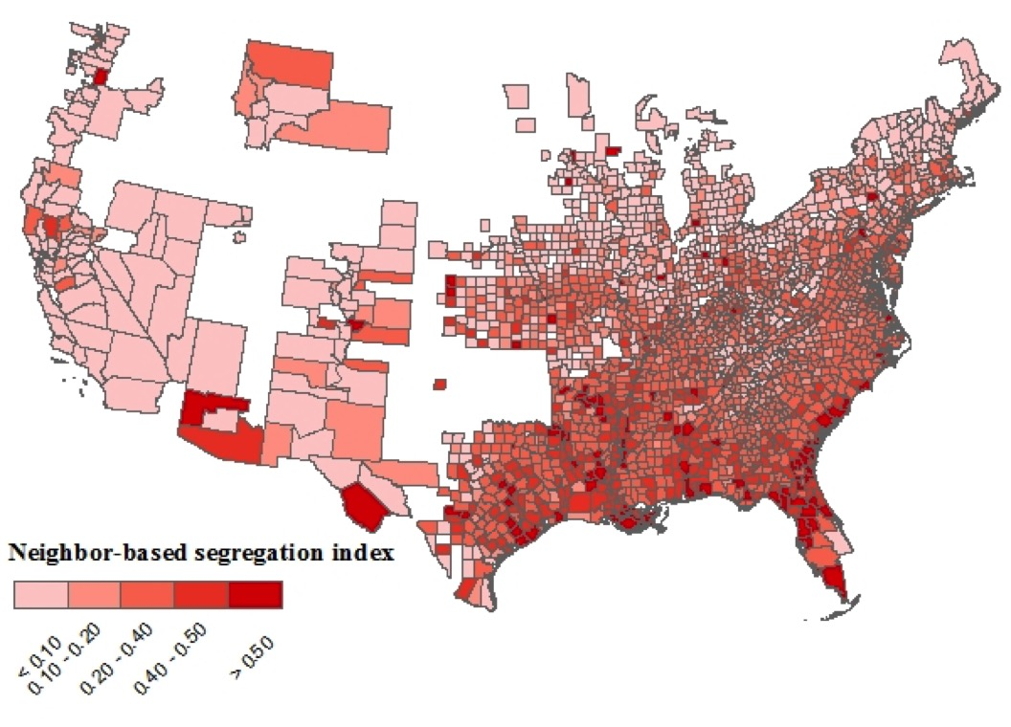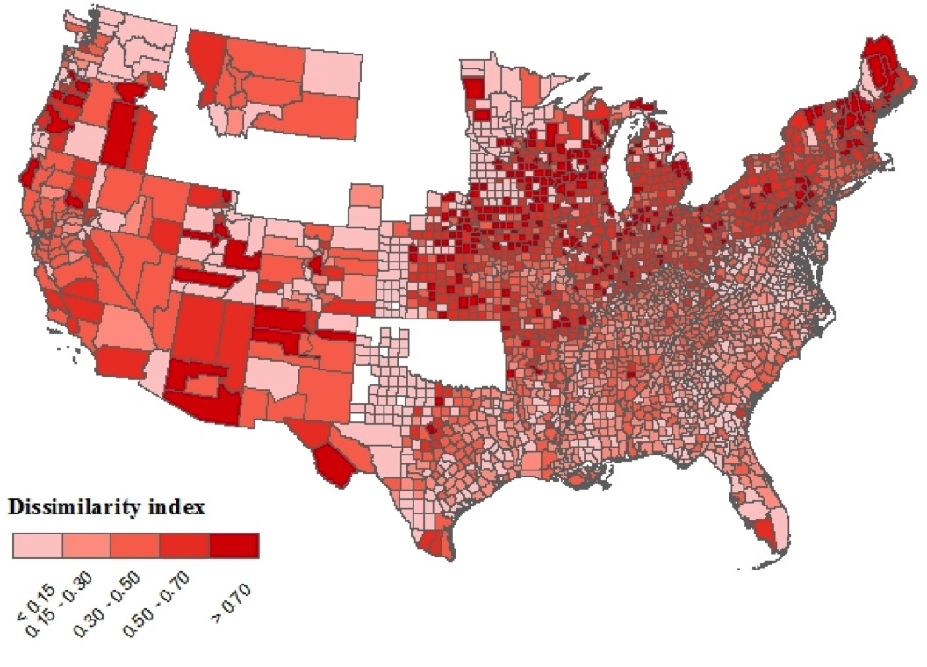

(a) (b)

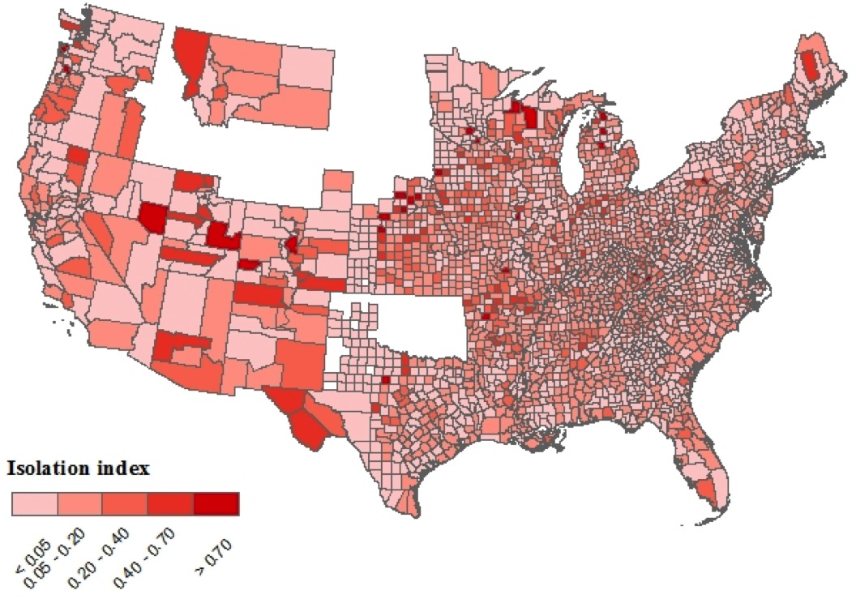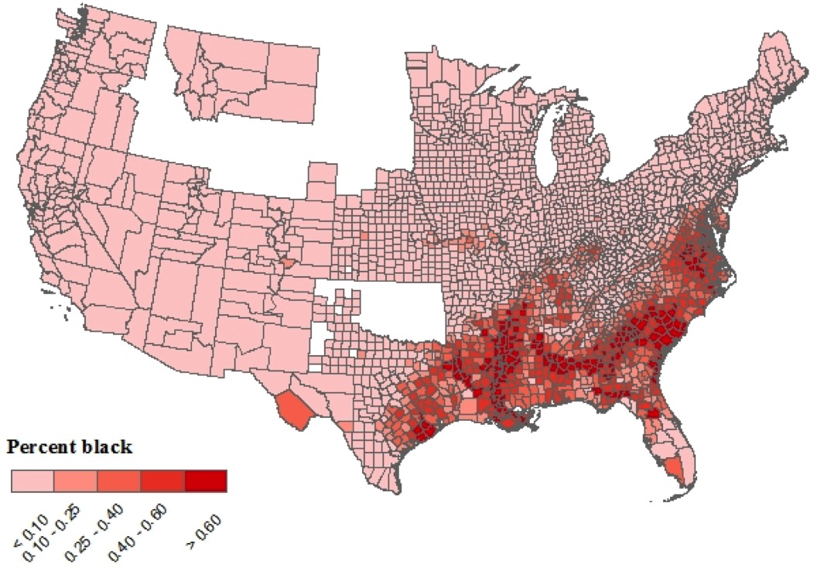

(c) (d)

Figure A1

Segregation measures by county for the entire United States, 1880: (a) our neighbor-based measure; (b) index of dissimilarity; (c) index of isolation; and, (d) percent black



Figure A2

Simulated values of segregation indices by county size   
and county racial composition under complete segregation   
(upper curve marked with X’s) and complete integration   
(lower curve marked with circles)

*Notes*: Points give the mean value while the shaded regions give the range between the 5th and 95th percentiles of the value. Dissimilarity and isolation are calculated using ten wards in all panels except (f) which uses twenty wards. Wards are gerrymandered to concentrate the black population in as few wards as possible in panels (g) and (h). Panels with percent black on the horizontal axis use county population sizes of 2020 households. Panels with number of black households on the horizontal axis have the percent black for the county fixed at 10 percent.

REFERENCES

Bayer, Patrick, Hanming Fang, and Robert McMillan. “Separate When Equal? Racial Inequality and Residential Segregation.” *Journal of Urban Economics* 82, July (2014): 32–48.

Carrington, William, and Kenneth Troske. “On Measuring Segregation in Samples with Small Units.” Journal of Business and Economic Statistics 15, no. 4 (1997): 402–409.

Coale, Ansley, and Norfleet Rives. “A Statistical Reconstruction of the Black Population of the United States, 1880–1970: Estimates of True Numbers by Age and Sex, Birth Rates, and Total Fertility.” Population Index 39, no. 1 (1973): 3–36.

Cortese, Charles, R. Frank Falk, and Jack Cohen. “Further Considerations on the Methodological Analysis of Segregation Indices.” American Sociological Review 41, no. 4 (1976): 630–37.

Cutler, David, Edward Glaeser, and Jacob Vigdor. “The Rise and Decline of the American Ghetto.” Journal of Political Economy 107, no. 3 (1999): 455–506.

Eblen, Jack. “New Estimates of Vital Rates of United States Black Population During the Nineteenth Century.” Demography 11, no. 2 (1974): 301–19.

Echenique, Federico, and Roland Fryer. “A Measure of Segregation Based on Social Interactions.” Quarterly Journal of Economics 122, no. 2 (2007): 441–85.

Massey, Douglas, and Nancy Denton. American Apartheid: Segregation and the Making of the Underclass. Cambridge, MA: Harvard University Press, 1993.

Preston, Samuel, Irma Elo, Andrew Foster, et al. “Reconstructing the Size of the African American Population by Age and Sex, 1930–1990.” Demography 35, no. 1 (1998): 1–21.

Taeuber, Karl, and Alma Taeuber. Negroes in Cities: Residential Segregation and Neighborhood Change. Chicago: Aldine Publishing Co., 1965.

Winship, Christopher. “The Desirability of Using the Index of Dissimilarity or Any Adjustment of It for Measuring Segregation.” Social Forces 57, no. 2 (1978): 717–20.

1. 1 Based on the race assigned at enumeration. This is similar to the *racesing* coding of race constructed by IPUMS. One key feature of *racesing* for our purposes is places people with their race given as “mulatto” in the same category as people with their race given as “black.” So a black individual living next to two neighbors listed on the census as mulatto would be considered to be of the same race as his neighbors.
2. 2 Note that a county can be more integrated than this. We have chosen to focus on random assignment of neighbors by race as the relevant bound because we generally think of people choosing to self-segregate, making this the appropriate counterfactual of no segregation. However, you could conceive of policies designed to move a community toward further integration leading to more black households having white neighbors than we would predict under random assignment. The theoretical maximum number of black households with white neighbors is the minimum of either the number of black households or two times the number of white households in the case of a majority-black area (in this case, two black households would lie between white households, giving every black household one white neighbor. Table A7 compares the segregation measure using our upper bound of random assignment and using this alternative upper bound. Using the alternative upper bound increases the levels of segregation but leaves all of the patterns we identify in the paper unchanged.
3. 3 Given the evidence that population counts of the size of the African American community in census returns is biased, we are concerned about the problem of missing African Americans (Coale and Rives 1973; Eblen 1974; Preston et al. 1998). While it would appear that under-reporting of African Americans would be a concern, it would only bias estimates of the segregation measure if the missing African American households had white neighbors. To see how, note that $E(\underline{x_{b}})$ is invariant to the number of black and white households as it estimates the minimum number of households who would have opposite race neighbors, which itself is not a function of the size of either group. Since the measure of segregation is the ratio of the two differences ( $E\left(\overline{x_{b}}\right)-x_{b}$ and $E\left(\overline{x_{b}}\right)-E(\underline{x_{b}})$), only if the estimate of $x_{b}$ is biased downward would missing black households have a material effect on the estimate of segregation. Given the reality of census enumeration, it is unlikely that enumerators deliberately skipped African American households in integrated communities as opposed to skipping entire groups of black households.
4. 4 The results are the same when increasing the number of missing households to 20 percent.
5. 5 One critique of traditional segregation measures is that they may fail to capture the emergence of separate neighborhoods housing members of the same race but of different socioeconomic status. For example, Bayer, Fang, and McMillan (2014) argue that increasing wealth among African Americans led to the development of middle-class black communities which increased measures of segregation.
6. 6 When calculating isolation, we follow the approach of Cutler, Glaeser, and Vigdor (1999) and rescale and normalize the isolation index such that it is independent of the overall size of the black population and ranges between zero and one.
7. 7 Note that the community is still completely segregated as only the two black households at the edge of the white communities have opposite race neighbors.
8. 8 Complete simulation results for all measures when varying area size, area racial composition, ward size and ward boundary location are available from the authors.