The effects of cow introductions on milk production and behaviour of the herd measured with sensors
Josje Scheurwater, Ruurd Jorritsma, Mirjam Nielen, Hans Heesterbeek, Jan van den Broek, Hilde Aardema

SUPPLEMENTARY FILE

Supplementary Materials & Methods
In total, 13 cows were selected as focal cows in Group A and 12 were selected as focal cows in Group B. At the beginning of both periods, from the 28 non-focal cows 11 cows were assigned to Group A and 11 to Group B and six cows were selected for the replacement treatment. These six cows were housed in a different housing away from the other animals for at least one week before using them to replace cows of the herd. The focal animals remained in their respective groups throughout the entire experiment. Before the start of the experiment, the cows in group A and B belonged to the same herd. On the first Monday of the run-in week of both periods, the cows were assigned to Group A and B immediately after the morning milking and feeding. After the run-in period of one week and the three weeks of data collection of the first period, the one-week run-in period of the second experimental period started immediately
The replacement treatment consisted of the following weekly actions: 1) On Monday three cows were replaced by three of the six cows housed in the other housing, 2) On Thursday one cow was selected and replaced by one cow not previously exposed to any of the other animals, 3) On Friday three cows were replaced by three of the six cows housed in the other housing. The selection of cows to be replaced at each action was as follows: replaced cows were randomly selected from all non-focal animals that were in the group for at least one week. The cows were re-introduced in the order that they were originally removed from the group. The cows replaced by a cow not previously exposed to any of the other animals (i.e. action on Thursdays) were excluded for the rest of the experiment and kept separate from the herd.
The Temperature Humidity Index (THI) was determined according to the formula:
(1.8* temperature(°C)+32)-(0.55-0.0055*relative air humidity(%))* (1.8*Temperature(°C)-26) (Herbut and Angrecka, 2018). Cold stress was defined to occur at THI ≤ 40 and heat stress was defined to occur at THI ≥ 67 as follows (Brügemann et al., 2012). When THI exceeded 66 at least once during the day or night, all animals that day or night were defined as experiencing heat stress. Similarly, a day or night with a THI <40 at least once defined cold stress.

Supplementary Figure S1. Schematic overview of weekly cow replacement protocol in the treatment period in an experiment consisting of 2x3 weeks treatment weeks with a cross-over design. No cows were replaced in the control period. Spotted cows were not previously exposed to any of the other animals. Striped cows in the figure represent animals that had been housed separately from the other animals for at least one week. The cows in the figure represent the cows added to the group to replace the same number of animals at the specified days during the week.
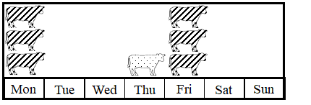

Supplementary Figure S2. Description of 24hr behaviour profile of 25 focal cows over the six weeks of observations. A: lying time, B: lying-to-standing transitions, C: standing time, D: walking time, E: rumination time (n=15) and F: milk production. Behavioural sensor data (A to E) are presented in minutes per hour during unrestricted movement. Boxplots are shown with median, interquartile range, which contains 50 % of the values, whiskers covering values up to 1.5 × interquartile range, and outliers (♦).
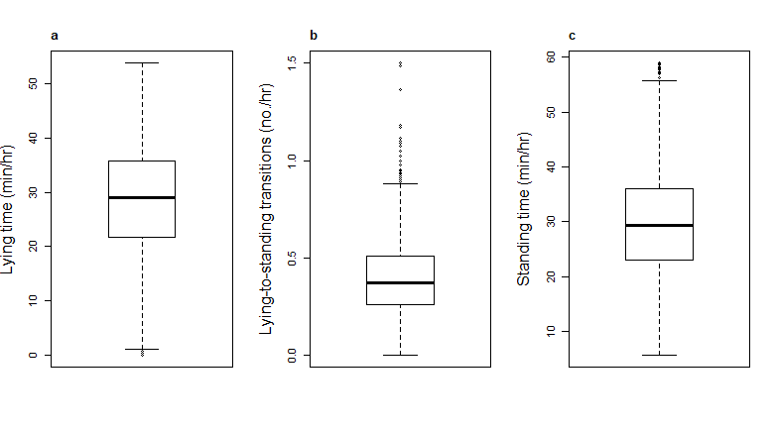
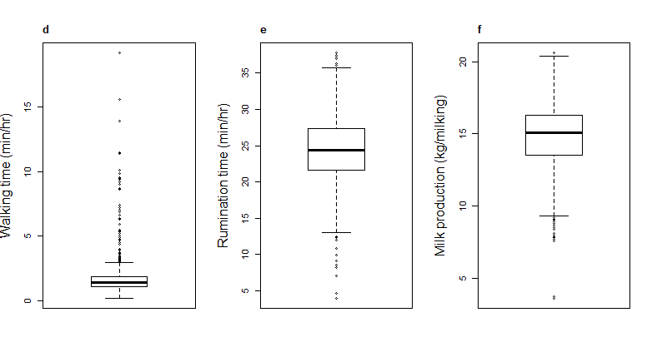

Supplementary Table S1. Variables in the final model for lying time (N=25) in minutes per hour during the unrestricted time period. Effects are shown for the focal cows remaining in the herd in a 2x3 week trial with a cross-over design where other cows were replaced. Random effects included were 'cow' and 'day'. The treatment effect was re-introduced into the final reduced model. Variables are in bold excluding the H₀-value in the 95% confidence interval.
Model | Intercept | (95% C.I.) | Fixed Effects | Estimate |  | (95% C.I.)
Lying time | 30.20 | (27.46 to 32.94) | Treatment | -0.04 |  | (-0.73 to 0.65)
(min/hr) |  |  | Day vs Night | -1.27 |  | (-1.96 to -0.58)
 |  |  | Estrus | -2.02 |  | (-3.59 to -0.44)
 |  |  | Heat stress | -1.91 |  | (-2.82 to -1.01)

Supplementary Table S2. Variables in the final model for standing time (N=25) in minutes per hour during the unrestricted time period. Effects are shown for the focal cows remaining in the herd in a 2x3 week trial with a cross-over design where other cows were replaced. Random effects included were 'cow' and 'day'. Estimates are expressed as the median of the standing time. The treatment effect was re-introduced into the final reduced model. Variables are in bold excluding the H₀-value in the 95% confidence interval.
Model | Intercept | (95% C.I.) | Fixed Effects | Estimate |  | (95% C.I.)
standing time | 28.43 | (25.76 to 31.11) | Treatment | -0.04 |  | (-0.69 to 0.62)
(min/hr) |  |  | Day vs Night | 1.05 |  | (0.39 to 1.70)
 |  |  | Heat stress | 1.79 |  | (0.94 to 2.65)

Supplementary Table S3. Variables in the final model for lying-to-standing transitions (N=25) in minutes per hour during unrestricted time periods. Effects are shown for the focal cows remaining in the herd in a 2x3 week trial with a cross-over design where other cows were replaced. The random effect included in the model was 'cow'. The treatment effect was re-introduced into the final reduced model. Variables are in bold excluding the H₀-value in the 95% confidence interval.
Model | Intercept | (95% C.I.) | Fixed Effects | Estimate (Ratio) | (95% C.I.)
Lying-to-standing | 0.39 | (0.33 to 0.45) | Treatment | 0.97 | (0.93 to 1.01)
(no./hr) |  |  | Day vs Night | 0.95 | (0.91 to 0.99)

Supplementary Table S4. Variables in the final model for average rumination time (N=14) in minutes per hour during unrestricted time periods. Effects are shown for the focal cows remaining in the herd in a 2x3-week trial with a cross-over design where other cows were replaced. The random effect included in the model was 'cow'. The treatment effect remained in the model during the model reduction steps. Variables are in bold excluding the H₀-value in the 95% confidence interval.
Model | Intercept | (95% C.I.) | Fixed effects | Estimate | (95% C.I.)
Rumination time | 27.09 | (26.16 to 28.03) | Treatment | -0.38 | (-0.76 to -0.00)
(min/hr) |  |  | Day vs Night | -4.69 | (-5.05 to -4.32)
 |  |  | Estrus | -3.79 | (-4.65 to -2.93)
 |  |  | Mon vs Sun | 0.00 | (-0.68 to 0.68)
 |  |  | Tue vs Sun | 0.91 | (0.26 to 2.22)
 |  |  | Wed vs Sun | 0.57 | (-0.11 to 1.24)
 |  |  | Thu vs Sun | 0.90 | (0.22 to 1.58)
 |  |  | Fri vs Sun | 0.92 | (0.25 to 1.60)
 |  |  | Sat vs Sun | 0.52 | (-0.15 to 1.20)
 |  |  | Week 2 vs 1 | -0.13 | (-0.57 to 0.32)
 |  |  | Week 3 vs 1 | -0.64 | (-1.08 to -0.20)
 |  |  | Period 2 vs 1 | -0.73 | (-1.11 to -0.35)

Supplementary File. Full model statements
The fixed part of the full model described in the section statistical analysis can be written as:
µ = β₀ + β₁ × trt + β₂ × w₂ + β₃ × w₃ + β₄ × gr + β₅ × p + β₆× d + β₇ × wd₂ + … + β₁₂ × wd₇ + β₁₃ × w₂ × wd₂ + … + β₂₄ × w₃ × wd₇ +β₂₅ × chs + β₂₆ × ccs + β₂₇ × p₂ + β₂₈ × p₃ + β₂₉ × dim + β₃₀ × mp + β₃₁ × eb+ β₃₂ × trt × wd₂ + … + β₃₇ × trt × wd₇
µ is the mean of the variables average lying time, average standing time, logarithm of the average walking time, and average rumination time in minutes per hour free time. For average lying-to-standing transitions per hour free time, the linear part of the model is for log (µ). For milk production per milking in kg milk, the fixed part of the model is similar, but without milk production as dependent variable.
Variable | Description
trt | 1 for treatment, 0 otherwise
w₂, w₃ | w₂ = 1 for week 2, 0 otherwise; w₃ similar
gr | 1 for group B, 0 otherwise
P | 1 for period 2, 0 otherwise
D | 1 for day, 0 for night
wd₂, …, wd₇ | wd₂ = 1 for weekday 2, 0 otherwise; wd₃,…wd₇ similar
chs | 1 for weather related heat stress, 0 otherwise
ccs | 1 for weather related cold stress, 0 otherwise
p₂, p₃ | p₂=1 for parity 2, 0 otherwise; p₃=1 for parity 3 or higher, 0 otherwise
dim | days in milk
mp | milk production in kg milk per milking
eb | 1 for estrous behaviour, 0 otherwise

References
Herbut P & Angrecka S 2018 Relationship between THI level and dairy cows’ behaviour during summer period. Italian Journal of Animal Science 17 226-233.
Brügemann K, Gernand E, König von Borstel U & König S 2012 Defining and evaluating heat stress thresholds in different dairy cow production systems. Archives Animal Breeding 55 13-24.

