Pictures suggested to accompany, Jeffrey and Doron piece, Feburary, JAS.

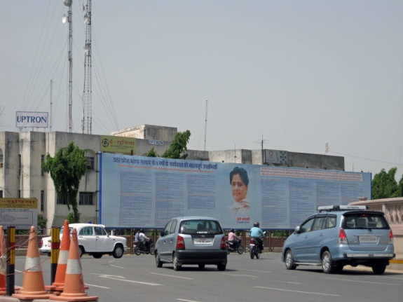
Figure X1. A transmission tower for mobile phones and a billboard proclaiming the achievements of Mayawati, Chief Minister of Uttar Pradesh, dominate intersection in state capital, Lucknow, June 2010. PHOTO: Assa Doron.

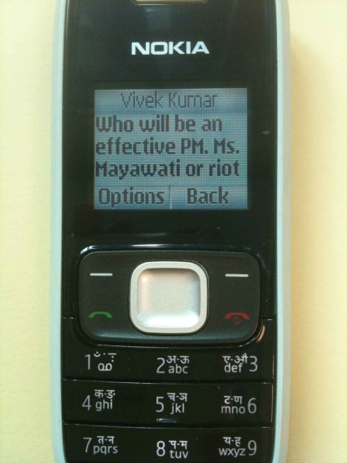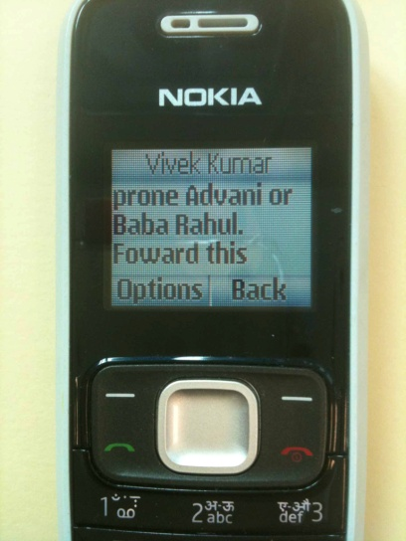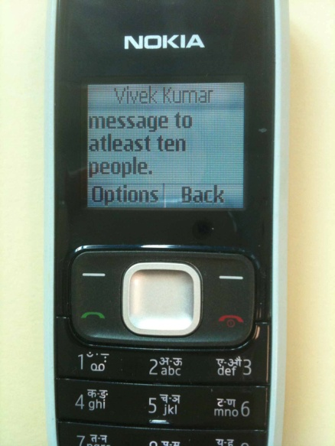
Figure X2. Text message in 2009 to remind BSP workers that their leader, Mayawati, would make a better Prime Minister than Rahul Gandhi or L. K. Advani. Workers were instructed to to “forward this message to at least ten people.” PHOTO: Robin Jeffrey.

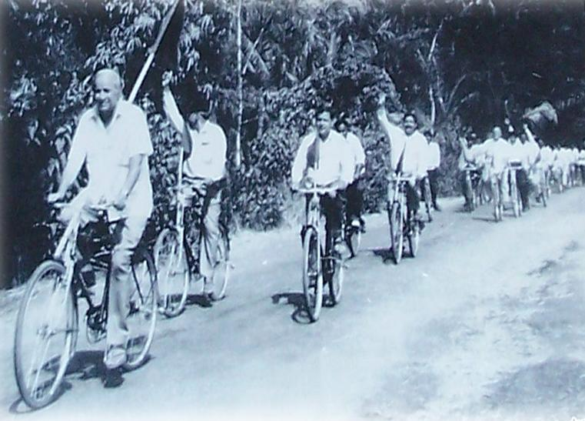
Figure X3. Kanshi Ram bicycle yatra, or propaganda procession, 1980s. This grainy photograph is from http://blog.insightyv.com/?p=754, a website called “Roundtable, Insight Young Voices Blog. A Dalit Youth Magazine,” which does not seem to have been active since 2009 (downloaded 26 October 2011).

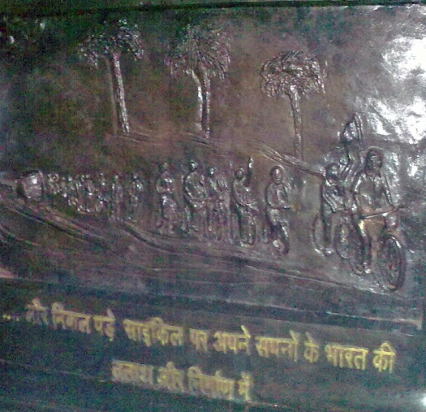
Figure X4. The bicycle yatras of Kanshi ram are celebrated in one of the bronze tableaux in the Prerna Kendra, the monument to Dalit achievement, built by the Mayawati government in Lucknow. A translation reads: “...and we embarked upon a journey by bicycle to build an India of our dreams.” June 2010. PHOTO: Assa Doron.

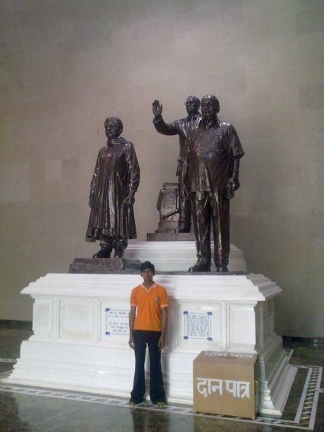
Figure X5. BSP heroes in the Prerna Kendra, Lucknow. Left to right, Mayawati, Dr B. R. Ambedkar and Kanshi Ram. The young man stands beside a donations box. June 2010. PHOTO: Assa Doron.

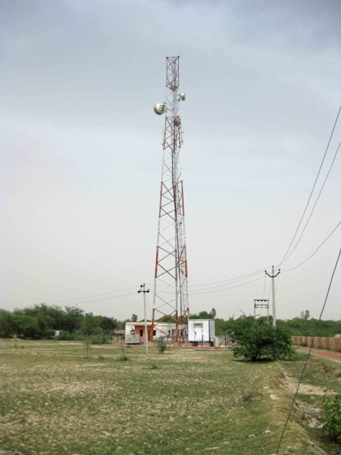
Figure X6. Staging posts of the digital age. More than 300,000 transmission towers dot India in 2012. Rural Uttar Pradesh, June 2010. PHOTO: Assa Doron.

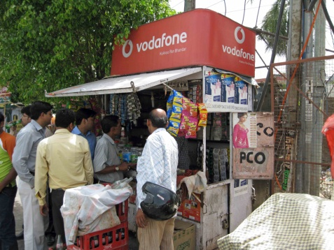
Figure X7. Top up your talk-time where you buy soap, snacks and cigarettes. Lucknow , June 2010. PHOTO: Assa Doron.

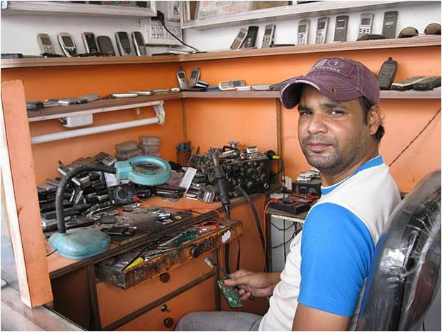
Figure X8. Friendly, find-them-everywhere phone-wallas fix phones and sell second-hand ones. Lucknow, 2010. PHOTO: Assa Doron.

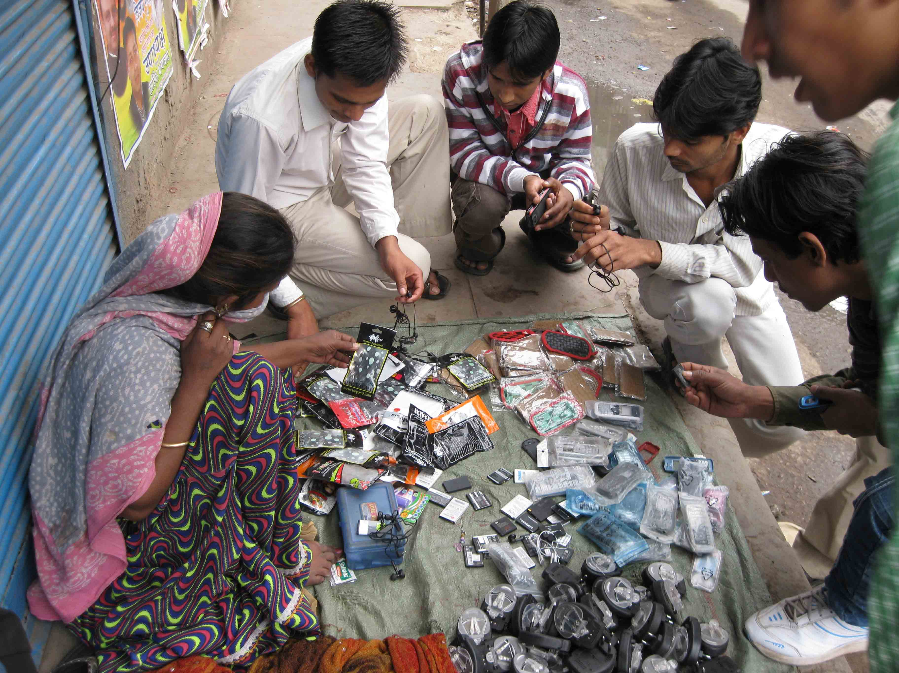
Figure X9: New kids in the old bazaar. Mobile phones and accessories are bought and solid in market-places and on pavements across India. New Delhi, June 2010. PHOTO: Assa Doron.

