Supplemental Material

Supplemental Table 1. Crop coefficients calibrated for the cultivars Haven and Maris Huntsam by the DSSAT-CERES (Dc), DSSAT-NWheat (Nw), and WheatGrow (Wg) model.
Crop model | Cultivar | P1V | P1D | P5 | G1 | G2 | G3 | PHINT
 |  | P1V | P1D | P5 | G1 | G2 | G3 | PHINT
Dc | Haven | 11.18 | 87.19 | 729.7 | 22.86 | 51.45 | 1.0 | 80
Dc | Maris H. | 63.36 | 63.75 | 760.2 | 25.57 | 50.80 | 1.9 | 80
 |  | VSEN | PPSEN | P5 | GRNO | MXFIL | STMMX | SLAP1 | SLAP2 | TC1P2 | P2AF
Nw | Haven | 4.80 | 3.30 | 660 | 99 | 3.0 | 3 | 350 | 280 | 1.0 | 0.4
Nw | Maris H. | 3.20 | 2.80 | 740 | 45 | 1.1 | 1.5 | 280 | 270 | 0.6 | 0.6
 |  | IE | PVT | PS | TS | FDF | SLA | HI | AMX
Wg | Haven | 0.84 | 50.5 | 0.000969 | 1.65 | 0.974 | 0.0022 | 0.42 | 40
Wg | Maris H. | 0.74 | 57.1 | 0.000992 | 1.53 | 0.948 | 0.002 | 0.38 | 39
P1D: Photoperiod response (% reduction in rate/10 h drop in pp)
P1V: Days,optimum vernalizing temperature,required for vernalization
P5: Grain filling (excluding lag) phase duration (oC.d)
G1: Kernel number per unit canopy weight at anthesis (#/g)
G2: Standard kernel size under optimum conditions (mg)
G3: Standard,non-stressed mature tiller wt (incl grain) (g dwt)
PHINT: Interval between successive leaf tip appearances (oC.d)
VSEN: sensitivity to vernalization
PPSEN: sensitivity to photoperiod
P5: Thermal time (base 0oC) from beginning of grainfill to maturity
GRNO: Coefficient of kernel number per stem weight at the beginning of grain filling [kernels (g stem)-1]
MXFIL: Potential kernel growth rate [mg kernel-1 day-1]
STMMX: Potential final dry weight of a single tiller (excluding grain) (g stem-1)
SLAP1: Ratio of leaf area to mass at emergence (cm2/g)
SLAP2: Ratio of leaf area to mass at end of leaf growth (cm2/g)
TC1P2: For calculating tc1: tiller number from emerg. to term. spik.(=stem elongation)
P2AF: Threshold AD in a layer becoming effective on root growth

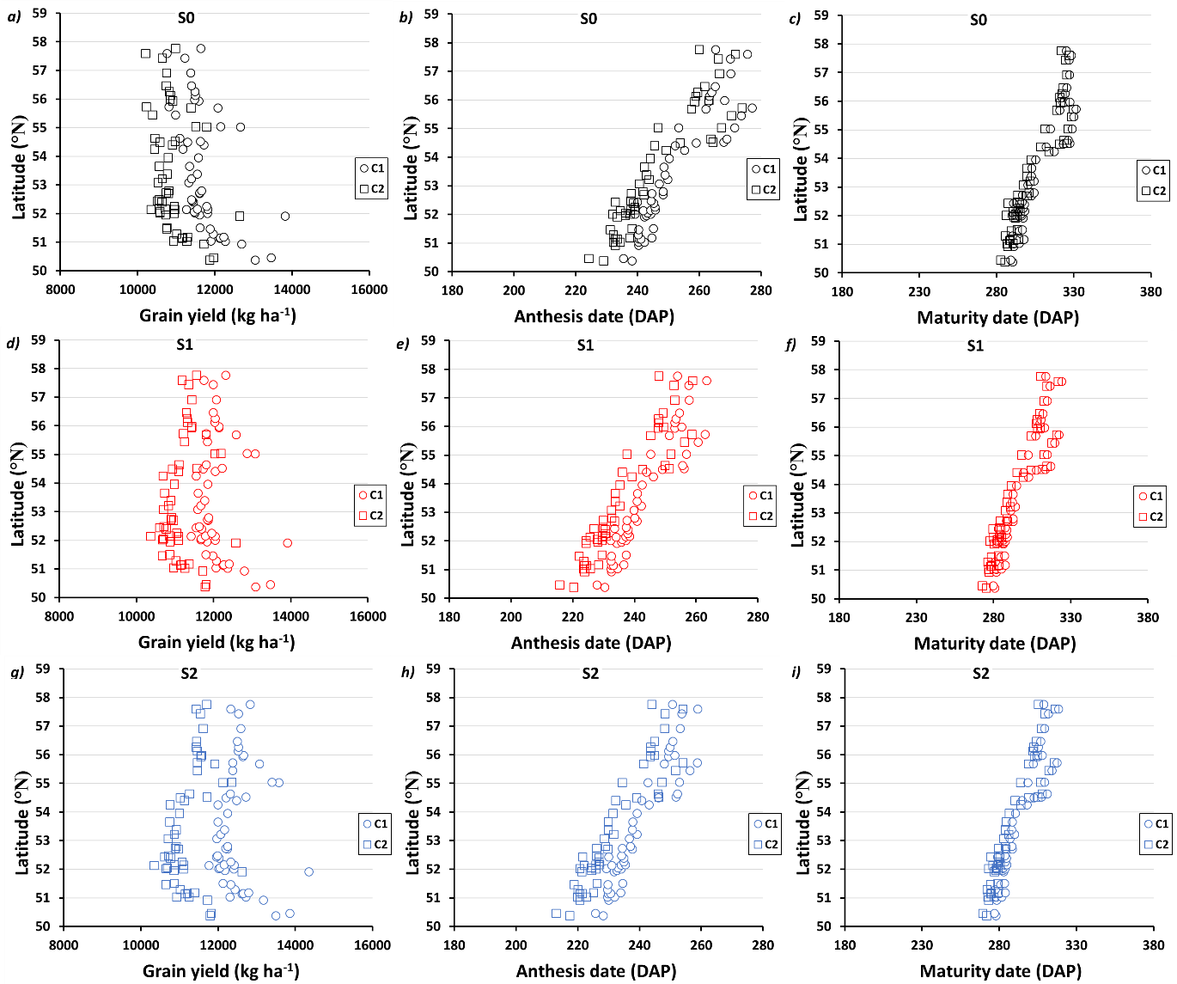

Supplemental Figure 1. Relationship between simulated (a,d,g) potential grain yield, (b,e,h) anthesis, (c,f,i) maturity dates and latitude of the different locations for the crop 1 (Haven, dots symbols) and crop 2 (Maris Huntsman, square symbols) for the baseline conditions (black), scenario 1 (1.5°C, red) and scenario 2 (2.0°C blue).

