Table S1. Means and standard deviations (SD) of the studied parameters at the three selection cycles C1, C2, and C3 for 18 half-sib families
Variable | Selection cycle | Mean | SD
NdB (day) | C1 | 247.0 | 23.2
 | C2 | 255.9 | 23.2
 | C3 | 258.1 | 21.5
NdF (day) | C1 | 270.3 | 20.4
 | C2 | 277.6 | 21.8
 | C3 | 280.2 | 21.4
DF (day) | C1 | 48.4 | 8.23
 | C2 | 47.4 | 9.5
 | C3 | 37.3 | 9.5
NdM (day) | C1 | 319.7 | 20.9
 | C2 | 325.7 | 22.2
 | C3 | 330.4 | 20.2
DM (day) | C1 | 45.4 | 7.9
 | C2 | 45.5 | 7.8
 | C3 | 36.0 | 7.9
TKW (g) | C1 | 19.9 | 2.3
 | C2 | 23.1 | 6.4
 | C3 | 21.7 | 3.6
Gr | C1 | 0.89 | 0.05
 | C2 | 0.86 | 0.06
 | C3 | 0.89 | 0.08
¹NdB: Number of days to bolting
²NdF: Number of days to flowering
³DF: Flowering period duration
⁴NdM: Number of days to maturity
⁵DM: Maturity duration
⁶TKW: One thousand glomeruli weight
⁷Gr: Germination rate
⁸SD: Standard deviation

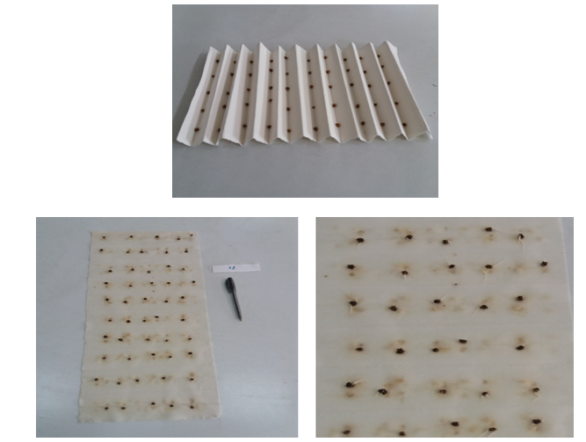
Fig. S1. Sugar beet seeds placed between the folds of the blotting paper

Fig. S2. Means (+/- standard deviation) of the 18 half-sib families’ (HSF) number of days to bolting (NdB) (a), number of days to flowering (NdF) (b) and number of days to maturity (NdM) (c) during the three selection cycles, C1, C2, and C3

Fig. S3. Means (+/- standard deviation) of the 18 half-sib families’ (HSF) one thousand glomeruli weight (TKW) (a) and germination percentage (Gr) (b) during the 3 selection cycles, C1, C2, and C3

