Intercropping with Chinese leek decreased Meloidogyne javanica populations and shifted microbial community structure in Sacha Inchi plantation

1. Supplementary text of the methods
1.1. Determination of soil traits
The air-drying soil samples were filtered through a 0.149 mm sieve for measuring soil nutrient content; this was conducted at the Public Technology Service Center of XTBG according to the methodology described by Bao (2000). Briefly, soil pH was determined in a 2.5:1 water/soil suspension using a pH meter. Total carbon and nitrogen were determined using a Vario MAX CN Analyzer (Elementar Analysensysteme GmbH, Hanau, Germany). Total phosphate was determined by ignition (550°C, 1 h) followed by extraction in 1 M H₂SO₄, with phosphate detection in neutralised extracts at 880 nm by automated molybdate colorimetry. Determination of the total and available potassium and phosphate concentration were carried out by the decomposition of samples using HClO₄-HF and detected by an inductively coupled plasma atomic emission spectrometry (ICP-AES, iCAP6300, Thermo Fisher Scientific, Massachusetts, USA).

1.2. Fine-root vigor assessments
Samples of fine-root (diameter<1 mm) were scanned on a desktop scanner. The acquired images were analyzed for root length and average diameter, using DT-SCAN image analysis software (Delta-T Devices, Cambridge, UK) at 400 dots per inch. Subsamples were assayed by a modified TTC test procedure (Steponkus and Lanphear, 1967). Control roots were boiled for 10 min in distilled water to ensure that enzymes were denatured. Maximum ability of tissue to reduce TTC has been found at a TTC concentration of 0.5%. All roots were cut into 1 cm pieces, submerged in 3 ml of 0.6% (w/v) 2,3,5-triphenyltetrazolium chloride in 0.05 M NaH₂PO₄- KH₂PO₄ (pH 7.4) + 0.05% wetting agent (Triton X-100), and vacuum-infiltrated for 5 min to insure infiltration of TTC. Samples were incubated at 30 for 24 h, rinsed twice with distilled water, and extracted four times in 4 ml of 95% (v/v) ethanol for 5 min in a water bath at 85C. The total solution extracted was brought up to a volume of 25 ml and measured with a spectrophotometer (Shimadzu UV160U, Kyoto, Japan) at 490 nm. Spectral analyses had been previously made of root extractions in 95% ethanol to verify that plant pigment would not interfere with the absorption of formazan.
1.3. DNA sequencing
Total microbial genomic DNA was extracted from the rhizosphere soil samples, using the FastDNA SPIN Kit for Soil (MP Biomedicals, Solon, CA, USA) with a DNA secure Plant Kit (Tiangen Biotech, Beijing, China) according to the manufacturers’ instructions. DNA quality was assessed using 1% agarose gel electrophoresis, and the final DNA concentrations were quantified using a NanoDrop UV-Vis spectrophotometer (Peqlab Biotechnologie GmbH, Erlangen, Germany). Poor-quality sequences (shorter than 200 bp length, Phred quality score lower than 15 and any ambiguous nucleotides) were discarded from the dataset. The hypervariable V4-V5 regions of 16S rRNA genes were amplified using the barcode primers 515F (5′-GTGCCAGCMGCCGCGG-3′) and 907R (5′- CCGTCAATTCMTTTRAGTTT-3′), and the fungal ITS region was amplified by ITS1 and ITS2 primers as described previously (Peiffer et al., 2013; Cai et al., 2018). Briefly, using the AxyPrep DNA Gel Extraction Kit (Axygen Biosciences, USA) and quantified using the QuantiFluorTM (Promega, Milano, Italy), the PCR products were purified. Afterwards, the DNA was added by a Y-type adapter, and the adapter's self-linking fragments were removed by magnetic beads. The DNA sequences were enriched using an affinity separation and then amplified using PCR and denatured with 0.3 mol L⁻¹ NaOH to generate single-stranded DNA. Finally, the qualified library was used for the paired-end sequencing on a MiSeq platform (Illumina, San Diego, CA). According to the manufacturer's instructions, the MiSeq Reagent Kit v3 was used to construct Illumina libraries. The PCR products from each sample were pooled and purified with QIAquick Gel Extraction kit (Qiagen), and high-throughput, paired-end sequencing was performed on the Illumina MiSeq PE300 platform. Raw sequence data were processed using the QIIME v1.7 pipeline, where sequences were de-multiplexed using their unique barcode specific to individual samples and assigned to phylotypes (operational taxonomic units, OTUs, at 97% similarity) using the 'open reference' clustering approach recommended in the pipeline (Caporaso et al., 2012). Raw paired-end reads were subjected to quality filtering using the Trimmomatic tool, and paired-end read assembling was conducted using Flash (Magoč and Salzberg, 2011). Taxonomy was determined for each phylotype using the RDP classifier (Wang et al., 2007) trained on the Greengenes (McDonald et al., 2012) and UNITE (Abarenkov et al., 2010) databases for bacterial and fungal sequences. Relatively abundant phylotypes were checked using BLAST and comparison against sequences contained within GenBank.

References
Abarenkov, K., et al., 2010. The UNITE database for molecular identification of fungi - recent updates and future perspectives. New Phytol. 186, 281–285.
Bao, S.D., 2000. Soil and Agricultural Chemistry Analysis. Agriculture Press of China, Beijing.
Cai, Z.Q., et al., 2018. Land-use type strongly shapes community composition, but not always diversity of soil microbes in tropical China. Catena 165, 369–380.
Caporaso, J.G., et al., 2012. Ultra- high-throughput microbial community analysis on the Illumina HiSeq and MiSeq platforms. Isme J. 6, 1621–1624.
Magoč, T., Salzberg, S. L., 2011. FLASH: fast length adjustment of short reads to improve genome assemblies. Bioinformatics 27, 2957–2963.
McDonald, D., et al., 2012. An improved Greengenes taxonomy with explicit ranks for ecological and evolutionary analyses of bacteria and archaea. Isme J. 6, 610–618.
Steponkus, P.L., Lanphear, F.O., 1967. Refinement of the triphenyl tetrazolium chloride method of determining cold injury. Plant Physiol. 35, 543–548.
Peiffer, J.A., et al., 2013. Diversity and heritability of the maize rhizosphere microbiome under field conditions. Proc. Natl. Acad. Sci. USA 110, 6548–6553.
Wang, Q., et al. 2007. Naive Bayesian classifier for rapid assignment of rRNA sequences into the new bacterial taxonomy. Appl. Environ. Microb. 73, 5261–5267.

2.1. Supplementary data
Table S1. Economic benefits estimated from the in P. volubilis monoculture (PV) and P. volubilis/A. tuberosum intercropping (PV_AT) groups.
Group* | PV production**  (RMB yuan/ha/y) | AT production#  (RMB yuan/ha/y) | Invest ⁽⁻⁾  (RMB yuan/ha/y) | Net income  (RMB yuan/ha/y)
PV | 38215 | 0 | 6300 | 31915
PV_AT | 39512 | 18645.6 | 8750 | 49407.6
Note: * When calculated the total seed yield per unit area, all died plants are covered in the plantations. ** 1 kg seed = 20 RMB yuan; # 1 kg fresh mass of A. tuberosum = 5 RMB yuan; ⁽⁻⁾ the costs of fertilizers and the hired labors for fruit harvesting and taking out weeds from the plantations are covered.

Table S2. Statistics of samples by 16S and internal transcribed spacer (ITS) sequencing data.

Samples | Sequence number (bp) | Bases  (bp) | Average length (bp) | Coverage  (%)
16S sequencing
PV_AT_1 | 39323 | 15599601 | 396.7 | 0.99818
PV_AT _2 | 41691 | 16534266 | 396.6 | 0.9985
PV_AT _3 | 37475 | 14862208 | 396.59 | 0.99813
PV_1 | 38112 | 15117837 | 396.67 | 0.99819
PV_2 | 43208 | 17126081 | 396.36 | 0.99954
PV_3 | 41919 | 16618333 | 396.44 | 0.99954
ITS sequencing
PV_AT _3 | 38097 | 9456131 | 248.21 | 0.99813
PV_AT _1 | 41900 | 10139512 | 241.99 | 0.97819
PV_AT _2 | 34585 | 8299871 | 239.98 | 0.98954
PV_1 | 38431 | 10003509 | 260.3 | 0.98809
PV_2 | 38117 | 9896276 | 259.63 | 0.97054
PV_3 | 39111 | 10159023 | 259.75 | 0.97421

Fig. S1. The population numbers of M. javanica in the rhizosphere (n=4-5) sampled in the wet season in 2015 and the corresponding plant symptoms of a 2-year P. volubilis plantation (ca. 10 ha) in Puwen (101°23′ E, 22°33′ N; alt. 650 m). Note: For normal plants in stages 1 and 2, no negative symptom occurred; in the stage 3, plants start to wilt; in the stage 4, plant start to die; in the stage 5, dying plants; in the stage 6, plant just died. The circle indicates the estimated threshold level of the survival of plants (600-750 no. 100 g⁻¹soil).

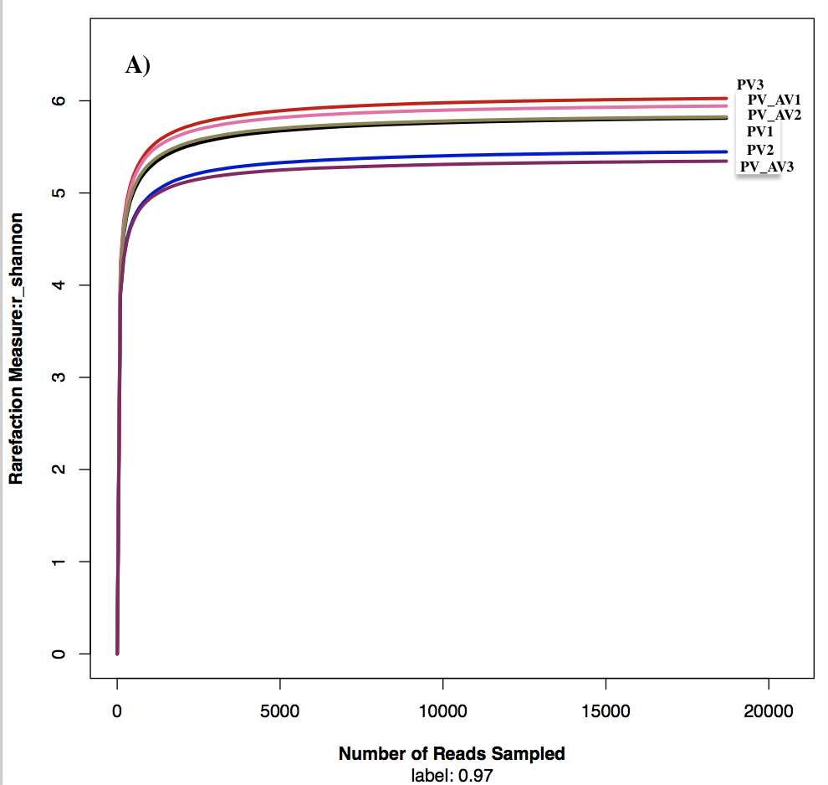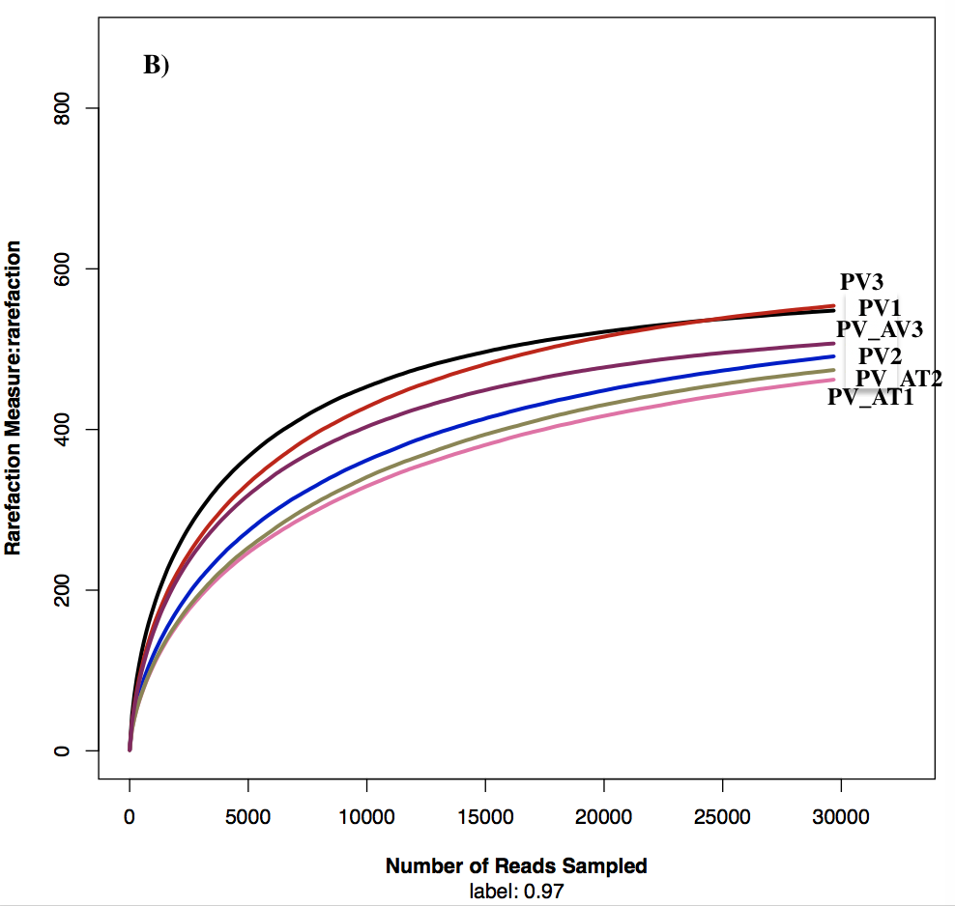
Fig. S2. Rarefaction curves showing accumulation of bacterial (A) and fungal (B) species with increasing sample size for each example. PV, P. volubilis monoculture; PV_AT, P. volubilis/A. tuberosum intercropping.

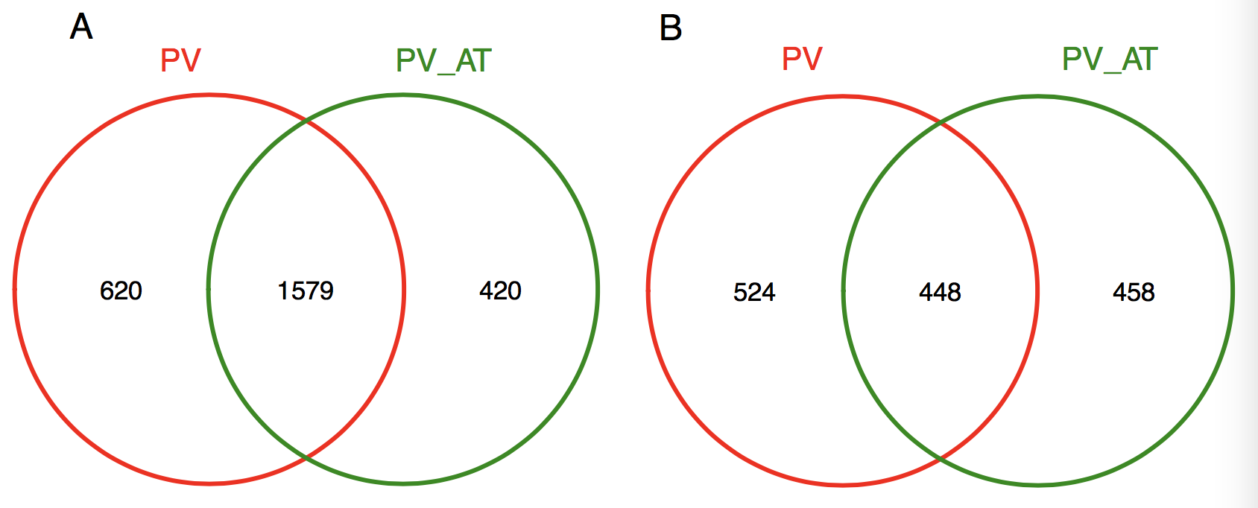
Fig. S3. Venn diagram showing the number of shared and unique bacterial (A) and fungal (B) communities at OTU level. PV, P. volubilis monoculture; PV_AT, P. volubilis/A. tuberosum intercropping.

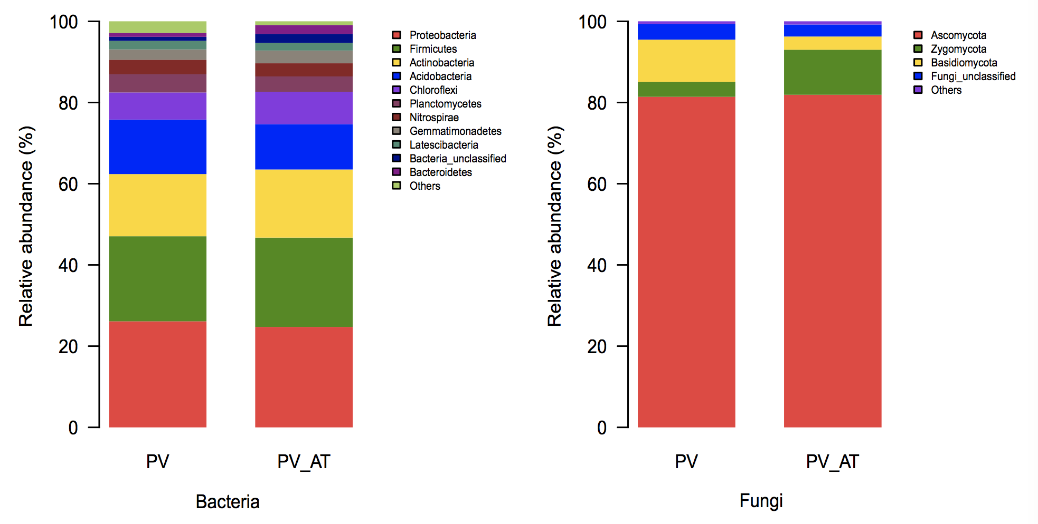
Fig. S4. The relative abundance of the most abundant bacterial and fungal communities at the phylum level. PV, P. volubilis monoculture; PV_AT, P. volubilis/A. tuberosum intercropping.

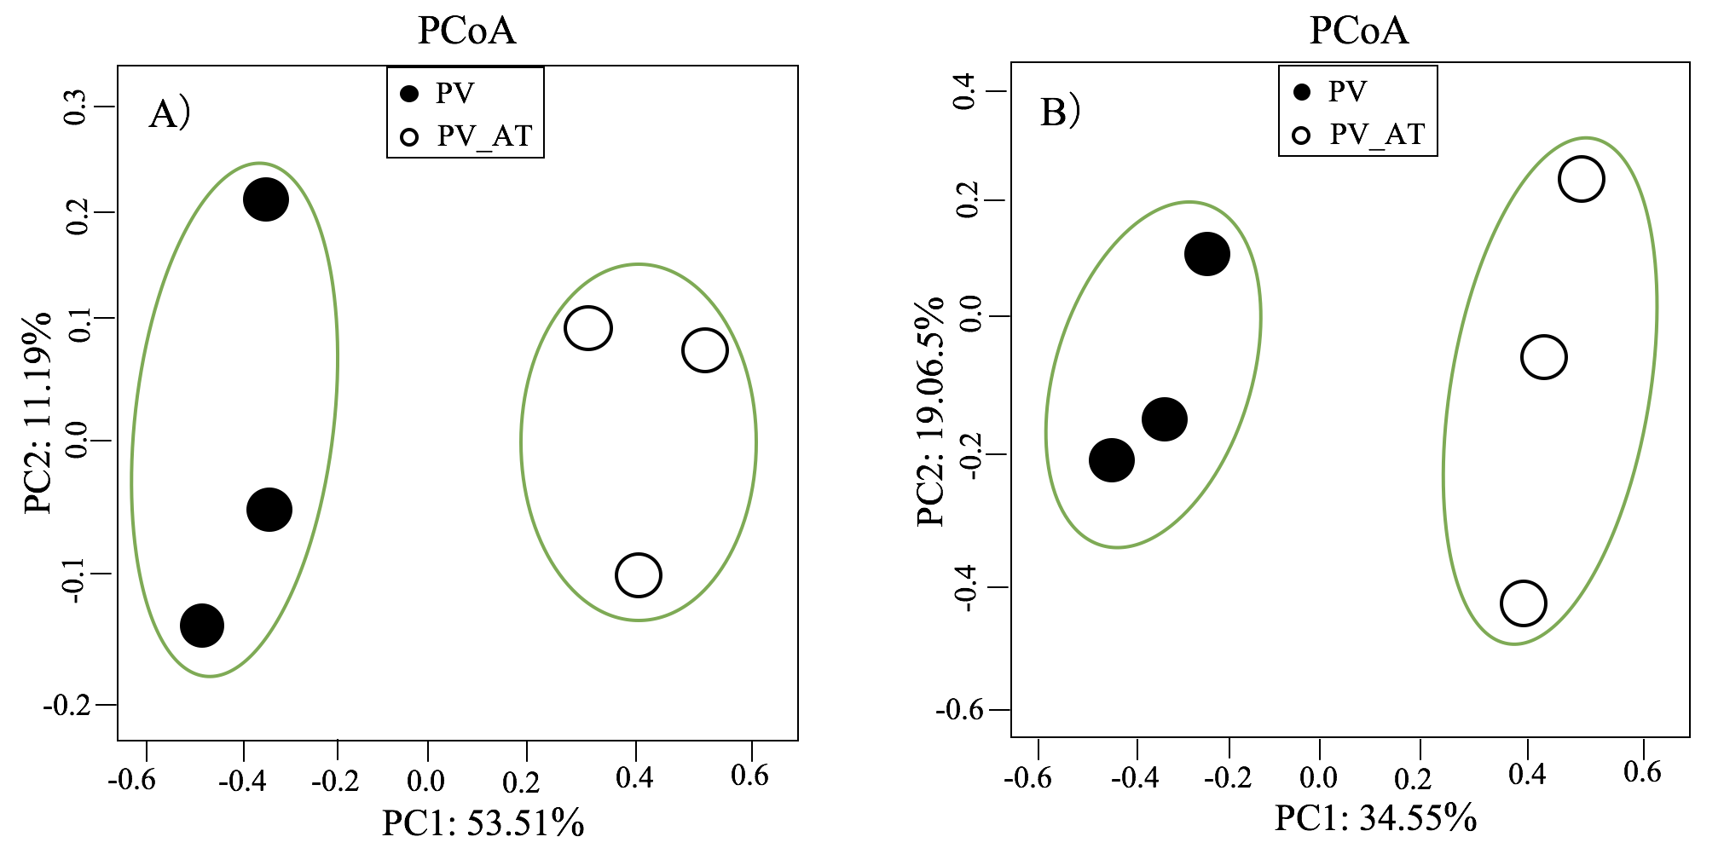
Fig. S5. Principal coordinate analysis plots of the OTU-based unweighted UniFrac distances showing the variation in the bacterial (A) and fungal (B) communities. PV, P. volubilis monoculture; PV_AT, P. volubilis/A. tuberosum intercropping.

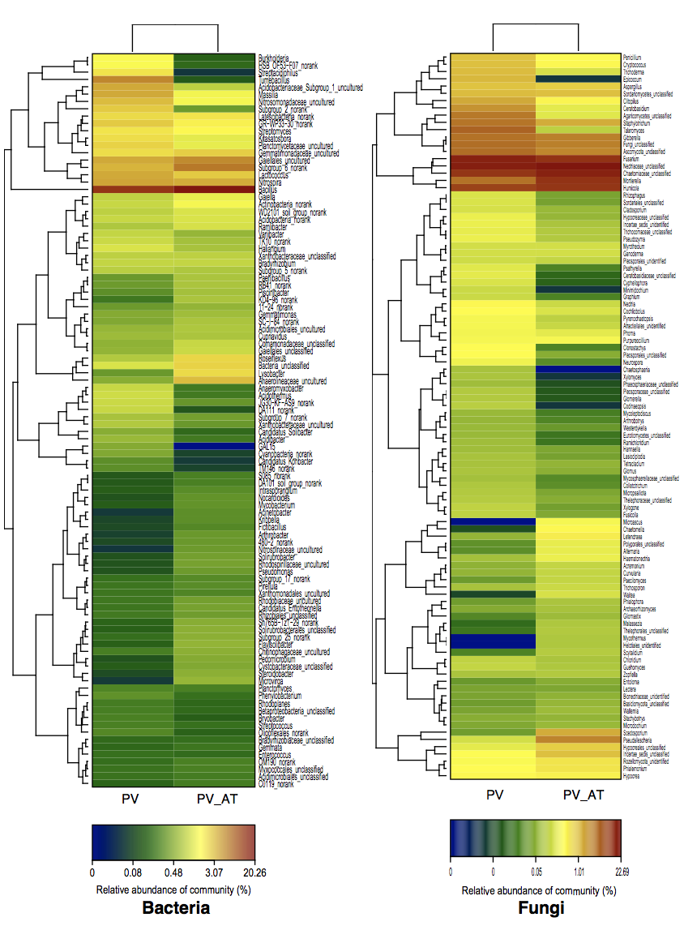
Fig. S6. The heat maps displaying the similarity of the 100 most abundant microbial genera in P. volubilis monoculture (PV) and P. volubilis/A. tuberosum intercropping (PV_AT) groups. The relative abundances for microbial phyla are indicated by color intensity.

