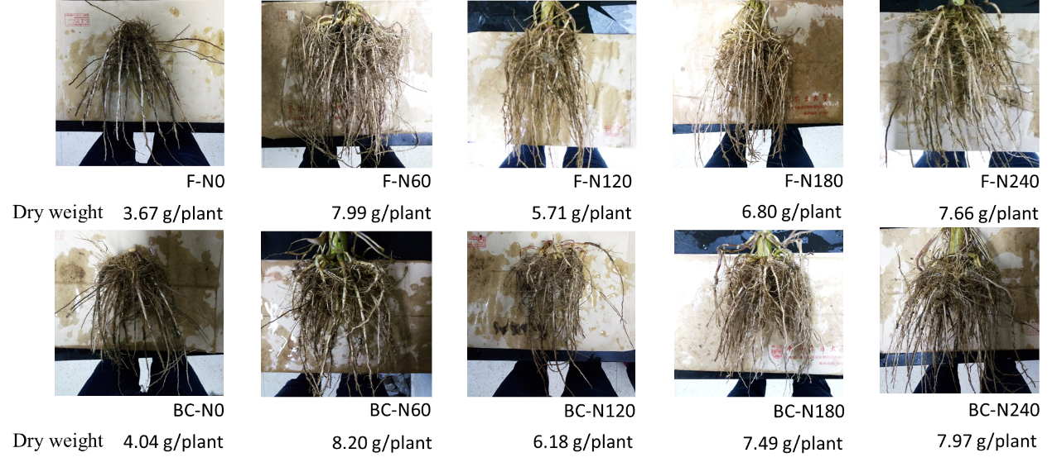
Figure S1 Root phenotype and dry weight of maize without (F) and with (BC) biochar input under different nitrogen (N) rates.

