Supplementary material

Figure S1. PCA graph identifying climate variables as significant for S. costaricensis, S. ocamponis, S. undatus).

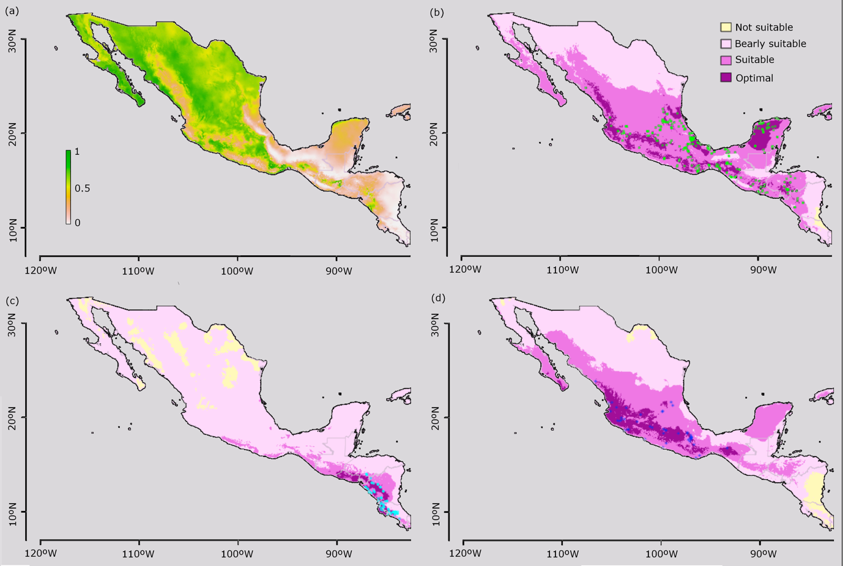

Figure S2. MaxEnt prediction models for the distribution of (a) Prosopis spp. the preferred host of S. undatus. (b) S. undatus. (c) S. costaricensis and d) S. ocamponi. Prediction models for Prosopis was modelled using a random forest classification. For the three Selenicereus species the results of the hierarchical analytical process were considered.

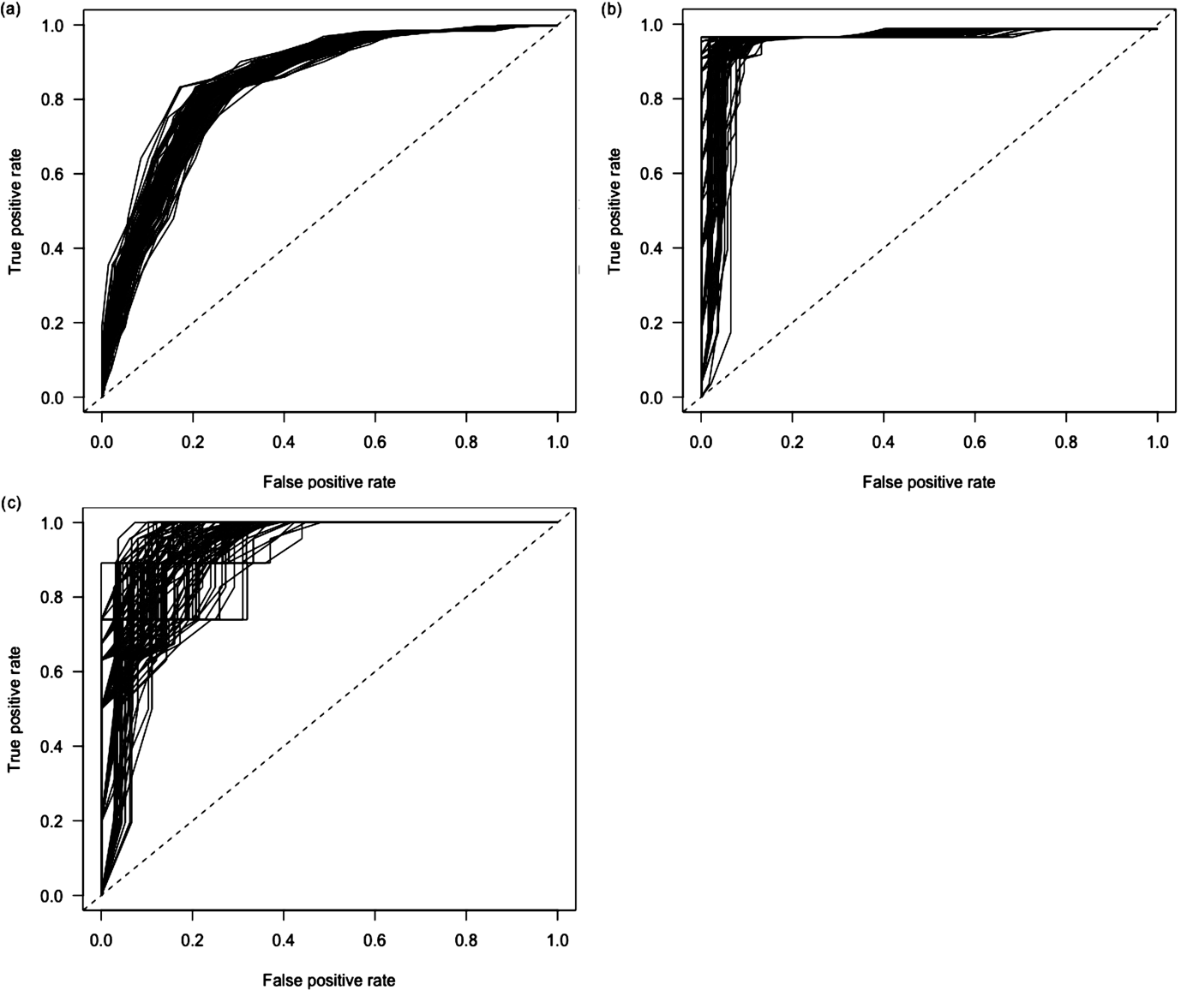

Figure S3. Receiving operating characteristic curves (ROC) for the weighted (hierarchical analytical procedures) MaxEnt models for the habitat suitability of three species of Selenicereus from Mexico and Central America. (a) S. undatus. (b) S. costaricencis. (c) S. ocamponis.

Table S1. Estimations of the receiving operating characteristic curves (ROC) for the weighted MaxEnt models.

Species | ROC
S. costaricensis | 0.983
S. ocamponis | 0.856
S. undatus | 0.909

