Supplemental materials: figures
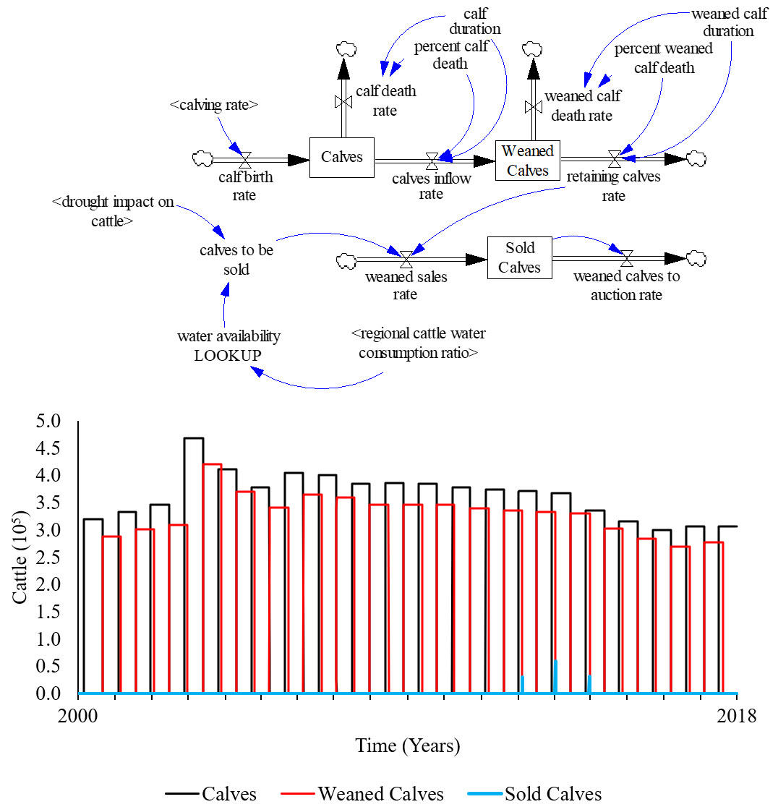
Fig. 1C. Simplified calf population dynamics of calves on milk, weaned and sold. Rectangles represent stocks (accumulations) which use fixed delays that hold cattle for an explicit duration (e.g., suckling and breeding durations) where outflows are only active at the end of that duration via rates (arrow-cloud-hourglass). The graph displays an example of the numerical accumulations and production delays of calves, weaned calves, and calves to be sold stocks.

Fig. 2C. Stock and flow diagram of the stocker, feedlot and replacement heifers population dynamics (above). Rectangles represent stocks (accumulations), all of which use fixed delays that hold cattle for an explicit duration (e.g., suckling and breeding durations) where outflows are only active at the end of that duration via rates (arrow-cloud-hourglass). Multiple heifer stocks kept annual heifer crops separate until joining the mature cow herd. The graph displays the aggregation of stocker cattle from the ten regions to the feedlot phase in region one (High Plains).

Fig. 3C. Description of the cattle designated for meat production and replacement heifers daily weight gain stock and flow diagram (above). Rectangles represent stocks (accumulations), all of which use fixed delays that hold cattle for an explicit duration (e.g., suckling and breeding durations) where outflows are only active at the end of that duration via rates (arrow-cloud-hourglass). The graph displays an example of calf (i.e., suckling calf), weaned calf, stocker, and feedlot cattle progression for each production cycle. Overlap exists because new calves enter the production chain before the current animals obtaining mature weight and leaving the chain (i.e., slaughter).

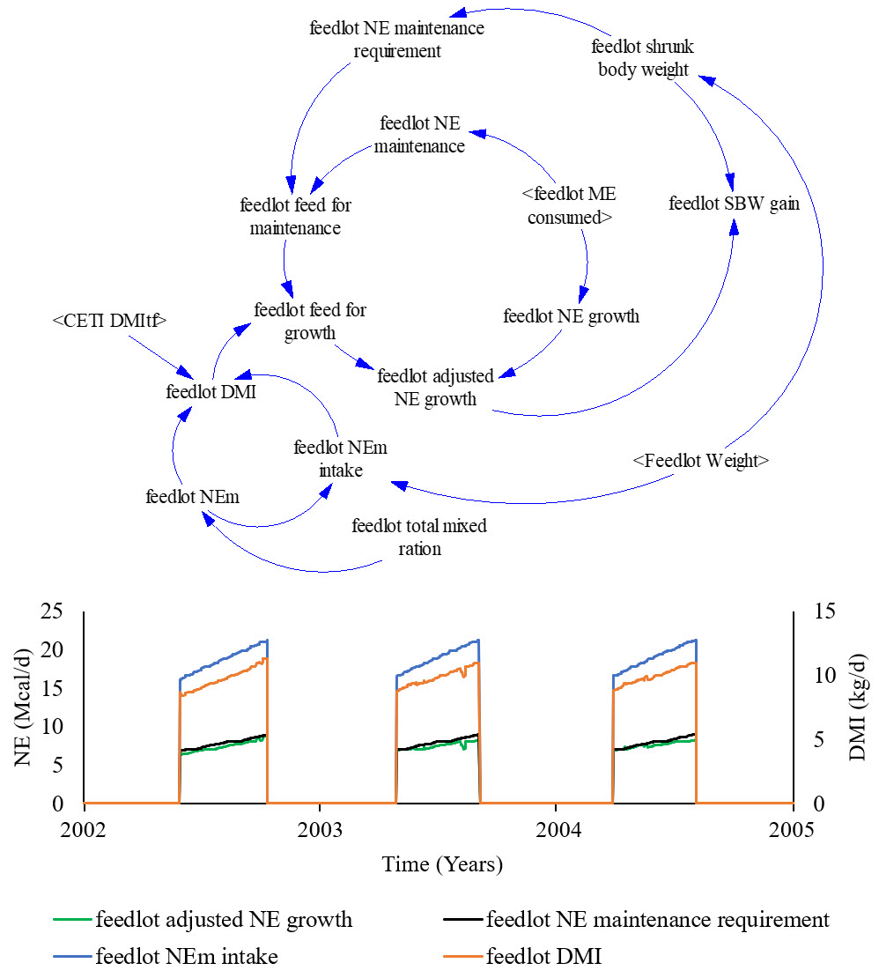
Fig. 4C. Example of the dry matter intake (DMI) structure that is dynamically connected to the weight stock and flow structure for each cattle type (i.e., calf, weaned calf, stocker, feedlot, and replacement heifers; above). Rectangles represent stocks (accumulations), all of which use fixed delays that hold cattle for an explicit duration (e.g., suckling and breeding durations) where outflows are only active at the end of that duration via rates (arrow-cloud-hourglass). The graph shows the behaviour of specific growth and nutrition factors for three feedlot periods.

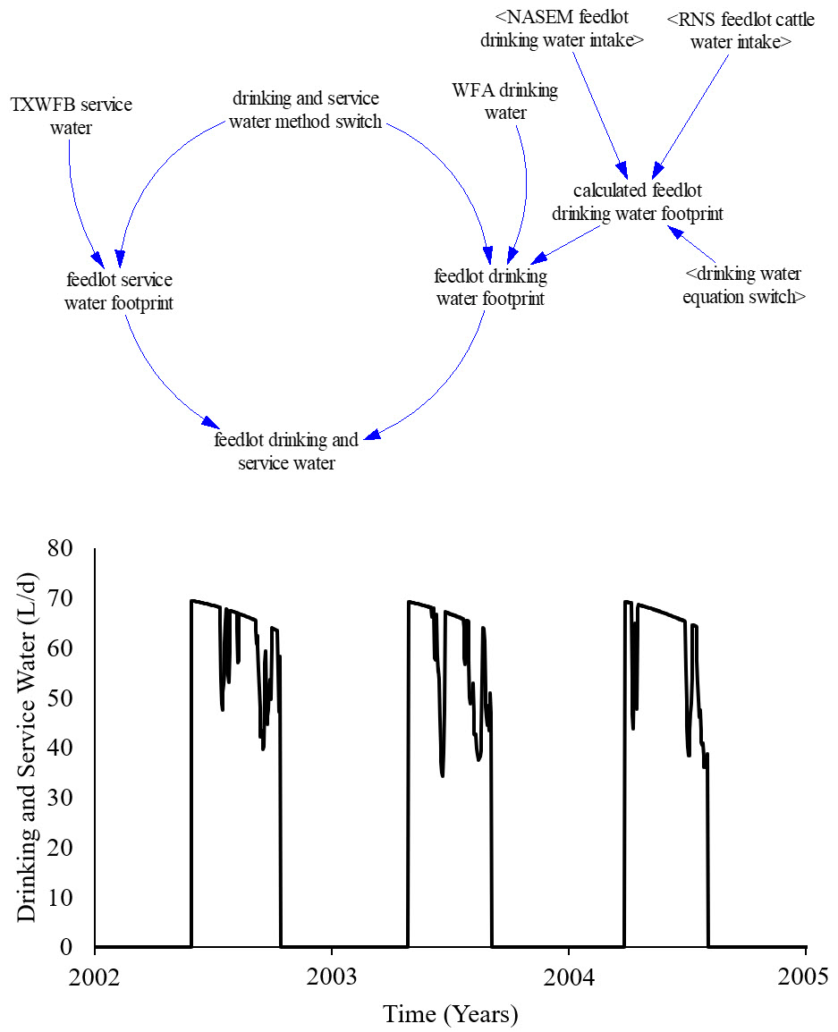
Fig. 5C. Example of drinking and servicing water estimation structure (above). Rectangles represent stocks (accumulations), all of which use fixed delays that hold cattle for an explicit duration (e.g., suckling and breeding durations) where outflows are only active at the end of that duration via rates (arrow-cloud-hourglass). The graph displays the daily drinking and servicing water levels of a single animal in during each feedlot phase duration for subsequent years in region one.

Fig. 6C. Example of the daily forage growth, hay, and specific water demand (SWD; m3/ton) stock and flow structure (above). Rectangles represent stocks (accumulations), all of which use fixed delays that hold cattle for an explicit duration (e.g., suckling and breeding durations) where outflows are only active at the end of that duration via rates (arrow-cloud-hourglass). The graph displays the daily values for total forage production and SWD for each season and the associated hay SWD of hay that has been stored from the previous year.

