Supplementary Material
Table S 1. Output of linear mixed effects models for the CP, ADF and ME content as well as for the clover content in mixture GC, the clover and forb contents in GCF as well as the CVCP, CVADF and CVME. The factor cut*year refers to a pseudofactor between each cut per year to account for varying harvests per year. GC: refers to the mixture of grass and white clover; GCF: refers to the mixture of grass, white clover, dandelion and plantain. Cut 1 to cut 4 were: 15 May (± 3 days), 20 June (± 4 days), 28 July (± 11 days) and 30 September (± 11 days). Year 1 - year 5 refer to 1999-2003.
CP content | numDF | denDF | F value | P value
Intercept | 1 | 656 | 7964.0 | ***
cut*year | 17 | 656 | 46.8 | ***
growth form | 1 | 36 | 20.2 | ***
crop stand | 2 | 36 | 16.6 | ***
phenology | 1 | 36 | 38.2 | ***
cut*year × growth form | 17 | 656 | 3.1 | ***
cut*year × crop stand | 34 | 656 | 28.0 | ***
cut*year × phenology | 17 | 656 | 7.7 | ***
growth form × crop stand | 2 | 36 | 4.2 | *
crop stand × phenology | 2 | 36 | 1.5 | n.s.
cut*year × crop stand × phenology | 34 | 656 | 4.1 | ***
ADF content | numDF | denDF | F value | P value
Intercept | 1 | 656 | 15621.1 | ***
cut*year | 17 | 656 | 47.4 | ***
growth form | 1 | 33 | 32.4 | ***
crop stand | 2 | 33 | 14.9 | ***
phenology | 1 | 33 | 59.1 | ***
cut*year × growth form | 17 | 656 | 3.4 | ***
cut*year × crop stand | 34 | 656 | 25.9 | ***
cut*year × phenology | 17 | 656 | 18.5 | ***
growth form × crop stand | 2 | 33 | 4.5 | *
growth form × phenology | 1 | 33 | 39.9 | ***
crop stand × phenology | 2 | 33 | 0.9 | n.s.
cut*year × crop stand × phenology | 34 | 656 | 3.4 | ***
growth form × crop stand × phenology | 2 | 33 | 5.3 | *
ME content | numDF | denDF | F value | P value
Intercept | 1 | 639 | 80129.57 | ***
cut*year | 17 | 639 | 33.9 | ***
growth form | 1 | 37 | 12.16 | **
crop stand | 2 | 37 | 8.8 | ***
phenology | 1 | 37 | 71.35 | ***
cut*year × growth form | 17 | 639 | 3.37 | ***
cut*year × crop stand | 34 | 639 | 21.36 | ***
cut*year × phenology | 17 | 639 | 12.59 | ***
growth form × phenology | 1 | 37 | 2 | n.s.
crop stand × phenology | 2 | 37 | 2.81 | n.s.
cut*year × growth form × phenology | 17 | 639 | 2.74 | ***
cut*year × crop stand × phenology | 34 | 639 | 4.1 | ***
clover in GC | numDF | denDF | F value | P value
Intercept | 1 | 210 | 88138.4 | ***
cut*year | 15 | 210 | 71.9 | ***
growth form | 1 | 10 | 8.2 | *
phenology | 1 | 10 | 6.0 | *
cut*year × phenology | 15 | 210 | 13.6 | ***
clover in GCF | numDF | denDF | F value | P value
Intercept | 1 | 225 | 226151.9 | ***
cut*year | 15 | 225 | 108.7 | ***
growth form | 1 | 11 | 2.9 | n.s.
forbs in GCF | numDF | denDF | F value | P value
Intercept | 1 | 210 | 177746.0 | ***
cut*year | 15 | 210 | 71.1 | ***
growth form | 1 | 10 | 14.5 | **
phenology | 1 | 10 | 1.5 | n.s.
cut*year × phenology | 15 | 210 | 4.7 | ***
CVCP | numDF | denDF | F value | P value
Intercept | 1 | 171 | 131.06 | ***
growth form | 1 | 38 | 1.08 | n.s.
year | 4 | 171 | 3.10 | *
crop stand | 2 | 38 | 8.84 | ***
phenology | 1 | 38 | 18.76 | ***
growth form × year | 4 | 171 | 3.48 | **
year × crop stand | 8 | 171 | 11.78 | ***
year × phenology | 4 | 171 | 18.25 | ***
crop stand × phenology | 2 | 38 | 2.75 | n.s.
CVADF | numDF | denDF | F value | P value
Intercept | 1 | 171 | 178.37 | ***
growth form | 1 | 37 | 7.85 | **
year | 4 | 171 | 7.92 | ***
crop stand | 2 | 37 | 29.82 | ***
phenology | 1 | 37 | 0.01 | n.s.
growth form × year | 4 | 171 | 3.63 | *
growth form × phenology | 1 | 37 | 2.98 | n.s.
year × crop stand | 8 | 171 | 17.64 | ***
year × phenology | 4 | 171 | 5.86 | ***
crop stand × phenology | 2 | 37 | 9.78 | ***
CVME | numDF | denDF | F value | P value
Intercept | 1 | 167 | 84.81 | ***
year | 4 | 167 | 12.50 | ***
crop stand | 2 | 39 | 7.16 | **
phenology | 1 | 39 | 0.00 | n.s.
year × crop stand | 8 | 167 | 7.03 | ***
year × phenology | 4 | 167 | 4.09 | **
crop stand × phenology | 2 | 39 | 0.52 | n.s.
year × crop stand × phenology | 8 | 167 | 3.01 | **

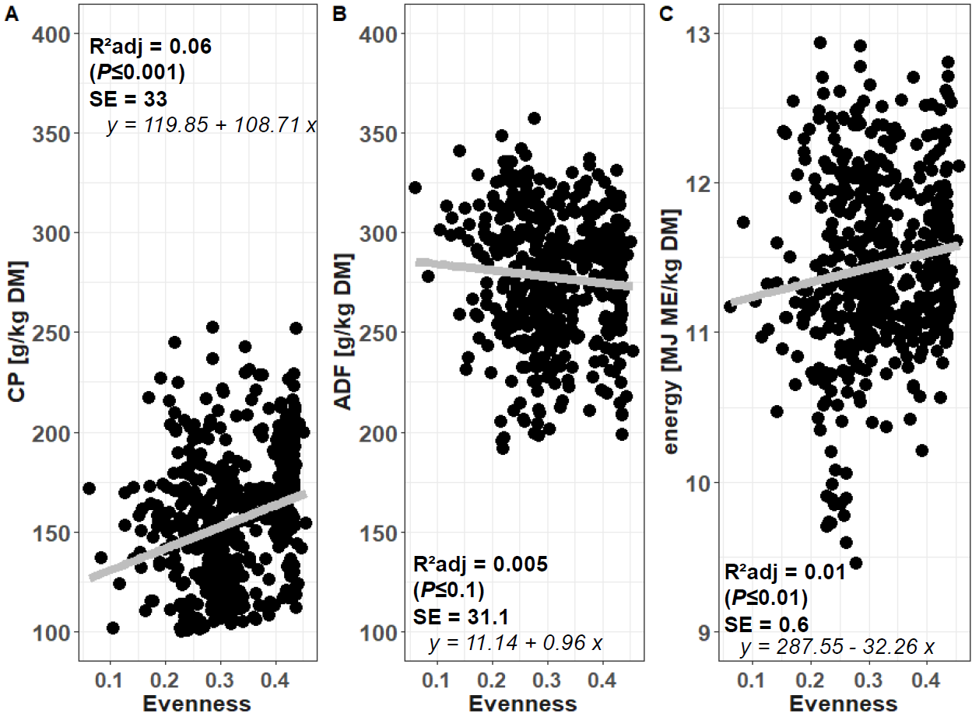
Figure S 1. Relationship between Evenness and A) CP, B) ADF and C) within the mixture swards GC and GCF. Analysis of covariance was conducted with phenology and growth form as well as their interaction as fixed factors, block as random factor and Evenness as covariate for each target variable. A significant effect of Evenness on CP and ME but not ADF was found. The resulting linear relationships are shown. Evenness was calculated according to Magurran (2004). CP: crude protein, ADF: acid detergent fibre, ME: metabolizable energy, G: grass pure stands, GC: refers to the mixture of grass and white clover; GCF: refers to the mixture of grass, white clover, dandelion and plantain. The Evenness was calculated as Shannon Index/Ln(species number). The Shannon Index was calculated as GC = grass proportion* log(grass proportion) + clover proportion * log(clover proportion), GCF = grass proportion* log(grass proportion) + clover proportion * log(clover proportion) + forb proportion * log(forb proportion).
Magurran AE (2004) Measuring Biological Diversity. Blackwell, Oxford, UK, 1-248.

