Table S1. Field management methods and soil texture in eight environments
Environment | Year | Location | Sowing  date | Seeding density  (Plants/ha) | Soil type | Fertilizer  N: P₂O₅: K2O  (kg/ha) | Chemical herbicides
E1 | 2013 | Harbin | 10 May | 2.22×10⁵ | Meadow black soil | 60:90:75 | 90% Acetochlor emulsifiable concentrates 2000 ml
E2 | 2013 | Keshan | 10 May | 2.80×10⁵ | Chernozem soil | 75:90:75 | 90% Acetochlor emulsifiable concentrates 2000 ml
E3 | 2014 | Harbin | 10 May | 2.22×10⁵ | Meadow black soil | 60:90:75 | 90% Acetochlor emulsifiable concentrates 2000 ml
E4 | 2014 | Harbin | 20 May | 2.22×10⁵ | Meadow black soil | 60:90:75 | 90% Acetochlor emulsifiable concentrates 2000 ml
E5 | 2015 | Harbin | 10 May | 2.22×10⁵ | Meadow black soil | 60:90:75 | 90% Acetochlor emulsifiable concentrates 2000 ml
E6 | 2015 | Harbin | 10 May | 3.08×10⁵ | Meadow black soil | 60:90:75 | 90% Acetochlor emulsifiable concentrates 2000 ml
E7 | 2015 | Keshan | 10 May | 2.58×10⁵ | Chernozem soil | 75:90:75 | 90% Acetochlor emulsifiable concentrates 2000 ml
E8 | 2015 | Keshan | 10 May | 3.51×10⁵ | Chernozem soil | 75:90:75 | 90% Acetochlor emulsifiable concentrates 2000 ml

Table S2. Protein and oil content of four parents in eight environments
Environment | Year | Location | Protein content (g/kg) |  |  |  | Oil content (g/kg)
 |  |  | P1 | P2 | P3 | P4 | P1 | P2 | P3 | P4
E1 | 2013 | Harbin | 426.20 | 416.90 | 413.90 | 419.00 | 200.40 | 202.60 | 210.50 | 196.50
E2 | 2013 | Keshan | 426.40 | 447.70 | 432.00 | 466.80 | 156.30 | 186.10 | 160.20 | 169.40
E3 | 2014 | Harbin | 423.10 | 421.90 | 422.50 | 451.10 | 213.80 | 205.10 | 197.50 | 190.90
E4 | 2014 | Harbin | 420.70 | 413.10 | 406.70 | 426.30 | 196.40 | 202.60 | 189.40 | 190.30
E5 | 2015 | Harbin | 429.00 | 411.00 | 399.00 | 439.00 | 203.70 | 202.70 | 218.80 | 198.20
E6 | 2015 | Harbin | 438.00 | 429.00 | 453.00 | 447.00 | 197.70 | 202.50 | 196.00 | 202.60
E7 | 2015 | Keshan | 430.00 | 409.00 | 395.00 | 433.00 | 190.80 | 198.50 | 209.70 | 191.90
E8 | 2015 | Keshan | 427.00 | 412.00 | 422.00 | 435.00 | 194.10 | 187.10 | 194.50 | 198.20
E, environment; E1, Harbin in 2013; E2, Keshan in 2013; E3, the first sowing date in Harbin in 2014; E4, the second sowing date in Harbin in 2014; E5, 2.22×10⁵ plants/ha in Harbin; E6, 3.08×10⁵ plants/ha in Harbin; E7, 2.58×10⁵ plants/ha in Keshan; E8, 3.51×10⁵plants/ha in Keshan. P1, Kenfeng14; P2, Kenfeng15; P3, Heinong48; P4, Kenfeng19

Table S3. Quantitative trait loci (QTL) with positive additive effect alleles in four-way parents
Trait | Parent name | QTL
protein | Kenfeng14 | qPro-A2-2 | qPro-B1-1 | qPro-D2-1 | qPro-D2-2 | qPro-D2-3
 |  | qPro-F-1 | qPro-F-2 | qPro-H-1 | qPro-K-3 | qPro-M-1
 |  | qPro-N-1
 | Kenfeng15 | qPro-B1-1 | qPro-B2-1 | qPro-B2-2 | qPro-D1b-1 | qPro-D1b-2
 |  | qPro-H-1 | qPro-K-1 | qPro-K-2 | qPro-K-3 | qPro-N-1
 |  | qPro-N-3 | qPro-N-4
 | Heinong48 | qPro-A1-3 | qPro-A2-2 | qPro-B2-1 | qPro-B2-3 | qPro-D1b-1
 |  | qPro-D1b-2 | qPro-D1b-3 | qPro-D2-2 | qPro-D2-3 | qPro-F-2
 |  | qPro-G-1 | qPro-G-2 | qPro-H-1 | qPro-H-2 | qPro-J-1
 |  | qPro-N-4
 | Kenfeng19 | qPro-A1-1 | qPro-A1-2 | qPro-A1-4 | qPro-A2-1 | qPro-B2-1
 |  | qPro-B2-2 | qPro-B2-3 | qPro-C2-1 | qPro-D1b-2 | qPro-D2-1
 |  | qPro-D2-2 | qPro-D2-3 | qPro-F-2 | qPro-G-1 | qPro-G-2
 |  | qPro-H-2 | qPro-L-1 | qPro-M-1 | qPro-N-1 | qPro-N-2
 |  | qPro-N-3 | qPro-N-4
oil | Kenfeng14 | qOil-A1-1 | qOil-A1-2 | qOil-A1-3 | qOil-A1-4 | qOil-A1-5
 |  | qOil-B2-1 | qOil-C1-1 | qOil-C1-2 | qOil-C2-1 | qOil-C2-2
 |  | qOil-D2-1 | qOil-D2-2 | qOil-D2-3 | qOil-F-3 | qOil-I-1
 |  | qOil-I-2 | qOil-J-1 | qOil-K-2 | qOil-K-4 | qOil-M-2
 |  | qOil-N-1 | qOil-N-2 | qOil-N-3 | qOil-N-4
 | Kenfeng15 | qOil-A1-2 | qOil-A2-1 | qOil-C2-2 | qOil-C2-3 | qOil-D1b-2
 |  | qOil-D2-1 | qOil-D2-2 | qOil-D2-3 | qOil-E-1 | qOil-G-1
 |  | qOil-I-2 | qOil-K-3 | qOil-K-5 | qOil-L-1 | qOil-N-4
 | Heinong48 | qOil-A1-4 | qOil-C1-2 | qOil-C2-1 | qOil-F-2 | qOil-G-1
 |  | qOil-K-1 | qOil-K-3 | qOil-K-4 | qOil-K-5
 | Kenfeng19 | qOil-A1-3 | qOil-E-1 | qOil-F-2 | qOil-F-3 | qOil-I-1
 |  | qOil-I-2 | qOil-N-3

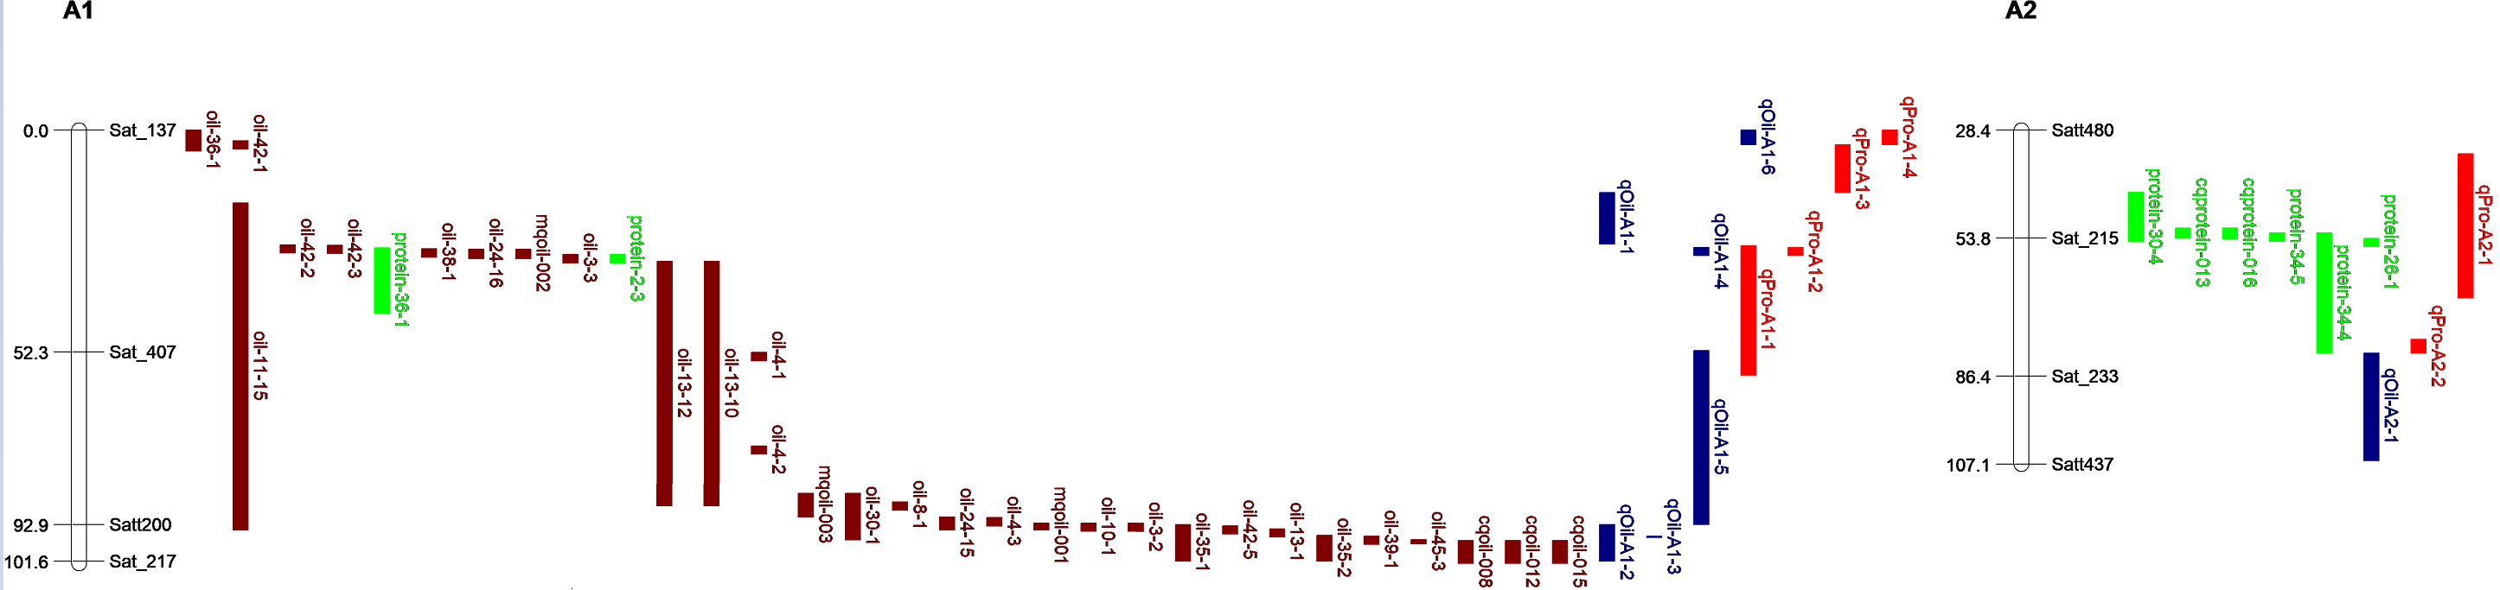
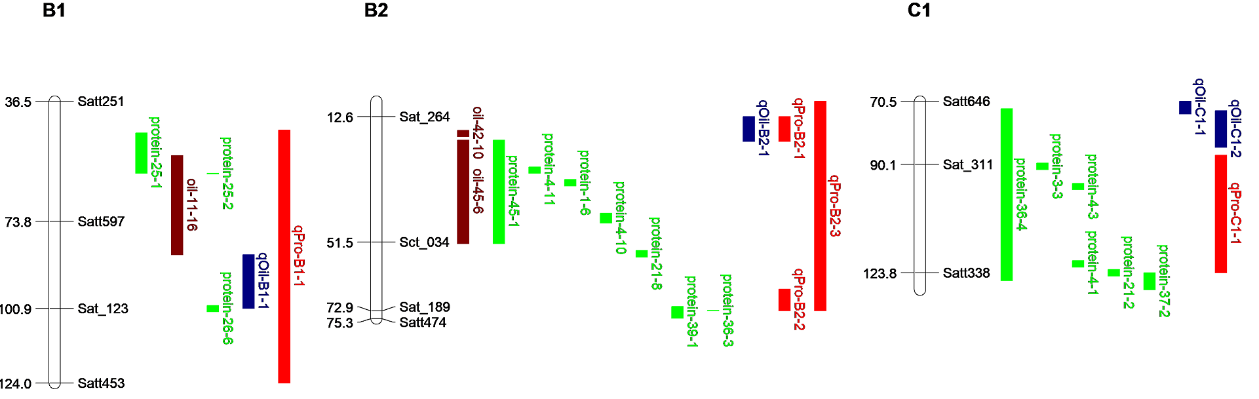
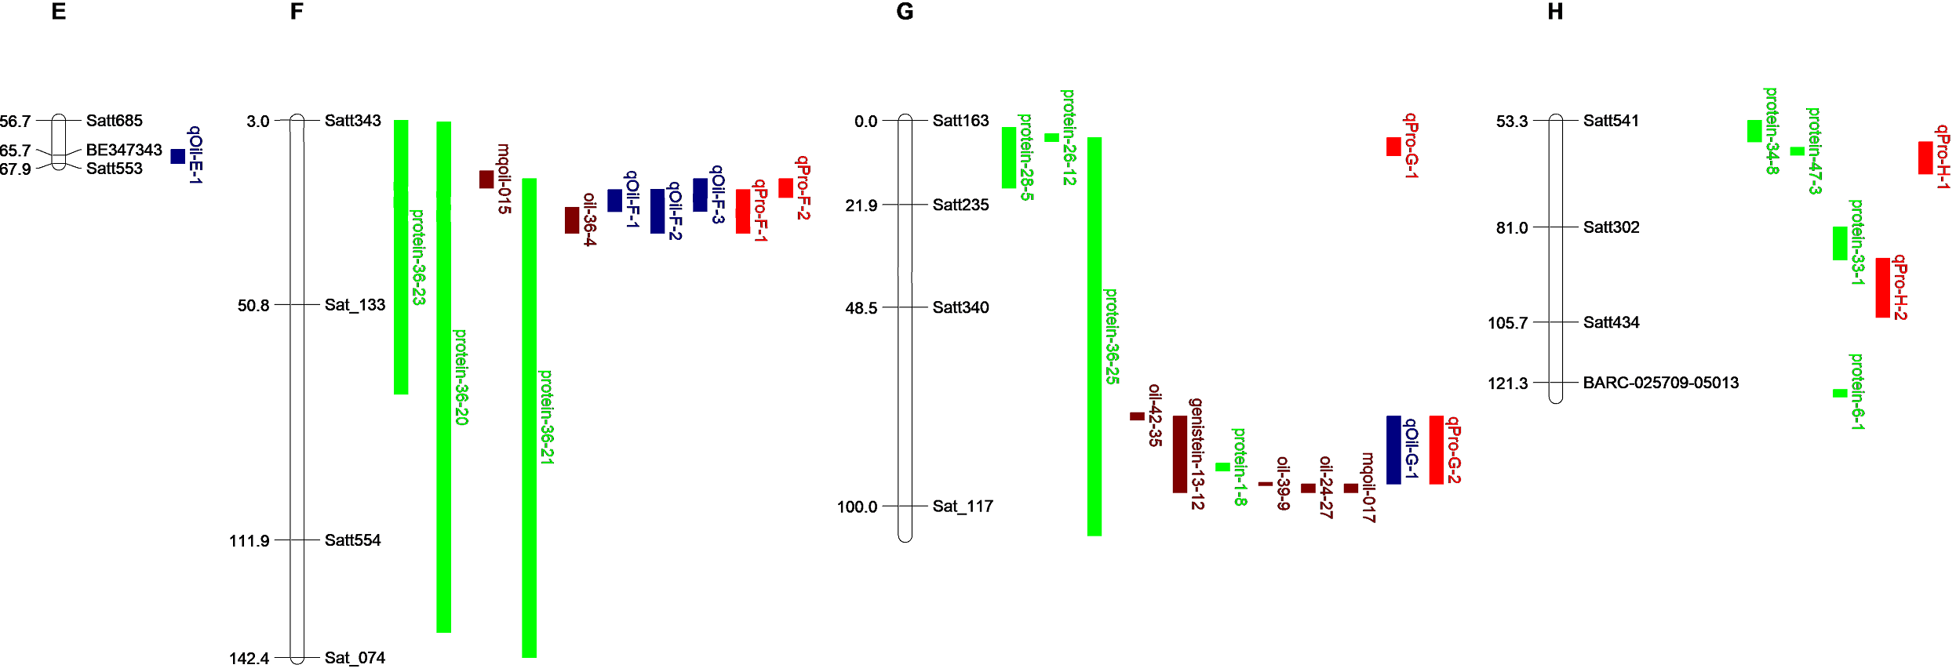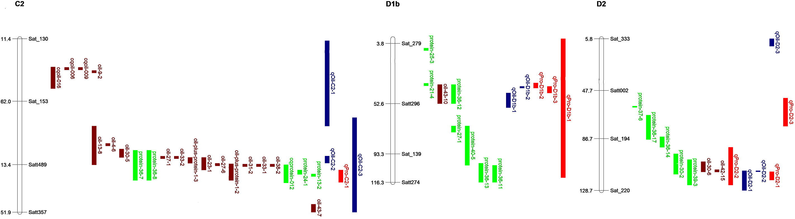
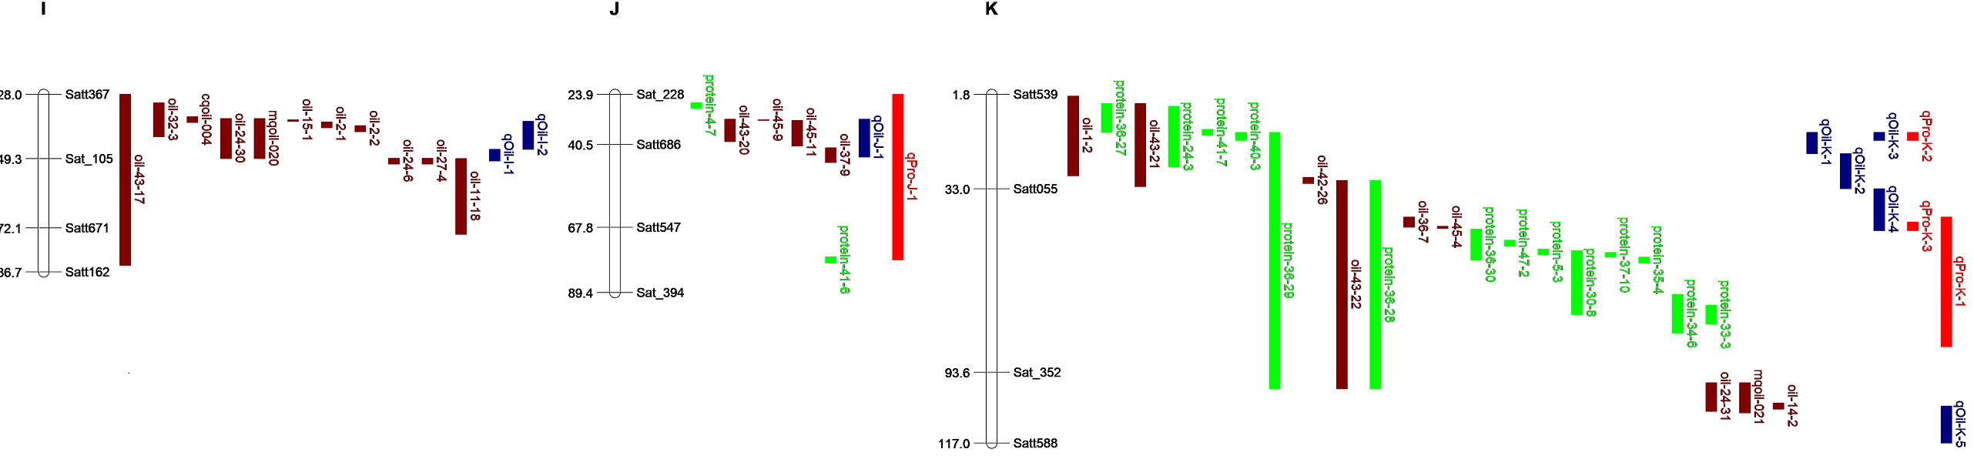
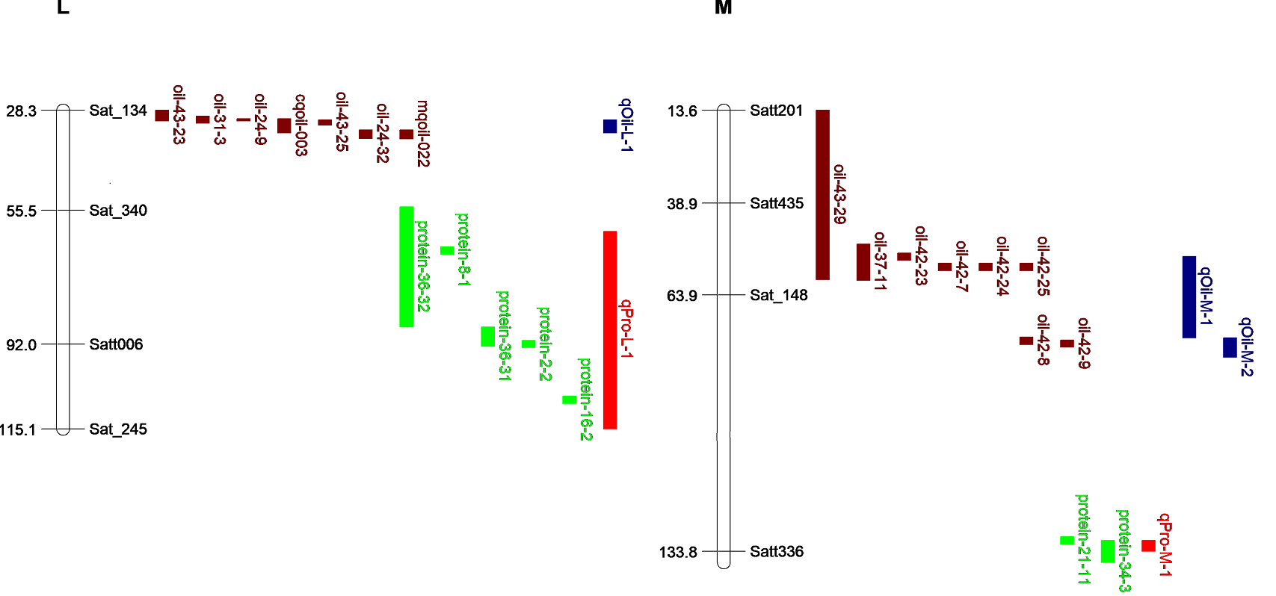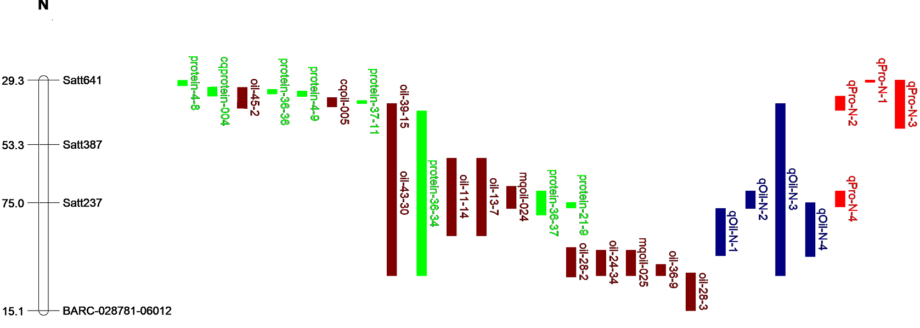
Fig. S1. Integrated linkage map of quantitative trait loci (QTLs) for protein and oil content detected in the present study and previous reports (in SoyBase) based on the positions of markers in the public map. These QTLs are distributed on the left chromosome, and the size of the QTL interval is represented by the length of the QTL. Red represents protein QTLs found in the four-way recombinant inbred line (FW-RIL); blue represents oil QTLs found in FW-RIL; brown represents oil QTLs reported previously; green represents protein QTLs reported previously. The chromosome unit is cM.

