SUPPLEMENT

Calibration and validation results

Calibration and validation were performed using experimental data from Lednice, Věrovany and Domanínek locations (Table 1). The input data are shown in Table 2. The parameters for the length of the vegetative and reproductive development stages used for calibration are shown in Table 3. The results of the calibration and validation for phenological phases of flowering and maturity and for grain yield were evaluated using the following statistical parameters RMSE, MBE and IA. The obtained results of calibration and validation can be found in Figs. 1-4.

**Tables & Figures**

Table 1. *Table of the years that were used for the calibration and validation of the Lednice, Věrovany and Domanínek locations.*

|  |  |  |  |  |  |  |  |  |  |  |  |  |  |  |
| --- | --- | --- | --- | --- | --- | --- | --- | --- | --- | --- | --- | --- | --- | --- |
| Year  Locality | 1998 | 1999 | **2000** | **2001** | **2002** | **2003** | **2004** | **2005** | **2006** | **2011** | **2012** | **2013** | **2014** | **Calibration** |
| Lednice |  |  |  |  |  |  |  |  |  |  |  |  |  | **Validation** |
| Věrovany |  |  |  |  |  |  |  |  |  |  |  |  |  |
| Domanínek |  |  |  |  |  |  |  |  |  |  |  |  |  |

Table 2. *Input data provided to models.*

|  |  |  |
| --- | --- | --- |
| Category | Variable | Type |
| *Meteorological data* | *Global radiation*  *Maximum temperature*  *Minimum temperature*  *Relative air humidity*  *Wind speed*  *Precipitation* | *daily sum (MJ, W/m2)*  *daily maximum (ºC)*  *daily minimum (ºC)*  *daily average (%, Pa)*  *daily average (m/s)*  *daily sum (mm)* |
| *Soil data (0 cm to 150 cm)* | *Texture*  *Corg*  *C:N ratio*  *Bulk density*  *Field capacity*  *Wilting point*  *Max. rooting depth*  *Soil water balance\** | *per layer clay, silt, sand (%)*  *per layer (%)*  *per layer (unitless)*  *per layer (cm3/cm3)*  *per layer (cm3/cm3)*  *per layer (cm3/cm3)*  *per layer (cm)*  *0-30 cm (cm3/cm3)* |
| *Crop data* | *Cultivar of spring barley*  *Germination*  *Flowering*  *Heading*  *Maturity*  *LAI\**  *Yield of grain* | *Tolar/Bojos*  *doy (day of year)*  *doy*  *doy*  *doy*  *doy (m2/m2)*  *t/ha* |
| *Management* | *Sowing date*  *Harvest date*  *Tillage*  *N fertilization*  *Previous crop (sowing, harvest)*  *Initial conditions\**   * *water content,* * *soil mineral N* | *doy*  *doy*  *doy, type, dept (cm)*  *doy (kg N/ha)*  *doy*  *per layer (cm3/cm3)*  *per layer (kg/ha)* |

*\*Only for Domanínek 2011-2014.*

Table 3. *Parameters used for calibration.* *Base temperature is not set to zero degree in models.*

*Parameters were adjusted by sensitivity analysis.*

|  |  |
| --- | --- |
| **Model**  **(version)** | **The parameters for the length of the vegetative and reproductive development phases** |
| *WOFOST*  *(7.3.1)* | *TSUMEN (Thermal time from sowing to emergence (ºC/day))*  *TSUM1(Thermal time from emergence to anthesis (ºC/day))*  *TSUM2(Thermal time from anthesis to maturity (ºC/day))* |
| *CERES-Barley*  *(4.6)* | *P1V (Days, optimum vernalizing temperature,required for vernalization)*  *P1D (Photoperiod response (% reduction in rate/10 h drop in pp))*  *P5 (Grain filling (excluding lag) phase duration (ºC/day))*  *G1 (Kernel number per unit canopy weight at anthesis (g))*  *G2 (Standard kernel size under optimum conditions (mg))*  *G3 (Standard,non-stressed mature tiller wt (incl grain) (g dwt))*  *PHINT (Interval between successive leaf tip appearances (ºC/day))* |
| *HERMES*  *(2.01.1)* | *1 Temperatursumme (temperature sum from sowing to emergence)*  *2 Temperatursumme (temperature sum from emergence to heading)*  *3 Temperatursumme (temperature sum from heading to anthesis)*  *4 Temperatursumme (temperature sum of anthesis )*  *5 Temperatursumme (temperature sum of filling grain)*  *6 Temperatursumme (temperature sum of maturity)* |
| *DAISY*  *(4.01)* | *EmrTSum (Soil temperature sum at emergence)*  *DSRate1 (Development rate in the vegetative phase)*  *DSRate2 (Development rate in the reproductive phase)* |
| *AQUACROP*  *(4.0)* | *GDDays (growing degree days): from sowing to emergence*  *GDDays: from sowing to maximum rooting depth*  *GDDays: from sowing to start senescence*  *GDDays: from sowing to maturity (length of crop cycle)*  *GDDays: from sowing to flowering*  *Length of the flowering phase (GDDays)* |

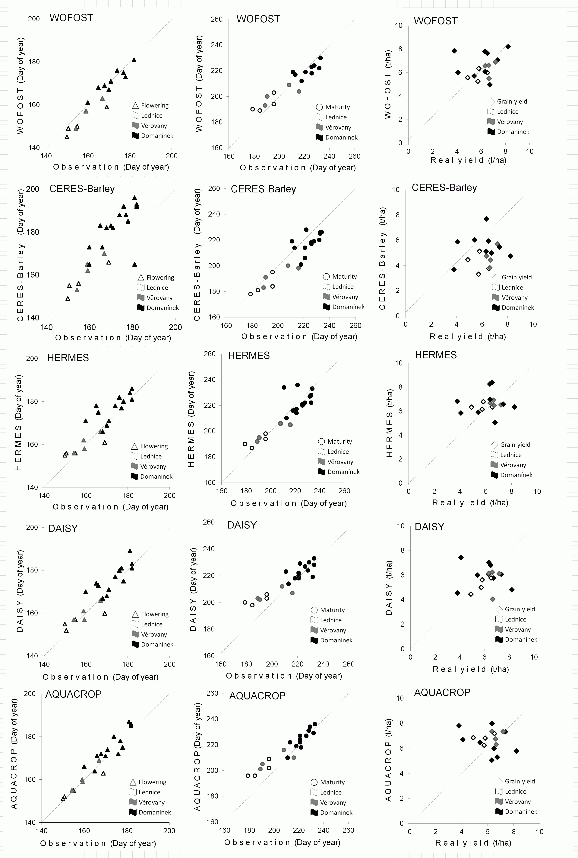

**Fig. 1.** Calibration results: simulated and observed phenological stages of development (flowering and maturity) and grain yield estimates (t/ha, dry matter) at the study locations: Lednice from 1998 and 2001-2003; Věrovany from 1998 and 2001-2003; Domanínek from 1998, 2000-2003 and 2011-2014. Simulation results are shown for the five individual models. Different study sites are depicted with different symbols, which are shown in the graph legend. The 1:1 line is shown, representing perfect agreement.

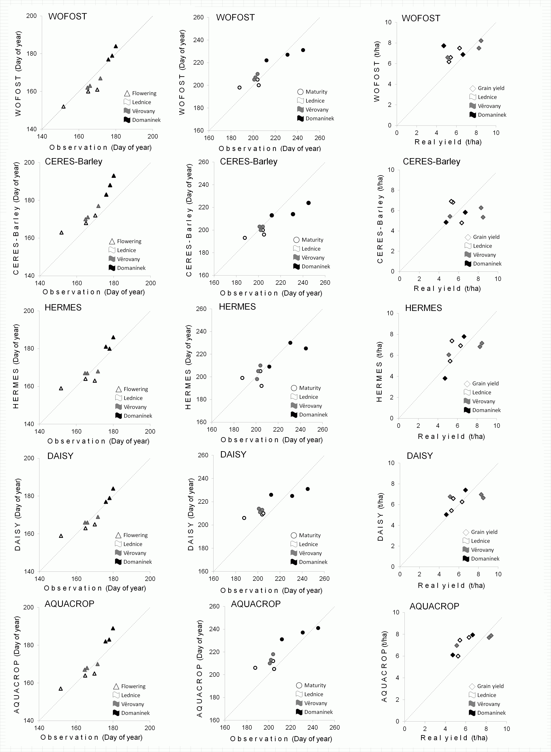

**Fig. 2.** Validation results: simulated and observed phenological stages of development (flowering and maturity) and grain yield estimates (t/ha, dry matter) at the study locations: Lednice from 2004-2006; Věrovany from 2004-2006; Domanínek from 2004-2006. Simulation results are shown for the five individual models. Different study sites are depicted with different symbols, which are shown in the graph legend. The 1:1 line is shown, representing perfect agreement.

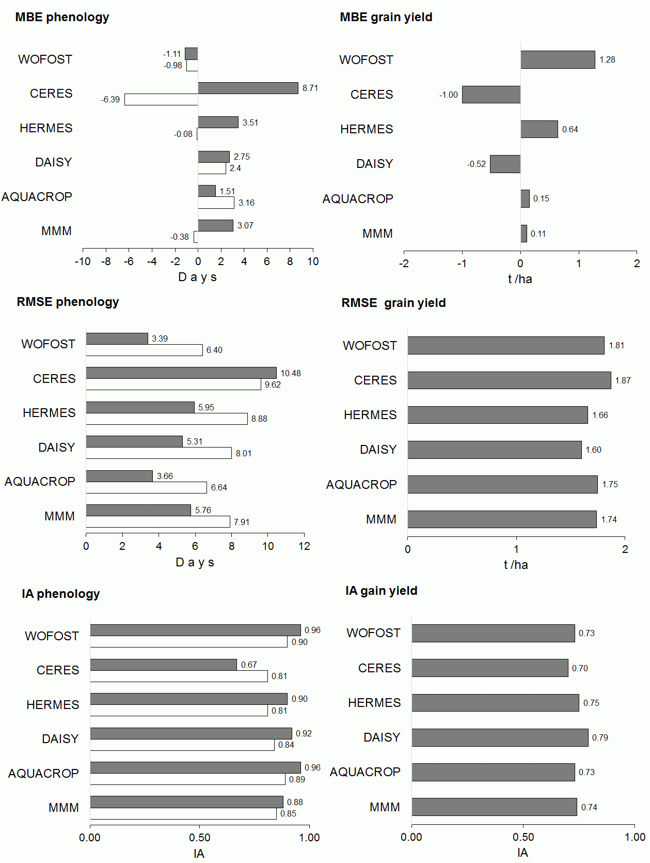

**Fig. 3.** Calibration results: graphical representation of statistics describing the performance of individual models in simulating all study sites and growing seasons as compared to ensemble arithmetic mean (EAM); mean bias error (MBE), root mean square error (RMSE) and index of agreement (IA). IA can have values within the range [0, 1], and the values closer to 1 indicate the better simulation quality.

Two phenology stages of development were compared: flowering and maturity. Filled bars indicate flowering, open bars indicate maturity.

*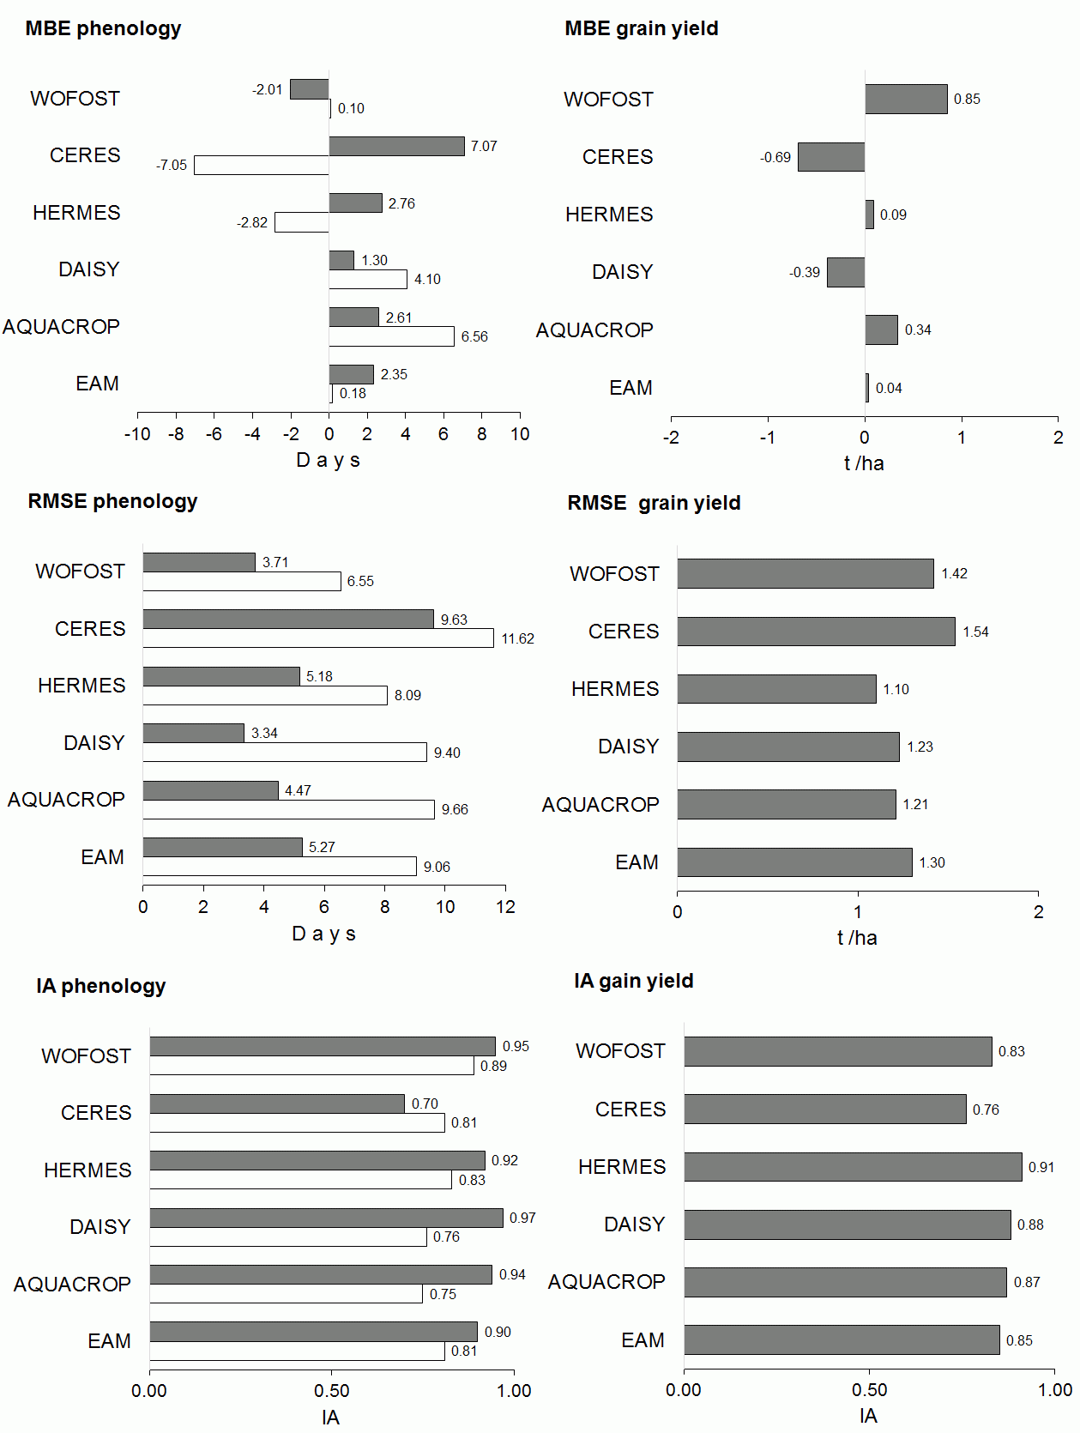***Fig. 4.** Validation results: graphical representation of statistics describing the performance of individual models in simulating all study sites and growing seasons as compared to ensemble arithmetic mean (EAM); mean bias error (MBE), root mean square error (RMSE) and index of agreement (IA). IA can have values within the range [0, 1], and the values closer to 1 indicate the better simulation quality.

Two phenology stages of development were compared: flowering and maturity. Filled bars indicate flowering, open bars indicate maturity.