Appendix 1: Schematic of the AusBeef rumen model and microbial growth equations
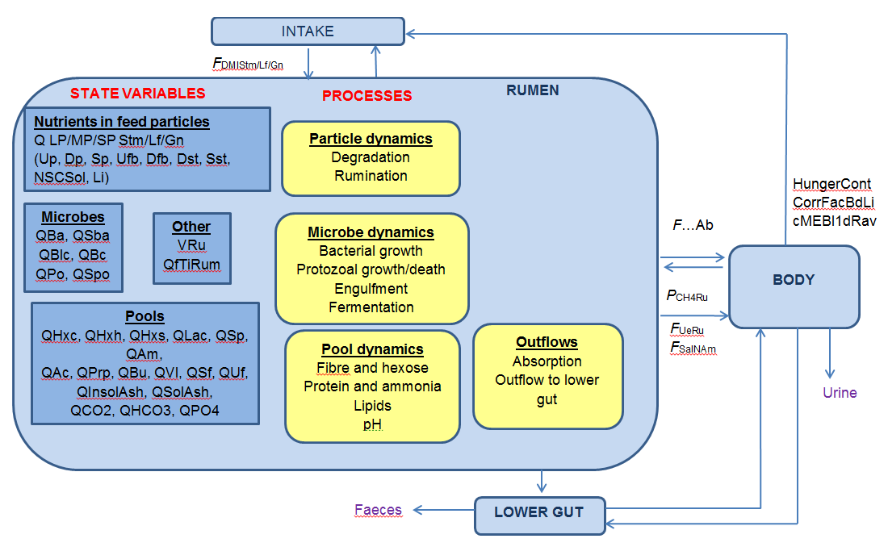
Fig. A1 A schematic representation of the AusBeef rumen model. See explanation of terms in table A1 (colour online).

Table A1. Explanation of terms in schematic representation of the AusBeef rumen model
Model Term | Description | Units
Q | Quantity | dimensionless
LP/MP/SP | Large/medium/small feed particles | grams/day
Stm/Lf/Gn | Stem/leaf/grain feed components | grams/day
Up/Dp/Sp | Undegradable/Degradable/Soluble protein | moles
Ufb/Dfb | Undegradable/Degradable fibre | moles
Dst/Sst | Degradable/Soluble starch | moles
NSCSol | Soluble non-starch carbohydrates | moles
Li | Lipids | moles
Ba/Sba | Amylolytic bacteria/storage polysaccharide | moles/grams
Blc | Lactolytic bacteria | moles
Po/Spo | Protozoa/storage polysaccharide | moles/grams
VRu | Rumen volume | liters
QfTiRu | Time spent ruminating | minutes
Hxc/Hxh/Hxs | Hexose from cellulose/hemicellulose/starch | moles
Lac | Lactate | moles
Am | Ammonia | moles
Prp | Propionate | moles
Ac | Acetate | moles
Vl | Valerate | moles
Bu | Butyrate | moles
Sf/Uf | Saturated/Unsaturated lipid | moles
InsolAsh/SolAsh | Insoluble/Soluble Ash | grams
F….Ab | Absorption across the rumen wall | moles/day
F_{UeRu} | Flow of urea into the rumen | moles/day
F_{SalNAm} | Rate of salivary nitrogen conversion to ammonia | moles/day
F_{DMIStm/Lf/Gn} | Dry matter intake of feed particles | grams/day
HungerCont/ CorrFacBdLi/ cMeBl1dRav | Energetic terms feeding into voluntary intake | dimensionless; dimensionless; MJ/kg live weight
P_{CH4Ru} | Production of CH₄ in the rumen | moles/day

Microbial growth equations
dQ_{Ba}/dt = ( (P_{BaAm} + P_{BaSp}) - (F_{BaPo} + F_{BaEx}) ) [1]
dQ_{Sba}/dt = ( (112.5 × P_{SbaHx}) - (F_{SbaPo} + F_{SbaEx}) ) [2]
dQ_{Bc}/dt = ( (P_{BcAm} + P_{BcSp}) - (F_{BcPo} + F_{BcEx}) ) [3]
dQ_{Blc}/dt = ( ((Y_{BaAm} × U_{AmBlc}) + (Y_{BaSp} × U_{SpBlc}) - (F_{BlcPo} + F_{BlcEx}) ) [4]
dQ_{Po}/dt = ( (min( ((F_{ChoPo} - U_{ChoMntPo}) x Y_{PoCho}), (F_{PrtPo}/0.0067))) - (F_{PoDth} + F_{PoEx} + F_{PoPo})) [5]
dQ_{Spo}/dt = ( ((112.5 x U_{HxsSpo}) + (112.5 x _{UDstSpo)}) - (F_{SpoPoDth} + F_{SpoPo} + F_{SpoEx}) ) [6]
Table A2: Description of variable names
Variable Name | Meaning | Units
F_{BaEx} | Rate of outflow of amylolytic bacteria from the rumen | grams/day
F_{BaPo} | Flux of amylolytic bacteria engulfed by protozoa | grams/day
F_{BcEx} | Rate of outflow of cellulolytic bacteria from the rumen | grams/day
F_{BcPo} | Flux of cellulolytic bacteria engulfed by protozoa | grams/day
F_{BlcEx} | Rate of outflow of lactolytic bacteria from the rumen | grams/day
F_{BlcPo} | Flux of lactolytic bacteria engulfed by Po | grams/day
F_{PoDth} | Rate of protozoal death | grams/day
F_{PoEx} | Rate of outflow of protozoa from the rumen | grams/day
F_{PrtPo} | Rate of protein engulfment by protozoa | moles/day
F_{SbaEx} | Rate of outflow of amylolytic bacterial storage polysaccharide from the rumen | grams/day
F_{SbaPo} | Engulfment rate of amylolytic bacterial storage polysaccharide by Po | grams/day
F_{SpoEx} | Rate of outflow of protozoal storage polysaccharide from the rumen | grams/day
F_{SpoPo} | Loss of protozoal storage polysaccharide via protozoal engulfment | grams/day
F_{SpoPoDth} | Rate of loss of storage particles due to protozoal death | grams/day
P_{BaSp} | Production of amylolytic bacteria from growth with soluble protein | grams/day
P_{BcAm} | Production of cellulolytic bacteria from growth with ammonia | grams/day
P_{BcSp} | Production of cellulolytic bacteria from growth with soluble protein | grams/day
P_{SbaHx} | Production of amylolytic bacterial storage polysaccharide from absorbed hexose | grams/day
Q_{Ba} | Amount of amylolytic bacteria in the rumen | grams
Q_{Bc} | Amount of cellulolytic bacteria in the rumen | grams
Q_{Blc} | Amount of lactolytic bacteria in the rumen | grams
Q_{Po} | Amount of protozoa in the rumen | grams
Q_{Sba} | Amount of amylolytic bacterial storage polysaccharide in the rumen | grams
Q_{Spo} | Amount of protozoal storage polysaccharide in the rumen | grams
U_{AmBlc} | Uptake of ammonia by lactolytic bacteria | moles/day
U_{ChoMntPo} | Carbohydrate uptake needed for protozoal maintenance | grams/day
U_{DstSpo} | Uptake of degradable starch into protozoal storage polysaccharide | grams/day
U_{HxsSpo} | Uptake of hexose from starch into protozoal storage polysaccharide | moles/day
U_{SpBlc} | Uptake rate of soluble protein by lactolytic bacteria | grams/day
Y_{PoCho} | Yield of protozoa from carbohydrates | grams/day

Table A3: Description of constants
Variable Name | Meaning | Units | Value | Source
Y_{BaAm} | Yield of amylolytic bacterial biomass from growth with ammonia | grams/mole | 121 | Nagorcka (unpublished)
Y_{BaSp} | Yield of amylolytic bacterial biomass from growth with Sp | grams/mole | 152 | Nagorcka (unpublished)
Y_{PoCho} | Yield of protozoa from carbohydrates | grams/mole | 142 | Dijkstra (1994)

