Effects of climatic factors, drought risk and irrigation requirement on maize yield in the Northeast Farming Region of China

X.G. YIN1,2,3,M. JABLOUN3, J. E. OLESEN3, I. ÖZTÜRK3, M. WANG1,2 AND F. CHEN1,2*

1*College of Agronomy and Biotechnology, China Agricultural University, Beijing, 100193, China*

2*Key Laboratory of Farming system, Ministry of Agriculture of China, Beijing, 100193, China*

3*Department of Agroecology,**Aarhus University, Blichers Allé 20, DK-8830 Tjele, Denmark*

SUPPORTING INFORMATION

Calculation of crop evapotranspiration, irrigation water requirement and water deficit using MABIA model

MABIA is a simulation model for irrigation scheduling using the dual crop coefficient approach to compute daily crop evapotranspiration and soil water balance (Jabloun & Sahli 2009). The dual Kc approach consists of two main components, where the Kc value is divided into a basal crop coefficient, representing crop transpiration Kcb under non water limited conditions, and a separate component, Ke, representing evaporation from the soil surface, hence Kc = Kcb+ Ke. Thus, the crop evapotranspiration is defined as:

ETc = (Kcb + Ke) ETo (1)

For water limiting conditions, the coefficient Kcb is multiplied by a reduction factor (Ks) when soil water in the root zone is depleted below a threshold value, and ETo was calculated by Penman–Monteith equation here (Allen *et al.* 1998, 2005), Thus the actual crop evapotranspiration is obtained by:

ETa = (Ks Kcb + Ke) ETo (2)

where Ks is the stress coefficient describing any reductions to Kcb resulting from water stress (0 ≤ Ks ≤ 1.0).

The soil water balance in the root zone, expressed in terms of depletion at the end of each day, is computed with a daily time step as (Allen *et al.* 1998):

Dr,i = Dr,i-1 – Peff,i – Ii – CRi + ETc,i + DPi (3)

where Dr,i is the root zone depletion at the end of day i [mm], Dr,i-1 is the root zone depletion at the end of the previous day, i-1 [mm], Peff,i is the effective rainfall on day i [mm], Ii is the net irrigation on day i that infiltrates the soil [mm], CRi is the capillary rise from the groundwater table on day i [mm] (which was set to zero for all stations in this study), ETa,i is the actual crop evapotranspiration on day i [mm], and DPi is the water loss out of the root zone by deep percolation on day i [mm]. The deep percolation was computed as the amount of soil water exceeding field capacity. The daily effective rainfall was calculated as defined by Kang & Cai (1996):

Peff,i = αi Pi (4)

where *Pi* is the daily rainfall at day *i* and αi is the effective rainfall coefficient defined as,

 (5)

In addition, the model performs a daily water balance of the soil evaporation layer according to the methodology proposed by Allen *et al.* (1998, 2007).

The input data required by MABIA for the present study consisted of:

* Daily meteorological data: rainfall, P [mm], minimum and maximum air temperature, Tmin and Tmax [°C], wind speed, u2 [m s-1], minimum and maximum relative humidity, RHmax and RHmin [%] and sunshine hours, n[h].
* Crop data: following the FAO-56 procedure, the crop growing season is divided into four distinct growth stages. The observed development stages for maize at each station were used. The recommended values in FAO-56 for maize for Kcb during the initial period (Kcb-ini), mid-season period (Kcb-mid), and at the end of season (Kcb-end) were used in this study (Kcb-ini = 0.15, Kcb-mid= 1.10, and Kcb-end= 0.35). The additional input factors are minimum and maximum root depths (Zr = 0.3 and 1.7 m, respectively) (Liu 2011), maximum plant height (h = 3.4m) (Chen 2013) and soil water depletion fraction for non-stress (p) for the whole cropping season (p = 0.55).
* Soil data: the total available soil water, TAW [mm m−1], which can be computed by the model from the soil water content at field capacity θFC and wilting point θWP; initial water content which was set to θFC; effective depth of the evaporation layer (Ze = 0.15 mm), and readily and total evaporable water in this layer, REW and TEW [mm]. TEW is also computed from θFC and θWP. REW was estimated from regression equations of Allen & Robison(2007) as:

*REW* = *Max* (0.8 *TEW*;  (6)

 (7)

 (8)

The estimate for REW is limited to less than or equal to 0.8 TEW during the growing season. The soil water content at field capacity and wilting point for each station were obtained from Dai *et al.* (2013).

* Irrigation data: The fraction of soil wetted by irrigation was set to 1, corresponding to flooded irrigation. Irrigation was assumed to occur when the water amount in the root zone equivalent to readily available water, RAW = p TAW, was depleted.

Calculation of heat degree days

The threshold temperature for maize in NFR is defined as 30 °C (Schlenker & Roberts2009; Lobell *et al.* 2011), the calculation of HDD in each growth phase was as follows:

,

where *T* is daily maximum temperature, *Tth* is the threshold temperature for crop growth, and *N* is the number of days in each crop growing phase.

REFERENCES

Allen, R.G., Pereira, L.S., Raes, D. & Smith, M. (1998). *Crop evapotranspiration-Guidelines for computing crop water requirements-FAO Irrigation and drainage paper 56*. FAO, Rome, 300, 6541.

Allen, R.G., Pereira, L.S., Smith, M., Raes, D. & Wright, J.L. (2005). FAO-56 dual crop coefficient method for estimating evaporation from soil and application extensions. *Journal of irrigation and drainage engineering* **131**, 2–13.

Allen, R.G. & Robison, C.W. (2007). Evapotranspiration and Consumptive Irrigation Water Requirements for Idaho. *University of Idaho Report*, 222.

Chen, P. (2013). *Climate factors effect on material production of high yield maize among different ecological regions in Jilin province*. Master Thesis. China Agricultural University, China.

Dai, Y., Shangguan, W., Duan, Q., Liu, B., Fu, S. & Niu, G.(2013). Development of a China Dataset of Soil Hydraulic Parameters Using Pedotransfer Functions for Land Surface Modeling. *Journal of Hydrometeorology* **14**, 869-887.

Jabloun, M. & Sahli, A. (2009). *MABIA-Region: Software for Irrigation Water Management, reference manual, Version 2.0*. Available at http://www.mabia-agrosoftware.co/

Kang, S. & Cai, H. (1996). *Agricultural water management*. Beijing: China Agriculture Press, 101-117.

Liu, Y. (2011). *Simulation and applications of maize evapotranspiration base on SIMITAW model*. Master Thesis. Chinese Academy of Agricultual Sciences, China.

Lobell, D., Bänziger, M., Magorokosh, M. & Vivek, B. (2011). Nonlinear heat effects on African maize as evidenced by historical yield trials. *Nature Climate Change* **1**, 42-45.

Schlenker, W. & Roberts, M.J. (2009). Nonlinear temperature effects indicate severe damages to US crop yields under climate change. *Proceedings of the National Academy of Sciences of the United States of America* **106**, 15594-15598.

Table 1S

*The variance inflation factors (VIF) for yield and both mean temperature (Tmean), average radiation (Radiation), effective rainfall (Erain) and either actual evapotranspiration (ETa), water deficit , drought stress days (Stress days) or irrigation water requirement (Irrigation) in different maize growth phases. The subscript* *‘S’, ‘V’, ‘F’ and ‘M’ respectively represents the seeding, vegetative, flowering and maturity phases.*

|  |  |  |  |  |  |  |  |  |  |  |
| --- | --- | --- | --- | --- | --- | --- | --- | --- | --- | --- |
| Model 1 | |  | Model 2 | |  | Model 3 | |  | Model 4 | |
| Variable | VIF |  | Variable | VIF |  | Variable | VIF |  | Variable | VIF |
| TmeanS | 1.42 |  | TmeanS | 1.37 |  | TmeanS | 1.36 |  | TmeanS | 1.44 |
| TmeanV | 2.28 |  | TmeanV | 2.16 |  | TmeanV | 2.20 |  | TmeanV | 2.38 |
| TmeanF | 3.63 |  | TmeanF | 3.42 |  | TmeanF | 3.43 |  | TmeanF | 3.55 |
| TmeanM | 3.74 |  | TmeanM | 3.66 |  | TmeanM | 3.87 |  | TmeanM | 3.69 |
| RadiationS | 1.67 |  | RadiationS | 1.62 |  | RadiationS | 1.62 |  | RadiationS | 1.72 |
| RadiationV | 2.06 |  | RadiationV | 1.96 |  | RadiationV | 2.08 |  | RadiationV | 2.11 |
| RadiationF | 1.79 |  | RadiationF | 1.72 |  | RadiationF | 2.13 |  | RadiationF | 1.79 |
| RadiationM | 1.83 |  | RadiationM | 1.82 |  | RadiationM | 2.09 |  | RadiationM | 1.86 |
| ErainS | 2.13 |  | ErainS | 1.63 |  | ErainS | 2.92 |  | ErainS | 1.55 |
| ErainV | 1.65 |  | ErainV | 1.27 |  | ErainV | 1.64 |  | ErainV | 1.59 |
| ErainF | 1.67 |  | ErainF | 1.42 |  | ErainF | 1.63 |  | ErainF | 1.69 |
| ErainM | 1.61 |  | ErainM | 1.44 |  | ErainM | 1.92 |  | ErainM | 1.49 |
| water deficitS | 2.63 |  | Stress daysS | 1.51 |  | ETaS | 2.53 |  | IrrigationS | 2.02 |
| water deficitV | 1.96 |  | Stress daysV | 1.35 |  | ETaV | 1.37 |  | IrrigationV | 2.18 |
| water deficitF | 2.61 |  | Stress daysF | 1.23 |  | ETaF | 1.52 |  | IrrigationF | 1.83 |
| water deficitM | 3.08 |  | Stress daysM | 1.36 |  | ETaM | 2.22 |  | IrrigationM | 1.56 |



**Fig. 1S.** Temporal changes of average maize yield and de-trended yield of maize from 1961 to 2010, and the linear models are significant (p<0.001).Where y1 represents the first period from 1961 to 2003, and y2 represents the second period from 2004 to 2010. The average maize yield was the average values of all the stations across NFR.

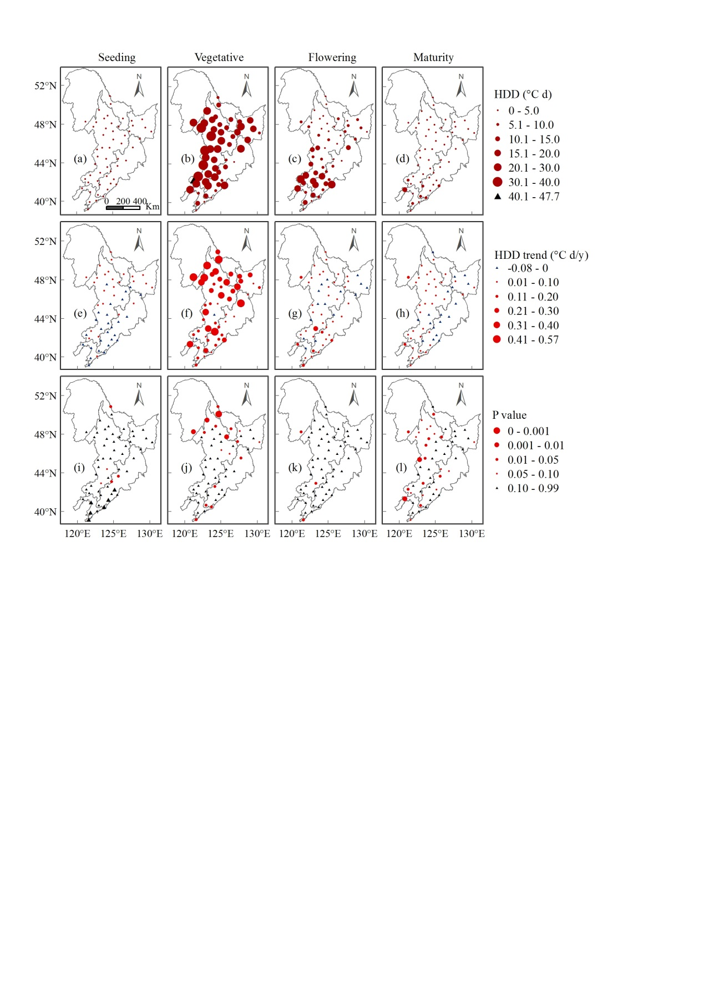

**Fig.2S.** Spatial variation of (a-d) heat degree days (HDD), (e-h) HDD trends and (i-l) the correlations between HDD and year in different maize growth phases during 1961 to 2010 across NFR. The blue triangles show the decreasing trend and the red points show the increasing (e-h). The black triangles show that the correlation between effective rainfall and year is not significant, while different size of red points indicates the level of significance (i-l).