SUPPORT INFORMATION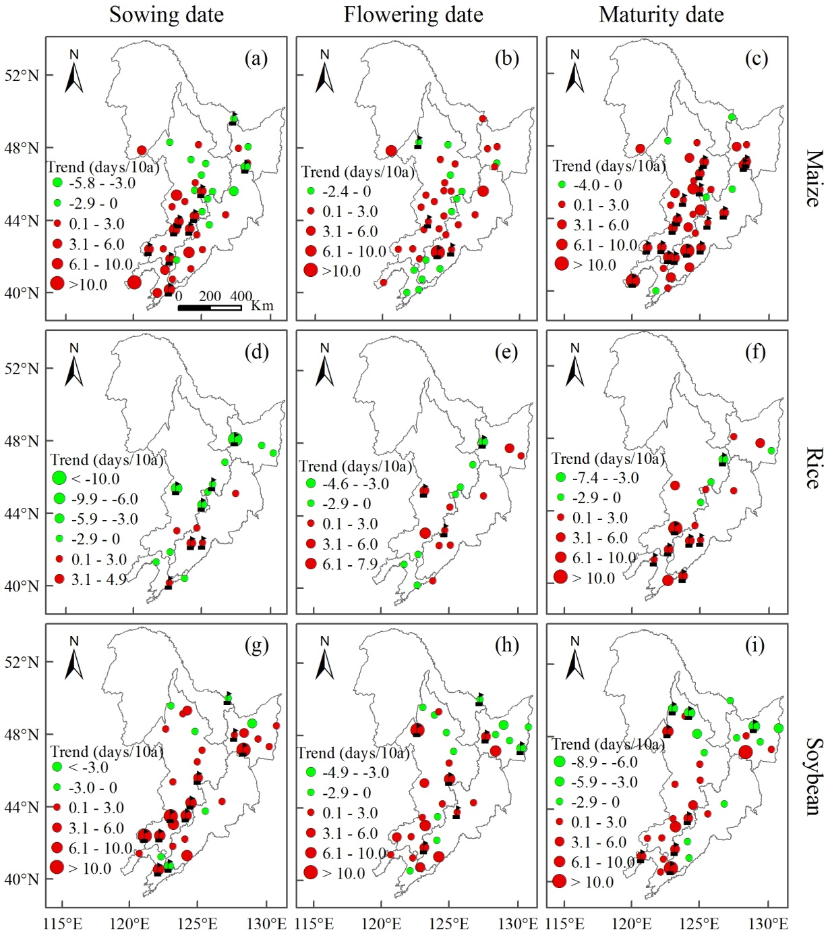
Fig. 1S Temporal trends of dates of sowing, flowering and maturity for maize, rice and soybean in NFR over the period of 1981 to 2010.

Fig. 2S Mean and temporal trends of dates of sowing, flowering and maturity for wheat in NFR over the period of 1981 to 2010.

Fig. 3S Spatial variation of average aridity in the pre-flowering, flowering and post-flowering phases for each crop during 1961 and 2010.

Fig. 4S Spatial variation of average HDD in the pre-flowering, flowering and post-flowering phases for each crop during 1961 and 2010.
Table 1S
The variance inflation factor (VIF) for the climate factors, comprising minimum temperature, radiation, aridity and heat degree days included in each mixed model. The subscript “pre” represents the pre-flowering, “flow” represents the flowering and “post” represents the post-flowering phase.
 | Maize model | Rice model | Soybean model | Wheat model
 | VIF value | VIF value | VIF value | VIF value
Year | 1.85 | 1.63 | 1.38 | 1.60
Tmin_{pre} | 2.10 | 1.92 | 3.32 | 4.63
Tmin_{flow} | 3.21 | 2.77 | 3.87 | 5.60
Tmin_{post} | 2.81 | 1.93 | 2.47 | 5.31
Radiation_{pre} | 1.85 | 1.97 | 1.92 | 2.21
Radiation_{flow} | 1.81 | 1.98 | 2.42 | 2.67
Radiation_{post} | 1.85 | 1.67 | 1.76 | 2.43
Aridity_{pre} | 2.04 | 2.03 | 2.14 | 2.69
Aridity_{flow} | 6.82 | 5.11 | 7.31 | 12.49
Aridity_{post} | 1.84 | 1.81 | 2.30 | 2.60
Aridity_{pre*} Aridity_{flow} | 6.51 | 4.43 | 7.96 | 13.76
Aridity_{flow*} Aridity_{post} | 2.09 | 2.41 | 2.41 | 2.98
HDD_{pre} | 1.82 | 1.65 | 1.84 | 2.22
HDD_{flow} | 2.51 | 2.16 | 2.87 | 4.58
HDD_{post} | 1.55 | 1.46 | 1.60 | 4.56

Table 2S
The standard error of parameter estimates in the mixed model of crop yield dependent on minimum temperature, radiation, aridity and HDD in the pre-flowering, flowering and post-flowering phases during 1961 and 2010. The subscript “pre” represents the pre-flowering, “flow” represents the flowering and “post” represents the post-flowering phase. The interactions of aridity were measured in the mixed model.
 | Maize  (kg/ha) | Rice  (kg/ha) | Soybean  (kg/ha) | Wheat  (kg/ha)
Intercept | 1121.9 | 1096.0 | 425.5 | 663.1
Year | 11.7 | 11.6 | 4.8 | 5.5
Tmin_{pre} (°C) | 40.9 | 42.0 | 14.7 | 21.6
Tmin_{flow} (°C) | 31.4 | 28.3 | 13.3 | 22.5
Tmin_{post} (°C) | 32.4 | 28.9 | 16.2 | 24.4
Radiation_{pre} (MJ/m²/d) | 31.1 | 32.9 | 11.3 | 21.4
Radiation_{flow} (MJ/m²/d) | 17.2 | 18.8 | 7.5 | 13.1
Radiation_{post} (MJ/m²/d) | 31.2 | 28.2 | 13.2 | 13.7
Aridity_{pre} | 189.5 | 185.5 | 71.0 | 146.6
Aridity_{flow} | 311.4 | 224.5 | 106.9 | 197.6
Aridity_{post} | 160.6 | 127.0 | 88.8 | 113.4
Aridity_{pre*} Aridity_{flow} | 584.4 | 477.0 | 182.9 | 309.0
Aridity_{flow*} Aridity_{post} | 507.4 | 363.7 | 207.2 | 244.0
HDD_{pre} (°C d) | 2.3 | 1.70 | 1.21 | 1.1
HDD_{flow} (°C d) | 5.1 | 4.87 | 1.73 | 1.6
HDD_{post} (°C d) | 4.8 | 9.15 | 1.43 | 1.7

