Manuscript title: Environmental impacts of the pork supply chain with regard to farm performance

SUPPORTING INFORMATION
Data inventory of the pork production system in Northern Germany
The data inventory necessary for the LCA of pork production is presented in the following. The base scenario represented the average pork production in the north of Germany in the marketing year 2010/2011. The data presented was described in Reckmann et al. (2013) in detail. The pig production at farm level was considered as ‘landless’, as described in Nguyen et al. (2011). Therefore, feed and other resources were imported which reflected common practice for conventional pig farms.
Life cycle inventory: crop and feed production
The data needed for the life cycle inventory of feed production were provided by a feed factory in Northern Germany, reflecting the production process in 2009. The data inventory of feed is partly listed in Table S1, per 1000 kg live weight.
Six different feed compositions were used: feed for lactating and gestating sows, piglet feed and three finisher feeds. The protein content of the feed was 14 % for gestating sows, 17 % for lactating sows and 17.5 % for weaned piglets. The finishing feeds were characterized by differing protein contents of 17.2 %, 16.5 % and 15.5 %. The main components of typical conventional feed mixtures were wheat, barley, soybean meal and feed supplements (e.g. calcium carbonate and lysine), of which the wheat and barley were mainly produced in Germany. We assumed a distance between the field in which the crop was grown and the feed company to be 100 km on average. The distance between the feed factory and the pig farm was estimated at 97 km. According to statistical data, the soy was imported from Brazil (Faostat 2011). This resulted in a shipping distance of 9700 km from Brazil to Rotterdam harbour in the Netherlands. The following transport by lorry to the feed factory in Germany was 412 km.
The inventory of feed encompassed the crop cultivation, including use of fertilizers, fossil-fuels and other resources. Data of resources used and emission data due to the transformation of crop products into feed ingredients as well as the production of feed (e.g. electricity, heat and water consumption) were also supplied by the feed company. Additional data were included in databases of the software used, i.e. SimaPro 7.3.3 (Pré Consultants 2009).
Life cycle inventory: pig production system
We used the most recent data available for average pig production in Northern Germany, mainly from the marketing year 2010/2011 (SSB 2011). Main performance parameters are highlighted in Table S2. The pig housing encompassed all life stages of the pig, i.e. sow, weaner (8 – 30 kg) and finisher (30 – 120 kg).
The data inventory of the pig production is listed in Table S3, related to the production of 1000 kg live weight at the farm gate. The inventory started with the calculation of the amount of feed needed to raise the pigs. The housing of the animals consumed electricity for light, ventilation, feeding etc., heat for piglets and finisher pigs as well as water for animals and cleaning. Additionally, the animals needed to be transported between the different housing stages. Therefore, we assumed that piglets were transported 60 km from the piglet production to the weaning. The distance to the finisher stable was 32 km. The carcasses of lost animals also had to be disposed (40 km).
In all housing stages, pigs produced certain amounts of manure. A scheme of the manure management factors included in this study is illustrated in Fig. S2. After excretion by the animals, the manure was first stored in the pit beneath the slats for around one month. After this period, it was pumped to an external storage tank outside the stable, where the manure developed a natural crust. This natural crust regulated the emission of methane and other greenhouse gases. German regulations prescribe an outside storage duration of six months before the slurry is ready for field application. The manure can then be used to replace synthetic fertilizers for the cultivation of crops. To be applied to the field, the manure in this study first needed to be transported to the field. The average distance was 10 km. The energy needed to spread the manure was 21 MJ per tonne slurry ex-storage, relating to Dalgaard et al. (2001a). The field application of manure had a dual effect. The substitution of synthetic fertilizer was regarded as a positive effect since it avoided the production of fertilizers as well as the related resource use (e.g. 0.4 MJ per kg fertilizer N; Dalgaard et al. 2001) and emissions. All impacts related to the avoided fertilizer use were deducted from the system. On the other hand, the spreading of manure also produced emissions, which would be regarded as a negative effect. Since pig manure cannot be used as efficiently as synthetic fertilizer by the plants, the substitution rate of N in manure was assumed to be 75 % (Nguyen et al. 2011). In contrast, the substitution rate of P in the manure was 97 % (Dalgaard et al. 2006), whereas K in manure would substitute 100 % of synthetic K fertilizer (Sommer et al. 2008). N2O, nitrate and ammonia were the most harmful substances from manure of the pollutants emitted. The emission of ammonia arose out of the N in the manure, which could be easily volatised in in-house and outside storage. Phosphate was the only P substance affecting the environment. It was considered that 3 % of the P in the manure was leached as phosphate. All environmental impacts related to manure management, including in-house storage, outside storage and field application, were allocated to the pork production. The calculations related to manure characteristics were based on those described in Nguyen et al. (2011).
Life cycle inventory: slaughter process
At the end of the fattening period, pigs were transported to the slaughterhouse. The final product was pork as slaughter weight. Primary slaughterhouse data were supplied by a slaughterhouse in Northern Germany for the production in 2008. Inventory data are presented in Table S4. In Germany, pigs are slaughtered at a live weight of 120 kg, resulting in a slaughter weight of about 97 kg. The slaughtering process consumed heat, electricity, water and transportation while producing emissions to air and water. The transport distance from the farm to the slaughterhouse was estimated at 350 km (Dreier 2012). It was assumed that the non-eatable parts of the pigs as well as the manure produced in the slaughterhouse were disposed as waste.
References
AEL. Elektroenergiebedarf in der Milchvieh- und Schweinehaltung. Arbeitsgemeinschaft für Elektrizitätsanwendung in der Landwirtschaft e.V.
Dalgaard, R., Halberg, N., Kristensen, I. S. & Larsen, I. (2006). Modelling representative and coherent Danish farm types based on farm accountancy data for use in environmental assessments. Agriculture, Ecosystems & Environment 117(4), 223-237.
Dalgaard, R., Halberg, N. & Porter, J. R. (2001a). A model for fossil energy use in Danish agriculture used to compare organic and conventional farming. Agriculture, Ecosystems & Environment 87(1), 54-65.
Dalgaard, T., Halberg, N. & Porter, J. R. (2001b). A model for fossil energy use in Danish agriculture used to compare organic and conventional farming. Agriculture, Ecosystems & Environment 87(1), 51-65.
Dreier, C. (2012). Untersuchung zu den Schlachtschweinetransporten aus dem Raum Norddeutschland in den Jahren 2005 bis 2011. Bachelor Thesis, Chritian-Albrechts University, Kiel.
EC (2003). Reference Document on Best Available Techniques for Intensive Rearing of Poultry and Pigs. In Integrated Pollution Prevention and Control (IPPC): European Commission.
FAOSTAT (2011). Food and Agriculture Organization of the United Nations. http://faostat.fao.org.
IPCC (2006). Guidelines for National Greenhouse Gas Inventories. Japan: IGES.
KTBL (2005). Faustzahlen für die Landwirtschaft. (Ed Kuratorium für Technik und Bauwesen in der Landwirtschaft e. V. (KTBL)), Darmstadt.
Nguyen, T. L. T., Hermansen, J. E. & Mogensen, L. (2011). Environmental assessment of Danish pork. Aarhus, Denmark: Aarhus University.
Pré Consultants (2009). Sima Pro.
Reckmann, K., Traulsen, I. & Krieter, J. (2013). Life Cycle Assessment of pork production: a data inventory for the case of Germany. Livestock Science 157, 586-596.
Rigolot, C., Espagnol, S., Pomar, C. & Dourmad, J. Y. (2010). Modelling of manure production by pigs and NH3, N2O and CH4 emissions. Part I: animal excretion and enteric CH4, effect of feeding and performance. animal 4, 1401-1412.
Sommer, S. G., Maahn, M., Poulsen, H. D., Hjorth, M. & Sehested, J. (2008). Interactions between phosphorus feeding strategies for pigs and dairy cows and separation efficiency of slurry. Environmental Technology 29, 75-80.
SSB (2011). Schweinereport 2011. Schweinespezialberatung Schleswig-Holstein e.V. und Landwirtschaftskammer Schleswig-Holstein.

Table S1. Feed components and main feed ingredients of the different feed compositions used in the various stages of pig housing.

Feed composition | Gestating sows | Lactating sows | Weaning pigs | 1st phase | Finisher  2nd phase | 3rd phase
Feed components
Crude protein [%] | 13.8 | 16.8 | 17.5 | 17.2 | 16.5 | 15.5
Lysine [%] | 0.7 | 1.0 | 1.3 | 1.2 | 1.0 | 0.9
Crude fat [%] | 2.4 | 2.7 | 4.0 | 4.5 | 3.5 | 2.5
Crude fibre [%] | 7.0 | 4.8 | 3.2 | 3.0 | 3.5 | 4.5
Metabolisable energy [MJ] | 11.8 | 13.0 | 13.8 | 13.6 | 13.2 | 12.8
Feed ingredients
Wheat [%] | 19.1 | 33.0 | 40.0 | 56.7 | 51.8 | 33.6
Barley [%] | 40.0 | 35.0 | 19.6 | 10.0 | 10.0 | 20.0
Rye [%] | 0 | 0 | 0 | 3.0 | 10.0 | 10.0
Soybean meal [%] | 3.0 | 17.0 | 17.5 | 12.4 | 5.5 | 1.7
Wheat bran [%] | 18.0 | 4.0 | 0 | 0 | 3.0 | 3.0

Table S2. Main performance parameters of the average pig production in 2010/2011.
 | Parameter | Value | Unit
Piglet production | No. of sows per farm | 240 | pcs.
 | Replacement rate  No. of live born piglets per sow and year | 47  31.8 | %  pcs.
 | No. of weaned piglets per sow and year  No. of litters per sow and year | 27.2  2.3 | pcs.  pcs.
 | Piglet losses | 14.6 | %
Weaning | Daily weight gain  Piglet losses | 460  1.5 | g  %
Finishing | No. of fattening pigs per farm  Final fattening weight  Carcass yield  Daily weight gain | 1354  120  79.0  788 | pcs.  kg  %  g
 | Feed conversion ratio 1: | 2.87 | kg
 | Lean-meat content | 56.6 | %
 | Animal losses | 3.0 | %

In- / Output | Unit | Amount | Data sources,  adapted or directly taken from
Feed
Wheat | kg | 1090
Barley | kg | 440
Rye | kg | 161 | Feed company
Soybean meal | kg | 188 | and extension service
Others | kg | 648
Energy and transports
Heat (oil) | kWh | 130.2 | (KTBL 2005)
Electricity mix | kWh | 117.6 | (KTBL 2005) & (AEL)
Transport
Ship | tkm | 3375 | Feed company
Truck 28 t | tkm | 868 | Various sources
Tractor and trailer | tkm | 108 | Farmers
Water (tap) | m³ | 353 | (EC 2003)
Farm traction | MJ | 206 | (Dalgaard et al. 2001b)
Emissions to air
Methane | kg | 26.7 | (Rigolot et al. 2010) & (IPCC 2006)
Dinitrogen monoxide | kg | 1.0 | (IPCC 2006)
Nitrogen dioxide | kg | -2.4 | See Nguyen et al. 2011
Ammonia | kg | 20.7
Emissions to water
Nitrate | kg | 1.2 | Nutrient balance
Phosphate | kg | 0.5
Avoided fertilizer production
N fertilizer | kg | 49 | (Nguyen et al. 2011)
P fertilizer | kg | 13 | (Dalgaard et al. 2006)
K fertilizer | kg | 12 | (Sommer et al. 2008)
Table S3. Data inventory per 1000 kg pig live weight at farm gate.
Table S4. Data inventory from a slaughterhouse, representing the slaughter process in the north of Germany in 2008.
 | Unit | Amount
Inputs
1 living pig | kg | 119.9
Electricity mix | kWh | 26.8
Water (tap) | m³ | 0.4
Diesel | kg | 0.8
Outputs
Pork | kg | 94.7
Carbon monoxide | g | 0.3
Carbon dioxide | g | 4537
Nitrogen oxides | g | 3.0
Nitrogen dioxide | g | 0.08
Methane | g | 0.09
Waste (-water) treatment
BOD5 * | g | 94.7
COD † | g | 2462
Nitrogen | g | 322
Phosphorus | g | 28.4
Biodegradable waste | kg | 0.4
*BOD5: Biochemical oxygen demand
†COD: Chemical oxygen demand
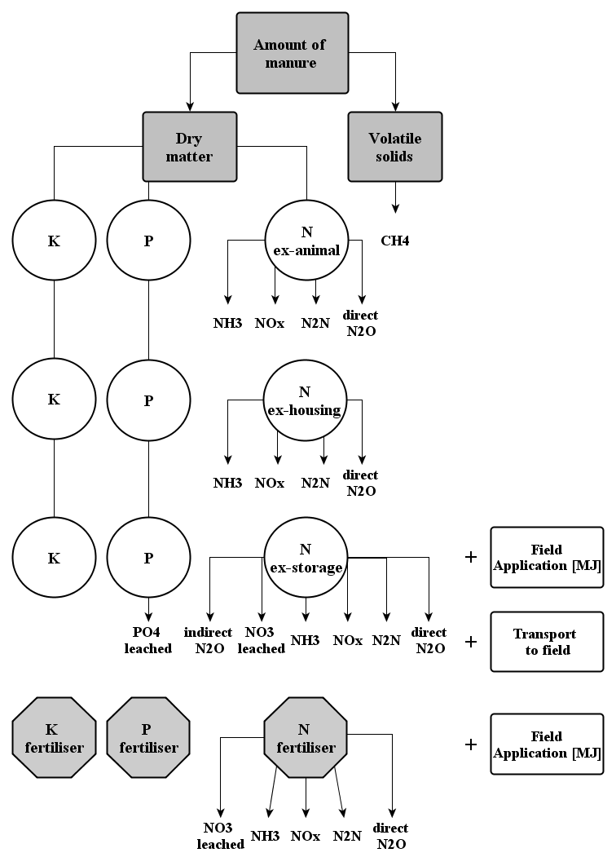
Figure S1. Simplified scheme of the calculation approach for manure management, including emissions and transports (Reckmann et al. 2013).

