Online Appendix for “The Collapse of State Power, the Cluniac Reform Movement, and the Origins of Urban Self-Government in Medieval Europe”

Contents
Description of Data 2
Robustness Check for Difference-in-Difference Estimates 6
Robustness Test Using Alternative Dataset 7
IV as Difference-in-Difference 8
Falsification Test for IV Analysis 9
Bishops and Urban Self-government 10
Ruling out Alternative Explanations 11
References 15

Description of Data
Our dataset contains 643 European towns/cities in the period from 800 and 1800. Figure A1 shows the 383 towns that achieved urban self-government as well as when they did so.

Figure A1: Urban Self-Government
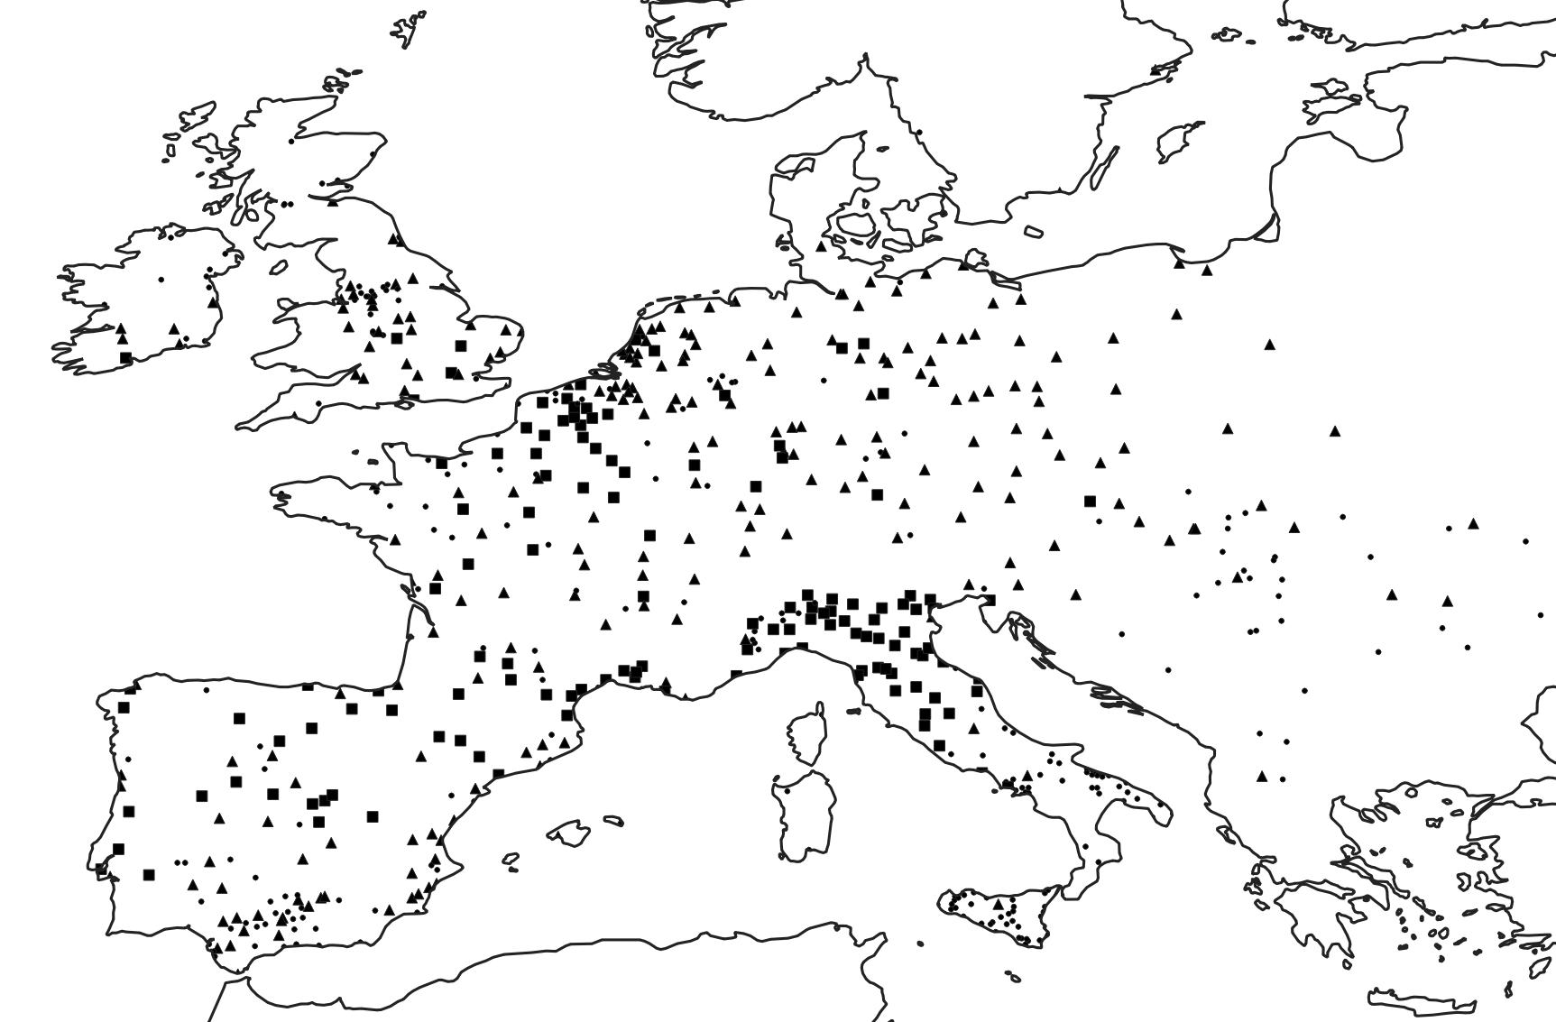
Note: Circles are towns that never achieve self-government. Squares are towns that achieve self-government before 1200. Triangles are towns that achieve self-government after 1200.

All control variables included in the difference-in-difference models are based on Bosker et al. (2013), which includes European towns that have 10,000 inhabitants at some point between 800 and 1800. As population data is missing for parts of the sample, we consider cities with missing data to have a population below 5,000, based on the intuition that larger cities are less likely to miss data. In our difference-in-difference sample, the logged town size variable has a mean of 0.97 and a standard deviation of 1.39. To get an overview of the principal urban centers in AD 1000, we have plotted the towns in our sample, scaled by population size, in Figure A2.

Figure A2: Town Size in AD 1000
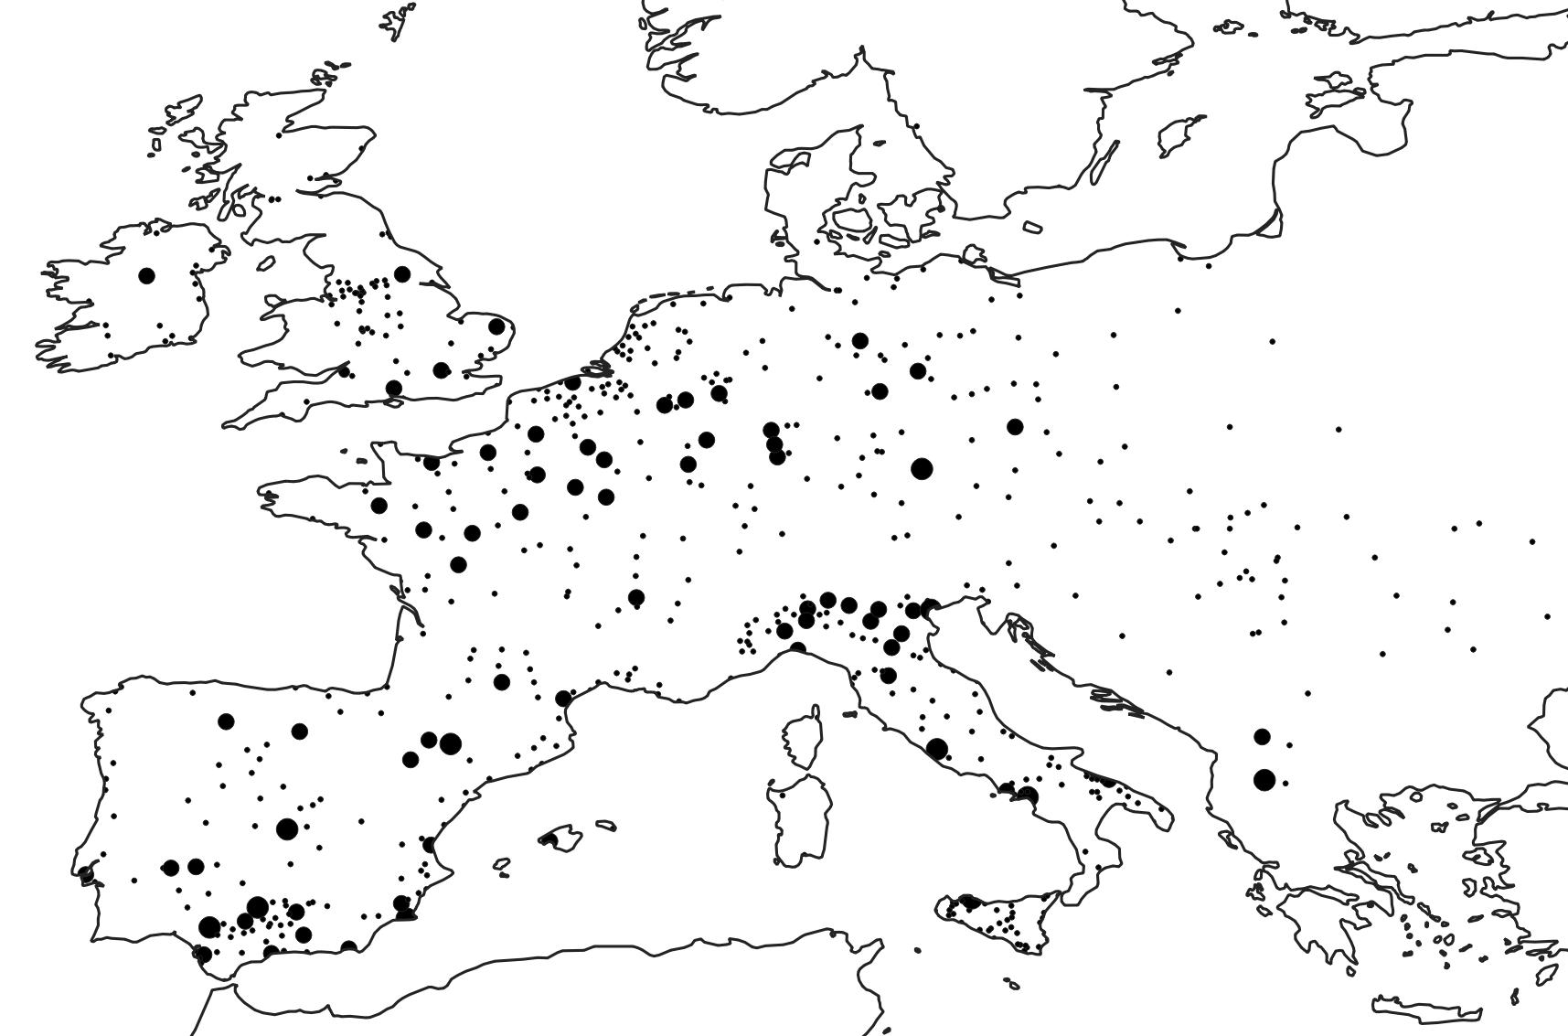
Note: Circle size denotes town size. Towns with a bigger population have a larger circle.

A total of 156 of the 643 towns in the sample have a bishop in AD 1000. The average proportion of town-years with a bishop in the difference-in-difference sample is 0.36, and the standard deviation of the variable is 0.48. Only 14 towns can be considered capitals, i.e. administrative centers of a larger realm, in AD 1000. This variable has a mean of 0.03 and a standard deviation of 0.18. In all, 11 towns were attacked in the tenth century, and the variable which measures the number of times a town was attacked by a foreign force in the proceeding century has a mean of 0.028 and standard deviation of 0.19. Only one university was established in AD 1000, but they become considerably more numerous over time. Consequently, this variable, which is equal to 1 if a town has a university in a given century, has a mean of 0.056 and a standard deviation of 0.23 in the full sample. Finally, we include an indicator for the presence of a realm-level parliament, which has a mean of 0.34 and a standard deviation of 0.47. Additional descriptive statistics for all control variables used in the main models are shown in Table A0 below.

Table A0: Descriptive Statistics for control variables
Variable | Mean | Standard deviation | Min | Max
Bishop | 0.360 | 0.480 | 0 | 1
Capital | 0.032 | 0.177 | 0 | 1
Attacked | 0.028 | 0.190 | 0 | 4
Ln(pop. size) | 0.973 | 1.390 | 0 | 6.855
University | 0.056 | 0.230 | 0 | 1
Realm-level parliament | 0.339 | 0.473 | 0 | 1
Note: 7073 observations

As described in the paper, the Peace of God councils of Languedoc were an important vehicle for spreading the Cluniac reform movement. Table A1 lists the peace councils reported by Cowdrey (1970). These data show two things. First, that the peace councils began by the end of the tenth century and continued up until the end of the eleventh century, which as we describe in the paper is the period where Cluniac influence ran highest. Second, that the peace movement was confined to West Francia for most of this period. It was much slower to make headway in the Roman Empire of the German Nation because monarchs here were strong enough to retain the responsibility of enforcing peace (Cowdrey 1970, 63-64; see also Jordan 2001; Bisson 2009, 220-21). Only at the very end of the period do we have peace councils in German cities (Cologne, 1084; Mainz, 1085).

Table A1: Peace of God Councils
Le Puy 975
Charroux 989
Narbonne 990
Le Puy 990
Limoges 994
Poitiers 1011
Verdun-sur-le-Doubs 1019
Anse 1025
Charroux 1027
Toulouges 1027
Limoges 1028
Poitiers 1029
Bourges 1031
Caen 1047
Narbonne 1054
Lillebonne 1080
Liege 1082
Cologne 1084
Mainz 1085
Rouen 1096
Note: Based on Cowdrey (1970). Cowdrey dates the first Charroux peace council to 990; we stick to the 989 date provided by Moore (2000, 102) and used in the research note.

Robustness Check for Difference-in-Difference Estimates
 | Table A2: Estimates Accounting for Possible Differential Trends
 |  | (1) | (2) | (3) | (4)
Distance x Post 1000 |  | -0.033*** | -0.022*** | -0.019*** | -0.028***
 |  | (0.004) | (0.004) | (0.004) | (0.004)
Town and century FE |  | Yes | Yes | Yes | Yes
Controls |  | Yes | Yes | Yes | Yes
Controls x Century |  | Yes | Yes | Yes | Yes
Country x Century |  | Yes | No | No | No
Realm AD 1000 x Century |  | No | Yes | No | No
Town x Century |  | No | No | Yes | No
Propensity to adapt new inst. x Century |  | No | No | No | Yes
N |  | 7073 | 7073 | 7073 | 7073
Standard errors clustered by town in parentheses
* p < 0.05, ** p < 0.01, *** p < 0.001

Table A2 shows that the negative relationship between distance to Cluniac monasteries and self-government remains even if we allow towns a differential trend in a variety of ways. In Figure A4 below, we plot the distribution of the predicted propensity to adopt new institutions. It shows significant variation between towns.

Figure A3: Predicted Probability of Introducing a Council Based on Tenth-Century Developments
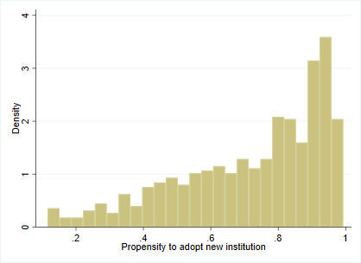
Our sample also contains a few towns under Muslim control that were located relatively far from the Cluniac monasteries. These are unlikely to have been affected by the reform movement. To ensure our results are not driven by these towns, we replicate Model 4 from Table 1 excluding all non-Christian towns (based on the muslim variable from Bosker et al. 2012). The coefficient for our interaction is -0.043*** (SE of 0.004), suggesting that our findings are not dependent on the inclusion of these towns.

Robustness Test Using Alternative Dataset
To ensure that our results are not driven by measurement error in the commune variable from Bosker et al. (2013), we employ an alternative indicator for urban self-government, namely the autonomy measure from Stasavage (2014, 342), which covers 169 towns in Western Europe. As in our other models, the main independent variable is equal to 1 if a town achieves autonomy after the tenth century, and 0 otherwise.

In the baseline model, we control for latitude, longitude, sea and river access (data from Patterson and Kelso 2019; EEA 2018), being on a Roman road (data from McCormick et al. 2013), elevation and terrain ruggedness (data from EEA 2019), soil quality (data from Zabel et al. 2014), and include dummies for being located within each of the three Carolingian successor kingdoms after its partition, based on data from Lienhard (2018). In an additional model, we control for tenth-century logged population size and bishop presence. Table A3 presents the results from the first and second stage. Mitigating worries about measurement error, the new estimates are similar in size to the ones based on the Bosker et al. (2013) dataset.
Table A3: IV Estimates Using Stasavage (2014)
 | (1) | (2) | (3) | (4)
Dependent variable in second stage | Council 1000-1800 | Council 1000-1800 | Council 1000-1200 | Council 1201-1800
Second stage
Distance to Cluniac monasteries | -0.0698** | -0.0558* | -0.0529* | -0.0053
 | (0.0231) | (0.0229) | (0.0254) | (0.0169)
First stage
Distance to Cluny | 0.7200*** | 0.7220*** | 0.7200*** | 0.7200***
 | (0.0502) | (0.0506) | (0.0502) | (0.0502)
F statistic | 206 | 204 | 206 | 206
Controls | Yes | Yes | Yes | Yes
Tenth-century developments | No | Yes | No | No
N | 169 | 169 | 169 | 169
Robust standard errors in parentheses
* p < 0.05, ** p < 0.01, *** p < 0.001

IV as Difference-in-Difference
To ensure that our IV results are not an artefact of the cross-sectional setup, we also present results from models that are similar to the ones reported in Table 1. Reassuringly, Table A4 shows that our IV approach returns estimates that are similar in size to the ones found using our difference-in-difference approach.
Table A4: IV Using a Dif-in-Dif Setup
 | (1) | (2) | (3)
Second stage
Distance x Post 1000 | -0.0402*** | -0.0401*** | -0.0421***
 | (0.0042) | (0.0040) | (0.0041)
First stage
Distance to Cluny x Post 1000 | 0.868*** | 0.870*** | 0.870***
 | (0.009) | (0.009) | (0.009)
F statistic | 10297 | 10267 | 10160
Town and century FE | Yes | Yes | Yes
Controls | No | Yes | Yes
Controls x century | No | No | Yes
N | 7073 | 7073 | 7073
Robust standard errors in parentheses
* p < 0.05, ** p < 0.01, *** p < 0.001

Falsification Test for the IV Analysis
In Table A5 below, we show that our instrument is uncorrelated with regime change that occurs after the Cluniac reform movement had ended (AD 1200). This lends additional credibility to our IV approach.

Table A5: Predicting Late Medieval Guild Revolts
 | (1) | (2) | (3)
Dependent variable | Guild revolt | Successful revolt | Failed revolt
Distance to Cluny | 0.0126 | 0.0050 | 0.0108
 | (0.0178) | (0.0162) | (0.0134)
Controls | Yes | Yes | Yes
N | 169 | 169 | 169
Robust standard errors in parentheses
* p < 0.05, ** p < 0.01, *** p < 0.001

Bishops and Urban Self-government
It follows from our argument that the reform movement was most important in sparking self-government where townsmen attempted to wrest power from unreformed lord-bishops, including towns such as Milan and Cambrai. To test this implication, and hence to further rule out confounders, we have coded a binary indicator measuring the presence of a bishop in 1000, based on the Catholic compendium of dioceses (Chow 2018). Our sample contains 156 episcopal towns and 487 non-episcopal towns. At the beginning of the eleventh-century, non-episcopal towns were ruled by secular lords, who were often appointed by monarchs, and episcopal towns were governed by their bishops, who acted as officials and had normally been appointed by monarchs (Southern 1970, 96; Berman 1983, 88-91; Oakley 2010, 165-173). Urban self-government came about when townsmen renounced their lay lord or lord-bishop and established a council of citizens, which took over the governing of the town (Wickham 2016, 147-151). In Table A6 we therefore present results from our main models where we interact the distance to Cluny with the presence of a bishop. As expected, we find that the effect of the Cluniac reform movement is more pronounced in episcopal towns, as (unreformed) bishops were the primary targets of the movement.

Table A6: Interaction with bishops
 | (1) | (2) | (3)
Model | Dif-in-dif | IV - Council 1000-1200 | IV- Council 1201-1800
Distance x post | -0.0344***
 | (0.0052)
Distance x post x bishop | -0.0249**
 | (0.0076)
Second stage
Distance to Cluniac monasteries |  | -0.0288** | -0.0126
 |  | (0.0093) | (0.0133)
Distance to Cluniac x bishop |  | -0.0318** | -0.0175
 |  | (0.0110) | (0.0134)
First stage
Kleibergen-Paap F statistic |  | 486 | 486
Town and century FE | Yes | NA | NA
Controls | Yes | Yes | Yes
Controls x century | Yes | NA | NA
N | 7073 | 643 | 643
Standard clustered on city in parentheses in model 1. Robust standard errors in parentheses in model 2-3; * p < 0.05, ** p < 0.01, *** p < 0.001

Ruling out Alternative Explanations
Even with the IV results, one might still worry that the empirical relationship we identify is driven by alternative factors that also changed considerable during the eleventh and twelfth centuries. Three worries seem most important. First, while we control for the presence of a university in a given town, universities also supplied nearby towns with administrators that were well-versed in Roman and Canon law, which might also have facilitated their urban development or the formalization of urban self-government (Cantoni and Yuchtman 2014). Second, while we control for urban population size – the most widely used proxy for pre-modern economic development (see e.g. Bosker et al. 2013; Stasavage 2014) – it might not adequately capture the multi-facetted development in trade and commercialization that European towns experienced during the high middle ages. Third, we do several things to account for the collapse of Carolingian realm and the subsequent rise of local lordship. First, we control for a town’s location within the partitioned parts of the old Carolingian realm (or if they never belonged to the Carolingians). Second, we account for the level of associated violence by controlling for the number of times a town was attacked in a century. Nonetheless, there might still be differences in the collapse of authority within the former Frankish realm we do not capture.
To check if the supply of university graduates are driving our results, we have therefore added a control for the distance to the nearest university town, as Cantoni and Yuchtman (2014, 846) show that distance is linearly related to the number of students a town sent to their nearest university.
To examine if differences in economic development that might not be captured by population size is influencing our findings, we use two additional indicators of development: First, regional fairs have been argued to appear in areas where trade proliferated and expanded (Epstein 1994, 475); we thus control for the distance to the nearest major fair in the period 900-1500 (based on McCormick et al. 2018). Second, we follow Bueno de Mesquita (2019) and use major trade routes as an indicator of economic activity. Specifically, we use data from the Old World Trade Routes Project (2005) to construct an indicator equal to 1 if a town is located on a major trade route in 1300, and 0 otherwise.
Finally, to further evaluate whether our findings are impacted by political fragmentation, we employ two additional measures. First, we rely on a geocoded dataset of European lords to construct two maps using spatial interpolation (Cummins 2017). The first shows the proportion of lords that died violently in each area between 800 and 1300. The second shows the average age of a lord in each area in the same period. Based on their location, we assign each town a value on these two proxies for “lord weakness”. The maps are shown in Figure A4 below. In areas where the collapse of authority were felt more acutely we should expect lords to die younger and be more likely to die a violent death. Second, we include measures for the size of the realm each town belongs to in 1000 and 1300, and the change in realm size between 1000 and 1300 (based on the Euratlas, Nüssli and Nüssli 2008). This serves to control for differences in the devolution of authority in the Central and Eastern Frankish realms in particular.

Figure A4: Lords’ lifespan and likelihood of dying a violent death, 800-1300
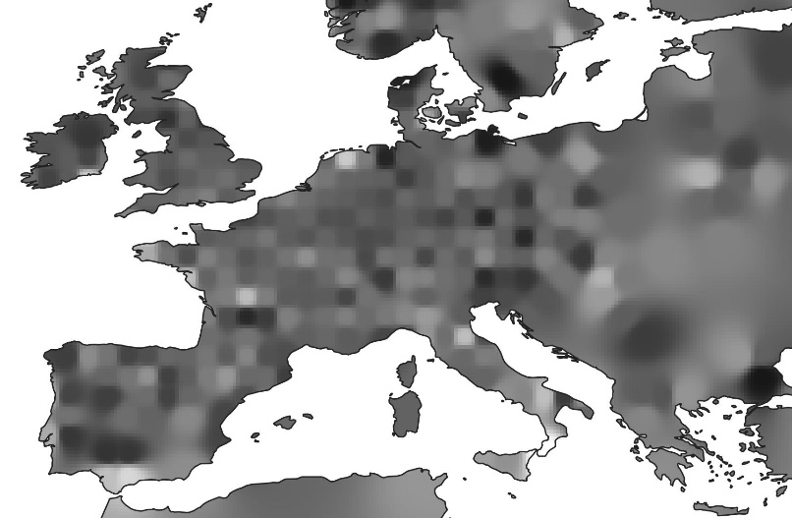 | 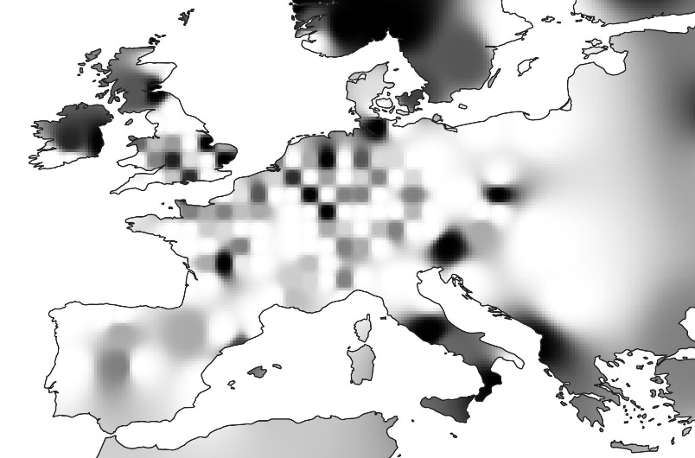
Lifespan: Darker areas indicate longer average lordly lifespan | Violence: Darker areas indicate a higher proportion of violent deaths

In Table A7, we present results from our main models where we include the above additional control variables. Across our different specifications, we find a robust negative relationship between proximity to a Cluniac monastery and the likelihood of attaining self-government. This suggests that our findings are not driven by innovations in education, development in trade, or the devolution of public power. Note that some of these control variables might induce post-treatment bias as they also measure developments that occur after the Cluniac reform movement (see e.g. Rosenbaum 1984).

Table A7: Ruling out alternative explanations
 | (1) | (2) | (3)
Model | Dif-in-dif | IV - Council 1000-1200 | IV- Council 1201-1800
Distance x post | -0.0253***
 | (0.0043)
Second stage
Distance to Cluniac monasteries |  | -0.0288* | 0.0009
 |  | (0.0123) | (0.0155)
First stage
Kleibergen-Paap F statistic |  | 1091 | 1091
Town and century FE | Yes | NA | NA
Controls | Yes | Yes | Yes
Controls x century | Yes | NA | NA
Add. controls | Yes | Yes | Yes
Add. controls x century | Yes | NA | NA
N | 7073 | 643 | 643
Standard clustered on city in parentheses in model 1. Robust standard errors in parentheses in model 2-3; * p < 0.05, ** p < 0.01, *** p < 0.001

References
Berman, Harold J. 1983. Law and Revolution: The Formation of the Western Legal Tradition. Cambridge: Harvard University Press.
Bisson, Thomas N. 2009. The Crisis of the Twelfth Century: Power, Lordship, and the Origins of European Government. Princeton: Princeton University Press.
Bosker, Maarten, Eltjo Buringh, and Jan Luiten van Zanden. 2013. “From Baghdad to London: unravelling urban development in Europe and the Arab world 800-1800.” Review of Economics and Statistics 95 (4):1418-1437.
Bueno de Mesquita, Bruce, and Ethan Bueno de Mesquita. 2019. “From Investiture to Worms: A Political Economy of European Development and the Rise of Secular Authority.” Working Paper. Available at: https://cpb-us-w2.wpmucdn.com/voices.uchicago.edu/dist/c/1708/files/2019/06/worms_2019_04_25.pdf
Cantoni, Davide, and Noam Yuchtman. 2014. “Medieval Universities, Legal Institutions, and the Commercial Revolution.” The Quarterly Journal of Economics, 129(2): 823-887.
Chow, Gabriel. 2018. Catholic Compendium of Dioceses. http://www.gcatholic.org.
Ciolek, T. Matthew. 2005. “The Old World Trade Routes Project.” Available at http://www.ciolek.com/OWTRAD/DATA/oddda.html
Cowdrey, Herbert Edward John. 1970. “The Peace and Truce of God in the Eleventh Century.” Past and Present 46 (1):42-67.
Cummins, Neil. 2017. “Lifespans of the European Elite, 800-1800.” Journal of Economic History, 77(2): 406-439.
EEA. 2018. “WISE Large Rivers and Lakes.” European Environment Agency. Accessed August 15 2018. Available at www.eea.europa.eu/data-and-maps/data/wise-large-rivers-and-large-lakes.
EEA. 2019. “1km x 1km Elevation Map of Europe.” European Environment Agency. Accessed March 4 2019. Available at www.eea.europa.eu/data-and-maps/data/digital-elevation-model-of-europe.
Epstein, Stephan R. 1994. “Regional Fairs, Institutional Innovation, and Economic Growth in Late Medieval Europe.” Economic History Review, 47(3): 459-482.
Jordan, William Chester. 2001. Europe in the High Middle Ages. London: Penguin.
Lienhard, Thomas. 2018. “Frankish Kingdoms in 843.” Accessed June 4 2019. Available at www.menestrel.fr.
McCormick, Michael, Guoping Huang, Giovanni Zambotti, and Jessica Lavash. 2013. “Roman Road Network (version 2008).” Harvard Dataverse. Available at https://doi.org/10.7910/DVN/TI0KAU.
McCormick, Michael, Eurydice Georganteli, and Alexander Moore, eds. 2018. “DARM The Digital Atlas of Roman and Medieval Civilization.” Accessed April 2 2019. Available at https://darmc.harvard.edu/maps.
Moore, R. I. 2000. The First European Revolution, c. 970-1215. Oxford: Blackwell.
Nüssli, Christos and Marc-Antoine Nüssli. 2008. “Georeferenced Historical Vector Data.” Euratlas. Online at euratlas.com
Oakley, Francis. 2010. Empty Bottles of Gentilism: Kingship and the Divine in Late Antiquity and the Early Middle Ages (to 1050). New Haven and London: Yale University Press.
Patterson, Tom, and Nathanial Kelso. 2019. “Coastline Vector.” Natural Earth. Available at https://www.naturalearthdata.com/downloads/50m-physical-vectors/.
Rosenbaum, Paul. 1984. “The Consequences of Adjustment for a Concomitant Variable That Has Been Affected by the Treatment.” Journal of the Royal Statistical Society. Series A. 147(5): 656-666.
Southern, Richard W. 1970. Western Society and the Church in the Middle Ages. New York: Penguin Books.
Stasavage, David. 2014. “Was Weber Right? The Role of Urban Autonomy in Europe’s Rise.” American Political Science Review 108 (2):337-354.
Wickham, Chris. 2016. Medieval Europe. New Haven: Yale University Press.
Zabel, Florian, Birgitta Putzenlechner, and Wolfram Mauser. 2014. “Global Agricultural Land Resources – A High Resolution Suitability Evaluation and Its Perspectives until 2100 under Climate Change Conditions.” PLOS ONE 9 (12):e114980.

Meaning that the town was governed by a body of members chosen among the citizenry, which had strong prerogatives in at least one of the following areas: taxes, judicial affairs and defense.
Note that after the collapse of imperial power in the Holy Roman Empire, the Euroatlas marks a large territory as “Small States”, this area is given the lowest observed realm size. 1300 is used as the end century, as this is when the former Central and Eastern Frankish realm splinter into many small lordships.

