The Determinants of Environmental Migrants’ Conflict Perception –Appendix
In order to ensure the robustness of our results, we changed a variety of model specifications and re-run the estimations. In the following, we briefly discuss these changes and corresponding results that further support our theory and results of the main text. These include:
- Appendix Table 1 re-estimates the core empirical models in the main text while including interactions of the environmental events variables with an item on political exclusion.
- Appendix Table 2 summarizes models that are based on a more constrained sample of rather inclusive states only.
- Appendix Table 3 focuses on individuals that only recently arrived at their new location of residence.
- Appendix Table 4 focuses on a heckman-type probit selection model on the decision to migrate and conflict perceptions.
- Appendix Table 5 omits all control covariates for the model estimation.
- Appendix Table 6 additionally incorporates two country-level covariates.
- Appendix Table 7 summarizes the main models while interacting the environmental events variables with political regime type.
- Appendix Table 8 summarizes the main models while interacting the environmental events variables with GDP per capita.
- Appendix Table 9 re-estimates the main models with logistic regression and country fixed effects.
The appendix concludes with an overview of the locations of the surveys, including maps (Figures A1-A5), and the questionnaire we used for our interviews. First, in the models presented above, we do not explicitly examine conditional effects capturing interactive relationships between the determinants of migration at different levels (micro, macro, and meso) as Hunter, Luna, and Norton describe these relationships as “additive.” We plan on investigating these conditional relationships more thoroughly in a subsequent project, although we conducted some preliminary analyses with an interaction of the environmental-event variables and an item on political exclusion. Specifically, Buhaug, Cederman, and Gleditsch report that the probability of conflict increases when a specific ethnic group is on average poorer than the country as a whole. In a related fashion, Cederman, Weidmann, and Gleditsch focus on horizontal inequalities and ethnic groups, and find that in highly unequal societies both affluent and poor groups relative to the national average are more likely to engage in conflict. In light of these studies, it seems plausible that ethnicity affects conflict and, in the first place, conflict perceptions. We control for this possibility in two ways.
On one hand, the country- and regional-level random intercepts capture these influences at the levels above the individual. This strategy is effective if all/most respondents do actually have the same ethnic background, which is largely given in our sample data, although some variation does exist in the countries as well. On the other hand, an alternative mechanism that leads to more conflictive perceptions could be that individuals are more conflict-prone and aggressive if there is an actor who is the “perpetrator of environmental degradation” – but the type of the environmental event may matter less. Hence, the theoretical mechanism behind conflict perceptions could simply be about “who is to blame.”
We decided to address this concern with data on ethnicity and ethnic exclusion. More specifically, our survey data include information on the ethnic group an individual belongs to. We combined this information with the Ethnic Power Relations (EPR) data set, which identifies all politically relevant ethnic groups and their access to state power in every country since 1946. Eventually, we are able to code whether an individual belongs to an ethnic group that is politically included or one that is excluded, i.e., when it is politically powerless, when group members are subject to active and intentional discrimination by the state, or when a group excludes itself from power (“separatist autonomy”). When incorporating this additional variable into our models and interacting it with the environmental-events variables, we can capture the mechanism that the grievance toward some actor to blame (i.e., the included group or the state) might either be more relevant than or moderate the effect of the environmental-events items. We re-estimated all models with this additional variable and its interactive specification. The corresponding results, which we summarize for the general conflict-perception variable in Table A1, show that while the political-exclusion variable is insignificant, our main finding that gradual, long-term environmental changes positively and significantly affects migrants’ conflict perceptions does hold. Moreover, the multiplicative terms are largely insignificant. This lends little support to the claim that a conditional effect does exist. However, other interactive relationships may be given in our data set and we seek to address this in the future.
__________
Table A1 here
__________
Related to this, it might be possible that people move from a relatively “benign environment” to a more hostile one (or vice versa), and that this affects conflict perceptions in turn. Given the information that our survey offers and the data from the EPR, we obtained the variable “size of the excluded population in a country” from the EPR data (in the year 2012). After having determined the mean value of this item in our sample (0.172), we dropped those countries that had excluded populations above that average value. Ultimately, we thus constrain our data to a sample of countries, which are relatively inclusive throughout their societies, their sub-regions, districts, and towns. Hence, the degree of political inclusion in that constrained sample is fairly constant then, since we dropped those cases in which people could move from a more inclusive area to a more excluded one (or vice versa). Afterwards, we re-estimated our models with this constrained, but overall relatively inclusive sample of individuals and countries. The main result for Gradual, Long-Term Events should hold with this sample as well (i.e., a sample that then basically captures “same-level-of-inclusion” within-country migration). Again, as demonstrated in Table A2, our core result remains robust as the positive and statistically significant effect of gradual, long-term events is still given.
__________
Table A2 here
__________
Third, and coming back to the main text, we repeated our analysis focusing on migrants that arrived rather shortly to their new location. This allows us to rule out a strong influence at the “new home” on conflict perceptions. To this end, we use a variable that measures how long a migrant has lived in his/her new location. We only include those migrants that are part of the lower 10 percent of that variables’ distribution (274 migrants; average duration spent in new location=0.986 years). The results (Table A3) show that Gradual, Long-Term Events remains to be positively signed and statistically significant, which increases the confidence in the validity of our findings and argument.
__________
Table A3 here
__________
Fourth, migrants are not a random sample of individuals. In the models above, we partly control for this circumstance with the Economic Reason item and other controls that may well have affected an individuals’ decision to migrate in the first place. However, the reasons to migrate may be more multi-faceted and there could also be unobserved determinants affecting an individual’s decision to stay or move. If these variables related the migration decision also affect a migrant’s perception of conflict, we may either over- or underestimate the effect of our core explanatory variables. In order to address this issue thoroughly, we created a data set comprising both migrants and non-migrants (i.e., individuals who decided to stay in the migrant’s previous location). Afterwards, we relied on a Heckman-type selection model for binary data (Heckman Probit Model), for which we had to specify a selection variable and a binary outcome.
The binary outcome variable is one of those dependent variables used for the core models above, while we rely on a binary migration variable (1=migrated; 0=not migrated) to capture sample selection. As Heckman-type models require that there must be at least one variable in the selection equation that does not appear in the outcome equation, we only include our core variables of interest (Sudden, Short-Term Events and Gradual, Long-Term Events) as well as any of the statistically significant controls from the main text’s Tables 2-6 in the outcome equation. For example, Female does not exert a statistically significant impact in Table 2, but in Models 5-8 (Table 3 in the main text). Hence, for the selection models based on Table 2, we only include Female in the selection equation, while this item is included in both the selection and outcome equation of those selection models that are based on the main article’s Table 3. Eventually, this ensures that the model is identified. That said, when estimating these selection models, our core results are not affected by this change in the estimation strategy; moreover, the coefficient capturing the correlation in the two equations’ error terms is mainly insignificant across estimations, suggesting that sample selection is of minor importance in our context.
__________
Table A4 here
__________
Fifth, one major concern could be that the environmental-events estimates are affected by the inclusion or exclusion of potentially endogenous factors. In fact, Clarke shows that including control variables in models can actually increase the bias. However, when omitting all control covariates in our models and only including the environmental-events items as explanatory variables, the effect of gradual, long-term and sudden, short-term events, respectively, does virtually not change across the regressions (Table A5). We are therefore confident that the effect of gradual, long-term events is indeed unbiased.
__________
Table A5 here
__________
Sixth, by incorporating country-level and regional-level random intercepts, we control for the fact that we study internal migration in five country contexts as well as in diverse regional settings. However, one could model these different contexts more directly by including relevant factors that might affect migration patterns within countries. Two factors seem most relevant from this perspective: a nation’s political system and a country’s economic development. Both influences could affect a country’s capability to react to specific environmental events and, thus, migrants’ conflict perceptions. We thus considered a variable on a country’s political system, measured by the polity2 variable from the Polity IV data, and GDP per capita in current US Dollars as taken from the World Bank Development Indicators. For both items, we use data from 2012 to ensure that they are measured before the surveys were conducted. When incorporating these country-level controls, the results show that basically none of them has a significant effect either for the aggregated or the disaggregated dependent variables (Table A6). Finally, we also examined the possibility of interactive effects, mirroring the rationale behind Table A1 to some extent. As demonstrated in Tables A7-A8, however, this does also not question our main finding.
Finally, it has been suggested to re-estimate our main models with “regular” logistic regression and country fixed effects. Such an approach could indicate where we see a stronger link at a country level, and this might be more accurately than the multi-level setup in the main text that merely controls for country-level variance and the robustness check above that incorporates country-level covariates (democracy and income). Table A9 summarizes our findings for this last robustness check (based on Model 1 of the main text; the findings are qualitatively the same for all other models). Furthermore, while logistic regression models with country dummies are inconsistent if the number of observations per country is not large enough, the results are identical if we employ a conditional logistic regression instead.
__________
Table A9 here
__________
On one hand, the main conclusion of our research pertaining to gradual, long-term environmental events is unchanged. On the other hand, all fixed effects are positively signed and statistically significant, and this result in Table A9 is representative of all other models discussed above when including fixed effects there. This emphasizes that these countries differ from the baseline, i.e., Nicaragua, in important ways. It may thus be an effort worth making in future research to focus on that country as the likelihood of conflict perceptions seems to be systematically lower there than elsewhere.

Table A1. General Conflict Perception Multilevel Logistic Regression Models

 | Model 1  (Conflict Perception) | Model 2  (Conflict Perception) | Model 3  (Conflict Perception) | Model 4  (Conflict Perception)
Sudden, Short-Term Events | 0.236 | 0.186 | 0.219 | 0.213
 | (0.183) | (0.205) | (0.183) | (0.184)
Gradual, Long-Term Events | 0.434 | 0.319 | 0.450 | 0.451
 | (0.146)*** | (0.178)* | (0.146)*** | (0.147)***
Political Exclusion | 0.671 | 0.844 | 0.714 | 0.682
 | (0.651) | (0.666) | (0.650) | (0.655)
Sudden, Short-Term Events * Political Exclusion | -1.000 | -1.226 | -1.042 | -1.025
 | (0.692) | (0.731)* | (0.693) | (0.695)
Gradual, Long-Term Events * Political Exclusion | -0.263 | -0.552 | -0.192 | -0.190
 | (0.680) | (0.825) | (0.684) | (0.684)
Female | 0.034 | 0.019 | 0.008 | -0.005
 | (0.118) | (0.147) | (0.117) | (0.117)
Age | -0.002 | -0.004 | -0.009 | -0.008
 | (0.007) | (0.007) | (0.006) | (0.006)
Household Member Migrated | -0.214 | -0.152 | -0.203 | -0.192
 | (0.117)* | (0.143) | (0.116)* | (0.117)*
No Education | -0.659
 | (0.419)
Primary Education | -0.375
 | (0.212)*
Secondary Education | -0.319
 | (0.131)**
Poor Household |  | 0.194
 |  | (0.197)
Rich Household |  | -0.113
 |  | (0.224)
Economic Reason |  |  | 0.123
 |  |  | (0.147)
Civil Servant |  |  |  | 0.144
 |  |  |  | (0.239)
Business Sales |  |  |  | 0.005
 |  |  |  | (0.158)
Craft and Trade Workers |  |  |  | -0.208
 |  |  |  | (0.239)
Elementary Occupation |  |  |  | 0.147
 |  |  |  | (0.199)
Other Sources of Income |  |  |  | -0.287
 |  |  |  | (0.364)
Constant | -0.297 | -0.439 | -0.380 | -0.295
 | (0.315) | (0.378) | (0.333) | (0.331)
Country Variance | 0.057 | 0.136 | 0.089 | 0.086
 | (0.083) | (0.142) | (0.105) | (0.105)
District Variance | 0.177 | 0.115 | 0.178 | 0.182
 | (0.082) | (0.076) | (0.082) | (0.084)
Observations | 1,440 | 949 | 1,441 | 1,441
Number of Groups | 4 | 4 | 4 | 4
Log Likelihood | -929.041 | -625.565 | -932.749 | -931.719
Wald χ² | 23.58** | 9.10 | 17.09** | 19.01
Table entries are coefficients from multilevel logistic regression models with country level and district level random effects; standard errors in parentheses.

*** significant at 1%; ** significant at 5%; * significant at 10%.

Table A2. General Conflict Perception – Constrained Sample (More Inclusive States)

 | Model 5  (Conflict Perception) | Model 6  (Conflict Perception) | Model 7  (Conflict Perception) | Model 8  (Conflict Perception)
Sudden, Short-Term Events | 0.147 | -0.038 | 0.097 | 0.088
 | (0.211) | (0.244) | (0.211) | (0.211)
Gradual, Long-Term Events | 0.533 | 0.431 | 0.553 | 0.555
 | (0.153)*** | (0.189)** | (0.152)*** | (0.152)***
Female | 0.039 | 0.027 | 0.003 | -0.002
 | (0.129) | (0.172) | (0.128) | (0.129)
Age | -0.004 | -0.007 | -0.013 | -0.013
 | (0.008) | (0.009) | (0.008)* | (0.008)*
Household Member Migrated | -0.272 | -0.214 | -0.254 | -0.250
 | (0.130)** | (0.168) | (0.129)** | (0.130)*
No Education | -0.826
 | (0.452)*
Primary Education | -0.666
 | (0.247)***
Secondary Education | -0.444
 | (0.148)***
Poor Household |  | 0.414
 |  | (0.261)
Rich Household |  | -0.149
 |  | (0.233)
Economic Reason |  |  | -0.027
 |  |  | (0.177)
Civil Servant |  |  |  | 0.085
 |  |  |  | (0.264)
Business Sales |  |  |  | 0.037
 |  |  |  | (0.177)
Craft and Trade Workers |  |  |  | -0.129
 |  |  |  | (0.269)
Elementary Occupation |  |  |  | 0.177
 |  |  |  | (0.232)
Other Sources of Income |  |  |  | 0.221
 |  |  |  | (0.450)
Constant | -0.211 | -0.323 | -0.178 | -0.216
 | (0.358) | (0.524) | (0.404) | (0.398)
Country Variance | 0.041 | 0.335 | 0.110 | 0.118
 | (0.079) | (0.332) | (0.137) | (0.147)
District Variance | 0.176 | 0.082 | 0.182 | 0.191
 | (0.089) | (0.078) | (0.092) | (0.096)
Observations | 1,190 | 699 | 1,191 | 1,191
Number of Groups | 3 | 3 | 3 | 3
Log Likelihood | -747.671 | -447.057 | -754.313 | -753.680
Wald χ² | 31.22*** | 11.32 | 19.54*** | 20.72**
Table entries are coefficients from multilevel logistic regression models with country level and district level random effects; standard errors in parentheses.

*** significant at 1%; ** significant at 5%; * significant at 10%.

Table A3. General Conflict Perception – Constrained Sample (More “Recent” Migrants)

 | Model 9  (Conflict Perception) | Model 10  (Conflict Perception) | Model 11  (Conflict Perception) | Model 12  (Conflict Perception)
Sudden, Short-Term Events | -0.689 | -0.841 | -0.663 | -0.619
 | (0.372) | (0.434)* | (0.395)* | (0.422)
Gradual, Long-Term Events | 0.765 | 0.760 | 0.847 | 0.786
 | (0.347)** | (0.427)* | (0.367)** | (0.376)**
Female | 0.017 | -0.025 | 0.006 | 0.129
 | (0.316) | (0.382) | (0.316) | (0.321)
Age | 0.013 | 0.024 | 0.017 | 0.010
 | (0.019) | (0.019) | (0.018) | (0.019)
Household Member Migrated | -0.202 | -0.635 | -0.178 | -0.341
 | (0.313) | (0.408) | (0.313) | (0.324)
No Education | 0.185
 | (0.627)
Primary Education | -0.290
 | (0.514)
Secondary Education | -0.810
 | (0.364)**
Poor Household |  | -0.612
 |  | (0.454)
Rich Household |  | -0.458
 |  | (0.803)
Economic Reason |  |  | -0.556
 |  |  | (0.350)
Civil Servant |  |  |  | 0.335
 |  |  |  | (0.639)
Business Sales |  |  |  | 0.389
 |  |  |  | (0.450)
Craft and Trade Workers |  |  |  | 0.757
 |  |  |  | (0.614)
Elementary Occupation |  |  |  | 0.676
 |  |  |  | (0.469)
Other Sources of Income |  |  |  | 0.146
 |  |  |  | (0.798)
Constant | -0.106 | -0.056 | -0.152 | -0.544
 | (0.687) | (0.836) | (0.739) | (0.763)
Country Variance | 0.001 | 0.001 | 0.270 | 0.553
 | (0.001) | (0.001) | (0.431) | (0.654)
District Variance | 0.554 | 1.196 | 0.477 | 0.458
 | (0.332) | (0.681) | (0.402) | (0.402)
Observations | 266 | 202 | 267 | 263
Number of Groups | 5 | 5 | 5 | 5
Log Likelihood | -152.643 | -113.793 | -154.548 | -150.744
Wald χ² | 19.49** | 12.46* | 11.59* | 11.03
Table entries are coefficients from multilevel logistic regression models with country level and district level random effects; standard errors in parentheses.

*** significant at 1%; ** significant at 5%; * significant at 10%.

Table A4. General Conflict Perception – Heckman-Probit Models

 | Model 13  (Conflict Perception) | Model 14  (Conflict Perception) | Model 15  (Conflict Perception) | Model 16  (Conflict Perception)
Sudden, Short-Term Events | -0.212 | -0.182 | -0.268 | -0.259
 | (0.188) | (0.161) | (0.255) | (0.259)
Gradual, Long-Term Events | 0.532 | 0.659 | 0.598 | 0.601
 | (0.213)** | (0.281)** | (0.252)** | (0.266)**
Secondary Education | -0.311
 | (0.150)*
Poor Household |  | 0.179
 |  | (0.281)
Constant | -0.014 | -0.126 | -0.003 | 0.007
 | (0.131) | (0.164) | (0.258) | (0.251)
Selection Equation (Migrant – 1/0)
Sudden, Short-Term Events | 0.035 | -0.100 | 0.001 | 0.108
 | (0.303) | (0.212) | (0.181) | (0.245)
Gradual, Long-Term Events | -0.239 | -0.150 | -0.365 | -0.311
 | (0.103)** | (0.138) | (0.037)*** | (0.060)***
Female | 0.082 | 0.106 | 0.144 | 0.035
 | (0.154) | (0.145) | (0.160) | (0.154)
Age | -0.036 | -0.037 | -0.037 | -0.045
 | (0.010)*** | (0.012)*** | (0.013)*** | (0.015)***
Household Member Migrated | 0.100 | 0.107 | 0.033 | 0.128
 | (0.140) | (0.157) | (0.117) | (0.148)
No Education | -0.743
 | (0.383)*
Primary Education | -1.093
 | (0.407)***
Secondary Education | -0.892
 | (0.280)***
Poor Household |  | -0.131
 |  | (0.160)
Rich Household |  | 0.281
 |  | (0.372)
Economic Reason |  |  | 1.866
 |  |  | (0.436)***
Civil Servant |  |  |  | -0.229
 |  |  |  | (0.145)
Business Sales |  |  |  | -0.304
 |  |  |  | (0.043)***
Craft and Trade Workers |  |  |  | -0.632
 |  |  |  | (0.156)***
Elementary Occupation |  |  |  | -0.391
 |  |  |  | (0.156)**
Other Sources of Income |  |  |  | -0.231
 |  |  |  | (0.137)*
Constant | 1.961 | 1.182 | 0.519 | 1.724
 | (0.621)*** | (0.449)*** | (0.463) | (0.512)***
Observations | 3,613 | 3,124 | 3,624 | 3,476
Log Likelihood | -3,237.061 | -2,782.845 | -2,684.508 | -3,238.877
Rho | 0.095 | -0.064 | -0.083 | -0.101

Table entries are coefficients from heckman-probit regression models with; standard errors clustered on country in parentheses.

*** significant at 1%; ** significant at 5%; * significant at 10%.
Table A5. General Conflict Perception Multilevel Logistic Regression Models

Model 25
(Conflict Perception)
Sudden, Short-Term Events | 0.120
 | (0.159)
Gradual, Long-Term Events | 0.503
 | (0.137)***
Constant | -0.188
 | (0.429)
Country Variance | 0.776
 | (0.544)
District Variance | 0.182
 | (0.081)
Observations | 1,842
Number of Groups | 5
Log Likelihood | -1,089.604
Wald χ² | 13.55***

Table entries are coefficients from multilevel logistic regression models with country level and district level random effects; standard errors in parentheses.

*** significant at 1%; ** significant at 5%; * significant at 10%.

Table A6. General Conflict Perception Multilevel Logistic Regression Models – Country-Level Covariates
 | Model 26  (Conflict Perception) | Model 27  (Conflict Perception) | Model 28  (Conflict Perception) | Model 29  (Conflict Perception)
Sudden, Short-Term Events | 0.117 | 0.051 | 0.118 | 0.085
 | (0.161) | (0.173) | (0.160) | (0.162)
Gradual, Long-Term Events | 0.493 | 0.393 | 0.496 | 0.502
 | (0.139)*** | (0.165)** | (0.138)*** | (0.139)***
Polity (Democracy) | -0.030 | -0.073 | -0.032 | -0.033
 | (0.077) | (0.070) | (0.076) | (0.077)
GDP per capita | -0.001 | -0.001 | -0.001 | -0.001
 | (0.001) | (0.001) | (0.001) | (0.001)
Female | 0.094 | 0.113 | 0.090 | 0.094
 | (0.111) | (0.135) | (0.110) | (0.111)
Age | -0.003 | -0.005 | -0.007 | -0.009
 | (0.006) | (0.007) | (0.006) | (0.006)
Household Member Migrated | -0.147 | -0.039 | -0.129 | -0.132
 | (0.110) | (0.133) | (0.110) | (0.111)
No Education | -0.165
 | (0.292)
Primary Education | -0.264
 | (0.199)
Secondary Education | -0.262
 | (0.130)**
Poor Household |  | 0.581
 |  | (0.180)***
Rich Household |  | -0.194
 |  | (0.213)
Economic Reason |  |  | 0.027
 |  |  | (0.139)
Civil Servant |  |  |  | 0.096
 |  |  |  | (0.233)
Business Sales |  |  |  | -0.040
 |  |  |  | (0.150)
Craft and Trade Workers |  |  |  | -0.179
 |  |  |  | (0.228)
Elementary Occupation |  |  |  | 0.171
 |  |  |  | (0.185)
Other Sources of Income |  |  |  | -0.193
 |  |  |  | (0.355)
Constant | 0.265 | -0.001 | 0.195 | 0.280
 | (0.638) | (0.603) | (0.636) | (0.638)
Country Variance | 0.712 | 0.575 | 0.696 | 0.710
 | (0.516) | (0.410) | (0.492) | (0.504)
District Variance | 0.188 | 0.146 | 0.188 | 0.193
 | (0.083) | (0.085) | (0.083) | (0.085)
Observations | 1,804 | 1,316 | 1,812 | 1,781
Number of Groups | 5 | 5 | 5 | 5
Log Likelihood | -1,069.344 | -762.116 | -1,076.511 | -1,061.226
Wald χ² | 20.96** | 21.84*** | 16.97** | 20.13*
Table entries are coefficients from multilevel logistic regression models with country level and district level random effects; standard errors in parentheses.

*** significant at 1%; ** significant at 5%; * significant at 10%.

Table A7. General Conflict Perception Multilevel Logistic Regression Models – Interaction with Polity
 | Model 17  (Conflict Perception) | Model 18  (Conflict Perception) | Model 19  (Conflict Perception) | Model 20  (Conflict Perception)
Sudden, Short-Term Events | 0.028 | -0.087 | 0.031 | -0.020
 | (0.200) | (0.262) | (0.199) | (0.202)
Gradual, Long-Term Events | 0.535 | 0.483 | 0.538 | 0.545
 | (0.141)*** | (0.193)** | (0.140)*** | (0.142)***
Polity (Democracy) | -0.042 | -0.088 | -0.042 | -0.046
 | (0.065) | (0.063) | (0.065) | (0.065)
Sudden Events * Polity | 0.013 | 0.021 | 0.012 | 0.016
 | (0.028) | (0.035) | (0.027) | (0.028)
Gradual Events * Polity | -0.032 | -0.023 | -0.034 | -0.034
 | (0.021) | (0.028) | (0.021) | (0.021)
Female | 0.089 | 0.111 | 0.085 | 0.089
 | (0.112) | (0.135) | (0.110) | (0.111)
Age | -0.003 | -0.005 | -0.007 | -0.009
 | (0.006) | (0.007) | (0.006) | (0.006)
Household Member Migrated | -0.151 | -0.036 | -0.134 | -0.135
 | (0.111) | (0.133) | (0.110) | (0.112)
No Education | -0.153
 | (0.292)
Primary Education | -0.248
 | (0.199)
Secondary Education | -0.253
 | (0.130)*
Poor Household |  | 0.576
 |  | (0.181)***
Rich Household |  | -0.198
 |  | (0.214)
Economic Reason |  |  | 0.043
 |  |  | (0.139)
Civil Servant |  |  |  | 0.059
 |  |  |  | (0.234)
Business Sales |  |  |  | -0.054
 |  |  |  | (0.151)
Craft and Trade Workers |  |  |  | -0.196
 |  |  |  | (0.228)
Elementary Occupation |  |  |  | 0.158
 |  |  |  | (0.185)
Other Sources of Income |  |  |  | -0.208
 |  |  |  | (0.355)
Constant | 0.217 | 0.001 | 0.142 | 0.262
 | (0.476) | (0.486) | (0.478) | (0.477)
Country Variance | 0.631 | 0.485 | 0.619 | 0.619
 | (0.473) | (0.366) | (0.451) | (0.455)
District Variance | 0.198 | 0.154 | 0.198 | 0.203
 | (0.086) | (0.089) | (0.086) | (0.088)
Observations | 1,804 | 1,316 | 1,812 | 1,781
Number of Groups | 5 | 5 | 5 | 5
Log Likelihood | -1,067.967 | -761.540 | -1,075.031 | -1,059.665
Wald χ² | 23.63** | 23.09** | 19.92** | 23.24**

Table entries are coefficients from multilevel logistic regression models with country level and district level random effects; standard errors in parentheses.

*** significant at 1%; ** significant at 5%; * significant at 10%.
Table A8. General Conflict Perception Multilevel Logistic Regression Models – Interaction with GDP per capita
 | Model 21  (Conflict Perception) | Model 22  (Conflict Perception) | Model 23  (Conflict Perception) | Model 24  (Conflict Perception)
Sudden, Short-Term Events | 0.031 | -0.041 | 0.034 | -0.031
 | (0.251) | (0.271) | (0.250) | (0.253)
Gradual, Long-Term Events | 0.745 | 0.765 | 0.750 | 0.766
 | (0.219)*** | (0.247)*** | (0.217)*** | (0.221)***
GDP per capita | -0.001 | -0.001 | -0.001 | -0.001
 | (0.001) | (0.001) | (0.001) | (0.001)
Sudden Events * GDP per capita | 0.001 | 0.001 | 0.001 | 0.001
 | (0.001) | (0.001) | (0.001) | (0.001)
Gradual Events * GDP per capita | -0.001 | -0.001 | -0.001 | -0.001
 | (0.001) | (0.000)* | (0.001) | (0.001)
Female | 0.095 | 0.118 | 0.090 | 0.093
 | (0.111) | (0.135) | (0.110) | (0.111)
Age | -0.003 | -0.004 | -0.007 | -0.008
 | (0.006) | (0.007) | (0.006) | (0.006)
Household Member Migrated | -0.137 | -0.018 | -0.119 | -0.122
 | (0.111) | (0.133) | (0.110) | (0.112)
No Education | -0.167
 | (0.292)
Primary Education | -0.257
 | (0.198)
Secondary Education | -0.250
 | (0.130)*
Poor Household |  | 0.577
 |  | (0.178)***
Rich Household |  | -0.204
 |  | (0.213)
Economic Reason |  |  | 0.029
 |  |  | (0.139)
Civil Servant |  |  |  | 0.080
 |  |  |  | (0.233)
Business Sales |  |  |  | -0.042
 |  |  |  | (0.150)
Craft and Trade Workers |  |  |  | -0.191
 |  |  |  | (0.227)
Elementary Occupation |  |  |  | 0.160
 |  |  |  | (0.186)
Other Sources of Income |  |  |  | -0.229
 |  |  |  | (0.357)
Constant | 0.241 | -0.033 | 0.172 | 0.281
 | (0.627) | (0.637) | (0.626) | (0.624)
Country Variance | 0.645 | 0.614 | 0.631 | 0.632
 | (0.474) | (0.431) | (0.452) | (0.456)
District Variance | 0.177 | 0.120 | 0.175 | 0.179
 | (0.079) | (0.077) | (0.078) | (0.080)
Observations | 1,804 | 1,316 | 1,812 | 1,781
Number of Groups | 5 | 5 | 5 | 5
Log Likelihood | -1,068.122 | -760.359 | -1,075.251 | -1,059.813
Wald χ² | 23.49** | 25.45*** | 19.61** | 23.06**
Table entries are coefficients from multilevel logistic regression models with country level and district level random effects; standard errors in parentheses.

*** significant at 1%; ** significant at 5%; * significant at 10%.

Table A9. General Conflict Perception Logistic Regression Models with Country Fixed Effects

Model 25
(Conflict Perception)
Sudden, Short-Term Events | 0.205
 | (0.157)
Gradual, Long-Term Events | 0.286
 | (0.127)**
Female | 0.082
 | (0.108)
Age | 0.003
 | (0.006)
Household Member Migrated | -0.184
 | (0.106)*
No Education | -0.277
 | (0.287)
Primary Education | -0.288
 | (0.191)
Secondary Education | -0.244
 | (0.125)*
Peru | 0.833
 | (0.182)***
Uganda | 3.081
 | (0.301)***
Cambodia | 1.024
 | (0.199)***
Vietnam | 0.467
 | (0.172)***
Constant | -1.106
 | (0.275)***
Observations | 1,804
Log Likelihood | -1,077.070
Likelihood Ratio χ² | 346.42***
Table entries are coefficients from logistic regression models with country fixed effects (Nicaragua as baseline); standard errors in parentheses.

*** significant at 1%; ** significant at 5%; * significant at 10%.

Table A10. Overview of Surveys
 | Vietnam | Uganda | Cambodia | Nicaragua | Peru
Non Migrants:  Subnational Locations and Type of Environmental Problems  Migrants:  Regional and Capital Cities | Ba Tri (salinity),  Chau Phu (flood),  Giao Thuy (cyclone), and  Ninh Hai (drought)  Hanoi and  Ho Chi Minh city | Kotido and Moroto (drought, heavy rain/flood)  Kampala,  Kotido, and  Mbale | Cheung Prey,  Kang Meas,  Koh Sotin, and  Krouch Chhma  (storm/flood)  Khsach kandal, Koaoh Thum, and Lvea Aem  S'ang  (flood/drought)  Phnom Penh, and  Kampong, Cham | Managua,  Chinandega,  and Leon  (drought)  R.A.A.N and R.A.A.S (storms)  Managua, Leon, and Chinandega | Cusco (flood, cold weather),  Puno (drought),  Piura (drought/flood),  Arequipa (flood),  Lima (drought)  Cusco,  Puno,  Piura,  Arequipa, and  Lima
Political System | Autocracy  Polity IV: -7 | Anocracy  Polity IV: -1 | Anocracy  Polity IV: 2 | Democracy  Polity IV: 9 | Democracy  Polity IV: 9
Income – GDP per capita 2012 | 1,755 USD | 653 USD | 946 USD | 6,424 USD | 1,777 USD
Number of Participants (50 percent Migrants) | 1,200 | 672 | 600 | 600 | 617
Survey Period | Sept-Oct 2013 | Sept-Oct 2013 | Jan-Feb 2014 | Mar-Apr 2014 | Jul-Aug 2014

Figure A1. Nicaragua with Locations of Interviews
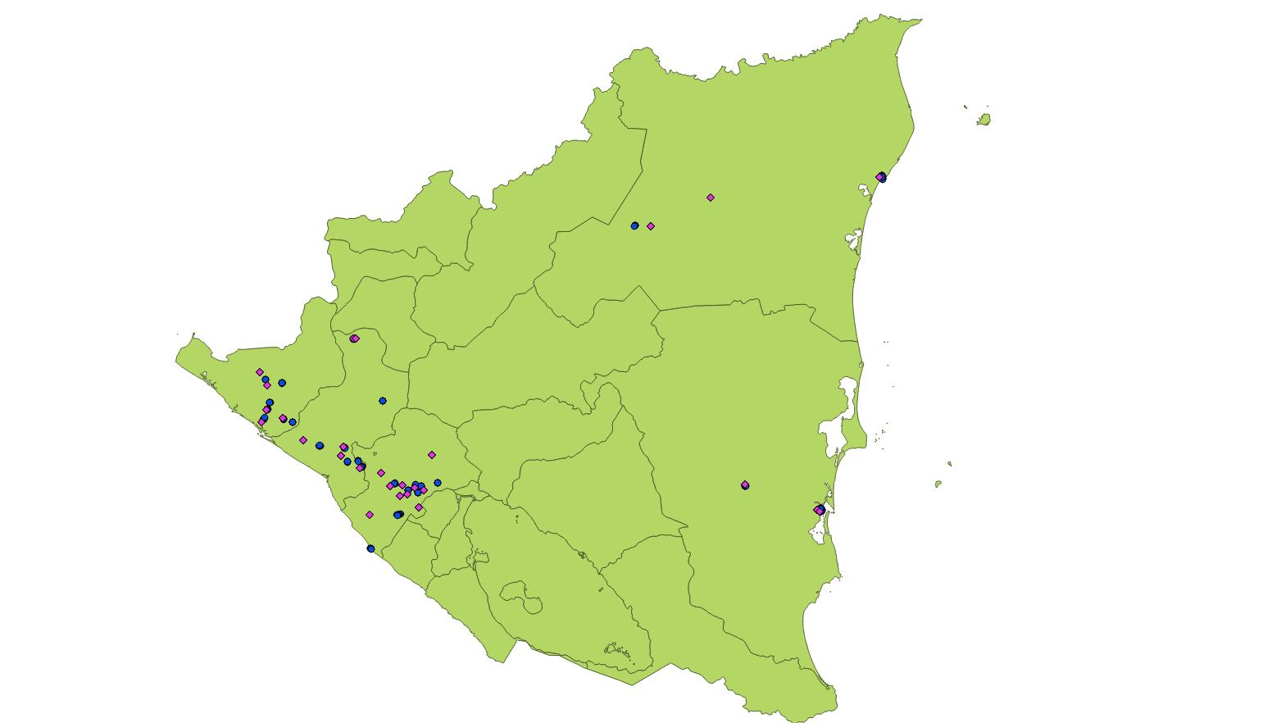
Graph shows map of Nicaragua. Blue circles pertain to non-migrants, while purple diamonds stand for interview locations of migrants.

Figure A2. Peru with Locations of Interviews
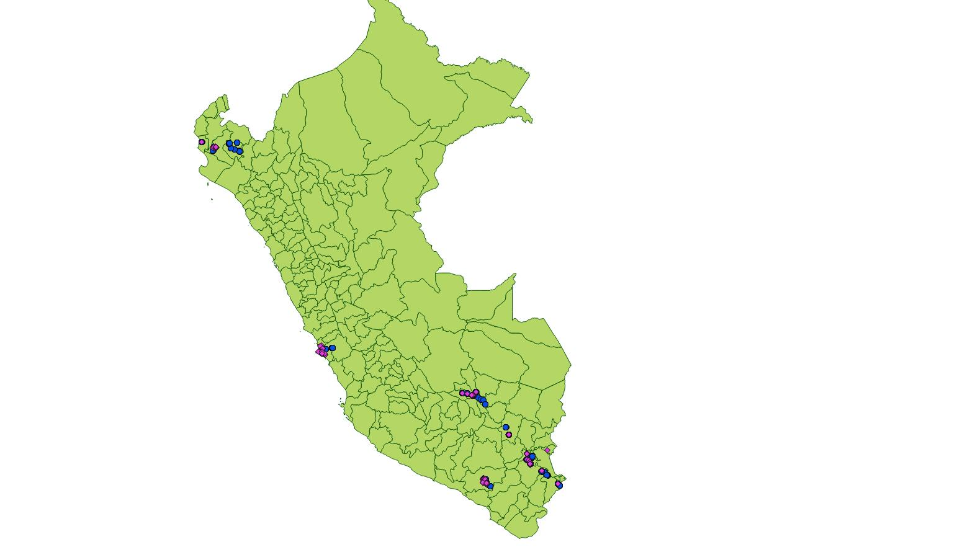
Graph shows map of Peru. Blue circles pertain to non-migrants, while purple diamonds stand for interview locations of migrants.
Figure A3. Cambodia with Locations of Interviews
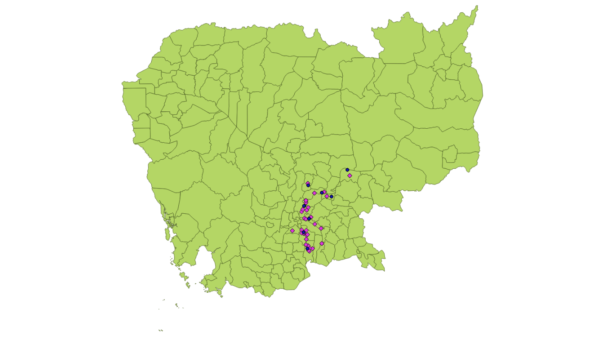
Graph shows map of Cambodia. Blue circles pertain to non-migrants, while purple diamonds stand for interview locations of migrants.

Figure A4. Uganda with Locations of Interviews
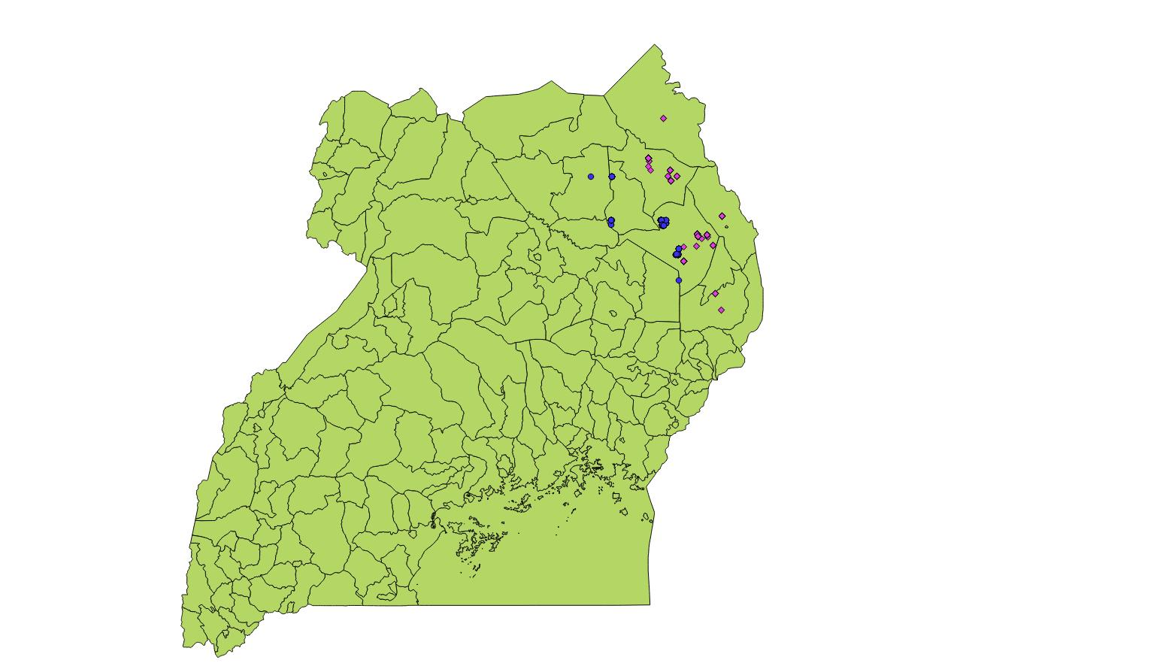
Graph shows map of Uganda. Blue circles pertain to non-migrants, while purple diamonds stand for interview locations of migrants.
Figure A5. Vietnam with Locations of Interviews

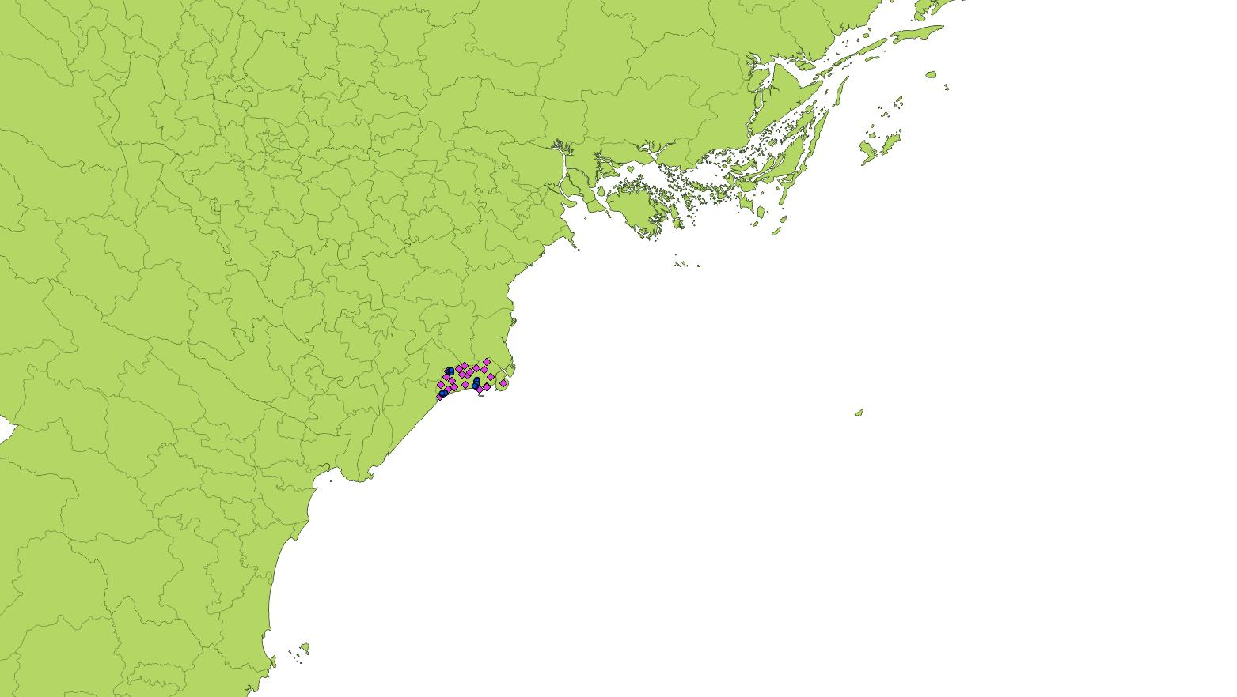
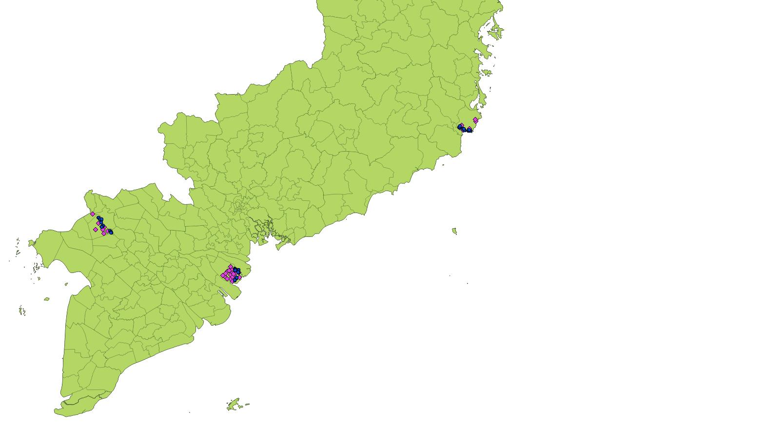

Graphs show map of Vietnam (upper panel: North; lower panel: South). Blue circles pertain to non-migrants, while purple diamonds stand for interview locations of migrants.

Questionnaire
Interview ID _____ --______--______
Date: ____/____/_____
Interviewer ID _____________________

Location: [to be filled out prior to interview]
Coordinates:
Commune/Village/Town:
District:
Province:

Current Weather [observed]:
Number of households (HH) in village/town:

Respondent: [based on observation]

Household Status [scale determined before start of interview]
1. Very poor
2. Poor
3. Average
4. Above average
5. Wealthy
99. N/A [Circle if interview not conducted in respondent home]

Sex of Respondent
1. Female 2. Male

Interview Schedule
How long have you lived in this location?
1. Since birth
2. ____________ [years]
99. Don’t Know/Refused to Answer

Where did you come from?
Commune/Village: ___________________ District_________________ Province___________

Were you born there?
1. Yes
2. No
99. Don’t Know/Refused to Answer

How long were you in that previous location for? _______________ years
99. Don’t Know/Refused to Answer

What is the highest level of formal education you have attended?
[Ask for specific number of years completed]
1. No formal education
2. Primary school _________ Years completed
3. Secondary_________ Years completed
4. Technical ________________Years completed
5. Post-Secondary ___________ Years completed
6. Other ________________
99. Don’t know/Refused to Answer

Could you tell us your age? ___________
[If does not know or refuses to respond, interviewer to guess]

Which ethnic group do you belong to? ________________
99. Don’t know/Refused to Answer

I will read you a list of sources of income. Could you tell us which are your (household) main source(s) of income? (Non-migrant) - I will read you a list of sources of income. Could you tell us which were your (household) main source(s) of income in your former location? (Migrant)
(Circle all mentioned. If more than one was mentioned, ask to rank them in order of importance (from 1-5, 1 the most important) (Insert number in spaces provided in question BELOW)

1. __________________ Agriculture/Farm /animal /fishing income
2.__________________ Proceeds as shop/business owner
3.__________________ Proceeds markets sales (non-farm)
4.__________________ Civil servant salary
5.__________________ Salary from industry (firm, factory, corporation)
6.__________________ Salary from labor (handicrafts, construction)
7.__________________ Day Labor-Temporary
8.__________________ Artisanal Mining
9.__________________ Remittances
10._________________ Professional
11.__________________Other
99._________________ Don’t Know /Refused to Answer

From your perspective, can you describe the main weather event(s) that have happened here during the last 5 years? (Non-migrant) – From your perspective, can you describe the main weather event(s) that occurred during the past five years before you left your previous residence? (Migrant)
[If respondent is unable to answer freely, read the list. For each reported event follow up with questions in the following table]. [Circle all that apply] Show Card
- Heavy Rains/Floods [please circle]
- Salinity
- Snow/Hail [please circle]
- Drought/Desertification [please circle]
- Storm/Cyclone/Typhoon [please circle]
- Landslide/Mudslide/Avalanche [please circle]
- Other______________________________
- None
99. Don’t Know/Refused to Answer

Circle events reported in previous question | 1. Heavy Rain/Flood | 2. Salinity | 3. Snow/Hail | 4. Drought/  Desertification | 5. Cyclone/  Typhoon/  Storm | 6. Landslide/  Mudslide/  Avalanche/ | 7. Other
[For short term events]  When did this event last occur?  [Or for progressive environmental events]  When did this event begin? | Month  Year  99. DK/RA | Month  Year  99. DK/RA | Month  Year  99. DK/RA | Month  Year  99. DK/RA | Month  Year  99. DK/RA | Month  Year  99. DK/RA | Month  Year  99. DK/RA
How long did this event last? | 1. days  2. weeks  3. months  4. years  99. DK/RA | 1. days  2. weeks  3. months  4. years  99. DK/RA | 1. days  2. weeks  3. months  4. years  99. DK/RA | 1. days  2. weeks  3. months  4. years  99. DK/RA | 1. days  2. weeks  3. months  4. years  99. DK/RA | 1. days  2. weeks  3. months  4. years  99. DK/RA | 1. days  2. weeks  3. months  4. years  99. DK/RA
Have you ever thought about migrating? If yes, then ask: What was/were the reason(s)? (Non-migrant) - I would like to ask you all the reason(s) why you decided to move from your former location. (Migrant)
[Allow respondents to answer without reading list and circle all responses in “Unprompted Column”. Then follow up by reading list/Show Card. Additional responses should be circled in “Prompted Column”]
Social reasons: for example, Marriage; There are family/relatives in the new location; I was facing
discrimination; There was insecurity (physical &/or sexual); To seek health care (inadequate health care in area); To seek schooling (e.g. no school in area); Other
Economic reasons: for example, Not enough income from livelihood sources; Unreliable harvest;
No land available for farming/agriculture; Crop failure; Unemployment in that location; Job opportunity in new place; Higher income in new place; Other
Environmental reasons: for example, Water shortage/Drought [1 event]; Repeated droughts /Long
Term salinity; Too much water; Short term events such as flood, storm, landslide, cyclone: Single event or Repeated Event; Other
Political reasons: for example, There was conflict; To seek political freedom; Government
provided incentives for me to go; Government forced me to move; Other

Of all the reasons you mentioned, could you please rank the top three most important factors?
[Write number of code from above reason in first, second and third place below, with number 1 as the most important]
1st _______________
2nd _______________
3rd________________
99. Don’t Know/Refused to Answer
Up until now, have members of your household left temporarily or permanently for other places or even abroad? (Non-migrant) -Up until now, have other members of your household in your previous location left temporarily or permanently for other places, or even abroad?
[Excluding respondent](Migrant)
1. Yes
2. No
99. Don’t Know/Refused to Answer

Do you know of anyone who left after having experienced the same event(s) (drought/desertification/flood/cyclone/etc)? [Not from the same HH] (Non-migrant) - Do you know anyone else who left from your previous location around the same time you did? [Other than you] (Migrant)
1. Yes
2. No
99. Don’t Know/Refused to Answer

Where did they go? [List all locations mentioned]

___________________________________________________________________________

Would you be willing to provide us with the name and contact information for these people so that we may ask a similar set of questions?

___________________________________________________________________________

References
Buhaug, Halvard, Lars-Eric Cederman, and Kristian Skrede Gleditsch. 2014. Square Pegs in Round Holes: Inequalities, Grievances, and Civil War. International Studies Quarterly 58(2): 418-431.
Cederman, Lars-Erik, Nils Weidmann, and Kristian Skrede Gleditsch. 2011. Horizontal Inequalities and Ethonationalist Civil War: A Global Comparison. American Political Science Review 105(3): 478-495.
Cederman, Lars-Erik, Andreas Wimmer, and Brian Min. 2010. Why Do Ethnic Groups Rebel? New Data and Analysis. World Politics 62(1): 87-119.
Clarke, Kevin. 2009. Return of the Phantom Menace: Omitted Variable Bias in Political Research. Conflict Management and Peace Science 26(1): 46-66.
Clarke, Kevin. 2005. The Phantom Menace: Omitted Variable Bias in Econometric Research. Conflict Management and Peace Science 22(4): 341-352.
Hunter, Lori M., Jessie K. Luna, and Rachel M. Norton. 2015. Environmental Dimensions of Migration. Annual Review of Sociology 41(6): 1-21.
Marshall Monty G., Keith Jaggers, and Ted Robert Gurr. 2013. Polity IV Project: Political Regime Characteristics and Transitions, 1800-2013. Available online at: http://www.systemicpeace.org/ inscrdata.html.
Vogt, Manuel, Nils-Christian Bormann, Seraina Rüegger, Lars-Erik Cederman, Philipp Hunziker, and Luc Girardin. 2015. Integrating Data on Ethnicity, Geography, and Conflict: The Ethnic Power Relations Dataset Family. Journal of Conflict Resolution 59(7): 1327-1342.

We mostly present only re-estimations of Table 2 from the main text, i.e., the general conflict perception variable. The models based on the other dependent variables produce qualitatively the same results as those discussed here, and can be replicated with our replication materials. The data and replication instructions can be obtained from the authors on request.
Hunter, Luna, and Norton 2015, 9.
Buhaug, Cederman, and Gleditsch 2014.
Cederman, Weidmann, and Gleditsch 2011.
We thank an anonymous reviewer for this suggestion.
Specifically, the exact survey question is: “which ethnic group do you belong to?”
Cederman, Wimmer, and Min 2010; Vogt et al. 2015.
Cederman, Wimmer, and Min 2010; Vogt et al. 2015.
Clarke 2005, 2009.
Marshall, Jaggers, and Gurr 2013.

