**— Supplementary materials —**

# Appendix 1. Additional estimation results

**Table S.1.** Two-sided *t*-tests for differences in means between women who have engaged in transactional sex with UN personnel and those who have not

|  |  |  |  |  |  |  |  |
| --- | --- | --- | --- | --- | --- | --- | --- |
|  | **Min** | **Max** | **Mean if ever engaged in transactional sex, also with UN personnel** | **Mean if ever engaged in transactional sex, not with UN personnel** | **Mean if never engaged in transactional sex** | **Diff.** | ***p*-val.** |
| Age | 18 | 30 | 25.48 | 24.84 |  | 0.64 | 0.26 |
|  | 26.90 | -1.42 | <0.01 |
| Christian | 0 | 1 | 0.97 | 0.93 |  | 0.03 | 0.30 |
|  | 0.94 | 0.03 | 0.16 |
| Married | 0 | 1 | 0.23 | 0.18 |  | 0.05 | 0.44 |
|  | 0.36 | -0.13 | 0.01 |
| Cognitive score | 0 | 3 | 1.77 | 1.87 |  | -0.10 | 0.57 |
|  | 2.25 | -0.48 | <0.01 |
| Ever sold good or service to PK | 0 | 1 | 0.31 | 0.16 |  | 0.15 | 0.04 |
|  | 0.31 | 0.00 | 0.99 |
| Ever socialized with PK | 0 | 1 | 0.58 | 0.13 |  | 0.45 | <0.01 |
|  | 0.31 | 0.28 | <0.01 |
| Ever spoken with PK | 0 | 1 | 0.79 | 0.42 |  | 0.36 | <0.01 |
|  | 0.66 | 0.12 | 0.01 |
| Ever contacted PK with a problem | 0 | 1 | 0.50 | 0.00 |  | 0.50 | <0.01 |
|  | 0.15 | 0.35 | <0.01 |
| PKs increase safety in city/town | 0 | 1 | 0.96 | 0.95 |  | 0.01 | 0.83 |
|  | 0.92 | 0.04 | 0.12 |
| PKs increase own personal security | 0 | 1 | 0.83 | 0.67 |  | 0.16 | 0.02 |
|  | 0.75 | 0.08 | 0.06 |
| PKs have positive non-security effect | 0 | 1 | 0.79 | 0.40 |  | 0.39 | <0.01 |
|  | 0.49 | 0.30 | <0.01 |

**Table S.1 (continued).**

|  |  |  |  |  |  |  |  |
| --- | --- | --- | --- | --- | --- | --- | --- |
|  | **Min** | **Max** | **Mean if ever engaged in transactional sex, also with UN personnel** | **Mean if ever engaged in transactional sex, not with UN personnel** | **Mean if never engaged in transactional sex** | **Diff.** | ***p*-val.** |
| PKs have solved family conflicts | 0 | 1 | 0.39 | 0.00 |  | 0.39 | <0.01 |
|  | 0.11 | 0.28 | <0.01 |
| PK presence has negative effects | 0 | 1 | 0.30 | 0.28 |  | 0.01 | 0.87 |
|  | 0.43 | -0.13 | 0.01 |
| PKs should stay in Liberia | 0 | 1 | 0.88 | 0.73 |  | 0.16 | 0.01 |
|  | 0.74 | 0.15 | <0.01 |
| Owns business or is self-employed | 0 | 1 | 0.24 | 0.29 |  | -0.05 | 0.50 |
|  | 0.27 | -0.03 | 0.45 |
| If owner, number of businesses | 1 | 2 | 1.04 | 1.08 |  | -0.04 | 0.58 |
|  | 1.02 | 0.02 | 0.50 |
| Owns business and sells to foreigners | 0 | 1 | 0.22 | 0.29 |  | -0.07 | 0.31 |
|  | 0.25 | -0.03 | 0.51 |
| Monthly earnings, all businesses, log | 0 | 11.35 | 8.63 | 8.09 |  | 0.54 | 0.10 |
|  | 8.82 | -0.20 | 0.44 |
| Has worked as employee last year | 0 | 1 | 0.34 | 0.29 |  | 0.05 | 0.54 |
|  | 0.49 | -0.15 | <0.01 |
| If employed, number of jobs | 1 | 2 | 1.01 | 1.00 |  | 0.01 | 0.67 |
|  | 1.00 | 0.01 | 0.23 |
| Monthly earnings, all jobs, log | 0 | 11.35 | 8.91 | 9.22 |  | -0.31 | 0.52 |
|  | 9.35 | -0.43 | 0.02 |
| Has savings | 0 | 1 | 0.61 | 0.56 |  | 0.05 | 0.53 |
|  | 0.72 | -0.11 | 0.02 |
| Total assets, log | 0 | 16.12 | 4.55 | 5.31 |  | -0.76 | 0.33 |
|  | 6.19 | -1.64 | <0.01 |
| Had enough food over past month | 0 | 2 | 0.85 | 0.71 |  | 0.13 | 0.20 |
|  | 0.88 | -0.04 | 0.50 |
| Has adequate housing | 0 | 2 | 0.84 | 0.73 |  | 0.10 | 0.32 |
|  | 0.83 | 0.01 | 0.85 |

**Table S.1 (continued).**

|  |  |  |  |  |  |  |  |
| --- | --- | --- | --- | --- | --- | --- | --- |
|  | **Min** | **Max** | **Mean if ever engaged in transactional sex, also with UN personnel** | **Mean if ever engaged in transactional sex, not with UN personnel** | **Mean if never engaged in transactional sex** | **Diff.** | ***p*-val.** |
| Has adequate health care | 0 | 2 | 0.79 | 0.89 |  | -0.10 | 0.35 |
|  | 0.90 | -0.11 | 0.05 |
| Need for children’s schooling met | 0 | 2 | 0.50 | 0.46 |  | 0.03 | 0.78 |
|  | 0.63 | -0.14 | 0.04 |
| Home has electricity | 0 | 1 | 0.34 | 0.29 |  | 0.05 | 0.54 |
|  | 0.44 | -0.10 | 0.03 |
| Home has running water | 0 | 1 | 0.07 | 0.00 |  | 0.07 | 0.07 |
|  | 0.07 | -0.01 | 0.84 |
| Home has indoor toilet | 0 | 1 | 0.56 | 0.33 |  | 0.23 | 0.01 |
|  | 0.63 | -0.07 | 0.16 |
| Any deaths since 1999 in household | 0 | 1 | 0.42 | 0.38 |  | 0.04 | 0.64 |
|  | 0.47 | -0.05 | 0.28 |
| If someone died, number of deaths | 1 | 20 | 2.43 | 1.65 |  | 0.78 | 0.23 |
|  | 1.59 | 0.84 | 0.01 |
| Head of household died since 1999 | 0 | 1 | 0.14 | 0.16 |  | -0.02 | 0.72 |
|  | 0.16 | -0.02 | 0.55 |
| Any disability since 1999 in household | 0 | 1 | 0.14 | 0.11 |  | 0.03 | 0.62 |
|  | 0.12 | 0.02 | 0.49 |
| Lost domicile since 1999 | 0 | 1 | 0.07 | 0.07 |  | 0.01 | 0.87 |
|  | 0.08 | -0.01 | 0.72 |

**Table S.2.** Correlates of first transactional sex, additional robustness tests

|  |  |  |  |  |  |  |
| --- | --- | --- | --- | --- | --- | --- |
|  | (1) | (2) | (3) | (4) | (5) | (6) |
|  | Model non- monotonic hazard | | Model time dependence using cohort trend | | Model time dependence using cohort indicators | |
|  | Odds ratio (Std. err.) | Odds ratio (Std. err.) | Hazard ratio (Std. err.) | Hazard ratio (Std. err.) | Hazard ratio (Std. err.) | Hazard ratio (Std. err.) |
| UNMIL troops (in 1000s) | 1.078*** (0.029) |  | 1.032* (0.019) |  | 1.031* (0.018) |  |
| UNMIL troops from Africa |  | 1.142*** (0.058) |  | 1.099*** (0.034) |  | 1.092*** (0.034) |
| Second War | 2.621*** | 2.274*** | 4.282*** | 4.400*** | 3.661*** | 3.745*** |
|  | (0.852) | (0.670) | (1.096) | (1.001) | (0.923) | (0.847) |
| First War | 0.459 | 0.479 | 2.313 | 2.763* | 2.168 | 2.544 |
|  | (0.302) | (0.317) | (1.338) | (1.594) | (1.255) | (1.474) |
| Cognitive score | 0.597*** (0.059) | 0.600*** (0.060) | 0.746*** (0.049) | 0.745*** (0.049) | 0.734*** (0.050) | 0.733*** (0.050) |
| Year | 1.027 | 1.057 |  |  |  |  |
|  | (0.049) | (0.049) |  |  |  |  |
| Age at survey |  |  | 0.791*** | 0.784*** |  |  |
|  |  |  | (0.023) | (0.023) |  |  |
| Cohort indicators | No | No | No | No | Yes | Yes |
| Shape *ln(p)* |  |  | 1.505*** (0.092) | 1.543*** (0.091) | 1.506*** (0.093) | 1.540*** (0.092) |
| Shape *ln(γ)* | -1.118*** (0.101) | -1.108*** (0.102) |  |  |  |  |
| Baseline Hazard | Log-logistic, hazard initially increasing and then decreasing in age | | Weibull, hazard increasing in age | | Weibull, hazard increasing in age | |
| Observations | 9688 | 9688 | 9688 | 9688 | 9688 | 9688 |
| \**p* ≤ 0.1, \*\**p* ≤ 0.05, \*\*\**p* ≤ 0.01 | | | | | | |

# Appendix 2. Survey items

Table S.3 provides the wording of individual-level survey questions and response options analyzed in this paper. Questions are listed in the order in which they appeared on the survey. For all relevant questions, subjects were provided with the option to respond that they “don’t know” or “refuse” to answer the question, in addition to the response options listed below. Questions with identifiers that start with Q were enumerator-administered. Those that start with S were self-administered.

**Table S.3.** Question wording and response items for relevant survey items

|  |  |
| --- | --- |
| Question identifier: | Q1 |
| Question text: | Age |
| Response options: | [Numeric entry] |
| Question identifier: | Q2 |
| Question text: | Gender |
| Response options: | ∘ Man  ∘ Woman |
| Question identifier: | Q3 |
| Question text: | Marital status |
| Response options: | ∘ Never married  ∘ Currently married monogamously  ∘ Currently married polygamously  ∘ Not married (divorced/separated)  ∘ Not married (widowed) |
| Question identifier: | Q5 |
| Question text: | Religion |
| Response options: | ∘ Christian  ∘ Muslim  ∘ Traditional  ∘ Other |

**Table S.3 (continued).**

|  |  |
| --- | --- |
| Question identifier: | Q6 |
| Question text: | Suppose you have the following letters written on a paper. Can you unscramble the letters SERAD into a real English word? You have 15 seconds. [Enumerator: Give paper to respondent. Did the respondent provide a real English word (DEARS, DARES, READS, etc.)?] |
| Response options: | ∘ [Correct]  ∘ [Incorrect] |
| Question identifier: | Q7 |
| Question text: | Please answer the following question: You are participating in a race. You overtake the person in second place. What position are you in? |
| Response options: | ∘ [First]  ∘ [Second]  ∘ [Other, specify] |
| Question identifier: | Q8 |
| Question text: | Please answer the following question: If you have 16 plantains and eat 9, how many plantains do you have? |
| Response options: | ∘ [Correct]  ∘ [Incorrect] |
| Question identifier: | Q9 |
| Question text: | Now, you have 30 seconds to stare at the image on the card. When the timer runs out, you’ll be asked about the image and see how much can you recall. Here it is. [Enumerator: Show picture for 30 seconds.] What is the color of the girl’s bow in her dress? |
| Response options: | ∘ [Red]  ∘ [Don’t know]  ∘ [Other, specify] |
| Question identifier: | Q10 |
| Question text: | What is the color of the mother’s dress? |
| Response options: | ∘ [Correct]  ∘ [Incorrect] |
| Question identifier: | Q11 |
| Question text: | What is the color of the boy’s sweater? |
| Response options: | ∘ [Correct]  ∘ [Incorrect] |

**Table S.3 (continued).**

|  |  |
| --- | --- |
| Question identifier: | Q17 |
| Question text: | When was the last time you sold a good or service to UNMIL PKO personnel? |
| Response options: | ∘ Within the last 24 hours  ∘ Within the last week  ∘ Within the last two weeks  ∘ Within the last month  ∘ Within the last three months  ∘ Within the last 6 months  ∘ Within the last year  ∘ Over a year ago  ∘ Never |
| Question identifier: | Q19 |
| Question text: | When was the last time you socialized with UNMIL PKO personnel? |
| Response options: | ∘ Within the last 24 hours  ∘ Within the last week  ∘ Within the last two weeks  ∘ Within the last month  ∘ Within the last three months  ∘ Within the last 6 months  ∘ Within the last year  ∘ Over a year ago  ∘ Never |
| Question identifier: | Q22 |
| Question text: | About when was the last time you spoke with UNMIL personnel about anything at all? |
| Response options: | ∘ Within the last 24 hours  ∘ Within the last week  ∘ Within the last two weeks  ∘ Within the last month  ∘ Within the last three months  ∘ Within the last 6 months  ∘ Within the last year  ∘ Over a year ago  ∘ Never |
| Question identifier: | Q24 |
| Question text: | Do you think the presence of UNMIL personnel has increased the city’s/town’s safety? |
| Response options: | ∘ Yes  ∘ No |

**Table S.3 (continued).**

|  |  |
| --- | --- |
| Question identifier: | Q25 |
| Question text: | Do you think the presence of UNMIL personnel has increased your own personal security? |
| Response options: | ∘ Yes  ∘ No |
| Question identifier: | Q27 |
| Question text: | Other than security what is the most positive contribution of UN military personnel? |
| Response options: | ∘ Provide money, food, medicines, clothing  ∘ Help solve interpersonal / family problems  ∘ Health, community, infrastructure and education services  ∘ Improving government  ∘ Other, specify  ∘ Nothing |
| Question identifier: | Q30 |
| Question text: | Has UN military personnel specifically helped you or any member of your family to solve family or interpersonal conflicts? |
| Response options: | ∘ Yes  ∘ No |
| Question identifier: | Q32 |
| Question text: | Could you think of any negative consequences of the presence of the UN military in your city? |
| Response options: | ∘ Yes  ∘ No |
| Question identifier: | Q35 |
| Question text: | How often do you contact UN peacekeepers with a problem? |
| Response options: | ∘ Daily  ∘ Weekly  ∘ Once every two weeks  ∘ Once a month  ∘ Once every six months  ∘ Once a year  ∘ Less than once a year  ∘ Never |
| Question identifier: | Q38 |
| Question text: | Would you like that UNMIL continues to stay in Liberia? |
| Response options: | ∘ Yes  ∘ No |

**Table S.3 (continued).**

|  |  |
| --- | --- |
| Question identifier: | Q47 |
| Question text: | Do you have any savings? |
| Response options: | ∘ Yes  ∘ No |
| Question identifier: | Q48 |
| Question text: | Do you own an enterprise / business or do you earn any money by working for yourself? |
| Response options: | ∘ Yes  ∘ No |
| Question identifier: | Q49 |
| Question text: | How many enterprises / sources of self-employment do you have? |
| Response options: | [Numeric entry] |
| Question identifier: | Q52 |
| Question text: | [Enterprise 1] Total earnings over last month (cash plus value of in-kind remuneration) |
| Response options: | [Numeric entry] |
| Question identifier: | Q60 |
| Question text: | [Enterprise 1] Does this enterprise / business sell products or services to foreigners (non-Liberians)? |
| Response options: | ∘ Yes  ∘ No |
| Question identifier: | Q68 |
| Question text: | [Enterprise 2] Total earnings over last month (cash plus value of in-kind remuneration) |
| Response options: | [Numeric entry] |
| Question identifier: | Q76 |
| Question text: | [Enterprise 2] Does this enterprise / business sell products or services to foreigners (non-Liberians)? |
| Response options: | ∘ Yes  ∘ No |
| Question identifier: | Q97 |
| Question text: | Not including enterprises listed before, have you worked outside the home as an employee of someone else in the last 12 months? |
| Response options: | ∘ Yes  ∘ No |
| Question identifier: | Q98 |
| Question text: | How many different jobs working outside the home for someone else did you have in the last 12 months? |
| Response options: | [Numeric entry] |

**Table S.3 (continued).**

|  |  |
| --- | --- |
| Question identifier: | Q101 |
| Question text: | [Occupation 1] Total earnings over last month (cash plus value of in-kind remuneration) |
| Response options: | [Numeric entry] |
| Question identifier: | Q113 |
| Question text: | [Occupation 2] Total earnings over last month (cash plus value of in-kind remuneration) |
| Response options: | [Numeric entry] |
| Question identifier: | Q134 |
| Question text: | Concerning your food consumption over the past one month, which of the following is true? |
| Response options: | ∘ It was less than enough for your needs  ∘ It was just enough for your needs  ∘ It was more than enough for your needs |
| Question identifier: | Q135 |
| Question text: | Concerning where you live (housing), which of the following is true? |
| Response options: | ∘ It is less than enough for your needs  ∘ It is just enough for your needs  ∘ It is more than enough for your needs |
| Question identifier: | Q136 |
| Question text: | Concerning the health care you receive, which of the following is true? |
| Response options: | ∘ It is less than enough for your needs  ∘ It is just enough for your needs  ∘ It is more than enough for your needs |
| Question identifier: | Q137 |
| Question text: | Concerning your children’s schooling, which of the following is true? |
| Response options: | ∘ It is less than enough for your needs  ∘ It is just enough for your needs  ∘ It is more than enough for your needs  ∘ Not applicable (no children in school) |
| Question identifier: | Q139 |
| Question text: | How much could your jewelry, including watches, you own be sold for? [0 if respondent does not own any jewelry.] |
| Response options: | [Numeric entry] |
| Question identifier: | Q140 |
| Question text: | Aside from what you have said, what else could you sell if you urgently needed money? |
| Response options: | ∘ Nothing  ∘ Other, specify |

**Table S.3 (continued).**

|  |  |
| --- | --- |
| Question identifier: | Q141 |
| Question text: | For how much money could you sell it? |
| Response options: | [Numeric entry] |
| Question identifier: | Q143 |
| Question text: | Does your home have electricity? |
| Response options: | ∘ Yes  ∘ No |
| Question identifier: | Q144 |
| Question text: | Does your home have running water? |
| Response options: | ∘ Yes  ∘ No |
| Question identifier: | Q145 |
| Question text: | Does your home have indoor toilets? |
| Response options: | ∘ Yes  ∘ No |
| Question identifier: | Q154 |
| Question text: | Did the household suffer any deaths since the start of the civil war in 1999? [If respondent can’t remember, prompt year by year] |
| Response options: | ∘ Yes  ∘ No |
| Question identifier: | Q155 |
| Question text: | Number of deaths in your household including head of household? |
| Response options: | [Numeric entry] |
| Question identifier: | Q156 |
| Question text: | [Deceased household member 1] Was this person the head of the household at the time of his / her death? |
| Response options: | ∘ Yes  ∘ No |
| Question identifier: | Q163 |
| Question text: | [Deceased household member 2] Was this person the head of the household at the time of his / her death? |
| Response options: | ∘ Yes  ∘ No |
| Question identifier: | Q170 |
| Question text: | [Deceased household member 3] Was this person the head of the household at the time of his / her death? |
| Response options: | ∘ Yes  ∘ No |

**Table S.3 (continued).**

|  |  |
| --- | --- |
| Question identifier: | Q177 |
| Question text: | [Deceased household member 4] Was this person the head of the household at the time of his / her death? |
| Response options: | ∘ Yes  ∘ No |
| Question identifier: | Q184 |
| Question text: | [Deceased household member 5] Was this person the head of the household at the time of his / her death? |
| Response options: | ∘ Yes  ∘ No |
| Question identifier: | Q190 |
| Question text: | Did the household suffer any cases of disability or long-term illness since the start of the civil war in 1999? |
| Response options: | ∘ Yes  ∘ No |
| Question identifier: | Q221 |
| Question text: | In the last 13 years, since the start of the civil war in 1999, has the household suffered the confiscation or substantial destruction of its domicile? |
| Response options: | ∘ Yes  ∘ No |
| Question identifier: | S4 |
| Question text: | Do you know anyone whom a member of the UN military personnel has asked for men business in exchange for food, money, or security? |
| Response options: | ∘ Yes  ∘ No |
| Question identifier: | S5 |
| Question text: | What specifically did the person receive in exchange for doing men business (sex)? |
| Response options: | ∘ Money  ∘ Food  ∘ Medicine  ∘ Clothing  ∘ Shelter  ∘ Help  ∘ Jewelry  ∘ Cell phone  ∘ Car  ∘ Job  ∘ Other  ∘ Not applicable |

**Table S.3 (continued).**

|  |  |
| --- | --- |
| Question identifier: | S6 |
| Question text: | Was this person yourself? |
| Response options: | ∘ Yes  ∘ No |
| Question identifier: | S10 |
| Question text: | Have you ever received money, food, shelter, help or anything of value from a man for doing men business (engaging in sexual intercourse) with him? |
| Response options: | ∘ Yes  ∘ No |
| Question identifier: | S11 |
| Question text: | When was the first time you had men business in exchange for something of value (money, food, medicines, help)? |
| Response options: | ∘ Less than 14  ∘ 14  ∘ 15  ∘ 16  ∘ 17  ∘ 18  ∘ 19  ∘ 20  ∘ 21  ∘ 22  ∘ 23  ∘ 24  ∘ 25  ∘ Older than 25  ∘ Not applicable |
| Question identifier: | S12 |
| Question text: | In general how often do you receive money/ food/ help in exchange for doing men business? |
| Response options: | ∘ Daily  ∘ Weekly  ∘ Monthly  ∘ Quarterly (once every 3 months)  ∘ Yearly  ∘ Less than once a year  ∘ Not applicable |

**Table S.3 (continued).**

|  |  |
| --- | --- |
| Question identifier: | S13 |
| Question text: | When you receive something of value for doing men business (sex) what do you usually receive? |
| Response options: | ∘ Money  ∘ Food  ∘ Clothing  ∘ Shelter  ∘ Medicine  ∘ Help with a problem  ∘ Jewelry  ∘ Cell phone  ∘ Car  ∘ Job  ∘ Not applicable |
| Question identifier: | S14 |
| Question text: | When you think of all the things you receive in return for doing men business with a man (money, food, clothing, and so on), how much do you think you make in an average week for doing men business? What is the approximate dollar value? |
| Response options: | ∘ One US dollar  ∘ Five US dollars  ∘ Ten US dollars  ∘ Twenty US dollars  ∘ Fifty US dollars  ∘ 100 US dollars  ∘ 200 US dollars  ∘ More than 200 US dollars  ∘ Not applicable |
| Question identifier: | S17 |
| Question text: | The last time you did men business in exchange for something of value about how much was that something worth? |
| Response options: | ∘ One US dollar  ∘ Five US dollars  ∘ Ten US dollars  ∘ Twenty US dollars  ∘ Fifty US dollars  ∘ 100 US dollars  ∘ 200 US dollars  ∘ More than 200 US dollars |

**Table S.3 (continued).**

|  |  |
| --- | --- |
| Question identifier: | S19 |
| Question text: | The last time you did men business in exchange for something of value did the man work for the UN? |
| Response options: | ∘ Yes  ∘ No |
| Question identifier: | S20 |
| Question text: | About how often do you engage in men business in exchange for something of value with a man who is from another country? |
| Response options: | ∘ Weekly  ∘ Daily  ∘ Monthly  ∘ Quarterly (once every 3 months)  ∘ Yearly  ∘ Less than once a year  ∘ Not applicable |
| Question identifier: | S22 |
| Question text: | Where do most of the foreign men who you did men business (sex) with come from? Click one. |
| Response options: | ∘ Another African country  ∘ Middle East  ∘ Asia (China, Japan, etc.)  ∘ Europe  ∘ United States  ∘ Latin America (Peru, Brazil, etc.)  ∘ South Asia (India, Pakistan, etc.)  ∘ Not applicable |
| Question identifier: | S25 |
| Question text: | About how often do you have men business in exchange for something of value with a man who you think is a UN peacekeeper or works for the UN? |
| Response options: | ∘ Daily  ∘ Weekly  ∘ Monthly  ∘ Quarterly  ∘ Yearly  ∘ Less than once a year  ∘ Not applicable |

# Appendix 3. Sampling and enumeration procedures

Survey respondents were sampled using a multistage stratified cluster sampling design. We prepared the sample by identifying all residences in the district of Greater Monrovia on the basis of current satellite imagery, which yielded a total of 110,750 geolocated dwellings.

We also subdivided Greater Monrovia into 81 enumeration areas of roughly equal size, as shown in Figure S.1. We randomly selected 39 of these areas as primary sampling units, with selection probabilities proportional to the number of dwellings in each enumeration area, and we allocated a target sample size to each enumeration area in proportion to its number of residences.[1]

In each sampled enumeration area, we then randomly selected as many residences as required to meet the sampling target as well as a set of potential replacement locations. On any given survey day, GPS-equipped enumerators received a map of an enumeration block, as seen in Figure S.2, and a list of coordinates that identified specific residences to be visited. If a target building was inaccessible or not residential, a replacement location was substituted.

After identifying a target building, enumerators completed a house quality questionnaire. If the selected residence contained more than one household, enumerators would record the number of households and use a random number sheet to randomly select a household to interview. Each selected household was visited up to four times if necessary to speak to an adult member of the household. After four attempts, enumerators would substitute a replacement location.

When contacting a household, enumerators would speak with an adult member of the household to complete a household roster. If participation was refused, a replacement location was substituted. We stratified the random selection of individual survey respondents by gender, age, and whether individuals have any contact with foreigners in order to oversample our subpopulation of interest, vulnerable women. Upon completion of the household roster, enumerators randomly selected a respondent type and then randomly selected one individual survey respondent of the appropriate type from the roster. Detailed instructions provided to enumerators are available upon request.

**Figure S.1.** Enumeration areas in Greater Monrovia, with labels for those selected

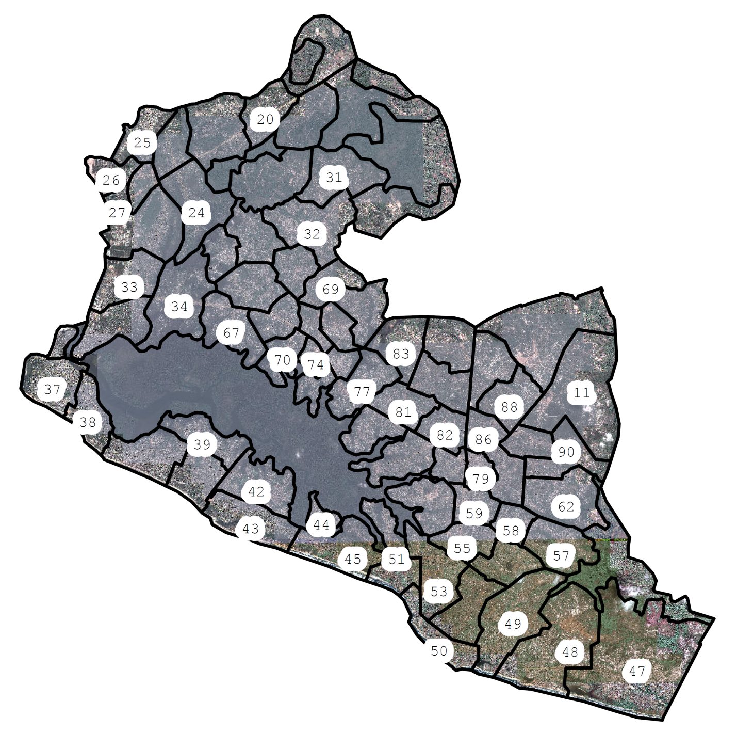

**Figure S.2.** An example of a daily enumeration block map provided to staff

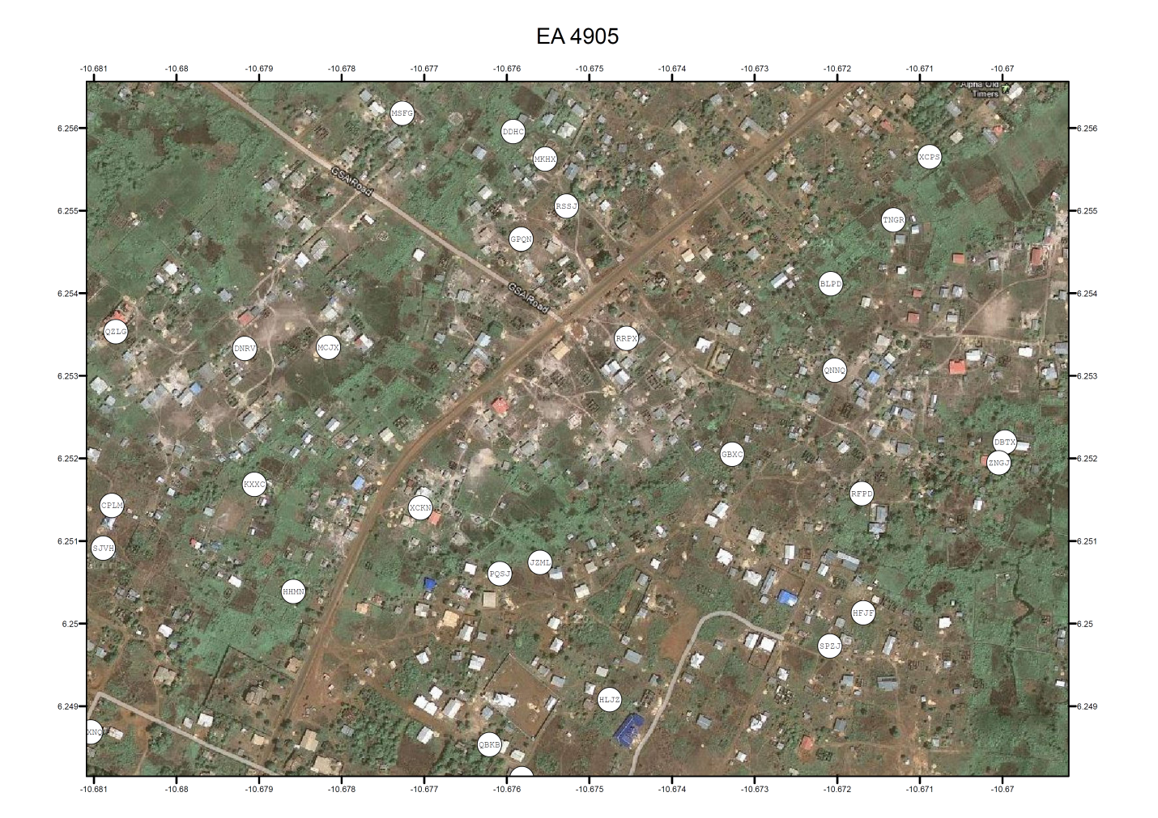

**Figure S.3** Example of an iPod screen respondents used to answer questions



**Figure S.4** Example of a poster produced by the UN’s Conduct and Discipline Unit to inform peacekeepers of the UN’s SEA rules

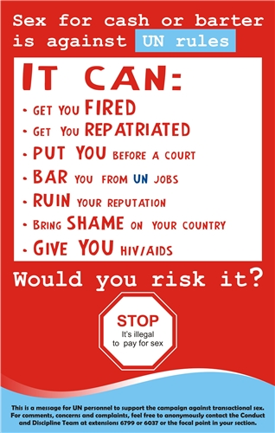

**Figure S.5** Cartoon produced jointly by UNMIL and the Liberian government to raise awareness in communities about SEA

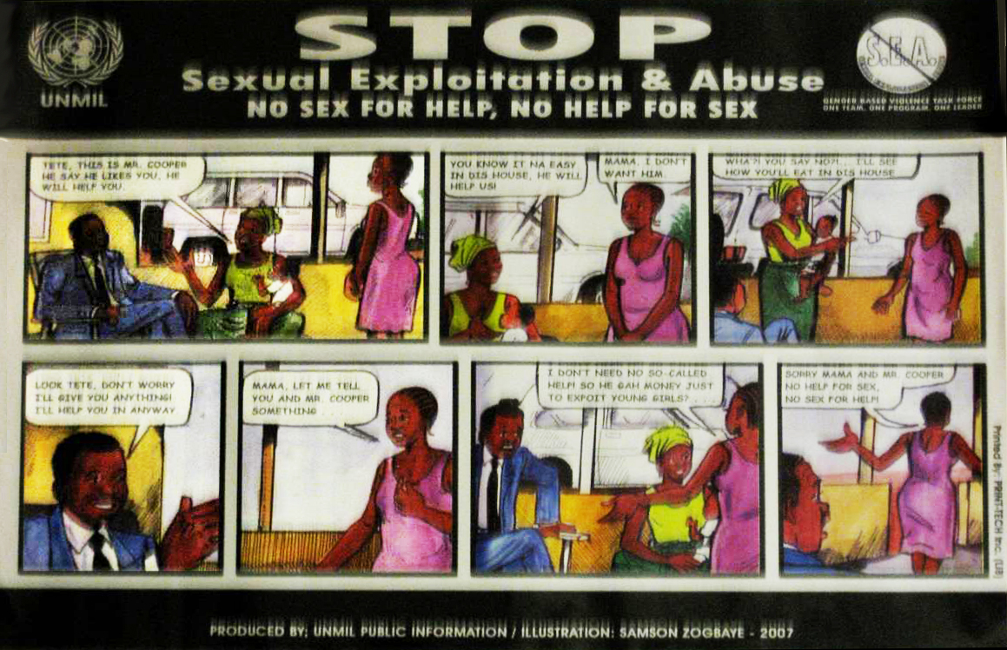

1. We initially selected 40 areas, but dropped one when enumerators reported that this particular area consisted of swamps and non-residential structures.