

**FIGURE A1.** *Change in Proportion of All Manufacturing Firms Engaging in International Trade Activities of Various Types: All Firms (295,000) in 1993 and All Firms (246,000) in 2009. Weighted by Employment as a Proxy for Market Share.*

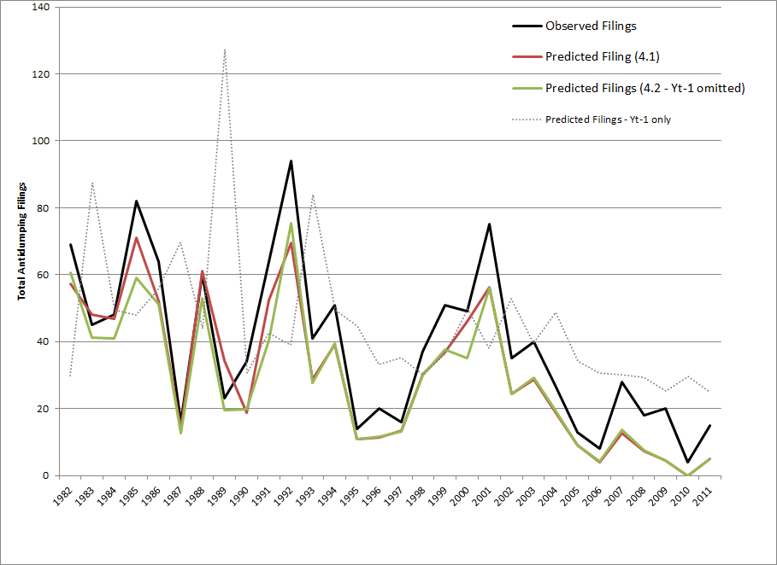

**FIGURE A2.** *Actual vs. Predicted Trade Disputes. (Derived from results in models 1 (with Yt-1) and 2 (without), Table 4.)*