Supplementary material for the article
“Voter Preferences for EU Asylum Policies: The Role of Government Cues”

Hanspeter Kriesi¹ and Alina Vrânceanu²
¹Department of Political and Social Sciences, European University Institute, Fiesole, Italy, and ²Department of Social Sciences, University Pompeu Fabra, Barcelona, Spain

Published in Government and Opposition.

Appendix
Table A1: Polarization between incumbent and opposition parties
 | PolDem 2017-2019 |  | chess 2019 |  | cmp |  | PolDem | chess | cmp | PolDem | chess | cmp
country | incumbents | opposition | incumbents | opposition | Incumbent | Opposition | difference (incumb-opp) |  |  | relative polarization incumb/opp
Greece | -1.00 | 1.00 | -7.78 | -4.76 |  |  | -2.00 | -3.02 |  | 1.00 | 0.57
United Kingdom | -0.77 | 0.03 | -7.59 | -4.38 | 0.51 | 2.12 | -0.80 | -3.21 | -1.61 | 0.40 | 0.61 | 0.34
Hungary | -0.75 | 0.74 | -9.93 | -4.67 | -5.42 | -0.65 | -1.49 | -5.26 | -4.78 | 0.75 | 1.00 | 1.00
Poland | -0.59 | 0.00 | -9.05 | -4.88 | -2.71 | -0.24 | -0.59 | -4.17 | -2.46 | 0.30 | 0.79 | 0.52
Latvia | -0.35 | -0.67 | -6.57 | -6.04 | -0.44 | 0.00 | 0.32 | -0.53 | -0.44 | 0.16 | 0.10 | 0.09
Austria | -0.31 | -0.26 | -5.65 | -6.27 | 0.10 | -1.32 | -0.05 | 0.62 | 1.42 | 0.02 | 0.12 | 0.30
Switzerland | -0.21 | 0.19 | -5.68 | -4.58 | -0.84 | 0.23 | -0.39 | -1.10 | -1.07 | 0.20 | 0.21 | 0.22
France | 0.00 | -0.12 | -6.31 | -5.14 | -0.33 | -0.31 | -0.12 | -1.17 | -0.01 | 0.06 | 0.22 | 0.00
Romania | 0.00 | 0.00 | -5.00 | -5.37 |  |  | 0.00 | 0.37 |  | 0.00 | 0.07
Netherlands | 0.01 | -0.38 | -4.82 | -5.70 | -0.26 | -0.93 | 0.38 | 0.88 | 0.67 | 0.19 | 0.17 | 0.14
Germany | 0.16 | 0.00 | -5.95 | -3.58 | 0.67 | 1.86 | 0.16 | -2.37 | -1.19 | 0.08 | 0.45 | 0.25
Italy | 0.23 | -0.56 | -6.56 | -5.56 | 1.48 | 0.05 | 0.78 | -1.00 | 1.43 | 0.39 | 0.19 | 0.30
Portugal | 0.44 | 0.00 | -3.88 | -3.41 | 4.47 | 1.59 | 0.44 | -0.47 | 2.88 | 0.22 | 0.09 | 0.60
Spain | 0.71 | -0.16 | -2.83 | -5.02 | 2.77 | 0.75 | 0.87 | 2.19 | 2.02 | 0.44 | 0.42 | 0.42
Ireland | 1.00 | 1.00 | -4.67 | -4.53 |  |  | 0.00 | -0.14 |  | 0.00 | 0.03
Sweden |  |  | -3.45 | -5.32 | -0.11 | -0.91 |  | 1.87 | 0.80 |  | 0.36 | 0.17
Finland |  |  | -3.80 | -5.59 | 1.00 | -0.83 |  | 1.79 | 1.83 |  | 0.34 | 0.38

Table A2: Descriptives of the variables included in the analysis
Variable | Obs | Mean | Std. dev. | Min | Max
probpress | 34,246 | 2.0 | 0.8 | 1 | 3
incumbent voter | 34,246 | 0.3 | 0.5 | 0 | 1
immigration attitude | 13,655 | 0.5 | 0.2 | 0 | 1
trust in EU | 34,246 | 0.5 | 0.3 | 0 | 1
political interest | 34,051 | 0.6 | 0.3 | 0 | 1
age | 34,246 | 45.3 | 17.4 | 18 | 99
gender | 34,245 | 1.5 | 0.5 | 1 | 2
educ | 34,246 | 2.3 | 0.7 | 1 | 3
left-right self-placem. | 34,246
left |  | 26.1
neither |  | 41.3
right |  | 32.6
party family | 30,753
radical left |  | 7.0
greens |  | 4.1
social-democrats |  | 14.6
liberals |  | 11.9
conservatives/CD |  | 17.7
radical right |  | 10.4
others |  | 4.7
non voters |  | 29.6

Table A3: Determinants of policy assessments: OLS-regression coefficients, t-values, and significance levels¹⁾
 | relocation | first entry | external borders | Externali-zation
 | b/t | b/t | b/t | b/t
political interest | 0.656*** | 0.582*** | 0.713*** | 0.673***
 | (4.734) | (3.921) | (7.275) | (6.707)
left, reference category
neither left nor right | -0.253*** | 0.450*** | 0.841*** | 0.261***
 | (-4.515) | (7.498) | (9.572) | (3.225)
right | -0.573*** | 0.803*** | 1.249*** | 0.357***
 | (-4.785) | (8.045) | (11.864) | (4.554)
radical left, reference category
green | 0.150 | -0.414* | -0.111 | 0.108
 | (0.814) | (-2.021) | (-0.509) | (0.858)
social-dem | -0.180 | -0.033 | 0.516*** | 0.087
 | (-1.358) | (-0.181) | (3.402) | (0.720)
liberal | -0.363** | -0.380 | 0.572*** | 0.027
 | (-2.159) | (-1.558) | (3.659) | (0.216)
conservative-Christian-democrats | -0.474*** | -0.159 | 0.535*** | 0.152
 | (-3.398) | (-0.803) | (3.353) | (1.558)
radical right | -1.318*** | -0.275 | 0.787*** | -0.117
 | (-5.334) | (-1.248) | (4.086) | (-0.972)
others | -0.278 | -0.084 | 0.329** | -0.125
 | (-1.419) | (-0.404) | (2.165) | (-0.830)
non-voter | -0.541*** | -0.136 | 0.291** | -0.187*
 | (-3.775) | (-0.675) | (2.664) | (-1.795)
age | 0.006 | -0.002 | 0.018*** | 0.020***
 | (1.477) | (-0.589) | (9.176) | (8.779)
gender | 0.336*** | 0.054 | -0.352*** | 0.065
 | (4.262) | (0.591) | (-5.901) | (1.015)
education | 0.008 | -0.202*** | -0.014 | 0.071*
 | (0.176) | (-5.596) | (-0.388) | (2.046)
problem pressure low, ref.
medium | 0.208 | 0.019 | -0.029 | -0.157
 | (1.329) | (0.061) | (-0.112) | (-0.621)
high | 0.798*** | -0.361 | 0.305 | 0.370*
 | (4.894) | (-1.350) | (1.295) | (1.782)
incumbent2021=0
incumbent2021=1 | -1.777*** | -0.350 | 0.077 | -0.141*
 | (-5.422) | (-1.387) | (0.944) | (-2.126)
EU no trust
EU trust | 1.381*** | 0.589** | 0.294*** | 0.561***
 | (10.543) | (2.605) | (5.804) | (4.551)
Immigration attitude=0
Immigration attitude=1 | 2.239*** | 1.344*** | -1.470*** | 0.084
 | (8.169) | (5.061) | (-9.644) | (0.369)
against-divided, reference category
against-undivided | -0.078
 | (-0.511)
bystander-divided |  | 1.130*** | -0.430* | -0.055
 |  | (4.552) | (-1.818) | (-0.140)
bystander-undivided | 0.762*** | 1.412*** | -0.069 | 0.085
 | (3.331) | (3.098) | (-0.293) | (0.273)
pro-undivided | 1.168*** | 2.553*** | -0.147 | -0.128
 | (6.000) | (9.954) | (-0.651) | (-0.750)
pro-divided: UK | 2.253*** | 2.925*** | -0.400** | 0.104
 | (11.492) | (15.756) | (-2.320) | (1.155)
pro-divided | 2.590***
 | (5.969)
against-divided#incumbent, ref.
against-undiv#incumbent | 1.685***
 | (5.269)
bystander-divided#incumbent |  | 0.706** | 0.360*** | 0.467
 |  | (2.771) | (3.524) | (1.719)
bystander-undivided#incumbent | 2.000*** | 0.549** | 0.042 | 0.283***
 | (6.064) | (2.270) | (0.319) | (4.475)
pro-undivided#incumbent | 2.210*** | 0.319 | -0.112 | 0.237
 | (6.837) | (1.320) | (-0.832) | (1.330)
pro-div:UK#incumbent | 1.857*** | 1.042*** | 0.450*** | 0.666***
 | (6.286) | (4.672) | (4.100) | (10.151)
pro-divided#incumbent | 2.410***
 | (8.103)
against-divided#immigration, ref
against-undiv#immigration | -0.191
 | (-1.458)
bystander-divided#immigration |  | -0.439 | -0.262** | -0.097
 |  | (-1.615) | (-2.656) | (-0.503)
bystander-undivided#immigration | -0.389** | -0.151 | -0.077 | 0.032
 | (-2.879) | (-0.599) | (-1.126) | (0.241)
pro-undivided#immigration | -0.377** | -0.510** | -0.046 | -0.016
 | (-2.903) | (-2.165) | (-0.501) | (-0.121)
pro-div:UK#immigration | -0.516*** | -0.551** | 0.185*** | 0.225*
 | (-3.965) | (-2.418) | (3.845) | (1.932)
pro-divided#immigration | -0.848***
 | (-4.024)
against-divided#EUtrust, ref
against-undiv#EUtrust | 0.369
 | (0.904)
bystander-divided#EUtrust |  | -1.171** | 0.675* | 0.111
 |  | (-2.829) | (2.006) | (0.298)
bystander-undivided#EUtrust | 0.287 | -1.044** | 0.052 | 0.036
 | (0.999) | (-2.691) | (0.251) | (0.138)
pro-undivided#EUtrust | -0.255 | -1.818*** | -0.096 | -0.110
 | (-0.761) | (-6.222) | (-0.382) | (-0.406)
pro-div:UK#iEUtrust | -1.006*** | -1.786*** | 0.138 | -0.139
 | (-3.555) | (-6.739) | (0.898) | (-0.595)
pro-divided#EUtrust | -1.128**
 | (-2.813)
Constant | 2.408*** | 3.429*** | 5.601*** | 4.723***
 | (7.998) | (8.471) | (21.996) | (16.397)
Observations | 12210 | 12210 | 12210 | 12210
aic | 59867.74 | 60156.51 | 56918.66 | 57452.49
bic | 59978.90 | 60267.66 | 57029.81 | 57563.64
r2 | 0.28 | 0.08 | 0.18 | 0.06
¹⁾***=.001; **=.01; *=.05. Standard errors clustered by country.

Figure A1: Predictive margins of immigration attitude and trust in EU on policy support, by policy and member state type for consensual policies
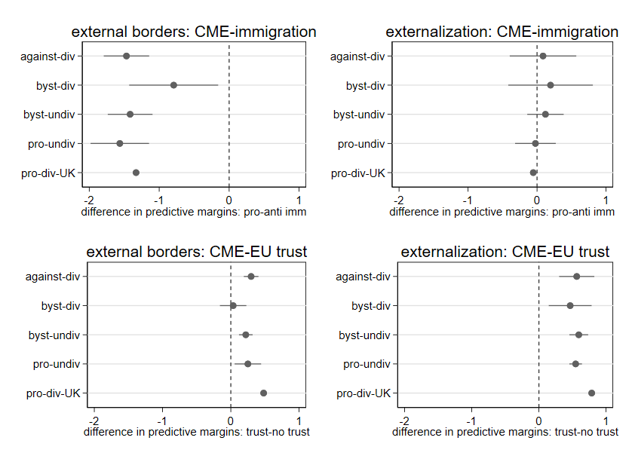

Figure A2: Contrast between effects of anti-immigration attitudes on policy support for different types of member states
