Supplementary Material for
“Judicial Inconsistency and Citizen Anti-Corruption Demobilization: Evidence from Brazil”

Government and Opposition

Letícia Barbabela

A. Full results with individual level covariates and regional fixed effects 2
B. Background information about Lula’s corruption case 4
C. Newspaper headlines on July 9, 2018 7
D. Relative salience of three types of judicial decisions on Lula’s corruption case 9
E. Survey questions and recoding 11
F. Information about survey fieldwork 16
G. Information about matching and sample size 17
H. Measuring attachment to Lula in July 2018 using the PT support indicator 19
I. Regression Discontinuity 24
J. Main models reproduced using different versions of the treatment 26
K. Robustness tests related to alternative explanations concerning media access 28
L. Analysis using Uruguayan data 29
M. Main results reproduced using non-linear models 30
N. Main results reproduced unmatched samples 34

Full results with individual level covariates and regional fixed effects

Table A.1. H.1A-B - Effects on willingness to report corruption
 |  | Willingness to report corruption
 |  | (1) |  |  | (2) |  | (3)
Treat |  | -0.196** (0.088) |  |  | -0.258** (0.100) |  | -0.235** (0.096)
Age |  | 0.021* (0.012) |  |  | 0.021* (0.012) |  | 0.020* (0.012)
Age(sq) |  | -0.240* (0.128) |  |  | -0.242* (0.128) |  | -0.236* (0.128)
Female |  | -0.001 (0.090) |  |  | -0.005 (0.090) |  | 0.002 (0.090)
Some education |  | 0.290*** (0.112) |  |  | 0.291*** (0.112) |  | 0.288** (0.112)
High education |  | 0.413*** (0.148) |  |  | 0.399*** (0.149) |  | 0.405*** (0.149)
Socioeconomic status |  | 0.030 (0.033) |  |  | 0.028 (0.033) |  | 0.030 (0.033)
Unemployed |  | -0.074 (0.167) |  |  | -0.091 (0.167) |  | -0.075 (0.167)
Catholic |  | -0.088 (0.091) |  |  | -0.092 (0.091) |  | -0.082 (0.091)
Receives social benefit |  | -0.041* (0.022) |  |  | -0.044** (0.022) |  | -0.042* (0.022)
Political knowledge |  | -0.157 (0.127) |  |  | -0.157 (0.127) |  | -0.278 (0.175)
N region |  | -0.145 (0.305) |  |  | -0.091 (0.306) |  | -0.192 (0.308)
NE region |  | -0.434*** (0.154) |  |  | -0.423*** (0.156) |  | -0.430*** (0.154)
S region |  | -0.316** (0.156) |  |  | -0.319** (0.156) |  | -0.313** (0.156)
SE region |  | -0.248* (0.149) |  |  | -0.257* (0.149) |  | -0.244 (0.149)
PT support |  |  |  |  | -0.281* (0.154)
Treat x PT |  |  |  |  | 0.293 (0.215)
Treat x benefit |  |  |  |  |  |  | 0.243 (0.241)
Constant |  | -0.013 (0.447) |  |  | 0.085 (0.451) |  | 0.026 (0.449)
Observations |  | 492 |  |  | 492 |  | 492
Note: Table shows ordinary least squares regression coefficients with standard errors in parentheses using standardized dependent variables and matched samples. Coefficients for all covariates are displayed + p<0.1; * p<0.05; ** p<0.01; *** p<0.001

Table A.2. H.2-3 - Effects on trust in institutions and corruption perceptions
 | Trust courts |  | Trust Parties | Trust Congress |  | Trust Government |  | Corruption perceptions
 | (1) |  | (2) | (3) |  | (4) |  | (5)
Treat | -0.281*** (0.091) |  | -0.004 (0.086) | -0.036 (0.093) |  | -0.026 (0.089) |  | -0.039 (0.088)
Age | -0.032** (0.012) |  | -0.033*** (0.012) | -0.064**** (0.013) |  | -0.015 (0.012) |  | 0.004 (0.012)
Age(sq) | 0.334** (0.132) |  | 0.415*** (0.126) | 0.697**** (0.136) |  | 0.194 (0.129) |  | -0.064 (0.128)
Female | 0.016 (0.093) |  | 0.020 (0.088) | 0.103 (0.096) |  | -0.022 (0.091) |  | 0.221** (0.090)
Some education | -0.013 (0.115) |  | -0.097 (0.110) | 0.131 (0.119) |  | -0.175 (0.113) |  | -0.009 (0.112)
High education | 0.170 (0.153) |  | 0.049 (0.146) | 0.167 (0.158) |  | -0.173 (0.151) |  | -0.072 (0.149)
Socioecn. status | -0.008 (0.034) |  | -0.051 (0.032) | -0.037 (0.035) |  | 0.025 (0.033) |  | 0.014 (0.033)
Unemployed | -0.046 (0.173) |  | -0.083 (0.164) | 0.081 (0.178) |  | 0.017 (0.169) |  | 0.115 (0.168)
Catholic | -0.113 (0.094) |  | -0.061 (0.090) | -0.043 (0.097) |  | -0.134 (0.093) |  | 0.143 (0.092)
Receives social benefit | 0.016 (0.131) |  | 0.185 (0.125) | 0.214 (0.135) |  | 0.252* (0.129) |  | -0.336*** (0.128)
Political knowledge | -0.032 (0.023) |  | 0.023 (0.022) | -0.004 (0.023) |  | 0.018 (0.022) |  | 0.052** (0.022)
N region | 0.250 (0.315) |  | 0.076 (0.300) | -0.036 (0.324) |  | -0.165 (0.309) |  | -0.073 (0.306)
NE region | -0.089 (0.159) |  | 0.202 (0.151) | -0.008 (0.163) |  | -0.101 (0.156) |  | 0.018 (0.154)
S region | -0.161 (0.161) |  | 0.161 (0.154) | 0.006 (0.166) |  | -0.316** (0.159) |  | -0.274* (0.157)
SE region | -0.175 (0.154) |  | 0.041 (0.146) | 0.020 (0.158) |  | -0.254* (0.151) |  | -0.175 (0.149)
Constant | 1.214*** (0.462) |  | 0.608 (0.440) | 1.422*** (0.475) |  | 0.200 (0.453) |  | -0.547 (0.449)
Observations | 492 |  | 492 | 492 |  | 492 |  | 492
Note: Table shows ordinary least squares regression coefficients with standard errors in parentheses using standardized dependent variables and matched samples. Coefficients for all covariates are displayed. + p<0.1; * p<0.05; ** p<0.01; *** p<0.001

Background information about Lula’s corruption case

This section provides a concise overview of Lula's involvement in the Car Wash investigation. Figure B.1 presents a timeline that highlights the key events related to the habeas corpus request made on July 8, 2018:

Figure B.1. Important developments before and after habeas corpus decisions on July 8, 2018

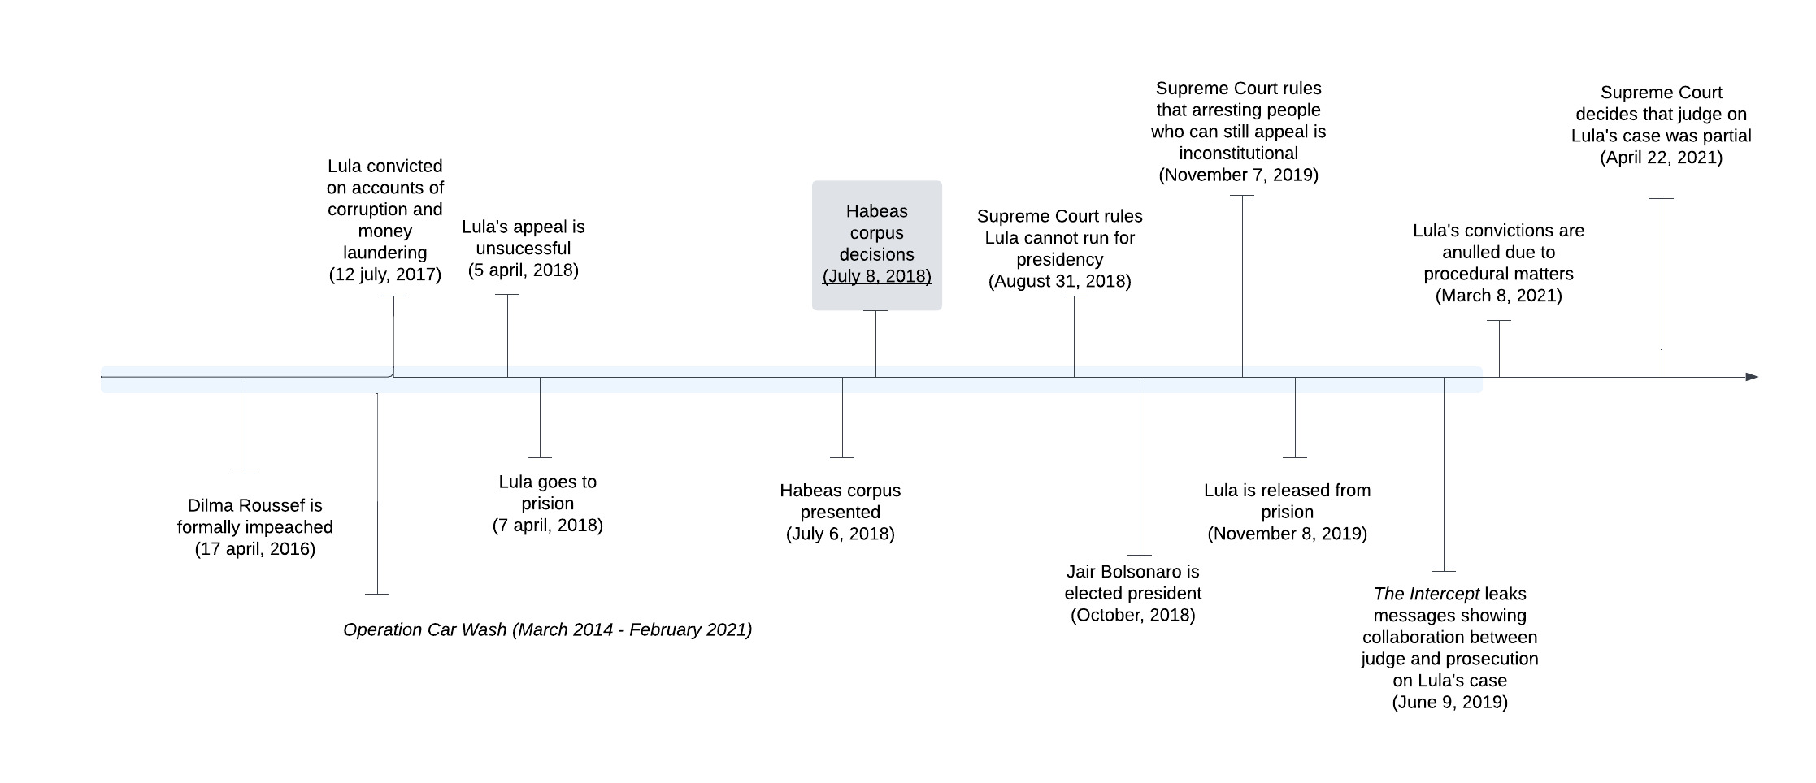

The Car Wash investigation, which took place from March 2014 to February 2021, was a major effort led by a task force comprising federal police officers and prosecutors. This investigation uncovered a large-scale embezzlement scheme within Petrobrás, a Brazilian state-owned company focused on oil, natural gas, and energy.
The outcome of the Car Wash investigation led to numerous legal cases involving corruption, money laundering, and fraud. By February 2021, there were a total of 174 convictions on various charges, including both first and second-degree convictions. Notable figures implicated in these cases included Petrobrás officials, executives from major engineering companies in Brazil, and several influential politicians, notably Lula.
Lula, who was a prominent political figure in Brazil, became the first president of the country to be found guilty of corruption and imprisoned. Prior to his presidency, Lula had a background as a union leader and was part of a generation of politicians who gained prominence during Brazil's transition to democracy. He was a co-founder of the Workers' Party (Partido dos Trabalhadores, or PT) and had run for the presidency three times before winning in 2002.
Despite the PT being embroiled in significant corruption scandals and experiencing a decline in electoral support as a result, the party's ability to win presidential elections remained somewhat intact (Zucco and Power, 2013). Lula managed to secure re-election and used his political influence to support the election of Dilma Rousseff as his successor, who also won re-election.
Even following Dilma's impeachment and prior to his arrest in 2018, Lula maintained substantial popularity as a potential presidential candidate, overshadowing Jair Bolsonaro, who eventually became president after Lula's conviction (Rennó, 2020). Leading up to the presidential election, polls from January 2018 indicated that Lula enjoyed 36% support, while Bolsonaro had 18% (Folha de São Paulo, August 22, 2018).
In July 2017, Lula was convicted and sentenced to nine years in prison for accepting and renovating an apartment valued at 3.7 million BRL, which was provided by the OAS construction company in exchange for public contracts. He appealed this verdict, and in April 2018, his sentence was extended to 12 years. Lula was incarcerated on April 7th, 2018. Three years later, the convictions were overturned by the Supreme Court due to procedural irregularities, ruling that the judge had shown bias and should not have presided over the case.
References
Brito, Ricardo and Gram Slattery. 2021. “After seven years , Brazil shuts down Car Wash anti-corruption squad.” pp. 1–8.
Casado, Letícia and Ernesto Londoño. 2019. “‘The Pendulum Has Swung Back’: Latin America’s Corruption Fight Stalls.”. URL: https://www.nytimes.com/2019/12/28/world/americas/latin-americacorruption.html
Ferreira, Flávio. 2018. “Lula permanece preso após guerra de decisões no TRF-4.”. URL: https://www1.folha.uol.com.br/poder/2018/07/lula-permanece-preso-aposguerra-de-decisoes-no-trf-4.shtml
Gielow, Igor. 2018. “Lula chega a 39 lidera.”. URL: https://www1.folha.uol.com.br/poder/2018/08/lula-chega-a-39-apontadatafolha-sem-ele-bolsonaro-lidera.shtml
Hunter, Wendy and Timothy J Power. 2007. “Rewarding Lula: Executive Power, Social Policy, and the Brazilian Elections of 2006.” Latin American Politics and Society (28636):3–20.
Londoño, Ernesto. 2017. “Ex-President of Brazil Sentenced to Nearly 10 Years in Prison for Corruption.”. URL: https://www.nytimes.com/2017/07/12/world/americas/brazil-lula-da-silvacorruption.html
Rennó, Lucio R. 2020. “The Bolsonaro Voter: Issue Positions and Vote Choice in the
2018 Brazilian Presidential Elections.” Latin American Politics and Society 62(4):1–23.
Zucco, Cesar and Timothy J Power. 2013. “Bolsa Família and the Shift in Lula’s Electoral Base , 2002-2006 : A Reply to Bohn.” Latin American Research Review 48(2):3–24.

C. Newspaper headlines on July 9, 2018

Table C.1. Newspapers’ Headlines in Brazil on July 9, 2018
Original Headline | Translated Headline | Newspaper | Link to Newspaper
Tribunal mantém Lula preso após guerra de decisões | Federal Court keeps Lula arrested after decisions’ war | Folha de São Paulo | https://www.folha.uol.com.br/
Lula permanece preso após batalha de decisões judiciais | Justice on watch: Lula remains in prison after battle of judicial decisions: Justice on watch | O Globo | https://oglobo.globo.com/
Fracassa manobra do PT para tirar Lula da cadeia | PT’s maneuver to get Lula out of jail fails | Correio Braziliense | https://www.correiobraziliense.com.br/
Embate sobre prisão de Lula expõe tensão política e jurídica | Clash concerning Lula’s prison exposes political and judicial tension | Zero Hora | https://gauchazh.clicrbs.com.br/
Lula segue preso após embate judicial | Lula remains arrested after judicial clash | Valor Econômico | https://valor.globo.com/
Tribunal barra manobra para tirar Lula da prisão | Court stops maneuver to get Lula out of jail | Estadão | https://www.estadao.com.br/
Em duelo de decisões, juiz mantém Lula preso | In duel of decisions, judge keeps Lula in prison | Diário de Pernambuco | https://www.diariodepernambuco.com.br/
Presidente de tribunal mantém Lula na cadeia | Judge president of court keeps Lula in jail | Agora São Paulo | https://agora.folha.uol.com.br/
Liberação de Lula divide TRF-4 | Lula’s freedom divides the TRF-4 [appellate court]” | Folha de Pernambuco | https://www.folhape.com.br/
Lula preso, Lula solto, Lula preso | Lula in prison, Lula free, Lula in prison | Super Notícia | https://www.otempo.com.br/super-noticia/
Lula continua lá | Lula is still there | Extra | https://extra.globo.com/
Lula livre, só que não | Lula is free, only he isn’t | Meia Hora | https://www.meiahora.com.br/
Note: Front page headlines from printed newspapers consulted using the website https://www.vercapas.com/

D. Relative salience of three types of judicial decisions on Lula’s corruption case

The unexpected July 8, 2018 habeas corpus decisions, initiated by a request from Lula's lawyers on July 7, 2018, remained off the public's radar until the actual judicial pronouncements. To validate this assertion, I analyze Google searches for "Luís Inácio Lula da Silva." I compare the search patterns before July 8 with two other judicial events (illustrated in Figure D.1). The red dashed line marks the habeas corpus event day, and the shaded area signifies the Latinobarometro survey fieldwork period.

Figure D.1. Relative salience of three judicial decisions on Lula’s corruption case
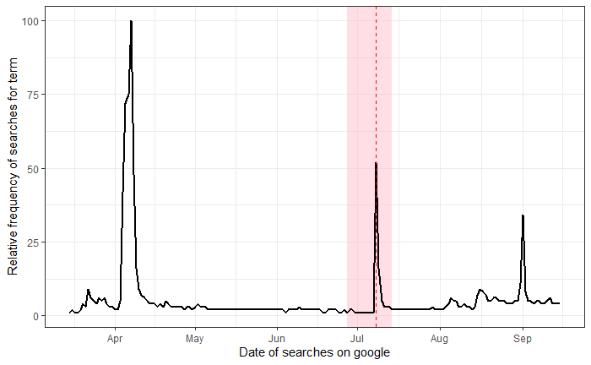

Figure D.1 shows three spikes, each coinciding with one of type of judicial decision on Lula’s case. The initial peak on the left side of the graph illustrates Judge Moro's decision to order Lula's arrest on April 5, 2018. This decision stands out more prominently compared to the subsequent decisions (depicted by the two other peaks). However, before this decision, there were noticeable fluctuations in late March, which likely reflect the growing public discourse and speculation surrounding Judge Moro's impending determination regarding Lula's arrest. Notably, on March 26, 2018, Judge Moro was interviewed on "Roda Viva," an influential interview program.

A similar pattern of anticipation emerges in the days leading up to the rightmost peak. This peak corresponds with the Supreme Court's ruling on August 31, 2018, which addressed Lula's eligibility to participate in the presidential election. Given that the official electoral campaign period had already commenced by this time, the uncertainty surrounding whether Lula could still contend for the presidency likely contributed to the heightened activity observed around August.

Conversely, the middle peak, positioned in the center of the graph and representing decisions related to the habeas corpus requests, arises after a relatively stable period of lower significance. This stable period suggests that these decisions were unexpected and had not been anticipated in a manner similar to the other events discussed.

E. Survey questions and recoding

Table E.1 – Survey questions used to operationalize variables
Variable | Survey Question | Recoded Answer
Willingness to  report corruption | Please tell me  whether you agree or disagree with the following statements: When you know of something corrupt it is better not to meddle and stay silent. | 1(agree a lot)-4 (disagree a lot)
Trust in courts, parties, congress, government | Please look at the  card and tell me, for each one of the groups, institutions, and people in the list, how much do you trust them? Courts, political parties, congress, government | 1 (no trust) – 4 (a lot of trust)
Corruption perceptions | Increase of the level of corruption in [Country] over the past year | 1 (decreased a lot) – 5 (increased a lot)
Corruption salience | What is the most important problem in your country? | 0 (does not mention corruption) – 1 (mentions corruption)
Access to journalistic sources (alternative explanation) | How do you inform yourself about politics? | Index calculated using PCA First factor extracted to indicate access to journalistic sources. See Figure E.3 and Table E.3
Age | How old are you? | Respondent’s age
Female | Respondent’s gender | 0 (Male)-1(Female)
Education | What is your highest level of education? | low (basic or less); some (at least some secondary); high (at least some tertiary).
Socioeconomic status | Does any member of your household own any of the following goods? (a) a house where the parents have their own bedroom; (b) own house; (c) computer; (e) washing machine; (f) phone; (g) mobile phone; (i) car; (j) hot water; (k) sewage; (l) at least one hot meal a day; (m) drinking water; (n) smartphone. | Index calculated using PCA. First factor extracted. See Figure E.2 and Table E.2
PT voter | If there were elections this Sunday, which party would you vote for? | 1 (Workers’ Party);  0 (other party; wouldn’t vote; null vote; don’t know; no answer).
Receives social benefit | Are you a beneficiary of an aid program run by the State | 1 (Yes);  0 (no, don’t know).
Unemployment | What is your current employment situation? | 1 (Temporarily unemployed);  0 (self employed; employed public/private retired; house work;student).
Catholic | What is your religion? | 1 (Catholic);  0 (Evangelical; Afro-brazilian religions Others;No religion; etc).
Political knowledge | From the list of institutions below, mention all the ones you know: see Table E.3. | Index calculated using PCA. First factor extracted. See Figure E.3 and Table E.3
Region | Region of Brazil | CW; N; NE; S; SE

Figure E.2 – Scree plot from principal component analysis of objective indicators of socioeconomic status
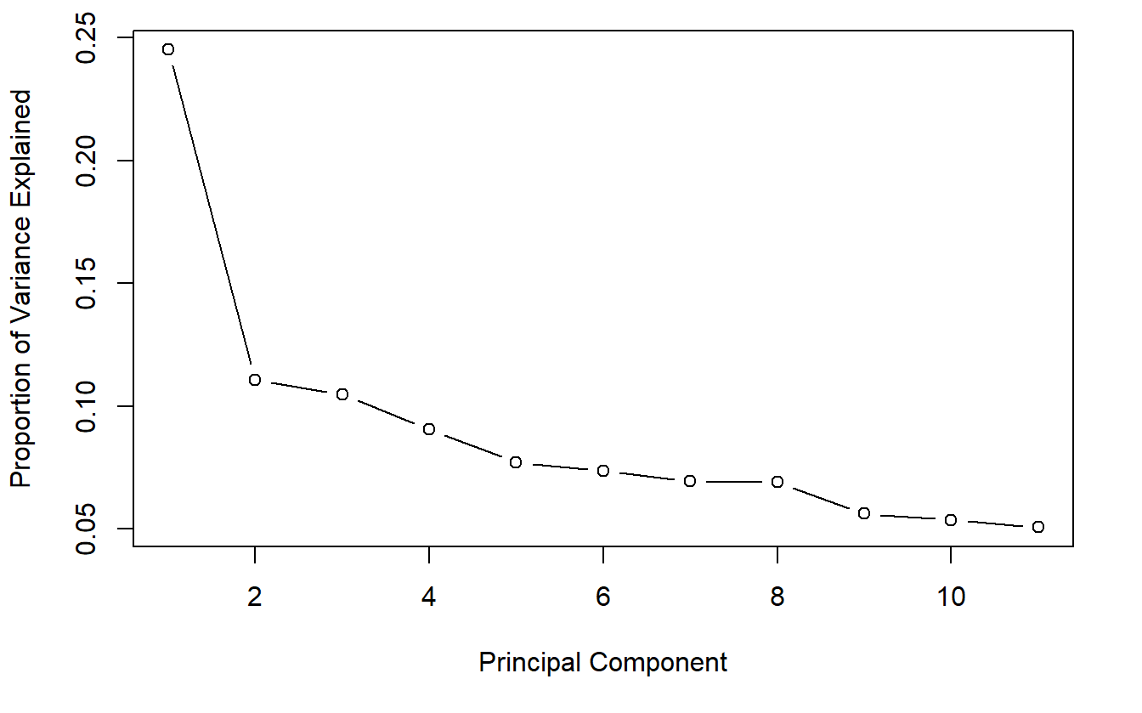

Table E.2 - PCA. Loadings of all components (Objective indicators of socioeconomic status)
 | PC 1 | PC 2 | PC 3 | PC 4 | PC 5 | PC 6 | PC 7 | PC 8 | PC 9 | PC 10 | PC 11
Room | 0.22 | 0.26 | 0.38 | 0.21 | -0.75 | -0.22 | -0.24 | -0.06 | -0.01 | -0.05 | -0.15
House | 0.13 | 0.47 | 0.43 | -0.32 | 0.08 | 0.63 | 0.03 | 0.14 | 0.12 | 0.05 | 0.19
Computer | 0.40 | 0.17 | -0.13 | -0.03 | 0.18 | -0.33 | -0.31 | 0.08 | 0.04 | 0.64 | 0.37
Mobile phone | 0.23 | -0.15 | 0.22 | 0.67 | 0.37 | 0.25 | -0.38 | 0.09 | -0.19 | -0.21 | 0.03
Washing machine | 0.41 | 0.08 | -0.08 | 0.09 | 0.01 | 0.13 | 0.48 | 0.05 | -0.51 | 0.30 | -0.45
Phone | 0.32 | 0.19 | -0.21 | -0.46 | 0.19 | -0.08 | -0.44 | -0.29 | -0.20 | -0.41 | -0.27
Car | 0.39 | 0.17 | 0.00 | 0.12 | 0.22 | -0.28 | 0.31 | 0.26 | 0.62 | -0.29 | -0.20
Water | 0.40 | -0.10 | -0.23 | 0.05 | -0.23 | 0.10 | 0.32 | -0.25 | -0.12 | -0.33 | 0.65
Sewage | 0.27 | -0.42 | -0.34 | -0.04 | -0.30 | 0.49 | -0.23 | 0.01 | 0.41 | 0.20 | -0.23
Food | 0.16 | -0.40 | 0.55 | -0.13 | 0.19 | -0.10 | 0.14 | -0.61 | 0.16 | 0.17 | -0.06
Drink | 0.19 | -0.50 | 0.29 | -0.39 | -0.07 | -0.16 | -0.04 | 0.61 | -0.22 | -0.14 | 0.09

Figure E.3 – Scree plot from principal component analysis of mentioned sources of information about politics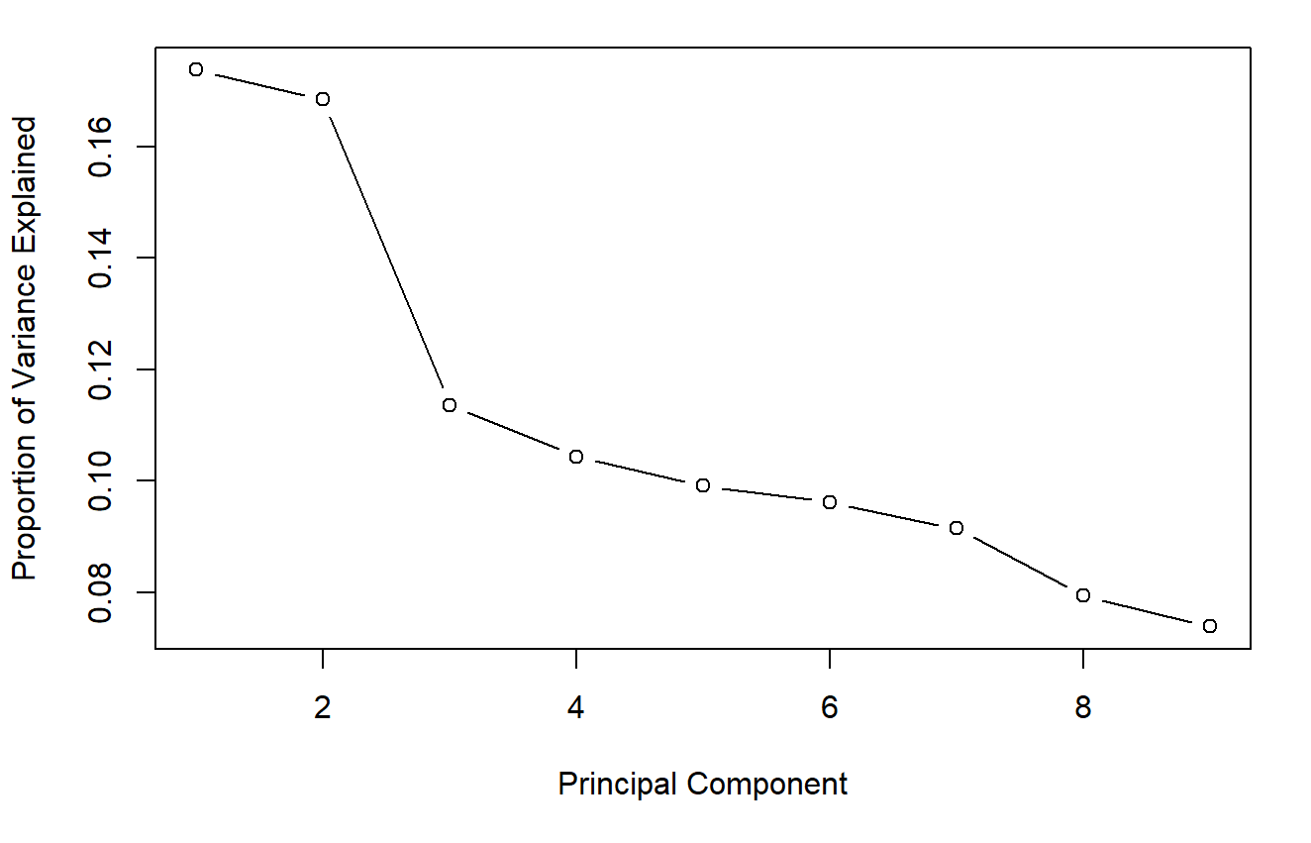
Table E.2 - PCA. Loadings of all components (Sources of information about politics)
 | PC 1 | PC 2 | PC 3 | PC 4 | PC 5 | PC 6 | PC 7 | PC 8 | PC 9
Family | -0.41 | 0.38 | 0.06 | 0.11 | -0.33 | -0.12 | -0.11 | -0.73 | -0.06
Friends | -0.42 | 0.32 | -0.12 | 0.29 | -0.04 | -0.04 | -0.55 | 0.56 | -0.12
Work colleagues | -0.14 | 0.43 | -0.01 | -0.03 | 0.34 | 0.78 | 0.25 | -0.02 | -0.02
School colleagues | -0.11 | 0.41 | 0.15 | -0.27 | 0.58 | -0.58 | 0.21 | 0.05 | -0.05
Radio | 0.27 | 0.33 | -0.28 | 0.63 | -0.14 | -0.18 | 0.44 | 0.10 | 0.30
Newspaper | 0.45 | 0.36 | 0.07 | -0.17 | -0.36 | 0.00 | 0.07 | 0.12 | -0.69
Internet | 0.37 | 0.38 | 0.33 | -0.28 | -0.17 | 0.06 | -0.35 | 0.05 | 0.61
TV | 0.46 | 0.02 | -0.25 | 0.28 | 0.49 | 0.02 | -0.51 | -0.36 | -0.15
Other | 0.03 | -0.11 | 0.84 | 0.50 | 0.12 | 0.04 | 0.03 | 0.02 | -0.13

Figure E.3 – Scree plot from principal component analysis of knowledge of international institutions

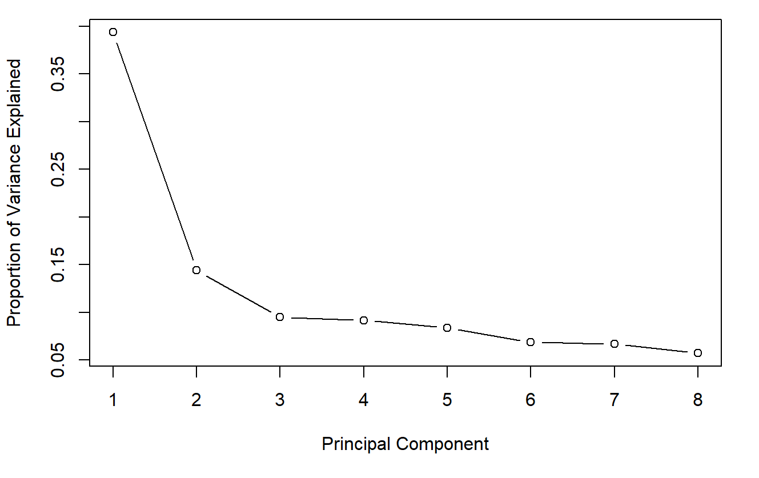
Table E.3 – PCA. Loadings of all components (Knowledge of international organization)
 | PC 1 | PC 2 | PC 3 | PC 4 | PC 5 | PC 6 | PC 7 | PC 8
UN | 0.37 | -0.42 | 0.08 | 0.18 | -0.24 | -0.47 | -0.41 | -0.45
IADB | 0.39 | 0.06 | -0.01 | -0.55 | 0.27 | 0.41 | -0.56 | -0.01
DBLA | 0.34 | 0.20 | 0.38 | 0.38 | 0.71 | -0.13 | 0.13 | -0.06
OAS | 0.39 | 0.17 | -0.15 | -0.55 | -0.05 | -0.31 | 0.58 | -0.26
UNDP | 0.28 | 0.40 | -0.76 | 0.39 | -0.03 | 0.04 | -0.12 | -0.04
ABEI | 0.23 | 0.61 | 0.48 | 0.09 | -0.56 | 0.05 | -0.11 | 0.09
IMF | 0.42 | -0.29 | -0.06 | 0.01 | -0.07 | -0.22 | 0.04 | 0.83
WB | 0.37 | -0.37 | 0.06 | 0.25 | -0.20 | 0.67 | 0.37 | -0.17
Acronyms refer to the following organizations: United Nations (UN), Inter-American Development Bank (IADB), Development Bank of Latin America (DBLA), Organization of American States (OAS), United Nations Development Program (UNDP), Central American Bank of Economic Integration (ABEI), International Monetary Fund (IMF), World Bank (WB)

F. Information about survey fieldwork

To collect data for the Latinobarometro 2018 public opinion survey in Brazil enumerators from IBOPE conducted face-to-face interviews with individuals in their households. There is no substantial difference in terms of unit non-response before and after July 8, as indicated by Table F.1:

Table F.1 - Unit non response before and after July 8, 2018
 | Before July 8th | After July 8th
Respondents interviewed | 834 | 266
Total interview attempts (rejects + interviews) | 2544 | 930
Share of unsuccessful surveys | 0.67 | 0.71

G. Information about matching and sample size

To achieve similarity in socioeconomic and regional terms, I employed matching. Matching is a method of nonparametric preprocessing suitable for improving any parametric method (Ho et al 2007:202). Although the name of this technique may suggest that observations are directly compared to their set, the goal is in fact to make the distributions of the covariates as similar as possible. Selecting the appropriate matching method depends on the characteristics of the data, the goal of the analysis, and the final balance achieved (Greiffer, 2022).

Perhaps the most intuitive approach would be to apply one-to-one exact matching, selecting identical observation in terms of subclasses, varying only in terms of treatment status. A drawback of one-to-one matching is using little of the data, producing large standard errors in the parametric analysis. In the particular case of the data used in this paper, measuring two covariates using indices (socioeconomic status and political knowledge, both rounded at just one) contributed for the impossibility of retrieving exact matches.

Gladly, inexact matching strategies (as in not one-to-one), can also improve similarity across the treatment and control groups while retaining more data. To conduct and evaluate different matching methods I used the R package MatchIt.

In all cases, it is necessary to exclude missing cases from the analysis, this leads to a reduction in the sample from 1,204 to 1,016. Following the advice by Munoz et al (2019), observations collected on July 8th – the day used to code the treatment – are also excluded (104 observations).

Following Greiffer (2022), I tried and compared three different methods: optimal pair matching, full matching, and nearest neighbor matching.

Two of these methods, usually yielding similar results, aim to select a control unit following a list (and a specific order) of treated units. Whereas in nearest neighbor matching this choice is made without reference to other pairing solutions (also called greedy matching), in the other, as indicated by its name, pair matching aims to be “optimal”. Another difference is that optimal pair matching uses the sum of the absolute pair distances as a criterion, whereas nearest neighbor uses closeness, measured according to the difference between the propensities scores, starting in descending order from units for which there are fewer close matches. Unlike nearest neighbor and optimal pair matching, optimal full matching uses all available units. As a result, balance tends to be better, but the effective sample size (ESS) can be smaller, as this matching method uses weights to accommodate every treated and control unit to a subclass.

Table G.1 shows the number of observations in the control and treated groups across the original sample (once missing cases and July 8th cases are excluded), and the three other samples generated through different matching methods.

Table G.1 - Sample size across different samples
 | Control | Treated | Discarded/Unmatched
Original sample (unmatched) | 770 | 246 | --
Optimal pair matching | 246 | 246 | 524
Full pair matching | 770 (195.25 EES) | 246 | 0
Nearest neighbor matching | 246 | 246 | 524

Figure G.2 compares the balance across the four samples matched using probit regressions. The socioeconomic and regional indicators included in the matching as covariates are on the y-axis and the x-axis shows the absolute standardized mean differences between treatment and control group. The higher the values on the x-axis, the bigger the differences between treatment and control characteristics in the sample. The four samples are indicated by the legend, where the dark crosses refer to the original sample, the yellow triangle to full pair matching, the blue circles to nearest neighbor matching, and the green squares to optimal pair matching.

Figure G.2. Covariate balance using different matching strategies in comparison with original sample

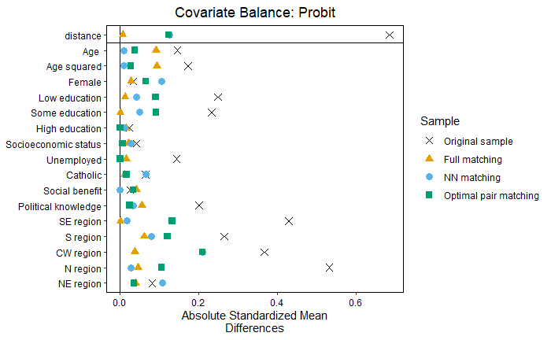
It is clear that all matching methods improve balance in comparison to the original sample, as summarized by the upper area of the graph labeled “distance”. In line with the previous discussion, the most balanced sample is the one using full pair matching, and the ones using nearest neighbor matching and optimal pair matching on average display a similar level of balance, which is reduced to around 0.2 in terms of standardized mean differences. Between these latter two methods, however nearest neighbor matching seems to be more appropriate, as it tends to provide more balance in terms of individual-level indicators. In comparison to nearest neighbor matching, optimal pair matching is more regional imbalanced, except concerning the northeast region. Full matching overall shows least imbalance in regional terms, but tends to perform worse than the other two in terms of age, social benefit and political knowledge. Another reason to choose the sample using nearest-neighbor matching is that it is a more common approach, adopted in similar applications to the one in the paper (Solaz et al 2017).

H. Measuring attachment to Lula in July 2018 using the PT support indicator

One of the strategies I employ to assess heterogeneous effects relies on the use of a dummy variable indicating support for the Workers’ Party (Partido dos Trabalhadores, or PT) to test whether motivated reasoning drives the results.

A reasonable concern to be raised in this respect relates to the possibility of post treatment bias. If that is the case, trying to assess motivated reasoning via heterogeneous effects in terms of partisan attachment would be problematic.

Exposure to corruption scandals may negatively affect support for politicians, incumbents or for a party (Muñoz et al. 2019). For instance, Hernandéz and Ares (2017) show that in Spain, a breaking news story about prominent politicians from the then incumbent Popular Party (Partido Popular, or PP) involvement in a corruption scheme - the Bárcenas Scandal - negatively affected trust in politicians. In a second study exploiting the same publication in the newspaper El País, Solaz and De Vries (2017) aim to test whether PP partisans reacted differently to the corruption scandal. They hypothesized that non-partisans would withdraw support for the incumbent (proxied as trust in government) after the Bárcenas Scandal, whereas PP partisans, out of in-group loyalty, would not.

Solaz and De Vries (2017) also consider the possibility of post treatment bias, that is, that respondents would be less likely to claim identification with the PP after the breaking news story about the Bárcenas Scandal. So before testing the hypothesis, they examine whether PP identification predicts treatment assignment of respondents (while including other covariates).

For coherence with the literature, I employ the same strategy as Solaz and De Vries (2017) to determine whether PT identification predicts treatment assignment of respondents in the habeas corpus case in Brazil. Table H.1. show the results using unmatched samples and table H.2 uses matched samples

The null results in Tables H.1. and H.2 show that PT identification does not predict the treatment assignment. As an additional test, I use PT identification (Table H.3) and placement in the left-right scale (Table H.4) as a dependent variable. Once again, the results are not statistically significant.

The results from table 4 are discrepant vis a vis survey experiments conducted in Brazil (Winters and Weitz-Shapiro, 2014 and 2015) show that even fictional prompts about mayors’ involvements in corruption may negatively change partisanship attachments. The discrepancy between the findings from Winters and Weitz-Shapiro (2014, 2015) and the ones in Tables H.1 to H.3 are probably due to two factors: the difference in nature between corruption scandals and the habeas corpus event; and the particular stage of support for the PT in July 2018, compared to when the experiments by Winters and Weitz-Shapiro (2014, 2015) were conducted in 2010, that is, during PT’s “popular” years, as I discuss later on.

Firstly, the habeas corpus event is likely to be different in nature than corruption scandals. Corruption scandals do disclose negative information about candidates - such as whether a mayor received bribes when giving out government contracts, as in the Winters and Weitz-Shapiro’s experiments - . Some citizens may consider these actions to be reproachable and as such withdraw support for the politician’s party. Substantive decisions on court cases, that is, those with repercussions in terms of acquittals or convictions potentially serve to re-expose citizens to elements of the corruption scandal, as they involve re-examination of evidence and assessments about the defendant's culpability (Magalhães 2022; Poetner and Zhang 2023). In that sense, some court decisions signal to citizens the same information as corruption scandals. However, the court decisions issued on the habeas corpus event were mainly about procedural matters, with little repercussion for the outcome regarding the defendant. The possible repercussions of the decision concerned simply whether Lula would have to await the appeal decision inside or outside prison. As such, the decisions did not involve any new information about Lula’s corruption case and it was essentially inconsequential for decisions concerning his culpability, rather, the focus was on the judge's behavior.

Still, one could argue that the null results reported in Tables H.1 to H.3 could be hiding ‘switchers’ - that is new PT sympathizers replacing defectors after the habeas corpus decisions. As the previous test included a number of individual and regional level controls, this is addressed empirically. Moreover, this is unlikely to be a significant trend, as most voters who turned away from Lula and the PT had arguably done so in the first years of the Car-Wash, which is a point I explore in more detail when I introduce the next explanation for the null results. Also those reconsidering their sympathies probably had done so to a larger extent around Lula’s conviction in 2017, when the politician was being interrogated by the judge presiding his case and depositions about his involvement in corrupt schemes were publicized in the media. Relatedly, Gonzales-Ocantos et al (2013:214) show a drop in perceptions of impartiality of the investigation around April 2017 - when Lula was convicted - but a stability in those beliefs from mid-2017 to mid-2018. Is to say, Lula’s conviction may have been a relevant signal shifting support for him or the PT - as it was a judicial decision with substantive repercussions for the outcome of his case - differently than the habeas corpus decision.

In fact, an additional explanation for the lack of association between PT support and the habeas corpus event relates to the stage of PT support in July 2018. Mass partisanship in Brazil is relatively weak, but as shown by Samuels and Zucco (2018), attachment to the PT is an exception. Studying party identification between 1986 and 2016, they show an ascending rate of PT identification throughout the 1990’s and the 2010’s, which peaks at slightly under 30% of the electorate in 2012. This was in sharp contrast with the other two parties in Brazil at the time, PMDB and PSDB, which in the same year had roughly 5% of support each. In the following years however, there was a sharp drop in PT support, reaching a historic low of roughly 10% in 2015. As indicated in section B of this supplementary information, the drop in popularity coincided with the Car Wash investigation, which started in 2014.

Beyond popularity, another relevant aspect of PT partisanship concerns the importance of the party label as a cue for its core base. In another study, Samuels and Zucco (2014) found that individuals in the PT’s base who received cues were always more likely to agree with their party. Out of the six items, in five was the difference significant. When one considers their findings in light of the political events that followed, particularly the dwindling support of the PT during the first years of the Car Wash, it is clear that party cues were not enough to maintain PT support at the 2010’s level. Which is consistent with the phenomenon indicated by Winters and Weitz-Shapiro (2014, 2015). Still, the relatively low rate of support for the PT in the midst of the Car-Wash suggests that party cues are likely to be the most important to shape policy preferences of those sticking with the party by then.

During the year of 2018, Lula was in prison and there was uncertainty on whether he would be allowed to run for presidency in October of that year, as there is a Brazilian law preventing candidates convicted for corruption from taking part in elections. Therefore in July 2018, those claiming to be willing to vote for Lula or for the PT were potentially more loyal and more intrinsically aligned with to Lula and the PT than the average supporters in the the “popular” years. To provide additional evidence for this claim, table H5 shows the results of representative public opinion surveys fielded in Brazil showing support for Lula and the PT in 2018:

The figures of support for the PT show a more stable indicator, which in all four months is roughly around 20%,. The renewal in support compared to the 2015 may have been motivated by some sympathy towards the PT after Lula’s conviction, in line with figures reported by Gonzales-Ocantos et al (2023). Still it is relevant to point out that throughout the year of 2018 support for the PT is relatively stable, and the figures are also in tune with the share of support for PT in the sample used to test the hypotheses in this paper, which is 22%, balanced across treatment and control.

These figures also suggest that Lula’s imprisonment affected support for him. But the variation in support for Lula in this case is likely to represent pragmatism rather than subjective attachment: people may have wanted to vote for him, but were unsure about whether he would be allowed to run. As such, using support for the PT is even a better indicator of using support for Lula as it is not subjected to such pragmatic fluctuations. In January, after Lula was convicted but before he went to prison he was spontaneously mentioned by roughly 17% of voters as their candidate in the elections. In April and June, after he was already imprisoned the figures were 13% and 10%. In August, a month after the habeas corpus event had taken place, support for Lula was around 20%, roughly similar to support for the PT.

Table H.1. Support for Lula and PT in Brazil, 2018 (in percentage points)
 | January | April | June | Aug
PT voter* | 18.7 | 20.5 | 19.2 | 23.9
Lula voter** | 16.8 | 13 | 10 | 19.6
Survey questions: *Preferred party PT; **In October there will be presidential elections, which candidate will you vote for? (spontaneous answers)
Source: CESOP-DATAFOLHA: 04699; 04700; 04579; 04572.

Table H.2. Predicting who is in the treatment group by PT identification (using unmatched data)
 | Being in Treatment Group
 | (1) | (2) | (3)
PT support | 0.023 (0.032) | 0.025 (0.033) | 0.033 (0.031)
Age |  | -0.005 (0.004) | -0.004 (0.004)
Age(sq) |  | 0.069* (0.041) | 0.053 (0.039)
Female |  | -0.020 (0.027) | -0.015 (0.026)
Some education |  | -0.031 (0.023) | -0.030 (0.022)
High education |  | 0.019** (0.008) | 0.013 (0.009)
Socioeconomic status |  | -0.070 (0.043) | -0.048 (0.041)
Unemployed |  | -0.042 (0.027) | -0.057** (0.025)
Catholic |  | 0.014** (0.006) | 0.011* (0.006)
Receives social benefit |  | 0.040 (0.038) | 0.033 (0.036)
Political knowledge |  |  | -0.570**** (0.068)
N region |  |  | -0.382**** (0.058)
NE region |  |  | -0.233**** (0.061)
S region |  |  | -0.488**** (0.054)
SE region | 1.237**** (0.015) | 1.165**** (0.126) | 1.605**** (0.135)
Observations | 1,100 | 1,094 | 1,094
Note: | + p<0.1; * p<0.05; ** p<0.01; *** p<0.001

Table H.3. Predicting who is in the treatment group by PT identification (using matched data)
 | Being in Treatment Group
 | (1) | (2) | (3)
PT support | 0.018 (0.055) | 0.008 (0.056) | 0.029 (0.057)
Age |  | 0.001 (0.006) | 0.001 (0.006)
Age(sq) |  | -0.003 (0.067) | -0.0004 (0.067)
Female |  | -0.054 (0.047) | -0.052 (0.047)
Some education |  | 0.045 (0.058) | 0.036 (0.058)
High education |  | 0.029 (0.078) | 0.028 (0.078)
Socioeconomic status |  | -0.008 (0.015) | -0.018 (0.017)
Unemployed |  | 0.0001 (0.087) | -0.004 (0.087)
Catholic |  | -0.032 (0.047) | -0.025 (0.048)
Receives social benefit |  | -0.002 (0.012) | -0.002 (0.012)
Political knowledge |  | 0.005 (0.067) | 0.008 (0.066)
N region |  |  | -0.219 (0.159)
NE region |  |  | -0.218*** (0.080)
S region |  |  | -0.178** (0.081)
SE region |  |  | -0.138* (0.077)
Constant | 1.496**** (0.026) | 1.563**** (0.211) | 1.798**** (0.230)
Observations | 492 | 492 | 492
Note: | + p<0.1; * p<0.05; ** p<0.01; *** p<0.001

Table H.4. Motivated reasoning additional test: Self-placement in the left-right scale and support for PT as a dependent variable
 | LR -SCALE | PT support
 | OLS | logistic
 | (1) | (2)
Treat | 0.144 (0.283) | 0.121 (0.230)
Age | -0.048 (0.039) | 0.041 (0.032)
Age(sq) | 0.740* (0.419) | -0.041 (0.032)
Female | -0.311 (0.292) | -0.489** (0.235)
Some education | -0.080 (0.365) | 0.199 (0.284)
High education | -0.246 (0.486) | -0.689 (0.444)
Socioeconomic status | 0.108 (0.114) | -0.013 (0.082)
Unemployed | -0.017 (0.531) | -0.365 (0.456)
Catholic | -0.346 (0.290) | -0.130 (0.238)
Receives social benefit | -0.090 (0.068) | -0.140 (0.322)
Political knowledge | 0.420 (0.417) | 0.015 (0.060)
N region | -0.746 (1.032) | 1.471** (0.718)
NE region | -0.224 (0.499) | 1.255** (0.438)
S region | 0.202 (0.508) | 0.331 (0.470)
SE region | -0.898* (0.479) | 0.251 (0.454)
Constant | 5.393**** (1.485) | -2.528** (1.175)
Observations | 416 | 492
Note: p<0.1; * p<0.05; ** p<0.01; *** p<0.001

I. Regression Discontinuity

Table I.1. Dynamic effects - Coefficients for each day
Days | Willingness to report corruption | Trust Courts
-11 | 0.927 (1.022) | -0.471 (1.012)
-10 | -0.463 (0.323) | -0.305 (0.320)
-9 | -0.368 (0.239) | -0.405* (0.236)
-8 | 0.105 (0.259) | -0.212 (0.256)
-7 | -0.408 (0.262) | -0.201 (0.259)
-6 | -0.442 (0.443) | 0.069 (0.438)
-5 | -0.007 (0.269) | -0.176 (0.267)
-4 | -0.206 (0.248) | -0.285 (0.245)
-3 | 0.033 (0.237) | -0.026 (0.235)
-2 | -0.264 (0.278) | -0.255 (0.275)
1 | -0.204 (0.195) | -0.293 (0.193)
2 | -0.361* (0.203) | -0.455** (0.201)
3 | -0.394* (0.215) | -0.640*** (0.213)
4 | -0.071 (0.250) | -0.509** (0.248)
5 | -0.716** (0.333) | -0.921*** (0.330)
6 | -1.264** (0.605) | 0.609 (0.599)
Note: Table shows ordinary least squares regression coefficients with standard errors in parentheses using matched samples. Time fixed effects included (days), with July 7 as reference. + p<0.1; * p<0.05; ** p<0.01; *** p<0.001

Table I.2. Results with 5-days window around 8th July
 | Willingness to report corruption | Trust in courts
 | (1) | (2)
Treat | -0.248** (0.104) | -0.346*** (0.106)
Age | 0.022 (0.014) | -0.020 (0.014)
Age(sq) | -0.264* (0.146) | 0.193 (0.149)
Female | 0.002 (0.103) | 0.086 (0.105)
Some education | 0.294** (0.127) | -0.028 (0.130)
High education | 0.333** (0.167) | 0.103 (0.170)
Socioeconomic status | 0.027 (0.038) | 0.011 (0.039)
Unemployed | -0.186 (0.189) | 0.016 (0.192)
Catholic | -0.047 (0.103) | -0.073 (0.105)
Receives social benefit | -0.060** (0.025) | -0.028 (0.025)
Political knowledge | -0.128 (0.149) | 0.041 (0.152)
N region | -0.241 (0.444) | 0.257 (0.452)
NE region | -0.407** (0.163) | -0.103 (0.167)
S region | -0.301* (0.168) | -0.216 (0.172)
SE region | -0.205 (0.158) | -0.181 (0.161)
PT support | 0.187 (0.517) | 0.831 (0.527)
Observations | 387 | 387
Note: Table shows ordinary least squares regression coefficients with standard errors in parentheses using standardized dependent variables and matched samples. Coefficients for all covariates are displayed. + p<0.1; * p<0.05; ** p<0.01; *** p<0.001

Table I.3. Results with 3-days window around 8th July
 | Willingness to report corruption | Trust in courts
 | (1) | (2)
Treat | -0.307** (0.126) | -0.406*** (0.130)
Age | 0.030* (0.016) | 0.002 (0.016)
Age(sq) | -0.366** (0.168) | -0.035 (0.174)
Female | -0.043 (0.120) | -0.055 (0.125)
Some education | 0.130 (0.149) | -0.015 (0.155)
High education | 0.319 (0.198) | 0.033 (0.205)
Socioeconomic status | 0.057 (0.043) | 0.014 (0.044)
Unemployed | -0.215 (0.204) | -0.0003 (0.211)
Catholic | -0.096 (0.120) | -0.116 (0.124)
Receives social benefit | -0.064** (0.029) | -0.029 (0.030)
Political knowledge | -0.171 (0.173) | -0.104 (0.179)
N region | -0.085 (0.457) | 0.392 (0.473)
NE region | -0.278 (0.180) | -0.036 (0.187)
S region | -0.155 (0.195) | -0.238 (0.202)
SE region | -0.179 (0.184) | -0.168 (0.191)
PT support | 0.004 (0.594) | 0.590 (0.616)
Observations | 296 | 296
Note: Table shows ordinary least squares regression coefficients with standard errors in parentheses using standardized dependent variables and matched samples. Coefficients for all covariates are displayed. + p<0.1; * p<0.05; ** p<0.01; *** p<0.001

J. Main models reproduced using different versions of the treatment

Table J.1 - Results using placebo treatment
 | Trust in Courts | Willingness to report corruption
 | (1) | (2)
Treat | 0.132 (0.125) | 0.161 (0.156)
Age | -0.055** (0.017) | 0.025 (0.021)
Age(sq) | 0.577** (0.180) | -0.302 (0.224)
Female | -0.033 (0.122) | 0.061 (0.151)
Some education | -0.022 (0.148) | 0.370* (0.184)
High education | 0.227 (0.200) | 0.586* (0.248)
Socioeconomic status | -0.024 (0.044) | 0.028 (0.055)
Unemployed | -0.436⁺ (0.223) | 0.153 (0.277)
Catholic | -0.127 (0.126) | -0.305⁺ (0.157)
Receives social benefit | -0.013 (0.030) | 0.028 (0.038)
Political knowledge | -0.032 (0.175) | -0.333 (0.217)
N region | 0.249 (0.427) | -0.041 (0.531)
NE region | -0.193 (0.241) | -0.428 (0.299)
S region | -0.091 (0.243) | -0.255 (0.302)
SE region | -0.137 (0.238) | -0.234 (0.296)
PT support | 3.807*** (0.624) | 1.932* (0.776)
Observations | 246 | 246
Note: Table shows ordinary least squares regression coefficients using placebo treatment, that is, excluding observations after July 8. Placebo treatment coded with control including interviewed between June 27 and June 30’ and treated interviewed between July 2 and July 7 -, with standard errors in parentheses using standardized dependent variables and matched samples. Coefficients for all covariates are displayed. + p<0.1; * p<0.05; ** p<0.01; *** p<0.001

Table J.2 - Results using conservative treatment
 | Willingness to report corruption | Trust Courts
 | (1) | (2)
Treat | -0.224⁺ (0.115) | -0.228* (0.091)
Age | 0.023 (0.016) | -0.032** (0.012)
Age(sq) | -0.258 (0.165) | 0.355** (0.131)
Female | -0.032 (0.116) | 0.077 (0.092)
Some education | 0.439** (0.146) | 0.010 (0.116)
High education | 0.513** (0.195) | 0.165 (0.154)
Socioeconomic status | 0.035 (0.044) | 0.00003 (0.035)
Unemployed | -0.018 (0.217) | 0.052 (0.172)
Catholic | -0.049 (0.118) | -0.115 (0.093)
Receives social benefit | -0.062* (0.029) | -0.034 (0.023)
Political knowledge | -0.092 (0.164) | 0.036 (0.130)
N region | -0.218 (0.379) | 0.330 (0.301)
NE region | -0.599** (0.207) | 0.027 (0.164)
S region | -0.494* (0.209) | -0.093 (0.166)
SE region | -0.385* (0.196) | -0.104 (0.155)
Constant | 2.714*** (0.591) | 3.138*** (0.468)
Observations | 433 | 433
Note: Table shows ordinary least squares regression coefficients using conservative treatment, that is, excluding July 6, 7, 8 observations. Placebo treatment coded with control including interviewed between June 27 and July 5 and treated interviewed between July 9 and July 14, with standard errors in parentheses using standardized dependent variables and matched samples. Coefficients for all covariates are displayed. + p<0.1; * p<0.05; ** p<0.01; *** p<0.001

K. Robustness tests related to alternative explanations concerning media access

Table K.1. – Results considering alternative explanations related to media access
 | Access to journalistic sources | Willingness to report corruption
 | (1) | (2)
Treat | 0.141 (0.180) | 0.730** (0.319)
Age | -0.035 (0.025) | 0.019 (0.012)
Age(sq) | 0.366 (0.261) | -0.229* (0.127)
Female | -0.242 (0.184) | -0.013 (0.089)
Some education | -0.283 (0.228) | 0.282** (0.111)
High education | -0.539* (0.303) | 0.423*** (0.147)
Socioeconomic status | 0.017 (0.067) | 0.024 (0.033)
Unemployed | -0.402 (0.342) | -0.076 (0.166)
Catholic | -0.416** (0.187) | -0.107 (0.091)
Receives social benefit | 0.204**** (0.045) | 0.019 (0.029)
Political knowledge | 0.287 (0.260) | -0.140 (0.126)
N region | 0.593 (0.623) | -0.206 (0.303)
NE region | -0.181 (0.314) | -0.462*** (0.153)
S region | -0.364 (0.320) | -0.337** (0.155)
SE region | -0.522* (0.304) | -0.285* (0.148)
Treat x Pol. Knowledge |  | -0.118*** (0.039)
Constant | 4.177**** (0.914) | -0.363 (0.458)
Observations | 492 | 492
Note: | p<0.1; * p<0.05; ** p<0.01; *** p<0.001

L. Analysis using Uruguayan data

As a robustness test, I reproduce the analysis using data from Uruguay. I chose this country because the Latinobarómetro fieldwork there took place around the same time as the one in Brazil. In that way I can assess whether the event of the 8th of July 2018 had any significant effects for Uruguayans - which should not be the case.

The Uruguayan data is more balanced than the Brazilian one, and the matching actually makes the balance worse, as indicated by the decreasing p-values. Thus, I perform the analysis on the unmatched sample The results are not statistically significant, reinforcing the importance of the event to the Brazilian context.

Table L.1. Balance table: Uruguayan data
 |  | Before matching |  |  | After matching
 | Range | Treat | Control | P-value | Treat | Control | P-value
Age | 18-93
Female | 0-1 | 0.54 | 0.62 | 0.050 | 0.43 | 0.62 | 0.000
Low education | 0-1 | 0.29 | 0.33 | 0.763 | 0.02 | 0.33 | 0.000
Some education | 0-1 | 0.45 | 0.50 | 0.029 | 0.07 | 0.50 | 0.000
High education | 0-1 | 0.26 | 0.17 | 0.003 | 0.91 | 0.17 | 0.000
Social status | 1-12 | 9.22 | 8.96 | 0.280 | 10.99 | 8.96 | 0.000
Region (capital) | 0-1 | 0.45 | 0.50 | 0.541 | 0.30 | 0.39 | 0.000

Table L.2. Logit regression results: Uruguayan data
 | Trust in courts |  | Will. Report corrup
 | (1) | (2) | (3) | (4)
Treat | -0.111(0.158) | -0.201(0.162) | -0.095 (0.165) | -0.203(0.172)
Individual controls | No | Yes | No | Yes
Region fixed effects | No | Yes | No | Yes
Observations | 1,056 | 1,056 | 1,056 | 1,056
Note: Controls: age, gender, education, socioeconomic status, region. Standard errors in parentheses. + p<0.10, * p<0.05, ** p<0.01, *** p<0.001

M. Main results reproduced using non-linear models

Table M.1 – Descriptive statistics of dependent variables in original ordinal form

Variable | Categories | Share of responses
Willingness to report corruption
Please tell me whether you agree or disagree with the following statements: When you know of something corrupt it is better not to get involved and stay quiet | 1 – agree a lot | 0.28
 | 2 – agree | 0.21
 | 3 – disagree | 0.15
 | 4 – disagree a lot | 0.36
Trust courts
 | 1 – no trust | 0.27
 | 2 – little trust | 0.41
 | 3 – some trust | 0.22
 | 4 – a lot of trust | 0.10
Trust congress
 | 1 – no trust | 0.50
 | 2 – little trust | 0.36
 | 3 – some trust | 0.11
 | 4 – a lot of trust | 0.03
Trust Government
 | 1 – no trust | 0.63
 | 2 – little trust | 0.30
 | 3 – some trust | 0.05
 | 4 – a lot of trust | 0.02
Trust parties
 | 1 – no trust | 0.70
 | 2 – little trust | 0.24
 | 3 – some trust | 0.04
 | 4 – a lot of trust | 0.02
Corruption perception
In your opinion, since last year, the level of corruption in your country has.. | 0 – decreased a lot | 0.01
 | 1 – decreased a little | 0.07
 | 2 – is the same | 0.14
 | 3 – increased a little | 0.15
 | 4 – increased a lot | 0.63
Corruption salience
In your opinion, what is the most serious problem in your country? | 0 – did not mention corruption | 0.85
 | 1 – mentioned corruption | 0.15

Table M.2. Effects of judicial inconsistency on willingness to report corruption using non-linear models
 | willingness to report corruption
 | (1) | (2) | (3)
Treat | 0.698** (0.170) | 0.617** (0.194) | 0.697** (0.170)
Age | 1.041* (0.023) | 1.041* (0.023) | 1.043* (0.023)
Age(sq) | 0.641* (0.242) | 0.635* (0.243) | 0.625* (0.243)
Female | 0.969 (0.174) | 0.951 (0.175) | 0.947 (0.175)
Some education | 1.790*** (0.216) | 1.786*** (0.216) | 1.773*** (0.217)
High education | 2.206*** (0.290) | 2.151*** (0.290) | 2.151*** (0.290)
Socioeconomic status | 1.066 (0.062) | 1.061 (0.062) | 1.066 (0.062)
Unemployed | 0.866 (0.331) | 0.833 (0.333) | 0.866 (0.332)
Catholic | 0.849 (0.175) | 0.850 (0.176) | 0.851 (0.176)
Receives social benefit | 0.790 (0.243) | 0.778 (0.242) | 0.693 (0.278)
Political knowledge | 0.924* (0.044) | 0.917** (0.044) | 0.924* (0.043)
N region | 0.712 (0.540) | 0.784 (0.542) | 0.779 (0.542)
NE region | 0.390*** (0.311) | 0.398*** (0.315) | 0.420*** (0.314)
S region | 0.514** (0.316) | 0.509** (0.317) | 0.515** (0.316)
SE region | 0.570* (0.303) | 0.561* (0.303) | 0.571* (0.303)
PT support |  | 0.600* (0.286) | 0.706 (0.234)
Treat x PT |  | 1.720 (0.414)
Treat x benefit |  |  | 1.621 (0.541)
Observations | 492 | 492 | 492
Note: Table shows odds ratios calculated based on ordered logit regressions with standard and matched samples. Coefficients for all covariates are displayed. + p<0.1; * p<0.05; ** p<0.01; *** p<0.001

Table M.3. Effects on trust in public institutions and corruption variables using non-linear models
 | Dependent variable:
 | Trust Courts | Trust Parties | Trust Congress | Trust Government | Corruption Perceptions | Corruption Salience
 | ordered | ordered | ordered | ordered | ordered | logistic
 | logistic | logistic | logistic | logistic | logistic
 | (1) | (2) | (3) | (4) | (5) | (6)
Treat | 0.583*** (0.169) | 1.004 (0.202) | 0.942 (0.176) | 0.937 (0.189) | 0.881 (0.187) | 0.874 (0.263)
Age | 0.942** (0.024) | 0.934** (0.027) | 0.883**** (0.025) | 0.954* (0.026) | 1.026 (0.025) | 1.035 (0.037)
Age(sq) | 1.859** (0.259) | 2.272*** (0.279) | 3.789**** (0.260) | 1.736** (0.270) | 0.763 (0.269) | 0.718 (0.392)
Female | 1.075 (0.172) | 1.095 (0.207) | 1.317 (0.181) | 1.002 (0.194) | 1.485** (0.190) | 0.527** (0.271)
Some education | 0.997 (0.212) | 0.831 (0.259) | 1.251 (0.223) | 0.710 (0.238) | 1.048 (0.239) | 1.103 (0.343)
High education | 1.385 (0.280) | 1.205 (0.337) | 1.238 (0.304) | 0.690 (0.323) | 0.906 (0.309) | 1.575 (0.422)
Socioeconomic status | 0.998 (0.064) | 0.899 (0.073) | 0.969 (0.067) | 1.051 (0.071) | 1.027 (0.072) | 1.314** (0.113)
Unemployed | 0.940 (0.323) | 0.813 (0.400) | 1.060 (0.335) | 0.977 (0.361) | 1.127 (0.351) | 0.589 (0.638)
Catholic | 0.835 (0.174) | 0.885 (0.209) | 0.903 (0.185) | 0.786 (0.197) | 1.364 (0.192) | 1.606* (0.281)
Receives social benefit | 0.971 (0.250) | 1.364 (0.280) | 1.618* (0.254) | 1.779** (0.261) | 0.503*** (0.259) | 2.021* (0.383)
Political knowledge | 0.934 (0.042) | 1.027 (0.050) | 0.995 (0.044) | 1.030 (0.048) | 1.119** (0.047) | 0.969 (0.061)
N region | 1.553 (0.572) | 1.143 (0.707) | 0.849 (0.597) | 0.741 (0.616) | 0.993 (0.647) | 1.503 (0.886)
NE region | 0.767 (0.281) | 1.594 (0.369) | 0.976 (0.305) | 0.717 (0.316) | 1.214 (0.336) | 0.661 (0.445)
S region | 0.665 (0.292) | 1.573 (0.376) | 0.972 (0.311) | 0.480** (0.330) | 0.547* (0.326) | 0.959 (0.418)
SE region | 0.629* (0.277) | 1.119 (0.367) | 0.949 (0.297) | 0.597* (0.306) | 0.719 (0.316) | 0.613 (0.420)
Constant |  |  |  |  |  | 0.013*** (1.409)
Observations | 492 | 492 | 492 | 492 | 492 | 492
Note: Table shows odds ratios calculated based on ordered logit regressions or logit regressions, as indicated in the columns, with standard and matched samples. Coefficients for all covariates are displayed. + p<0.1; * p<0.05; ** p<0.01; *** p<0.001

N. Main results reproduced unmatched samples

Table N.1. - Effects of judicial inconsistency on willingness to report corruption using unmatched samples
 | willingness to report corruption
 | (1) | (2) | (3) | (4) | (5)
Treat | -0.107 (0.071) | -0.153** (0.074) | -0.109 (0.073) | -0.146* (0.082) | -0.124 (0.079)
Age |  |  | 0.008 (0.009) | 0.008 (0.009) | 0.007 (0.009)
Age(sq) |  |  | -0.104 (0.094) | -0.111 (0.094) | -0.104 (0.094)
Female |  |  | -0.036 (0.061) | -0.044 (0.061) | -0.035 (0.061)
Some education |  |  | 0.096 (0.077) | 0.086 (0.077) | 0.096 (0.077)
High education |  |  | 0.264** (0.104) | 0.253** (0.104) | 0.264** (0.104)
Socioeconomic status |  |  | 0.048** (0.021) | 0.047** (0.021) | 0.049** (0.021)
Unemployed |  |  | -0.049 (0.098) | -0.050 (0.098) | -0.049 (0.098)
Catholic |  |  | -0.039 (0.061) | -0.036 (0.061) | -0.038 (0.061)
Receives social benefit |  |  | -0.063**** (0.014) | -0.064**** (0.014) | -0.063**** (0.014)
Political knowledge |  |  | -0.079 (0.086) | -0.082 (0.086) | -0.102 (0.099)
N region |  | -0.425** (0.169) | -0.262 (0.166) | -0.249 (0.167) | -0.264 (0.166)
NE region |  | -0.610**** (0.140) | -0.424*** (0.140) | -0.419*** (0.141) | -0.422*** (0.140)
S region |  | -0.314** (0.152) | -0.292** (0.147) | -0.298** (0.147) | -0.290** (0.147)
SE region |  | -0.329** (0.137) | -0.336** (0.133) | -0.344** (0.134) | -0.335** (0.133)
PT support |  |  |  | -0.159* (0.086)
Treat x PT |  |  |  | 0.183 (0.169)
Treat x benefit |  |  |  |  | 0.089 (0.188)
Constant | 0.026 (0.035) | 0.431*** (0.134) | 0.332 (0.315) | 0.381 (0.317) | 0.334 (0.315)
Observations | 1,075 | 1,075 | 1,071 | 1,071 | 1,071
Note: Table shows ordinary least squares regression coefficients with standard errors in parentheses using standardized dependent variables and unmatched samples. Coefficients for all covariates are displayed + p<0.1; * p<0.05; ** p<0.01; *** p<0.001

Table N.2. Effects of judicial inconsistency on trust in institutions and corruption perceptions using unmatched samples
 | Trust courts | Trust Parties | Trust Congress | Trust Government | Corruption perceptions
 | (1) | (2) | (3) | (4) | (5)
Treat | -0.188*** (0.070) | -0.028 (0.050) | -0.019 (0.057) | -0.053 (0.051) | -0.068 (0.080)
Age | -0.024*** (0.008) | -0.020**** (0.006) | -0.044**** (0.007) | -0.011* (0.006) | 0.009 (0.009)
Age(sq) | 0.253*** (0.089) | 0.242**** (0.065) | 0.458**** (0.074) | 0.126* (0.065) | -0.099 (0.101)
Female | 0.005 (0.058) | -0.036 (0.042) | 0.064 (0.047) | -0.038 (0.043) | 0.277**** (0.066)
Some education | -0.126* (0.074) | -0.113** (0.053) | 0.049 (0.060) | -0.102* (0.054) | -0.033 (0.084)
High education | -0.051 (0.100) | -0.032 (0.072) | 0.037 (0.081) | -0.071 (0.073) | -0.082 (0.113)
Socioecn. status | 0.013 (0.020) | -0.035** (0.015) | -0.018 (0.017) | -0.010 (0.015) | 0.026 (0.023)
Unemployed | 0.005 (0.095) | 0.068 (0.068) | -0.023 (0.076) | 0.045 (0.069) | -0.001 (0.107)
Catholic | 0.006 (0.059) | 0.005 (0.042) | 0.017 (0.048) | 0.005 (0.043) | 0.038 (0.067)
Receives social benefit | 0.007 (0.083) | -0.010 (0.060) | 0.133* (0.068) | 0.037 (0.061) | -0.091 (0.095)
Political knowledge | -0.031** (0.014) | 0.019** (0.010) | 0.006 (0.011) | 0.013 (0.010) | 0.058**** (0.015)
N region | 0.072 (0.159) | 0.071 (0.115) | -0.006 (0.129) | -0.051 (0.117) | -0.404** (0.182)
NE region | -0.181 (0.134) | 0.133 (0.097) | -0.049 (0.109) | -0.052 (0.099) | 0.056 (0.153)
S region | -0.157 (0.141) | 0.087 (0.102) | -0.049 (0.114) | -0.213** (0.103) | -0.291* (0.161)
SE region | -0.105 (0.128) | 0.137 (0.093) | 0.030 (0.104) | -0.131 (0.094) | -0.223 (0.146)
Constant | 3.007**** (0.301) | 1.825**** (0.217) | 2.571**** (0.246) | 1.820**** (0.221) | 2.525**** (0.342)
Observations | 1,066 | 1,078 | 1,060 | 1,084 | 1,063
Note: Table shows ordinary least squares regression coefficients with standard errors in parentheses using standardized dependent variables and unmatched samples. Coefficients for all covariates are displayed + p<0.1; * p<0.05; ** p<0.01; *** p<0.001

