Supplementary Material

The Relationship between Economic Populist Sovereignism, Globalization and Populist Radical Right Politics: Voter Attitudes in Western Europe and the United States,
Government and Opposition

Oscar Mazzoleni¹ and Gilles Ivaldi²

¹Institute of Political Studies, University of Lausanne, Lausanne, Switzerland.
²Cevipof, Science-Po Paris, Paris, France

June 2023

A Survey items of economic populist, sovereignist and globalization
Economic Populism

- The overall economic well-being of this country has declined compared to the past
- Today in our country, many economic decisions are made without considering the interests of the people
- In this country, one does not really care about people who work hard
- In our country, politicians don’t really care about the people’s living standard
- Citizens should have more say in the economic decisions of our country

Economic Sovereignism

- Our country must regain control of its economic destiny
- To guarantee its well-being, our country should be able to close its economic borders
- We must strengthen our national sovereignty to ensure more social justice

Globalization

- To ensure economic prosperity, our country should work more together with other countries
- Globalization is an opportunity for economic growth in our country
- Globalization increases inequalities in our country
- International trade leads to jobs creation in our country

All items were a 7-point Likert scale ranging from 1 ‘Strongly disagree’ to 7 ‘Strongly agree’

A Descriptive statistics for economic populist, sovereignist and globalization items by country

Item | Country | n | mean | sd | min | max
WellBeingCountryDecline | France | 1739 | 5.55 | 1.48 | 1 | 7
WellBeingCountryDecline | Germany | 1742 | 4.71 | 1.76 | 1 | 7
WellBeingCountryDecline | Italy | 1762 | 5.84 | 1.36 | 1 | 7
WellBeingCountryDecline | Switzerland | 1652 | 4.61 | 1.68 | 1 | 7
WellBeingCountryDecline | United States | 2273 | 5.11 | 1.92 | 1 | 7
NoInterestofPeople | France | 1819 | 5.78 | 1.46 | 1 | 7
NoInterestofPeople | Germany | 1803 | 5.26 | 1.54 | 1 | 7
NoInterestofPeople | Italy | 1762 | 5.69 | 1.46 | 1 | 7
NoInterestofPeople | Switzerland | 1716 | 5.05 | 1.62 | 1 | 7
NoInterestofPeople | United States | 2331 | 5.81 | 1.45 | 1 | 7
NoCareWorkHard | France | 1831 | 5.61 | 1.54 | 1 | 7
NoCareWorkHard | Germany | 1796 | 4.93 | 1.73 | 1 | 7
NoCareWorkHard | Italy | 1754 | 5.64 | 1.44 | 1 | 7
NoCareWorkHard | Switzerland | 1750 | 4.70 | 1.72 | 1 | 7
NoCareWorkHard | United States | 2251 | 4.22 | 1.94 | 1 | 7
PoliticiansIgnoreLivingStds | France | 1836 | 5.87 | 1.47 | 1 | 7
PoliticiansIgnoreLivingStds | Germany | 1820 | 5.06 | 1.68 | 1 | 7
PoliticiansIgnoreLivingStds | Italy | 1779 | 5.91 | 1.41 | 1 | 7
PoliticiansIgnoreLivingStds | Switzerland | 1760 | 4.90 | 1.73 | 1 | 7
PoliticiansIgnoreLivingStds | United States | 2361 | 5.69 | 1.50 | 1 | 7
CitizenHaveMoreSay | France | 1818 | 5.48 | 1.48 | 1 | 7
CitizenHaveMoreSay | Germany | 1786 | 4.82 | 1.59 | 1 | 7
CitizenHaveMoreSay | Italy | 1753 | 5.31 | 1.60 | 1 | 7
CitizenHaveMoreSay | Switzerland | 1758 | 4.95 | 1.50 | 1 | 7
CitizenHaveMoreSay | United States | 2293 | 5.53 | 1.44 | 1 | 7
CountryRegainControlEcoDestiny | France | 1813 | 5.92 | 1.22 | 1 | 7
CountryRegainControlEcoDestiny | Germany | 1748 | 5.32 | 1.47 | 1 | 7
CountryRegainControlEcoDestiny | Italy | 1766 | 5.81 | 1.39 | 1 | 7
CountryRegainControlEcoDestiny | Switzerland | 1694 | 5.06 | 1.49 | 1 | 7
CountryRegainControlEcoDestiny | United States | 2253 | 5.69 | 1.42 | 1 | 7
ProsperityWorkOtherCountries | France | 1678 | 4.42 | 1.63 | 1 | 7
ProsperityWorkOtherCountries | Germany | 1744 | 4.95 | 1.47 | 1 | 7
ProsperityWorkOtherCountries | Italy | 1706 | 4.97 | 1.62 | 1 | 7
ProsperityWorkOtherCountries | Switzerland | 1713 | 4.79 | 1.63 | 1 | 7
ProsperityWorkOtherCountries | United States | 2241 | 5.03 | 1.67 | 1 | 7
WellBeingCloseEcoBorders | France | 1692 | 4.05 | 1.99 | 1 | 7
WellBeingCloseEcoBorders | Germany | 1651 | 3.97 | 1.85 | 1 | 7
WellBeingCloseEcoBorders | Italy | 1666 | 3.62 | 2.04 | 1 | 7
WellBeingCloseEcoBorders | Switzerland | 1678 | 3.47 | 1.94 | 1 | 7
WellBeingCloseEcoBorders | United States | 2108 | 4.11 | 2.08 | 1 | 7
MoreNatSovMoreSocialJustice | France | 1637 | 5.07 | 1.63 | 1 | 7
MoreNatSovMoreSocialJustice | Germany | 1715 | 4.85 | 1.65 | 1 | 7
MoreNatSovMoreSocialJustice | Italy | 1645 | 4.61 | 1.94 | 1 | 7
MoreNatSovMoreSocialJustice | Switzerland | 1587 | 4.71 | 1.60 | 1 | 7
MoreNatSovMoreSocialJustice | United States | 1929 | 4.70 | 1.86 | 1 | 7
GlobalizationEcoGrowth | France | 1692 | 3.90 | 1.72 | 1 | 7
GlobalizationEcoGrowth | Germany | 1745 | 4.76 | 1.52 | 1 | 7
GlobalizationEcoGrowth | Italy | 1698 | 4.46 | 1.76 | 1 | 7
GlobalizationEcoGrowth | Switzerland | 1680 | 4.36 | 1.60 | 1 | 7
GlobalizationEcoGrowth | United States | 2050 | 4.40 | 1.96 | 1 | 7
GlobalizationIncreaseInequalities | France | 1710 | 5.41 | 1.58 | 1 | 7
GlobalizationIncreaseInequalities | Germany | 1687 | 4.58 | 1.66 | 1 | 7
GlobalizationIncreaseInequalities | Italy | 1672 | 4.63 | 1.79 | 1 | 7
GlobalizationIncreaseInequalities | Switzerland | 1670 | 4.57 | 1.70 | 1 | 7
GlobalizationIncreaseInequalities | United States | 1905 | 4.16 | 1.95 | 1 | 7
InternationalTradeJobCreation | France | 1704 | 4.46 | 1.62 | 1 | 7
InternationalTradeJobCreation | Germany | 1742 | 5.03 | 1.41 | 1 | 7
InternationalTradeJobCreation | Italy | 1710 | 5.07 | 1.52 | 1 | 7
InternationalTradeJobCreation | Switzerland | 1680 | 4.89 | 1.40 | 1 | 7
InternationalTradeJobCreation | United States | 2129 | 4.84 | 1.66 | 1 | 7

A Exploratory Factor Analysis (EFA) – Pooled data
EFA is a method that reduces data to a smaller set of summary variables and allows to explore and interpret the underlying theoretical structure of the data. EFA is appropriate when the goal of the research is to create a measurement instrument that reflects meaningful underlying latent dimensions or constructs represented in the observed variables. In such context, researchers want to identify groups of variables, each of which has high correlations with only one factor, and to interpret and label each factor (Fabrigar et al. 1999).

For the purpose of the analysis, we pool all five countries together and run a preliminary parallel analysis to determine the number of factors that should be retained from EFA to correctly represent the data. Parallel analysis advises retaining a number of factors equal to the number of eigenvalues obtained for random data that are smaller than the eigenvalues in the observed data (Fabrigar et al. 1999). Preliminary parallel analysis suggests that 3 factors should be retained.

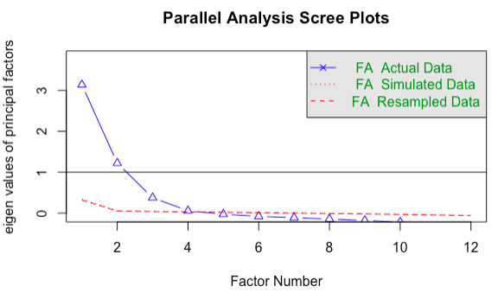

Consequently, we run EFA retaining the proposed 3-factor solution. EFA is performed using oblique rotation (oblimin) and polychoric correlation matrix for ordinal data. Oblique rotation assumes that there is a correlation between the factors, which is the most likely situation as regards our data.

We use Ordinary Least Squared/Minres factoring which is known to provide results similar to Maximum Likelihood without assuming multivariate normal distribution, and which derives solutions through iterative eigendecomposition (Harman and Wayne 1966).

Standardized loadings (pattern matrix) based upon correlation matrix

MR1 MR2 MR3
SS loadings 2.41 1.62 1.37
Proportion Var 0.20 0.13 0.11
Cumulative Var 0.20 0.34 0.45

Factor Loadings (pooled data)

 | MR1 | MR2 | MR3
WellBeingCountryDecline | 0.587 | 0.063 | 0.039
NoInterestofPeople | 0.771 | 0.013 | -0.009
NoCareWorkHard | 0.582 | -0.012 | 0.026
PoliticiansIgnoreLivingStds | 0.770 | -0.067 | -0.042
CitizenHaveMoreSay | 0.513 | 0.072 | 0.190
CountryRegainControlEcoDestiny | 0.271 | 0.051 | 0.491
ProsperityWorkOtherCountries | 0.109 | 0.648 | -0.126
WellBeingCloseEcoBorders | -0.019 | -0.251 | 0.565
MoreNatSovMoreSocialJustice | 0.015 | 0.056 | 0.711
GlobalizationEcoGrowth | -0.036 | 0.714 | -0.038
GlobalizationIncreaseInequalities | 0.239 | -0.293 | 0.250
InternationalTradeJobCreation | -0.057 | 0.691 | 0.133

A Exploratory Factor Analysis (EFA) – Individual countries

EFA France
(Analytical sample N=1334)

The root mean square of the residuals (RMSA) is 0.03
The df corrected root mean square of the residuals is 0.04

Tucker Lewis Index of factoring reliability = 0.94
RMSEA index = 0.057 and the 10 % confidence intervals are 0.049 0.065
BIC = -62.6
With factor correlations of
MR1 MR2 MR3
MR1 1.00 -0.25 0.58
MR2 -0.25 1.00 -0.25
MR3 0.58 -0.25 1.00

France
 | MR1 | MR2 | MR3
WellBeingCountryDecline | 0.450 | 0.047 | 0.283
NoInterestofPeople | 0.811 | -0.012 | -0.064
NoCareWorkHard | 0.536 | 0.048 | 0.146
PoliticiansIgnoreLivingStds | 0.789 | -0.018 | -0.022
CitizenHaveMoreSay | 0.579 | -0.008 | 0.082
CountryRegainControlEcoDestiny | 0.239 | 0.094 | 0.461
ProsperityWorkOtherCountries | 0.114 | 0.627 | -0.124
WellBeingCloseEcoBorders | 0.024 | -0.250 | 0.526
MoreNatSovMoreSocialJustice | 0.026 | 0.030 | 0.663
GlobalizationEcoGrowth | -0.051 | 0.681 | -0.017
GlobalizationIncreaseInequalities | 0.424 | -0.198 | 0.213
InternationalTradeJobCreation | -0.070 | 0.690 | 0.102

EFA Italy
(Analytical sample N=1444)

The root mean square of the residuals (RMSA) is 0.03
The df corrected root mean square of the residuals is 0.04

Tucker Lewis Index of factoring reliability = 0.934
RMSEA index = 0.06 and the 10 % confidence intervals are 0.052 0.068
BIC = -35.6
With factor correlations of
MR1 MR2 MR3
MR1 1.00 -0.14 0.57
MR2 -0.14 1.00 -0.26
MR3 0.57 -0.26 1.00

Italy
 | MR1 | MR2 | MR3
WellBeingCountryDecline | 0.629 | 0.009 | -0.029
NoInterestofPeople | 0.755 | -0.036 | 0.066
NoCareWorkHard | 0.595 | 0.037 | 0.092
PoliticiansIgnoreLivingStds | 0.757 | -0.053 | -0.102
CitizenHaveMoreSay | 0.396 | 0.056 | 0.377
CountryRegainControlEcoDestiny | 0.472 | 0.062 | 0.328
ProsperityWorkOtherCountries | 0.134 | 0.547 | -0.247
WellBeingCloseEcoBorders | -0.001 | -0.207 | 0.601
MoreNatSovMoreSocialJustice | 0.075 | 0.042 | 0.735
GlobalizationEcoGrowth | -0.110 | 0.751 | 0.045
GlobalizationIncreaseInequalities | 0.229 | -0.307 | 0.184
InternationalTradeJobCreation | 0.064 | 0.582 | 0.047

EFA Germany
(Analytical sample N=1375)

The root mean square of the residuals (RMSA) is 0.02
The df corrected root mean square of the residuals is 0.03

Tucker Lewis Index of factoring reliability = 0.965
RMSEA index = 0.046 and the 10 % confidence intervals are 0.038 0.054
BIC = -110
With factor correlations of
MR1 MR2 MR3
MR1 1.00 -0.14 0.63
MR2 -0.14 1.00 -0.15
MR3 0.63 -0.15 1.00

Germany
 | MR1 | MR2 | MR3
WellBeingCountryDecline | 0.333 | -0.088 | 0.346
NoInterestofPeople | 0.837 | 0.015 | -0.026
NoCareWorkHard | 0.557 | -0.042 | 0.121
PoliticiansIgnoreLivingStds | 0.697 | -0.080 | 0.096
CitizenHaveMoreSay | 0.572 | 0.082 | 0.117
CountryRegainControlEcoDestiny | 0.191 | 0.151 | 0.591
ProsperityWorkOtherCountries | 0.221 | 0.668 | -0.206
WellBeingCloseEcoBorders | 0.034 | -0.194 | 0.584
MoreNatSovMoreSocialJustice | 0.056 | 0.040 | 0.707
GlobalizationEcoGrowth | -0.180 | 0.700 | 0.035
GlobalizationIncreaseInequalities | 0.406 | -0.204 | 0.129
InternationalTradeJobCreation | -0.058 | 0.748 | 0.119

EFA Switzerland
(Analytical sample N=1319)

The root mean square of the residuals (RMSA) is 0.02
The df corrected root mean square of the residuals is 0.03

Tucker Lewis Index of factoring reliability = 0.954
RMSEA index = 0.048 and the 10 % confidence intervals are 0.039 0.056
BIC = -105
With factor correlations of
MR1 MR3 MR2
MR1 1.00 0.56 -0.17
MR3 0.56 1.00 -0.19
MR2 -0.17 -0.19 1.00

Switzerland
 | MR1 | MR3 | MR2
WellBeingCountryDecline | 0.307 | 0.341 | -0.067
NoInterestofPeople | 0.790 | -0.018 | 0.044
NoCareWorkHard | 0.595 | 0.066 | -0.078
PoliticiansIgnoreLivingStds | 0.787 | -0.020 | -0.049
CitizenHaveMoreSay | 0.505 | 0.185 | 0.111
CountryRegainControlEcoDestiny | 0.115 | 0.656 | 0.065
ProsperityWorkOtherCountries | 0.099 | -0.138 | 0.618
WellBeingCloseEcoBorders | -0.058 | 0.628 | -0.221
MoreNatSovMoreSocialJustice | 0.035 | 0.684 | 0.096
GlobalizationEcoGrowth | -0.057 | 0.011 | 0.653
GlobalizationIncreaseInequalities | 0.318 | 0.208 | -0.283
InternationalTradeJobCreation | -0.078 | 0.138 | 0.613

EFA United States
(Analytical sample N=1441)

The root mean square of the residuals (RMSA) is 0.03
The df corrected root mean square of the residuals is 0.04

Tucker Lewis Index of factoring reliability = 0.923
RMSEA index = 0.057 and the 10 % confidence intervals are 0.049 0.065
BIC = -51.1
With factor correlations of
MR1 MR2 MR3
MR1 1.00 0.36 -0.32
MR2 0.36 1.00 0.00
MR3 -0.32 0.00 1.00

United States
 | MR1 | MR2 | MR3
WellBeingCountryDecline | 0.210 | 0.503 | -0.094
NoInterestofPeople | 0.010 | 0.718 | -0.022
NoCareWorkHard | -0.002 | 0.452 | -0.022
PoliticiansIgnoreLivingStds | -0.114 | 0.636 | 0.025
CitizenHaveMoreSay | 0.169 | 0.468 | 0.222
CountryRegainControlEcoDestiny | -0.018 | 0.140 | 0.546
ProsperityWorkOtherCountries | 0.748 | 0.122 | -0.017
WellBeingCloseEcoBorders | -0.359 | -0.048 | 0.505
MoreNatSovMoreSocialJustice | 0.115 | -0.065 | 0.627
GlobalizationEcoGrowth | 0.717 | 0.025 | -0.117
GlobalizationIncreaseInequalities | -0.291 | 0.081 | 0.336
InternationalTradeJobCreation | 0.722 | -0.086 | 0.124

A Multigroup Confirmatory Factor Analysis (MGCFA)
CFA is typically used to test the fit of a model obtained from exploratory factor analysis or a previously existing theoretical model with the data in the sample. CFA allows the researcher to test the hypothesis that a relationship between the observed variables and their underlying latent constructs exists in their data (Harrington 2009).

Group 1 [France]:

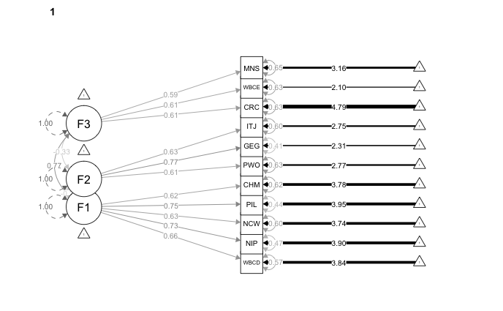

Latent Variables:
Estimate Std.Err z-value P(>|z|) Std.lv Std.all
F1 =~
WllBngCntryDcl 0.949 0.030 31.987 0.000 0.949 0.655
NoInterestfPpl 1.077 0.032 33.600 0.000 1.077 0.731
NoCareWorkHard 0.951 0.031 30.304 0.000 0.951 0.632
PltcnsIgnrLvnS 1.107 0.032 34.571 0.000 1.107 0.748
CitizenHavMrSy 0.895 0.028 31.855 0.000 0.895 0.617
F2 =~
PrsprtyWrkOthC 0.960 0.049 19.581 0.000 0.960 0.606
GlblztnEcGrwth 1.300 0.061 21.350 0.000 1.300 0.769
IntrntnlTrdJbC 1.023 0.051 19.975 0.000 1.023 0.634
F3 =~
CntryRgnCntrED 0.754 0.028 26.614 0.000 0.754 0.611
WllBngClsEcBrd 1.188 0.044 27.302 0.000 1.188 0.610
MrNtSvMrSclJst 0.947 0.036 26.203 0.000 0.947 0.591

Covariances:
Estimate Std.Err z-value P(>|z|) Std.lv Std.all
F1 ~~
F2 -0.271 0.017 -15.702 0.000 -0.271 -0.271
F3 0.769 0.027 28.099 0.000 0.769 0.769
F2 ~~
F3 -0.334 0.027 -12.358 0.000 -0.334 -0.334

Intercepts:
Estimate Std.Err z-value P(>|z|) Std.lv Std.all
.WllBngCntryDcl 5.552 0.039 141.131 0.000 5.552 3.835
.NoInterestfPpl 5.747 0.040 143.578 0.000 5.747 3.902
.NoCareWorkHard 5.623 0.041 137.596 0.000 5.623 3.739
.PltcnsIgnrLvnS 5.838 0.040 145.172 0.000 5.838 3.945
.CitizenHavMrSy 5.495 0.039 139.254 0.000 5.495 3.784
.PrsprtyWrkOthC 4.388 0.043 101.993 0.000 4.388 2.772
.GlblztnEcGrwth 3.908 0.046 85.027 0.000 3.908 2.311
.IntrntnlTrdJbC 4.434 0.044 101.037 0.000 4.434 2.746
.CntryRgnCntrED 5.908 0.034 176.200 0.000 5.908 4.788
.WllBngClsEcBrd 4.089 0.053 77.278 0.000 4.089 2.100
.MrNtSvMrSclJst 5.063 0.044 116.301 0.000 5.063 3.161
F1 0.000 0.000 0.000
F2 0.000 0.000 0.000
F3 0.000 0.000 0.000

Variances:
Estimate Std.Err z-value P(>|z|) Std.lv Std.all
.WllBngCntryDcl 1.195 0.106 11.279 0.000 1.195 0.571
.NoInterestfPpl 1.010 0.120 8.424 0.000 1.010 0.465
.NoCareWorkHard 1.357 0.114 11.953 0.000 1.357 0.600
.PltcnsIgnrLvnS 0.963 0.122 7.906 0.000 0.963 0.440
.CitizenHavMrSy 1.307 0.096 13.560 0.000 1.307 0.620
.PrsprtyWrkOthC 1.585 0.132 12.050 0.000 1.585 0.632
.GlblztnEcGrwth 1.170 0.183 6.406 0.000 1.170 0.409
.IntrntnlTrdJbC 1.561 0.141 11.109 0.000 1.561 0.599
.CntryRgnCntrED 0.954 0.085 11.167 0.000 0.954 0.627
.WllBngClsEcBrd 2.380 0.145 16.470 0.000 2.380 0.628
.MrNtSvMrSclJst 1.669 0.115 14.559 0.000 1.669 0.650
F1 1.000 1.000 1.000
F2 1.000 1.000 1.000
F3 1.000 1.000 1.000

Group 2 [Italy]:

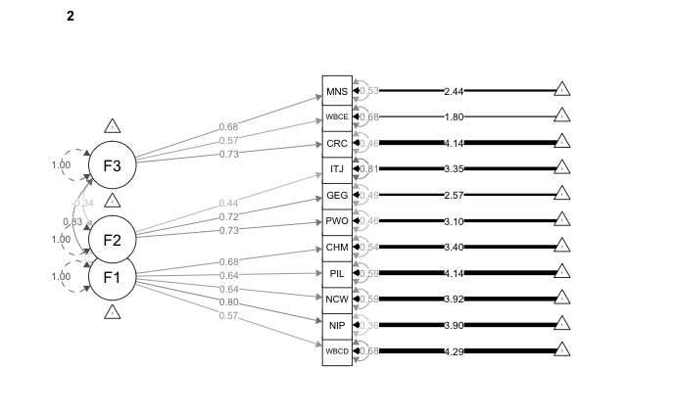

Latent Variables:
Estimate Std.Err z-value P(>|z|) Std.lv Std.all
F1 =~
WllBngCntryDcl 0.773 0.024 32.125 0.000 0.773 0.568
NoInterestfPpl 1.163 0.030 39.017 0.000 1.163 0.797
NoCareWorkHard 0.926 0.027 33.846 0.000 0.926 0.644
PltcnsIgnrLvnS 0.915 0.027 33.787 0.000 0.915 0.643
CitizenHavMrSy 1.064 0.029 37.301 0.000 1.064 0.678
F2 =~
PrsprtyWrkOthC 1.176 0.061 19.274 0.000 1.176 0.733
GlblztnEcGrwth 1.246 0.065 19.143 0.000 1.246 0.716
IntrntnlTrdJbC 0.664 0.043 15.434 0.000 0.664 0.440
F3 =~
CntryRgnCntrED 1.028 0.031 33.212 0.000 1.028 0.735
WllBngClsEcBrd 1.154 0.036 31.653 0.000 1.154 0.567
MrNtSvMrSclJst 1.297 0.039 33.109 0.000 1.297 0.683

Covariances:
Estimate Std.Err z-value P(>|z|) Std.lv Std.all
F1 ~~
F2 -0.187 0.017 -11.179 0.000 -0.187 -0.187
F3 0.832 0.025 33.840 0.000 0.832 0.832
F2 ~~
F3 -0.337 0.024 -14.001 0.000 -0.337 -0.337

Intercepts:
Estimate Std.Err z-value P(>|z|) Std.lv Std.all
.WllBngCntryDcl 5.830 0.036 163.522 0.000 5.830 4.285
.NoInterestfPpl 5.685 0.038 148.722 0.000 5.685 3.898
.NoCareWorkHard 5.644 0.038 149.570 0.000 5.644 3.920
.PltcnsIgnrLvnS 5.888 0.037 157.873 0.000 5.888 4.137
.CitizenHavMrSy 5.329 0.041 129.642 0.000 5.329 3.398
.PrsprtyWrkOthC 4.964 0.042 118.115 0.000 4.964 3.095
.GlblztnEcGrwth 4.478 0.046 98.110 0.000 4.478 2.571
.IntrntnlTrdJbC 5.062 0.040 127.854 0.000 5.062 3.351
.CntryRgnCntrED 5.789 0.037 157.826 0.000 5.789 4.136
.WllBngClsEcBrd 3.661 0.053 68.601 0.000 3.661 1.798
.MrNtSvMrSclJst 4.635 0.050 93.189 0.000 4.635 2.442
F1 0.000 0.000 0.000
F2 0.000 0.000 0.000
F3 0.000 0.000 0.000

Variances:
Estimate Std.Err z-value P(>|z|) Std.lv Std.all
.WllBngCntryDcl 1.254 0.088 14.172 0.000 1.254 0.678
.NoInterestfPpl 0.776 0.110 7.049 0.000 0.776 0.365
.NoCareWorkHard 1.214 0.103 11.769 0.000 1.214 0.586
.PltcnsIgnrLvnS 1.189 0.110 10.814 0.000 1.189 0.587
.CitizenHavMrSy 1.329 0.107 12.432 0.000 1.329 0.540
.PrsprtyWrkOthC 1.190 0.173 6.888 0.000 1.190 0.463
.GlblztnEcGrwth 1.480 0.189 7.825 0.000 1.480 0.488
.IntrntnlTrdJbC 1.841 0.105 17.523 0.000 1.841 0.807
.CntryRgnCntrED 0.902 0.110 8.163 0.000 0.902 0.460
.WllBngClsEcBrd 2.815 0.129 21.817 0.000 2.815 0.679
.MrNtSvMrSclJst 1.920 0.145 13.264 0.000 1.920 0.533
F1 1.000 1.000 1.000
F2 1.000 1.000 1.000
F3 1.000 1.000 1.000

Group 3 [Germany]:

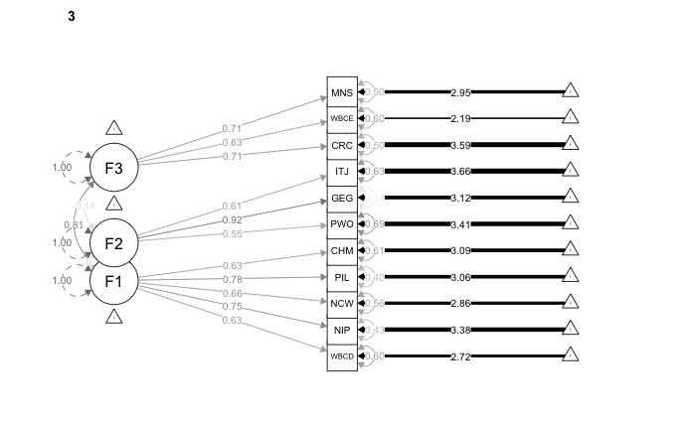

Latent Variables:
Estimate Std.Err z-value P(>|z|) Std.lv Std.all
F1 =~
WllBngCntryDcl 1.100 0.031 35.048 0.000 1.100 0.632
NoInterestfPpl 1.167 0.030 39.377 0.000 1.167 0.752
NoCareWorkHard 1.139 0.032 35.997 0.000 1.139 0.661
PltcnsIgnrLvnS 1.291 0.032 40.546 0.000 1.291 0.777
CitizenHavMrSy 0.985 0.027 35.982 0.000 0.985 0.627
F2 =~
PrsprtyWrkOthC 0.807 0.047 17.268 0.000 0.807 0.554
GlblztnEcGrwth 1.411 0.073 19.226 0.000 1.411 0.925
IntrntnlTrdJbC 0.840 0.047 17.834 0.000 0.840 0.609
F3 =~
CntryRgnCntrED 1.046 0.033 32.131 0.000 1.046 0.710
WllBngClsEcBrd 1.150 0.037 31.087 0.000 1.150 0.629
MrNtSvMrSclJst 1.164 0.036 32.024 0.000 1.164 0.708

Covariances:
Estimate Std.Err z-value P(>|z|) Std.lv Std.all
F1 ~~
F2 -0.226 0.017 -13.358 0.000 -0.226 -0.226
F3 0.806 0.024 33.834 0.000 0.806 0.806
F2 ~~
F3 -0.184 0.022 -8.362 0.000 -0.184 -0.184

Intercepts:
Estimate Std.Err z-value P(>|z|) Std.lv Std.all
.WllBngCntryDcl 4.731 0.046 101.775 0.000 4.731 2.720
.NoInterestfPpl 5.239 0.041 126.405 0.000 5.239 3.378
.NoCareWorkHard 4.922 0.046 106.899 0.000 4.922 2.857
.PltcnsIgnrLvnS 5.087 0.044 114.483 0.000 5.087 3.060
.CitizenHavMrSy 4.851 0.042 115.575 0.000 4.851 3.089
.PrsprtyWrkOthC 4.979 0.039 127.778 0.000 4.979 3.415
.GlblztnEcGrwth 4.756 0.041 116.632 0.000 4.756 3.117
.IntrntnlTrdJbC 5.056 0.037 137.094 0.000 5.056 3.664
.CntryRgnCntrED 5.293 0.039 134.348 0.000 5.293 3.591
.WllBngClsEcBrd 4.000 0.049 81.847 0.000 4.000 2.187
.MrNtSvMrSclJst 4.850 0.044 110.305 0.000 4.850 2.948
F1 0.000 0.000 0.000
F2 0.000 0.000 0.000
F3 0.000 0.000 0.000

Variances:
Estimate Std.Err z-value P(>|z|) Std.lv Std.all
.WllBngCntryDcl 1.816 0.114 15.968 0.000 1.816 0.600
.NoInterestfPpl 1.044 0.111 9.416 0.000 1.044 0.434
.NoCareWorkHard 1.671 0.119 14.055 0.000 1.671 0.563
.PltcnsIgnrLvnS 1.098 0.121 9.101 0.000 1.098 0.397
.CitizenHavMrSy 1.497 0.095 15.755 0.000 1.497 0.607
.PrsprtyWrkOthC 1.473 0.111 13.279 0.000 1.473 0.693
.GlblztnEcGrwth 0.337 0.225 1.498 0.134 0.337 0.145
.IntrntnlTrdJbC 1.199 0.109 11.029 0.000 1.199 0.630
.CntryRgnCntrED 1.078 0.110 9.794 0.000 1.078 0.496
.WllBngClsEcBrd 2.020 0.127 15.908 0.000 2.020 0.604
.MrNtSvMrSclJst 1.351 0.127 10.668 0.000 1.351 0.499
F1 1.000 1.000 1.000
F2 1.000 1.000 1.000
F3 1.000 1.000 1.000

Group 4 [Switzerland]:

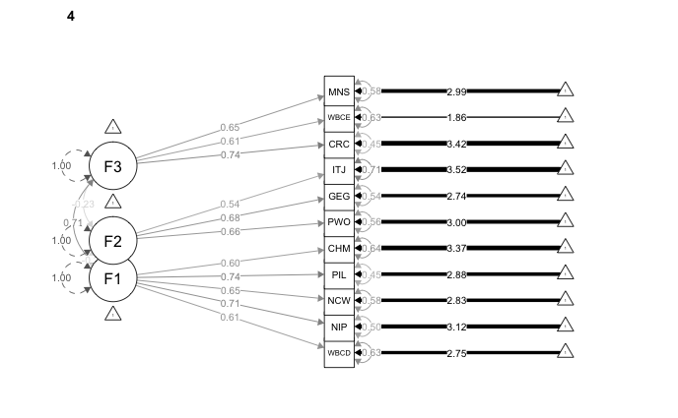

Latent Variables:
Estimate Std.Err z-value P(>|z|) Std.lv Std.all
F1 =~
WllBngCntryDcl 1.020 0.033 30.610 0.000 1.020 0.609
NoInterestfPpl 1.151 0.034 34.004 0.000 1.151 0.710
NoCareWorkHard 1.083 0.033 32.384 0.000 1.083 0.648
PltcnsIgnrLvnS 1.271 0.035 36.062 0.000 1.271 0.744
CitizenHavMrSy 0.892 0.029 30.768 0.000 0.892 0.603
F2 =~
PrsprtyWrkOthC 1.066 0.064 16.535 0.000 1.066 0.663
GlblztnEcGrwth 1.077 0.065 16.597 0.000 1.077 0.677
IntrntnlTrdJbC 0.752 0.048 15.561 0.000 0.752 0.542
F3 =~
CntryRgnCntrED 1.093 0.037 29.277 0.000 1.093 0.740
WllBngClsEcBrd 1.166 0.043 27.241 0.000 1.166 0.605
MrNtSvMrSclJst 1.026 0.038 27.305 0.000 1.026 0.652

Covariances:
Estimate Std.Err z-value P(>|z|) Std.lv Std.all
F1 ~~
F2 -0.211 0.020 -10.587 0.000 -0.211 -0.211
F3 0.706 0.024 29.479 0.000 0.706 0.706
F2 ~~
F3 -0.233 0.027 -8.777 0.000 -0.233 -0.233

Intercepts:
Estimate Std.Err z-value P(>|z|) Std.lv Std.all
.WllBngCntryDcl 4.599 0.046 100.131 0.000 4.599 2.747
.NoInterestfPpl 5.051 0.044 113.584 0.000 5.051 3.116
.NoCareWorkHard 4.728 0.046 103.124 0.000 4.728 2.829
.PltcnsIgnrLvnS 4.929 0.047 105.169 0.000 4.929 2.885
.CitizenHavMrSy 4.977 0.041 122.724 0.000 4.977 3.366
.PrsprtyWrkOthC 4.833 0.044 109.521 0.000 4.833 3.004
.GlblztnEcGrwth 4.351 0.044 99.777 0.000 4.351 2.737
.IntrntnlTrdJbC 4.879 0.038 128.319 0.000 4.879 3.520
.CntryRgnCntrED 5.049 0.041 124.647 0.000 5.049 3.419
.WllBngClsEcBrd 3.590 0.053 67.956 0.000 3.590 1.864
.MrNtSvMrSclJst 4.706 0.043 108.962 0.000 4.706 2.989
F1 0.000 0.000 0.000
F2 0.000 0.000 0.000
F3 0.000 0.000 0.000

Variances:
Estimate Std.Err z-value P(>|z|) Std.lv Std.all
.WllBngCntryDcl 1.764 0.113 15.624 0.000 1.764 0.629
.NoInterestfPpl 1.304 0.120 10.874 0.000 1.304 0.496
.NoCareWorkHard 1.620 0.115 14.109 0.000 1.620 0.580
.PltcnsIgnrLvnS 1.305 0.125 10.402 0.000 1.305 0.447
.CitizenHavMrSy 1.391 0.093 14.992 0.000 1.391 0.636
.PrsprtyWrkOthC 1.451 0.167 8.667 0.000 1.451 0.561
.GlblztnEcGrwth 1.368 0.165 8.269 0.000 1.368 0.541
.IntrntnlTrdJbC 1.356 0.106 12.782 0.000 1.356 0.706
.CntryRgnCntrED 0.986 0.116 8.467 0.000 0.986 0.452
.WllBngClsEcBrd 2.350 0.142 16.583 0.000 2.350 0.634
.MrNtSvMrSclJst 1.427 0.118 12.099 0.000 1.427 0.576
F1 1.000 1.000 1.000
F2 1.000 1.000 1.000
F3 1.000 1.000 1.000

Group 5 [United States]:

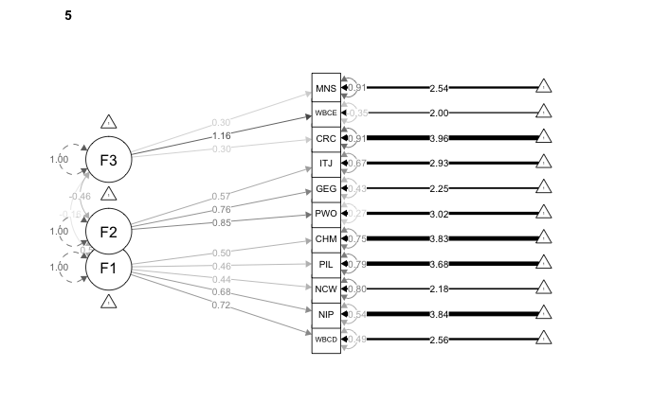

Latent Variables:
Estimate Std.Err z-value P(>|z|) Std.lv Std.all
F1 =~
WllBngCntryDcl 1.396 0.049 28.613 0.000 1.396 0.716
NoInterestfPpl 1.016 0.037 27.612 0.000 1.016 0.682
NoCareWorkHard 0.853 0.041 21.007 0.000 0.853 0.443
PltcnsIgnrLvnS 0.696 0.033 21.064 0.000 0.696 0.456
CitizenHavMrSy 0.719 0.031 23.415 0.000 0.719 0.505
F2 =~
PrsprtyWrkOthC 1.414 0.043 32.928 0.000 1.414 0.852
GlblztnEcGrwth 1.473 0.046 32.165 0.000 1.473 0.756
IntrntnlTrdJbC 0.948 0.035 26.935 0.000 0.948 0.572
F3 =~
CntryRgnCntrED 0.435 0.032 13.546 0.000 0.435 0.305
WllBngClsEcBrd 2.400 0.145 16.588 0.000 2.400 1.164
MrNtSvMrSclJst 0.557 0.043 12.952 0.000 0.557 0.304

Covariances:
Estimate Std.Err z-value P(>|z|) Std.lv Std.all
F1 ~~
F2 0.495 0.020 24.472 0.000 0.495 0.495
F3 -0.163 0.019 -8.582 0.000 -0.163 -0.163
F2 ~~
F3 -0.463 0.030 -15.544 0.000 -0.463 -0.463

Intercepts:
Estimate Std.Err z-value P(>|z|) Std.lv Std.all
.WllBngCntryDcl 4.987 0.050 99.346 0.000 4.987 2.558
.NoInterestfPpl 5.728 0.038 149.341 0.000 5.728 3.845
.NoCareWorkHard 4.186 0.050 84.492 0.000 4.186 2.175
.PltcnsIgnrLvnS 5.617 0.039 143.126 0.000 5.617 3.685
.CitizenHavMrSy 5.459 0.037 148.884 0.000 5.459 3.833
.PrsprtyWrkOthC 5.015 0.043 117.284 0.000 5.015 3.019
.GlblztnEcGrwth 4.389 0.050 87.504 0.000 4.389 2.253
.IntrntnlTrdJbC 4.859 0.043 113.926 0.000 4.859 2.933
.CntryRgnCntrED 5.653 0.037 153.970 0.000 5.653 3.964
.WllBngClsEcBrd 4.121 0.053 77.600 0.000 4.121 1.998
.MrNtSvMrSclJst 4.655 0.047 98.695 0.000 4.655 2.541
F1 0.000 0.000 0.000
F2 0.000 0.000 0.000
F3 0.000 0.000 0.000

Variances:
Estimate Std.Err z-value P(>|z|) Std.lv Std.all
.WllBngCntryDcl 1.854 0.176 10.527 0.000 1.854 0.487
.NoInterestfPpl 1.188 0.119 9.981 0.000 1.188 0.535
.NoCareWorkHard 2.975 0.115 25.810 0.000 2.975 0.803
.PltcnsIgnrLvnS 1.840 0.103 17.815 0.000 1.840 0.792
.CitizenHavMrSy 1.512 0.090 16.814 0.000 1.512 0.745
.PrsprtyWrkOthC 0.758 0.152 4.993 0.000 0.758 0.275
.GlblztnEcGrwth 1.625 0.169 9.603 0.000 1.625 0.428
.IntrntnlTrdJbC 1.847 0.115 16.016 0.000 1.847 0.673
.CntryRgnCntrED 1.845 0.093 19.901 0.000 1.845 0.907
.WllBngClsEcBrd -1.505 0.701 -2.146 0.032 -1.505 -0.354
.MrNtSvMrSclJst 3.047 0.109 27.997 0.000 3.047 0.908
F1 1.000 1.000 1.000
F2 1.000 1.000 1.000
F3 1.000 1.000 1.000

Let us note that the standardized loading for the item on ‘closing economic borders’ is above 1 and that it has negative variance, which is typical of a ‘Heywood case’. Such problem is primarily due to non-normality of that particular item in American sample, however not significantly affecting the overall quality of the model’s fit.

A Mokken scales of economic populist, sovereignist and globalization attitudes
We first test a scale of Economic Populism (EcoPop) from the 5 items retained in the first factor of CFA. The coefficient of homogeneity for the scale in the pooled data is 0.44 (s.e.=0.006), which suggests a ‘moderate’ Mokken scale. Standard errors are very small due to the large sample size and the 95% confidence intervals around the value of H_{i} do not include the lower bound cut-off. The second Mokken scale refers to Positive Views of Globalization (Global). It has a coefficient of 0.49 (s.e.=0.005) which is just below the conventional threshold for a ‘strong’ scale. Finally, the third scale refers to Economic Sovereignism (EcoSov). The coefficient of homogeneity is 0.43 (s.e.=0.006) which again suggests a moderate scale.

All three scales have high internal coherence and they meet the classic IRT assumptions of unidimensionality, local independence of items and monotonicity. We test all three scales for unidimensionality, local independence and monotonicity. The internal consistency reliability of our scales is estimated by the reliability coefficient Rho (a.k.a. Molenaar Sijtsma statistic), values of which should exceed 0.70. We also provide the Cronbach's alpha. In order to assess inter-item and item-to-total correlations, we use bootstrapped polychoric correlations. This method is a suitable tool to (i) evaluate the strength of inter-item relationships between normally distributed continuous latent variables when these are ordinal; (ii) consider the appropriateness of scoring them together on a single scale, and (iii) investigate local dependency (Van Hauwaert et al. 2019).

All details of the three Mokken scales of economic populist, sovereignist and globalization attitudes are provided below. All inter-item correlation coefficients are significant (at p<0.05) and below 0.80, which indicates they are positively, yet not too highly, correlated, thus confirming conditional association –i.e. local independence– of items across the three scales. Values of the Rho coefficient are all above 0.7, showing good internal consistency reliability. We find no significant deviation from monotonicity with all Crit values below the conventional 0.4 threshold –with just one exception of the Crit index for the item concerning national sovereignty as a means to ensure social justice, which is 0.4, thus suggesting only moderate violation of monotonicity in the Economic Sovereignism scale.

Summary Table of Mokken scales of economic populist, sovereignist and globalization attitudes

Indicator | Eco. Populism | Eco. Sovereignism | Positive Globalization
H | 0.44 | 0.43 | 0.49
Range of H_{i} | 0.40-0.50 | 0.42-0.44 | 0.48-0.50
Reliability (Rho) | 0.8 | 0.7 | 0.7
Cronbach’s Alpha | 0.8 | 0.7 | 0.7
Inter-items correlations | 0.4 to 0.7  All p < 0.05 | 0.4 to 0.5  All p < 0.05 | 0.5  All p < 0.05
Monotonicity | All crit < 0.4 | All crit ⩽ 0.4 | All crit < 0.4

A Graded Response Model for polytomous items
Tables below show item parameters for each of the three Mokken scales constructed from IRT analysis. Item information trace lines are shown in the corresponding figures. We also show the distribution of the IRT scores calculated from the GRM.

Economic Populism

 | a | b1 | b2 | b3 | b4 | b5 | b6
WellBeingCountryDecline | 1.54 | -2.62 | -2.02 | -1.44 | -0.745 | 0.027 | 0.737
NoInterestofPeople | 2.85 | -2.35 | -1.92 | -1.40 | -0.833 | -0.218 | 0.364
NoCareWorkHard | 1.55 | -2.47 | -1.92 | -1.33 | -0.636 | 0.123 | 0.856
PoliticiansIgnoreLivingStds | 2.59 | -2.38 | -1.91 | -1.35 | -0.801 | -0.252 | 0.313
CitizenHaveMoreSay | 1.65 | -3.03 | -2.39 | -1.67 | -0.750 | 0.095 | 0.820

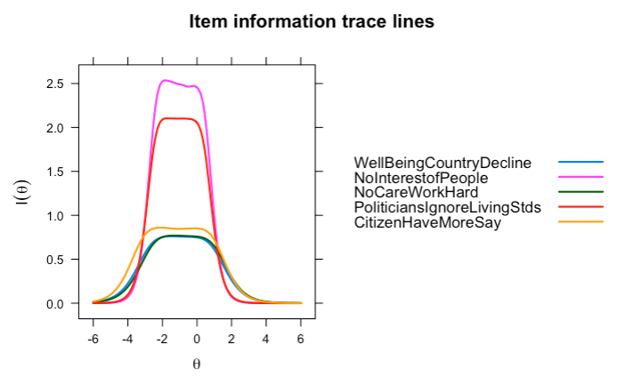
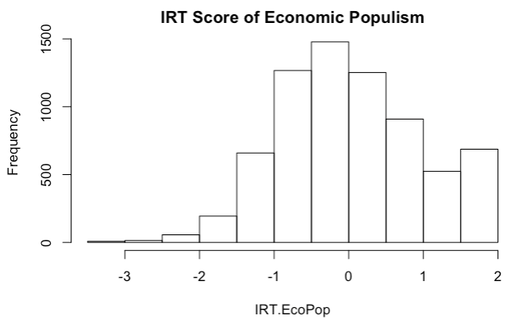

Globalization positive

 | a | b1 | b2 | b3 | b4 | b5 | b6
ProsperityWorkOtherCountries | 1.93 | -2.23 | -1.87 | -1.266 | -0.361 | 0.514 | 1.17
GlobalizationEcoGrowth | 2.05 | -1.68 | -1.35 | -0.833 | -0.057 | 0.788 | 1.50
InternationalTradeJobCreation | 1.85 | -2.37 | -1.93 | -1.346 | -0.429 | 0.523 | 1.34

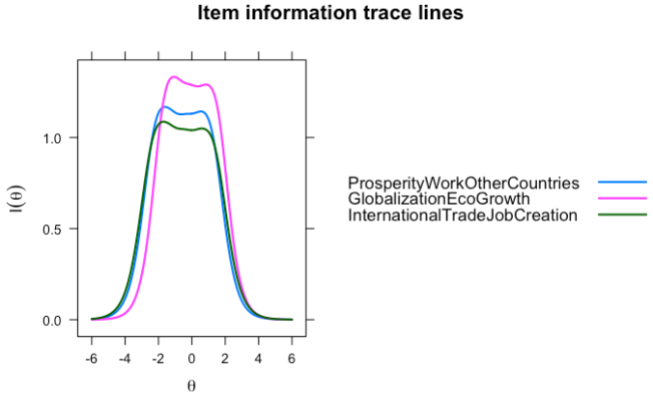
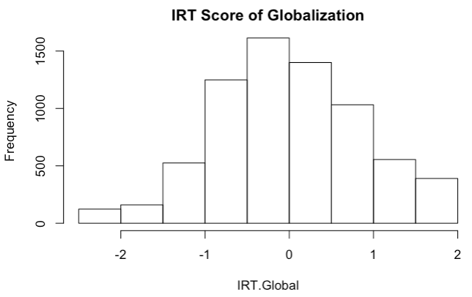

Economic Sovereignism

 | a | b1 | b2 | b3 | b4 | b5 | b6
CountryRegainControlEcoDestiny | 1.70 | -3.10 | -2.583 | -1.974 | -1.065 | -0.182 | 0.553
WellBeingCloseEcoBorders | 1.42 | -1.48 | -0.942 | -0.396 | 0.365 | 1.090 | 1.677
MoreNatSovMoreSocialJustice | 2.04 | -2.01 | -1.611 | -1.092 | -0.293 | 0.439 | 1.023

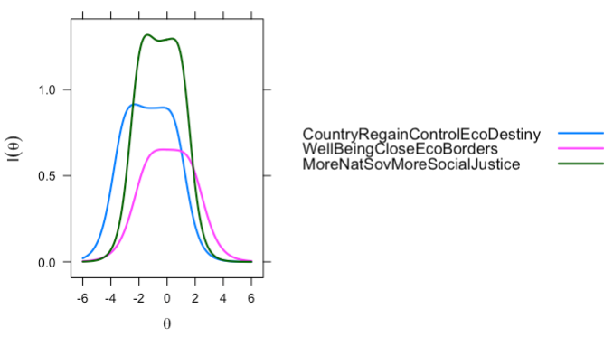
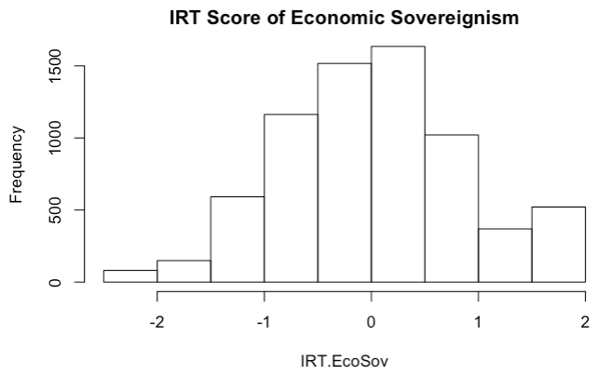

A Binary logistic regressions of radical right populist voting in Europe and the United States
Here we show the details for the binary logistic regressions of RRP voting in Europe and the United States. We first present the model for the pooled European countries, then the results for similar analyses conducted for each country individually.

Pooled European countries (France, Italy, Germany and Switzerland)

Model 1. Radical right populist voting European countries
 | Dependent variable:
 | VoteRRP
GenderFemale | -0.215** (0.094)
AgeContinuous | -0.012*** (0.003)
EducationRMiddle | -0.027 (0.121)
EducationRHigh | -0.285** (0.134)
ImmigrantsEnrichCulture | -0.335*** (0.027)
TakeRichGivePoor | -0.164*** (0.025)
MoreLawOrder | 0.233*** (0.029)
EcoPop | 0.274*** (0.068)
Global | -0.600*** (0.061)
EcoSov | 0.692*** (0.078)
countrygermany | -0.284* (0.150)
countryitaly | 1.530*** (0.137)
countryswiss | 1.320*** (0.146)
Constant | -0.378 (0.311)
Observations | 3,880
Log Likelihood | -1,484.000
Akaike Inf. Crit. | 2,995.000
Note: | *p<0.1; **p<0.05; ***p<0.01

United States

Model 2. Trump versus Biden in the United States
 | Dependent variable:
 | VoteRRP
GenderFemale | -0.504** (0.198)
AgeContinuous | -0.005 (0.006)
EducationRMiddle | -0.071 (0.236)
EducationRHigh | 0.259 (0.254)
ImmigrantsEnrichCulture | -0.222*** (0.068)
TakeRichGivePoor | -0.423*** (0.054)
MoreLawOrder | 0.547*** (0.055)
EcoPop | -0.711*** (0.149)
Global | -1.050*** (0.142)
EcoSov | 1.040*** (0.175)
Constant | 0.249 (0.577)
Observations | 1,350
Log Likelihood | -346.000
Akaike Inf. Crit. | 714.000
Note: | *p<0.1; **p<0.05; ***p<0.01

Similar models for individual European countries are shown below.

France

Radical right populist voting in France
 | Dependent variable:
 | VoteRRP
GenderFemale | 0.113 (0.199)
AgeContinuous | -0.028*** (0.007)
EducationRMiddle | -0.456* (0.243)
EducationRHigh | -0.700*** (0.247)
ImmigrantsEnrichCulture | -0.348*** (0.057)
TakeRichGivePoor | -0.074 (0.056)
MoreLawOrder | 0.345*** (0.067)
EcoPop | 0.574*** (0.155)
Global | -0.600*** (0.123)
EcoSov | 0.287* (0.168)
Constant | -0.336 (0.681)
Observations | 884
Log Likelihood | -333.000
Akaike Inf. Crit. | 687.000
Note: | *p<0.1; **p<0.05; ***p<0.01

Italy

Radical right populist voting in Italy
 | Dependent variable:
 | VoteRRP
GenderFemale | 0.028 (0.163)
AgeContinuous | 0.001 (0.006)
EducationRMiddle | 0.434** (0.212)
EducationRHigh | 0.162 (0.232)
ImmigrantsEnrichCulture | -0.266*** (0.047)
TakeRichGivePoor | -0.251*** (0.047)
MoreLawOrder | 0.264*** (0.048)
EcoPop | 0.203* (0.122)
Global | -0.629*** (0.113)
EcoSov | 0.889*** (0.146)
Constant | 0.063 (0.469)
Observations | 1,039
Log Likelihood | -472.000
Akaike Inf. Crit. | 966.000
Note: | *p<0.1; **p<0.05; ***p<0.01

Germany

Radical right populist voting in Germany
 | Dependent variable:
 | VoteRRP
GenderFemale | -0.695*** (0.253)
AgeContinuous | -0.018** (0.009)
EducationRMiddle | -0.030 (0.374)
EducationRHigh | -0.076 (0.401)
ImmigrantsEnrichCulture | -0.496*** (0.085)
TakeRichGivePoor | -0.222*** (0.063)
MoreLawOrder | 0.079 (0.071)
EcoPop | 0.642*** (0.176)
Global | -0.749*** (0.164)
EcoSov | 0.713*** (0.205)
Constant | 1.110 (0.805)
Observations | 1,085
Log Likelihood | -244.000
Akaike Inf. Crit. | 511.000
Note: | *p<0.1; **p<0.05; ***p<0.01

Switzerland

Radical right populist voting in Switzerland
 | Dependent variable:
 | VoteRRP
GenderFemale | -0.548*** (0.187)
AgeContinuous | -0.007 (0.006)
EducationRMiddle | -0.076 (0.236)
EducationRHigh | -0.516* (0.296)
ImmigrantsEnrichCulture | -0.310*** (0.052)
TakeRichGivePoor | -0.122** (0.050)
MoreLawOrder | 0.253*** (0.058)
EcoPop | -0.191 (0.132)
Global | -0.500*** (0.120)
EcoSov | 0.775*** (0.145)
Constant | 0.438 (0.557)
Observations | 872
Log Likelihood | -389.000
Akaike Inf. Crit. | 800.000
Note: | *p<0.1; **p<0.05; ***p<0.01

A Binary logistic regression of radical left populist voting in France, Germany and Italy
Here we show the details for the binary logistic regressions of radical left populist voting in France, Germany and Italy, which all have a relevant radical left populist party i.e. La France Insoumise (LFI) in France, Die Linke in Germany and the Five Star Movement (M5S) in Italy. In model 3 below, we contrast radical left-wing populist voters with all other voters in the pooled dataset for all three countries, with country fixed effects. Radical left populist voters are selected based on the same voting intention question as previously, as follows: LFI in France (n=76 voters against 854 for other parties), Die Linke in Germany (n=100 / 1005), and the M5S in Italy (n=182 / 878).

We use again the IRT scores of economic populism (EcoPop), economic sovereignism (EcoSov) and pro-globalization (Global) attitudes as our main independent variables, controlling for standard socio-demographic variables –i.e. gender, age, education– as well as immigration, law and order, and pro-redistribution attitudes.

We first present the model for the pooled three countries, then the results for similar analyses conducted for each country individually.

Model 3. Radical left populist voting
in France, Germany and Italy (pooled)
 | VoteLWP
GenderFemale | -0.240* (0.123)
AgeContinuous | -0.002 (0.004)
EducationRMiddle | 0.102 (0.168)
EducationRHigh | -0.137 (0.180)
ImmigrantsEnrichCulture | 0.188*** (0.036)
TakeRichGivePoor | 0.272*** (0.040)
MoreLawOrder | -0.181*** (0.034)
EcoPop | 0.235*** (0.088)
Global | -0.253*** (0.078)
EcoSov | 0.042 (0.094)
countrygermany | 0.167 (0.180)
countryitaly | 0.946*** (0.167)
Constant | -3.680*** (0.433)
Observations | 3,008
Log Likelihood | -958.000
Akaike Inf. Crit. | 1,943.000
Note: | *p<0.1; **p<0.05; ***p<0.01

