Supplementary Material

“Come Together: Far-Right Parties and Mainstream Coalitions”

Nicolas Bichay (Government and Opposition, 2023)

Table A1: Radical-Right Parties in Europe: 1989-2018
Austria | BZO FPÖ
Belgium | FN Pp VB
Bulgaria | Ataka NFSB RZS Volya
Croatia | HDSSB Hrast HSP HSP-AS
Cyprus | ELAM
Czech Republic | SPD SPR-RSC UPD
Denmark | DF FrP
Estonia | EKo ERa/EKR
Finland | SP|P
France | DLR|DLF FN RPF
Germany | AfD
Greece | LAOS LS-CA POLAN
Hungary | Fi-MPSz Jobbik KDNP MIEP
Italy | FdI-CN LAM LN MSI
Latvia | KPV LV TB
Lithuania | JL LTS
Netherlands | CD FvD PVV
Norway | Fr
Poland | K LPR PiS ROP UPR|KNP X
Romania | PRM PUNR
Slovakia | LsNS SNS SR
Slovenia | SDS SNS
Sweden | NyD SD
Switzerland | FPS LdT MCR NA|SD SVP-UDC
United Kingdom | UKIP

Table A2: Coalitions in Europe: 1989-2018
 | Total | Coalitions w/ | Coalitions w/ | Avg. RRP | RRP
Country | Coalitions | RRP in Parl | RRP in Govt | Seat-Share | Prime Ministers
Austria | 14 | 14 | 5 | 0.21 | 0
Belgium | 15 | 15 | 0 | 0.09 | 0
Bulgaria | 15 | 8 | 1 | 0.06 | 0
Switzerland | 8 | 8 | 7 | 0.27 | 0
Cyprus | 14 | 1 | 0 | 0.00 | 0
Czechia | 18 | 7 | 0 | 0.03 | 0
Germany | 9 | 2 | 0 | 0.03 | 0
Denmark | 13 | 13 | 0 | 0.12 | 0
Spain | 11 | 0 | 0 | 0.00 | 0
Estonia | 16 | 10 | 2 | 0.05 | 0
Finland | 16 | 16 | 1 | 0.08 | 0
France | 21 | 4 | 0 | 0.00 | 0
United Kingdom | 10 | 2 | 0 | 0.00 | 0
Greece | 18 | 10 | 1 | 0.03 | 0
Croatia | 12 | 12 | 0 | 0.03 | 0
Hungary | 12 | 10 | 5 | 0.23 | 3
Ireland | 11 | 0 | 0 | 0.00 | 0
Iceland | 14 | 0 | 0 | 0.00 | 0
Italy | 21 | 21 | 5 | 0.10 | 0
Lithuania | 19 | 8 | 0 | 0.01 | 0
Luxembourg | 9 | 0 | 0 | 0.00 | 0
Latvia | 25 | 5 | 2 | 0.02 | 0
Netherlands | 14 | 10 | 0 | 0.06 | 0
Norway | 12 | 12 | 3 | 0.15 | 0
Poland | 22 | 17 | 5 | 0.17 | 5
Portugal | 10 | 0 | 0 | 0.00 | 0
Romania | 25 | 13 | 1 | 0.07 | 0
Slovakia | 18 | 15 | 8 | 0.11 | 0
Slovenia | 17 | 17 | 6 | 0.23 | 2
Sweden | 10 | 4 | 0 | 0.04 | 0
Total | 449 | 254 | 52 | 0.07 | 10
Note: “total” value for average seat-share refers to overall mean.

Figure A1 illustrates the theoretical argument as an extensive form game. Overall, I assume far-right parties (player R) would rather be invited than not be invited, but that their preferred outcome is to join the government coalition for the potential to affect government policy, as well as the sense of legitimacy it affords them. As argued, I assume these payoffs do not change as external conditions shift.
When the threat posed by this far-right party is low, the mainstream party (player M) has nothing to gain by coopting them, and would rather avoid cooperation to avoid the associated costs that come with such a partner in government. Under conditions of high threat, however, the payoffs of forming a coalition are larger than not forming a coalition, as the threat of the far-right party has grown while the costs generally remain the same.

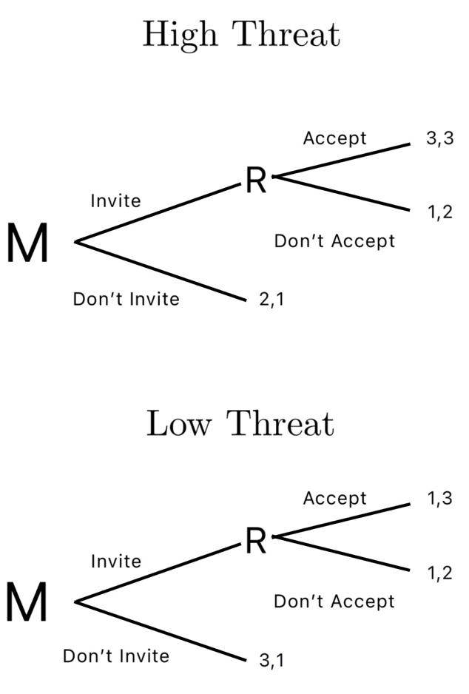
Figure A1 Extensive Game of Theoretical Argument

Table A3: Unemployment Model
 | Right Coalition
Unemployment | 0.436*
 | (0.211)
Ideological Range | -1.720***
 | (0.495)
Far-right Seat Share | 28.337**
 | (9.185)
Effective Number of Parties | -1.382*
 | (0.656)
Parliamentary System | 7.039*
 | (3.185)
GDP Per Capita (Logged) | 3.894
 | (2.661)
Polity | 1.401
 | (1.567)
Eastern Europe | 0.353
 | (1.853)
Constant | -66.048*
 | (28.041)
Observations | 137
Log Likelihood | -21.575
Akaike Inf. Crit. | 69.149
Bayesian Inf. Crit. | 107.109
Standard errors appear in parentheses. Year cubic
splines omitted *p<0.05; **p<0.01; ***p<0.001

Table A4: Immigration Ideological Range
 | (1) | Right Coalition  (2) | (3)
GDP Growth | -18.589 | -21.516*
 | (10.468) | (10.978)
Asylum Inflows | 3.696* | 4.211*
 | (1.828) | (1.963)
Neighbour Far-Right |  |  | 6.417**
 |  |  | (2.001)
Immigration Ideological Range | 0.436* | 0.456* | 0.197*
 | (0.177) | (0.195) | (0.099)
Far-Right Seat Share | 9.818** | 10.267** | 5.851***
 | (3.025) | (3.171) | (1.467)
Effective Number of Parties |  | -0.049 | 0.114
 |  | (0.182) | (0.097)
Parliamentary System |  | -0.833 | -0.501
 |  | (1.166) | (0.482)
GDP Per Capita (Logged) |  | -0.013 | 0.809
 |  | (1.255) | (0.537)
Polity |  | 0.013 | 0.130
 |  | (0.382) | (0.237)
Eastern Europe | 0.956 | 0.908 | 0.533
 | (0.890) | (1.175) | (0.430)
Constant | -2.537** | -1.753 | -11.458*
 | (0.816) | (11.959) | (4.847)
Observations | 151 | 150 | 180
Log Likelihood | -41.609 | -41.153 | -49.932
Akaike Inf. Crit. | 103.218 | 110.306 | 125.864
Bayesian Inf. Crit. | 133.391 | 152.455 | 167.373
Standard errors appear in parentheses. Year cubic
splines omitted *p<0.05; **p<0.01; ***p<0.001

