**Supplemental Appendix to “The Appointment of Women to Authoritarian Cabinets in Africa” by Dr. Alex M. Kroeger and Dr. Alice J. Kang**

**(Published in Government and Opposition)**

**Table A1: Summary Statistics, All Authoritarian Sample**

|  | Mean | SD | N |
| --- | --- | --- | --- |
| Cabinet % Women | 8.16 | 7.89 | 1110 |
| ln(DAC aid per capita) | 3.63 | 0.92 | 1110 |
| 2000-2013 | 0.31 | 0.46 | 1110 |
| Autocratize | 0.38 | 0.49 | 1110 |
| Postconflict | 0.08 | 0.27 | 1110 |
| ln(GDP per capita) | 7.51 | 0.72 | 1110 |
| ln(Years since CEDAW) | -1.31 | 4.54 | 1110 |
| Politicized ethnic groups | 4.33 | 3.10 | 1110 |
| Legislature % Women | 8.96 | 8.34 | 1110 |
| Cabinet size | 23.50 | 8.13 | 1110 |
| Electoral Authoritarian | 0.39 | 0.49 | 1110 |

**Table A2: Summary Statistics, Electoral Authoritarian Sample**

|  | Mean | SD | N |
| --- | --- | --- | --- |
| Cabinet % Women | 12.53 | 7.97 | 434 |
| ln(DAC aid per capita) | 3.67 | 0.80 | 434 |
| 2000-2013 | 0.61 | 0.49 | 434 |
| Autocratize | 0.40 | 0.49 | 434 |
| Postconflict | 0.18 | 0.39 | 434 |
| ln(GDP per capita) | 7.65 | 0.83 | 434 |
| ln(Years since CEDAW) | 1.41 | 3.30 | 434 |
| Politicized ethnic groups | 4.50 | 2.82 | 434 |
| Legislature % Women | 12.09 | 10.70 | 434 |
| Cabinet size | 26.74 | 7.70 | 434 |

| Table A3: Lexical Index of Democracy Autocracies, 1973-2013 | | | |
| --- | --- | --- | --- |
| Country | Spell Start | Spell End | Regime Type |
| Angola | 1980 | 1991 | Closed autocracy |
| Angola | 1992 | 2013 | Electoral autocracy |
| Benin | 1979 | 1990 | Closed autocracy |
| Burkina Faso | 1973 | 1977 | Closed autocracy |
| Burkina Faso | 1978 | 1979 | Electoral autocracy |
| Burkina Faso | 1980 | 1997 | Closed autocracy |
| Burkina Faso | 1998 | 2013 | Electoral autocracy |
| Burundi | 1982 | 1992 | Closed autocracy |
| Burundi | 1993 | 1995 | Electoral autocracy |
| Burundi | 1996 | 2004 | Closed autocracy |
| Burundi | 2010 | 2013 | Electoral autocracy |
| Cameroon | 1973 | 1989 | Closed autocracy |
| Cameroon | 1990 | 2013 | Electoral autocracy |
| Cape Verde | 1980 | 1990 | Closed autocracy |
| Comoros | 1978 | 1991 | Closed autocracy |
| Comoros | 1993 | 1994 | Electoral autocracy |
| Comoros | 1995 | 2001 | Closed autocracy |
| Comoros | 2002 | 2005 | Electoral autocracy |
| Congo - Brazzaville | 1973 | 1991 | Closed autocracy |
| Congo - Brazzaville | 1992 | 1996 | Electoral autocracy |
| Congo - Brazzaville | 1997 | 2001 | Closed autocracy |
| Congo - Brazzaville | 2002 | 2013 | Electoral autocracy |
| Congo - Kinshasa | 1973 | 2005 | Closed autocracy |
| Congo - Kinshasa | 2006 | 2013 | Electoral autocracy |
| Cote d'Ivoire | 1973 | 1989 | Closed autocracy |
| Cote d'Ivoire | 1990 | 1998 | Electoral autocracy |
| Cote d'Ivoire | 1999 | 1999 | Closed autocracy |
| Cote d'Ivoire | 2000 | 2007 | Electoral autocracy |
| Cote d'Ivoire | 2008 | 2010 | Closed autocracy |
| Djibouti | 1977 | 1992 | Closed autocracy |
| Djibouti | 1993 | 2004 | Electoral autocracy |
| Djibouti | 2005 | 2012 | Closed autocracy |
| Djibouti | 2013 | 2013 | Electoral autocracy |
| Equatorial Guinea | 1979 | 1992 | Closed autocracy |
| Equatorial Guinea | 1993 | 2013 | Electoral autocracy |
| Ethiopia | 1973 | 1993 | Closed autocracy |
| Ethiopia | 1994 | 2013 | Electoral autocracy |
| Gabon | 1973 | 1992 | Closed autocracy |
| Gabon | 1993 | 2013 | Electoral autocracy |
| Gambia | 1994 | 1996 | Closed autocracy |
| Gambia | 1997 | 2013 | Electoral autocracy |
| Ghana | 1973 | 1991 | Closed autocracy |
| Ghana | 1992 | 1995 | Electoral autocracy |
| Guinea | 1973 | 1994 | Closed autocracy |
| Guinea | 1995 | 2007 | Electoral autocracy |
| Guinea | 2008 | 2012 | Closed autocracy |
| Guinea | 2013 | 2013 | Electoral autocracy |
| Guinea-Bissau | 1976 | 1993 | Closed autocracy |
| Guinea-Bissau | 1998 | 1999 | Electoral autocracy |
| Guinea-Bissau | 2002 | 2004 | Closed autocracy |
| Guinea-Bissau | 2010 | 2011 | Electoral autocracy |
| Guinea-Bissau | 2012 | 2013 | Closed autocracy |
| Kenya | 1973 | 1991 | Closed autocracy |
| Kenya | 1992 | 2012 | Electoral autocracy |
| Lesotho | 1985 | 1997 | Closed autocracy |
| Lesotho | 1998 | 2001 | Electoral autocracy |
| Liberia | 1997 | 2002 | Electoral autocracy |
| Liberia | 2003 | 2005 | Closed autocracy |
| Madagascar | 1973 | 2012 | Closed autocracy |
| Malawi | 1973 | 1993 | Closed autocracy |
| Mali | 1979 | 2012 | Closed autocracy |
| Mauritania | 1973 | 1991 | Closed autocracy |
| Mauritania | 1992 | 2004 | Electoral autocracy |
| Mauritania | 2005 | 2006 | Closed autocracy |
| Mauritania | 2007 | 2007 | Electoral autocracy |
| Mauritania | 2008 | 2008 | Closed autocracy |
| Mauritania | 2009 | 2010 | Electoral autocracy |
| Mauritania | 2011 | 2012 | Closed autocracy |
| Mauritania | 2013 | 2013 | Electoral autocracy |
| Mozambique | 1977 | 1993 | Closed autocracy |
| Mozambique | 2009 | 2013 | Electoral autocracy |
| Niger | 1973 | 1992 | Closed autocracy |
| Niger | 1996 | 1998 | Electoral autocracy |
| Niger | 2009 | 2010 | Closed autocracy |
| Nigeria | 1992 | 1998 | Closed autocracy |
| Nigeria | 1999 | 2010 | Electoral autocracy |
| Rwanda | 1974 | 2002 | Closed autocracy |
| Rwanda | 2003 | 2013 | Electoral autocracy |
| Senegal | 1973 | 1977 | Closed autocracy |
| Senegal | 1978 | 1999 | Electoral autocracy |
| Sierra Leone | 1973 | 1975 | Electoral autocracy |
| Sierra Leone | 1976 | 1995 | Closed autocracy |
| Sierra Leone | 1996 | 1996 | Electoral autocracy |
| Sierra Leone | 1997 | 1997 | Closed autocracy |
| Sierra Leone | 1998 | 2000 | Electoral autocracy |
| Sudan | 1973 | 2004 | Closed autocracy |
| Sudan | 2005 | 2013 | Electoral autocracy |
| Swaziland | 1973 | 2013 | Closed autocracy |
| Tanzania | 1973 | 1994 | Closed autocracy |
| Tanzania | 1995 | 2013 | Electoral autocracy |
| Togo | 1979 | 1992 | Closed autocracy |
| Togo | 1993 | 2013 | Electoral autocracy |
| Uganda | 1980 | 1984 | Electoral autocracy |
| Uganda | 1985 | 2005 | Closed autocracy |
| Uganda | 2006 | 2013 | Electoral autocracy |
| Zambia | 1973 | 1990 | Closed autocracy |
| Zambia | 1996 | 2005 | Electoral autocracy |
| Zimbabwe | 1985 | 2013 | Electoral autocracy |

Yearly Number of EA and CA Regimes in the Sample, 1966-2016

**Figure A1:** **Yearly Number of EA and CA Regimes in the Sample, 1966-2016**

| Table A4: Freedom House Autocratization Periods | | |
| --- | --- | --- |
| Country | Spell Start | Spell End |
| Angola | 1980 | 1982 |
| Angola | 1992 | 1994 |
| Benin | 1984 | 1988 |
| Burkina Faso | 1974 | 1976 |
| Burkina Faso | 1980 | 1988 |
| Burkina Faso | 2004 | 2004 |
| Burundi | 1984 | 1988 |
| Burundi | 1993 | 1993 |
| Burundi | 1996 | 1997 |
| Burundi | 2010 | 2013 |
| Cameroon | 1976 | 1976 |
| Cameroon | 1978 | 1985 |
| Cameroon | 1995 | 2000 |
| Cape Verde | 1980 | 1980 |
| Cape Verde | 1984 | 1985 |
| Comoros | 1978 | 1982 |
| Comoros | 1984 | 1988 |
| Comoros | 1993 | 2001 |
| Congo - Brazzaville | 1977 | 1979 |
| Congo - Brazzaville | 1994 | 1998 |
| Congo - Brazzaville | 2002 | 2002 |
| Congo - Brazzaville | 2005 | 2010 |
| Congo - Kinshasa | 1975 | 1975 |
| Congo - Kinshasa | 1983 | 1986 |
| Congo - Kinshasa | 1993 | 1997 |
| Congo - Kinshasa | 2008 | 2012 |
| Cote d'Ivoire | 1984 | 1988 |
| Cote d'Ivoire | 1993 | 1996 |
| Cote d'Ivoire | 1999 | 2000 |
| Cote d'Ivoire | 2002 | 2002 |
| Cote d'Ivoire | 2004 | 2006 |
| Cote d'Ivoire | 2010 | 2010 |
| Djibouti | 1982 | 1988 |
| Djibouti | 1992 | 1994 |
| Djibouti | 2003 | 2007 |
| Djibouti | 2010 | 2013 |
| Equatorial Guinea | 1985 | 1989 |
| Equatorial Guinea | 1993 | 1997 |
| Equatorial Guinea | 2002 | 2006 |
| Equatorial Guinea | 2008 | 2012 |
| Ethiopia | 1975 | 1982 |
| Ethiopia | 1989 | 1990 |
| Ethiopia | 1993 | 1994 |
| Ethiopia | 1999 | 2003 |
| Ethiopia | 2010 | 2013 |
| Gabon | 1992 | 1997 |
| Gabon | 2005 | 2013 |
| Gambia | 1994 | 1997 |
| Gambia | 2005 | 2013 |
| Ghana | 1973 | 1973 |
| Ghana | 1982 | 1987 |
| Ghana | 1991 | 1991 |
| Guinea | 1987 | 1989 |
| Guinea | 2008 | 2009 |
| Guinea-Bissau | 1983 | 1983 |
| Guinea-Bissau | 1986 | 1988 |
| Guinea-Bissau | 1998 | 2003 |
| Guinea-Bissau | 2010 | 2010 |
| Guinea-Bissau | 2012 | 2013 |
| Kenya | 1975 | 1977 |
| Kenya | 1982 | 1991 |
| Kenya | 1993 | 1996 |
| Kenya | 2008 | 2009 |
| Kenya | 2012 | 2012 |
| Lesotho | 1987 | 1988 |
| Lesotho | 1994 | 1998 |
| Liberia | 2000 | 2003 |
| Madagascar | 1973 | 1976 |
| Madagascar | 1978 | 1982 |
| Madagascar | 2009 | 2012 |
| Mali | 2012 | 2012 |
| Mauritania | 1975 | 1984 |
| Mauritania | 1989 | 1994 |
| Mauritania | 2003 | 2004 |
| Mauritania | 2008 | 2012 |
| Mozambique | 1977 | 1980 |
| Mozambique | 1993 | 1993 |
| Mozambique | 2009 | 2013 |
| Niger | 1974 | 1978 |
| Niger | 1989 | 1989 |
| Niger | 1996 | 1998 |
| Niger | 2009 | 2010 |
| Nigeria | 1993 | 1995 |
| Nigeria | 2000 | 2002 |
| Nigeria | 2008 | 2009 |
| Rwanda | 1994 | 1994 |
| Rwanda | 2012 | 2012 |
| Senegal | 1979 | 1983 |
| Senegal | 1993 | 1995 |
| Sierra Leone | 1973 | 1976 |
| Sierra Leone | 1985 | 1995 |
| Sierra Leone | 1997 | 1997 |
| Sierra Leone | 2000 | 2000 |
| Sudan | 1984 | 1985 |
| Sudan | 1989 | 1993 |
| Swaziland | 1973 | 1977 |
| Swaziland | 1984 | 1988 |
| Swaziland | 1999 | 2007 |
| Tanzania | 1994 | 1994 |
| Togo | 1979 | 1979 |
| Togo | 1993 | 1993 |
| Togo | 2002 | 2006 |
| Uganda | 1982 | 1982 |
| Uganda | 1988 | 1991 |
| Uganda | 1999 | 2001 |
| Uganda | 2013 | 2013 |
| Zambia | 1975 | 1983 |
| Zambia | 1988 | 1990 |
| Zambia | 1996 | 2000 |
| Zimbabwe | 1985 | 1988 |
| Zimbabwe | 1993 | 1997 |
| Zimbabwe | 1999 | 2008 |

| Table A5: Post-conflict periods (Kang and Tripp (2018)) | | |
| --- | --- | --- |
| Country | Start year | End year |
| Angola | 2002 | 2014 |
| Burundi | 2010 | 2014 |
| Central African Republic | 2007 | 2011 |
| Central African Republic | 2014 | 2014 |
| Chad | 2000 | 2004 |
| Chad | 2010 | 2014 |
| Congo - Brazzaville | 2000 | 2014 |
| Congo - Kinshasa | 2003 | 2003 |
| Congo - Kinshasa | 2009 | 2011 |
| Congo - Kinshasa | 2013 | 2014 |
| Ethiopia | 2000 | 2001 |
| Ethiopia | 2003 | 2014 |
| Liberia | 2000 | 2001 |
| Liberia | 2003 | 2005 |
| Mozambique | 2009 | 2014 |
| Rwanda | 2000 | 2014 |
| Somalia | 2001 | 2005 |
| Somalia | 2008 | 2008 |
| Somalia | 2014 | 2014 |
| Sudan | 2006 | 2014 |
| Uganda | 2006 | 2014 |

| Table A6: Examining Indirect Effects 1: Dropping Women's Share in Legislature *1* | | |
| --- | --- | --- |
|  | All Authoritarian | Electoral Authoritarian |
|  | Model 1 | Model 2 |
| ln(DAC aid per capita) | 0.299 | 1.767* |
|  | (0.322) | (0.782) |
| Autocratize | 0.249 | -0.106 |
|  | (0.410) | (0.817) |
| 2000-2013 | 1.362 | 3.444 |
|  | (2.727) | (3.560) |
| Postconflict | 6.140** | 3.671 |
|  | (2.247) | (2.540) |
| ln(GDP per capita) | 0.854 | 2.347 |
|  | (0.953) | (1.567) |
| ln(Years since CEDAW) | 0.497*** | 0.448 |
|  | (0.081) | (0.256) |
| Politicized ethnic groups | -0.703 | -1.272* |
|  | (0.412) | (0.479) |
| Cabinet size | 0.069 | 0.116 |
|  | (0.062) | (0.082) |
| ln(DAC aid per capita) x 2000-2013 | 0.645 | -0.492 |
|  | (0.710) | (0.897) |
| Autocratize x 2000-2013 | 0.325 | 1.202 |
|  | (1.065) | (1.385) |
| Num.Obs. | 1279 | 467 |
| R2 | 0.614 | 0.684 |
| *1*Linear regressions with country fixed effects. Standard errors clustered by country are in parentheses. All independent variables are lagged 1 year. | | |
| * p < 0.05, ** p < 0.01, *** p < 0.001 | | |

**Figure A2: Marginal effects from Table A6 Model 1 (all authoritarian sample)**

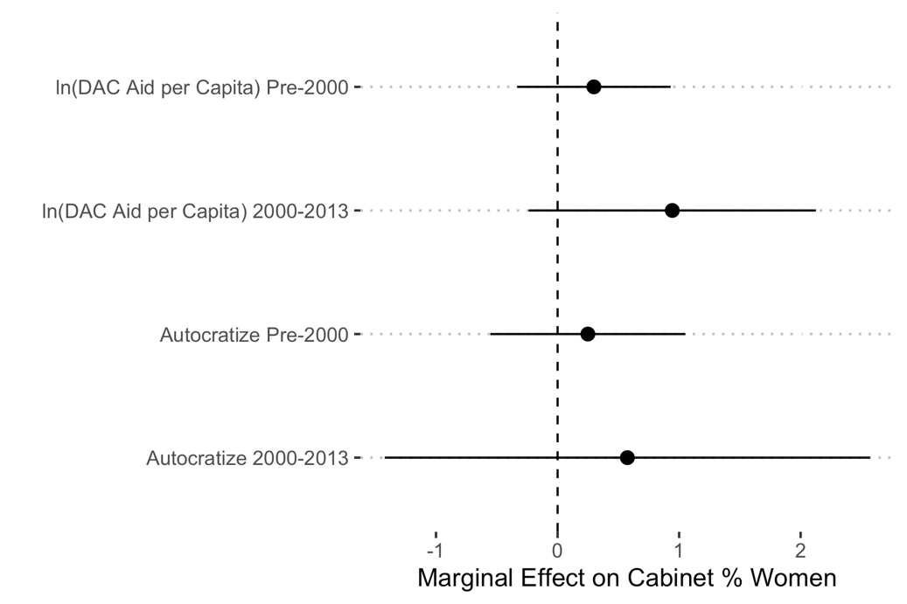

**Figure A3: Marginal effects from Table A6 Model 2 (electoral authoritarian sample)**

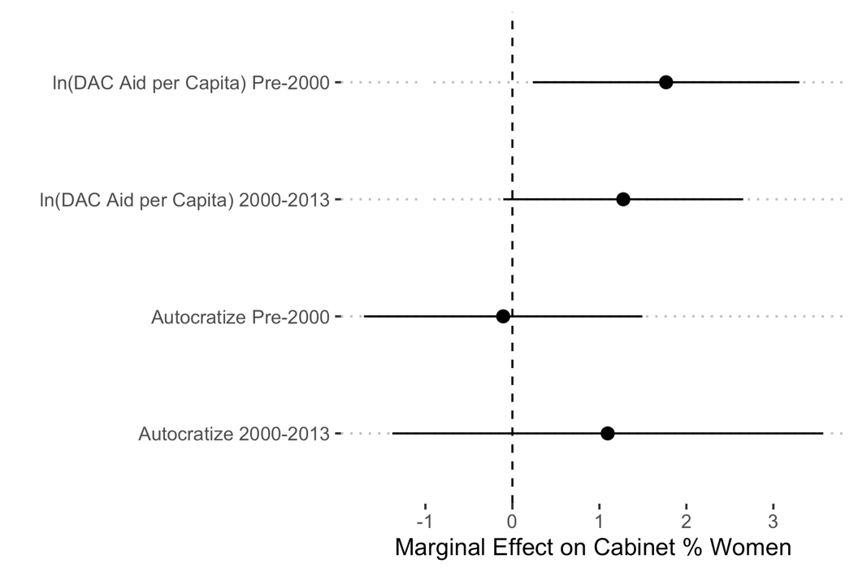

| Table A7: Indirect Effects 2: Fixed Effects Models of Women's Share of Legislative Seats *1* | | | | |
| --- | --- | --- | --- | --- |
|  | All Authoritarian | | Electoral Authoritarian | |
|  | Model 1 | Model 2 | Model 3 | Model 4 |
| ln(DAC aid per capita) | 0.219 | 0.277 | 0.610 | 1.589* |
|  | (0.285) | (0.330) | (0.524) | (0.664) |
| Autocratize | -0.042 | 0.378 | 0.292 | 1.758 |
|  | (0.383) | (0.519) | (0.545) | (1.001) |
| 2000-2013 |  | 4.501 |  | 10.926** |
|  |  | (2.527) |  | (3.399) |
| Gender quota | 9.503** | 8.743** | 8.692** | 8.164** |
|  | (2.967) | (3.126) | (2.390) | (2.587) |
| Postconflict | 11.309** | 9.353* | 8.040** | 5.654* |
|  | (3.635) | (3.818) | (2.587) | (2.347) |
| ln(GDP per capita) | 1.992** | 1.386 | 4.240* | 3.800 |
|  | (0.732) | (0.776) | (2.023) | (1.948) |
| ln(Years since CEDAW) | 0.388*** | 0.224** | 0.498** | 0.331* |
|  | (0.100) | (0.072) | (0.150) | (0.137) |
| ln(DAC aid per capita) x 2000-2013 |  | -0.192 |  | -1.856* |
|  |  | (0.629) |  | (0.740) |
| Autocratize x 2000-2013 |  | -1.452 |  | -2.793 |
|  |  | (1.547) |  | (1.548) |
| Num.Obs. | 1098 | 1098 | 427 | 427 |
| R2 | 0.681 | 0.696 | 0.856 | 0.870 |
| *1*Linear regressions with country fixed effects. Standard errors clustered by country are in parentheses. All independent variables are lagged 1 year. | | | | |
| * p < 0.05, ** p < 0.01, *** p < 0.001 | | | | |

**Figure A4: Marginal effects from Table A7 Model 2 (all authoritarian sample)**

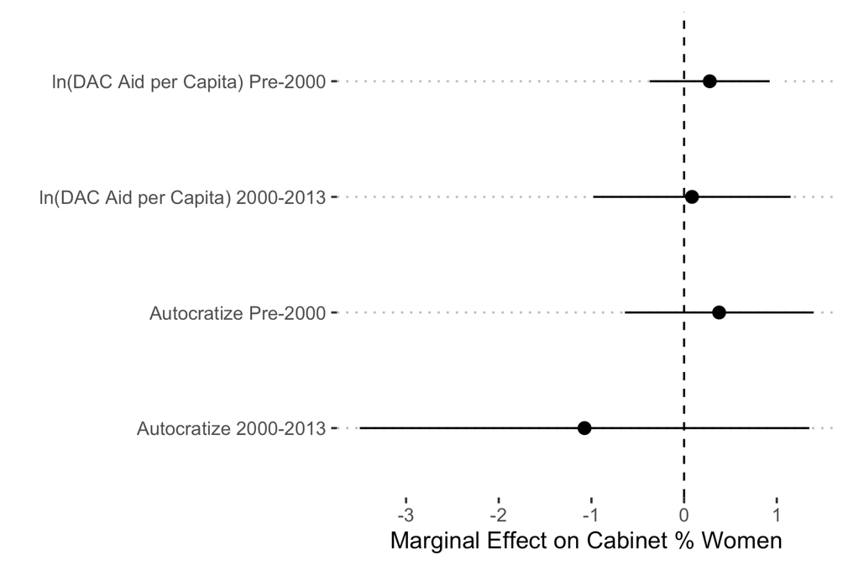

**Figure A5: Marginal effects from Table A7 Model 4 (electoral authoritarian sample)**

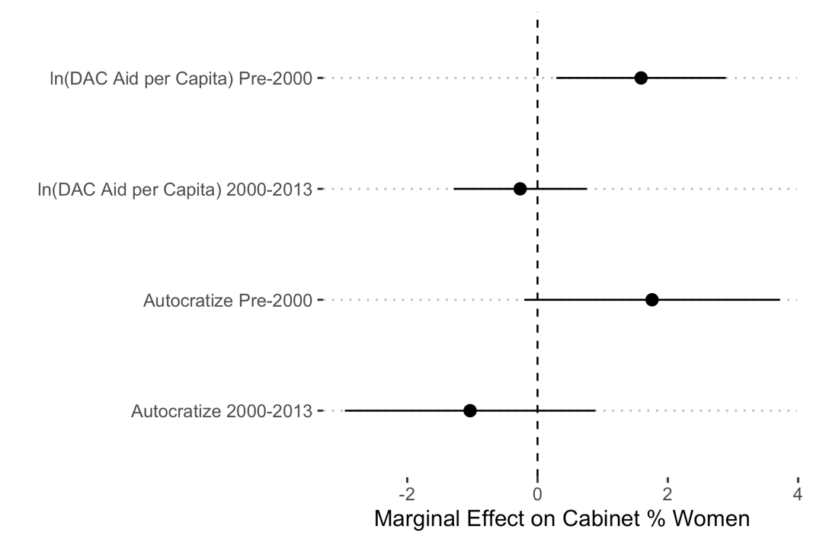

| Table A8: DAC Aid as Percent of GDP *1* | | |
| --- | --- | --- |
|  | All Authoritarian | Electoral Authoritarian |
|  | Model 1 | Model 2 |
| ln(DAC Aid % GDP) | 1.098 | 1.281 |
|  | (0.647) | (1.122) |
| Autocratize | 0.485 | -1.444 |
|  | (0.666) | (0.893) |
| 2000-2013 | 3.988** | -0.080 |
|  | (1.394) | (2.037) |
| Postconflict | 3.861* | 1.433 |
|  | (1.780) | (2.691) |
| ln(GDP per capita) | 0.754 | 2.838 |
|  | (1.158) | (1.438) |
| ln(Years since CEDAW) | 0.291** | 0.276 |
|  | (0.107) | (0.250) |
| Politicized ethnic groups | -0.910* | -1.465** |
|  | (0.347) | (0.472) |
| Women's share legislature | 0.336*** | 0.399*** |
|  | (0.057) | (0.107) |
| Cabinet size | 0.030 | 0.113 |
|  | (0.063) | (0.077) |
| ln(DAC Aid % GDP) x 2000-2013 | -0.642 | 0.455 |
|  | (0.559) | (0.985) |
| Autocratize x 2000-2013 | 0.355 | 2.212 |
|  | (1.126) | (1.516) |
| Num.Obs. | 935 | 440 |
| R2 | 0.667 | 0.739 |
| *1*Linear regressions with country fixed effects. Standard errors clustered by country are in parentheses. All independent variables are lagged 1 year. | | |
| * p < 0.05, ** p < 0.01, *** p < 0.001 | | |

**Figure A6: Marginal effects from Table A8 Model 1 (all authoritarian sample)**

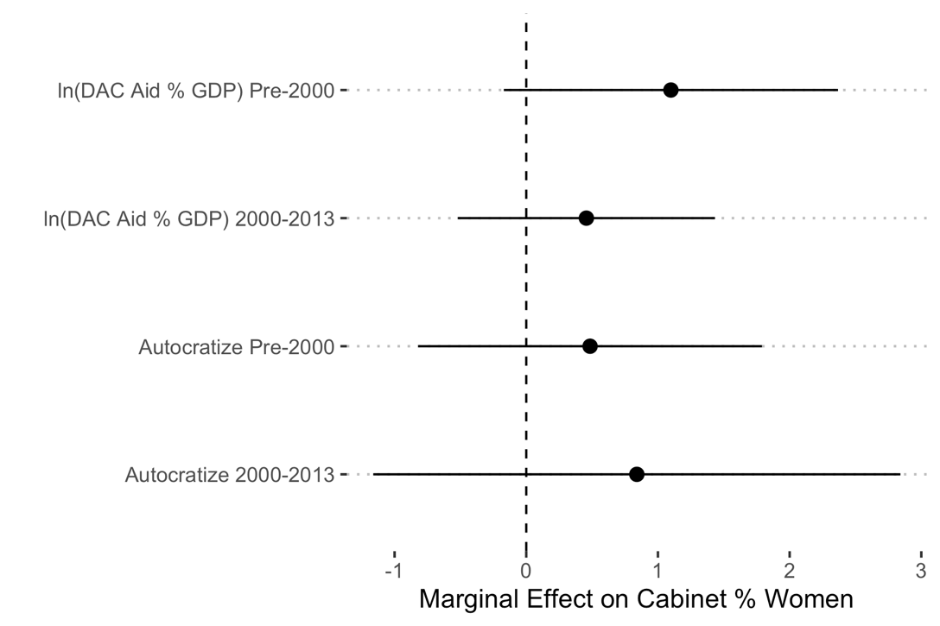

**Figure A7: Marginal effects from Table A8 Model 2 (electoral authoritarian sample)**

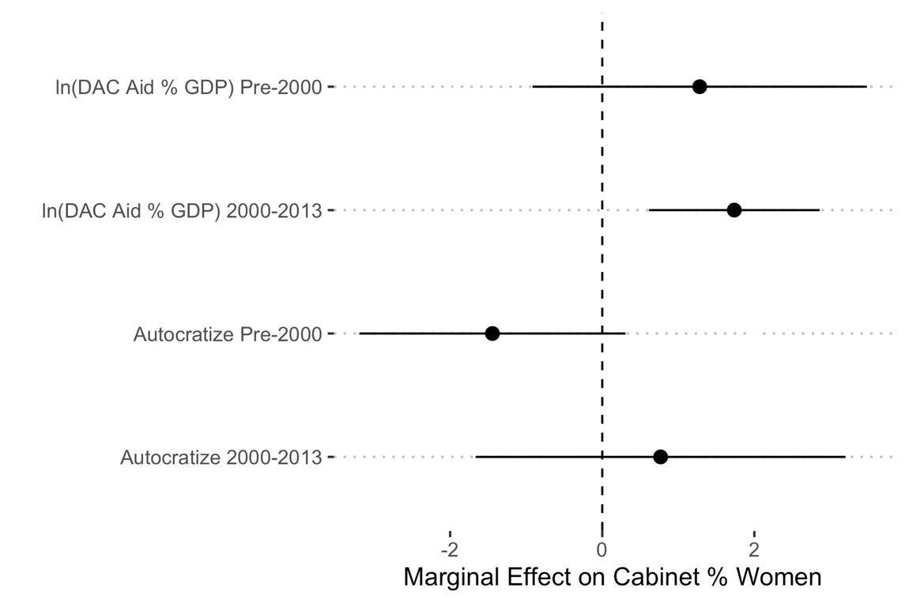

**Figure A8: Effect of DAC aid as a percent of GDP during 2000-2013 period from Table A8 Model 2**

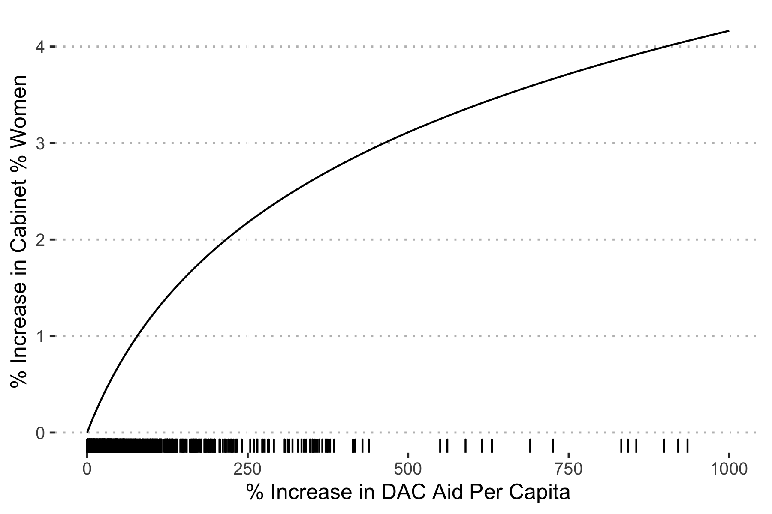

| Table A9: 3 Year Moving Average of DAC Aid Per Capita *1* | | |
| --- | --- | --- |
|  | All Authoritarian | Electoral Authoritarian |
|  | Model 1 | Model 2 |
| ln(DAC aid per capita)(3yr moving average) | 0.401 | 1.970* |
|  | (0.637) | (0.841) |
| Autocratize | 0.592 | -0.905 |
|  | (0.459) | (0.770) |
| 2000-2013 | -0.663 | -2.320 |
|  | (3.461) | (4.143) |
| Postconflict | 4.210* | 1.860 |
|  | (1.571) | (2.760) |
| ln(GDP per capita) | -0.150 | 0.324 |
|  | (1.015) | (1.038) |
| ln(Years since CEDAW) | 0.347*** | 0.203 |
|  | (0.095) | (0.216) |
| Politicized ethnic groups | -0.987* | -1.566** |
|  | (0.367) | (0.444) |
| Women's share legislature | 0.308*** | 0.393** |
|  | (0.055) | (0.116) |
| Cabinet size | 0.025 | 0.086 |
|  | (0.065) | (0.069) |
| ln(DAC aid per capita)(3yr moving average) x 2000-2013 | 0.940 | 0.606 |
|  | (0.906) | (0.985) |
| Autocratize x 2000-2013 | 0.517 | 2.412 |
|  | (1.033) | (1.521) |
| Num.Obs. | 1063 | 432 |
| R2 | 0.670 | 0.738 |
| *1*Linear regressions with country fixed effects. Standard errors clustered by country are in parentheses. All independent variables are lagged 1 year. | | |
| * p < 0.05, ** p < 0.01, *** p < 0.001 | | |

**Figure A9: Marginal effects from Table A9 Model 1 (all authoritarian sample)**

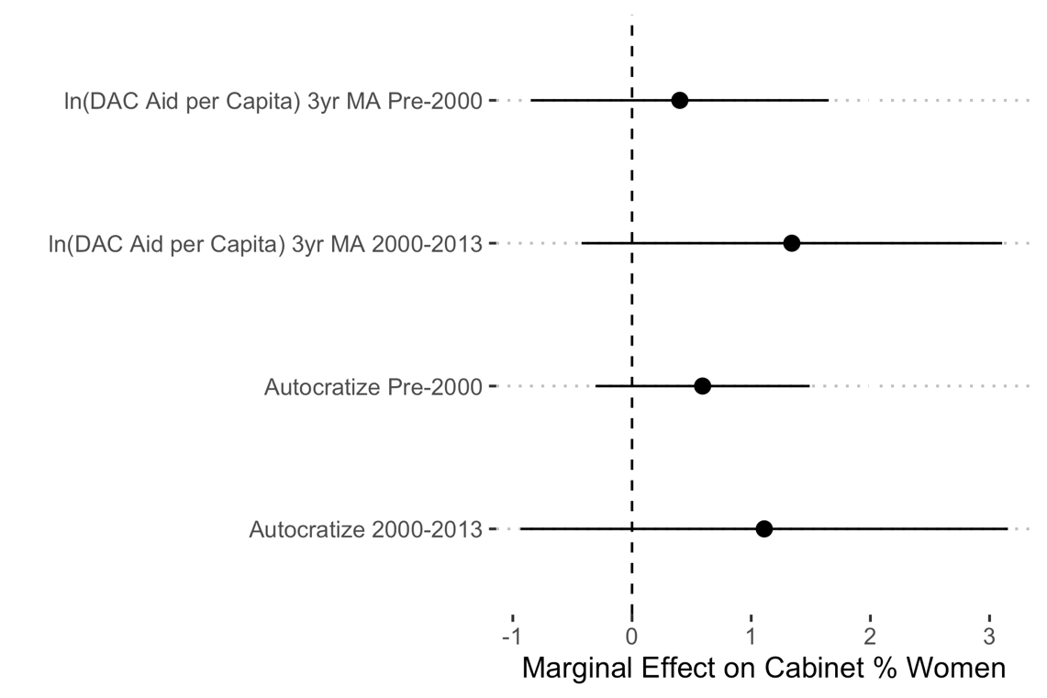

**Figure A10: Marginal effects from Table A9 Model 2 (electoral authoritarian sample)**

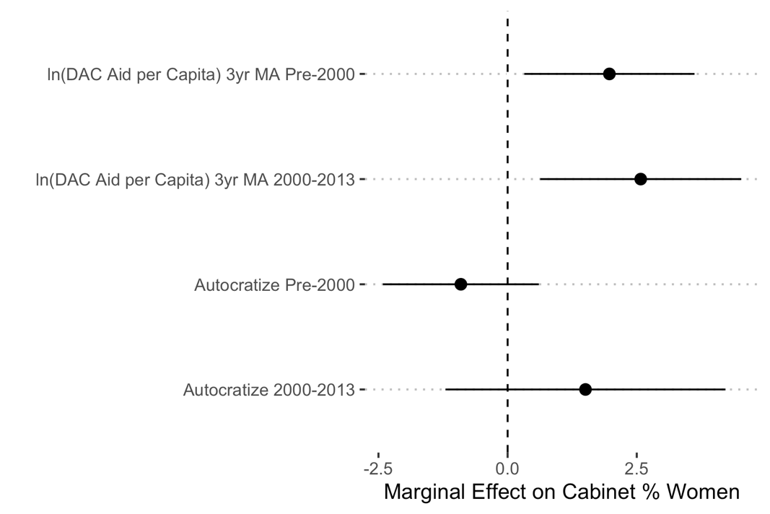

**Figure A11: Effect of 3 year moving average of DAC aid per capita during 2000-2013 period from Table A9 Model 2**

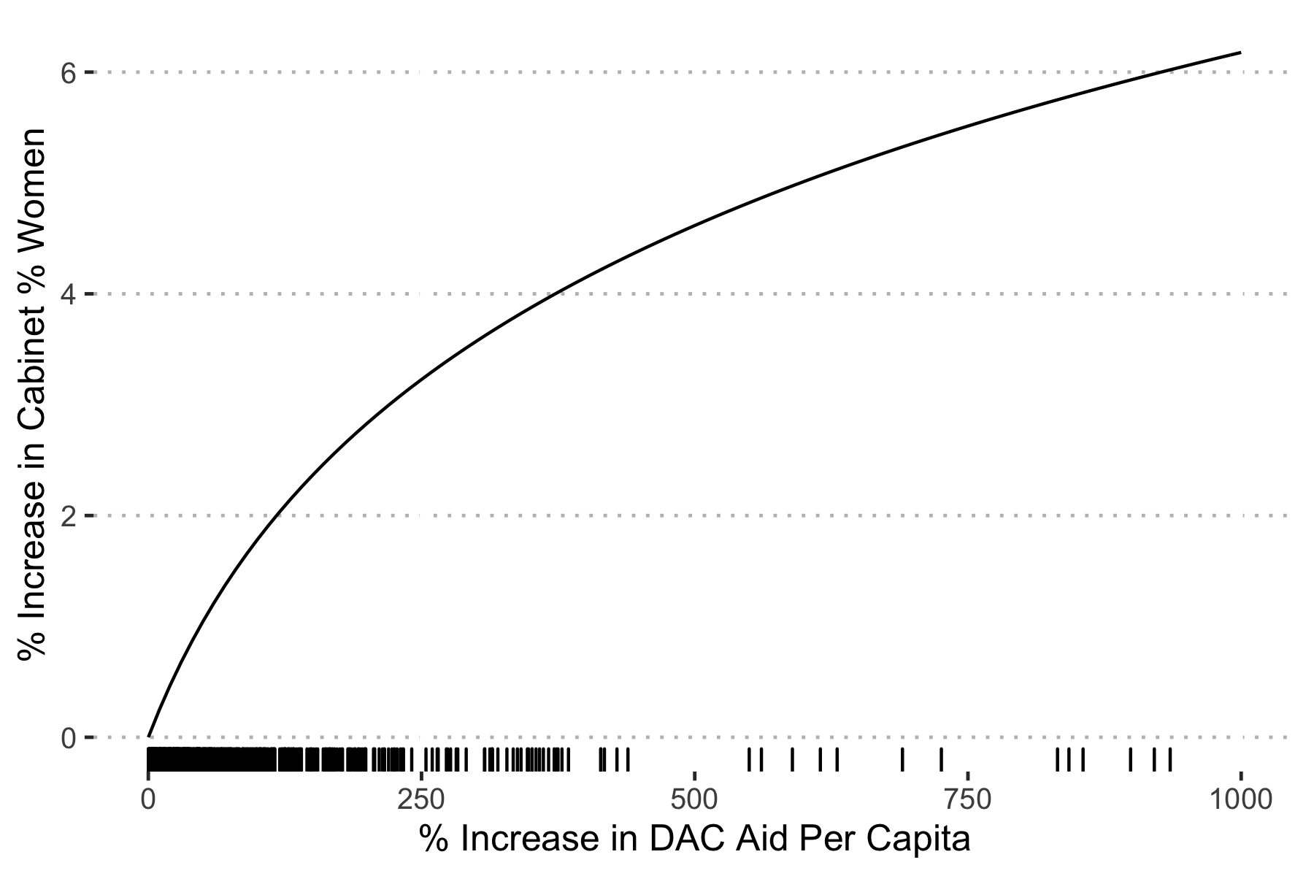

| Table A10: IVs Lagged 3 Years *1* | | |
| --- | --- | --- |
|  | All Authoritarian | Electoral Authoritarian |
|  | Model 1 | Model 2 |
| ln(DAC aid per capita) | 0.372 | 2.067* |
|  | (0.416) | (0.811) |
| Autocratize | 0.789 | 0.190 |
|  | (0.506) | (1.066) |
| 2000-2013 | 4.806 | 8.884** |
|  | (2.728) | (3.130) |
| Postconflict | 3.664* | 0.532 |
|  | (1.595) | (2.162) |
| ln(GDP per capita) | 0.736 | 1.575 |
|  | (1.075) | (1.430) |
| ln(Years since CEDAW) | 0.424*** | 0.257 |
|  | (0.091) | (0.218) |
| Politicized ethnic groups | -1.218** | -1.046 |
|  | (0.375) | (0.524) |
| Women's share legislature | 0.296*** | 0.365*** |
|  | (0.042) | (0.073) |
| Cabinet size | -0.003 | -0.004 |
|  | (0.047) | (0.079) |
| ln(DAC aid per capita) x 2000-2013 | -0.092 | -1.545* |
|  | (0.737) | (0.683) |
| Autocratize x 2000-2013 | -0.845 | -0.634 |
|  | (0.877) | (1.331) |
| Num.Obs. | 1110 | 434 |
| R2 | 0.667 | 0.714 |
| *1*Linear regressions with country fixed effects. Standard errors clustered by country are in parentheses. All independent variables are lagged 3 years. | | |
| * p < 0.05, ** p < 0.01, *** p < 0.001 | | |

**Figure A12: Marginal effects from Table A10 Model 1 (all authoritarian sample)**

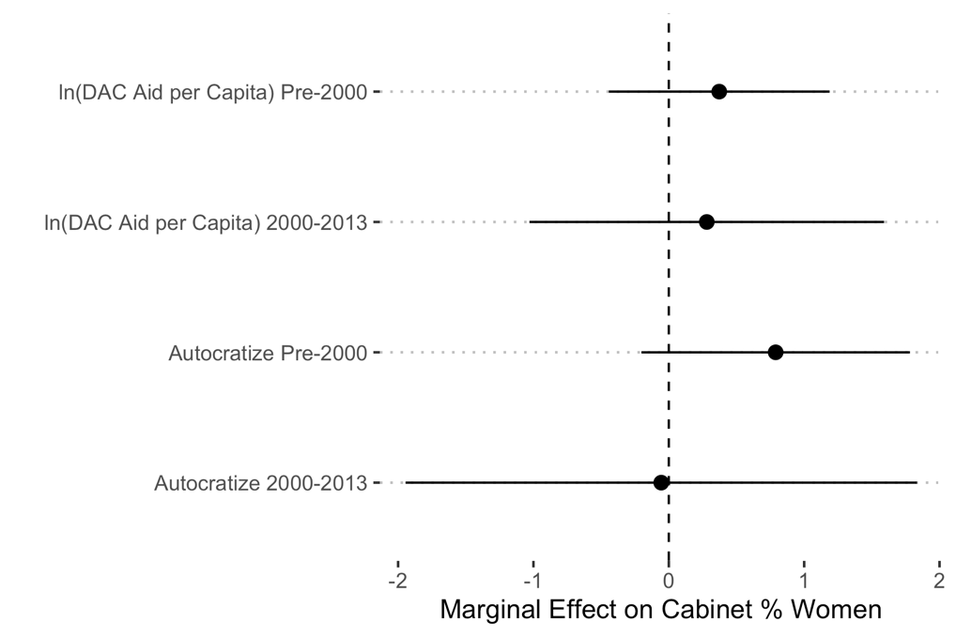

**Figure A13: Marginal effects from Table A10 Model 2 (electoral authoritarian sample)**

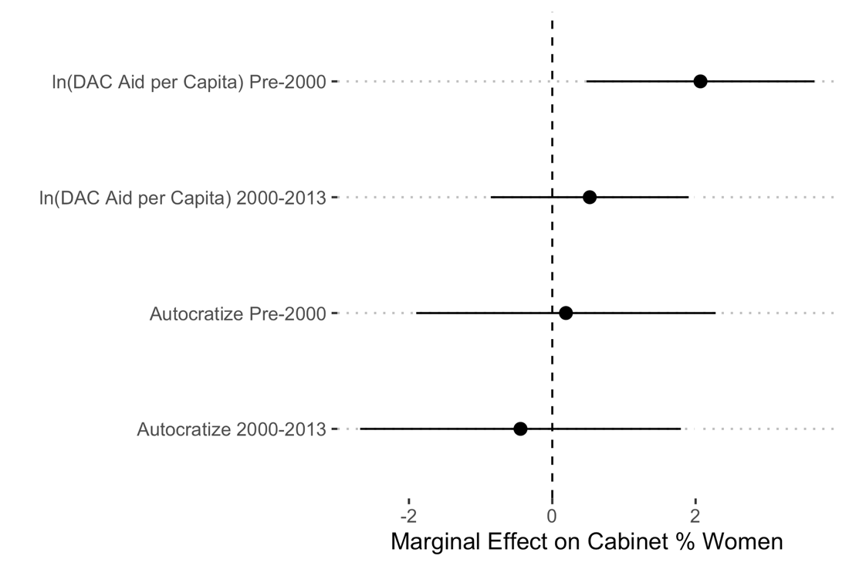

| Table A11: Using a Stricter Autocratize Measure *1* | | |
| --- | --- | --- |
|  | All Authoritarian | Electoral Authoritarian |
|  | Model 1 | Model 2 |
| ln(DAC aid per capita) | 0.234 | 1.327 |
|  | (0.379) | (0.679) |
| Strict Autocratize | 0.942 | -0.853 |
|  | (0.619) | (0.984) |
| 2000-2013 | 0.159 | 0.134 |
|  | (2.508) | (3.128) |
| Postconflict | 4.076* | 1.785 |
|  | (1.613) | (2.987) |
| ln(GDP per capita) | 0.192 | 0.885 |
|  | (0.943) | (1.017) |
| ln(Years since CEDAW) | 0.377*** | 0.222 |
|  | (0.099) | (0.214) |
| Politicized ethnic groups | -0.998* | -1.377** |
|  | (0.376) | (0.459) |
| Women's share legislature | 0.314*** | 0.380** |
|  | (0.052) | (0.107) |
| Cabinet size | 0.028 | 0.096 |
|  | (0.064) | (0.073) |
| ln(DAC aid per capita) x 2000-2013 | 0.734 | 0.098 |
|  | (0.662) | (0.757) |
| Strict Autocratize x 2000-2013 | 0.092 | 1.587 |
|  | (1.130) | (1.718) |
| Num.Obs. | 1110 | 434 |
| R2 | 0.670 | 0.733 |
| *1*Linear regressions with country fixed effects. Standard errors clustered by country are in parentheses. All independent variables are lagged 3 years. | | |
| * p < 0.05, ** p < 0.01, *** p < 0.001 | | |

**Figure A14: Marginal effects from Table A11 Model 1 (all authoritarian sample)**

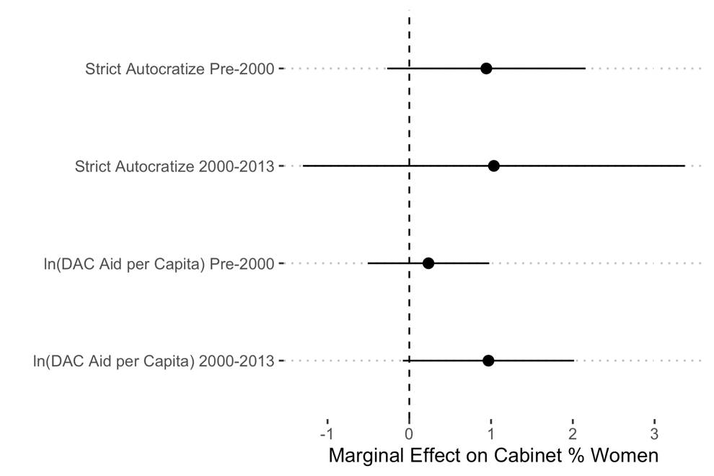

**Figure A15: Marginal effects from Table A11 Model 2 (electoral authoritarian sample)**

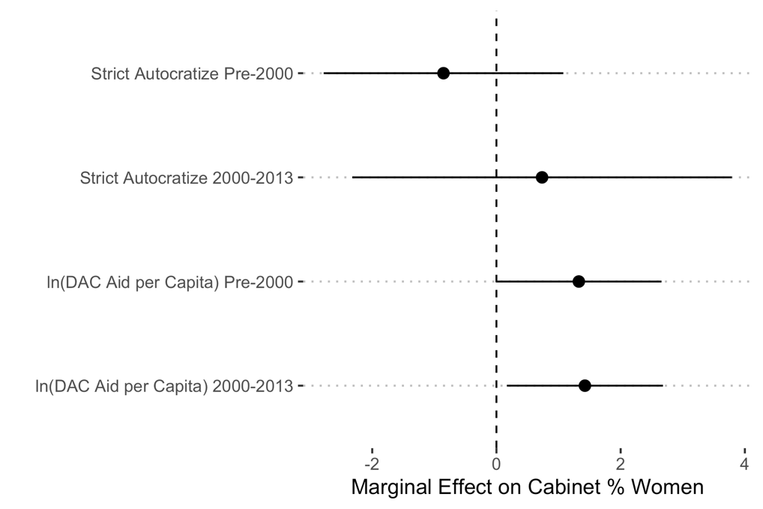

| Table A12: Changing Time Dummy to 1995-2013 *1* | | |
| --- | --- | --- |
|  | All Authoritarian | Electoral Authoritarian |
|  | Model 1 | Model 2 |
| ln(DAC aid per capita) | 0.377 | 1.554 |
|  | (0.390) | (0.863) |
| Autocratize | 0.668 | 0.935 |
|  | (0.411) | (1.463) |
| 1995-2013 | 1.950 | 2.820 |
|  | (2.121) | (3.346) |
| Postconflict | 3.932* | 1.775 |
|  | (1.619) | (2.901) |
| ln(GDP per capita) | 0.342 | 0.990 |
|  | (0.947) | (1.070) |
| ln(Years since CEDAW) | 0.220* | 0.130 |
|  | (0.096) | (0.195) |
| Politicized ethnic groups | -0.996* | -1.400** |
|  | (0.429) | (0.441) |
| Women's share legislature | 0.332*** | 0.389*** |
|  | (0.048) | (0.103) |
| Cabinet size | 0.029 | 0.105 |
|  | (0.060) | (0.077) |
| ln(DAC aid per capita) x 1995-2013 | 0.550 | -0.176 |
|  | (0.502) | (0.779) |
| Autocratize x 1995-2013 | 0.117 | -0.448 |
|  | (1.087) | (1.986) |
| Num.Obs. | 1110 | 434 |
| R2 | 0.683 | 0.734 |
| *1*Linear regressions with country fixed effects. Standard errors clustered by country are in parentheses. All independent variables are lagged 1 year. | | |
| * p < 0.05, ** p < 0.01, *** p < 0.001 | | |

**Figure A16: Marginal effects from Table A12 Model 1 (all authoritarian sample)**

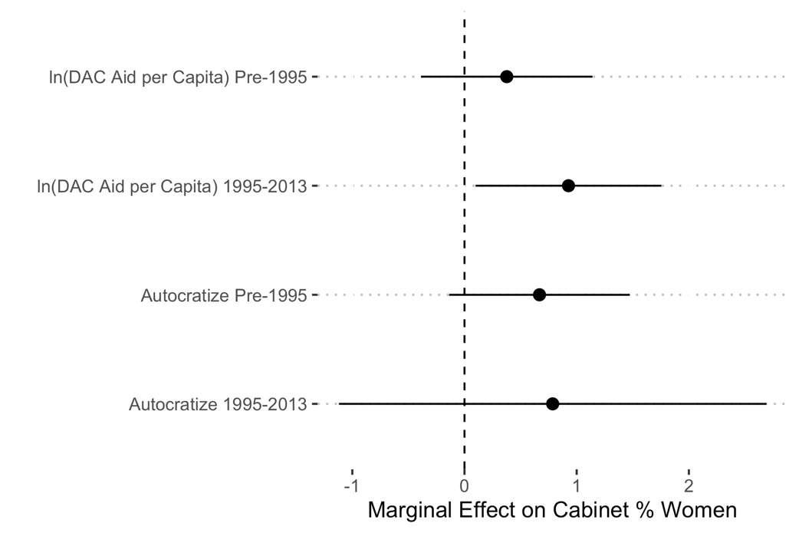

**Figure A17: Marginal effects from Table A12 Model 2 (electoral authoritarian sample)**

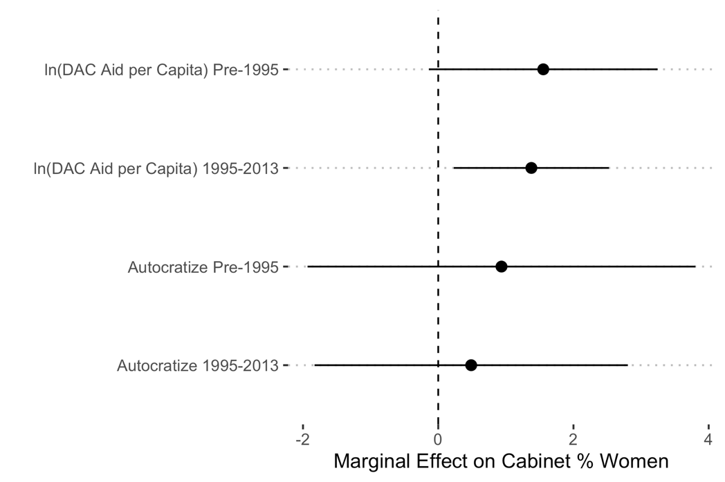

| Table A13: Controlling for Leader's First Cabinet *1* | | |
| --- | --- | --- |
|  | All Authoritarian | Electoral Authoritarian |
|  | Model 1 | Model 2 |
| ln(DAC aid per capita) | 0.192 | 1.218 |
|  | (0.389) | (0.682) |
| Autocratize | 0.458 | -0.746 |
|  | (0.408) | (0.705) |
| 2000-2013 | -0.159 | -0.924 |
|  | (2.635) | (3.205) |
| Postconflict | 4.118* | 1.634 |
|  | (1.642) | (2.796) |
| ln(GDP per capita) | 0.103 | 0.661 |
|  | (0.980) | (0.988) |
| ln(Years since CEDAW) | 0.367*** | 0.212 |
|  | (0.098) | (0.225) |
| Politicized ethnic groups | -0.969* | -1.420** |
|  | (0.366) | (0.424) |
| Women's share legislature | 0.314*** | 0.389** |
|  | (0.054) | (0.108) |
| Cabinet size | 0.031 | 0.112 |
|  | (0.066) | (0.072) |
| Leader Start Year | -0.187 | -3.106 |
|  | (0.642) | (1.530) |
| ln(DAC aid per capita) x 2000-2013 | 0.750 | 0.225 |
|  | (0.670) | (0.710) |
| Autocratize x 2000-2013 | 0.582 | 1.949 |
|  | (1.029) | (1.455) |
| Leader Start Year x 2000-2013 | 0.792 | 2.594 |
|  | (1.056) | (2.217) |
| Num.Obs. | 1110 | 434 |
| R2 | 0.669 | 0.739 |
| *1*Linear regressions with country fixed effects. Standard errors clustered by country are in parentheses. All independent variables are lagged 1 year. | | |
| * p < 0.05, ** p < 0.01, *** p < 0.001 | | |

**Figure A18: Marginal effects from Table A13 Model 1 (all authoritarian sample)**

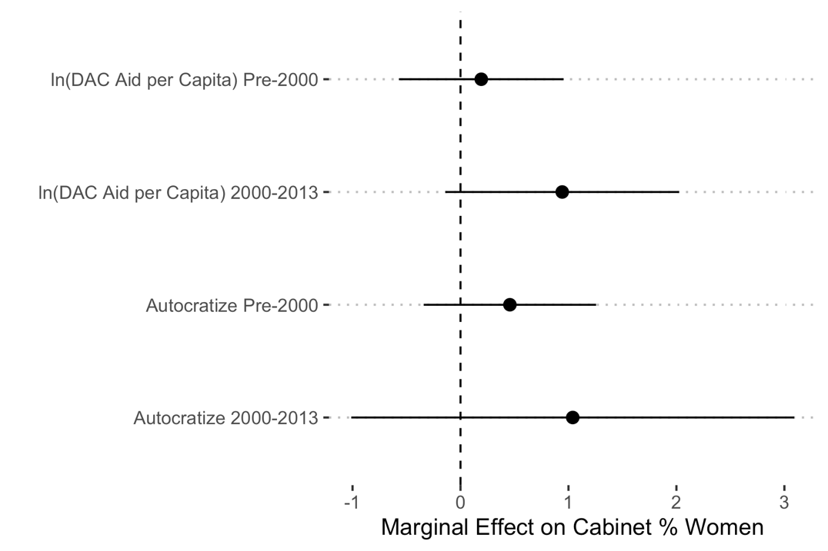

**Figure A19: Marginal effects from Table A13 Model 2 (electoral authoritarian sample)**

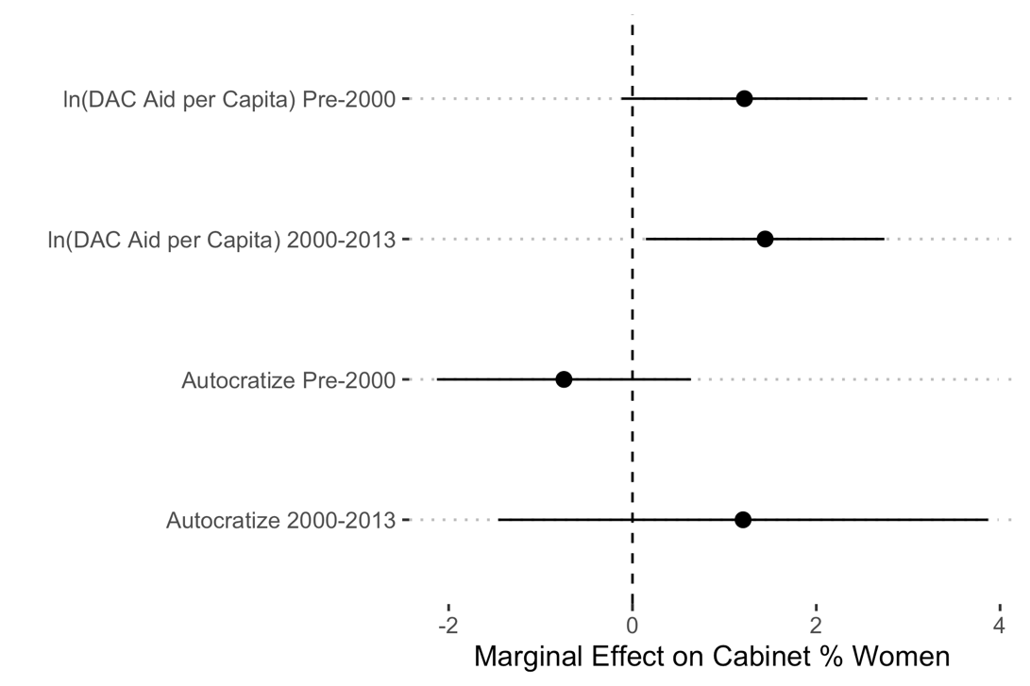

| Table A14: Controlling for Legislative Gender Quotas *1* | | |
| --- | --- | --- |
|  | All Authoritarian | Electoral Authoritarian |
|  | Model 1 | Model 2 |
| ln(DAC aid per capita) | 0.224 | 1.315 |
|  | (0.453) | (0.685) |
| Autocratize | 0.510 | -0.594 |
|  | (0.434) | (0.788) |
| 2000-2013 | -0.639 | -0.565 |
|  | (2.980) | (3.349) |
| Postconflict | 4.690** | 1.941 |
|  | (1.643) | (3.316) |
| ln(GDP per capita) | 0.086 | 0.571 |
|  | (1.055) | (1.052) |
| ln(Years since CEDAW) | 0.374*** | 0.187 |
|  | (0.097) | (0.210) |
| Politicized ethnic groups | -1.005* | -1.370** |
|  | (0.378) | (0.431) |
| Women's share legislature | 0.259*** | 0.353** |
|  | (0.054) | (0.103) |
| Cabinet size | 0.029 | 0.092 |
|  | (0.067) | (0.076) |
| Legislative gender quota | 2.532 | 1.672 |
|  | (1.891) | (2.067) |
| ln(DAC aid per capita) x 2000-2013 | 0.781 | 0.205 |
|  | (0.744) | (0.754) |
| Autocratize x 2000-2013 | 0.867 | 1.925 |
|  | (1.014) | (1.534) |
| Num.Obs. | 1070 | 426 |
| R2 | 0.680 | 0.737 |
| *1*Linear regressions with country fixed effects. Sample includes all authoritarian regimes. Standard errors clustered by country are in parentheses. All independent variables are lagged 1 year. | | |
| * p < 0.05, ** p < 0.01, *** p < 0.001 | | |

**Figure A20: Marginal effects from Table A14 Model 1 (all authoritarian sample)**

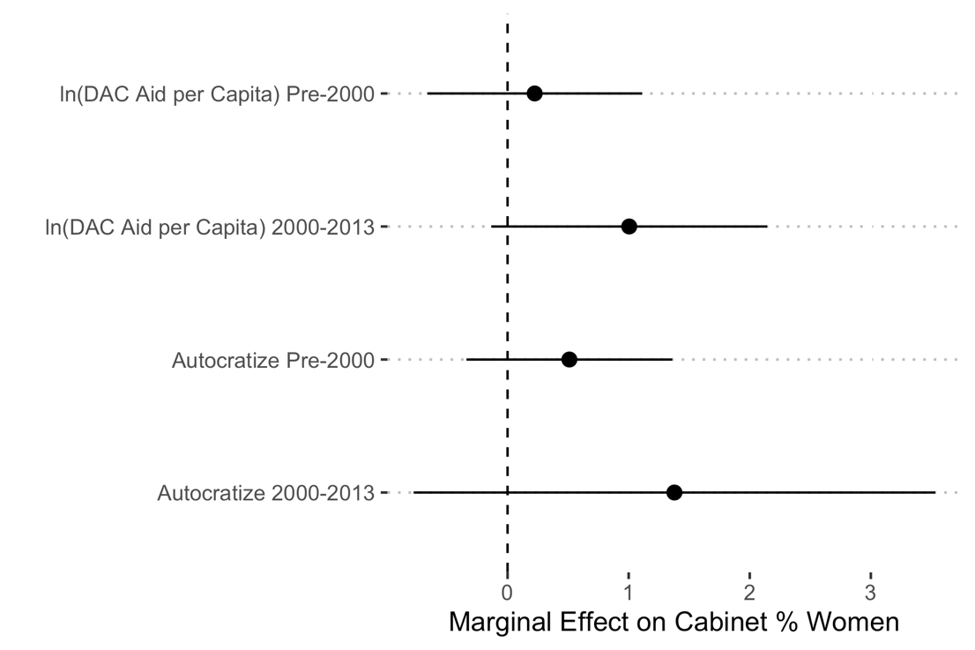

**Figure A21: Marginal effects from Table A14 Model 2 (electoral authoritarian sample)**

