Visible elites  (official government members) | Invisible elites (LPS members  within the expanded government)
Prime Ministers or government presidents -presidentes del gobierno español.  Ministers -ministros o titulares de los ministerios del gobierno de España.  State Secretaries -secretarios de Estado del gobierno de España.  Deputy secretaries -subsecretarios ministeriales. | Advisors and consultants of big private firms -asesores y consejeros de grandes empresas.  Ex-presidents of the Spanish government or ex-prime ministers -ex presidentes del gobierno de España.  Ex-ministers -exministros del gobierno de España.  Presidents of Autonomous Governments of Spain -presidentes de Comunidades Autónomas españolas.  Ex-party leaders (PP and PSOE) -exdirigentes del Partido Político (PP y PSOE).  Ex-presidents of the parliamentary group in the Spanish Congress of Deputies -ex presidentes del grupo parlamentario en el Congreso de los Diputados.
Figure 1. Visible and invisible elites. Positions, ranks and roles of the members of the official and expanded governments, in English and Spanish.

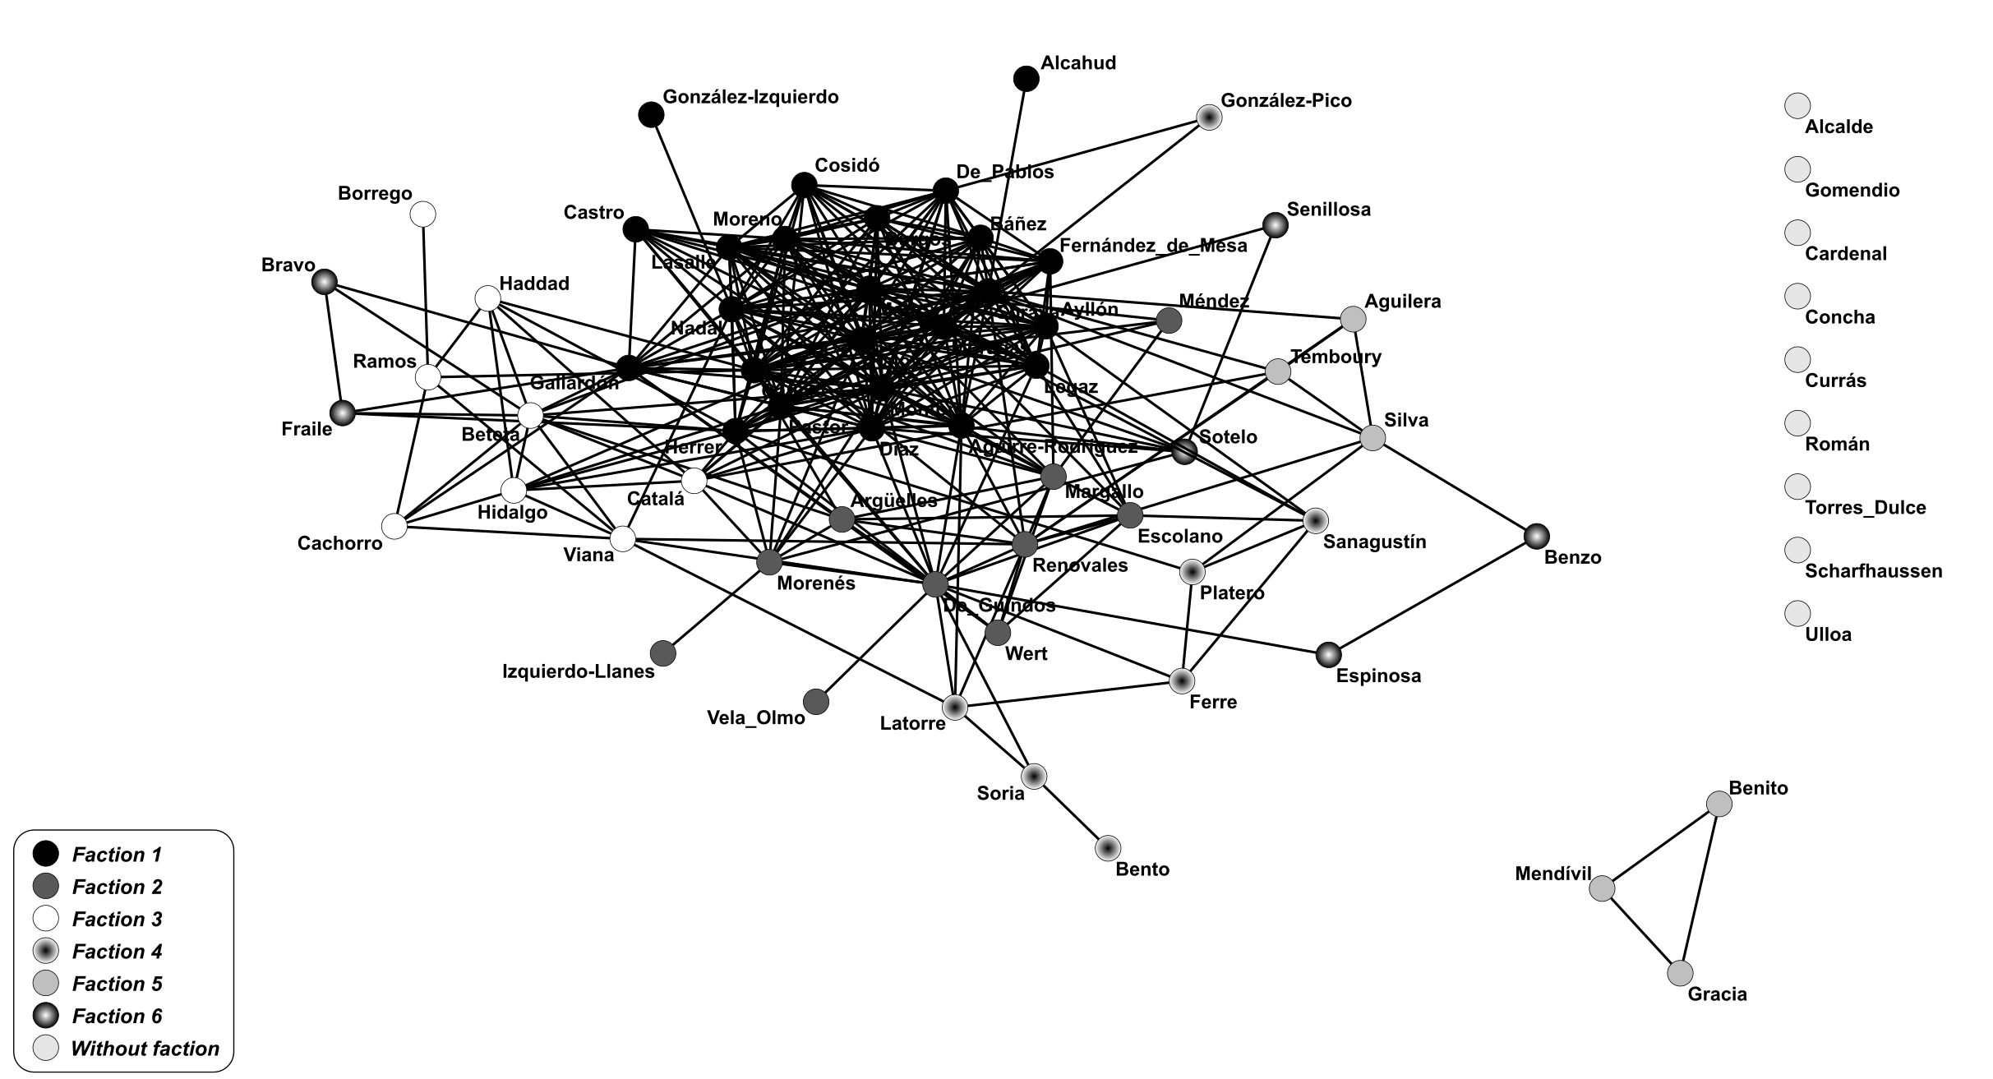
Figure 2. PP official government network.

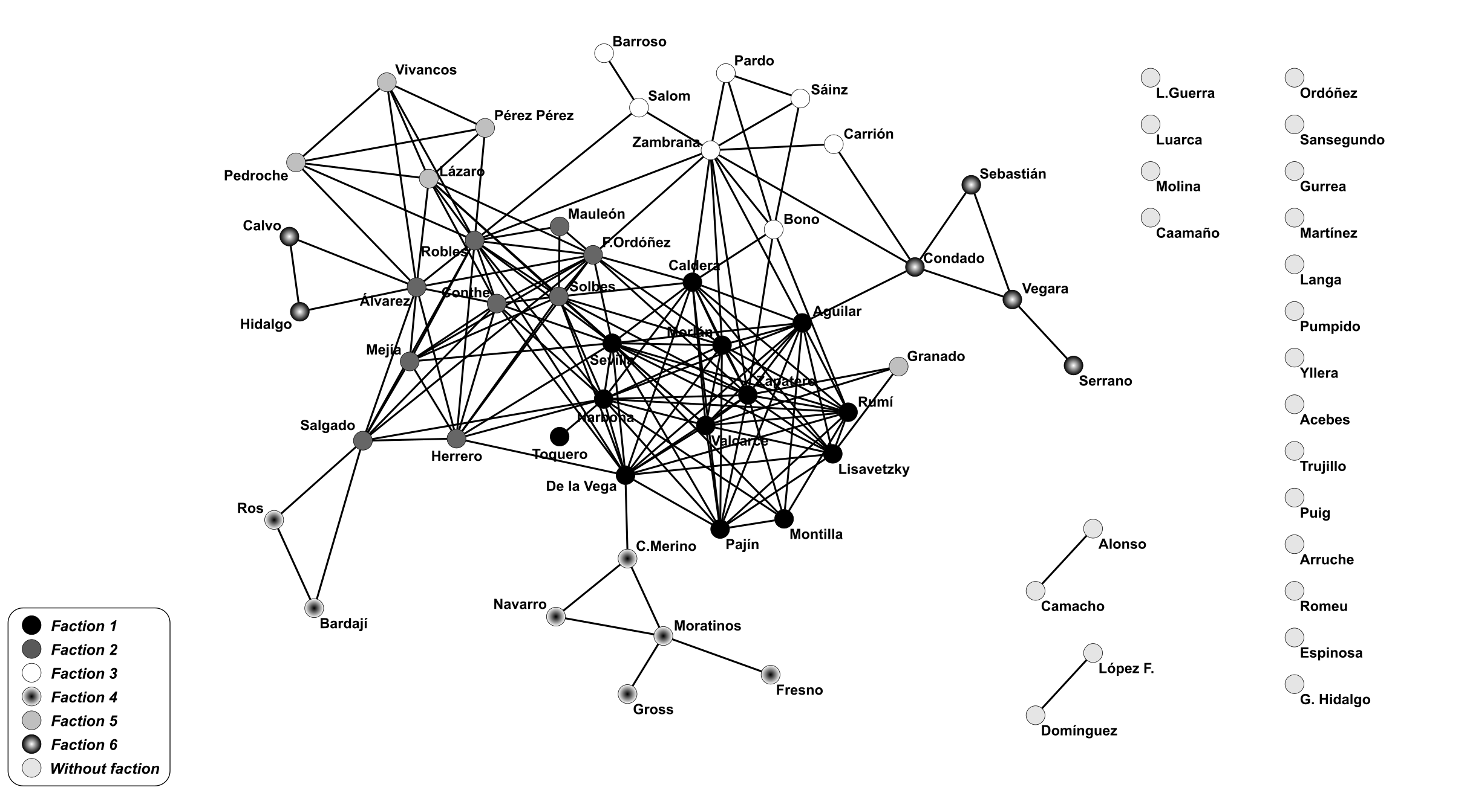
Figure 3. PSOE official government network.

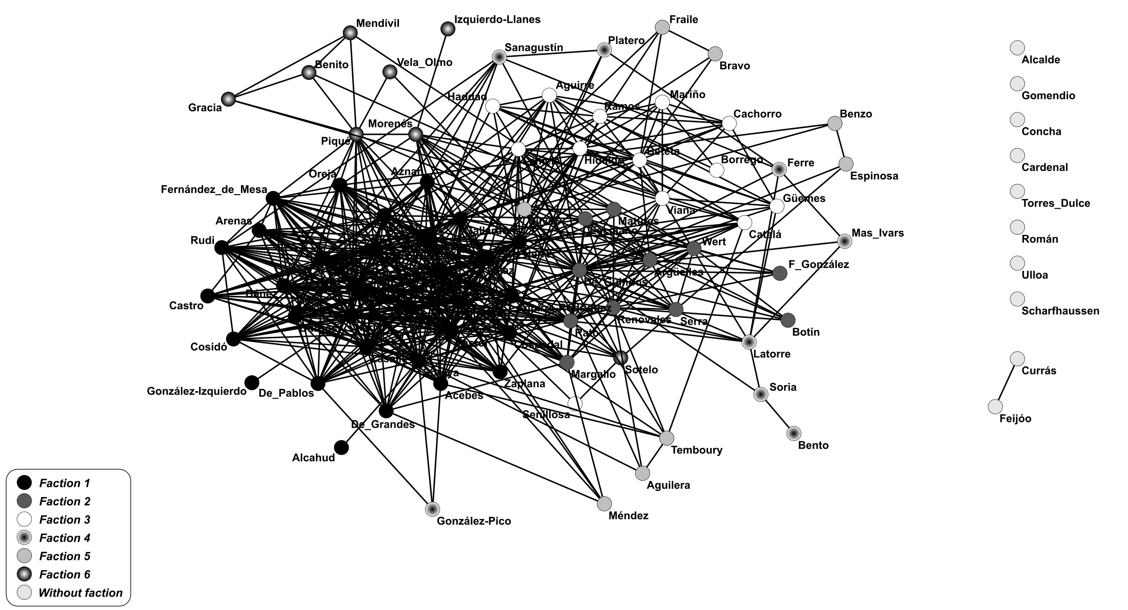
Figure 4. PP expanded government network (with the LPS).

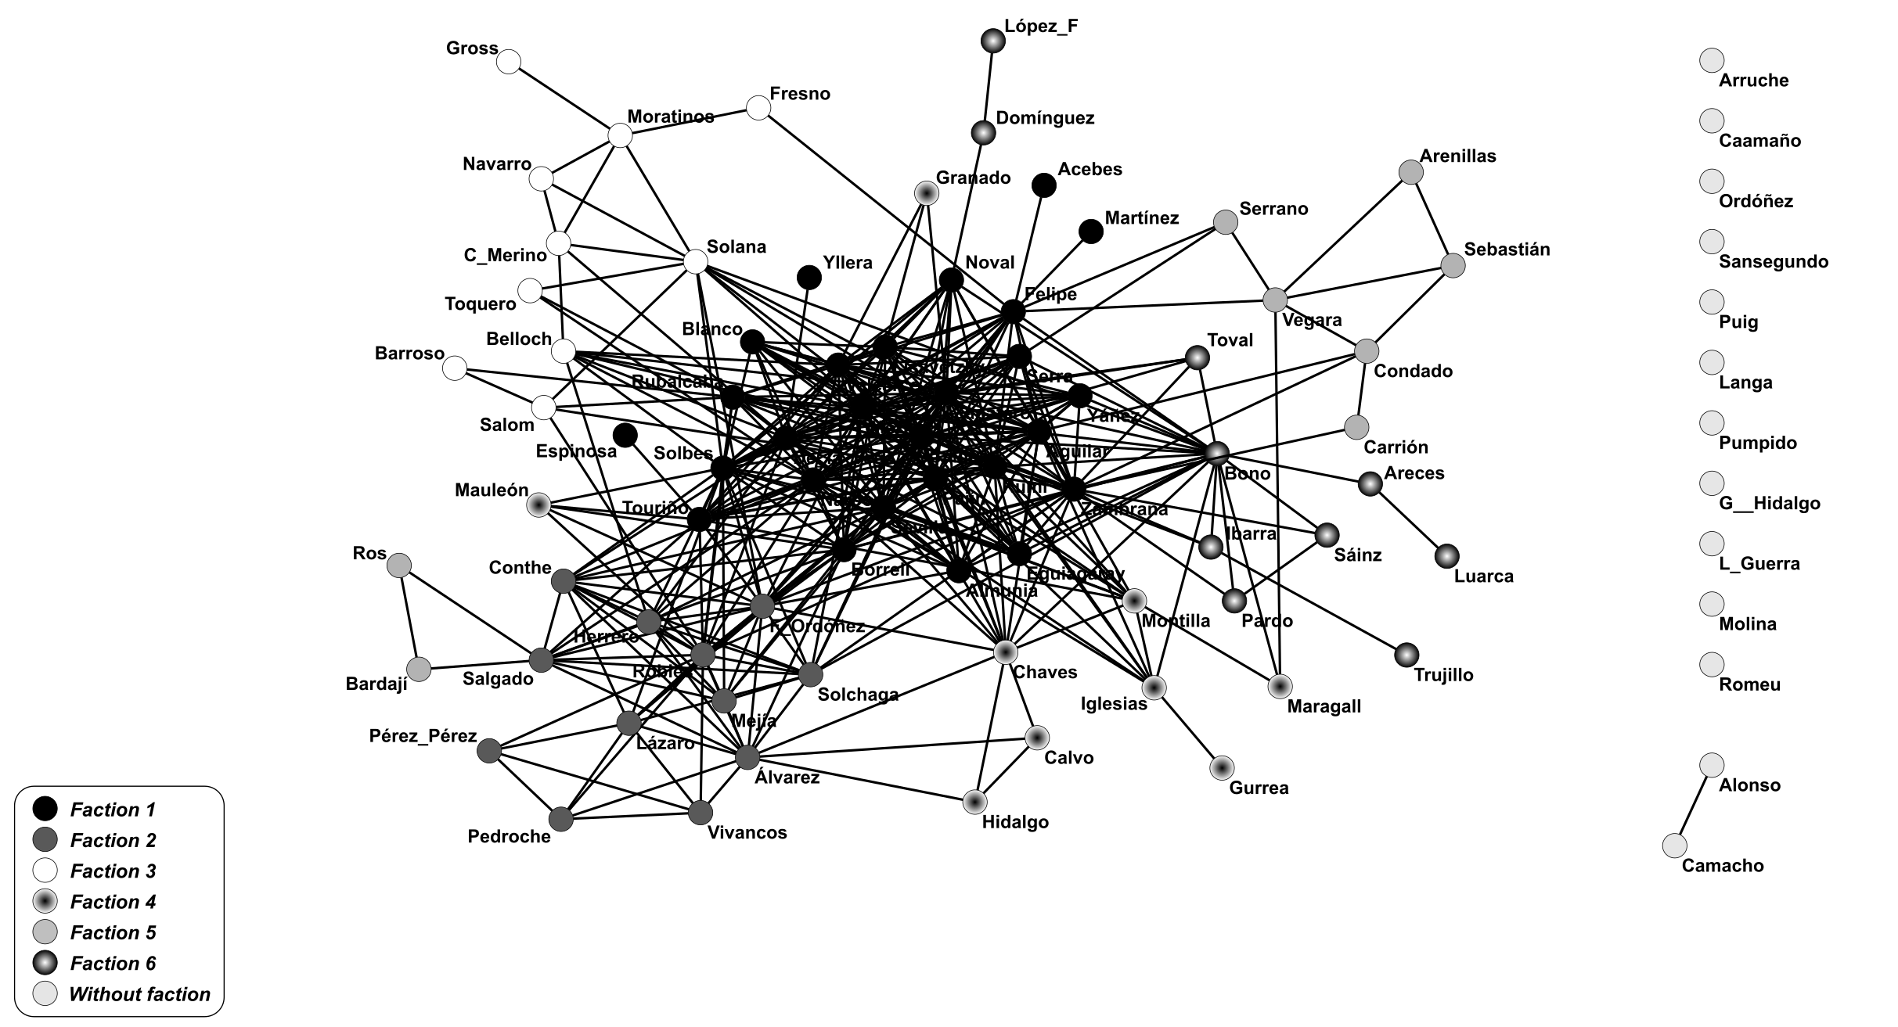
Figure 5. PSOE expanded government network (with the LPS).

Network | #Nodes | #Edges | Average Degree | Diameter | Size Main Component (%) | Closeness Centralization  (Main Component)
PP Official | 70 | 343 | 9.800 | 5 | 82 | 0.336
PP Expanded | 90 | 617 | 13.711 | 5 | 88 | 0.346
PSOE Official | 69 | 172 | 4.985 | 7 | 68 | 0.317
PSOE Expanded | 89 | 409 | 9.191 | 6 | 85 | 0.337
Figure 6. Descriptive statistics of the official and expanded networks.

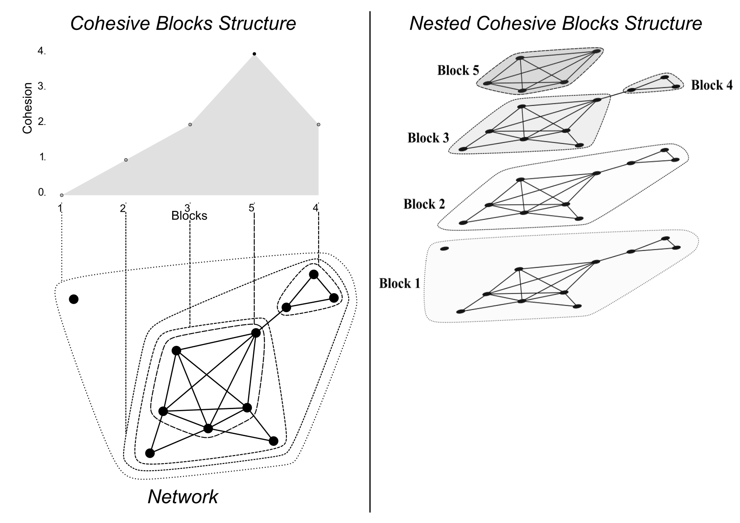
Figure 7. Cohesive blocks analysis example.
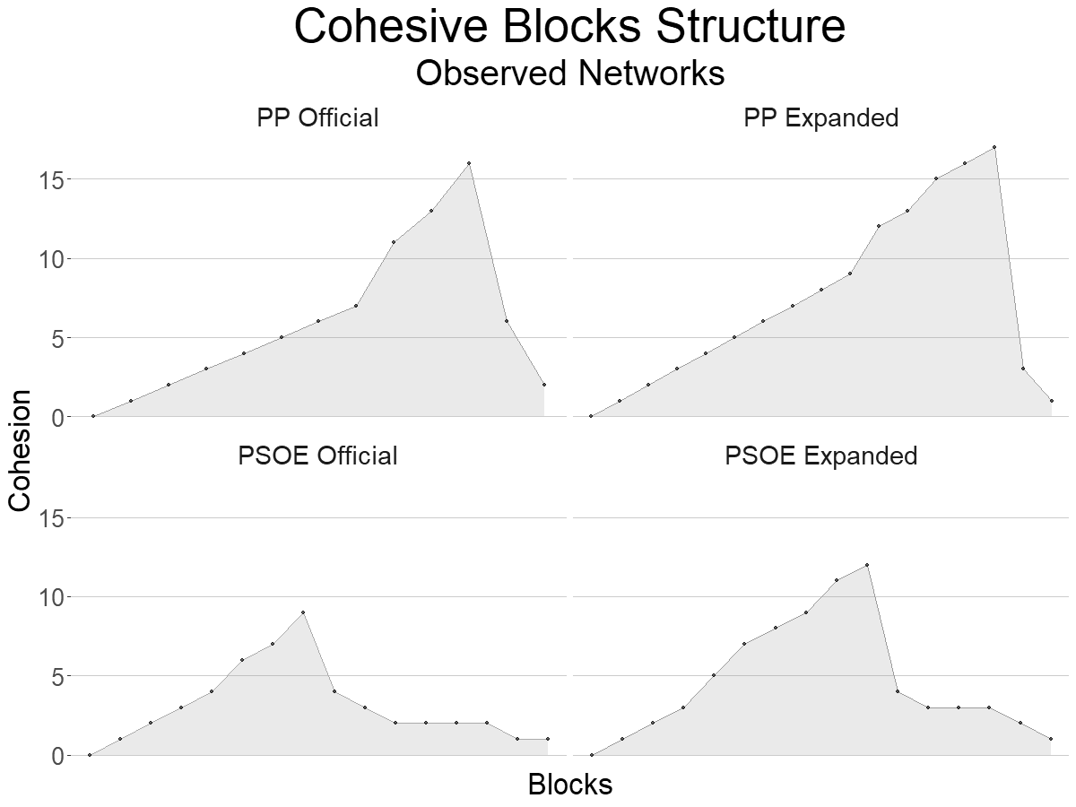
Figure 8. Cohesive blocks analysis of the official and expanded networks (PP and PSOE).

Network | Size Main Component (%) | Closeness Centralization  (Main Component) | #Cohesive Blocks | Maximum Cohesion
PP Official | 82 % | 0.336 | 13 | 16
PP Expanded | 88 % | 0.346 | 17 | 17
PP randomly simulated (n=100) | 92% - 97% - 100%  (Min - Mean - Max) | 0.226 - 0.301 -0.355  (Min - Mean - Max) | 12 - 14 - 16  (Min - Mean - Max) | 16 - 16 - 16  (Min - Mean - Max)
PSOE Official | 68 % | 0.317 | 16 | 9
PSOE Expanded | 85 % | 0.337 | 16 | 12
PSOE randomly simulated (n=100) | 85% - 91% - 96%  (Min - Mean - Max) | 0.211 - 0.297 - 0.367  (Min - Mean - Max) | 9 - 11 - 14  (Min - Mean - Max) | 9 - 9 - 10  (Min - Mean - Max)
Figure 9. Official, expanded and randomly simulated government networks.

