**Appendix 1**

**Supplementary material to the article:**

**Cabinet Reshuffles in Latin America: A Function of Presidential Reputation**

**Written by:**

**Magna Inácio,1* Mariana Llanos2 and Bruno Pinheiro3**

1Department of Political Science, Federal University of Minas Gerais, Minas Gerais, Brazil. <https://orcid.org/0000-0003-1747-8820>

2German Institute for Global and Area Studies (GIGA), Hamburg, Germany. <https://orcid.org/0000-0003-2699-8852>

3Department of Political Science, Federal University of Minas Gerais, Minas Gerais, Brazil. <https://orcid.org/0000-0001-6260-8511>

**Published in:**

**Government and Opposition**

**An International Journal of Comparative Politics**

**PART I – PANEL MODEL**

**1 - Country**

|  |  |  |  |
| --- | --- | --- | --- |
| **Country** | **Years** | **Country** | **Years** |
| Argentina | 1985,1986,1987,1988,1990,1991,1992,1993,1994,1995  1996,1997,1998,1999,2001,2009,2010,2011,2012,2013  2014,2015 | Honduras | 1991,1992,1993,1995,1996,1997,1999,2000,2001,2003  2004,2005,2007,2008,2009,2011,2012,2013,2015,2016 |
| Bolivia | 1999,2000,2001,2007,2008,2009,2010,2011,2012,2013  2014,2015,2016 | Mexico | 2002,2003,2004,2005,2006,2008,2009,2010,2011,2012  2014,2015,2016,2017,2018 |
| Brazil | 1991,1992,1994,1996,1997,1998,1999,2000,2001,2002  2004,2005,2006,2007,2008,2009,2010,2012,2013,2014  2015,2016 | Nicaragua | 1991,1992,1993,1994,1995,1996,1998,1999,2000,2001  2003,2004,2005,2006,2008,2009,2010,2011,2012,2013  2014,2015,2016 |
| Chile | 1991,1992,1993,1995,1996,1997,1998,1999,2001,2002  2003,2004,2005,2007,2008,2009,2011,2012,2013,2015  2016,2017 | Panama | 1991,1992,1993,1994,1996,1997,1998,1999,2001,2002  2003,2004,2006,2007,2008,2009,2011,2012,2013,2014  2016 |
| Colombia | 2000,2001,2002,2004,2005,2006,2007,2008,2009,2010  2012,2013,2014,2015,2016,2017,2018 | Paraguay | 2011,2013,2015,2016 |
| Costa Rica | 1979,1980,1981,1983,1984,1985,1987,1988,1989,1991  1992,1993,1995,1996,1997,1999,2000,2001,2003,2004  2005,2007,2008,2009,2011,2012,2013,2015,2016,2017 | Peru | 2003,2004,2005,2006,2008,2009,2010,2011,2013,2014  2015,2016 |
| Dominican Republic | 2004,2006,2007,2008,2009,2010,2011,2012,2014,2015  2016,2017,2018 | Uruguay | 1988,1989,1991,1992,1993,1994,1996,1997,1998,1999  2001,2002,2003,2004,2006,2007,2008,2009,2011,2012  2013,2014 |
| Ecuador | 1990,1991,1992,1994,1995,1996,1998,2004,2008,2009  2010,2011,2012,2013,2014,2015,2016 | Venezuela | 1988,1990,1991,1992,1995,1996,1997,1998,2001,2002  2003,2004,2005,2006,2007,2008,2009,2010,2011,2012  2014,2015 |
| Guatemala | 1988,1989,1990,1992,1997,1998,1999,2001,2002,2003  2005,2006,2007,2009,2010,2011,2013,2014,2015 |  |  |

**2 - Data Sources**

|  |  |  |
| --- | --- | --- |
| **Variables** | **Variable name** | **Source** |
| Turnover Minister | 1 – (retention_rateadj_minister) | WhoGov dataset |
| Political Leverage | $${(maj+approval_simple+percent1)}/3$$ | The Database of Political Institutions, Executive Approval Database |
| Reputation Asset (PolEx Measure) | gamma | PolEx Dataset |
| Type of Government | n_party | WhoGov dataset |
| Polity2 | polity2 | PolEx Dataset |
| Mandate Course | (leaderexperience_total - 1) | WhoGov dataset |
| Terms of Trade | (cgdpe-cgdpo)/cgdpo | Penn World Table 10.0 |
| GDP (growth) | growth | WhoGov dataset |

**3 – Descriptive statistics**

Table 1: Summary Statistics

|  | Unique (#) | | Missing (%) | | Mean | | SD | | Min | Median | Max |
| --- | --- | --- | --- | --- | --- | --- | --- | --- | --- | --- | --- |
| Turnover Cabinet | 108 | | 0 | | 0.3 | | 0.2 | | 0.0 | 0.2 | 0.8 |
| Political Leverage | 314 | | 0 | | 0.5 | | 0.1 | | 0.3 | 0.5 | 0.8 |
| Reputational Assets | 82 | | 0 | | 0.2 | | 0.6 | | -2.2 | 0.2 | 1.3 |
| Polity 2 | 8 | | 0 | | 8.2 | | 1.4 | | 3.0 | 8.0 | 10.0 |
| Mandate Course | 20 | | 0 | | 3.9 | | 3.3 | | 1.0 | 3.0 | 20.0 |
| Terms of Trade | 314 | | 0 | | -0.0 | | 0.0 | | -0.1 | -0.0 | 0.1 |
| GDP Growth | 82 | | 0 | | 1.3 | | 3.9 | | -10.8 | 1.7 | 12.7 |
| Categorical Var. | |  | | N | | % | |
| Type of Gov. | | Single-party | | 56 | | 17.8 | |
|  | | Coalition | | 258 | | 82.2 | |

**4 – Diagnostic test-results**

|  |  |  |
| --- | --- | --- |
| **Method** | **Test-statistic** | **p-valor** |
| F test for individual effects | F = 4.2164 | 2.32333e-07 |
| Hausman Test | chisq = 7.2049 | 0.4079 |
| Lagrange Multiplier Test - (Honda) for unbalanced panels | normal = 5.7689 | 3.989e-09 |
| Lagrange Multiplier Test - (Breusch-Pagan) for unbalanced panels | chisq = 33.28 | 7.978e-09 |
| Lagrange Multiplier Test - two-ways effects (Breusch-Pagan) for unbalanced panels | chisq = 35.295 | 2.167e-08 |
|  |  |  |
| **Diagnostics Test** |  |  |
| Breusch-Godfrey/Wooldridge test for serial correlation in panel models | chisq = 8.3078 | 0.08093 |
| Breusch-Godfrey/Wooldridge test for serial correlation in panel  models | F = 2.0519 | 0.08712 |
| Studentized Breusch-Pagan test for heteroskedasticity | BP = 3.2361 | 0.8623 |
| Pesaran CD test for cross-sectional dependence in panels | z = 0.13683 | 0.8912 |
| Breusch-Pagan LM test for cross-sectional dependence in panels | chisq = 158.02 | 0.09522 |
| Augmented Dickey-Fuller Test for unit roots/stationarity | Dickey-Fuller = -4.3755 | 0.01 |

**5 – Random-effects Panel Data**

Table - Turnover Cabinet and Presidential Reputation

Dependent Variable = Turnover Cabinet (%)

|  | Model 1 | Model 2 | Model 3 | Model 4 | Model 5 | Model 6 |
| --- | --- | --- | --- | --- | --- | --- |
| Political Leverage | -0.22** | -0.22* | -0.25** | -0.25** | -0.26** | -0.28** |
|  | (0.11) | (0.11) | (0.12) | (0.12) | (0.12) | (0.12) |
| Reputation Asset (PolEx Measure) | -0.05*** | -0.05*** | -0.04** | -0.04** | -0.04** | -0.04** |
|  | (0.02) | (0.02) | (0.02) | (0.02) | (0.02) | (0.02) |
| Type of Government |  | 0.01 | 0.01 | 0.01 | 0.01 | 0.01 |
|  |  | (0.03) | (0.03) | (0.03) | (0.03) | (0.03) |
| Polity2 |  |  | -0.01 | -0.01 | -0.01 | -0.01 |
|  |  |  | (0.01) | (0.01) | (0.01) | (0.01) |
| Mandate Course |  |  |  | 0.00 | 0.00 | 0.00 |
|  |  |  |  | (0.00) | (0.00) | (0.00) |
| Terms of Trade |  |  |  |  | -0.46 | -0.31 |
|  |  |  |  |  | (0.39) | (0.37) |
| GDP (growth) |  |  |  |  |  | -0.01** |
|  |  |  |  |  |  | (0.00) |
| Num.Obs. | 314 | 314 | 314 | 314 | 314 | 314 |
| R2 | 0.043 | 0.042 | 0.048 | 0.048 | 0.052 | 0.068 |
| R2 Adj. | 0.036 | 0.032 | 0.036 | 0.033 | 0.033 | 0.047 |
| Model 1, 2, 3, 4, 5 and 6: Random model. Clustered robust standard errors by country in parentheses. | | | | | | |
| * p < 0.1, ** p < 0.05, *** p < 0.01 | | | | | | |

**6 – Alternative panel data estimators**

Table - Cabinet Reshuffles and Presidential Reputation

Dependent Variable = Turnover Cabinet (%)

|  | Model 1 | Model 2 | Model 3 | Model 4 |
| --- | --- | --- | --- | --- |
| Political Leverage | -0.22* | -0.29** | -0.34*** | 0.31*** |
|  | (0.13) | (0.14) | (0.11) | (0.01) |
| Reputation Asset (PolEx Measure) | -0.03 | -0.04* | -0.05*** | -0.06 |
|  | (0.02) | (0.02) | (0.02) | (0.09) |
| Type of Government | 0.01 | -0.01 | 0.00 | 0.06 |
|  | (0.03) | (0.03) | (0.03) | (0.09) |
| Polity2 | -0.01 | 0.00 | -0.02** | -0.07 |
|  | (0.01) | (0.01) | (0.01) | (0.10) |
| Mandate Course | 0.00 | 0.00 | 0.00 | 0.02 |
|  | (0.00) | (0.00) | (0.00) | (0.55) |
| Terms of Trade | -0.64 | -0.38 | 0.30 | -1.09*** |
|  | (0.45) | (0.50) | (0.33) | (0.00) |
| GDP (growth) | -0.01 | -0.01 | -0.01*** | 0.00 |
|  | (0.00) | (0.00) | (0.00) | (0.63) |
| Num.Obs. | 314 | 314 | 314 | 297 |
| R2 | 0.046 | 0.045 | 0.123 | 0.058 |
| R2 Adj. | -0.029 | -0.186 | 0.103 | 0.035 |
| Model 1: Country-Specific Fixed Effects; Model 2: Country-Specific Two-Way Fixed Effects; Model 3: Pooling Linear Panel; Model 4: Panel estimators for limited dependent variables. Clustered robust standard errors by country in parentheses. | | | | |
| * p < 0.1, ** p < 0.05, *** p < 0.01 | | | | |

**PART II – SURVIVAL MODEL**

**1 – Descriptive statistics**

Table 1: Summary Statistics

|  |  |  |  |  |  |  |
| --- | --- | --- | --- | --- | --- | --- |
|  |  | |  | |  | |
|  | | Unique (#) | | Missing (%) | | Mean | | SD | Min | Median | Max |
| Days in Office | | 846 | | 3 | | 513.1 | | 417.6 | 3.0 | 382.0 | 2922.0 |
| Event | | 3 | | 3 | | 0.7 | | 0.5 | 0.0 | 1.0 | 1.0 |
| Reputation Assets | | 35 | | 20 | | 0.1 | | 0.8 | -2.2 | 0.4 | 1.0 |
| Political Leverage | | 23 | | 41 | | 0.5 | | 0.1 | 0.3 | 0.5 | 0.7 |
| Partyness | | 3 | | 4 | | 0.6 | | 0.5 | 0.0 | 1.0 | 1.0 |
| Expertise | | 3 | | 7 | | 0.8 | | 0.4 | 0.0 | 1.0 | 1.0 |
| Own | | 3 | | 20 | | 0.6 | | 0.5 | 0.0 | 1.0 | 1.0 |
| Gender | | 3 | | 31 | | 0.9 | | 0.4 | 0.0 | 1.0 | 1.0 |
| Minister’s Political Network (Union) | | 3 | | 15 | | 0.0 | | 0.2 | 0.0 | 0.0 | 1.0 |
| Minister’s Political Network (Economic sectors) | | 3 | | 15 | | 0.1 | | 0.3 | 0.0 | 0.0 | 1.0 |
| Minister’s Political Network (Religious groups) | | 3 | | 15 | | 0.0 | | 0.1 | 0.0 | 0.0 | 1.0 |
| Minister’s Political Network (Military) | | 3 | | 15 | | 0.0 | | 0.2 | 0.0 | 0.0 | 1.0 |
| Type of Government | | 3 | | 4 | | 0.6 | | 0.5 | 0.0 | 1.0 | 1.0 |

**2 – Models**

Table: Cox Proportional Hazard Models of Minister Survival (whole sample)

|  | (1) | (2) | (3) | (4) | (5) | |
| --- | --- | --- | --- | --- | --- | --- |
| **President’s Reputational Assets** | 0.73** | 0.79*** | 0.76*** | 0.79* | 1.16 | |
|  | (0.04) | (0.04) | (0.04) | (0.07) | (0.17) | |
| **Political Leverage** | 0.31* | 0.29** | 0.52 | 0.41 | 0.37 | |
|  | (0.37) | (0.40) | (0.44) | (0.57) | (0.57) | |
| **President’s Own People** |  | 1.12 | 1.05 | 0.93 | 0.95 | |
|  |  | (0.08) | (0.08) | (0.09) | (0.09) | |
| **Minister’s Party Attachment** |  | 1.26*** | 1.19*** | 1.19* | 1.23*** | |
|  |  | (0.09) | (0.10) | (0.11) | (0.11) | |
| **Minister’s Policy Expertise** |  | 1.08 | 0.95 | 0.86 | 0.85 | |
|  |  | (0.12) | (0.12) | (0.12) | (0.12) | |
| **Type of Government** |  |  | 0.65*** | 0.65** | 0.69* | |
|  |  |  | (0.11) | (0.16) | (0.17) | |
| **Minister’s Political Network** |  |  |  |  |  | |
| Union |  |  | 1.38*** | 1.46*** | 1.54*** | |
|  |  |  | (0.20) | (0.20) | (0.21) | |
| Economic sectors |  |  | 0.90 | 0.84* | 0.85 | |
|  |  |  | (0.14) | (0.18) | (0.18) | |
| Religious groups |  |  | 0.91 | 0.94 | 0.91 | |
|  |  |  | (0.27) | (0.39) | (0.39) | |
| Military |  |  | 0.89 | 2.07* | 1.91* | |
|  |  |  | (0.31) | (0.39) | (0.39) | |
| **Gender** |  |  |  | 1.28** | 1.29*** | |
|  |  |  |  | (0.12) | (0.12) | |
| **Interactive model** |  |  |  |  |  | |
| Partisan × President’s reputational assets |  |  |  |  | 0.85 | |
|  |  |  |  |  | (0.12) | |
| Expert × President’s reputational assets |  |  |  |  | 0.76** | |
|  |  |  |  |  | (0.12) | |
| President’s own people × President’s reputational assets |  |  |  |  | 0.86*** | |
|  |  |  |  |  | (0.10) | |
| Num.Obs. | 1301 | 1085 | 1077 | 845 | 845 | |
| R2 | 0.075 | 0.059 | 0.079 | 0.068 | 0.076 | |
| Confidence intervals of the hazard ratios in parentheses. | | | | | |
| * p < 0.1, ** p < 0.05, *** p < 0.01 | | | | | |

Table: Cox Proportional Hazard Models of Minister Survival (restrict sample)

|  | (1) | (2) | (3) | (4) | (5) | |
| --- | --- | --- | --- | --- | --- | --- |
| **President’s Reputational Assets** | 0.74** | 0.86*** | 0.86*** | 1.00 | 1.11*** | |
|  | (0.06) | (0.06) | (0.07) | (0.13) | (0.39) | |
| **Political Leverage** | 0.11** | 0.14*** | 0.24*** | 0.09*** | 0.08*** | |
|  | (0.61) | (0.77) | (0.87) | (1.37) | (1.42) | |
| **President’s Own People** |  | 1.10 | 1.06 | 0.93 | 1.03 | |
|  |  | (0.12) | (0.13) | (0.18) | (0.21) | |
| **Minister’s Party Attachment** |  | 1.31** | 1.22** | 1.11 | 1.13 | |
|  |  | (0.15) | (0.16) | (0.19) | (0.22) | |
| **Minister’s Policy Expertise** |  | 0.97 | 0.98 | 1.01 | 0.99 | |
|  |  | (0.27) | (0.27) | (0.31) | (0.33) | |
| **Type of Government** |  |  | 0.78*** | 0.73*** | 0.76** | |
|  |  |  | (0.16) | (0.23) | (0.25) | |
| **Minister’s Political Network** |  |  |  |  |  | |
| Union |  |  | 1.33*** | 1.43*** | 1.48*** | |
|  |  |  | (0.26) | (0.28) | (0.28) | |
| Economic sectors |  |  | 1.09 | 1.24** | 1.25** | |
|  |  |  | (0.19) | (0.28) | (0.29) | |
| Religious groups |  |  | 0.62 | 0.47 | 0.53 | |
|  |  |  | (0.45) | (0.73) | (0.75) | |
| Military |  |  | 0.42*** | 0.74 | 0.72 | |
|  |  |  | (0.51) | (1.01) | (1.01) | |
| **Gender** |  |  |  | 1.02 | 1.04*** | |
|  |  |  |  | (0.22) | (0.22) | |
| **Interactive model** |  |  |  |  |  | |
| Partisan × President’s reputational assets |  |  |  |  | 0.92** | |
|  |  |  |  |  | (0.28) | |
| Expert × President’s reputational assets |  |  |  |  | 1.09 | |
|  |  |  |  |  | (0.31) | |
| President’s own people × President’s reputational assets |  |  |  |  | 0.78*** | |
|  |  |  |  |  | (0.24) | |
| Num.Obs. | 601 | 456 | 456 | 260 | 260 | |
| R2 | 0.089 | 0.052 | 0.071 | 0.062 | 0.066 | |
| Confidence intervals of the hazard ratios in parentheses. | | | | | |
| * p < 0.1, ** p < 0.05, *** p < 0.01 | | | | | |

**3 – Test the proportional hazard model (Schoenfeld Individual test)**

|  |  |  |  |
| --- | --- | --- | --- |
| **variable** | **chisq** | **df** | **p-value** |
| President’s Reputational Assets | 7.502668e-01 | 1 | 0.3863918 |
| Political Leverage | 6.499561e-02 | 1 | 0.7987676 |
| President’s Own People | 2.009242e-01 | 1 | 0.6539759 |
| Minister’s Party Attachment | 3.628754e-01 | 1 | 0.5469137 |
| Minister’s Policy Expertise | 1.124984e-05 | 1 | 0.9973238 |
| Type of Government | 4.308462e-02 | 1 | 0.8355660 |
| Minister’s Political Network (Union) | 3.869234e-01 | 1 | 0.5339211 |
| Minister’s Political Network (Economic sectors) | 6.477139e-01 | 1 | 0.4209312 |
| Minister’s Political Network (Religious groups) | 9.801910e-01 | 1 | 0.3221517 |
| Minister’s Political Network (Military) | 2.027992e+00 | 1 | 0.1544245 |
| Gender | 9.573352e-02 | 1 | 0.7570109 |
| Partisan × President’s reputational assets | 7.242030e-0 | 1 | 0.8355660 |
| Expert × President’s reputational assets | 2.081495e+00 | 1 | 0.1490941 |
| President’s own people × President’s reputational assets | 6.786488e-01 | 1 | 0.4100524 |
| Global | 1.446683e+01 | 14 | 0.4155422 |

**4 –** **Schoenfeld Individual test**

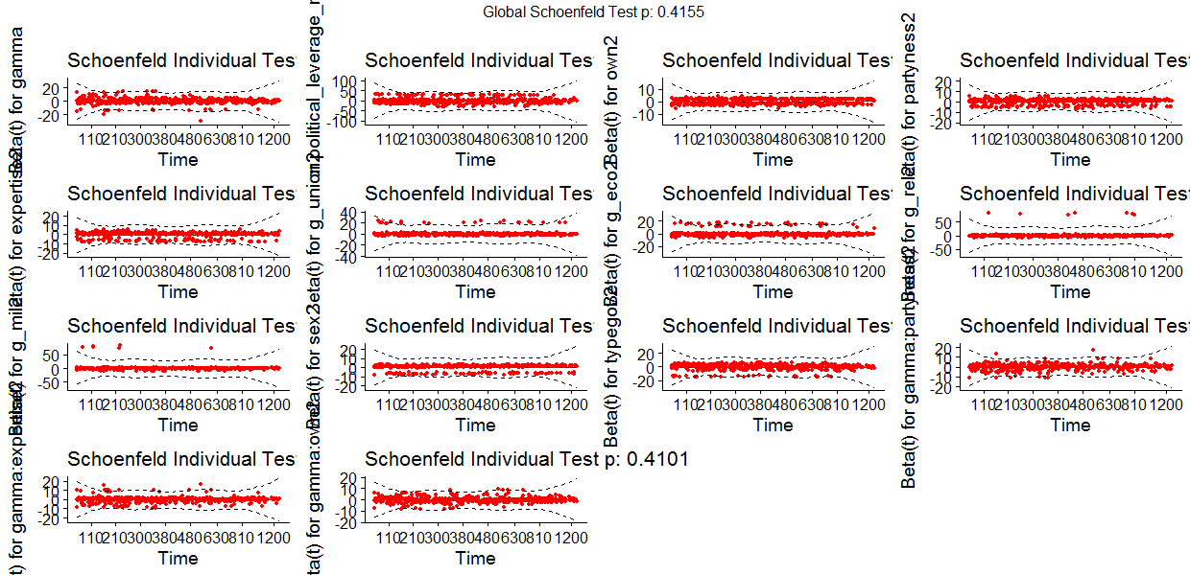

**5 – Testing influential observations**

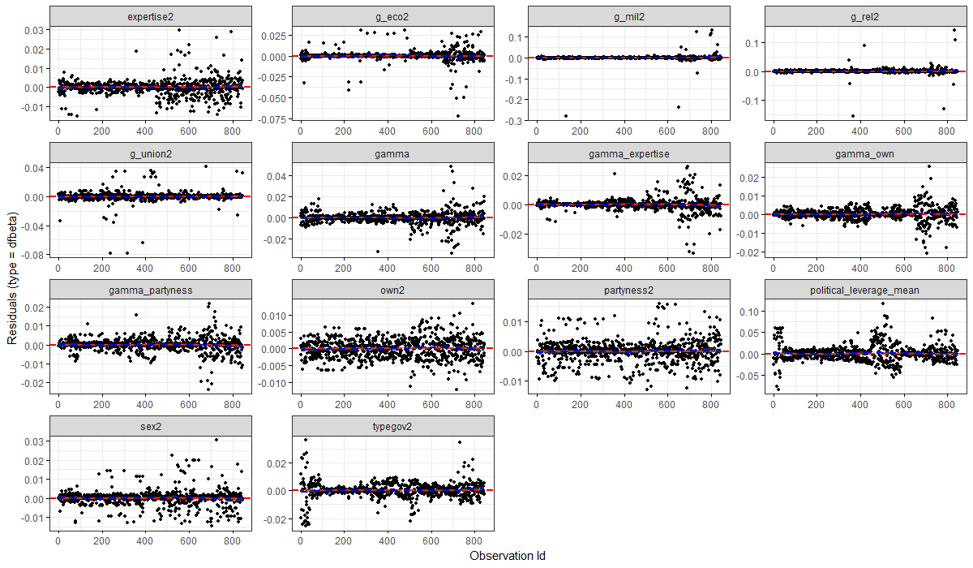

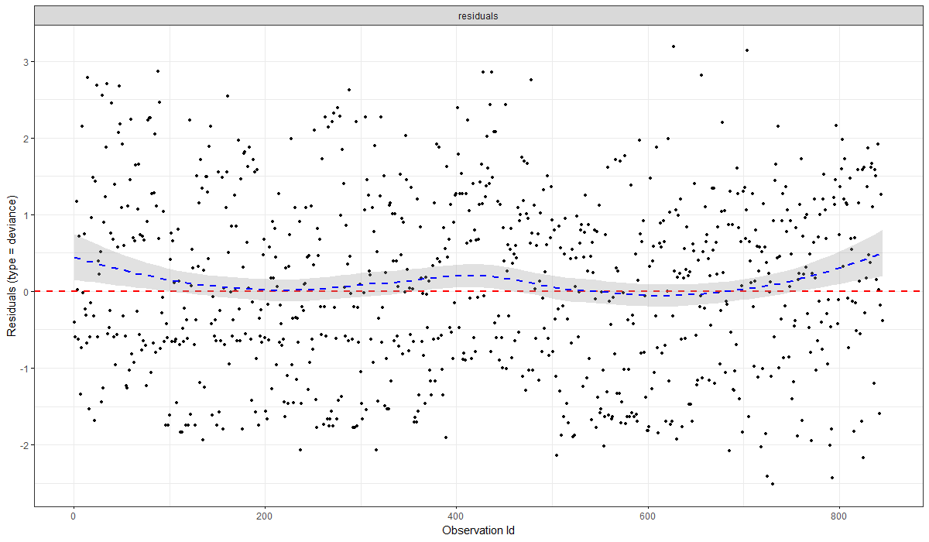

**References**

Achim Zeileis, Torsten Hothorn (2002). Diagnostic Checking in Regression Relationships. R News 2(3), 7-10. URL <https://CRAN.R-project.org/doc/Rnews/>

Adrian Trapletti and Kurt Hornik (2020). tseries: Time Series Analysis and Computational Finance. R package version 0.10-48.

Alboukadel Kassambara, Marcin Kosinski and Przemyslaw Biecek (2021). survminer: Drawing Survival Curves using 'ggplot2'. R package version 0.4.9. <https://CRAN.R-project.org/package=survminer>

Barret Schloerke, Di Cook, Joseph Larmarange, Francois Briatte, Moritz Marbach, Edwin Thoen, Amos Elberg and Jason Crowley (2021). GGally: Extension to 'ggplot2'. R package version 2.1.2. <https://CRAN.R-project.org/package=GGally>

Christian Kleiber and Achim Zeileis (2008). Applied Econometrics with R. New York: Springer-Verlag. ISBN 978-0-387-77316-2. URL: <https://CRAN.R-project.org/package=AER>

Chung-hong Chan, Geoffrey CH Chan, Thomas J. Leeper, and Jason Becker (2021). rio: A Swiss-army knife for data file I/O. R package version 0.5.27.

Claus O. Wilke (2020). cowplot: Streamlined Plot Theme and Plot Annotations for 'ggplot2'. R package version 1.1.1. <https://CRAN.R-project.org/package=cowplot>

Croissant Y, Millo G (2008). “Panel Data Econometrics in R: The plm Package.” _Journal of Statistical Software_, *27*(2), 1-43. doi: 10.18637/jss.v027.i02 (URL: <https://doi.org/10.18637/jss.v027.i02>).

Garrett Grolemund, Hadley Wickham (2011). Dates and Times Made Easy with lubridate. Journal of Statistical Software, 40(3), 1-25. URL <https://www.jstatsoft.org/v40/i03/>.

Hao Zhu (2021). kableExtra: Construct Complex Table with 'kable' and Pipe Syntax. R package version 1.3.4. <https://CRAN.R-project.org/package=kableExtra>

Kirill Müller (2020). here: A Simpler Way to Find Your Files. R package version 1.0.1. <https://CRAN.R-project.org/package=here>

Lüdecke D (2021). _sjPlot: Data Visualization for Statistics in Social Science_. R package version 2.8.9, <URL: <https://CRAN.R-project.org/package=sjPlot>>.

Therneau T (2021). _A Package for Survival Analysis in R_.R package version 3.2-11, <URL:<https://CRAN.R-project.org/package=survival>>.

Vincent Arel-Bundock (2021). modelsummary: Summary Tables and Plots for Statistical Models and Data: Beautiful, Customizable, and Publication-Ready. R package version 0.8.1. <https://CRAN.R-project.org/package=modelsummary>

Vincent Arel-Bundock (2022). marginaleffects: Marginal Effects, Marginal Means, Predictions, and Contrasts. R package version 0.3.2. <https://CRAN.R-project.org/package=marginaleffects>

Wickham et al., (2019). Welcome to the tidyverse. Journal of Open Source Software, 4(43), 1686, <https://doi.org/10.21105/joss.01686>