SUPPLEMENTARY MATERIAL

Paper: The Rassemblement National and COVID19. How nativism, authoritarianism, and expert populism did not pay-off during the pandemic

Caterina Froio*
Department of Political Science, Sciences Po/CEE, Paris, France
ORCID: 000-0003-3715-1665
*Corresponding author. Email: caterina.froio@sciencespo.fr

APPENDIX

Annex 1.
COVID19 Stringency Index: France in Europe

Annex 2.
Table A. Political parties mentioned in the analyses
Party | Translation | Acronym
Rassemblement National | National Rally | RN
Front National | National Front | FN
Parti Socialiste | Socialist Party | PS
Les Républicains | The Republicans | LR
La République en Marche | The Republic on the Move | REM
La France Insoumise | Unbowed France | FI
Europe Ecologie Les Verts | Europe Ecology the Greens | EELV

Annex 3.
The analysis of Facebook posts & press releases
Quantitative text analysis of Facebook posts
The Facebook posts data has been collected in the framework of the project: “What do the people want? Analysing online populist challenges to Europe” funded by the Volkswagen Foundation (Grant No. 94758). Among other, this project applies methods of quantitative text analysis to parties’ social media communication. For this paper the data collection followed three steps: 1) CrowdTangle was used to download all public content from the official Facebook accounts/pages of French parties from 01 January 2020 to 30 April 2021. Subsequently, a keyword search (using COVID-19) was performed to filter the posts that were relevant for the analysis. This resulted in 813 posts in total (see Table B, Figure A and Figure B below); 2) to classify the content of the posts in different policy areas, the paper relies on a comprehensive dictionary of around 60 words developed by Lexicoder in the framework of the Comparative Agendas Project (Albugh, Sevenans, and Soroka 2013) adapted to France by using the policy categories of the French Agendas Project (Baumgartner, Breunig, and Grossman 2019). The dictionary allows to capture the content of the posts dealing with diverse policy issues that could be associated with the pandemic, notably health, education, economy, immigration and apply it to political parties’ official Facebook posts. 3) Based on this dictionary, the 813 posts mentioning COVID19 have been then automatically classified as either containing or not words related to one of the different policy categories. To check the reliability of the data, I also coded manually the policy issues of the 813 Facebook posts and compared these to the automatic classification. This test yielded a strong consistency regarding the identification of the policy content of each post. The Cronbach alpha was 0.86. The collection and treatment of Facebook content data for this study was done in full compliance with EU GDPR (General Data Protection Regulation) regulations. Institutional Review Board (IRB) approval was obtained from the Oxford Internet Institute’s Departmental Research Ethics Committee at the University of Oxford (Reference Number SSH IREC 18 004).

Qualitative content analysis Facebook posts and press releases
In the paper I use a deductive qualitative content analysis to identify the frames of the pandemic as they appear in the Facebook posts and in Marine Le Pen’s official press releases (retrieved through EUROPRESSE). In line with the guidelines in the literature (Hsieh and Shannon 2005) The deductive qualitative content analysis of this material followed five steps. First, based on Benford and Snow’s theory I developed operational definitions of the two main pandemic frames: prognostic ones pointing at the causes/origins of the pandemic, and diagnostic frames advancing possible remedies/solutions. Second, I reviewed all text material carefully, highlighting all text that appeared to describe a frame of the pandemic. Third, all highlighted text was coded using the predetermined frame categories wherever possible. Text that could not be coded into one of these categories was coded with another label. Fourth, after coding, I examined the data for each category to determine whether subcategories were needed for a category (e.g., diagnostic frame immigration, prognostic frame vaccination). Data that could not be coded into one of the two categories derived from the theory were reexamined to describe different frames. Finally, I compared the extent to which the data were supportive of Benford and Snow’s theory of diagnostic and prognostic frames versus how much represented different frames/content. The incidence of codes that represented the two main categories derived from Belford and Snow is 89%, while the incidence of newly identified content/frames is 11%.

Table B. Breakdown of Facebook posts
Party | Nr of Facebook posts
La République en Marche | 173
Parti Socialiste | 146
Les Républicains | 318
Rassemblement National | 56
La France Insoumise | 58
Europe Ecologie Les Verts | 62
Tot | 813
Average | 135.5

Figure A. Salience of COVID19 Facebook posts in France, by party (daily)
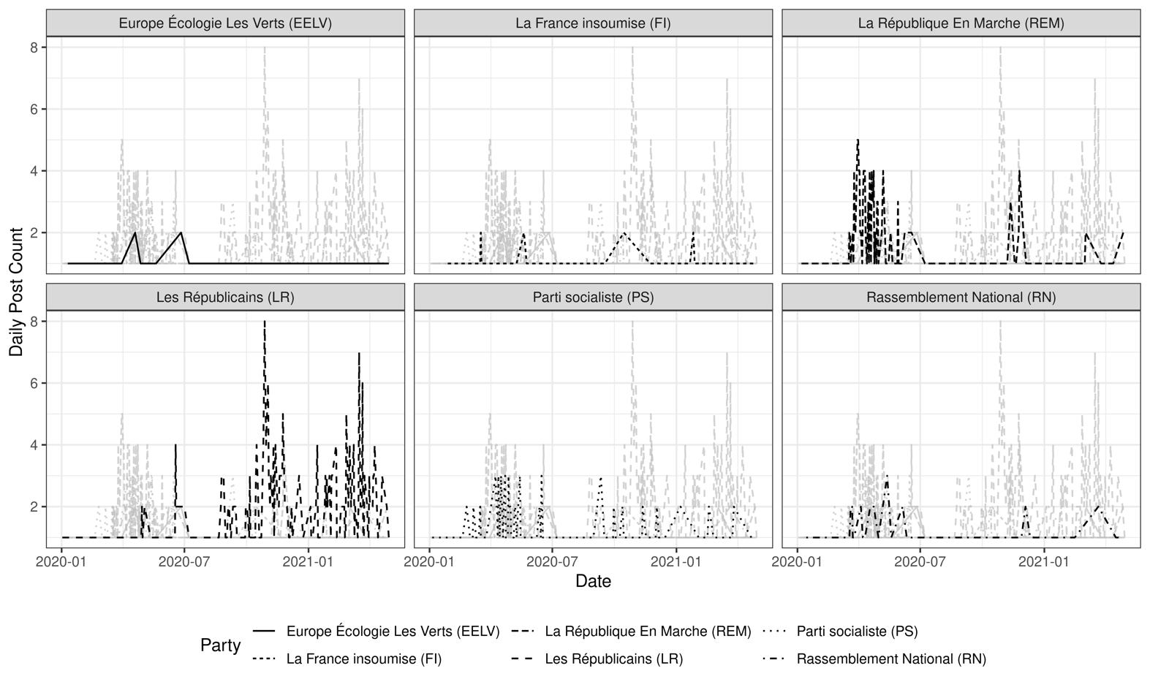

Figure B. Salience of COVID19 Facebook posts in France, by party (monthly)
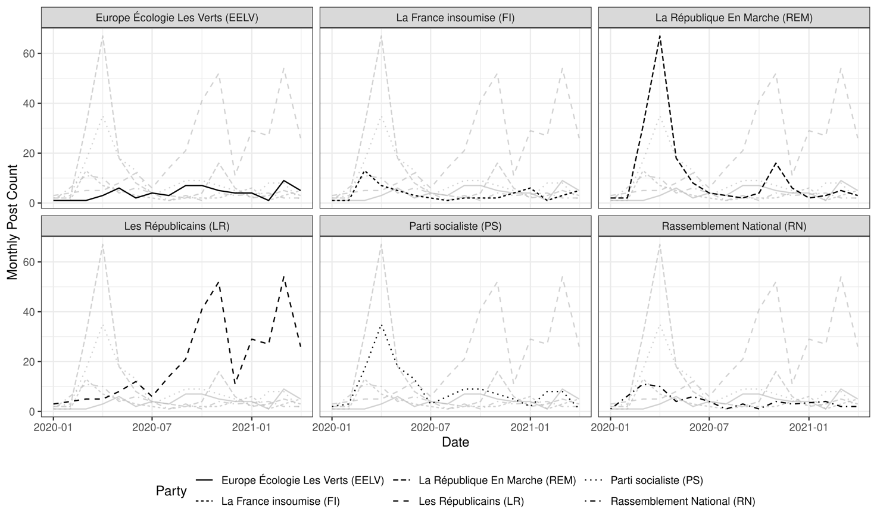

References
Albugh, Quinn, Julie Sevenans, and Stuart Soroka. 2013. “Lexicoder Topic Dictionaries, June 2013 Versions.” McGill University. Www. Lexicoder. Com.
Baumgartner, Frank R., Christian Breunig, and Emiliano Grossman, eds. 2019. Comparative Policy Agendas: Theory, Tools, Data. Oxford, New York: Oxford University Press.
Hsieh, Hsiu-Fang, and Sarah E. Shannon. 2005. “Three Approaches to Qualitative Content Analysis.” Qualitative Health Research 15 (9): 1277–88.

