Appendix A. Participating parties (N=14)

Party | Country | Party Family# | Vote Share | Total Staff | Governing status | Response rate | Survey period
N-VA | Belgium | Conservative | 20% | 560 | Government | 32% | November 2018 - January 2019
CD&V | Belgium | Christian-Democratic | 12% | 521 | Government | 33% | December 2018 – March 2019
PS | Belgium | Socialist | 12% | 565 | Opposition | 29% | February 2019 - April 2019
VLD | Belgium | Liberal | 10% | 417 | Government | 37% | December 2018 - March 2019
Sp.a | Belgium | Socialist | 9% | 192 | Opposition | 34% | November 2018 – May 2019
Groen | Belgium | Green | 5% | 91 | Opposition | 45% | January 2019 - March 2019
PVDA-PTB | Belgium | Radical Left | 4% | 65 | Opposition | 38% | January 2019 - April 2019
Ecolo | Belgium | Green | 3% | 104 | Opposition | 46% | March 2019 – April 2019
Défi | Belgium | Liberal | 2% | 103 | Opposition | 19% | March 2019 – April 2019
VVD | Netherlands | Liberal | 21% | 107 | Government | 51% | October 2019 - December 2019
D66 | Netherlands | Liberal | 12% | 93 | Government | 47% | September 2019 - November 2019
PvdA | Netherlands | Socialist | 6% | 62 | Opposition | 48% | September 2019 - January 2020
50Plus | Netherlands | Liberal | 3% | 27 | Opposition | 22% | October 2019 - November 2019
SGP | Netherlands | Conservative | 2% | 29 | Opposition | 48% | December 2019
#: Parlgov Database

Appendix B. Variables
B.1. DEPENDENT VARIABLE

 | Central office | Parliament | Ministerial office | TOTAL
Belgium | 228 | 252 | 380 | 860
The Netherlands | 59 | 85 | 5 | 149
TOTAL | 287 | 337 | 385 | 1009

B.2. INDEPENDENT VARIABLES
B.2.1. Education by party face
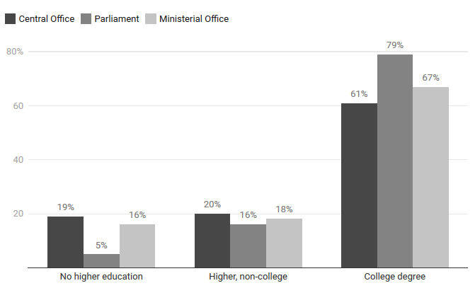
B.2.2. Professional experience by party face
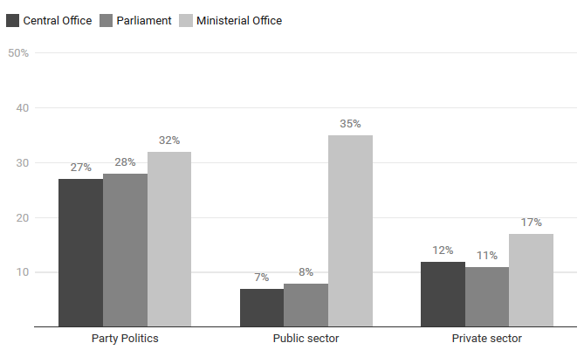

B.2.3. Tasks
Staffers’ individual tasks
Managers | Chief of staff (central office, ministerial office), party group secretary, cabinet secretary (ministerial office)
Policy experts | Policy advice (party study service, party group or ministerial office)
Communication experts | Director of communications, communication cell staff, spokesperson, internal party communication staff, translator, public relations staff
Political assistants | Personal assistant, parliamentary liaison (ministerial office)
Party organizers | Coach of local sections/campaigns, experts in local policy, assistants to party subgroups (youth, women, elderly, ...)
Administration  & support | Finance and accounting, human resources, IT, reception, administration, catering, personal driver

Managers ensure that the political machine runs smoothly. As central figureheads, they are responsible for translating a party’s political-strategic goals into an effective political operation. In this role, they often coordinate with elected elites and monitor the activities of other staffers as people managers. Policy experts provide elected elites with tailored policy advice by drafting legislative documents and writing briefings (Maley, 2000; Busby & Belkacem, 2013; Gouglas, Brans & Jaspers, 2015; Pittoors, Pattyn & Van Hecke, 2017; Wolfs & De Winter, 2017). In ministerial offices, they often coordinate with policy experts from other coalition parties (Maley, 2011; Askim, Karlsen & Kolltveit, 2018) and civil servants (Connaughton, 2015; Askim, Karlsen & Kolltveit, 2017). Communication experts help elected elites to connect with voters effectively in a mediatized political environment. They run electoral campaigns and promote the (social) media presence of elected elites on a daily basis (Askim et al., 2017; Dommett et al., 2020; Sabag Ben-Porat & Lehman-Wilzig, 2020). Political assistants are the main sidekicks for many individual politicians as they manage the practical, daily routines of holding an elected office. In this role, they act as gatekeepers to elected elites by managing their daily schedule (Busby & Belkacem, 2013) and organizing constituency services (Landgrave & Weller, 2020). Party organizers support the party on the ground as the available pool of volunteers becomes increasingly limited (Van Biezen, Mair & Poguntke, 2012; Scarrow, 2014). In this role, they support local office-holders, candidates and party members (Super, 2009). Lastly, staffers in the administration & support category are part of the collective support structure of a specific party, party group or ministerial office and contribute to bureaucratic routines or provide operational services to guests, personnel and elected elites.

Tasks by party face

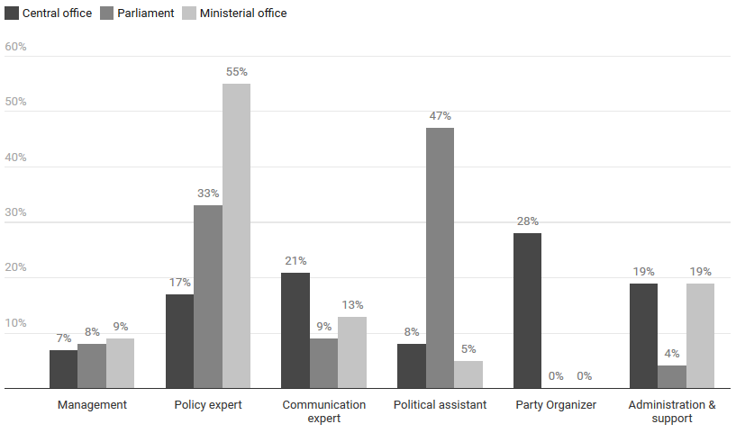

Appendix C. Control variables
C.1. Age
C.1.2. Age by country

 | Belgium | Netherlands | Total | Sig.
Meanª | 42 | 36 | 41 | ***
Median | 40 | 32,5 | 39
18-35^{b} | 34% | 60% | 37% | ***
36-50^{b} | 40% | 25% | 39% | **
50+^{b} | 26% | 16% | 25% | *
N | 898 | 110 | 1008
a: Independent samples T-test; b: Adjusted standardized residuals
Age distribution by country, X-axis from 18 to 65.
Light gray area: Belgium, dark gray area: The Netherlands
C.1.2. Age by party face
Central office
Age distribution by party face, X-axis from 18 to 65
Light gray area: general distribution, dark gray area: central office
Parliamentary office
Age distribution by party face, X-axis from 18 to 65
Light gray area: general distribution, dark gray area: parliamentary office

Ministerial office
Age distribution by party face, X-axis from 18 to 65
Light gray area: general distribution, dark gray area: ministerial office

C.2. Gender

C.2.1. Gender by country

 | Belgium | Netherlands | Total | Sig.
Male | 58% | 53% | 57% | -
Female | 42% | 47% | 43% | -
N | 898 | 110 | 1008
Sig. test: Chi-square, Adj. standardized residuals

C.2.2. Gender by party face
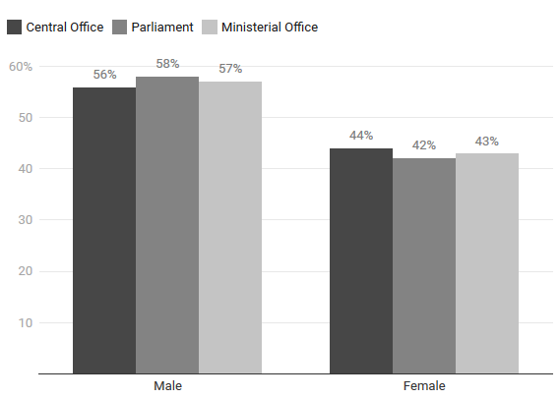

Appendix D. Understanding the qualitative staffing advantage
 | BELGIUM  (N=898) |  |  |  | THE NETHERLANDS  (N=110)
 | Central office | Parliament | Ministerial office |  | Central office | Parliament
Education (Ref. cat. No higher education)
Higher, non-college education | 0,84 (0,39) | 3,18 (0,49) * | 0,61 (0,35) |  | 1,09 (1,26) | 1,30 (1,16)
College degree | 0,70 (0,38) | 3,98 (0,46) *** | 0,55 (0,34) ° |  | 0,17 (1,12) | 3,09 (1,03)
Professional experience
Party politics | 0,76 (0,30) | 1,81 (0,27) * | 0,78 (0,23) |  | 0,21 (1,26) | 1,80 (0,94)
Public sector | 0,19 (0,45) *** | 0,33 (0,35) *** | 4,93 (0,29) *** |  | 4,66 (1,29) | 0,14 (1,28)
Private sector | 0,85 (0,38) | 1,52 (0,37) | 0,85 (0,30) |  | 0,56 (1,46) | 0,58 (1,18)
Tasks (Ref. cat. Manager)
Policy expert | 0,35 (0,39) ** | 0,81 (0,36) | 2,16 (0,32) ** |  | 0,27 (1,44) | 1,55 (1,42)
Communication expert | 1,71 (0,41) | 0,36 (0,49) * | 1,08 (0,36) |  | 0,78 (1,40) | 0,52 (1,41)
Political assistant | 0,29 (0,46) ** | 17,42 (0,41) *** | 0,09 (0,41) |  | 0,22 (1,41) | 0,63 (1,35)
Party organizer | 5E+9 (5991) | 0,00 (5955) | 0,00 (5935) |  | 2E+9 (15387) | 0,0 (16102)
Administration & support | 0,95 (0,45) | 0,45 (0,52) | 1,42 (0,39) |  | 34,84 (1,90) ° | 0,02 (1,92) *
Controls
Age | 1,00 (0,01) | 0,99 (0,01) | 1,01 (0,01) |  | 0,97 (0,04) | 1,03 (0,04)
Sex (Ref. cat. Male)
Female | 0,93 (0,23) | 0,75 (0,22) | 1,28 (0,19) |  | 0,87 (0,64) | 1,92 (0,57)
Constant | 0,60 (0,76) | 0,11 (0,82) ** | 1,22 (0,64) |  | 9,67 (1,98) | 0,41 (1,88)
Nagelkerke R² | 0,40 | 0,46 | 0,43 |  | 0,55 | 0,48
Note: Odd’s ratios (SE’s) of separate binary logistic regressions; ° p ≤ .1, * p ≤ .05, ** p ≤ .01, *** p ≤ .001

Appendix E. Understanding staffers’ individual qualifications

 | Manager | Policy  expert | Communication expert | Political  assistant | Party  organizer | Administration  & support
Education (Ref. cat. No higher education)
Higher, non-college education | 3,34 (0,64) ° | 2,93 (0,41) ** | 2,24 (0,38) * | 1,51 (0,35) | 0,40 (0,57) ° | 0,28 (0,28) ***
College degree | 4,66 (0,60) ** | 14,31 (0,38) *** | 1,06 (0,36) | 1,02 (0,31) | 0,56 (0,42) | 0,04 (0,30) ***
Professional experience
Party politics | 2,17 (0,30) ** | 1,04 (0,20) | 0,89 (0,29) | 0,80 (0,26) | 0,48 (0,42) ° | 1,15 (0,29)
Public sector | 0,57 (0,37) | 2,99 (0,23) *** | 0,65 (0,34) | 0,62 (0,31) | 0,10 (0,81) ** | 0,98 (0,30)
Private sector | 1,02 (0,42) | 1,13 (0,28) | 1,41 (0,36) | 0,87 (0,36) | 0,32 (0,63) ° | 1,25 (0,33)
Controls
Age | 1,06 (0,02) *** | 1,00 (0,01) | 0,98 (0,01) ° | 0,97 (0,01) ** | 1,03 (0,02) | 1,01 (0,01)
Sex (Ref. cat. Male)
Female | 1,07 (0,27) | 0,60 (0,15) *** | 0,87 (0,21) | 1,19 (0,18) | 1,33 (0,30) | 1,75 (0,23) *
Constant | 0,00 (0,90) *** | 0,07 (0,51) *** | 0,38 (0,58) ° | 0,87 (0,52) | 0,05 (0,79) *** | 0,51 (0,54)
Nagelkerke R² | 0,11 | 0,23 | 0,04 | 0,06 | 0,07 | 0,34

Note: Odd’s ratios (SE’s) of multiple logistic regressions; ° p ≤ .1, * p ≤ .05, ** p ≤ .01, *** p ≤ .001

