**How Do Voters Evaluate Performance in Opposition?**

**Supplementary material**

**Government & Opposition**

**Dieter Stiers**

**Appendix A: Variables in the analyses**

Variables used for distribution

-*Satisfaction with party performance*: answer to the question: ‘In general, how satisfied or dissatisfied are you with the performance of the following parties as governing parties or opposition parties in the Federal House of Representatives during the last term?’ Respondents could answer using a scale ranging from 0 (“very dissatisfied”) over 2 (“not dissatisfied, not satisfied) to 4 (“very satisfied”).

-*Factors of opposition evaluation*: Answer to the question: ‘When judging the political parties that were in opposition during the last term, which specific factors do you think about?’ Two lines were left for respondents to answer.

-*Responsibility attribution*: Respondents were asked: ‘How responsible are the following parties, according to you, for the current state of affairs in Belgium?’ For every party, they could answer using a scale ranging from 0 (“not at all responsible”), over 1 (“rather not responsible”), 2 (a little responsible”) 3 (“to a large extent responsible”), to 4 (“fully responsible”).

Variables used in models explaining positive/negative opinions

-*Sex*: Sex of the respondent; coded as male=0 (reference category), female 1.

-*Age*: Age of the respondent, calculating by subtracting the year of birth of the year of the election.

-*Educational level*: Educational level of the respondent. Divided in three categories: low (kindergarten, primary education, lower secondary education; reference category); middle (higher secondary education, post-secondary non-tertiary education); high (tertiary education short cycle, bachelor, master, PhD).

-*Political interest*: Respondent’s self-reported interest in politics in general, on a scale ranging from 1 (not interested at all) over 2 (hardly interested) and 3 (quite interested) to 4 (very much interested).

-*Satisfaction with democracy*: Respondent’s satisfaction with the way in which democracy works in Belgium on a scale ranging from 1 (not satisfied at all) over 2 (not very satisfied) and 3 (rather satisfied) to 5 (fully satisfied).

-*Performance of government general*: Respondents were asked: ‘If you think about the policies of the Belgian (federal [national]) government in the last five years, how well or badly of a job did the government do?’ They could answer on a scale ranging from 1 (very badly) over 2 (badly) and 3 (well) to 4 (very well).

-*Party ID incumbent*: An indicator of whether the respondent indicates to identify with an incumbent party (code 1) or not (code 0).

Variables used in models explaining responsibility attributions

-*Party in government*: Indicator of whether the party was an incumbent party (code 1) or not (code 0).

- *Ideological distance to party*: the absolute difference between the respondent’s self-placement on the ideological left-right axis and the mean placement of the party by all respondents.

-*Party ID party*: An indicator of whether the respondent indicates to identify with the party (code 1) or not (code 0).

-*Leader rating*: Respondents could indicate to what extent they liked the leader of every party on a scale ranging from 0 (not like at all) to 10 (like a lot).

-*Satisfaction with party*: see above.

-*Satisfaction with current state of affairs*: Respondents were asked: ‘to which extent are you satisfied with the current state of affairs in Belgium?’ and they could respond using a scale ranging from 1 (very dissatisfied) and 2 (dissatisfied) over 3 (dissatisfied nor satisfied) to 4 (satisfied) and 5 (very satisfied).

**Appendix B: Explaining (non-)response to opposition evaluation question**

Table B.1. Logit model predicting responding to the evaluation question

|  |  |
| --- | --- |
|  | B |
|  | (s.e.) |
| Age | -0.010** |
|  | (0.003) |
| Sex (ref.=male) | -0.230* |
|  | (0.111) |
| Education (ref.=low) |  |
| Middle | 0.212 |
|  | (0.179) |
| High | 0.575** |
|  | (0.178) |
| Income | -0.013 |
|  | (0.038) |
| Interest in politics | 0.882*** |
|  | (0.079) |
| Constant | -2.449*** |
|  | (0.343) |
| *N* | 1593 |
| pseudo *R*2 | 0.096 |

*Note*: Entries are log-odds coefficients, standard errors in parentheses. Dependent variable coded so that 0 denotes not responding to the question and 1 responding to the question. Significance levels: * p<0.05; **: p<0.01; ***: p<0.001.

**Appendix C: Results for groups of voters separately**

Figure C.1. Other factors to evaluate performance in opposition for groups of voters

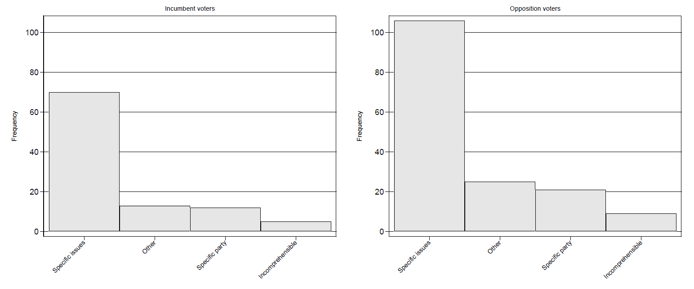*Note*: Figure shows the number of times the respective factors were mentioned by the respondents.

**Appendix D: Responsibility attributions for (un-)primed respondents**

Figure D.1. Responsibility of the different parties for “current state of affairs” for respondents who did or did not respond to the opposition evaluation question, respectively

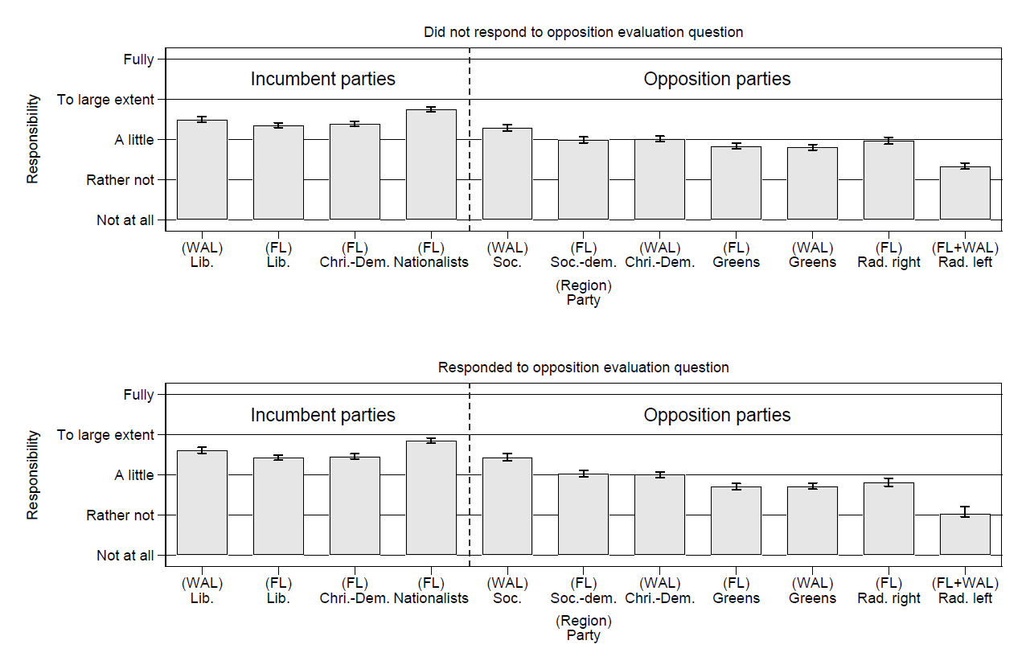

*Note*: Figure shows the mean score and 95% confidence intervals of responsibility for the current state of affairs assigned to every party respectively.

**Appendix E: Responsibility for groups of respondents separately**

Figure E.1. Responsibility of the different parties for “current state of affairs” for respondents of the two regions, respectively

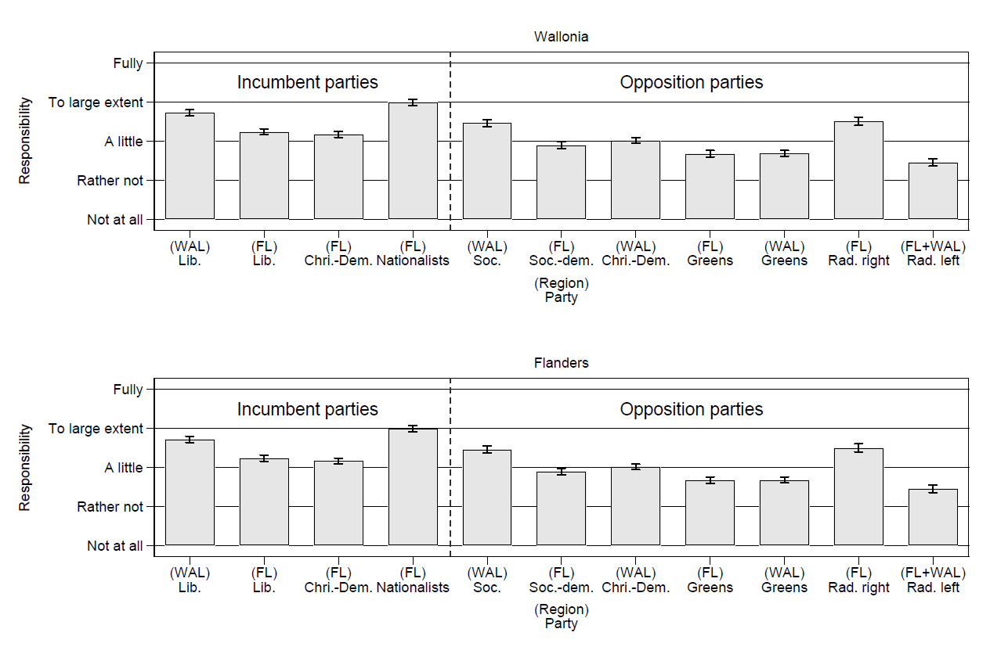

*Note*: Figure shows the mean score and 95% confidence intervals of responsibility for the current state of affairs assigned to every party respectively.

**Appendix F: Vote choice models**

Table F.1. Conditional logit models explaining the vote choice

|  |  |  |  |
| --- | --- | --- | --- |
|  | Model 1 | Model 2 | Model 3 |
|  | B  (s.e.) | B  (s.e.) | B  (s.e.) |
| Party ID with incumbent | 3.151*** | 2.599*** | 2.107*** |
|  | (0.104) | (0.112) | (0.120) |
| Ideological distance to party | -0.332*** | -0.276*** | -0.207*** |
|  | (0.047) | (0.052) | (0.057) |
| Party in government | -0.012 | -0.129 | -0.074 |
|  | (0.145) | (0.152) | (0.158) |
| Party in government X satisfaction with government performance | 0.868***  (0.227) | 0.446  (0.245) | 0.213  (0.256) |
| Satisfaction with party |  | 0.910*** | 0.629*** |
|  |  | (0.098) | (0.108) |
| Like-dislike party |  |  | 0.395*** |
|  |  |  | (0.043) |
| *N* | 5844 | 5844 | 5844 |
| pseudo *R*2 | 0.695 | 0.725 | 0.753 |
| *AIC* | 1053.012 | 950.566 | 855.591 |
| *BIC* | 1079.705 | 983.932 | 895.630 |

*Note*: Entries are log-odds coefficients, standard errors in parentheses. Results of a conditional logit model. For more information, see Stiers (2019a, 2019b). Significance levels: * p<0.05; **: p<0.01; ***: p<0.001.

**Appendix G: Data quality**

Table G.1: Comparison between population and sample statistics

|  |  |  |  |  |
| --- | --- | --- | --- | --- |
| Characteristic | Geographical scope | Value | Population distribution | Sample distribution |
| Sex | Belgium | Male | 48.79% | 51.32 |
|  |  | Female | 5.21% | 48.68 |
|  | Flanders region | Male | 49.07% | 52.31 |
|  | Female | 50.93% | 47.69 |
|  | Walloon Region | Male | 48.28% | 49.86 |
|  | Female | 51.72% | 50.14 |
| Age | Belgium | Age 18-64 | 75.51% | 70.67% |
|  |  | Age 65+ | 24.49% | 29.33% |
|  | Flanders region | Age 18-64 | 74.92% | 69.93% |
|  | Age 65+ | 25.08% | 30.07% |
|  | Walloon Region | Age 18-64 | 76.59% | 71.78% |
|  | Age 65+ | 23.41% | 28.22% |
| Educational level | Belgium | No/primary | 6.65% | 3.91% |
|  | Lower secondary | 13.82% | 13.78% |
|  |  | Higher secondary | 39.37% | 23.87% |
|  |  | Post-secondary, non-tertiary | 1.58% | 6.86% |
|  |  | Tertiary, vocational | 0.61% | 12.13% |
|  |  | Tertiary, bachelor | 23.24% | 19.33% |
|  |  | Tertiary, master | 14.06% | 18.54% |
|  |  | PhD | 0.69% | 1.59% |
|  | Flanders region | No/primary | 5.50% | 4.36% |
|  | Lower secondary | 12.64% | 13.00% |
|  |  | Higher secondary | 40.03% | 24.86% |
|  |  | Post-secondary, non-tertiary | 1.80% | 6.36% |
|  |  | Tertiary, vocational | 0.74% | 8.44% |
|  |  | Tertiary, bachelor | 23.68% | 22.11% |
|  |  | Tertiary, master | 14.82% | 19.54% |
|  |  | PhD | 0.78% | 1.33% |
|  | Walloon region | No/primary | 8.72% | 3.15% |
|  | Lower secondary | 15.95% | 14.93% |
|  |  | Higher secondary | 38.18% | 22.39% |
|  |  | Post-secondary, non-tertiary | 1.17% | 7.61% |
|  |  | Tertiary, vocational | 0.37% | 17.61% |
|  |  | Tertiary, bachelor | 22.42% | 15.21% |
|  |  | Tertiary, master | 12.67% | 17.04% |
|  |  | PhD | 0.52% | 1.97% |

*Note*: As only Belgians who reached the age of adulthood (i.e., 18 years old) were included in the sample, the distributions are calculated and compared for the adult population only.

**Appendix H: Specific parties and issues mentioned**

Figure H.1. Specific parties mentioned by the respondents.

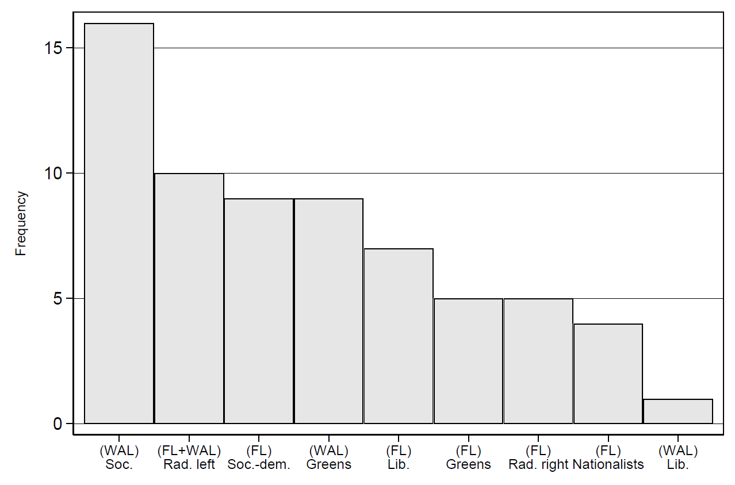

*Note*: Figure shows the number of times the parties factors were mentioned by the respondents.

Figure H.2. Specific issues mentioned by the respondents

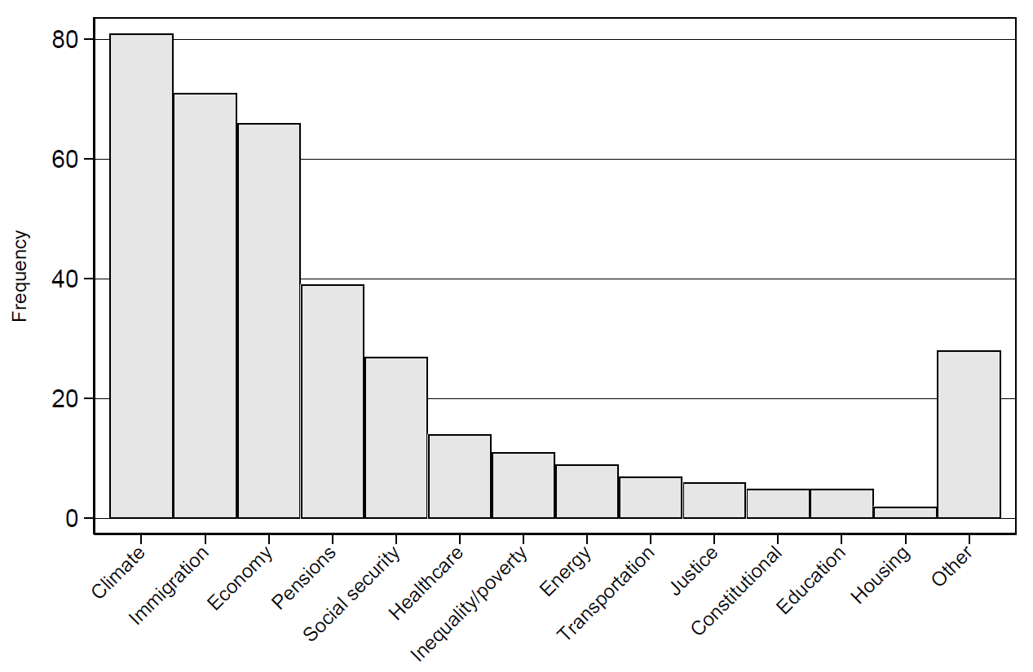

*Note*: Figure shows the number of times the respective issues were mentioned by the respondents.

**Appendix I: Comparison between coders**

Figure I.1. Comparison between the distributions of both coders

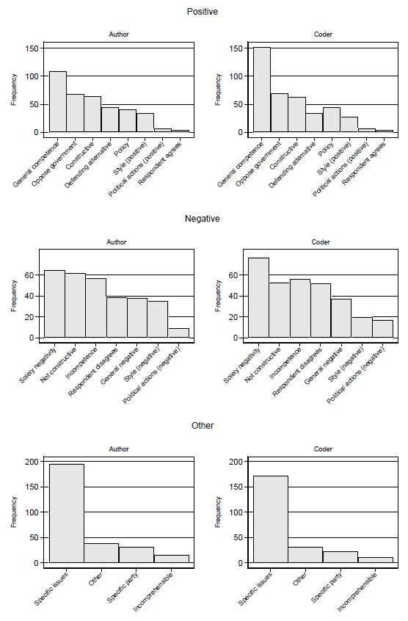

*Note*: Figure shows the number of times the respective factors were mentioned by the respondents.

**Appendix J: Discussion of smaller categories of responses**

Positive factors (Figure 1)

Besides the most important factors, there are also some other aspects of opposition performance that are important to some voters. While somewhat overlapping with being constructive, several respondents attach importance to the extent to which the opposition explicitly defends alternative proposals. In this regard, agenda setting power was mentioned several times, especially in combination with issues the government is not addressing – deliberately or not. Some respondents mentioned policy-related topics, such as how parties in opposition voted on several proposals, the long-term decisions they took, and their tacit support for governmental action. Also the style with which parties run in opposition is judged, especially the way in which they present themselves in the media, whether they act professionally overall, and whether they use direct, clear, and civil language. Some voters take into account the extent to which they agree with the opposition. Finally, a handful of respondents consider the political actions of the opposition – explicitly referring to large-scale strikes at the beginning of the governmental term that were supported by some opposition parties.

Negative factors (figure 2)

Besides the most important factors mentioned in the text, voters care more about opposition style in a negative sense than in a positive, frequently referring to a way of communicating and making certain statements. Rather unsurprisingly, a negative evaluation is also often made because of explicit disagreement with the party’s platform. Besides these factors that were mentioned frequently, several respondents made generally negative statements such as “waste of money”, “disappointing”, “everything for themselves”. Finally, several respondents referred to opposition support for large-scale strikes at the beginning of the governmental term – this time in a negative fashion – which is categorised under political actions here.