ONLINE APPENDIX
Who Teams up with the European Parliament? Examining Multilevel Party Cooperation in the European Union

Katharina L. Meissner¹* and Guri Rosén²

¹Centre for European Integration Research (EIF), University of Vienna, Vienna, Austria, and ²ARENA Centre for European Studies, Oslo Metropolitan University, Oslo, Norway

*Corresponding author. Email: Katharina.meissner@univie.ac.at

Online Supplement

Data sources:
The data for our study are drawn from two main sources: First, we have conducted 20 semi-structured interviews with parliamentarians and staff members both at the EU and national levels in Austria, Germany, and Sweden. In the case of Austria, interview partners cover EU and trade specialists of the political groups, members of parliament as well as staff members of parliamentarians from the conservative (ÖVP), social-democratic (SPÖ), liberal (Neos) political groups as well as the Greens. Regarding the German Bundestag, staff members of the parliament’s administration, namely the EU-committee and the specialized committee on ‘Economics and Energy’, of parliamentarians from all political groups except for the AfD as well as EU and trade specialists of fractions (Bündnis 90/Die Grünen, Die Linke, SPD, CDU/CSU) were interviewed. This material was complemented with interviews in Brussels with staff members and members of the EP of Austrian and German nationality further to NPs’ representatives to the EP. In the Swedish case, interviews have been conducted with MPs from the Swedish Riksdagen, across the party political spectrum: the conservatives (M), the social democrats (S), the Greens and the socialist left-party (V). The MPs are members of two committees dealing with EU trade matters: The Committee on European Union Affairs and the Committee for Industry and Trade. Interviews were also made with some Swedish MEPs as well as staff of MEPs. Second, we have collected a range of documentary data consisting of parliamentary reports, speeches and questions. In all three countries, we mapped the agendas of two parliamentary committees between 2013 and 2018: regarding the German Bundestag, these agendas came from the EU-committee and the specialized committee on ‘Economics and Energy’; regarding the Austria Nationalrat, the agendas from the EU-committee and the main committee were analyzed and mapped; in Sweden, the agendas were from the Committee on European Union Affairs, the Committee for Industry and Trade and the Committee on Foreign Affairs.

Measurement of driving factors of transnational cooperative behavior:
Based on the 2019 Chapel Hill Expert Survey, we have classified the parties on a culturally liberal to culturally conservative axis. The placement is based on the parties’ views on social and cultural values (GALTAN) (Bakker et al. 20202). The scale runs from 0 (libertarian/postmaterialist), via 5 (center), to 10 (traditional/authoritarian). We categorise parties who score above 5 as traditionalist. In the Austrian case, we find FPÖ and ÖVP at the traditional end of the spectrum, with Grüne and Neos at the other end. On the culturally liberal side in Germany we find the Greens and FDP with AfD, CSU and CDU on the opposite side. In Sweden, SD, KD and M are on the more traditional side, whereas MP and V are ascribed more liberal values. The Social Democrats (S) are close to the centre, with more traditionalist scores than the social democrats in both Austria and Germany.
In our period under study (2013-2017), the following parties were in government and opposition respectively: In government in Austria, we find the ÖVP and SPÖ. In Germany it is CDU/CSU and SPD. The Swedish government consisted of M, C, FP and KD (until October 2014), and then S and MP. In the opposition in Austria were FPÖ, Neos and Grüne (in the legislative term XXV only). In Germany it is Bündnis 90/Die Grünen, Die Linke, FDP and AfD (the latter two parties only in the 19th legislative term). The Swedish opposition is S, MP, V (until October 2014), and then M, C, FP and KD.
To determine which political parties are more protectionist, we build on the Chapel Hill Expert Survey and use the parties’ position towards trade liberalization/protectionism (Bakker et al. 2020). The scale runs from 0 (strongly favours trade liberalization) to 10 (strongly favours protection of domestic producers). We categorise parties who score above 5 as protectionist. Our assumption is that parties who are more in favour of protectionism will also be more skeptical of free trade. In Austria, FPÖ and Grüne are most in favour of protectionism, with SPÖ not far behind, whilst NEOS are most opposed. In Germany, we find die Linke and AfD most in favour with FDP and CDU/CSU at opposite sides of the spectrum. The Swedish Left Party (V) and the Swedish Democrats (SD) are most in favour of protectionism , whereas C and L are most clearly opposed.

Table 3: Empirical results
Country | Party | Outcome | Culturally liberal | Opposition | Trade protectionism
Austria | Green | Positive coordination, information exchange | Y | Y | Y
Austria | Social democrat | Negative coordination, information exchange | Y | N | Y
Austria | Conservative | Co-existence, no interaction | N | N | N
Austria | Liberal | Information exchange | Y | Y | N
Germany | Green | Positive coordination, information exchange | Y | Y | N
Germany | Social democrat | Information exchange | Y | N | N
Germany | Conservative | Information exchange | N | N | N
Germany | Liberal | Co-existence, no interaction | Y | Y | N
Germany | Leftist | Information exchange | Y | Y | Y
Sweden | Green | Positive coordination, information exchange | Y | Y/N | N
Sweden | Social democrat | Negative coordination | N | Y/N | N
Sweden | Moderate | Co-existence, information exchange | N | N/Y | N
Sweden | Leftist | Positive coordination, information exchange | Y | Y | Y
Source: own compilation combining findings with variables based on data from CHES (Bakker et al. 2020)

Figure 1: Austria – GALTAN (2019).

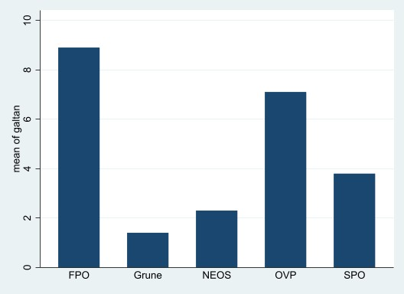

Figure 2: Germany – GALTAN (2019).
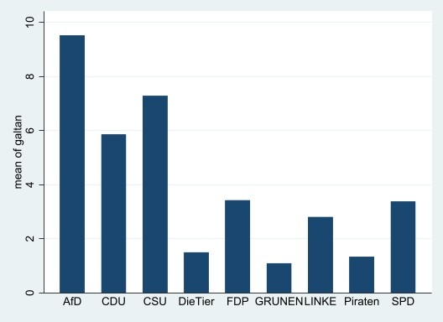

Figure 3. Sweden – GALTAN (2019).
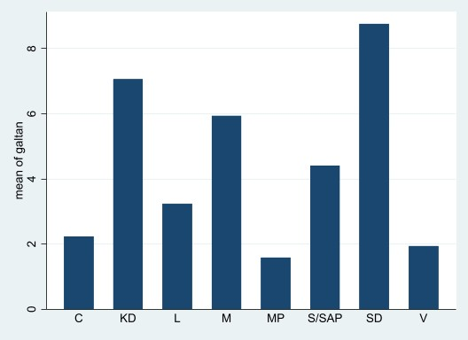

Figure 4: Austria – Protectionism (2019).
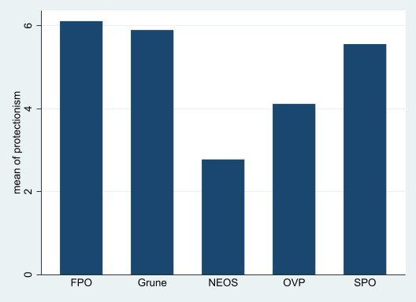

Figure 5: Germany – Protectionism (2019).

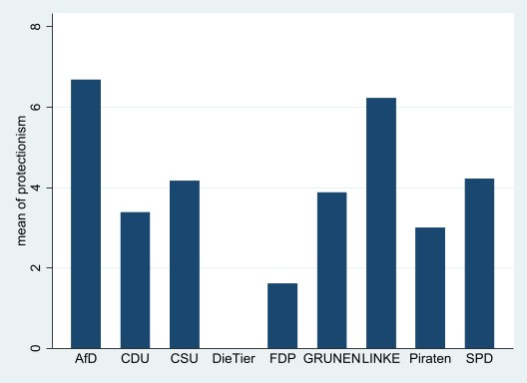

Figure 6: Sweden – Protectionism (2019).

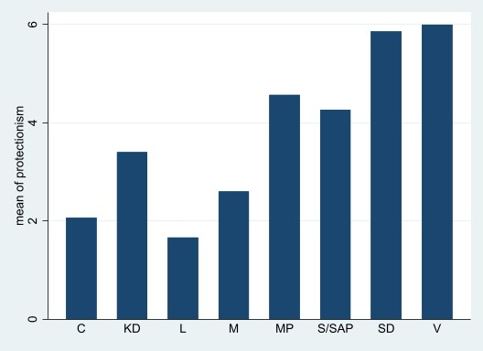

Reference:
Ryan Bakker, Liesbet Hooghe, Seth Jolly, Gary Marks, Jonathan Polk, Jan Rovny, Marco Steenbergen, and Milada Anna Vachudova. 2020. “2019 Chapel Hill Expert Survey.” Version 2019.1. Available on chesdata.eu. Chapel Hill, NC: University of North Carolina, Chapel Hill.

The period of data collection stretches from January 2013 to July 2018.
In addition to Team Stronach (legislative term XXV) and Liste Pilz (legislative term XXVI).
In addition to four parliamentarians who do not belong to any party group in parliament (legislative term 19).
An alternative source could be the Comparative Manifesto Project. The problem is that not all parties have scores on relevant variables (support for free market economy vs protectionism for example).

