ONLINE APPENDIX for:  
**“Arrived in power, and yet still disgruntled? How government inclusion moderates ‘protest voting’ for far-right populist parties”**,published in *Government and Opposition.*Jasper Muis, Tobias Brilsand Teodora Gaidytė

*Contents:*  
**Appendix A: Comparison of our selection of far-right parties**

**Appendix B: Government inclusion of far-right parties   
Appendix C: Descriptive statistics  
Appendix D: Additional analyses (follow-up of regressions in Table 2)**

**Appendix E: Effects of anti-immigration attitudes by far-right party’s political status**

***Appendix A: Comparison of our selection of far-right parties***  
  
Cohen (2019) studies 14 Western European far-right parties in three most recent waves of the European Elections Study (2004, 2009, and 2014). Our study covers 10 countries that are also included in the research of Cohen (2019). All his 14 far-right parties are also included in our selection, except for the British National Party (BNP), because in ESS rounds 7–8 its voters are merged into the category ‘other’. There is one opposite case: our sample includes the National Democratic Party of Germany (NPD), whereas Cohen’s study (2019) does not include this party. The effect of these differences seems negligible, as the amount of electoral support for both parties is rather small.   
 The comparison with the selection of Kriesi and Schulte-Cloos (2020) shows a similarly large overlap with again only a few differences concerning mostly marginal parties, such as Liveable Netherlands and the Belgium People’s Union (which we both did not include). We followed the scholars’ suggestion to classify the Italian Northern League as separatist party during ESS round 1.   
 Krause and Wagner (2019) also cover Central Eastern Europe. They identify 15 right-wing populist parties in the 15 EU member states that also participated in ESS round 7 (2014). Our analysis includes all these parties, except for ANO (Action of Dissatisfied Citizens) in Czech Republic. We consider this party as centrist anti-establishment/populist rather than far right (Hanley and Sikk 2016). Furthermore, we identify six far-right parties that Krause and Wagner (2019) omitted, perhaps because they did not participate in European Parliament elections: our analysis moreover includes EKRE (Estonia), National Front (Belgium), National Movement (Poland), Úsvit (Czech Republic), Slovenian Democratic Party (Slovenia), and NPD (Germany).   
 To conclude, our far-right party identification appears sufficiently reliable if we compare it with three similar selections. We also observe a large agreement with the parties that *The PopuList 2.0* (Rooduijn et al. 2019) identified as ‘far right’ – and virtually all these far-right parties are simultaneously considered ‘populist’. This confirms the general agreement in the scholarly literature about which parties belong to the far-right populist family.

|  |  |  |  |  |  |  |  |
| --- | --- | --- | --- | --- | --- | --- | --- |
| ***Appendix B: Government inclusion of far-right parties***  **Table A1.** Far-right partiesin government: corresponding ESS rounds, elections dates, cabinets, and duration of cabinet (ParlGov) | | | | | | | |
| **ESS round** | **Country** | **Election** | **Cabinet name (ParlGov)** | **Start** | **End** | **Far-right party** | **Form, coalition partner(s)** |
| **2002 (1)** | Austria | 2002-11-24 | Schuessel II | 2002-11-24 | 2003-02-27 | FPÖ | Caretaker, previously coalition with ÖVP (Christian democrats, conservative). |
| **2002 (1)** | Austria | 2002-11-24 | Schuessel III | 2003-02-28 | 2005-02-27 | FPÖ | Coalition with ÖVP. |
| **2004 (2)** | Austria | 2002-11-24 | Schuessel III | 2003-02-28 | 2005-02-27 | FPÖ | Coalition with ÖVP. |
| **2004 (2)** | Austria | 2002-11-24 | Schuessel IV | 2005-04-05 | 2007-01-10 | BZÖ | Coalition with ÖVP. |
| **2010 (5)** | Bulgaria | 2009-07-05 | Borisov I | 2009-07-27 | 2013-03-12 | Ataka | Support of minority government of GERB (centre-right, nationalist). |
| **2012 (6)** | Bulgaria | 2009-07-05 | Borisov I | 2009-07-27 | 2013-03-12 | Ataka | Support of minority government of GERB (centre-right, nationalist). |
| **2002 (1)** | Switzerland | 1999-10-24 | Bundesrat 1999 | 1999-12-15 | 2003-12-09 | SVP | FDP (Radical democratic party), CVP (Christian democratic party), SP (social democratic party) |
| **2004 (2)** | Switzerland | 2003-10-19 | Bundesrat 2003 | 2003-12-10 | 2007-12-11 | SVP | FDP (Radical democratic party), CVP (Christian democratic party), SP (social democratic party) |
| **2006 (3)** | Switzerland | 2003-10-19 | Bundesrat 2003 | 2003-12-10 | 2007-12-11 | SVP | FDP (Radical democratic party), CVP (Christian democratic party), SP (social democratic party) |
| **2008 (4)** | Switzerland | 2007-10-21 | Bundesrat 2008 | 2008-12-10 | 2011-12-13 | SVP | BDP (Conservative democratic party), FDP (Radical democratic party), CVP (Christian democratic party), SP (social democratic party) |
| **2010 (5)** | Switzerland | 2007-10-21 | Bundesrat 2008 | 2008-12-10 | 2011-12-13 | SVP | BDP (Conservative democratic party), FDP (Radical democratic party), CVP (Christian democratic party), SP (social democratic party) |
| **2012 (6)** | Switzerland | 2011-10-23 | Bundesrat 2011 | 2011-12-14 | 2015-10-17 | SVP | BDP (Conservative democratic party), FDP (Radical democratic party), CVP (Christian democratic party), SP (social democratic party) |
| **2014 (7)** | Switzerland | 2011-10-23 | Bundesrat 2011 | 2011-12-14 | 2015-12-08 | SVP | BDP (Conservative democratic party), FDP (Radical democratic party), CVP (Christian democratic party), SP (social democratic party) |
| **2016 (8)** | Switzerland | 2015-10-18 | Bundesrat 2015 | 2015-12-09 | -- | SVP | FDP (Radical democratic party), CVP (Christian democratic party), SP (social democratic party) |
| **2002 (1)** | Denmark | 2001-11-20 | Rasmussen F I | 2001-11-27 | 2005-02-17 | DF | Support of minority government of Venstre (liberal party) and Konservative (conservatives). |
| **2004 (2)** | Denmark | 2001-11-20 | Rasmussen F I | 2001-11-27 | 2005-02-17 | DF | Support of minority government of Venstre (liberal party) and Konservative (conservatives). |
| **2006 (3)** | Denmark | 2005-02-08 | Rasmussen F II | 2005-02-18 | 2007-11-22 | DF | Support of minority government of Venstre (liberal party) and Konservative (conservatives). |
| **2008 (4)** | Denmark | 2007-11-13 | Rasmussen F III | 2007-11-23 | 2009-04-04 | DF | Support of minority government of Venstre (liberal party) and Konservative (conservatives). |
| **2010 (5)** | Denmark | 2007-11-13 | Rasmussen L I | 2009-04-05 | 2011-10-01 | DF | Support of minority government of Venstre (liberal party) and Konservative (conservatives). |
| **2016 (8)** | Finland | 2015-04-19 | Sipilae I | 2015-05-29 | 2017-06-12 | PS | Coalition with National Coalition Party (KOK) and Finnish Centre (KESK). |
| **2014 (7)** | Hungary* | 2014-04-06 | Orban III | 2014-05-10 | 2018-05-09 | Fidesz | Coalition with KDNP (Christian Democrat) |
| **2016 (8)** | Hungary | 2014-04-06 | Orban III | 2014-05-10 | 2018-05-09 | Fidesz | Coalition with KDNP (Christian Democrat) |
| **2012 (6)** | Lithuania | 2012-10-14 | Butkevicius | 2012-11-22 | 2016-11-21 | TT | Coalition with Labour Party (DP), Election Action of Lithuania’s Pole’s (LLRA), and Social Democratic Party (LSDP). |
| **2014 (7)** | Lithuania | 2012-10-14 | Butkevicius | 2012-11-22 | 2016-11-21 | TT | Coalition with Labour Party (DP), Election Action of Lithuania’s Pole’s (LLRA), and Social Democratic Party (LSDP). |
| **2002 (1)** | Netherlands | 2002-05-15 | Balkenende I | 2002-07-22 | 2002-10-15 | LPF | Coalition with Christian Democrats (CDA) and Liberals (VVD) |
| **2010 (5)** | Netherlands | 2010-06-09 | Rutte I | 2010-10-14 | 2012-04-22 | PVV | Support of minority government of Christian Democrats (CDA) and Liberals (VVD) |
| **2014 (7)** | Norway | 2013-09-09 | Solberg I | 2013-10-16 | 2017-09-10 | FrP | Coalition with Conservative Party (Høyre) |
| **2016 (8)** | Norway | 2013-09-09 | Solberg I | 2013-10-16 | 2017-09-10 | FrP | Coalition with Conservative Party (Høyre) |
| **2016 (8)** | Poland** | 2015-10-25 | Szydlo | 2015-11-16 | 2017-12-10 | PiS | Cabinet includes Poland Together (PR) and United Poland (SP) as members of the PiS parliamentary group |
| **2012 (6)** | Slovenia | 2011-12-04 | Jansa II | 2012-01-28 | 2013-03-19 | SDS | Coalition with Civic List (DL), Party of Pensioners (DeSUS), Slovenian People’s Party (SLS), and Christian People’s Party (NSI) |
| **2006 (3)** | Slovakia | 2006-06-17 | Fico I | 2006-07-04 | 2010-07-07 | SNS | Coalition with HZDS (Movement for a Democratic Slovakia) and Smer (Direction-Social Democracy) |
| **2008 (4)** | Slovakia | 2006-06-17 | Fico I | 2006-07-04 | 2010-07-07 | SNS | Coalition with HZDS (Movement for a Democratic Slovakia) and Smer (Direction-Social Democracy) |
|  |  |  |  |  |  |  |  |
| Sources: ParlGov (Döring and Manow 2019); Minkenberg (2017); Cohen (2019)   Notes: *We left out the Orban II government, because this was formed after the elections of 2010-04-25. During these elections, we do not (yet) consider Fidesz as far right. **We left out the Kaczynski government in Poland that was formed after the 2005 elections. During these elections, we do not (yet) consider PiS as far right. | | | | | | | |

***Appendix C: Descriptive statistics***

**Table A2.**Descriptive statistics of independent variables, ESS data (2002-2016). Statistics presented: n (%); mean (SD).

|  |  |  |  |  |
| --- | --- | --- | --- | --- |
|  | **Far-right voters** | | **Other parties or blank vote** | |
| **Independent variables (range)** | **Far right in opposition** | **Far right in government** | **Far right in opposition** | **Far right in government** |
| Gender: Female | 3 667 (44%) | 2 256 (46%) | 49 808 (52%) | 12 348 (53%) |
| Age (18-102) | 50 (17) | 52 (17) | 51 (17) | 52 (16) |
| Education (0-5) | 2.07 (1.09) | 2.20 (1.05) | 2.45 (1.28) | 2.57 (1.19) |
| Perceived income (0-3) | 2.03 (0.81) | 2.08 (0.81) | 2.12 (0.81) | 2.21 (0.86) |
| Living area: Urban | 4 611 (55%) | 2 519 (51%) | 59 411 (62%) | 14 288 (61%) |
| Religiosity (0-10) | 4.8 (3.0) | 5.0 (2.9) | 4.59 (3.01) | 4.90 (2.84) |
| Political interest (0-3) | 1.51 (0.84) | 1.61 (0.82) | 1.67 (0.83) | 1.79 (0.79) |
| Political trust (0-10) | 3.23 (2.06) | 4.45 (2.22) | 4.27 (2.14) | 4.84 (2.19) |
| Anti-immigration attitudes (0-10) | 5.87 (2.09) | 5.67 (1.95) | 4.63 (2.04) | 4.31 (1.91) |
| Authoritarian values (0-5) | 3.48 (0.84) | 3.55 (0.79) | 3.33 (0.87) | 3.30 (0.89) |
| Bad evaluation economy (0-10) | 5.62 (2.47) | 4.64 (2.35) | 5.09 (2.41) | 4.44 (2.46) |
| Income distribution (1-5) | 2.89 (1.07) | 2.76 (1.12) | 2.82 (1.06) | 2.66 (1.13) |
| Valid N | 8,424 | 4,906 | 95,3071 | 23,297 |

***Appendix D: Additional analyses (follow-up of regressions in Table 2)***This table shows the outcomes of analyses based on countries as level-2 units, instead of “country-periods” (see explanation in main article).

**Table A3.** Countries as level-2 units: multilevel binary logistic regressions of far-right voting (Other party or blank voters are the reference category).

|  |  |  |  |  |  |  |  |  |
| --- | --- | --- | --- | --- | --- | --- | --- | --- |
|  | **Model 1** | **Model 2** | **Model 3** | **Model 4: Overall** | **Model 5a: Western Europe** | **Model 5b: C-Eastern Europe** | **Model 6a: WE subsample** | **Model 6b: CCE subsample** |
|  | OR | OR | OR | OR | OR | OR | OR | OR |
| Gender: female | **.83** | **.83** | **.83** | **.81** | **.79** | **.85** | **.78** | **.85** |
| Age | **.91** | **.86** | **.86** | **.83** | **.81** | **.89** | **.82** | **.89** |
| Education | **.75** | **.84** | **.83** | **.81** | **.78** | **.93** | **.75** | **.91** |
| Subjective income | .98 | 1.01 | 1.00 | 1.00 | .98 | 1.02 | **.93** | 1.02 |
| Living area: Urban | **.94** | **.96** | **.96** | **.95** | .98 | **.91** | **1.05** | **.91** |
| Religiosity | **1.02** | **1.01** | 1.01 | **1.04** | **.92** | **1.33** | **.91** | **1.33** |
| Political interest | **.93** | .98 | .99 | 1.00 | 1.02 | .99 | 1.02 | .98 |
| Political trust | **.71** | **.80** | **.73** | **.63** | **.62** | **.68** | **.63** | **.67** |
| Anti-immigration attitudes | - | **1.92** | **1.91** | **1.87** | **2.31** | **1.35** | **2.27** | **1.34** |
| Authoritarian sentiment | - | **1.07** | **1.07** | **1.07** | **1.07** | 1.00 | **1.07** | 1.00 |
| Bad economy | - | .91 | **.93** | 1.01 | 1.03 | .99 | **1.08** | .99 |
| Income redistribution | - | **.97** | **.97** | **.96** | **.97** | **1.10** | **.95** | **1.11** |
| Far right in power | - | - | **2.38** | **1.48** | 1.07 | **3.05** | **1.09** | **3.10** |
| Far right in power * pol. trust | - | - | **1.21** | **1.24** | **1.33** | **1.77** | **1.26** | **1.78** |
| Far-right seat share | - | - | - | **2.94** | **4.03** | **2.25** | **4.14** | **2.25** |
| Far-right seat share * pol. trust | - | - | - | **1.21** | **.94** | **1.13** | .92 | **1.14** |

*Notes:* Coefficients in bold are statistically significant (*p* < .05, two-tailed).   
Models 1-4: N1 = 131,934; N2 = 22 countries  
Model 5A: N1 = 95,626; N2 = 13 countries; Model 5B: N1 = 36,308; N2 = 9 countries.

Model 6A: N1 = 44,251; N2 = 5 countries; Model 6B: N1 = 29,658; N2 = 6 counties.

This figure shows the conditional predicted probabilities of far-right voting for far-right parties in power or not (government vs. opposition). Calculations are based on regressions of model 3 and 4 (see Table A3).

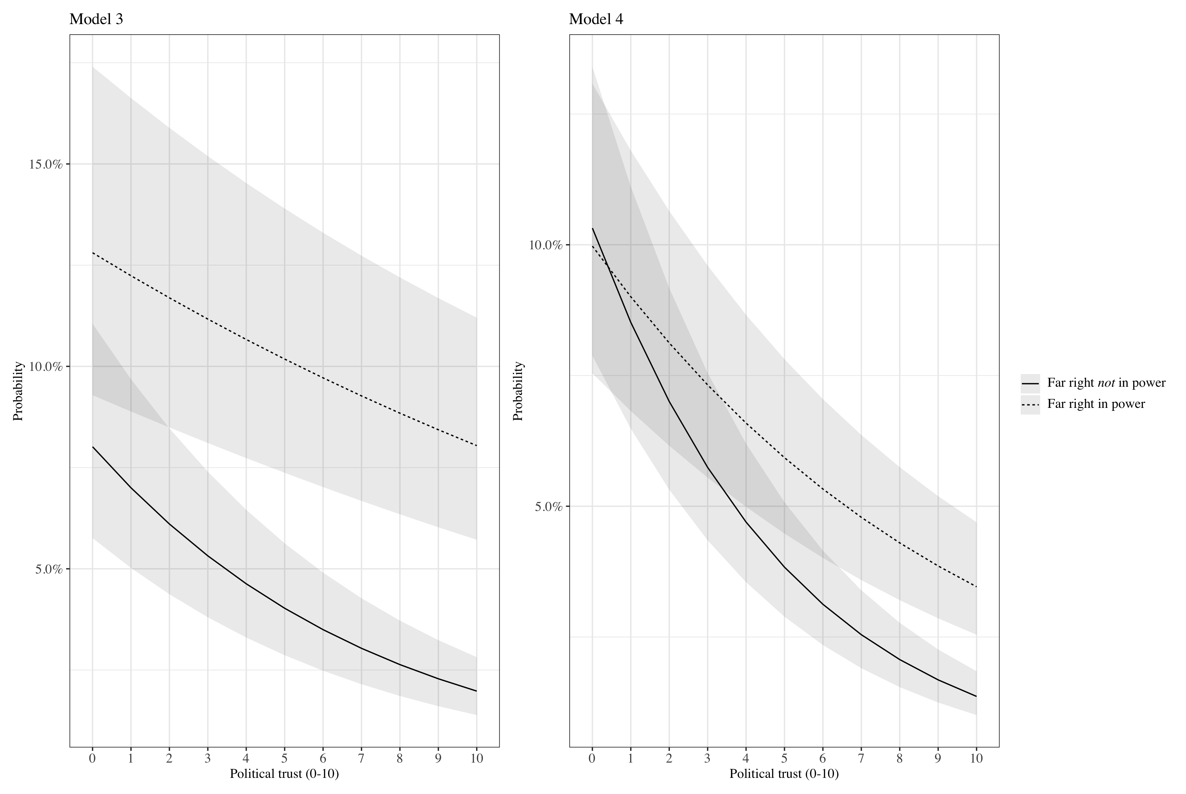 **Figure A1.** Effect of political trust: the conditional predicted probabilities of far-right voting for far-right parties in opposition and in government (calculations based on regression model 3 (left) and model 4 (right), see Table 2). The other independent variables are kept constant at the mean.

***Appendix E: Effects of anti-immigration attitudes by far-right party’s political status***In contrast to protest voting, we conclude that ideological voting is not conditional: it does not depend on the political status of far-right parties. Additional analyses with interactions of the four variables that represent economic and cultural policy-related preferences show that ‘economic grievances’ and ‘cultural backlash’ are not weaker predictors of electoral support for far-right parties when these parties are in the government.   
 To illustrate this outcome, Figure A2 shows the results of a country-by-country analysis of what is generally considered as the main predictor of far-right voting – anti-immigration attitudes. We conclude: far-right voters are not less negative about immigration when their parties are included in the government. Remarkably, the opposite is clearly the case in Poland and Hungary, which might be due to period effects: the presence of far-right governments coincides with the European refugee crisis that unfolded in 2015. It could perhaps also explain the large difference we observe in Finland (the far-right Finns Party was member of the government coalition in 2016).



**Figure A2.** The effect of anti-immigration attitudes on the probability to vote for far-right parties, broken down by far-right party’s status (in government vs. opposition), per country (for the control variables, see model 2 in Table 2).

***References***  
  
**Cohen D** (2019) Between Strategy and Protest: How Policy Demand, Political Dissatisfaction and Strategic Incentives matter for Rar-Right Voting. *Political Science Research and Methods*, published online, 10 June, https://doi.org/10.1017/psrm.2019.21.  
  
**Döring H and Manow P** (2019). Parliaments and Governments Database (ParlGov): Information on parties, elections and cabinets in modern democracies. Accessed: http://www.parlgov.org/

**Hanley S and Sikk A** (2016) Economy, corruption or floating voters? Explaining the breakthroughs of anti-establishment reform parties in Eastern Europe. *Party Politics* **22**(4), 522-533.  
  
**Krause W and Wagner A** (2019) Becoming Part of the Gang? Established and Nonestablished Populist Parties and the Role of External Efficacy. *Party Politics*, published online, 11 April, https://doi.org/10.1177/1354068819839210.

**Kriesi H and Schulte-Cloos J** (2020) Support for Radical Parties in Western Europe: Structural Conflicts and Political Dynamics. *Electoral Studies*, published online, 22 April,

https://doi.org/10.1016/j.electstud.2020.102138  
  
**Minkenberg M** (2017) *The Radical Right in Eastern Europe: Democracy under Siege?* New York: Springer.

**Rooduijn M, Van Kessel S, Froio C, Pirro,A, De Lange S, Halikiopoulou D, Lewis P, Mudde C and Taggart P** (2019). The PopuList: An Overview of Populist, Far Right, Far Left and Eurosceptic Parties in Europe. Accessed: http://www.popu-list.org.