Supplementary Material for
Borges André & Ribeiro, Pedro Floriano. “Presidents, Prime Ministers and Legislative Behaviour: The Conditional Effect of Presidential Legislative Powers on Party Unity”. Government and Opposition, 2021.
Appendix A: Classification of government systems

We coded countries’ government systems following the classificatory scheme proposed by Samuels and Shugart (2010). To classify the cases absent from Samuels and Shugart’s (2010) analysis, we relied to a substantial extent on three measures of regime type available in the V-Dem dataset. The first indicates whether the head of government is appointed (either directly or indirectly) by the legislature (v2_exlegconhog). The second measure indicates whether the head of state is elected (v2_exelechos). Finally, we relied on a categorical variable indicating to what extent the head of state has the power to appoint the whole cabinet without confirmation of the legislature (v2exdfcbhs). Typically, pure presidential systems are characterized by a popularly elected head of state with the power to appoint the cabinet independently of the legislature’s approval. Semi-presidential countries are also characterized by a popularly elected executive, but they differ from presidentialism in what concerns the existence of a prime minister dependent on legislative confidence. Thus, the measures of cabinet appointment powers (v2exdfcbhs) and appointment of the head of government (v2_exlegconhog) allowed us to separate presidential from semi-presidential cases. Finally, parliamentarism differs from presidentialism and semi-presidentialism due to the lack of a directly elected head of state (v2_exelechos).
Although our final dataset does not include hybrid regimes that do not fit any of these three regimes types – for instance, polities in which an assembly-elected president serves a fixed term and is not subject to early dismissal by the parliament – we did categorize some of these cases. But we opted for excluding them from our analysis for two reasons. First, we were unable to obtain data on all the relevant variables for almost all of these hybrid regimes. Second, given that our central interest lies in the comparison of presidential and semi-presidential regimes, including hybrid regime types would further complicate model estimation without bringing any substantial gains with regard to the total number of observations.
In addition to extending the original classification of regime types proposed by Samuels and Shugart (2010), we cross checked their data against the information provided by the V-Dem measures (https://www.v-dem.net/en/). Whenever the classification produced by the latter conflicted with the data obtained from Samuels and Shugart’s (2010) , we sought information on other sources, including the Database of Political Institutions (DPI) (https://publications.iadb.org/en/database-political-institutions-2020-dpi2020) and the Comparative Constitutions Project (CCP) https://comparativeconstitutionsproject.org/). As a final check, we compared our classification with that provided by Sedelius and Linden (2018) and found very few divergent classifications. Again, we obtained additional information on the incongruent cases relying on the previously mentioned sources.
A list of the countries included in the dataset, classified by regime type, is presented below.
Table A.1 - List of countries by regime type

Parliamentary | Presidential | Semi-presidential
Albania | Argentina | Austria
Australia | Benin | Bulgaria
Bangladesh | Bolivia | Cape Verde
Barbados | Brazil | Croatia
Belgium | Burundi | Finland
Botswana | Chile | France
Canada | Colombia | Georgia
Czech Republic | Costa Rica | Iceland
Denmark | Dominican Republic | Lithuania
Estonia | Ecuador | Macedonia (1994-2001)
Hungary | El Salvador | Mali
Jamaica | Guatemala | Moldova (1994-2001)
Japan | Honduras | Mozambique
Latvia | Indonesia | Namibia
Lesotho | Kenya | Niger
Macedonia (1992-1993) | Malawi | Peru
Mauritius | Mexico | Poland
Moldova (2002-2005) | Nicaragua | Portugal
Netherlands | Panama | Russia
New Zealand | Paraguay | Senegal
Norway | Philippines | Slovakia (1999-2006)
Slovakia (1994-1998) | South Korea | Slovenia
Spain | United States | Taiwan
Sweden | Uruguay | Ukraine
Thailand | Venezuela
United Kingdom

Table A2 reports average V-Dem party unity scores for each of the countries in our dataset, classified by regime type. Countries were rank ordered from the highest to the lowest average party unity scores within each regime type.

Table A.2 – Average party unity scores (V-Dem) by regime type and country

Parliamentary |  | Presidential |  | Semi-presidential
Country | Average party unity | Country | Average party unity | Country | Average party unity
Denmark | 2.28 | Chile | 1.54 | Macedonia (1994-2001) | 2.22
Sweden | 2.26 | Uruguay | 1.34 | Austria | 2.16
Macedonia (1992-1993) | 2.24 | Venezuela | 1.24 | Cape Verde | 1.83
Norway | 2.14 | Bolivia | 1.17 | Namibia | 1.68
Spain | 2.13 | El Salvador | 1.06 | Mozambique | 1.53
Australia | 2.06 | Mexico | 1.05 | Iceland | 1.52
Jamaica | 1.96 | Malawi | 0.94 | Georgia | 1.48
New Zealand | 1.85 | Argentina | 0.91 | Romania | 1.30
Bangladesh | 1.79 | South Korea | 0.84 | Poland | 1.30
Belgium | 1.78 | Dominican Rep. | 0.77 | Portugal | 1.23
Netherlands | 1.74 | Kenya | 0.69 | Croatia | 0.98
Canada | 1.65 | Panama | 0.42 | Bulgaria | 0.93
Botswana | 1.45 | Honduras | 0.40 | Slovenia | 0.83
Mauritius | 1.31 | Indonesia | 0.31 | Finland | 0.79
Japan | 1.14 | Nicaragua | 0.01 | Moldova (2002-2005) | 0.77
Barbados | 1.12 | United States | -0.05 | Slovakia (1998-2006) | 0.50
Moldova (2002-2005) | 1.07 | Benin | -0.11 | Senegal | 0.49
Hungary | 0.94 | Burundi | -0.26 | Taiwan | 0.34
Slovakia (1994-1998) | 0.87 | Brazil | -0.28 | France | 0.23
Lesotho | 0.81 | Ecuador | -0.51 | Niger | 0.21
Czech Republic | 0.60 | Costa Rica | -0.63 | Russia | 0.21
Thailand | 0.58 | Guatemala | -0.73 | Lithuania | 0.11
Estonia | 0.47 | Paraguay | -1.12 | Peru | -0.40
United Kingdom | 0.43 | Philippines | -1.55 | Ukraine | -0.51
Albania | 0.17 | Colombia | -1.80
Latvia | 0.16
Lithuania | -0.53

Appendix B: The Personal Vote Score

The “Particularism around the World” database developed by Wallack and Johnson (2012) attributes scores to electoral systems ranging from 1 to 13. A hypothetical country with a score of 13 would have a tier with the largest possible rank of incentives to cultivate a personal vote and this tier would also have the largest number of legislators. A score of one, on the other hand, would indicate that the electoral rules used to elect legislators in the dominant or single tier are party-centric to the highest possible extent. Aggregate scores are based on the values assigned to the ballot, vote and pooling dimensions present in Carey and Shugart’s (1995) original ranking. Scores on each of these dimensions range from zero to two.
Wallack and Johnson’s (2012) classification relies on data gathered up to the year 2005 for most countries. We updated the original database by obtaining information on electoral systems in the post-2005 period. In those cases in which electoral rules remained unchanged, we simply repeated the last score available on the “Particularism Around the World” database. Otherwise, we computed new scores using the same coding rules proposed by Wallack and Johnson (2012). Also, we calculated scores for a few countries absent from the original database. We relied on the Parline database of national parliaments and on the classification of electoral systems available from the V-Dem database, in addition to a few secondary sources (see below).

Bibliography:

Project Electoral System Change in Europe since 1945. http://www.electoralsystemchanges.eu/Public/DatasPage.php?ID=6
Gallagher, Michael, and Paul Mitchell, eds. (2005). The politics of electoral systems. OUP Oxford, 2005.
Johnson, J. W., & Wallack, J. S. k. (2012). Electoral Systems and the Personal Vote, Harvard Dataverse, V1

Otero, Laura Wills, and Aníbal Pérez-Linán. "La evolución de los sistemas electorales en América: 1900-2004." Colección 16 (2017): 47

Appendix C – Alternative models utilizing a subset of the data.

Table C.1 –GEE models for the determinants of party unity excluding observations prior to 2005
 | Model 2a |  | Model 2b |  | Model 2c
 | B | SE | B | SE | B | SE
(Intercept) | 1.60 | 1.00 | 1.99*** | 0.76 | 2.32*** | 0.91
Presidentialism | -0.65* | 0.34 | -2.00*** | 0.42 | -2.08*** | 0.44
Parliamentarism | -0.08 | 0.26 | -0.03 | 0.17 | -0.04 | 0.16
Legislative powers | -0.08 | 0.07 | -0.17*** | 0.02 | -0.17*** | 0.03
Old democracy | 0.46* | 0.26 | 0.44** | 0.20 | 0.18 | 0.38
Personal vote score | 0.05 | 0.06 | 0.01 | 0.03 | -0.01 | 0.03
Candidate selection | 0.10 | 0.15 | -0.07 | 0.08 | -0.06 | 0.08
GDP per capita (logged) | -0.06 | 0.10 | -0.14 | 0.44 | -0.23 | 0.45
Ethnic fracionalization | -0.33 | 0.45 | 0.35*** | 0.12 | 0.36*** | 0.12
Cand. selection x Personal vote | - | - | -0.09*** | 0.03 | -0.09*** | 0.03
Presidentialism x Leg. Powers | - | - | 0.29*** | 0.06 | 0.26*** | 0.07
Parliamentarism x Leg. Powers | - | - | -0.01 | 0.05 | 0.00 | 0.05
Eastern Europe | - | - | - | - | -0.54 | 0.39
Africa | - | - | - | - | -0.03 | 0.47
Latin America |  |  |  |  | -0.04 | 0.47
Asia |  |  |  |  | -0.13 | 0.51
X² |  | 39 |  | 129 |  | 219
Countries |  | 69 |  | 69 |  | 69
Observations |  | 489 |  | 489 |  | 489

Appendix D – Comparing the reputational V-Dem measure of party unity with the weighted Rice index.

The graph below is a simple scatter plot of the weighted Rice index (Y-axis) and V-Dem measure of party unity (X-axis) for a selected group of countries. Coman’s (2015) original data on the weighted Rice index covers 33 countries. Most observations are an average of the weighted Rice index observed over a two-year or three-year period. We calculated the average V-Dem party unity score for the same periods, covering the 24 countries that are present in both our dataset and in Coman’s.

Figure D.1: Scatter Plot of Party Unity (V-Dem) and Weighted Rice Index, selected countries (regression line in red)
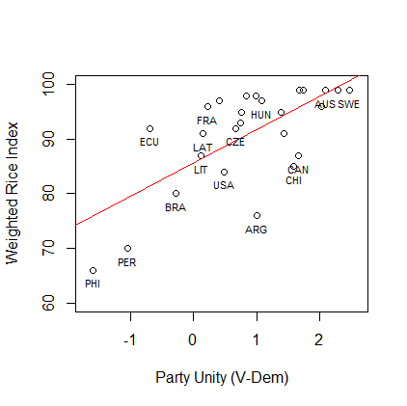

Sources: Coman (2015); V-Dem (2018).

Appendix E – Alternative models using Doyle and Elgie’s (2015) composite presidential power scores

As an additional robustness test, we estimated two regression models (reported below) using the measures of presidential powers created by Doyle and Elgie (2016). They identified a total of 28 comparative studies that attempted to measure president’s constitutional authority in different regions of the world. Based on these 28 datasets, Doyle and Elgie (2015) created two aggregate scores. The first measure (prespow1) is the normalized mean of the 28 measures of presidential powers, ranging from zero to one. Because most of the measures surveyed by Doyle and Elgie (2015) cover a limited set of countries, the number of scores used to calculate normalized means varies significantly across countries and periods, which in turns likely reduces the reliability of prespow1. Thus, the second measure (prespow2) tries to deal with these limitations by relying on maximum likelihood data imputation techniques and principal component analysis (PCA). Using PCA, presidential scores are estimated as a linear weighted construct of all existing presidential power measures.
Although prespow1 and prespow2 are correlated with our measure of presidential legislative authority (r=0.49 and r=0.46, respectively), they are inadequate to directly test our hypotheses because they result from the aggregation of legislative and nonlegislative powers. Note, further, that several of the studies utilized by Doyle and Elgie (2016) include presidents’ authority to appoint and dismiss the cabinet in the calculus of presidential power scores. Therefore, prespow1 and prespow2 tend to reflect intrinsic properties of regime types. Presidents’ authority to appoint and dismiss the cabinet in pure presidentialism is, by definition, always higher than zero, whereas presidents in parliamentary countries are never endowed with such powers. Under semi-presidentialism, presidents’ authority over the cabinet is almost always higher than in parliamentarism but lower than in presidentialism. Presidential legislative authority lacks such direct and strong correlation with regime types because it is both theoretically and empirically possible to observe cases in which presidents have no legislative powers under pure presidentialism or under semi-presidentialism (as shown in table 1 of the article).
Figures E1 and E2 present separate boxplots of presidential power scores for presidential, semi-presidential and parliamentary cases. The figures show that the typical or median presidential country has more powerful presidents than any other system of government. No presidential case obtains scores lower than 0.10 (if we rely on prespow1) or lower than 0.24 (if we rely on prespow2). Also as expected, semi-presidential countries feature, on average, substantially stronger presidents than parliamentary cases and these differences are rather large when we rely on the more reliable measure constructed using principal component analysis (prespow2). In sum, presidential powers are highly correlated with regime types.

Figure E.1 : Boxplot of presidential powers (prespow1) by regime type
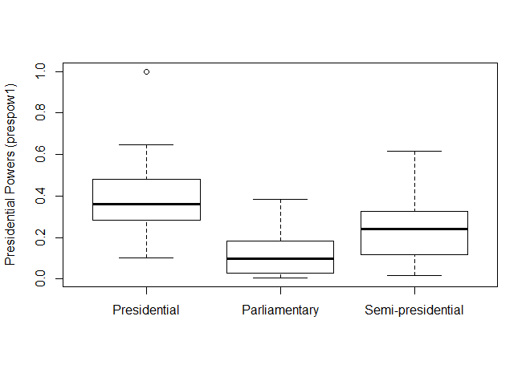
Figure E.2 : Boxplot of presidential powers (prespow2) by regime type
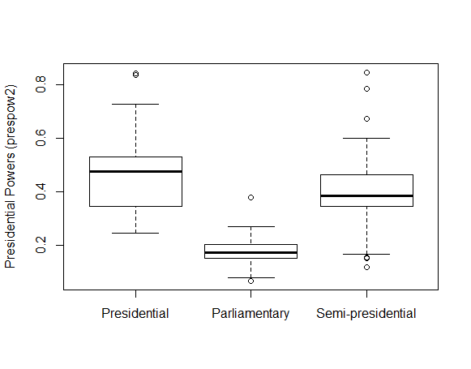

Due to the limitations of prespow1 and prespow2, it is not possible to use these measures to directly compare levels of party unity under presidentialism and semi-presidentialism while maintaining levels of legislative authority constant, as we did to test H2 and H3 in the main statistical analyses reported in table 3. Instead, we perform a more indirect test of our theoretical claims. Recall that according to H1, we expect party unity in presidential countries with high legislative authority to be higher than in presidential countries with weak presidents. We also expect semi-presidential countries with low legislative authority to exhibit substantially higher levels of party unity compared to both presidential countries with low legislative authority (H2) and semi-presidential countries with average/high levels of legislative authority (H1). If these hypotheses are both correct, we should observe a nonlinear U-shaped relationship between presidential powers and party unity. That is, because low presidential powers are likely associated with parliamentary systems and semi-presidential countries where presidents lack substantial legislative authority (and these are the instances where we expect levels of party unity to be highest), an increase from low to medium levels of presidential powers should decrease party unity. In fact, presidential countries with low levels and semi-presidential countries with medium/high levels of legislative authority should be found in the middle of the distribution of presidential powers, and these are the cases associated with the lowest scores of party unity in our hypotheses. Finally, as we move from average to extreme levels of presidential powers (where we would expect to find presidential countries with very powerful presidents in terms of legislative authority), party unity should increase, to the extent that broad legislative powers in presidential systems are expected to produce more cohesive and disciplined party behavior.
We tested these claims by running GEE models similar to those reported on table 3 of the article. The only difference is that we replaced the dummies for parliamentarism and presidentialism and the measure of presidential legislative authority with the aggregate measures of presidential powers created by Doyle and Elgie (2016). We ran separate models using prespow1 and prespow2. We include the square of presidential powers in both specifications to account for the nonlinear nature of the hypothesized effects. Following the same procedure adopted in our main statistical analyses, parliamentary countries lacking an unelected president received a score of zero in prespow1 and prespow2. The dataset used in the alternative regressions has 80 countries and over 1700 observations.

Table E.1 – Alternative GEE models for the determinants of party unity

 | Model 1 (prespow1) |  | Model 2 (prespow2)
 | B | SE | B | SE
(Intercept) | 2.59*** | 0.69 | 3.00*** | 0.72
Presidential powers | -0.31 | 0.68 | -2.51*** | 0.94
Presidential powers (squared) | 0.80 | 1.06 | 2.37*** | 0.74
Old democracy | -0.24 | 0.36 | -0.33 | 0.31
Personal vote score | 0.08** | 0.04 | 0.08** | 0.04
Candidate selection | 0.31*** | 0.10 | 0.31*** | 0.10
GDP per capita | -0.10 | 0.06 | -0.11 | 0.07
Ethnic fractionalization | -0.78* | 0.46 | -0.80* | 0.46
Cand. selection x personal vote | -0.11*** | 0.04 | -0.11*** | 0.04
Eastern Europe | -0.94*** | 0.26 | -0.78*** | 0.23
Africa | -0.91** | 0.48 | -0.65 | 0.43
Latin America | -1.29** | 0.33 | -1.09*** | 0.30
Asia | -1.06 | 0.46 | -1.00** | 0.42
X² |  | 34.7 |  | 47
Countries |  | 80 |  | 80
Observations |  | 1753 |  | 1753

The results of the second model are consistent with the expectations. The coefficients for presidential powers and presidential powers squared are both statistically significant. The positive sign for the squared term indicates that the negative marginal effect of presidential powers decreases as presidents become stronger, consistent with theoretical expectations. In the first equation, which relies on simple normalized means of various measures of presidential powers, the coefficients came with the right signs but did not achieve statistical significance.
We relied on the coefficients reported for model 2 to simulate the values of party unity conditional on presidential powers while maintaining all other variables at their means, using R package Zelig. Figure E.1 below plots the expected values and the respective 95% confidence intervals.

Figure E.1 – Expected values of party unity conditional on presidential powers (prespow2)
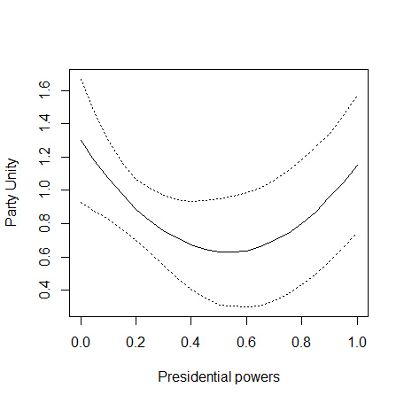
Source: Model 2, table E.2

The graph shows that the effect of presidential powers on party unity decreases as we move from null to average values. As we move from average to extreme levels of presidential powers, party unity increases. This is consistent with the theoretical expectations that party unity should be highest in semi-presidential countries with low levels of presidential legislative authority and in presidential countries where presidents are endowed with extensive legislative powers. In sum, these results demonstrate that our findings do not depend on the operationalization of our main explanatory variables or on the cases that we use to test the hypotheses. Using different measures and relying on a slightly different (and larger) sample of countries, we arrive at results that are consistent with our theory.

Appendix F – Simulation tables for within-system variation in party unity

Tables F.1 and F.2 below report the Zelig simulations that we used to compare levels of party unity in countries with low, high and extreme levels of legislative within the presidential and semi-presidential groups. By default, Zelig computes one thousand simulations to estimate expected and predicted values and the associated standard deviations. We obtained first-differences (reported in the last column of each table) by estimating the respective expected values for high (3rd quarter) and extreme (3rd quarter + 2 standard deviations) levels of legislative powers and then asking Zelig to subtract from these values the expected value of party unity for low levels of presidential legislative authority (1st quarter of the distribution). All the simulations were estimated by changing only three variables in the model: the dummies for presidentialism and parliamentarism and the measure of presidential legislative authority. By default, Zelig keeps all model variables not entered in the simulation at their means.

Table F1 - Expected differences in party unity for semi-presidential countries, conditional on the legislative powers of the presidency (low presidential powers = ref category)

 | Expected value | Difference (Low pres. powers = ref. category)
Extreme Leg. Powers | 0.40 | -0.89***
High Leg. Powers | 0.84 | -0.45***
Low Leg. Powers | 1.29 | -
Source: Table 3 ; *** p<0.01

Table F2 - Expected differences in party unity for presidential countries, conditional on the legislative powers of the presidency (low presidential powers = ref category)

 | Expected value | Difference (Low pres. powers = ref. category)
Extreme Leg. Powers | 1.09 | 1.26***
High Leg. Powers | 0.46 | 0.63***
Low leg. Powers | -0.17 | -
Source: Table 3 ; *** p<0.01

