Appendix – How Do Populist Radical Right Parties Differentiate their Appeal? Evidence from the Media Strategy of the Hungarian Jobbik Party
Endre Borbáth and Theresa Gessler

Appendix A: Dictionary for populism and nativism 1
Appendix B: Additional figures and tables 8
Appendix C: Content based transformation of nativism and populism 12
Appendix D: Distribution of documents classified with a proportional measure 14

Replication material available at https://doi.org/10.7910/DVN/NYMEP5

Appendix A: Dictionary for populism and nativism
In the current appendix we present further details of the dictionary we constructed. First in table 1 we list the terms we include to detect anti-elitism, people-centrism and nativism. As discussed in the paper, we classify documents as populist if they include at least one word from each of the two dimensions of populism: anti-elitism and people-centrism. We classify documents as nativist, when they include at least one term from the nativism dictionary.
Table 1: Terms in the dictionary
Concept | Source | Hungarian | English (approximate translation)
Anti-elitism | Previous Literature | antidemokratikus* | anti-democratic*
 |  | arrog* | arrogant*
 |  | árulás* | traitor*
 |  | áruló* | betrayal*
 |  | botrány* | scandal*
 |  | bürokr* | bureaucratic *
 |  | elit | elite
 |  | félrevezet* | deceive*
 |  | gyáva* | coward*
 |  | hatalom* | rule*
 |  | hazug* | liar*
 |  | igazság | just
 |  | igazságot | the just
 |  | igazságtalan | unjust
 |  | korrupt | corrupt
 |  | magánérdek* | private interest*
 |  | meghátr* | retreat*
 |  | megtéveszt* | deceive*
 |  | oligarch* | oligarch*
 |  | propagand* | propagand*
 |  | ^rendszer[^(es)]+ | “system” or order, but not “regular”
 |  | rezsim* | regime*
 |  | szégye* | shame*
 | Manifesto | csalás* | cheating*
 |  | ellop* | steal*
 |  | elszámol* | hold to account*
 |  | lop* | steal*
 |  | mentelm* | immunity*
 |  | rendszer | system
 | Context Specific | diktát* | dictat*
 |  | maffiakormány* | mafia government*
 |  | maffiaállam* | mafia state*
 |  | megalku* | opportunist*
 |  | offshore* | offshore*
 |  | politikus bűn* | politician crime*
 |  | politikusbűn* | politician crime*
 |  | önkény* | arbitrariness*
 |  | visszaél* | misuse*
People-centrism | Previous Literature | ^nemzeti*$[^(együttmuködés)]+ | national*, but not national cooperation
 |  | állampolgár* | citizen*
 |  | dolgozó ember* | working people*
 |  | egyszerű ember* | simple people*
 |  | magyar ember* | Hungarian people*
 |  | normális ember* | normal people*
 |  | rengeteg ember* | multitude of people*
 |  | tisztességes ember* | honest people*
 |  | nép | folk
 |  | referend* | referend*
 |  | szavazóbáz* | voter base*
 |  | választóink* | our voters*
 | Manifesto | konzultá* | consult*
 |  | néphez | for the people*
 |  | népnek | to the people*
 |  | néppel | with the people
 |  | népszavaz* | people's vote*
 |  | választók | voters*
 | Context Specific | népakar* | popular will*
 |  | polgárikezdemény* | citizen initiative*
 |  | választói akarat* | voters’ will*
 |  | választók akarat* | the voters’ will*
Nativism | Previous Literature | anyaország* | motherland*/ homeland*
 |  | arab* | arab*
 |  | betelepítés* | resettlement*
 |  | bevándorl* | immigrant*
 |  | cigány* | gipsy*
 |  | elcigányos* | To become populated by gypsies
 |  | határ | border
 |  | határa | to the border
 |  | határon | on the border
 |  | határt | border
 |  | határzár* | border fence*
 |  | határőr | border guard
 |  | holokauszt* | holocaust*
 |  | idegen | foreign/foreigner
 |  | idegenek | foreigners
 |  | izrael* | Israel*
 |  | kóser | kosher*
 |  | menekült* | refugee*
 |  | migráns* | migrant*
 |  | muszlim* | Muslim*
 |  | zsidó* | jew*
 | Manifesto | demográfi* | demography*
 |  | elcsatolt terület* | detached territory*
 |  | Kárpát-medence* | Carpathian Basin*
 |  | magyarság* | Hungarians/Hungarianism*
 |  | szegreg* | segregate*
 |  | Trianon* | Trianon*
 | Context Specific | elcigányos* | becomes populated by gipsies*
 |  | elszakított magyar* | detached Hungar*
 |  | elszakított nemzet* | detached nation*
 |  | elszakított ország* | detached country*
 |  | elszakított terület* | detached country*
 |  | Fehér ember* | White man*
 |  | Gárda* | Guard*
 |  | holokam* | holofiction*
 |  | Horthy* | Horthy*
 |  | néger* | nigger*
 |  | roma | Roma
 |  | turul* | turul*

In our operationalization, nativism and populism are not mutually exclusive concepts. The same document might be classified as both nativist and populist if it contains terms from the respective dictionary. Empirically, we indeed observe a certain overlap in our classification of documents, as shown by figure 1 (also see table 1, appendix B). In general, documents that are classified as both populist and nativist are included in both our nativism and populism measure.
Figure 1: Number of documents classified based on the dictionaries (binary classification)
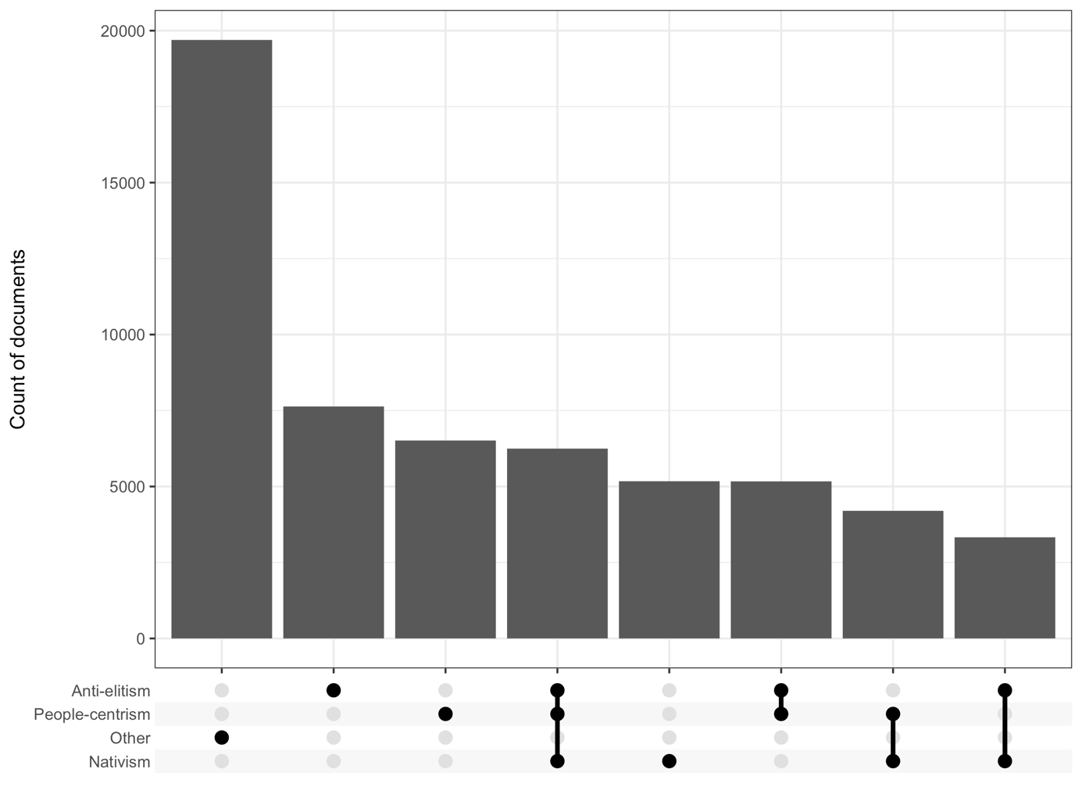
One concern relates to the possibility to empirically distinguish between nativism and populism. For instancewe include the term “nemzeti” (national) and “nép” (folk) in our dictionary of people-centrism, even though they might also be included in a dictionary of nativism. Although conceptually ambiguous, empirically this decision only affects the level of populism, but not the conclusions we draw about its distribution over time or across platforms. To show this, we include below figure 1 and figure 2 replicated from the paper with a dictionary where we do not include the following terms for people-centrism: “nép”, “népnek”, “néppel”, “néphez”, “népakar*”, “nép akar*”, “nemzeti*”
Figure 2: Documents with a nativist and populist appeal on the different platforms 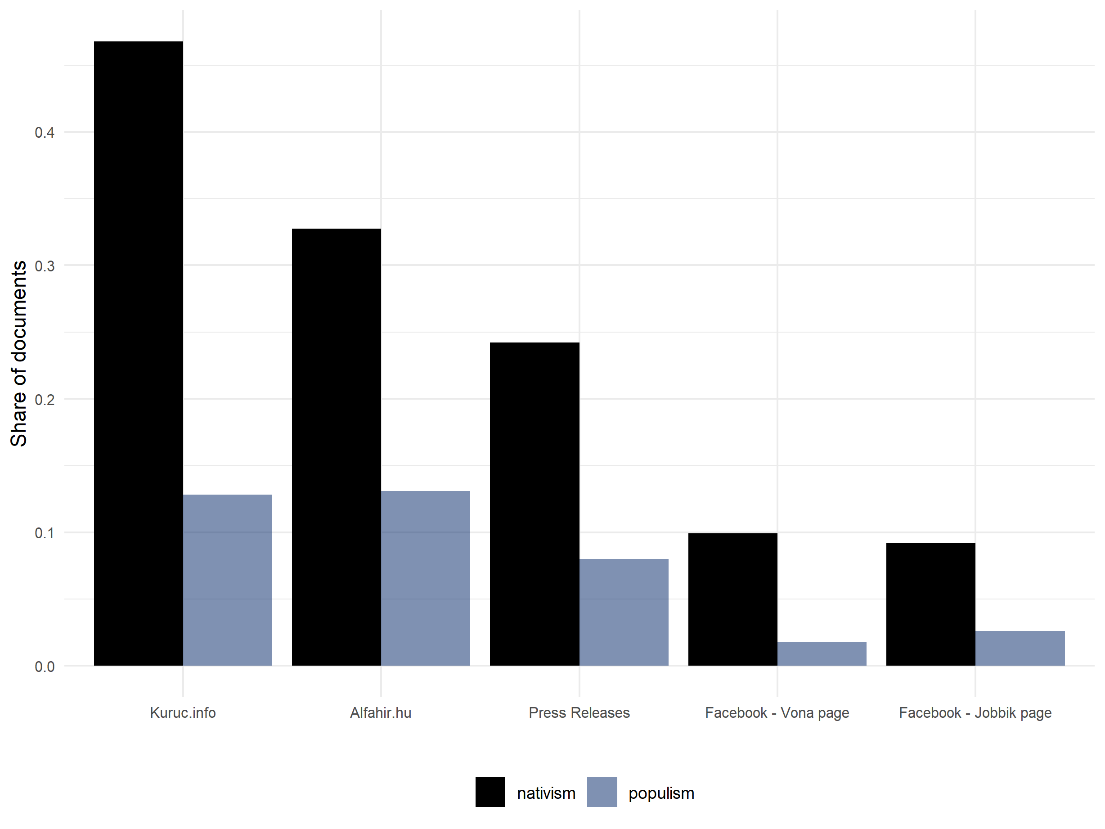

Figure 3: The share of documents over time with a populist or nativist appeal on the different platforms
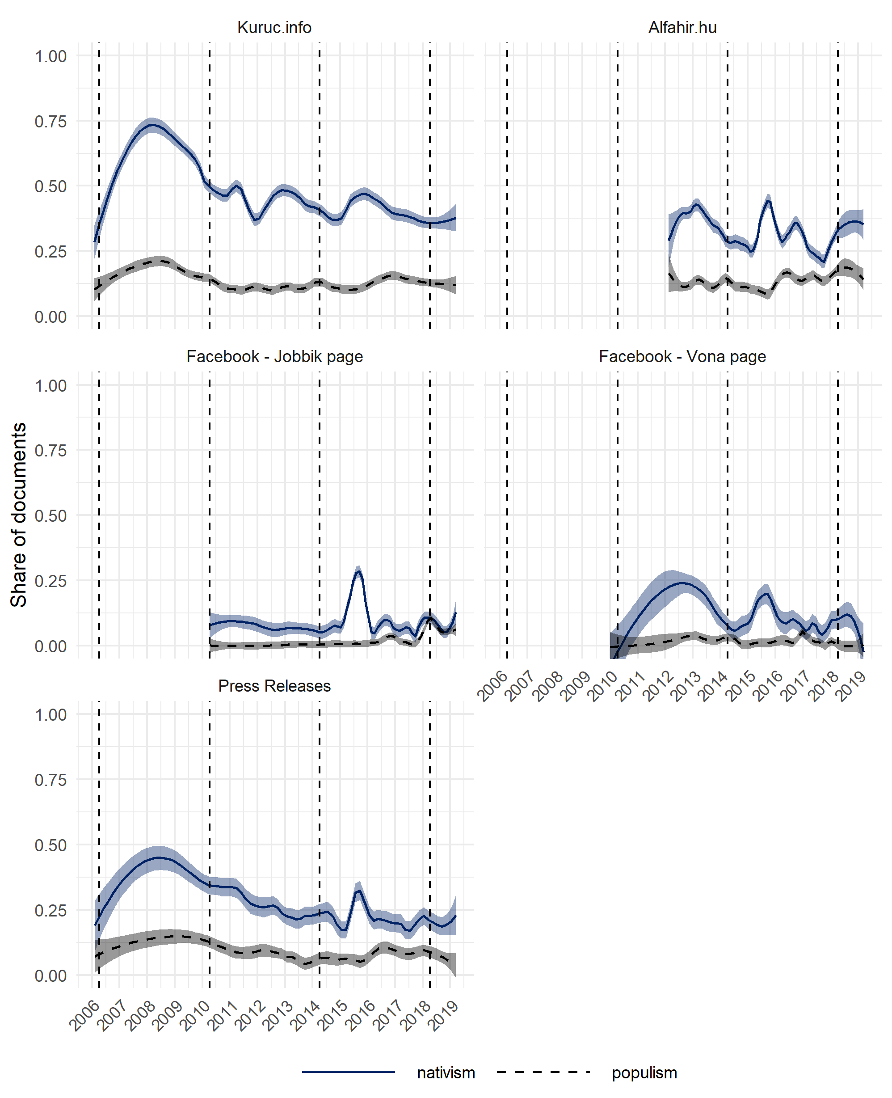
Note: The coloured line represents the LOESS smoother we apply on all documents within a corpus and its associated 95 percent confidence interval. The dashed vertical reference lines represent the dates of the national parliamentary elections.

Appendix B: Additional figures and tables

Table 1: Descriptive features of the five corpuses
Period | Kuruc.info | Alfahir.hu | Facebook - Jobbik page | Facebook - Vona page | Press Releases
First observation | 01.02.2006 | 18.02.2012 | 07.04.2010 | 02.01.2010 | 06.02.2006
Last observation | 14.03.2019 | 15.03.2019 | 15.03.2019 | 15.03.2019 | 15.03.2019
Corpus characteristics
Total number of documents | 21977 | 17432 | 7481 | 3485 | 7582
Average length of document (# of words) | 689 | 599 | 66 | 92 | 233
Number of classified documents (share in corpus in parenthesis)
Populist | 5521 (25%) | 4362 (25%) | 293 (4%) | 113 (3%) | 1095 (14%)
Nativist | 10281 (47%) | 5708 (33%) | 690 (9%) | 346 (10%) | 1837 (24%)
Co-occurrence (share in corpus in parenthesis)
Populism and Nativism | 3767 (17%) | 2014 (12%) | 36 (0%) | 39 (1%) | 355 (5%)

Figure 1: Marginal effects of Fidesz’ nativism on Jobbik’s nativism
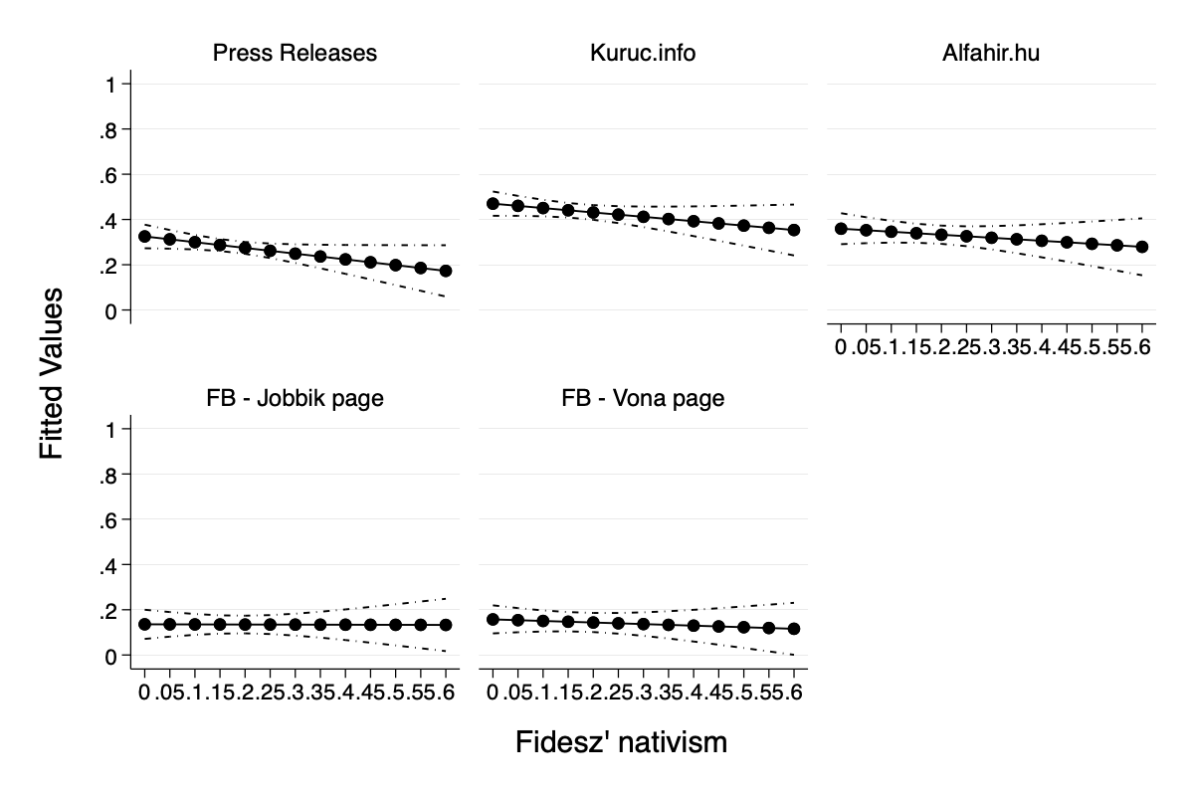
Note: The marginal effects figure is estimated based on the two-way interaction shown in model 2 in table 1 in the main text.

Figure 2: Marginal effects of the share of undecided voters on Jobbik’s nativism
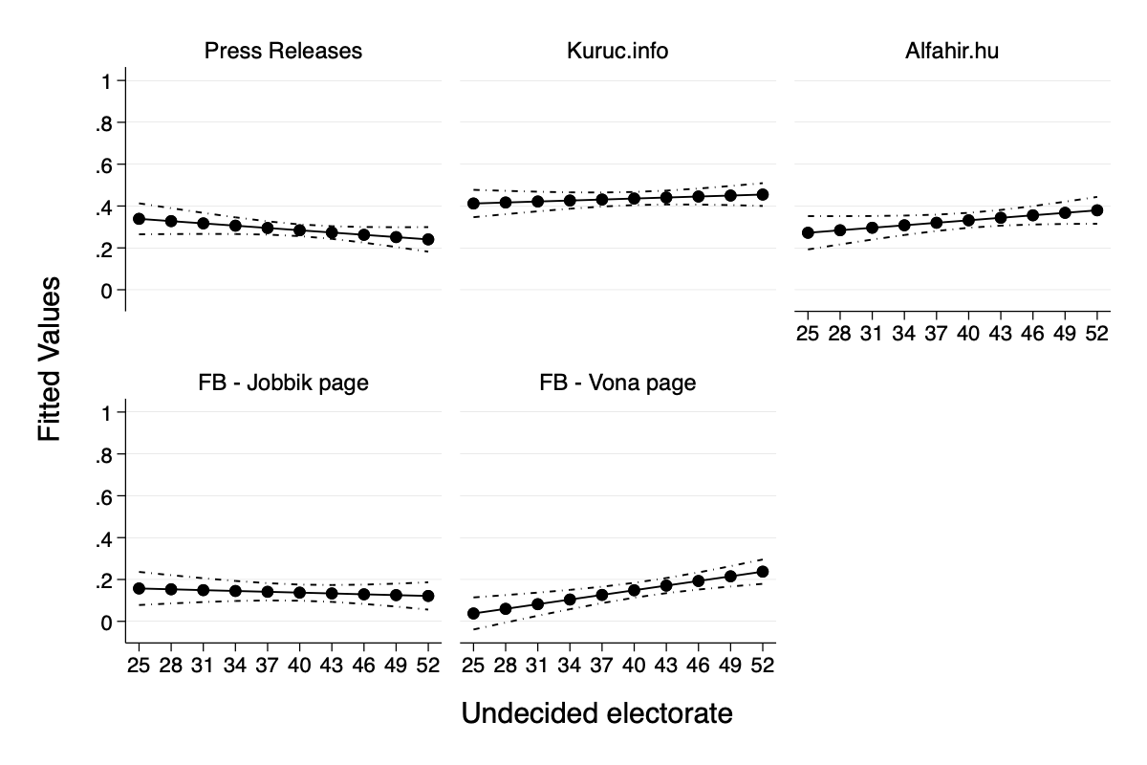
Note: The marginal effects figure is estimated based on the two-way interaction shown in model 3 in table 1 in the main text.

Figure 3: Electoral share of Jobbik in public opinion polls and national elections

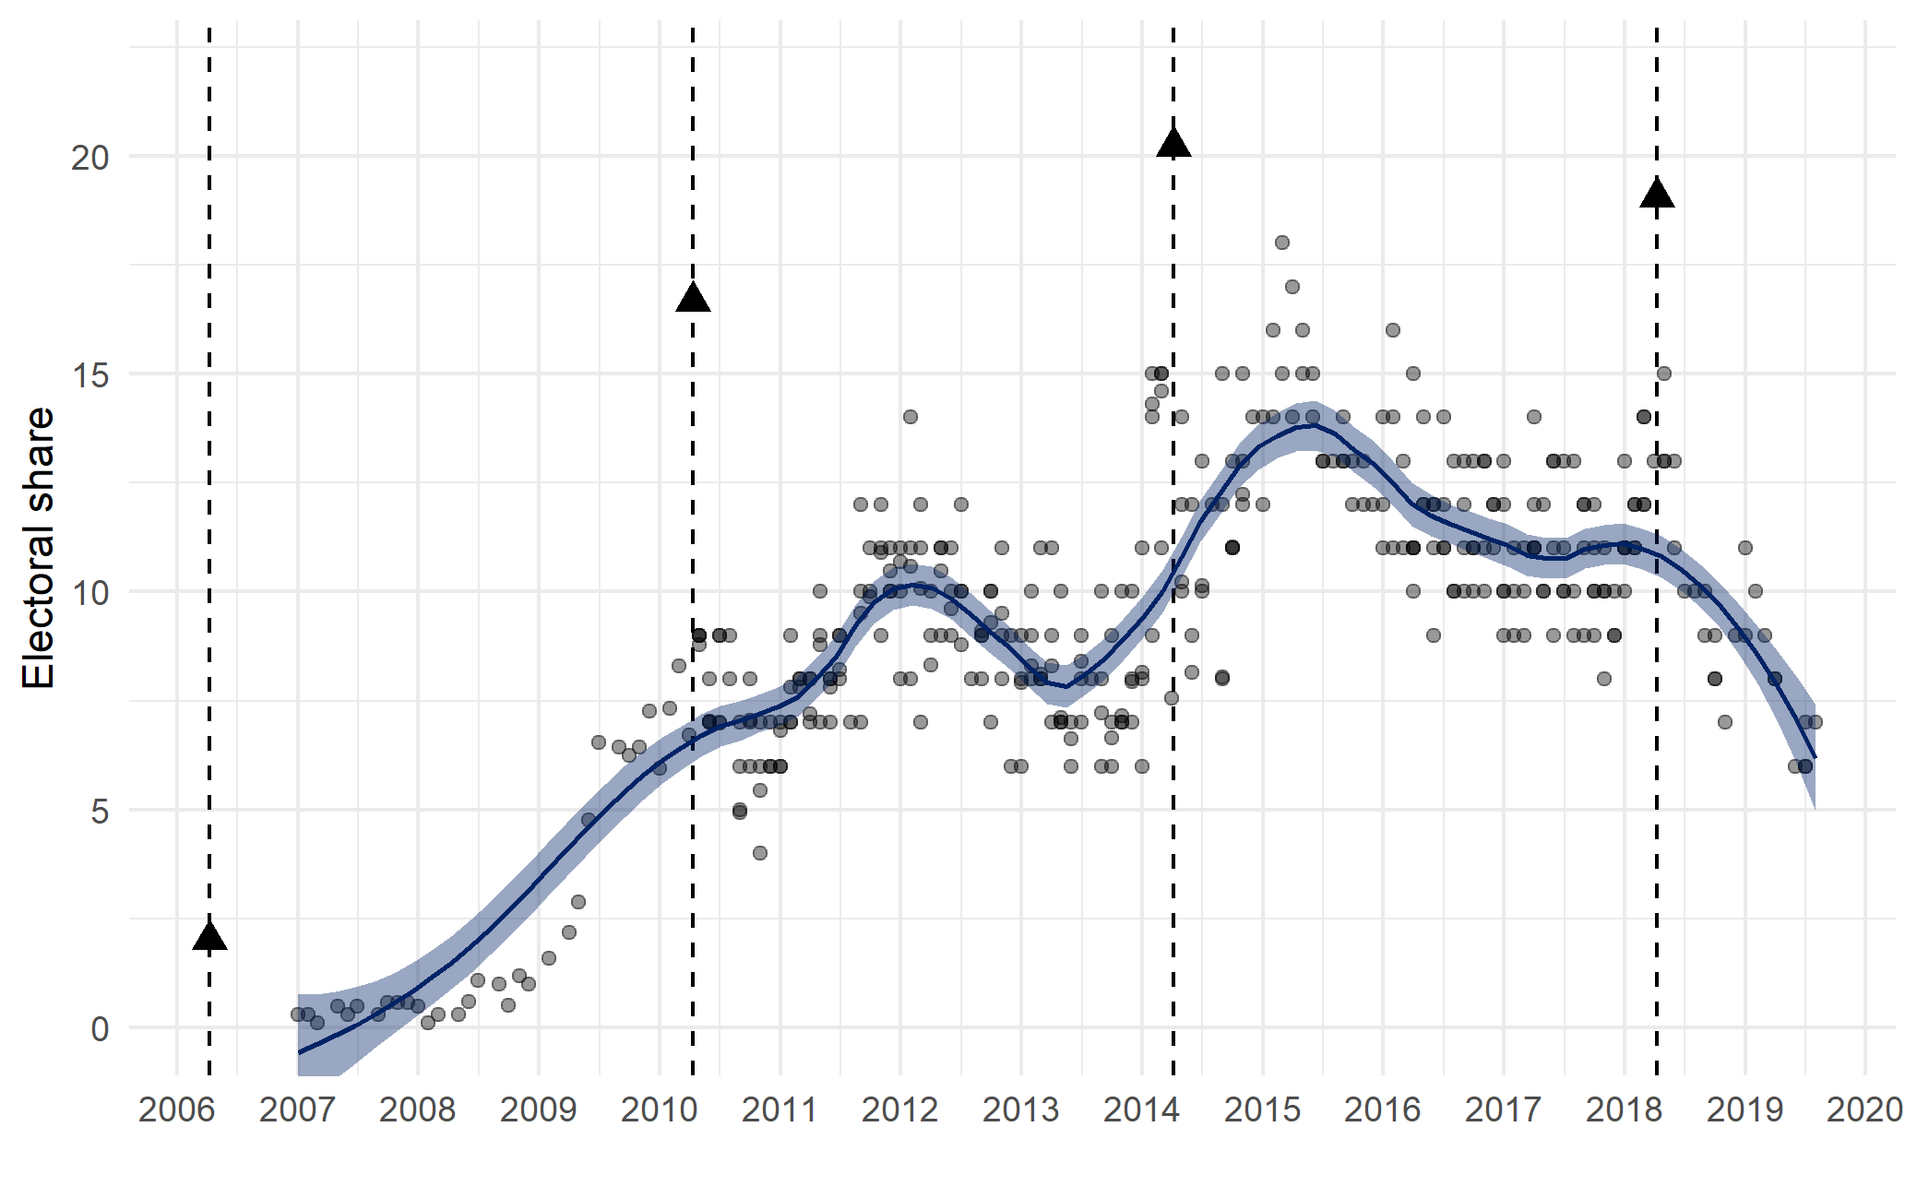
Note: The vertical reference lines show the four national parliamentary elections Jobbik contested (in 2006 in a coalition with MIÉP), the triangles show the vote share the party achieved.

Appendix C: Content based transformation of nativism and populism
Figure 1: Over time prevalence of the most prevalent keywords associated with anti-Roma and anti-immigration mobilization
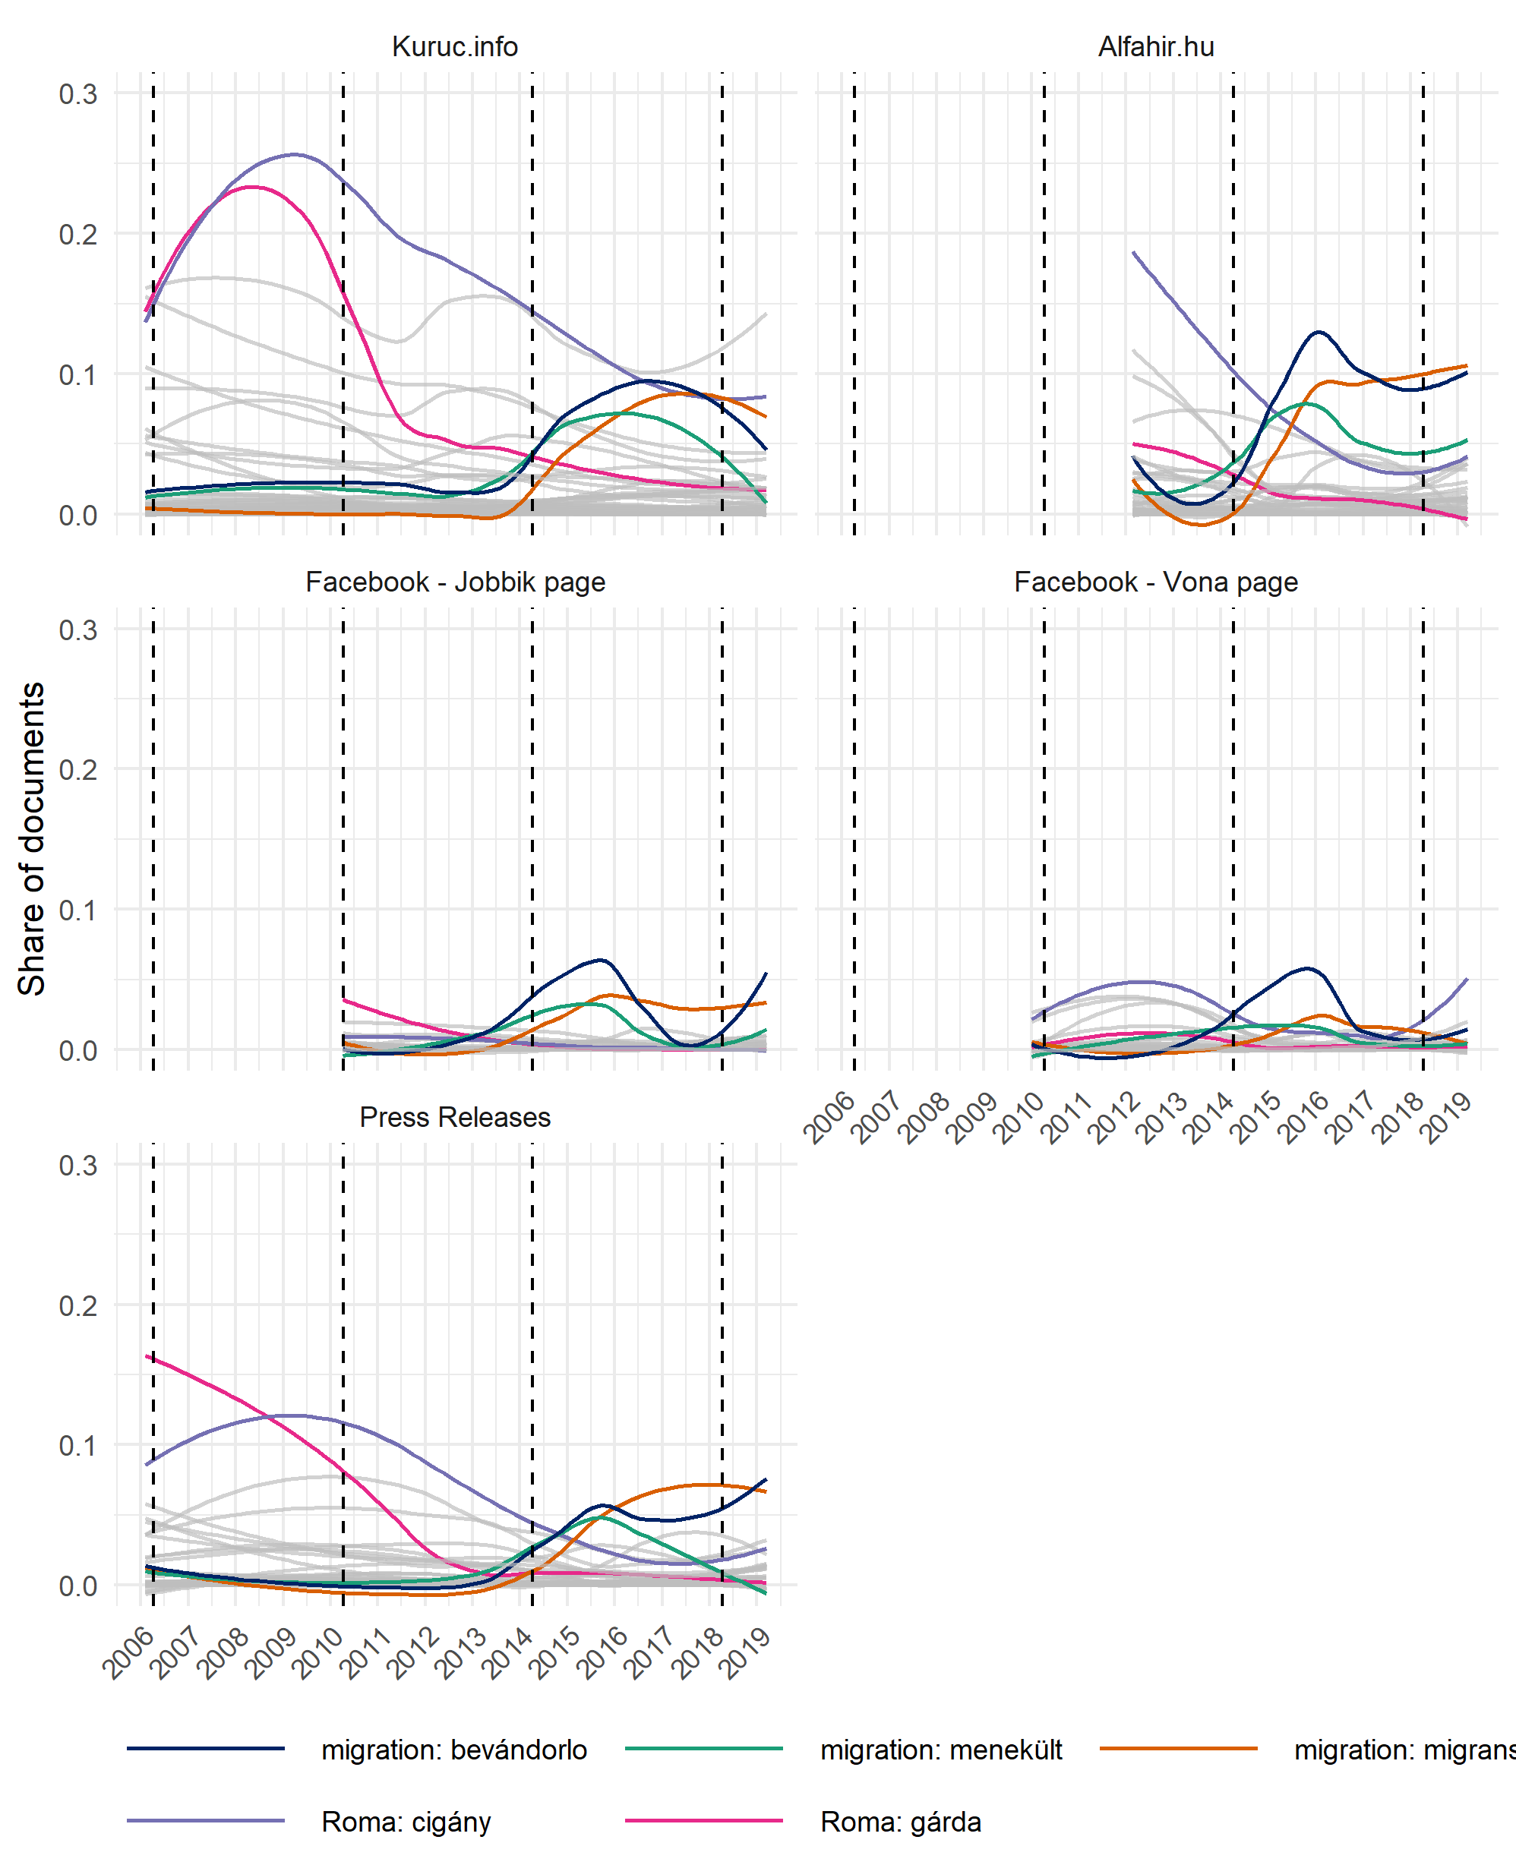
Note: The coloured line represents the LOESS smoother we apply on all documents within a corpus. The dashed vertical reference lines represent the dates of the national parliamentary elections.
Figure 2: Over time prevalence of documents classified as having a people centrist or an anti-establishment appeal
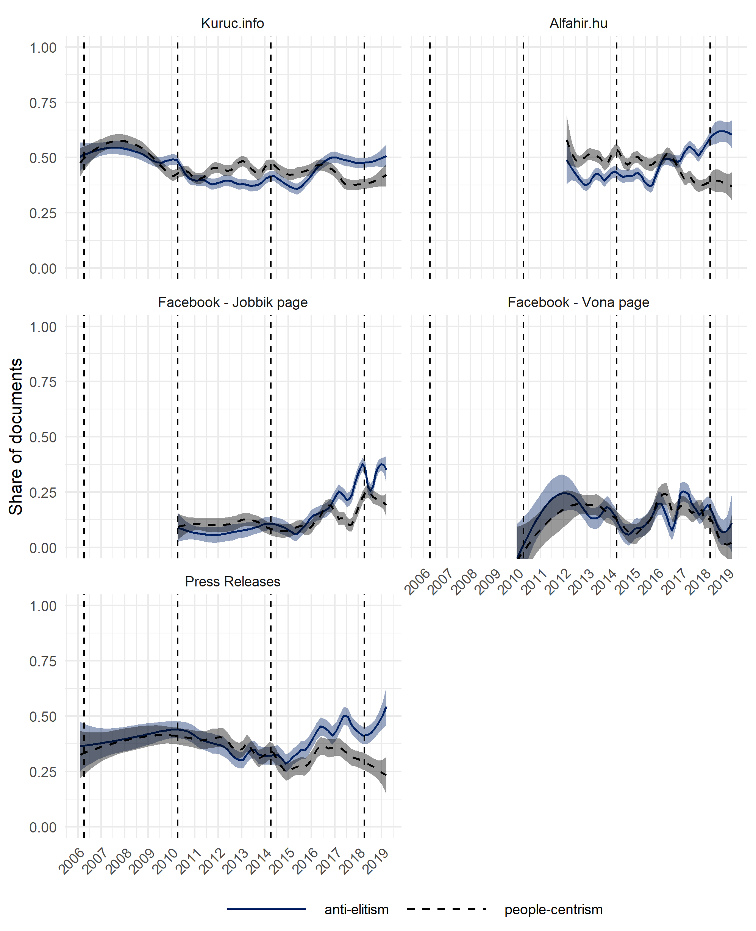
Note: The coloured line represents the LOESS smoother we apply on all documents within a corpus and its associated 95 percent confidence interval. The dashed vertical reference lines represent the dates of the national parliamentary elections.

Appendix D: Distribution of documents classified with a proportional measure
Figure 1: Documents with a nativist and populist appeal on the different platforms 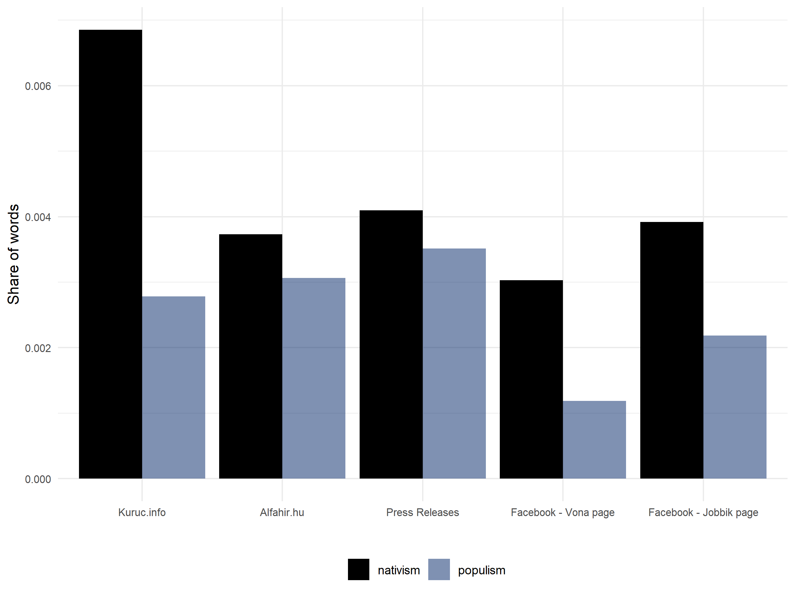

Figure 2: The share of documents over time with a populist or nativist appeal on the different platforms
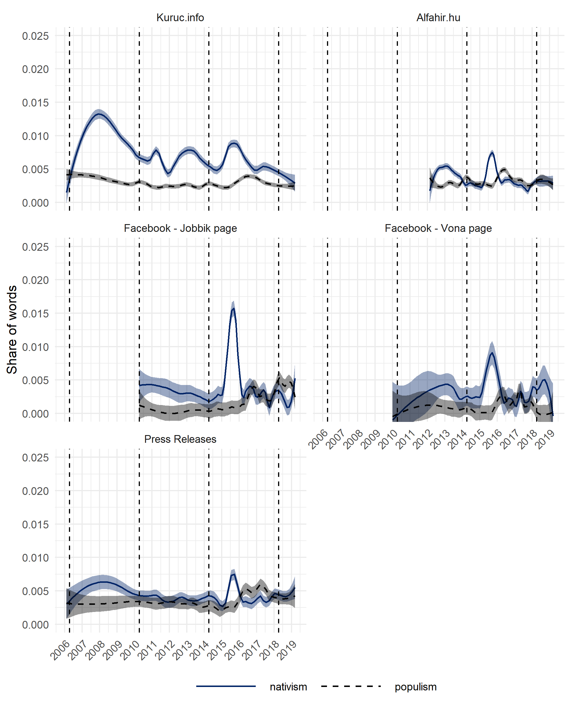
Note: The coloured line represents the LOESS smoother we apply on all documents within a corpus and its associated 95 percent confidence interval. The dashed vertical reference lines represent the dates of the national parliamentary elections.

