Appendix – Threat or Corrective? Assessing the impact of populist parties in government on qualities of democracy: a 19 countries comparison

Table 1A – Exclusionary and inclusionary populist parties included in the dataset. Exclusionary parties are those classified as far right according to Roodujin et al. (2019); inclusionary parties are those classified as far left according to Roodujin et al. (2019), the only exception being SMER, which is considered here as an inclusionary populist party. Source: own elaboration from Roodujin et al. (2019).
Country | Party | Populist | Exclusionary | Inclusionary | Other
Austria | FPÖ | 1 | 1 | 0 | 0
Austria | TS | 1 | 0 | 0 | 1
Austria | BZÖ | 1 | 1 | 0 | 0
Austria | Martin | 1 | 0 | 0 | 1
Belgium | VB | 1 | 1 | 0 | 0
Belgium | LDD | 1 | 0 | 0 | 1
Belgium | FN | 1 | 1 | 0 | 0
Czech Republic | ANO2011 | 1 | 0 | 0 | 1
Czech Republic | Dawn | 1 | 1 | 0 | 0
Czech Republic | SPD | 1 | 1 | 0 | 0
Czech Republic | S-JB | 1 | 0 | 0 | 1
Czech Republic | SPR-RSC | 1 | 1 | 0 | 0
Denmark | DF | 1 | 1 | 0 | 0
Denmark | FrP | 1 | 1 | 0 | 0
Finland | Ps | 1 | 1 | 0 | 0
Finland | SIN | 1 | 0 | 0 | 1
France | FN | 1 | 1 | 0 | 0
Germany | Linke | 1 | 0 | 1 | 0
Germany | AfD | 1 | 1 | 0 | 0
Greece | SYRIZA | 1 | 0 | 1 | 0
Greece | ANEL | 1 | 0 | 0 | 1
Greece | LAOS | 1 | 1 | 0 | 0
Hungary | FIDESZ | 1 | 1 | 0 | 0
Hungary | Jobbik | 1 | 1 | 0 | 0
Hungary | MIÉP | 1 | 1 | 0 | 0
Ireland | SF | 1 | 0 | 1 | 0
Italy | PdL | 1 | 0 | 0 | 1
Italy | LN | 1 | 1 | 0 | 0
Italy | M5S | 1 | 0 | 0 | 1
Italy | FdI | 1 | 1 | 0 | 0
Netherlands | PVV | 1 | 1 | 0 | 0
Netherlands | SP | 1 | 0 | 1 | 0
Netherlands | LPF | 1 | 1 | 0 | 0
Norway | FrP | 1 | 1 | 0 | 0
Poland | PiS | 1 | 1 | 0 | 0
Poland | Kukiz '15 | 1 | 1 | 0 | 0
Poland | LPR | 1 | 1 | 0 | 0
Poland | SRP | 1 | 0 | 0 | 1
Slovakia | Smer | 1 | 0 | 1 | 0
Slovakia | ANO | 1 | 0 | 0 | 1
Slovakia | SNS | 1 | 1 | 0 | 0
Slovakia | OLaNO | 1 | 0 | 0 | 1
Slovakia | SR | 1 | 1 | 0 | 0
Slovakia | PSNS | 1 | 1 | 0 | 0
Slovenia | ZdLe / L | 1 | 0 | 1 | 0
Spain | Podemos | 1 | 0 | 1 | 0
Sweden | SD | 1 | 1 | 0 | 0
United Kingdom | UKIP | 1 | 1 | 0 | 0

Region | Country | Party name | Party Type  (EPP, IPP, Other) | Role in the government | Years in government | Government main ideological orientation
Northern Europe | Denmark | Danish People’s Party | EPP | External Support | 2001 – 2011 in 4 different governments | Right Wing
 |  |  |  |  | 2015-2019 | Right Wing
Northern Europe | Finland | Finns Party | EPP | Junior Partner | 2015 – 17 | Right Wing
Northern Europe | Finland | Blue Reform | Splinter from EPP | Junior Partner | 2017 – 2019 | Right Wing
Northern Europe | Norway | Progress Party | EPP | Junior Partner | 2013 – 2020 in 4 different governments | Right Wing
Continental Europe | The Netherlands | Pim Fortuyn List | EPP | Junior Partner | 2002 – 2003 | Right Wing
Continental Europe | The Netherlands | Party for Freedom | EPP | External Support | 2010 – 2012 | Right Wing
Continental Europe | Austria | Freedom Party of Austria | EPP | Junior Partner | 1999 – 2005 in 2 different governments | Right Wing
 |  |  |  |  | 2017 – 2019 | Right Wing
Continental Europe | Austria | Alliance for the Future of Austria | EPP | Junior Partner | 2005 – 2006 | Right Wing
Southern Europe | Italy | Forward Italy | Other | Major Partner | 1994 – 95 | Right Wing
 |  |  |  | External Support | 1995-1996 | Technocratic
 |  |  |  | Major Partner | 2001 – 06 | Right Wing
 |  |  |  | Major Partner | 2008 – 11 | Right Wing
 |  |  |  | Major Partner | 2011 – 13 | Technocratic
 |  |  |  | Junior Partner | 2013-2013 | Grand Coalition
Southern Europe | Italy | (Northern) League | EPP | Junior Partner | 1994 – 95 | Right Wing
 |  |  |  | Junior Partner | 2001 –06 | Right Wing
 |  |  |  | Junior Partner | 2008 – 11 | Right Wing
 |  |  |  | Junior Partner | 2018 - 2019 | Populist
Southern Europe | Italy | Five Stars Movement | Other | Major Partner | 2018 – 2019 | Populist
 |  |  |  |  | 2019-2020 | Populist + centre-left
Southern Europe | Greece | LAOS | EPP | Junior Partner | 2011 – 2012 | Technocratic
Southern Europe | Greece | SYRIZA | IPP | Major Partner | Jan. – Sept. 2015 | Populist
 |  |  |  |  | 2015 – 2019
Southern Europe | Greece | ANEL | EPP | Junior Partner | Jan. – Sept. 2015 | Populist
 |  |  |  |  | Sept. 2015 – 2019
Visegrad countries | Poland | Law and Justice | EPP | Major Partner | 2005 – 2006 | Populist
 |  |  |  | Major Partner | 2015 – 2017 | Radical Right
 |  |  |  | Major Partner | 2017 – 2019 | Radical Right
Visegrad countries | Poland | Self-Defence of the Republic of Poland | Other | Junior Partner | 2001 – 2004 | Left-wing
 |  |  |  | Junior Partner | 2005 – 2006 | Populist
Visegrad countries | Poland | League of Polish Families | EPP | Junior Partner | 2005 – 2006 | Populist
 |  |  |  | Junior Partner | 2006 – 2007 | Populist
Visegrad countries | Hungary | Fidesz | EPP | Major Partner | 1998 – 2002 | Right Wing
 |  |  |  | Major Partner | 2010 – 2014 | Radical Right
 |  |  |  | Major Partner | 2014 – 2018 | Radical Right
 |  |  |  | Major Partner | 2018 – pres | Radical Right
Visegrad countries | Czech Republic | ANO 2011 | Other | Junior Partner | 2014 – 2017 | Centre-right
 |  |  |  | Major Partner | 2017 – 2018 | Centre-right
 |  |  |  | Major Partner | 2018 – pres | Centre-right
Visegrad countries | Czech Republic | Public Affairs | Other | Junior Partner | 2010 – 2013 | Centre-right
Visegrad countries | Slovakia | Smer | IPP | Major Partner | 2006 – 2010 | Left Wing
 |  |  |  | Major Partner | 2012 – 2016 | Left Wing
 |  |  |  | Major Partner | 2016 –pres | Left Wing
Visegrad countries | Slovakia | ANO | Other | Junior Partner | 1998 – 2002 | Centre-right
 |  |  |  | Junior Partner | 2002 – 2006 | Centre-right
Visegrad countries | Slovakia | SNS | EPP | Junior Partner | 1992–1994 | Right Wing
 |  |  |  | Junior Partner | 1994–1998 | Right Wing
Visegrad countries | Slovakia | Union of the Workers of Slovakia | IPP | Junior Partner | 1994–1998 | Right Wing
Table 2A – Populist parties in government (1991-2019). The definition of populist party is derived from the PopuList (Roodujin et al. 2019); for the classification of exclusionary, inclusionary or none, the categories “far right”, “far left” or none of the two is derived from the PopuList. The only exception is SMER, which is considered here as a IPP, even though it is not classified as “far left”. For the years in government column, I relied on ParlGov dataset (Döring and Manow 2019).

Coding procedure for structural breaks:
Attributing a structural break to either a populist or non-populist government is not a straightforward task, though, as this procedure might imply a certain degree of arbitrariness: here, the choice is to attribute a structural break to a populist government if the structural break occurs during the legislature in which populists are in governments, with the exception of the very last year of government, as the structural break occurs due to the change in the following year, when populist are excluded by the government. The only exception of this rule is when a country experiences two or more consecutive populist governments; in this case a structural break is not attributed to a populist in government only if it occurs in the very last year of government. Along the same lines, structural breaks are attributed to non-populist in government if they occur when non-populist parties are governments, with the exception of the last year of the legislature before they are replaced by a populist government; for two or more consecutive governments, I apply the same rules used for populists in government. Following Zeileis et al. (2003), I plot together the asymptotic boundaries and the corresponding significance test. The results for each indicator and for each country can be found in the Appendix (Figure from 1A to 10A). Rather than reporting the t-test for the significance, I include the plots of the test. In order to interpret correctly the plots, results over the top asymptotic boundary mean a negative structural break, results below the bottom asymptotic boundary mean a positive structural break. No significant structural breaks occur when the fluctuation is within the limit of the boundaries.

 |  | Pre crisis |  | Within-crisis
 |  | Positive | Negative | Positive | Negative
Representative government | Representative Government | Netherlands, UK, Finland, Sweden, Denmark, Slovakia, Portugal |  |  | Germany, Hungary, Greece
 | Power distributed by social group | UK | Austria | Belgium, Italy, Portugal | Netherlands, Ireland, Sweden, Norway, Greece
 | Representation of Disadvantaged Social Groups |  | UK, Denmark, Hungary, Slovakia | Belgium, France, Ireland, Greece | Hungary, Poland
Pluralism | Checks on Government | Belgium, France, Ireland, Slovakia, Italy |  | Netherlands, Italy | Finland, Denmark, Norway, Hungary, Czech Republic, Greece, Spain
 | Freedom of Expression | UK, Ireland, Slovakia | Italy |  | Netherlands, France, Austria, Denmark, Hungary, Poland, Czech Republic, Greece, Portugal
Participation | Civil Society Partecipation | UK, Finland, Sweden, Denmark, Slovakia |  | Czech Republic, Spain, Greece | Belgium, Germany, Hungary, Poland
Fundamental and Minority Rights | Fundamental Right | Czech Republic, Spain | Hungary | Italy, Greece | Sweden, Denmark, Norway, Hungary
 | Civil Liberties | UK, Ireland, Slovakia |  |  | Netherlands, Belgium, France, Germany, Austria, Finland, Denmark, Norway, Hungary, Poland, Czech Republic, Italy, Greece, Spain, Portugal
 | Social Group Equality | Germany, Slovakia | Austria, Netherlands |  | Belgium, Finland, Sweden, Denmark, Norway, Hungary, Spain, Portugal
 | Social Group Equality in respect for civil liberties | Germany, Slovakia |  |  | Austria, Belgium, Finland, Hungary, Poland, Czech Republic, Spain
Table 3A – Negative and positive structural breaks for 10 different indicators. Source: own elaboration from GsoD data.
Legend: countries in bold indicate that populist parties were in government where in government the year after the structural break occurred.

Figure from 1A to 10A Structural breaks – plots per country and democratic dimensions (alphabetic order)
Figure 1A - Checks on Government

- Northern Europe
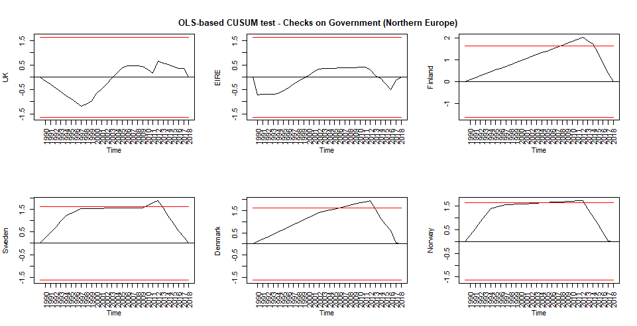
- Continental Europe
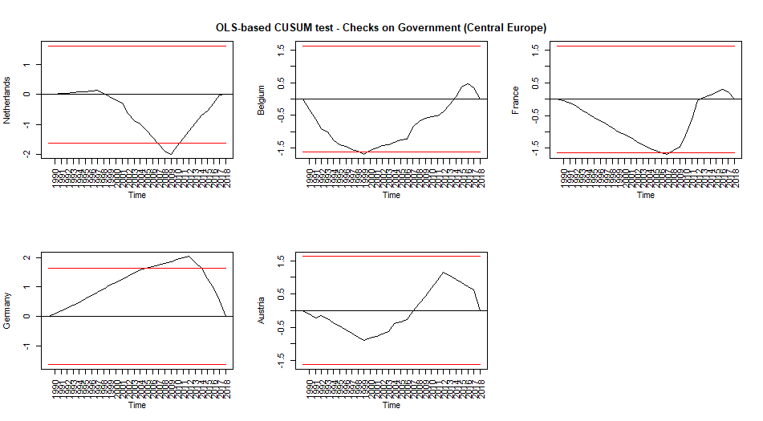
- Southern Europe
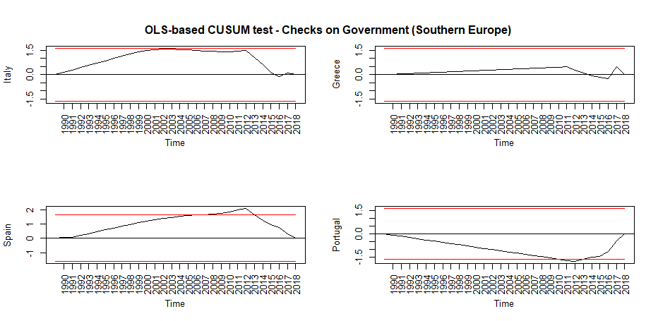
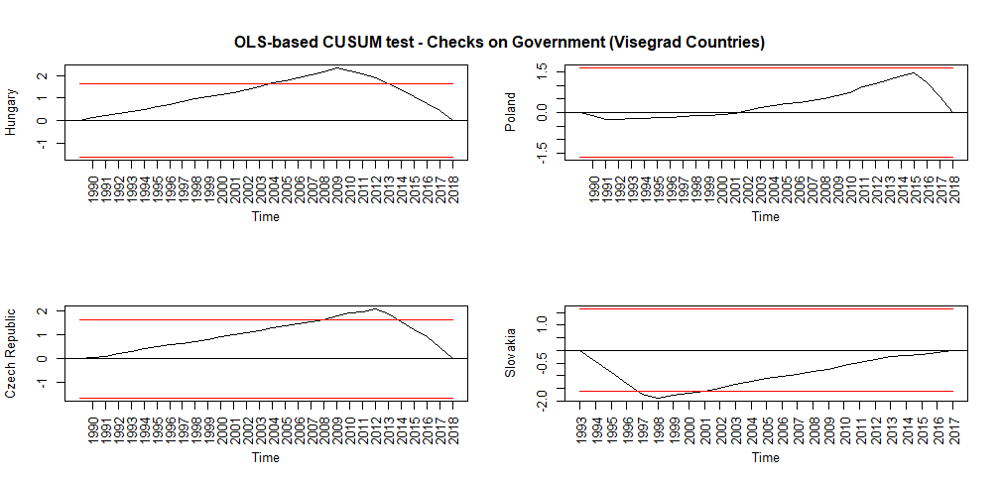
- Visegrad countries

Figure 2A - Civil liberties

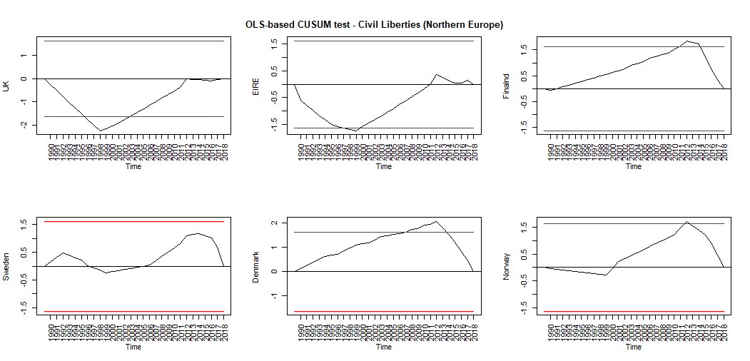
- Northern Europe

- Continental Europe
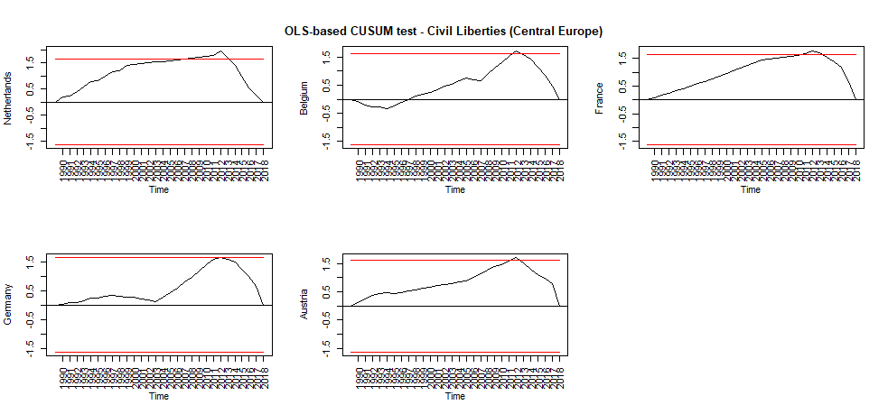
- Southern Europe
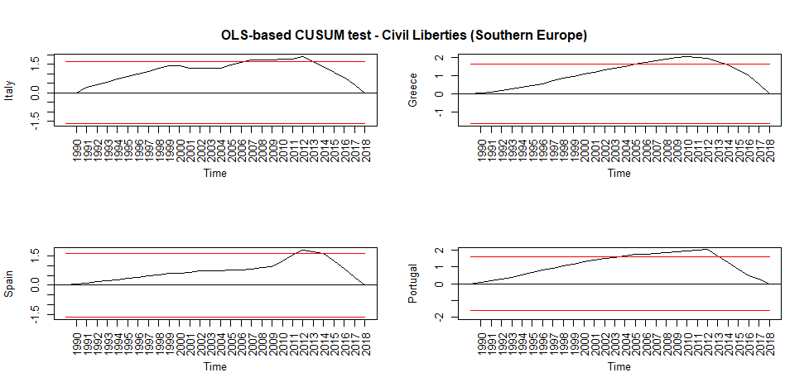
- Visegrad countries
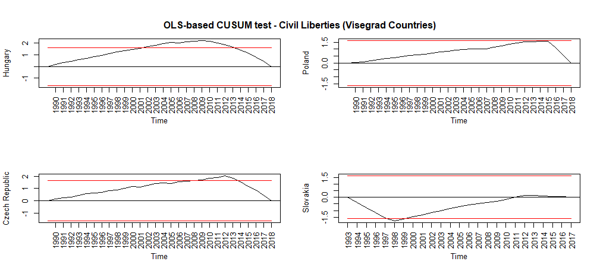

Figure 13A - Civil Society Participation

- Northern Europe
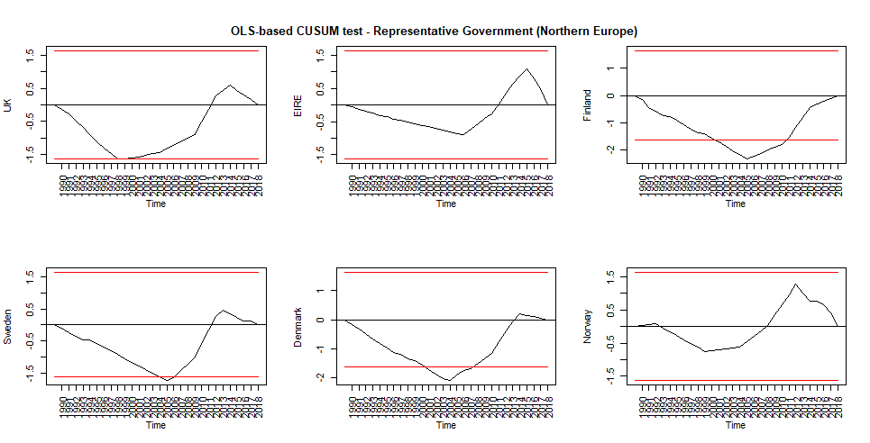
- Continental Europe

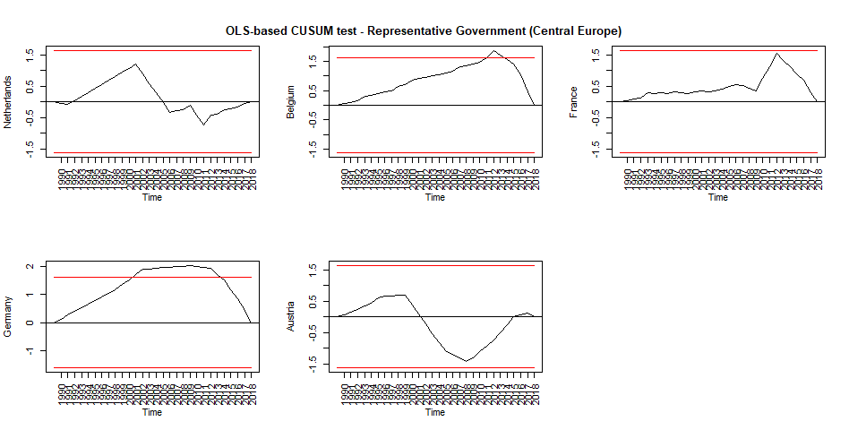
- Southern Europe
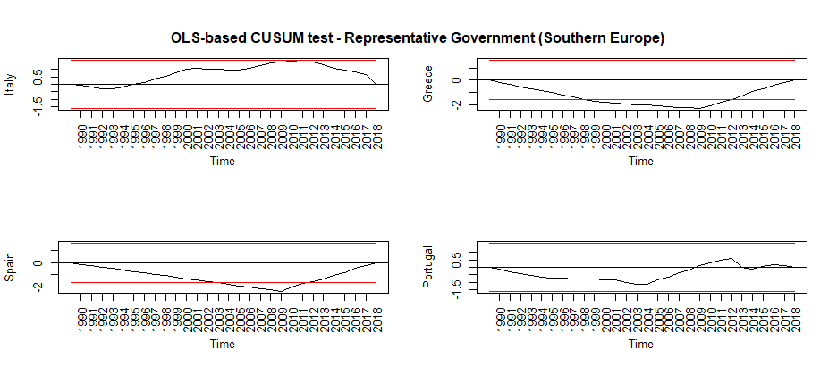
- Visegrad countries
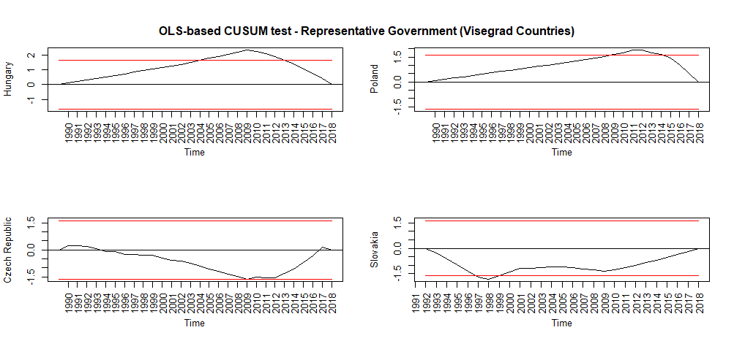

Figure 4A - Freedom of expression

- Northern Europe
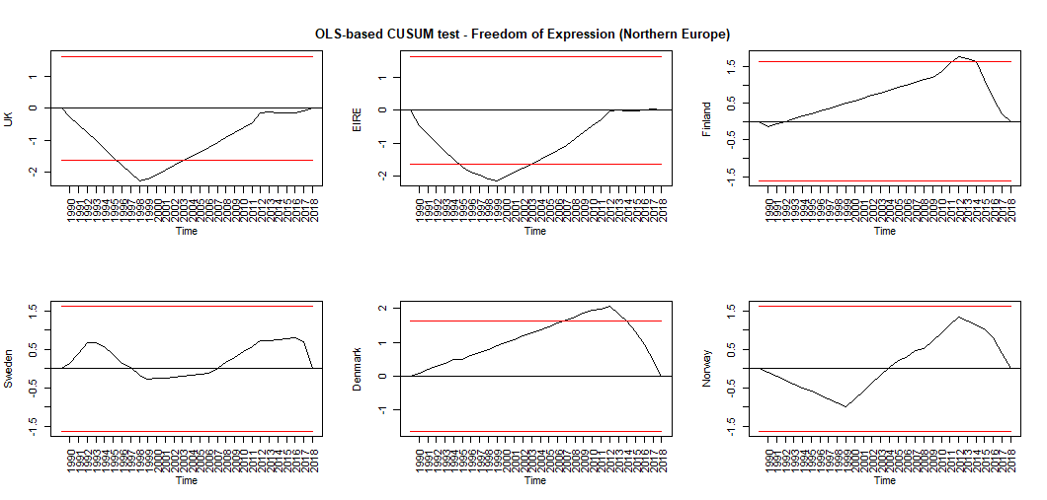
- Continental Europe
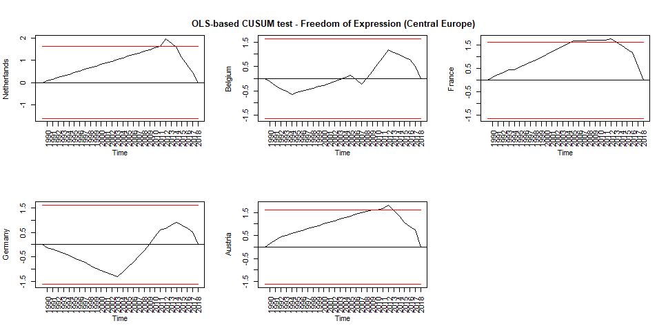
- Southern Europe
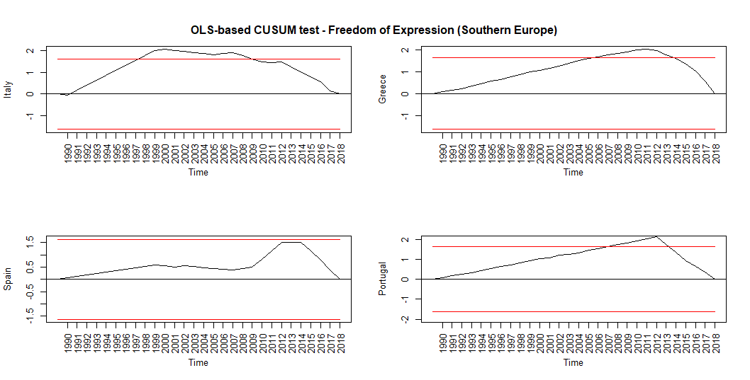
- Visegrad countries
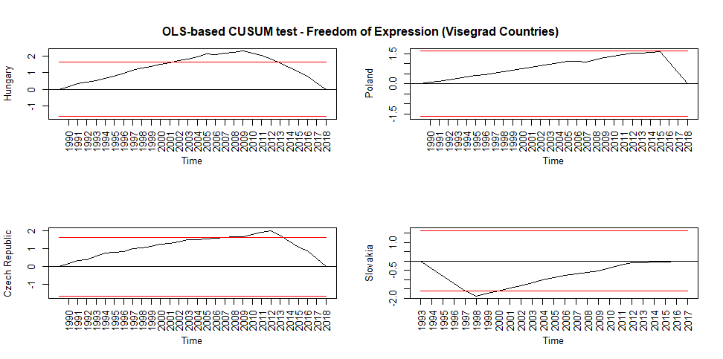

Figure 5A - Fundamental rights

- Northern Europe
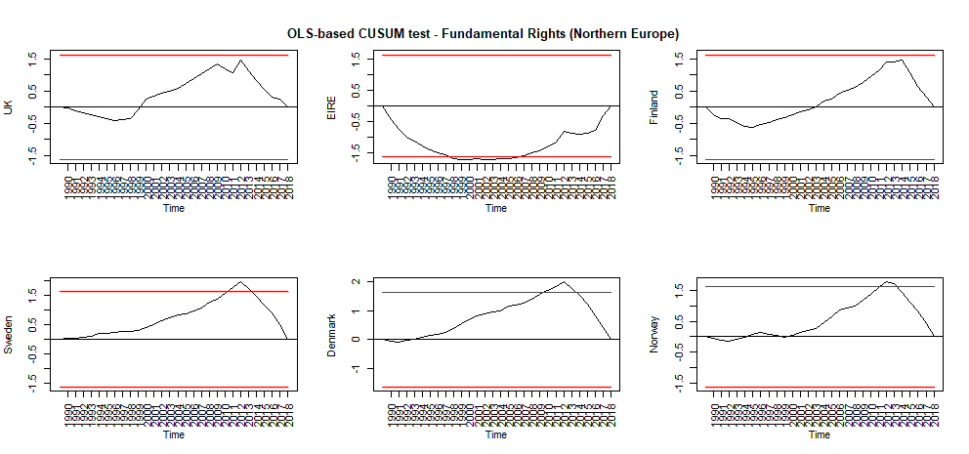
- Continental Europe
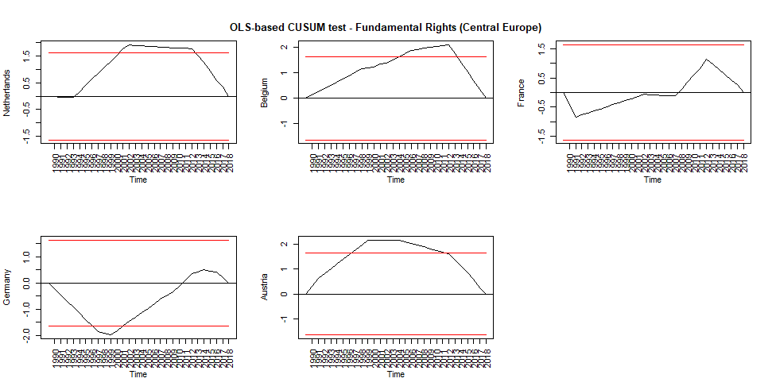
- Southern Europe
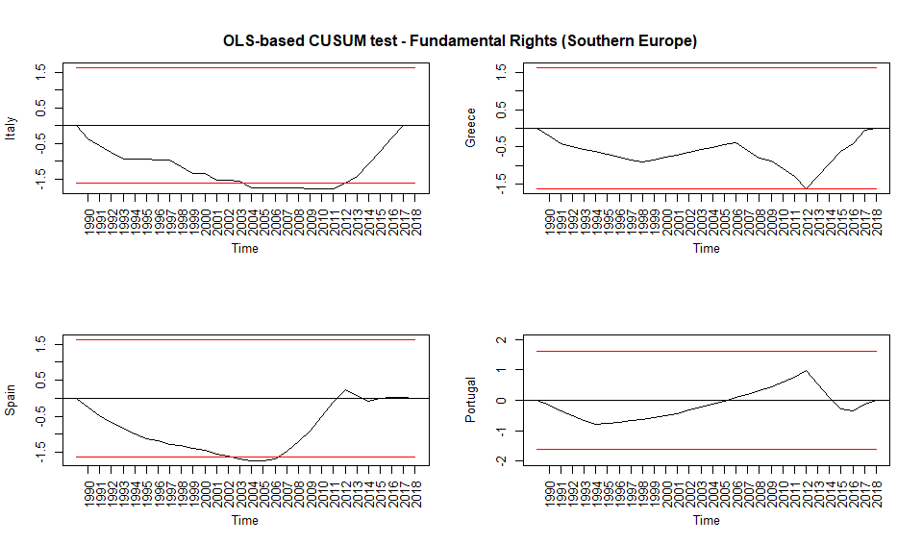
- Visegrad countries
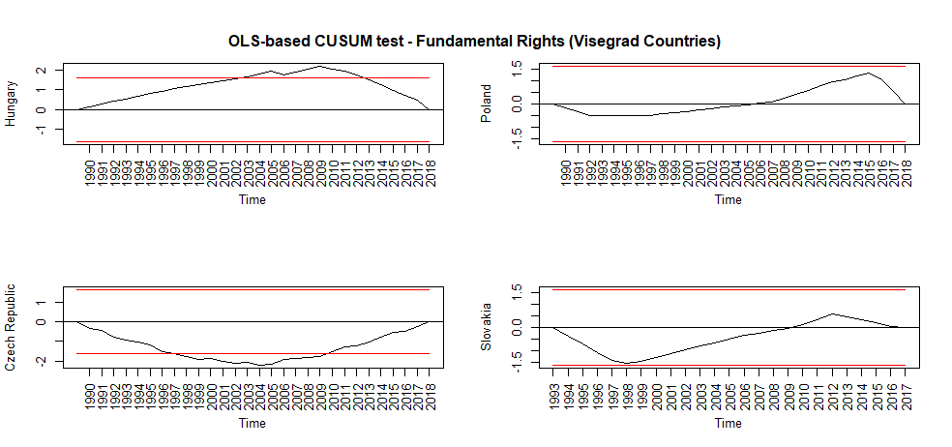

Figure 6A - Power distributed by social group

- Northern Europe
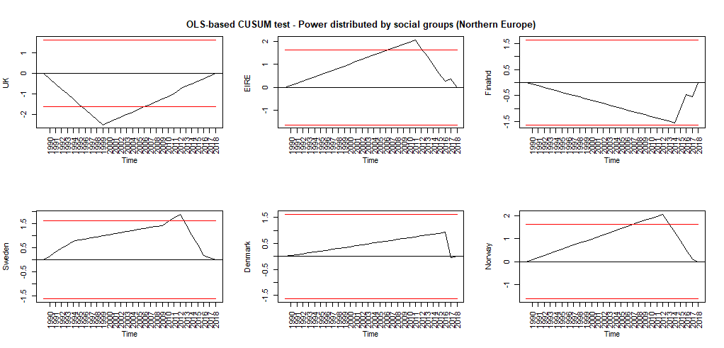
- Continental Europe
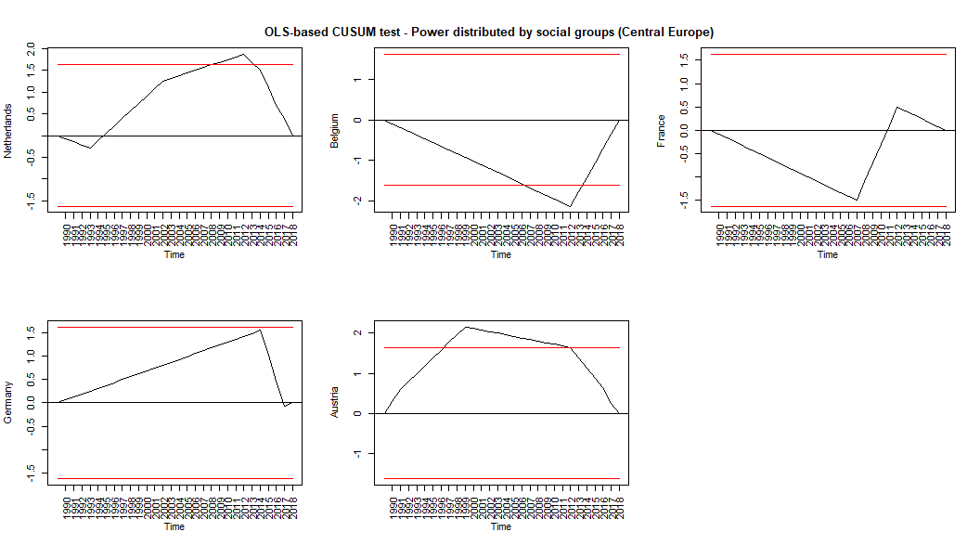
- Southern Europe
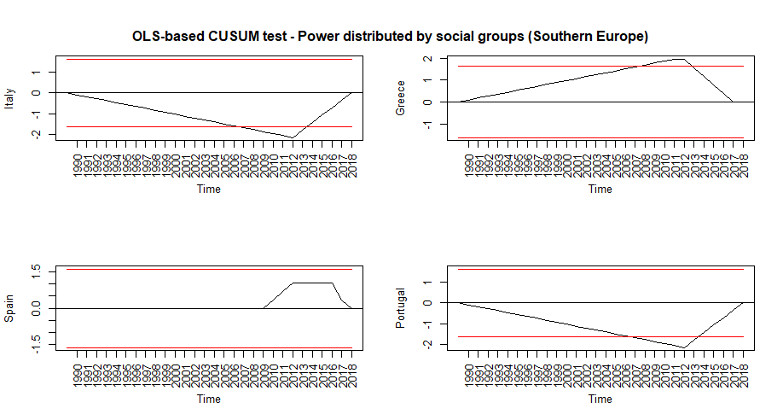
- Visegrad countries
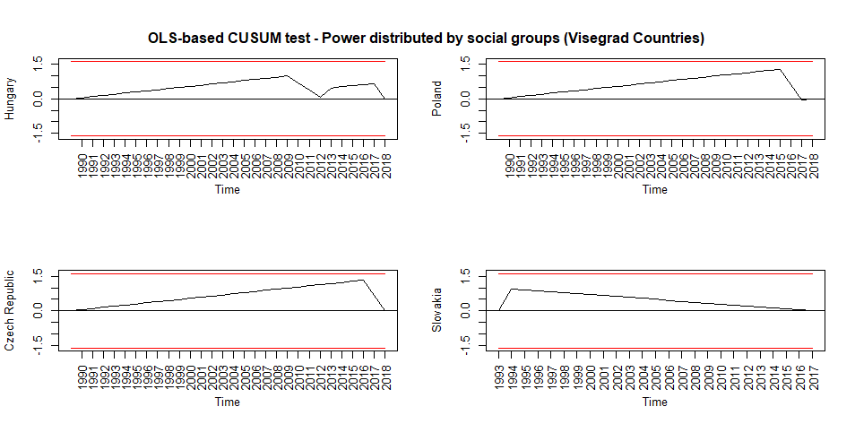

Figure 7A - Representation of Disadvantaged Social Groups

- Northern Europe
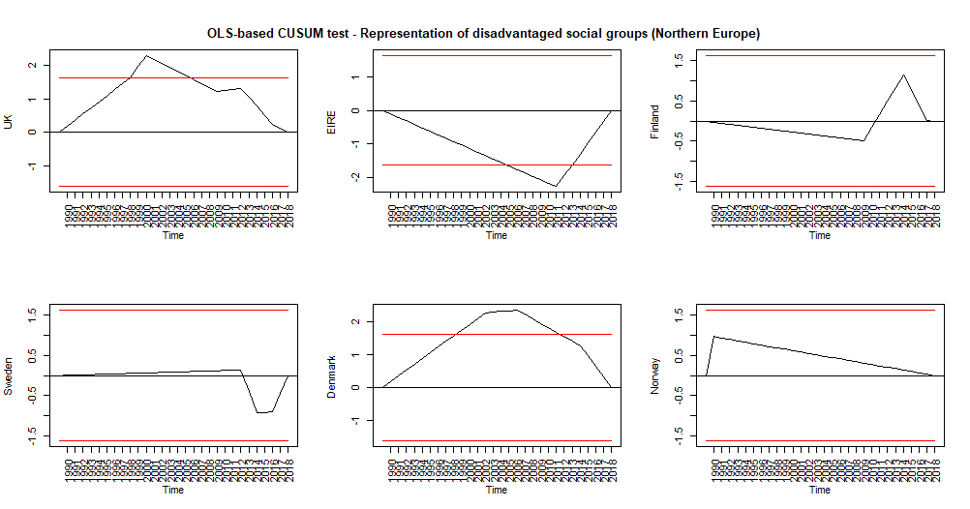
- Continental Europe
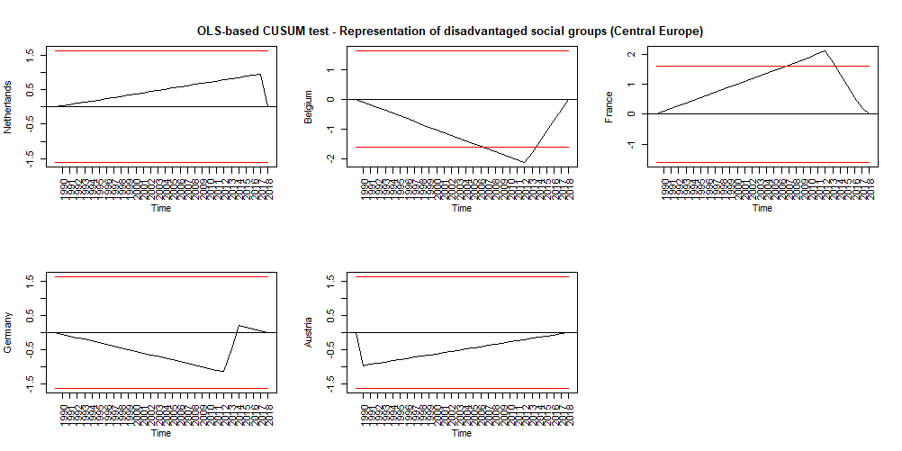
- Southern Europe
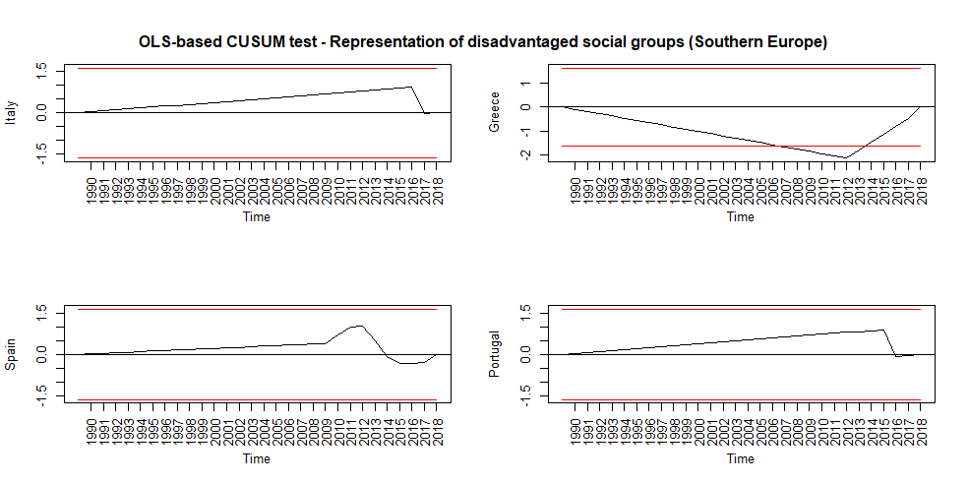
- Visegrad countries

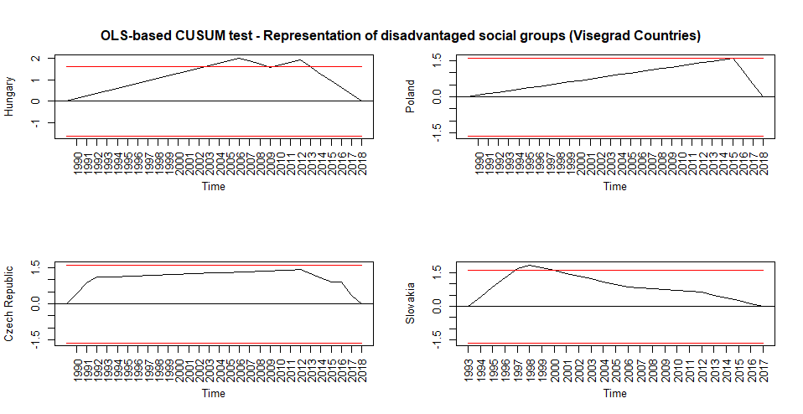

Figure 8A - Representative Government

- Northern Europe
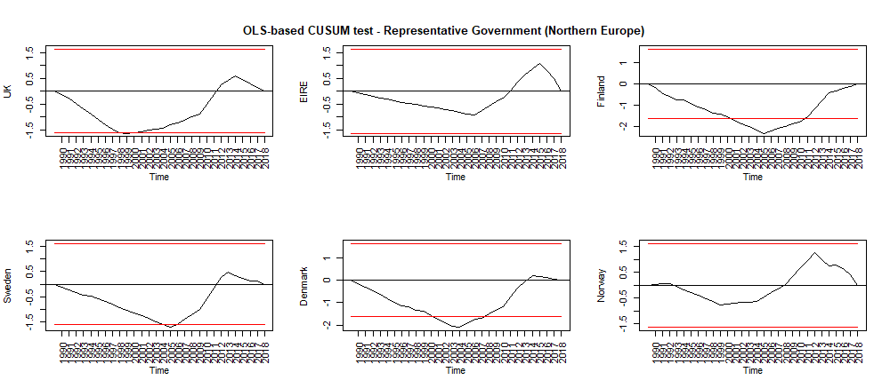
b) Continental Europe
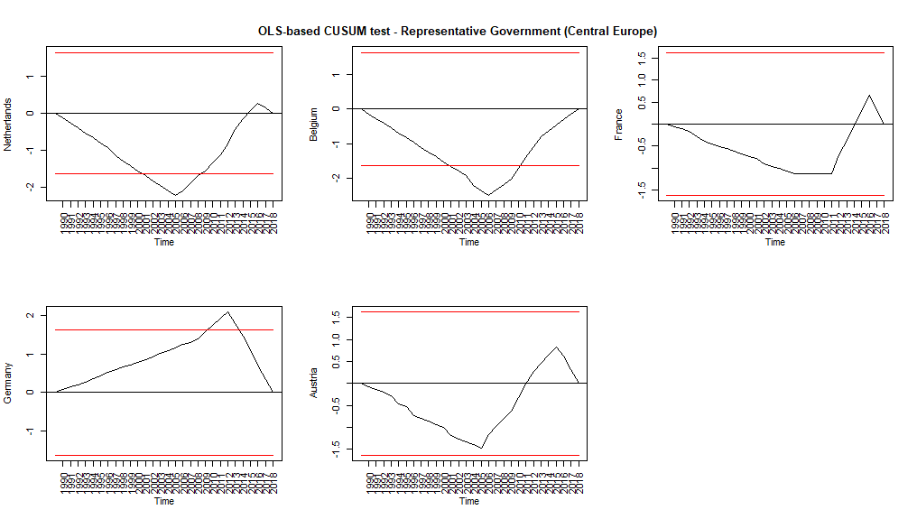
c) Southern Europe
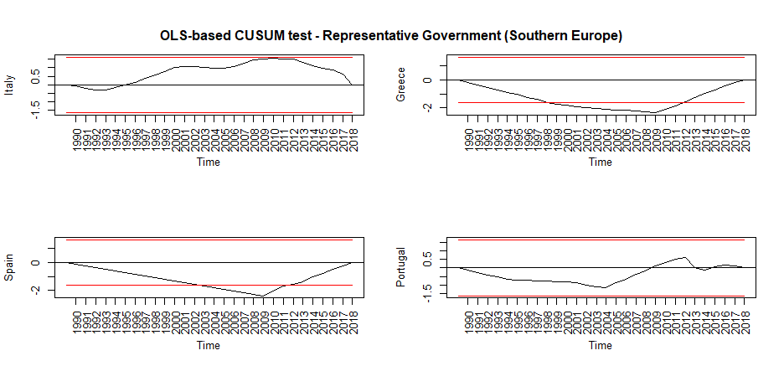
d) Visegrad countries
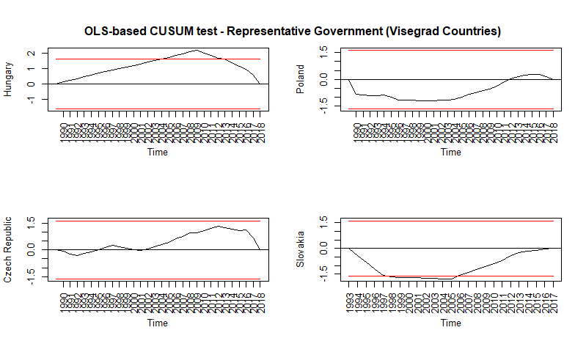

Figure 9A - Social group equality
- Northern Europe
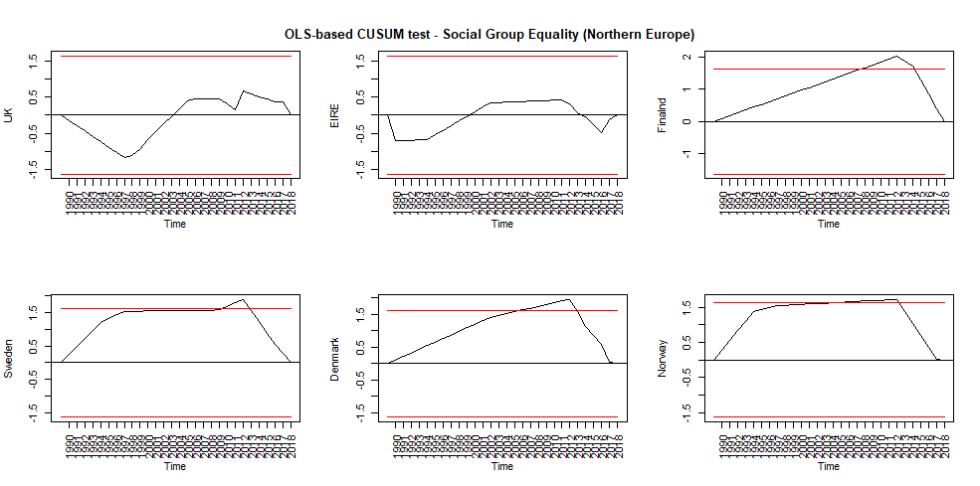

- Continental Europe
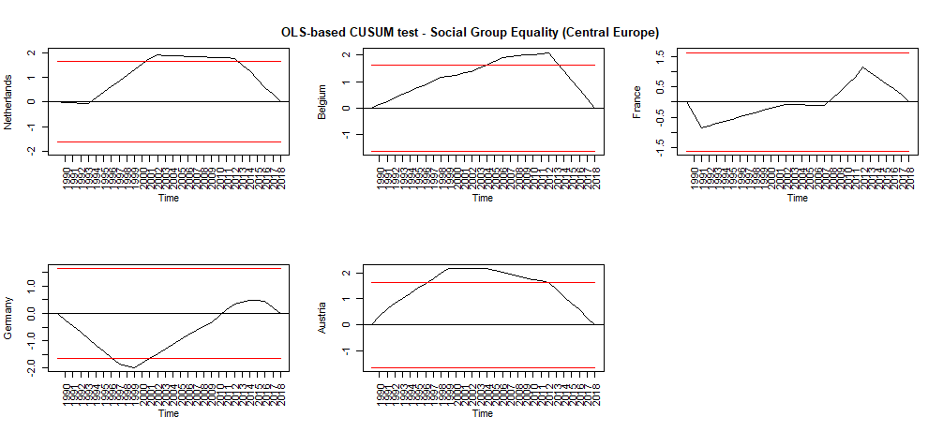
- Southern Europe
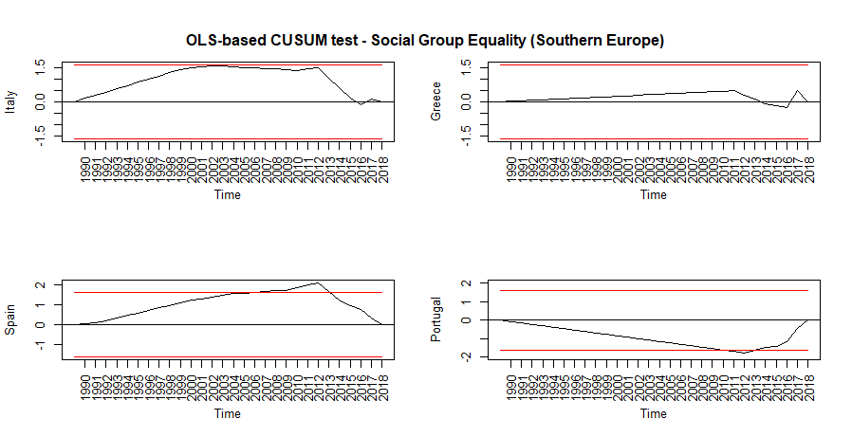
- Visegrad countries
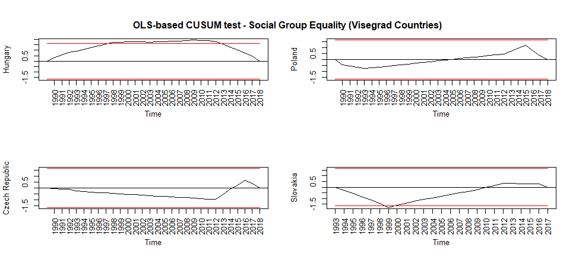

Figure 10A - Social group equality with regard to civil liberties

- Northern Europe
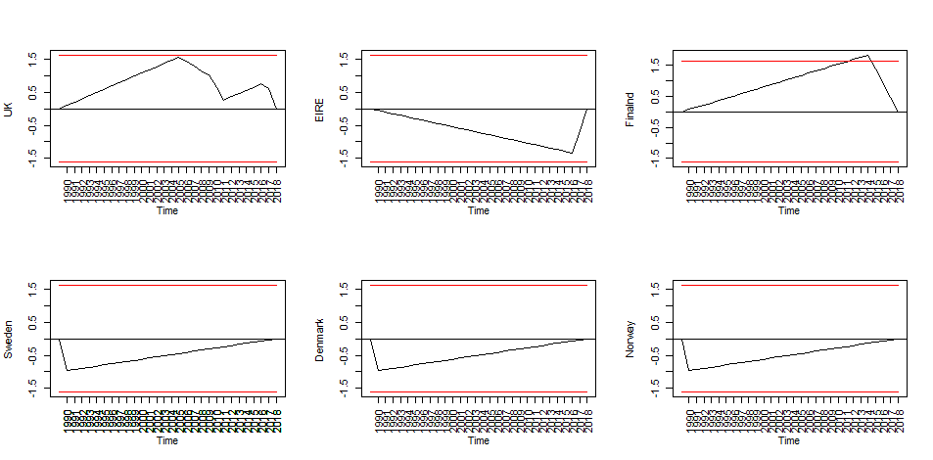
- Continental Europe
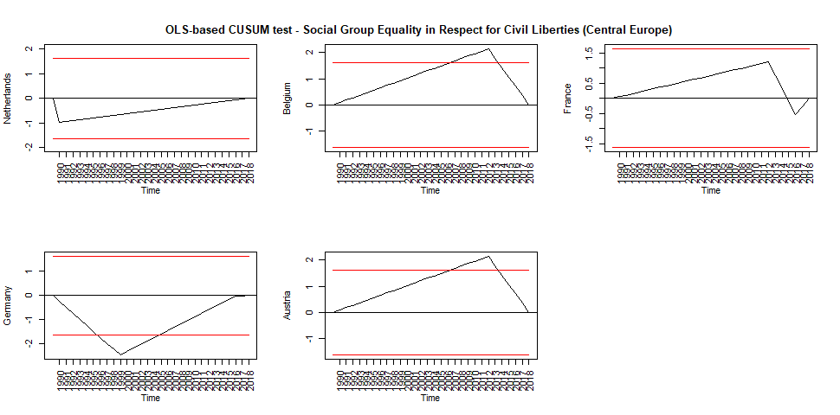
- Southern Europe
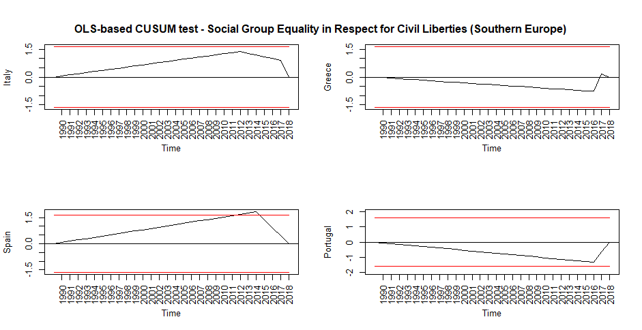
- Visegrad countries

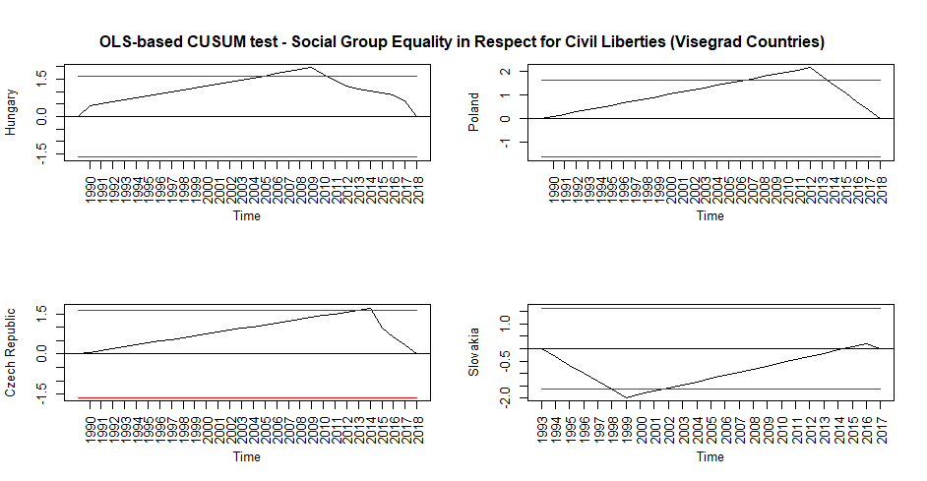

Table 4A – Role of populist parties in government. Panel regression models for ten democratic qualities.
 | Dependent variable:
 | Political representation |  |  | Pluralism and participation |  |  | Minority rights protection
 | Repres. government | Pow. Soc. Gr | Rep. dis. soc. gr. | Check on Gvt | Freedom Express | Civil soc. part. | Fundam. Rights | Civil liberties | Soc. gr. equality | Soc. gr. equality civ. lib.
Role - External, ref. None | 0.002 | 0.009 | -0.045** | -0.005 | -0.008 | -0.003 | -0.008 | -0.007 | -0.001 | 0.015
 | (0.009) | (0.020) | (0.018) | (0.010) | (0.013) | (0.011) | (0.006) | (0.011) | (0.011) | (0.016)
Role - Junior, ref. None | -0.018*** | -0.014 | 0.0003 | -0.038*** | -0.034*** | -0.036*** | -0.016*** | -0.032*** | -0.027*** | -0.034***
 | (0.005) | (0.011) | (0.010) | (0.006) | (0.007) | (0.006) | (0.004) | (0.006) | (0.006) | (0.009)
Role - Major, ref. None | -0.011* | -0.057*** | 0.008 | -0.054*** | -0.061*** | -0.033*** | -0.022*** | -0.048*** | -0.015** | -0.012
 | (0.006) | (0.013) | (0.012) | (0.006) | (0.008) | (0.007) | (0.004) | (0.007) | (0.007) | (0.010)
ENEP | -0.002* | -0.014*** | -0.003 | -0.005*** | 0.001 | 0.008*** | -0.00005 | -0.001 | -0.002 | 0.003
 | (0.001) | (0.003) | (0.002) | (0.001) | (0.002) | (0.002) | (0.001) | (0.001) | (0.001) | (0.002)
GDP per capita | 0.039*** | 0.010 | 0.002 | 0.012** | 0.013 | -0.005 | 0.001 | 0.008 | -0.031*** | -0.033***
 | (0.006) | (0.012) | (0.011) | (0.006) | (0.008) | (0.007) | (0.004) | (0.006) | (0.006) | (0.010)
Unemployment | 0.019*** | -0.032*** | 0.024*** | 0.021*** | 0.006 | 0.031*** | 0.008*** | 0.007 | 0.008 | 0.005
 | (0.004) | (0.009) | (0.008) | (0.004) | (0.006) | (0.005) | (0.003) | (0.005) | (0.005) | (0.007)
Party institution. | 0.171*** | 0.119 | -0.280*** | 0.220*** | 0.250*** | 0.082* | 0.010 | 0.196*** | 0.060 | 0.183***
 | (0.038) | (0.080) | (0.073) | (0.040) | (0.053) | (0.045) | (0.026) | (0.043) | (0.043) | (0.065)
Age of democracy | -0.038*** | -0.033* | -0.056*** | -0.023*** | -0.042*** | 0.011 | 0.004 | -0.036*** | 0.021** | 0.030**
 | (0.009) | (0.018) | (0.016) | (0.009) | (0.012) | (0.010) | (0.006) | (0.010) | (0.010) | (0.014)
Observations | 494 | 494 | 494 | 494 | 494 | 494 | 494 | 494 | 494 | 494
R² | 0.182 | 0.141 | 0.210 | 0.306 | 0.221 | 0.232 | 0.104 | 0.228 | 0.119 | 0.096
Adjusted R² | 0.136 | 0.093 | 0.166 | 0.267 | 0.177 | 0.190 | 0.055 | 0.185 | 0.070 | 0.045
F Statistic (df = 8; 467) | 12.948*** | 9.589*** | 15.488*** | 25.704*** | 16.540*** | 17.673*** | 6.808*** | 17.255*** | 7.862*** | 6.183***
Note: | *p**p***p<0.01

Table 5A – Types of populist parties in government. Panel regression models for ten democratic qualities.

 | Dependent variable:
 | Political representation |  |  | Pluralism and participation |  |  | Minority rights protection
 | Repres. government | Pow. Soc. Gr | Rep. dis. soc. gr. | Check on Gvt | Freedom Express | Civil soc. part. | Fundam. Rights | Civil liberties | Soc. gr. equality | Soc. gr. equality civ. lib.
Type: Inclus. v. EPP | 0.027*** | -0.059*** | 0.057*** | 0.029*** | 0.009 | 0.049*** | 0.016** | 0.008 | 0.024** | 0.037**
 | (0.009) | (0.020) | (0.018) | (0.010) | (0.013) | (0.011) | (0.006) | (0.011) | (0.010) | (0.016)
Type: Other v. EPP | 0.031*** | -0.014 | 0.005 | 0.005 | 0.036*** | 0.072*** | 0.028*** | 0.037*** | 0.052*** | 0.040**
 | (0.010) | (0.020) | (0.019) | (0.010) | (0.013) | (0.011) | (0.007) | (0.011) | (0.011) | (0.017)
Type: None v. EPP | 0.019*** | 0.020** | 0.011 | 0.040*** | 0.050*** | 0.045*** | 0.023*** | 0.044*** | 0.029*** | 0.029***
 | (0.004) | (0.009) | (0.009) | (0.005) | (0.006) | (0.005) | (0.003) | (0.005) | (0.005) | (0.008)
ENEP | -0.002** | -0.013*** | -0.003 | -0.004*** | 0.002 | 0.007*** | -0.0003 | 0.0001 | -0.002 | 0.003
 | (0.001) | (0.003) | (0.002) | (0.001) | (0.002) | (0.001) | (0.001) | (0.001) | (0.001) | (0.002)
GDP per capita | 0.042*** | 0.014 | -0.001 | 0.020*** | 0.014* | 0.002 | 0.004 | 0.008 | -0.028*** | -0.031***
 | (0.006) | (0.012) | (0.011) | (0.006) | (0.008) | (0.006) | (0.004) | (0.006) | (0.006) | (0.009)
Unemployment | 0.020*** | -0.015** | 0.015* | 0.023*** | 0.002 | 0.034*** | 0.010*** | 0.003 | 0.009** | 0.004
 | (0.004) | (0.007) | (0.008) | (0.004) | (0.004) | (0.005) | (0.003) | (0.003) | (0.005) | (0.006)
Party institutional. | 0.192*** | 0.118 | -0.314*** | 0.235*** | 0.234*** | 0.129*** | 0.028 | 0.192*** | 0.096** | 0.187***
 | (0.038) | (0.079) | (0.074) | (0.040) | (0.051) | (0.043) | (0.026) | (0.043) | (0.042) | (0.065)
Age of democracy | -0.047*** | -0.030* | -0.053*** | -0.040*** | -0.041*** | -0.010 | -0.006 | -0.035*** | 0.012 | 0.029**
 | (0.008) | (0.016) | (0.016) | (0.009) | (0.010) | (0.009) | (0.006) | (0.009) | (0.009) | (0.014)
Observations | 494 | 494 | 494 | 494 | 494 | 494 | 494 | 494 | 494 | 494
R² | 0.202 | 0.117 | 0.196 | 0.284 | 0.187 | 0.306 | 0.138 | 0.204 | 0.156 | 0.100
Adjusted R² | 0.158 | 0.103 | 0.183 | 0.244 | 0.173 | 0.267 | 0.090 | 0.191 | 0.109 | 0.085
F Statistic (df = 8; 467) | 14.821*** | 64.549*** | 118.128*** | 23.105*** | 111.403*** | 25.738*** | 9.317*** | 124.165*** | 10.761*** | 53.711***
Note: | *p<0.1, ** p<0.05, ***p<0.01

It is assumed here that populist parties do not change their thin-centred ideology during the time span; in particular the case of PiS, Fidesz and Forza Italia are bordering cases, as the three parties were not consistently populist throughout the three decades under consideration.

