Does Learning About Protest Abroad Inform Individuals’ Attitudes About Protest at Home? Experimental Evidence from Egypt

Government and Opposition Manuscript No. GOV-20-05-79.R1

Appendix

This appendix presents information relevant to interpreting the results of the experimental manipulation as reported in the body of the paper. After discussing the sample structure, we show the primes as they appeared to the respondents. We then present demographic balance tests, as well as regression results (as compared to the t-tests in the paper). A final section discusses the results of a power analysis.
Sample Structure
In both experiments, recruitment was conducted by an advertisement hung on one of the university’s billboards as well as by an email sent to students inviting them to participate. Due to reasons that have to do with formal approvals, we were only able to recruit from the departments of economics, statistics and political science. All students were 18 years of age or older. After students signed up for the experiment, they were randomly assigned to any of the designed treatments. Random assignment was done by z-tree (which is also the software on which the experiment was programmed). In each treatment, students first had to answer questions on demographics, methods and frequency of news consumption and political attitudes before the different treatments were introduced depending on the treatment.
In line with the lab's prior practice, each subject was paid a modest stipend for completing the survey (around $4.00), as well as an additional amount (up to $1.00) depending on their performance in the BRET game embedded in the instrument.
The student sample were randomly split into three groups, one exposed to a null control, one to a visual and textual prime about Tunisia, and the other to a visual and textual prime about Syria. We specifically selected these two cases across two criteria. First, they were both prominent and well covered examples of the outcomes we wanted to prime, cases where protest suggested a positive outcome, i.e. democratization, and another where protest suggested a negative outcome, i.e. civil war. Second, a pre-survey beta test, distributed among a separate group of 50 university students shortly before the survey, supported our assumption that students viewed these two cases at opposite ends of a spectrum. Students were asked to rate a group of countries in terms of the domestic situation they offer from 0-10, with zero being the worst and ten being the best. Students rated Syria at 1.86, while Tunisia was rated at 6.12. For reference, Egypt was rated 5.1.
Reference to the economic situations in the different countries used in the primes was made mainly to show a starker comparison between the countries. Indeed, any assessment of the situation in Syria post-2011 cannot ignore the huge economic cost of that period. To balance the primes therefore, we had to refer to the economic situation in Tunisia. Although we acknowledge that the Tunisian economy has been doing better in the last years of Ben Ali’s rule than after his ouster, nevertheless, compared to the Syrian (and eventually Sudanese) economy in 2017 and 2019, it has been doing relatively well (having achieved positive GDP growth of 1.2% in 2015, 1.3% in 2016, 1.9% in 2017 and 2.7% in 2018), compared to negative growth in Syria between 2012 and 2016 and negative figures in Sudan in 2018.
English translations of each were included in the body of the text, but the screenshots of how they appeared to the respondents are presented below.

Figure A1: Tunisia Prime
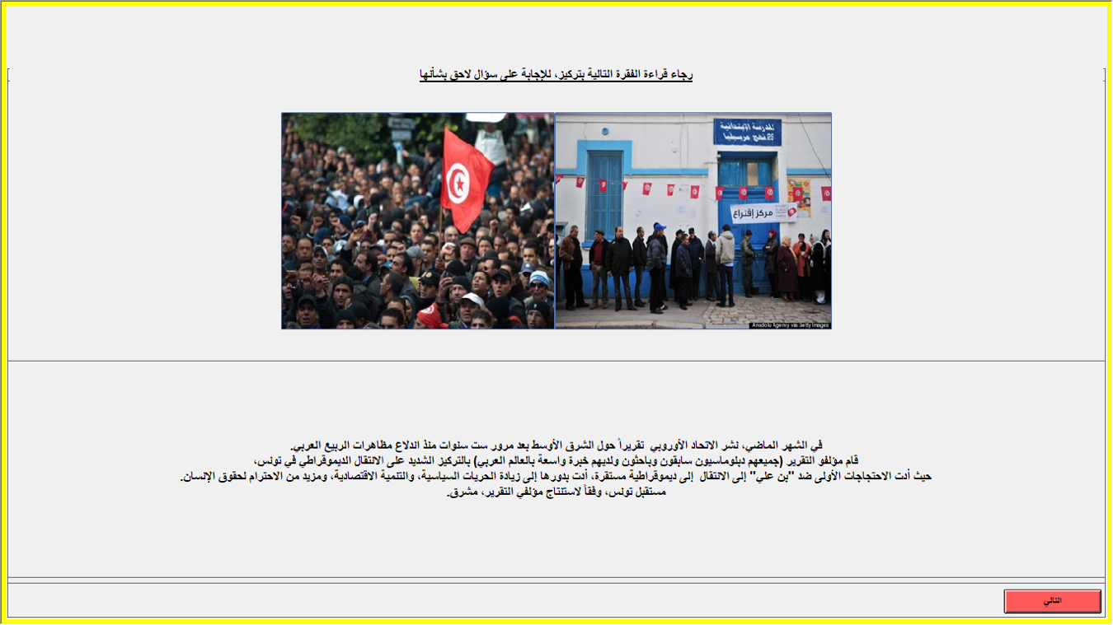
Figure A2: Syria Prime
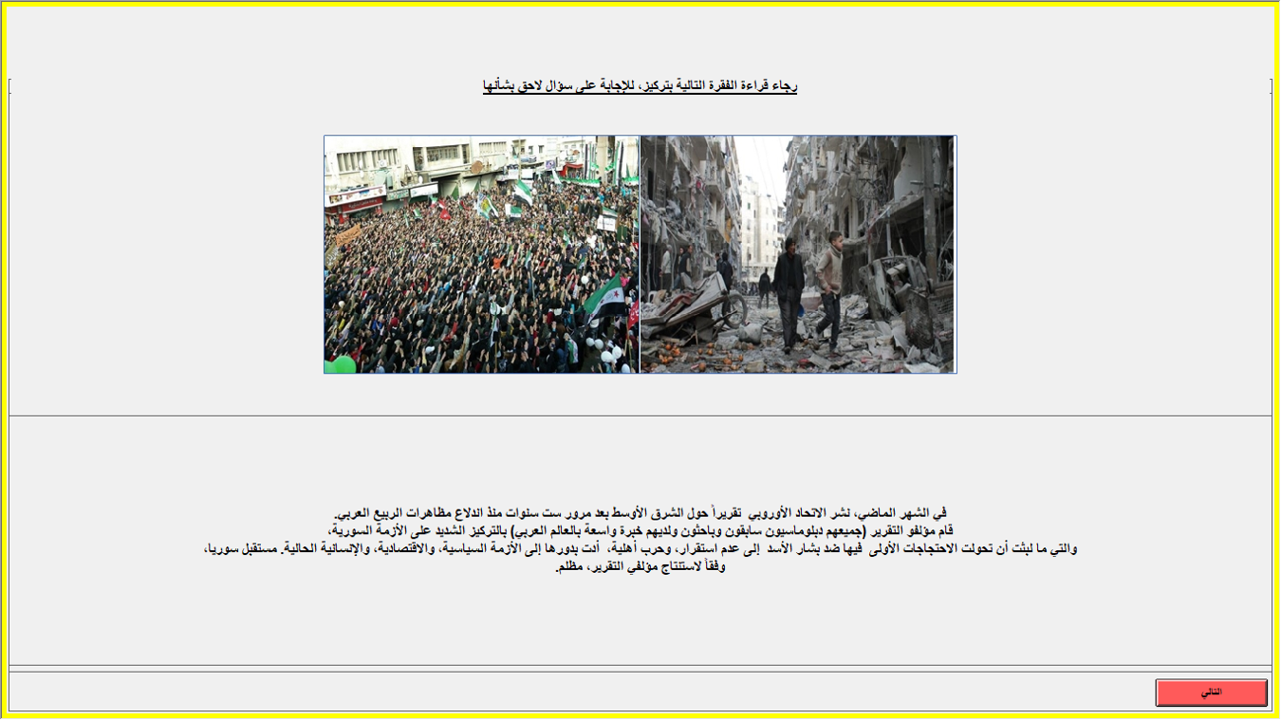

The second survey was conducted similarly, although in that case respondents were split into only two groups, a null control and the Sudan treatment. That treatment is below.

Figure A3: Sudan Prime
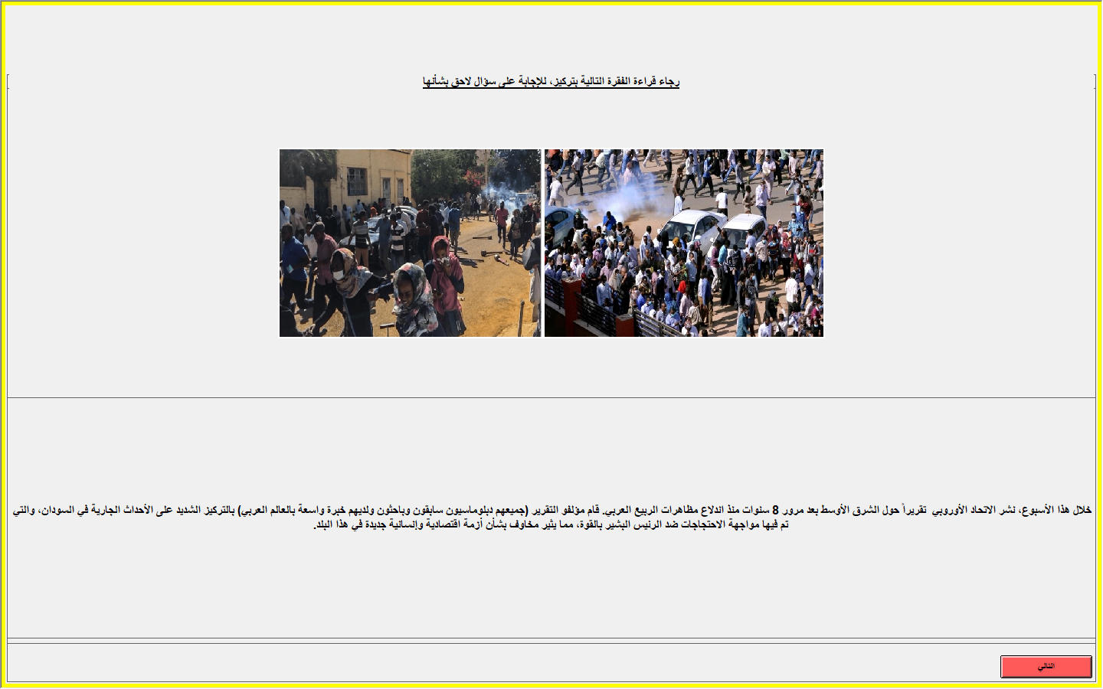

Descriptive Statistics

The following five tables (Appendix Tables A1- A5) present descriptive statistics across the entire sample, as well as each subgroup. For the three primes, asterix indicate differences with respective control groups. Note that each variable is normalized 0-1.
Table A1: Summary Statistics: Entire Sample
 | Mean | Median | min | max | St.Dev
View of Arab Spring | .482 | .333 | 0 | 1 | .234
Protest Efficacy (General) | .472 | .333 | 0 | 1 | .261
Risk Assumed | .448 | .449 | 0 | 1 | .224
Age (Years) | .105 | .115 | 0 | 1 | .072
Male | .247 | 0 | 0 | 1 | .431
Christian | .059 | 0 | 0 | 1 | .237
Socioeconomic Status | .575 | .5 | 0 | 1 | .316
Interest in Politics | .667 | 1 | 0 | 1 | .472
Uses Foreign Media | .645 | 1 | 0 | 1 | .479
Follows Political News | .358 | .333 | 0 | 1 | .253
Activist | .608 | 1 | 0 | 1 | .489

Table A2: Summary Statistics: Tunisia Treatment
 | Mean | Median | min | max | St.Dev
View of Arab Spring | .484 | .333 | 0 | 1 | .257
Protest Efficacy (General) | .47 | .333 | 0 | 1 | .27
Risk Assumed | .418 | .439 | .01 | .949 | .225
Age (Years) | .095* | .077 | 0 | .192 | .042
Male | .214 | 0 | 0 | 1 | .412
Christian | .026 | 0 | 0 | 1 | .159
Socioeconomic Status | .573 | .5 | 0 | 1 | .336
Interest in Politics | .65 | 1 | 0 | 1 | .479
Uses Foreign Media | .667 | 1 | 0 | 1 | .473
Follows Political News | .353 | .333 | 0 | 1 | .285
Activist | .547 | 1 | 0 | 1 | .5

Table A3: Summary Statistics: Syria Treatment
 | Mean | Median | min | max | St.Dev
View of Arab Spring | .493 | .667 | 0 | 1 | .237
Protest Efficacy (General) | .468 | .333 | 0 | 1 | .269
Risk Assumed | .392 | .388 | .01 | .99 | .197
Age (Years) | .104 | .115 | 0 | .423 | .056
Male | .176 | 0 | 0 | 1 | .383
Christian | .025 | 0 | 0 | 1 | .158
Socioeconomic Status | .576 | .5 | 0 | 1 | .323
Interest in Politics | .672 | 1 | 0 | 1 | .471
Uses Foreign Media | .597 | 1 | 0 | 1 | .493
Follows Political News | .37 | .333 | 0 | 1 | .26
Activist | .529 | 1 | 0 | 1 | .501

Table A4: Summary Statistics: Sudan Control
 | Mean | Median | min | max | St.Dev
View of Arab Spring | .512 | .667 | 0 | 1 | .222
Protest Efficacy (General) | .466 | .333 | 0 | 1 | .228
Risk Assumed | .497 | .49 | 0 | 1 | .232
Age (Years) | .101 | .077 | 0 | 1 | .081
Male | .298 | 0 | 0 | 1 | .459
Christian | .071 | 0 | 0 | 1 | .258
Socioeconomic Status | .571 | .5 | 0 | 1 | .311
Interest in Politics | .655 | 1 | 0 | 1 | .477
Uses Foreign Media | .679 | 1 | 0 | 1 | .468
Follows Political News | .359 | .333 | 0 | 1 | .245
Activist | .643 | 1 | 0 | 1 | .481

Table A5: Summary Statistics: Sudan Treatment
 | Mean | Median | min | max | St.Dev
View of Arab Spring | .46 | .333 | 0 | 1 | .224
Protest Efficacy (General) | .476 | .333 | 0 | 1 | .277
Risk Assumed | .463 | .454 | 0 | 1 | .248
Age (Years) | .113 | .115 | 0 | .808 | .096
Male | .28 | 0 | 0 | 1 | .45
Christian | .084 | 0 | 0 | 1 | .278
Socioeconomic Status | .61 | .5 | 0 | 1 | .316
Interest in Politics | .69 | 1 | 0 | 1 | .464
Uses Foreign Media | .649 | 1 | 0 | 1 | .479
Follows Political News | .349 | .333 | 0 | 1 | .239
Activist | .708 | 1 | 0 | 1 | .456

Across all demographic covariates and three treatment-control comparisons there was only one relatively minor (p < .05) failure in randomization. Comparing the mean ages of the Tunisian and Control groups does, however, reveal a statistically robust difference in age: unstandardized, the average age in the Tunisian group was roughly half a year younger than in the control.

Regression Results

The below tables estimate treatment effects for the outcome variables first as a function of assignment to treatment, then adjusting for the suite of control variables.

Table A6: Tunisia Prime

 | (1) | (2) | (3) | (4) | (5) | (6) | (7) | (8)
 | Egypt Rating | Egypt Rating | View of Arab Spring | View of Arab Spring | Protest Efficacy (General) | Protest Efficacy (General) | Risk Assumed | Risk Assumed
Tunisia Treatment | 0.0106 | 0.00207 | 0.0270 | 0.0401 | -0.00925 | -0.00570 | -0.0241 | -0.0181
 | (0.0302) | (0.0295) | (0.0320) | (0.0326) | (0.0349) | (0.0346) | (0.0270) | (0.0278)
Age (Years) |  | -0.658* |  | 0.521 |  | 0.00872 |  | 0.222
 |  | (0.319) |  | (0.353) |  | (0.374) |  | (0.301)
Male |  | 0.0322 |  | -0.0401 |  | -0.0365 |  | 0.0429
 |  | (0.0365) |  | (0.0403) |  | (0.0428) |  | (0.0348)
Christian |  | 0.0703 |  | 0.0874 |  | 0.126 |  | 0.00201
 |  | (0.0671) |  | (0.0742) |  | (0.0787) |  | (0.0649)
Socioeconomic Status |  | 0.134** |  | 0.0633 |  | 0.00390 |  | 0.00429
 |  | (0.0462) |  | (0.0511) |  | (0.0542) |  | (0.0435)
Interest in Politics |  | 0.0367 |  | 0.0208 |  | -0.158*** |  | 0.0521
 |  | (0.0371) |  | (0.0410) |  | (0.0435) |  | (0.0348)
Uses Foreign Media |  | -0.000346 |  | 0.0249 |  | 0.0834* |  | -0.00302
 |  | (0.0323) |  | (0.0357) |  | (0.0379) |  | (0.0306)
Follows Political News |  | -0.0592 |  | 0.124+ |  | -0.0981 |  | 0.114+
 |  | (0.0676) |  | (0.0747) |  | (0.0793) |  | (0.0641)
Activist |  | -0.0700* |  | 0.0492 |  | -0.0610+ |  | 0.0141
 |  | (0.0293) |  | (0.0324) |  | (0.0344) |  | (0.0276)
Constant | 0.365*** | 0.387*** | 0.457*** | 0.264*** | 0.479*** | 0.592*** | 0.442*** | 0.324***
 | (0.0212) | (0.0689) | (0.0224) | (0.0762) | (0.0245) | (0.0808) | (0.0190) | (0.0649)
Observations | 238 | 237 | 238 | 237 | 238 | 237 | 233 | 232
AIC | -16.27 | -31.67 | 11.18 | 15.92 | 53.01 | 43.91 | -72.92 | -62.04
Standard errors in parentheses
+ p<0.1, * p<0.05, ** p<0.01, *** p<0.001

Table A7: Syria Prime

 | (1) | (2) | (3) | (4) | (5) | (6) | (7) | (8)
 | Egypt Rating | Egypt Rating | View of Arab Spring | View of Arab Spring | Protest Efficacy (General) | Protest Efficacy (General) | Risk Assumed | Risk Assumed
Syria Treatment | 0.000540 | 0.00143 | 0.0357 | 0.0425 | -0.0116 | -0.0120 | -0.0496* | -0.0420+
 | (0.0300) | (0.0297) | (0.0306) | (0.0312) | (0.0347) | (0.0344) | (0.0249) | (0.0248)
Age (Years) |  | -0.180 |  | 0.143 |  | -0.167 |  | -0.0323
 |  | (0.286) |  | (0.300) |  | (0.331) |  | (0.238)
Male |  | 0.00712 |  | 0.0819* |  | -0.0328 |  | 0.0774*
 |  | (0.0385) |  | (0.0404) |  | (0.0446) |  | (0.0323)
Christian |  | 0.0801 |  | 0.0195 |  | 0.0639 |  | 0.0360
 |  | (0.0691) |  | (0.0724) |  | (0.0799) |  | (0.0593)
Socioeconomic Status |  | 0.115* |  | 0.0609 |  | 0.0672 |  | -0.0911*
 |  | (0.0486) |  | (0.0510) |  | (0.0562) |  | (0.0405)
Interest in Politics |  | 0.0182 |  | 0.00296 |  | -0.0642 |  | 0.0531
 |  | (0.0389) |  | (0.0407) |  | (0.0449) |  | (0.0323)
Uses Foreign Media |  | 0.0127 |  | -0.00247 |  | 0.0233 |  | -0.0200
 |  | (0.0330) |  | (0.0347) |  | (0.0382) |  | (0.0277)
Follows Political News |  | -0.0707 |  | 0.0443 |  | 0.0401 |  | 0.133*
 |  | (0.0720) |  | (0.0755) |  | (0.0832) |  | (0.0601)
Activist |  | -0.0373 |  | 0.0195 |  | -0.0939** |  | 0.0352
 |  | (0.0300) |  | (0.0315) |  | (0.0347) |  | (0.0250)
Constant | 0.365*** | 0.338*** | 0.457*** | 0.360*** | 0.479*** | 0.526*** | 0.442*** | 0.385***
 | (0.0211) | (0.0715) | (0.0215) | (0.0749) | (0.0244) | (0.0826) | (0.0176) | (0.0594)
Observations | 240 | 238 | 240 | 238 | 240 | 238 | 236 | 234
AIC | -18.22 | -21.13 | -8.675 | 1.415 | 51.93 | 47.97 | -108.9 | -108.5
Standard errors in parentheses
+ p<0.1, * p<0.05, ** p<0.01, *** p<0.001

Table A8: Sudan Prime
 | (1) | (2) | (3) | (4) | (5) | (6) | (7) | (8)
 | Egypt Rating | Egypt Rating | View of Arab Spring | View of Arab Spring | Protest Efficacy (General) | Protest Efficacy (General) | Risk Assumed | Risk Assumed
Sudan Treatment | -0.0450 | -0.0438 | -0.0516* | -0.0556* | 0.00992 | 0.0110 | -0.0344 | -0.0264
 | (0.0288) | (0.0284) | (0.0243) | (0.0246) | (0.0277) | (0.0275) | (0.0262) | (0.0265)
Age (Years) |  | 0.141 |  | -0.0872 |  | 0.217 |  | -0.126
 |  | (0.162) |  | (0.140) |  | (0.157) |  | (0.151)
Male |  | 0.0323 |  | -0.0119 |  | 0.0398 |  | 0.0405
 |  | (0.0326) |  | (0.0282) |  | (0.0315) |  | (0.0304)
Christian |  | -0.00441 |  | 0.000127 |  | -0.0177 |  | -0.0171
 |  | (0.0530) |  | (0.0459) |  | (0.0513) |  | (0.0495)
Socioeconomic Status |  | 0.106* |  | 0.0242 |  | 0.0905* |  | -0.0686
 |  | (0.0456) |  | (0.0395) |  | (0.0442) |  | (0.0426)
Interest in Politics |  | -0.00563 |  | 0.0193 |  | 0.0296 |  | -0.0384
 |  | (0.0353) |  | (0.0305) |  | (0.0341) |  | (0.0329)
Uses Foreign Media |  | 0.0171 |  | -0.0303 |  | -0.0174 |  | 0.00971
 |  | (0.0310) |  | (0.0269) |  | (0.0300) |  | (0.0290)
Follows Political News |  | -0.117+ |  | 0.0531 |  | 0.0993 |  | -0.00160
 |  | (0.0663) |  | (0.0574) |  | (0.0642) |  | (0.0619)
Activist |  | -0.106*** |  | 0.0543* |  | -0.0900** |  | -0.0212
 |  | (0.0309) |  | (0.0268) |  | (0.0299) |  | (0.0289)
Constant | 0.502*** | 0.520*** | 0.512*** | 0.464*** | 0.466*** | 0.397*** | 0.497*** | 0.571***
 | (0.0203) | (0.0627) | (0.0172) | (0.0543) | (0.0196) | (0.0607) | (0.0185) | (0.0586)
Observations | 336 | 335 | 336 | 335 | 336 | 335 | 336 | 335
AIC | 59.70 | 51.81 | -53.05 | -44.43 | 33.71 | 30.16 | -2.550 | 6.366
Standard errors in parentheses
+ p<0.1, * p<0.05, ** p<0.01, *** p<0.001

Power Analysis

In the presence of the largely null results reported in the body of the article a brief discussion of the parameters of effect sizes that are detectable with our sample size is valuable. Duflo et. al. (2007) recommend using Cohen’s d as a standardized measure of effect size that is useful in the absence of other studies. Cohen’s rule of thumb (1988) is that an effect of 0.2 is “small,” 0.5 is “medium,” and 0.8 is a “large” effect. With this in mind, Figure 4 shows the effect size that our sample size could be expected to detect at various levels of power.

Figure A4
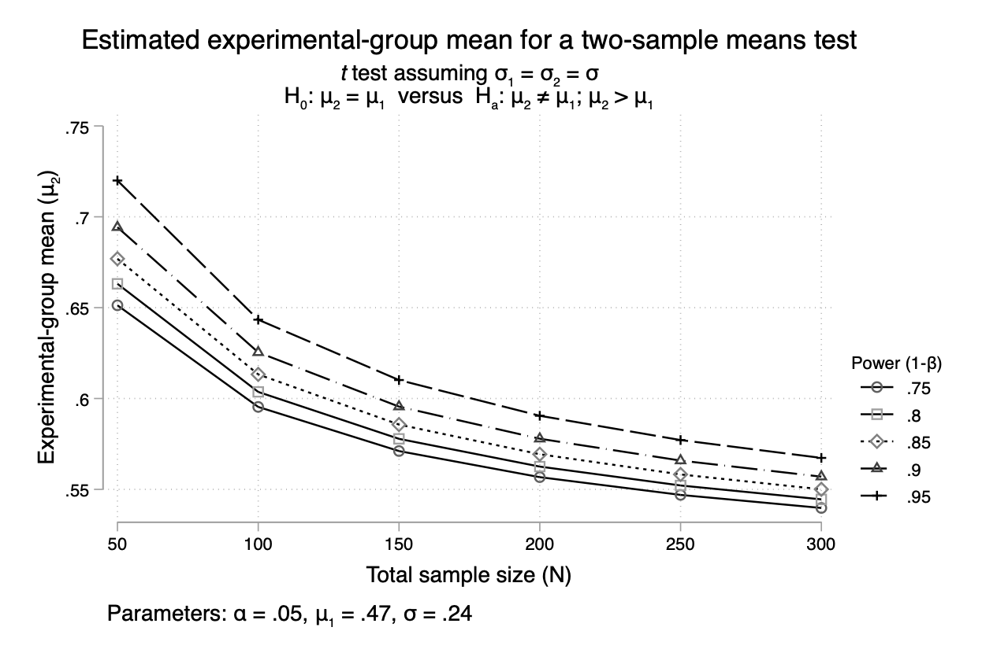

By reference to Figure A5, we could be confident that at our sample sizes (238 for the Tunisia- Control comparison, 240 for the Syria-Control comparison, and 336 for the Sudan- Control comparison), “large” to “medium” effect sizes would be detectable.

Further contextualizing Figure A5, we conceptualized our own experiment with reference to prior work on the diffusion of protest through social networks. In a Facebook experiment, Lawrence exposed Moroccan respondents to brief textual primes relating to regime repression, tolerance, and concession towards popular protests. Part of the outcome was measured through a question for respondents beginning "in the future, would you favor new demonstrations..." On a seven-point outcome scale, these three primes shifted respondents’ means against a null control by 1.32, .82, and .54, respectively. To the extent that this experiment can be roughly analogized to our own four point scales, the expected shift in means in our unstandardized variables would be a shift of .75, .47, and .31.

Figure A5: Comparison with Lawrence (2017)
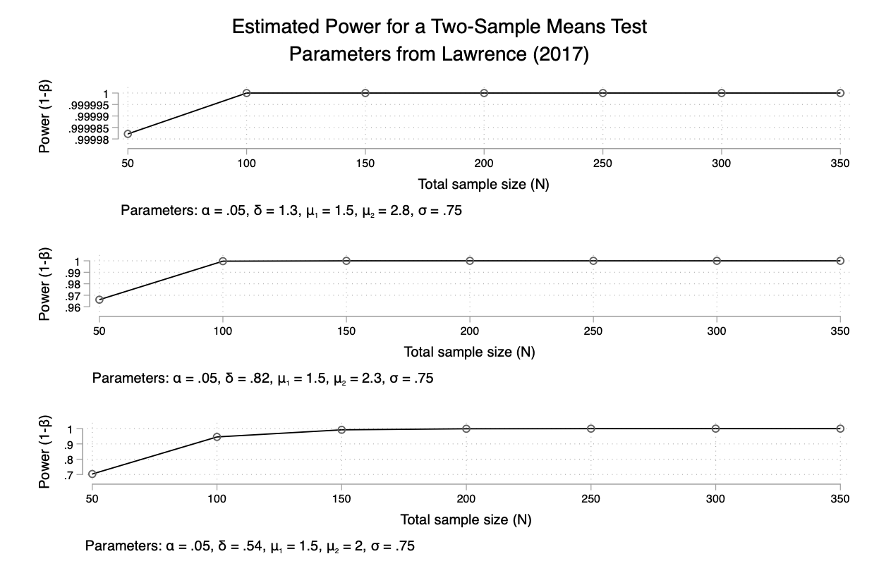

At the beginning of each session, the program randomly assigns each PC to a group (corresponding to either a treatment or a control). Since there were two servers inside the lab, we could administer more than one treatment in the same session (e.g. Syria treatment/control + Tunisia treatment/control).
The treatment and control groups were relatively small, approximately three dozen respondents in each.

