Anders Ejrnæs and Mads Dagnis Jensen, ‘Go Your Own Way: The Pathways to Exiting the European Union’, published in *Government and Opposition*

Online appendix

Appendix 1. Probability of being in favour of leaving the EU. Logistic regression marginal effects

|  |  |  |
| --- | --- | --- |
|  | (1) | (2) |
|  |  |  |
| Age | 0.005 | 0.006* |
| Female (ref: male) | -0.028*** | -0.021*** |
| Years of education | -0.036*** | -0.013*** |
| Income decile | -0.033*** | -0.016*** |
| Paid work | 0.033*** | 0.021*** |
| Support for multiculturalism |  | -0.075*** |
| Emotionally attached to the country |  | -0.006*** |
| Trust in the political establishment |  | -0.059*** |
| Country-level variance | .2114264 | .3921243 |
| *N* | 23880 | 23745 |

* *p* < 0.05, ** *p* < 0.01, *** *p* < 0.001

Appendix 2. The hierarchical cluster analysis

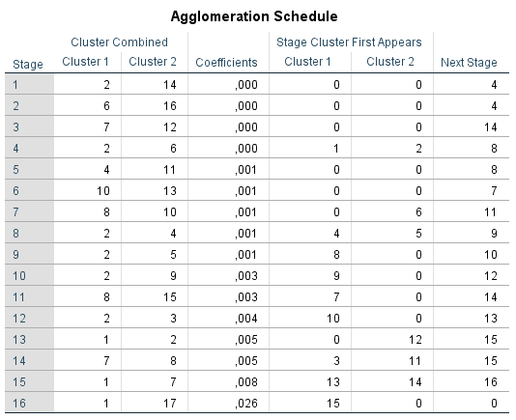

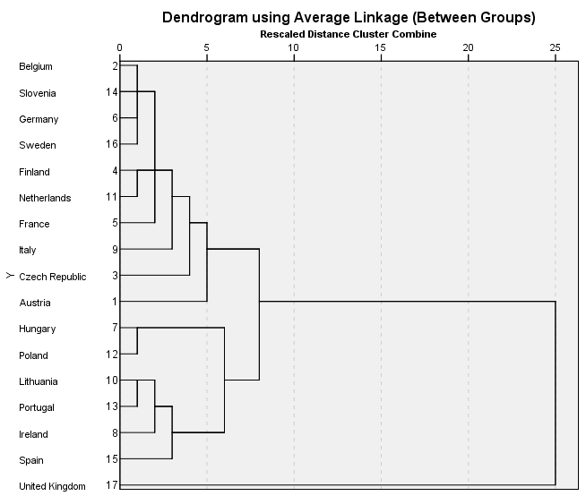

Appendix 3. Multilevel path model with coefficients (all countries except the UK) controlled for age



Appendix 4: The UK path model controlled for age



Appendix 5. Multilevel path model with coefficients (all countries except the UK) (excluding DK)



Appendix 6: The UK path model excluding ‘don’t know’

