ONLINE APPENDIX for:
“Dissecting electoral support for the far right. A comparison between mature and post-communist European democracies”, published in Government and Opposition.
Tobias Brils, Jasper Muis and Teodora Gaidytė

Contents:
Appendix A: Centre-right parties in Europe
Appendix B: Left-wing party family in Europe
Appendix C: Variables list, including question wording and answer categories
Appendix D: Descriptive statistics
Appendix E: Correlation matrix

Appendix F: Interaction effect anti-immigration attitudes and country type (hypothesis H1b)

Appendix G: Robustness checks

Appendix A: Centre-right parties in Europe

Table A: Centre-right party political parties of the 16 investigated countries which are considered part of the centre-right party family. The schema corresponds to the categorization by Immerzeel et al. (2015).

Country | Parties | Parties (EN) | ABB | Vote (2014) | Vote (2016)
Austria | Das Neue Österreich  Österreichische Volkspartei  Team Frank Stronach | The new Austria  Austrian People’s Party  Team Frank Stronach | NEOS  ÖVP  - | 5.2%  29.0%  N/A | 2.7%  26.5%  1.3%
Belgium | Christen-Democratisch en Vlaams  Nieuw-Vlaamse Alliantie  Open Vlaamse Liberalen en Democraten  Centre Démocrate Humaniste  Mouvement Réformateur  Lijst Dedecker  Parti Populaire | Christian Democratic and Flemish  New Flemish Alliance  Open Flemish Liberals and Democrats  Humanist Democratic Centre  Reformist Movement  List Dedecker  People’s Party | CD&V  N-VA  Open VLD  CDH  MR  -  PP | 13.5%  20.2%  7.6%  4.8%  10.6%  N/A  1.0% | 13.0%  20.4%  8.3%  3.3%  10.3%  0.2%  0.4%
Czech Republic | Top 09  Občanská demokratická strana  Křesťanská a demokratická unie – Československá strana lidová  ANO 2011 | Top 09  Civic Democratic Party  Christian and Democratic Union – Czechoslovak People's Party  ANO | Top09  ODS  KDU-ČSL  ANO | 10.8%  8.6%  5.7%  26.7% | 12.3%  9.5%  6.7%  27.4%
Denmark | Det Radikale Venstre  Det Konservative Folkeparti  Danmarks liberale parti  Liberal Alliance  Kristendemokraterne | Danish Social Liberal Party  Conservative People's Party  Venstre  Liberal Alliance  Christian democrats | B  C  V  I  K | 11.4%  5.5%  26.4%  4.1%  0.7% | N/A  N/A  N/A  N/A  N/A
Estonia | Eesti Reformierakond  Eesti Keskerakond  Erakond Isamaa ja Res Publica Liit  Eesti Vabaerakond  Erakond Eesti Kristlikud Demokraadid | Estonian Reform Party  Estonian Centre Party  Union of Pro Patria and Res Publica  Free Party  Estonian Christian Democrats | REF  KESK  IRL  V  - | 31.2%  27.6%  15.7%  N/A  0.4% | 30.7%  24.1%  11.5%  7.5%  N/A
Finland | Kansallinen Kokoomus  Suomen ruotsalainen kansanpuolue  Suomen Keskusta  Suomen Kristillisdemokraatit | National Coalition Party  Swedish People's Party of Finland  Centre Party  Christian Democrats of Finland | Kok.  RKP  Kesk.  KD | 24.1%  4.6%  18.0%  3.0% | 21.6%  5.0%  21.7%  3.8%
France | Les Républicains (former UMP)  Mouvement démocrate  Nouveau Centre  Parti Radical Valoisien  Mouvement pour la France | The Republicans  Democratic Movement  New Centre  The Radical Party  Movement for France | LR (UMP)  MoDem  PR  MPF | 28.6%  6.0%  1.2%  0.1%  1.0% | 28.8%  2.6%  1.4%  0.4%  1.9%
Germany | Christlich Demokratische Union Deutschlands / Christlich-Soziale Union in Bayern  Freie Demokratische Partei | Christian Democratic Union of Germany / Christian Social Union in Bavaria  Free Democratic Party | CDU/CSU  FDP | 40.4%  2.4% | 41.1%  2.6%
Hungary | - | - | - | - | -
Lithuania | Liberalų sąjūdis  Tėvynės sąjunga - Lietuvos krikščionys demokratai  Lietuvos laisvės sąjunga  Partija "Jaunoji Lietuva"  Tėvynės sąjunga (formerly part of Homeland Union)  Lietuvos centro partija | Liberal Movement  Homeland Union - Lithuanian Christian Democrats  Lithuanian Freedom Union  Party ‘Young Lithuania’  Nationalist Union  Lithuanian Centre Party | LRLS  TS-LKD  LLSL  JL  TS  LCP | 5.6%  7.7%  N/A  N/A  N/A  0.1% | 2.6%  11.2%  1.3%  0.2%  0.1%  0.1%
Netherlands | Volkspartij voor Vrijheid en Democratie  Christen-Democratisch Appèl  Democraten 66  ChristenUnie  Staatkundig Gereformeerde Partij  50plus | People's Party for Freedom and Democracy  Christian Democratic Appeal  Democrats 66  Christian Union  Reformed Political Party  50plus | VVD  CDA  D66  CU  SGP  50+ | 23.8%  12.5%  13.4%  3.7%  2.0%  1.7% | 23.0%  12.5%  13.8%  3.1%  1.9%  1.3%
Norway | Venstre  Kristelig Folkeparti  Senterpartiet  Høyre | Liberal Party  Christian Democratic Party  Centre Party  Conservative Party | V  KrF  Sp  H | 6.0%  4.8%  5.4%  30.3% | 4.4%  4.9%  5.2%  30.2%
Poland | Kongres Nowej Prawicy  Platforma Obywatelska  Polskie Stronnictwo Ludowe  Nowoczesna Pyszarda Petru  Polska jest Najważniejsza | Congress of the New Right  Civic Platform  Polish Peasants Party  Modern Poland  Poland Comes First | KNP  PO  PSL  M  PJN | 2.2%  49.0%  6.0%  N/A  0.3% | N/A  26.2%  4.2%  5.4%  N/A
United Kingdom | Conservative Party  Liberal Democrats  Scottish National Party | Conservative Party  Liberal Democrats  Scottish National Party | CP  LD  SNP | 34.8%  15.0%  2.8% | 38.0%  8.7%  3.9%
Slovenia | Demokratična stranka upokojencev Slovenije  Nova Slovenija - Krščanski demokrati  Slovenska ljudska stranka  Stranka modernega centra  Zavezništvo Alenke Bratušek  Državljanska lista | Democratic Party of Pensioners of Slovenia  New Slovenia - Christian Democrats  Slovenian People's Party  Modern Centre Party  Alliance of Alenka Bratušek  Civic List | DeSUS  NSi  SLS  SMC  ZAAB  DL | 10.1%  5.9%  5.2%  37.9%  3.3%  0.2% | 9.7%  6.6%  3.2%  35.7%  2.0%  N/A
Sweden | Centerpartiet  Liberalerna  Kristdemokraterna  Moderata samlingspartiet | Centre Party  Liberals  Christian Democrats  Moderate Party | C  L  KD  M | 6.6%  7.8%  4.6%  26.2% | 6.4%  6.3%  3.5%  26.1%
Switzerland | Die Liberalen  Christlichdemokratische Volkspartei der Schweiz  Bürgerlich-Demokratische Partei Schweiz  Evangelische Volkspartei der Schweiz | The Liberals  Christian Democratic People's Party  Conservative Democratic Party  Evangelical’s People Party | FDP  CVP  BDP  EVP | 18.3%  17.0%  3.6%  1.0% | 18.5%  15.5%  3.3%  1.7%

Appendix B: Left-wing party family in Europe

Table B: left-wing political parties of the 16 investigated countries which are considered part of the centre/left party family. The schema corresponds to the categorization by Immerzeel et al. (2015).

Country | Parties | Parties (EN) | ABB | Vote (2014) | Vote (2016)
Austria | Sozialdemokratische Partei Österreichs  KPÖ | Social Democratic Party of Austria  Communist Party of Austria | SPÖ  KPÖ | 32.4%  1.4% | 35.2%  0.4%
Belgium | Socialistische Partij Anders  Parti Socialiste  Parti du travail de Belgique  Partij van de Arbeid | Socialist Party Different  Socialist Party  Workers' Party  Labour Party (Flanders) | SP.A  PS  PTB  PVDA+ | 6.9%  14.2%  2.1%  1.5% | 9.0%  13.9%  2.2%  1.4%
Czech Republic | Komunistická strana Čech a Moravy  Česká strana sociálně demokratická | Communist Party of Bohemia and Moravia  Czech Social Democratic Party | KSČM  ČSSD | 11.1%  30.0% | 10.2%  26.7%
Denmark | Socialdemokraterne  Socialistisk Folkeparti | Social Democrats  Socialist People's Party | A  F | 22.7%  9.2% | N/A  N/A
Estonia | Sotsiaaldemokraatlik Erakond | Social Democratic Party | SDE | 17.1% | 16.2%
Finland | Suomen Sosialidemokraattinen Puolue  Vasemmistoliitto  Suomen Työväenpuolue  Kommunistinen Työväenpuolue – Rauhan ja Sosialismin puolesta | Social Democratic Party of Finland  Left Alliance  Workers’ Party  Communist Workers’ Party | SDP  Vas.  STP  KTP | 17.8%  6.5%  N/A  0.1% | 14.4%  5.3%  0.1%  N/A
France | Front de Gauche  Parti Socialiste  Nouveau Parti Anticapitaliste  Lutte Ouvrière  Parti Radical de Gauche | Left Front  Socialist Party  New Anticapitalistic Party  Workers’ Struggle  Radical Left Party | FDG  PS  NPA  LO  PCF | 3.8%  31.6%  0.6%  0.9%  1.5% | 4.0%  33.3%  0.5%  1.4%  2.1%
Germany | Sozialdemokratische Partei Deutschlands  Die Linke | Social Democratic Party of Germany  The Left | SPD  LINKE | 31.3%  9.5% | 32.0%  8.7%
Hungary | Magyar Szocialista Párt  Magyar Kommunista Munkáspárt | Hungarian Socialist Party  Hungarian Communist Party | MSZP  MKP | 26.1%  0.7% | 18.7%  0.6%
Lithuania | Darbo partija  Lietuvos socialdemokratų partija | Labour Party  Social Democratic Party of Lithuania | DP  LSDP | 9.2%  14.4% | 2.9%  11.2%
Netherlands | Partij van de Arbeid  Socialistische Partij | Labour Party  Socialist Party | PvdA  SP | 15.6%  10.9% | 18.6%  8.5%
Norway | Sosialistisk Venstreparti  Arbeiderpartiet  Rødt | Socialist Left Party  Labour Party  The Red Party | SV  AP  R | 4.5%  31.3%  1.0% | 5.3%  34.4%  1.3%
Poland | Sojusz Lewicy Demokratycznej  Partia Razem  Zjednoczona Lewica  Polska Partia Pracy  Ruch Palikota | Democratic Left Alliance  Together Party  United Left  Polish Labour Party  Palikot Movement | SLD  Razem  ZL  PPP  TR | 6.2%  N/A  N/A  0.1%  2.1% | 5.1%  1.1%  5.1%  N/A  N/A
United Kingdom | Labour Party | Labour Party | LP | 32.9% | 33.8%
Slovenia | Pozitivna Slovenija  Socialni demokrati  Združena levica | Positive Slovenia  Social Democrats  United Left | PS  SD  ZL | 2.3%  10.6%  5.7% | 2.2%  12.9%  4.2%
Sweden | Vänsterpartiet  Sveriges Socialdemokratiska arbetarparti | Left Party  Swedish Social Democratic Party | V  S | 6.1%  29.5% | 6.3%  33.2%
Switzerland | Sozialdemokratische Partei der Schweiz  Partei der Arbeit der Schweiz | Social Democratic Party  Swiss Labour Party | SP  PdA | 17.9%  0.1% | 17.2%  0.4%

Appendix C: Variables list, including question wording and answer categories

Variables | Questions | Answers
Anti-immigrant attitudes | - Would you say it is generally bad or good for [country]'s economy that people come to live here from other countries?  - would you say that [country]'s cultural life is generally undermined or enriched by people coming to live here from other countries?  - Would you say it is generally bad or good for [country]'s economy that people come to live here from other countries? | - Good for the economy (1); Cultural life enriched (2); People mostly look out for themselves (3)  - –  - –  - –  - –  - –  - –  - –  - –  - –  - Bad for economy (1); Cultural life undermined (2); Worse place to live (3)
Authoritarian sentiments | Now I will briefly describe some people. Please listen to each description and tell me how much each person is or is not like you. Use this card for your answer.  - She/he believes that people should do what they're told. She/he thinks people should follow rules at all times. even when no-one is watching.  - It is important to her/him that the government ensures her/his safety against all threats. She/he wants the state to be strong so it can defend its citizens.  - It is important to her/him always to behave properly. She/he wants to avoid doing anything people would say is wrong.  - Tradition is important to her/him. She/he tries to follow the customs handed down by her/his religion or her/his family. | - Not like me at all  - Not like me  - A little like me  - Somewhat like me  - Like me  - Very much like me
Education | Generated variable: Highest level of education. ES - ISCED | - Less than lower secondary  - Lower secondary  - Lower tier upper secondary  - Upper tier upper secondary  - Advanced vocational –sub degree  - Lower tertiary education. BA level  - Higher tertiary education. >= MA level
Unemployment | MAIN ACTIVITY | - Paid work  - Education  - Unemployed. looking for a job  - Unemployed. not looking for a job  - Permanently sick or disabled  - Retired  - Community or military service  - Housework. looking after children. other  - Other
Income redistribution | Please say to what extent you agree or disagree with each of the following statements:  The government should take measures to reduce differences in income levels | - Disagree strongly  - Disagree  - Neither agree nor disagree  - Agree  - Agree strongly
National political trust  Global political trust | Using this card. please tell me on a score of 0-10 how much you personally trust each of the institutions I read out. 0 means you do not trust an institution at all. and 10 means you have complete trust;  - [country]'s parliament?  - the legal system?  - the police?  - politicians?  - political parties?  - the European Parliament?  - the United Nations? | - No trust  - –  - –  - –  - –  - –  - –  - –  - –  - –  - Complete trust
External political efficacy | - How much would you say the political system in [country] allows people like you to have a say in what the government does?  - And how much would you say that the political system in [country] allows people like you to have an influence on politics? | - Not at all  - –  - –  - –  - Completely
Age | Age | 18 or higher
Female | Gender | - Male  - Female

Appendix D: Descriptive statistics
Table D: Descriptive statistics ESS data (2014/2016) for mature and post-communist democracies and reporting the N, mean, standard deviation (SD), scale, number of items, and Cronbach’s alpha. The descriptive table only reports the valid cases.
 |  | Mature democracies |  |  | Post-communist democracies
Variables (range) | N of indicators | Mean | SD | α | Mean | SD | α
Perceived income (1-4) | - | 3.30 | 0.74 | - | 2.82 | 0.77 | -
Education (1-7) | - | 4.07 | 1.83 | - | 4.09 | 1.60 | -
Unemployment (0-1) | - | 0.04 | 0.20 | - | 0.05 | 0.21 | -
Income distribution (1-5) | - | 3.72 | 1.07 | - | 3.94 | 1.03 | -
Authoritarian sentiments (1-6) | 4 | 4.17 | 0.90 | .62 | 4.42 | 0.84 | .67
Anti-immigration attitudes (0-10) | 3 | 4.61 | 2.07 | .85 | 5.52 | 2.08 | .85
National political trust (0-10) | 5 | 5.33 | 1.90 | .88 | 4.08 | 2.05 | .89
Supranational political trust (0-10) | 2 | 4.79 | 2.19 | .79 | 4.56 | 2.42 | .89
External political efficacy (1-5) | 2 | 2.54 | .89 | .78 | 2.04 | .86 | .77
Age (18-102/97) | - | 52.14 | 17.46 | .78 | 49.81 | 17.06 | -
Female (0-1) | - | 0.50 | 0.50 | - | 0.55 | 0.50 | -
Valid N |  | 28,517 |  |  | 14,553

Appendix E: Correlation matrix
 | Mature democracies
 | A.S | A.I.A | P.I | Education | Unemployment | I.D | N.P.T | S.P.T | E.P.E | Age | Female
Authoritarian sentiments (1-6) | - | 0.18 | -0.03 | -0.15 | -0.04 | 0.03 | 0.06 | 0.00 | -0.04 | 0.18 | 0.01
Anti-immigration attitudes (0-10) | - | - | -0.20 | -0.33 | 0.03 | 0.01 | -0.43 | -0.40 | -0.36 | 0.06 | 0.02
Perceived income (1-4) | - | - | - | 0.24 | -0.21 | -0.18 | 0.25 | 0.18 | 0.24 | 0.05 | -0.05
Education (1-7) | - | - | - | - | -0.04 | -0.13 | 0.23 | 0.20 | 0.26 | -0.21 | -0.03
Unemployment (0-1) | - | - | - | - | - | 0.05 | -0.07 | -0.04 | -0.06 | -0.12 | -0.02
Income distribution (1-5) | - | - | - | - | - | - | -0.12 | -0.07 | -0.13 | 0.08 | 0.08
National political trust (0-10) | - | - | - | - | - | - | - | 0.70 | 0.57 | -0.03 | -0.03
Supranational political trust (0-10) | - | - | - | - | - | - | - | - | 0.44 | -0.11 | 0.03
External political efficacy (1-5) | - | - | - | - | - | - | - | - | - | -0.11 | -0.05
Age (18-102/97) | - | - | - | - | - | - | - | - | - | - | 0.01
Female (0-1) | - | - | - | - | - | - | - | - | - | - | -
 | Post-communist democracies
Authoritarian sentiments (1-6) | - | 0.06 | -0.01 | -0.06 | -0.05 | 0.12 | 0.00 | -0.01 | -0.01 | 0.18 | 0.09
Anti-immigration attitudes (0-10) | - | - | -0.17 | -0.18 | 0.01 | 0.06 | -0.19 | -0.25 | -0.22 | 0.11 | -0.01
Perceived income (1-4) | - | - | - | 0.30 | -0.18 | -0.13 | 0.14 | 0.12 | 0.17 | -0.17 | -0.07
Education (1-7) | - | - | - | - | -0.08 | -0.14 | 0.14 | 0.13 | 0.20 | -0.19 | 0.09
Unemployment (0-1) | - | - | - | - | - | 0.03 | -0.07 | -0.04 | -0.05 | -0.10 | -0.02
Income distribution (1-5) | - | - | - | - | - | - | -0.12 | -0.05 | -0.15 | 0.11 | 0.06
National political trust (0-10) | - | - | - | - | - | - | - | 0.63 | 0.41 | 0.01 | 0.02
Supranational political trust (0-10) | - | - | - | - | - | - | - | - | 0.29 | -0.04 | 0.02
External political efficacy (1-5) | - | - | - | - | - | - | - | - | - | -0.12 | -0.05
Age (18-102/97) | - | - | - | - | - | - | - | - | - | - | 0.06
Female (0-1) | - | - | - | - | - | - | - | - | - | - | -

Appendix F: Interaction effect anti-immigration attitudes and country type (hypothesis H1b)
Hypothesis H1b states that anti-immigration attitudes have a weaker effect in explaining electoral support for far-right parties in post-communist democracies compared to mature democracies. This claim is ad oculum clearly supported by our findings. To statistically test this hypothesis, we ran an additional regression model with all countries pooled together in which we included an interaction term, in addition to all independent variables (see Table F). It shows that the effects of anti-immigrant attitudes on far-right voting are indeed significantly stronger in the West than in the East, thus supporting H1b.

Table F: Multilevel multinomial logistic regression: all countries. The interaction effect of anti-immigration attitudes and country type on far-right voting.
 | Centre right | Left-wing | Non-voters
 | Estimate (S.E.) | Estimate (S.E.) | Estimate (S.E.)
Cultural backlash
Anti-immigration attitudes (0-10) | -.37 (.01) | -.51 (.01) | -.36 (.01)
Authoritarian sentiments (1-6) | -.02 (.02) | -.20 (.02) | -.20 (.02)
Economic grievances
Perceived income (1-4) | .20 (.03) | -.01 (.03) | -.16 (.03)
Education (1-7) | .16 (.01) | .09 (.01) | -.12 (.01)
Unemployment (0-1) | -.31 (.10) | -.02 (.10) | .14 (.09)
Income distribution (1-5) | -.18 (.02) | .32 (.02) | -.00 (.02)
Protest vote
National political trust (0-10) | -.01 (.01) | -.07 (.02) | -.19 (.01)
Supranational political trust (0-10) | .12 (.01) | .12 (.01) | .11 (.01)
External political efficacy (1-5) | .13 (.03) | .10 (.03) | -.20 (.03)
Control variables
Age (18-102/97) | .01 (.00) | .02 (.00) | -.02 (.00)
Female (0-1) | .34 (.04) | .36 (.04) | .36 (.04)
Interaction
Anti-immigration*Post-communist democracies | .23 (.02) | .32 (.02) | .25 (.02)
Note: Far-right voters are the reference category. Coefficients in bold are statistically significant (p < .05, two-tailed)

Appendix G: Robustness checks
First, we have assessed how the results would differ if we use the standard technique of comparing far-right voters with the rest of the electorate, thus all other people who are entitled to vote in national elections. The results are shown in Table G1. The results show that important nuances we highlighted in our article are obfuscated in a conventional design. For instance, the conventional designs shows that far-right voters have significantly stronger authoritarian sentiments, whereas our analysis reveals that this is actually not true if we compare them with centre right voters. Moreover, Table G1 shows that far-right voters are lower educated than the rest of the electorate, but our analysis has revealed that this is clearly incorrect if we compare far-right voters with non-voters, since we showed that they are even significantly higher educated.

Table G1. Multilevel binary logistic regressions of far-right voting vs all other eligible citizens for mature democracies and post-communist democracies.
 | Mature  democracies | Post-communist  democracies
 |  Estimate  S | Estimate  S
Cultural backlash
Anti-immigration attitudes (0-10) | -.39 (.01) | -.21 (.02)
Authoritarian sentiments (1-6) | -.06 (.03) | -.14 (.04)
Economic grievances
Perceived income (1-4) | .06 (.04) | .13 (.05)
Education (1-7) | .15 (.02) | .16 (.02)
Unemployment (0-1) | -.33 (.12) | .07 (.17)
Income distribution (1-5) | .00 (.02) | -.01 (.04)
Protest vote
National political trust (0-10) | .15 (.02) | -.24 (.02)
Supranational political trust (0-10) | .10 (.02) | .17 (.02)
External political efficacy (1-5) | .17 (.04) | -.03 (.04)
Control variables
Age (18-102/97) | .02 (.00) | .02 (.00)
Female (0-1) | .43 (.05) | .25 (.07)
Log Likelihood | -5,980.84 | -3,110.92
N= | 22,629 | 8,869
Note: Far-right voters are the reference category. Coefficients in bold are statistically significant (p < .05, two-tailed)

Second, we conducted a series of robustness checks to assess to what extent the results are influenced by the classification of parties and the inclusion or exclusion of countries and parties. We start with far-right parties: to what extent are the results influenced by the exclusion or inclusion of a few additional parties that could arguably also be classified as far right? As we have explained in the paper, our selection of far-right parties consists of parties that have a strong authoritarian-nativist position (7.5 or higher) and deem anti-elitism and/or authoritarian-nativist issues as most important issue, as indicated by the two most important issues mentioned in CHES 2014. Four marginal parties that were not included but nevertheless possess both attributes could arguably have been added. These four parties are: People’s Party (Belgium), Movement for France (France), The Way of Courage (Lithuania) and Congress of the New Right (Poland). In our main analysis, three of these parties are coded as centre-right and one of them is excluded as it is difficult to categorize as either centre-right or left-wing party (The Way of Courage).
Our robustness check consisted of four additional analyses in which we included one of the four parties. These findings show that each addition did not affect our findings, which is not surprising given the fact that these four parties are rather small (see Table G2).
Table G2. Four marginal parties that could additionally be coded as far-right parties.
Country | Parties + ABB | Vote (ESS 2014) | Vote (ESS 2016) | Position score  (CHES 2014) | Main issue  (CHES 2014) | Second issue  (CHES 2014)
Belgium | Parti Populaire (PP) | 1.0% | 0.4% | 8.5 | tie: anti-elite and immigration | ethnic minorities
France | Mouvement pour la France (MPF) | 1.0% | 1.9% | 9.1 | nationalism | immigration
Lithuania | The Way of Courage (DK) | 1.3% | 0.2% | 7.7 | anti-elite rhetoric | corruption.
Poland | Congress of the New Right (KNP) | 2.2% | -- | 8.8 | anti-elite rhetoric | public services vs taxes

Furthermore, we have checked the opposite possibility, namely the removal of some far-right parties from our analysis. Since they are popular among a large portion of the population, particularly PiS (Poland) and Fidesz (Hungary) are the most important cases to consider. We classified PiS and Fidesz as part of the far-right family. Table G3 shows the results if we classify them as centre-right, instead of far-right parties.
Table G3 interestingly shows that trust in national politics has some opposite significant effects when parties PiS (Poland) and Fidesz (Hungary) are coded as centre-right (model 2) rather than far-right party (model 1): the results show that far-right voters in post-communist democracies have less trust in national politics when compared to centre-right voters and left-wing voters (in line with H5). They are still more trustful than non-voters. It is important to note that three parties we classified as far right were in power at the time of the surveys, namely PiS in Poland (since 2015), Fidesz in Hungary (since 2014) and Order and Justice in Lithuania (2012–2016). This robustness check thus suggests that the ‘protest voting’ explanation is context-dependent: when far-right parties are in government, their supporters are not politically dissatisfied, or at least not more so than voters of other mainstream parties. To further clarify this dependency, we conducted a country-by-country analysis of the effect of trust in national politics (see Figure G1).
Table G3. Comparison of two multilevel multinomial logistic regressions of post-communist democracies. In model 2 the parties PiS (Poland) and Fidesz (Hungary) are coded as centre-right instead of far-right parties.
 | Centre-right |  | Left-wing |  | Non-voters
 | model 1 | model 2 | model 1 | model 2 | model 1 | model 2
 | Estimate (S.E.) | Estimate (S.E.) | Estimate (S.E.) | Estimate (S.E.) | Estimate (S.E.) | Estimate (S.E.)
Cultural backlash
Anti-immigration attitudes (0-10) | -.22 (.02) | -.17 (.02) | -.15 (0.02) | -.14 (.02) | -.15 (.02) | -.13 (.02)
Authoritarian sentiments (1-6) | -.07 (.04) | .15 (.05) | -.19 (0.04) | -.07 (.05) | -.28 (.04) | -.16 (.05)
Economic grievances
Perceived income (1-4) | .21 (.05) | .14 (.06) | .06 (0.05) | .04 (.06) | -.09 (.05) | -.10 (.06)
Education (1-7) | .13 (.02) | -.02 (.03) | .10 (0.02) | .04 (.03) | -.16 (.02) | -.22 (.03)
Unemployment (0-1) | .08 (.16) | -.26 (.18) | .06 (0.18) | -.18 (.21) | .23 (.14) | .00 (.17)
Income distribution (1-5) | -.16 (.03) | -.06 (.04) | .10 (0.04) | .11 (.05) | .02 (.03) | .02 (.04)
Protest vote
National political trust (0-10) | -.20 (.02) | .16 (.03) | -.23 (0.02) | .07 (.03) | -.35 (.02) | -.06 (.03)
Supranational political trust (0-10) | .10 (.02) | -.03 (.02) | .15 (0.02) | .05 (.02) | .13 (.02) | .03 (.02)
External political efficacy (1-5) | .00 (.04) | .07 (.05) | -.01 (0.04) | .02 (.06) | -.30 (.04) | -.26 (.05)
Control variables
Age (18-102/97) | .01 (.00) | .02 (.00) | .03 (0.00) | .03 (.00) | -.02 (.00) | -.01 (.00)
Female (0-1) | .25 (.06) | .52 (.08) | .20 (0.07) | .46 (.09) | .33 (.06) | .60 (.08)
Note: Far-right voters are the reference category. Coefficients in bold are statistically significant (p < .05, two-tailed)

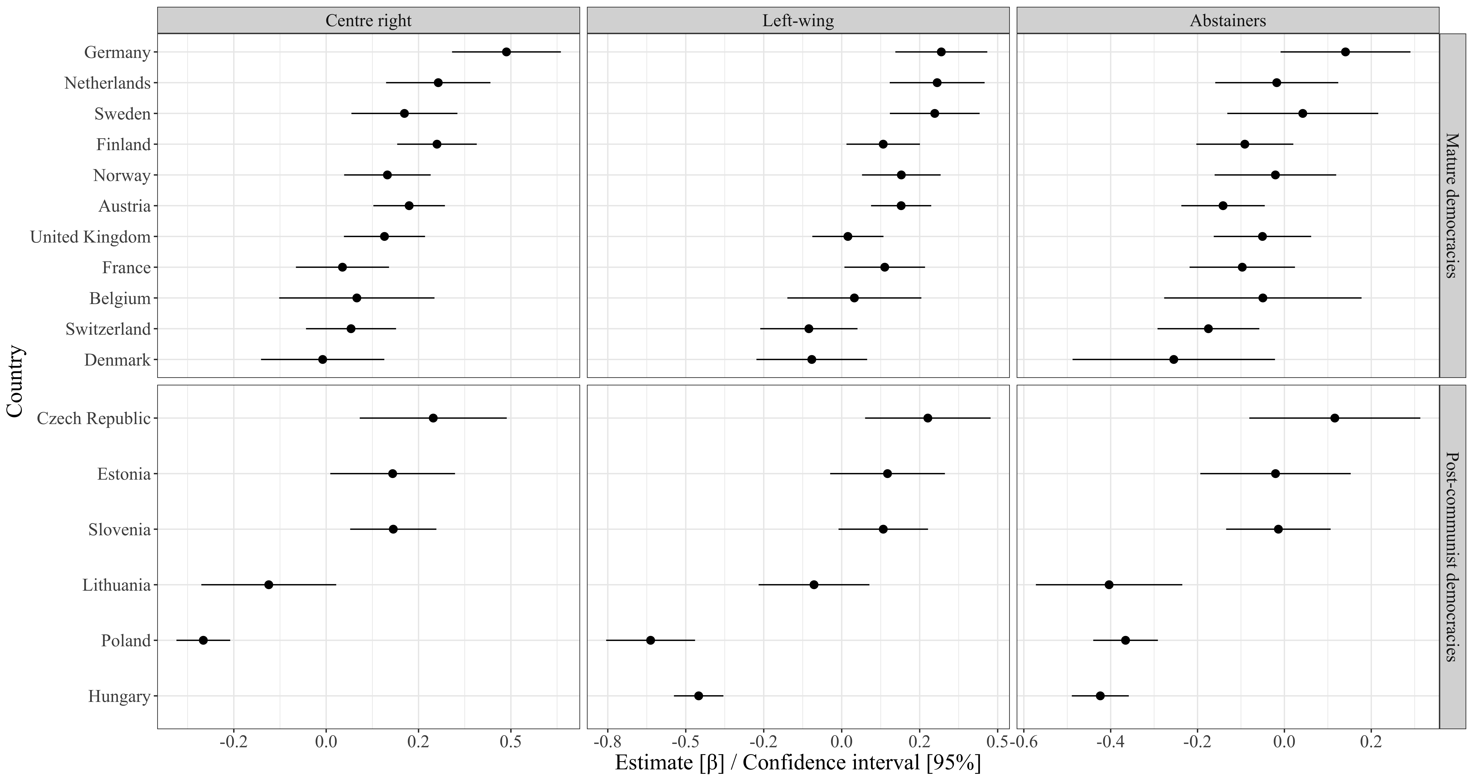
Figure G1. Country-by-country analysis of the effect of trust in national politics. Far-right voters are the reference category.

Furthermore, we have estimated our regression models for different subsets of the sample of countries: we dropped the countries one at a time to assess how sensitive the results are for outlying cases. These results show that our findings are robust to inclusion or exclusion of particular countries.

Third, we assess the effect of the inclusion of different independent variables and thus the three different theories. In order to be able to adequately execute this particular robustness check, we used a series of multilevel logistic regressions. The change of regression method is aimed at enabling the independent specification per model.

To investigate the fit of the model, we made use of Akaike’s Information Criterion (AIC) (Akaike 1974). The reason behind this choice is twofold. First, it controls for the sample size and the number of independent variables per theory. Second, the AIC is appropriate for comparing different hypotheses. This paper investigates multiple hypotheses wherein the question is not: ‘which hypothesis holds the singular truth?’, but rather ‘which hypothesis explains the differences between far-right voters and other groups in a given region most accurately?’ (Chamberlin 1965, as cited in Burnham and Anderson 2004).

Figure G2 presents the results. It shows that, considering the AIC of the models, the model which includes all the hypotheses accounts for the least information loss compared to the models in which the separate hypotheses are tested. This indicates that the three explanatory approaches complement each other, rather than substitute each other.

Furthermore, the results demonstrate that for every comparison between far-right voters and another group, the cultural backlash hypothesis is the best fitting explanatory model, both in mature democracies and post-communist democracies. The only exception occurs when the abstainers are compared to the far-right supporters in CEE – in that case, the differences between far right voters and non-voters is best explained through the ‘protest vote’ approach, rather than the cultural backlash explanation.

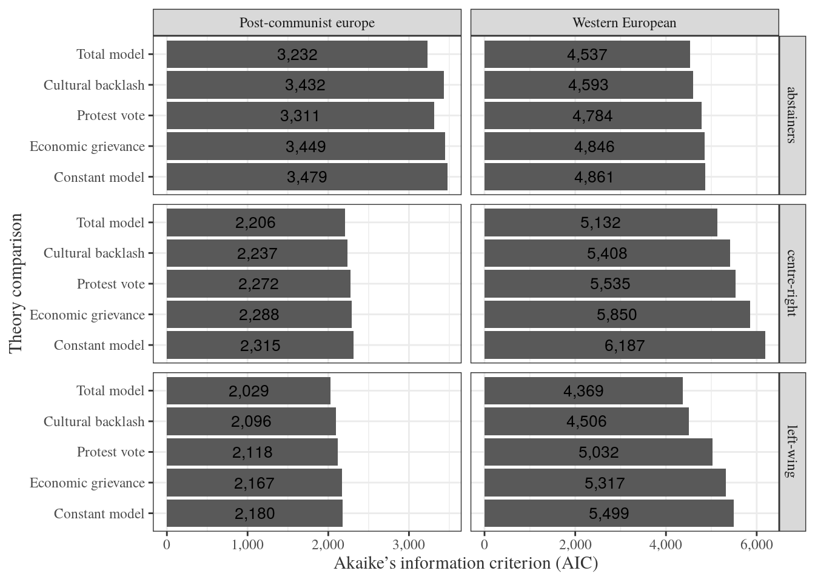
Figure G2. Comparing the model fit of different model specifications based on three explanatory approaches, using multilevel logistic regressions.

References

Akaike, H. (1974). A new look at the statistical model identification. IEEE Transactions on Automatic Control, 19(6), 716-723.
Burnham, K. P., & Anderson, D. R. (2004). Multimodel inference: understanding AIC and BIC in model selection. Sociological Methods & Research, 33(2), 261-304.

