Beyond the Dichotomous Vote: Can Expressive Ballots Increase Ideological Congruence and Decrease Parliamentary Polarization?

Online Appendix

Victor Ellenbroek¹, Maurits J. Meijers²* and André Krouwel³

¹Victor Ellenbroek, Department of Political Science, Nijmegen School of Management, Radboud University, Nijmegen, Netherlands, ²Maurits J. Meijers Department of Political Science, Nijmegen School of Management, Radboud University, Nijmegen, Netherlands, and ³André Krouwel, Department of Communication Science, Vrije Universiteit Amsterdam, Amsterdam, Netherlands
* Corresponding author. Email: m.meijers@fm.ru.nl
Published in Government & Opposition: An International Journal of Comparative Politics, Accepted in 2019.

Appendix 1
Figure A1: Histogram of the number of parties selected in the AB.
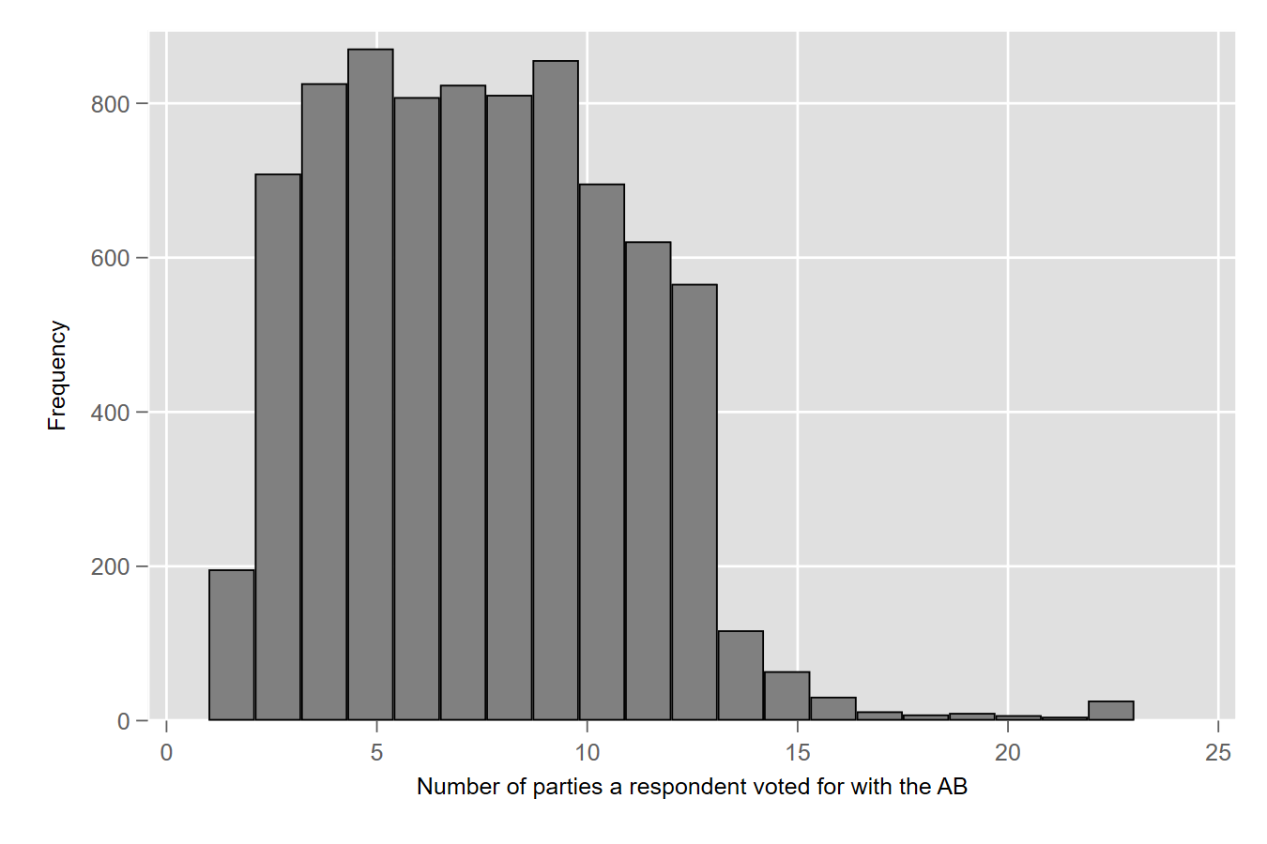
Table A1: Party placements on the economic and cultural dimensions (0–10).
Party | Economic Dimension | Cultural  Dimension
50PLUS | 2 | 3.2
CDA | 5.6 | 6.6
CU | 4.8 | 4.3
D66 | 5.2 | 0.7
DENK | 2.3 | 1.5
Groen Links | 2.7 | 0.7
PvdA | 2.9 | 1.9
PvdD | 0.6 | 1.6
PVV | 6 | 7.5
SGP | 6.3 | 6.6
SP | 0.4 | 2.1
VNL | 6.9 | 6.4
VVD | 8.7 | 7.1

Table A2: Descriptive statistics.

Variable | Obs | Mean | Std.Dev. | Min | Max
Ideological Congruence (Economic Dimension) | 13403 | -1.428 | 1.166 | -9.375 | 0
Ideological Congruence  (Cultural Dimension) | 13401 | -1.73 | 1.432 | -9 | 0
Ballot Type | 13529 | .41 | .492 | 0 | 1
Self-Placement (Economic Dimension) | 13403 | 5.326 | 2.266 | 1 | 11
Self-Placement (Cultural Dimension) | 13401 | 4.403 | 1.99 | 1 | 11
Seat Proportion Largest Party (AB) | 5545 | .344 | .15 | .12 | 1
Political Interest | 9376 | 7.742 | 2.013 | 1 | 10
Sex | 13340 | .675 | .468 | 0 | 1
Age | 13334 | 54.909 | 16.54 | 14 | 108
Education | 13346 | 2.241 | 1.231 | 1 | 7

Source: Election Compass Survey Dutch Elections March 2017.

Table A3: OLS regression models of ideological congruence per dimension.
 | (1) | (2)
 | Congruence Economic Dimension | Congruence Cultural Dimension
Assembly Ballot  (Baseline is Closed List Ballot) | 0.157***  (0.0204) | 0.278***  (0.0250)
Constant | −1.493***  (0.0131) | −1.844***  (0.0160)
N | 13403 | 13401
R² | 0.004 | 0.009
Standard errors in parentheses + p < 0.10, * p < 0.05, ** p < 0.01, *** p < 0.001; (two-tailed)
Source: Election Compass Survey Dutch Elections March 2017.
Table A4: OLS regression models of ideological congruence per dimension including individual-level controls.
 | Model 1  Congruence Economic Dimension | Model 2  Congruence Cultural Dimension
Assembly Ballot  (Baseline is Closed List Ballot) | 0.137***  (0.0233) | 0.292***  (0.0284)
Economic Self-Placement | −0.0762***  (0.00602) | −0.203***  (0.00732)
Cultural Self-Placement | 0.0142*  (0.00687) | 0.103***  (0.00835)
Political Interest | 0.0176**  (0.00580) | 0.00896  (0.00706)
Male (Baseline is Female) | 0.0151  (0.0258) | −0.0816**  (0.0314)
Age | −0.00329***  (0.000745) | −0.00344***  (0.000907)
Education (Baseline is PhD doctoral or Master degree)
University or College undergraduate or candidate | −0.0713**  (0.0275) | −0.122***  (0.0334)
Senior Higher general secondary education or pre-university education | −0.190***  (0.0395) | −0.238***  (0.0480)
Intermediate Vocational training | −0.334***  (0.0391) | −0.302***  (0.0476)
Junior higher general secondary education | −0.267***  (0.0673) | −0.214**  (0.0819)
Lower secondary vocational education | −0.428***  (0.0910) | −0.570***  (0.111)
No/basic education | 0.00442  (0.232) | −0.548⁺  (0.282)
Constant | −0.964***  (0.0708) | −0.906***  (0.0861)
N | 9315 | 9315
R² | 0.041 | 0.101
Standard errors in parentheses + p < 0.10, * p < 0.05, ** p < 0.01, *** p < 0.001; (two-tailed)
Source: Election Compass Survey Dutch Elections March 2017.
Table A5: OLS regression models of ideological congruence per dimension with interactions with distance to closest party.

 | Model 1  Congruence Economic Dimension | Model 2  Congruence Cultural Dimension
Assembly Ballot  (Baseline is Closed List Ballot) | 0.106*  (0.0448) | 0.432***  (0.0618)
Distance Closest Party (Economic) | −2.469***  (0.269)
Assembly Ballot × Distance Closest Party (Economic) | 0.461  (0.420)
Distance Closest Party (Economic)² | 2.457***  (0.313)
Assembly Ballot × Distance Closest Party (Economic)² | −0.0849  (0.488)
Distance Closest Party (Cultural) |  | 0.721***  (0.211)
Assembly Ballot × Distance Closest Party (Cultural) |  | −1.415***  (0.330)
Distance Closest Party (Cultural)² |  | −1.427***  (0.204)
Assembly Ballot × Distance Closest Party (Cultural)² |  | 2.530***  (0.318)
Constant | −1.162***  (0.0288) | −1.796***  (0.0395)
N | 12644 | 11301
R² | 0.024 | 0.052
Standard errors in parentheses + p < 0.10, * p < 0.05, ** p < 0.01, *** p < 0.001; (two-tailed)
Source: Election Compass Survey Dutch Elections March 2017.

Table A6: OLS regression models of ideological congruence per dimension with interactions with ideological self-placement.

 | Model 1  Congruence Economic Dimension | Model 2  Congruence Cultural Dimension
Assembly Ballot  (Baseline is Closed List Ballot) | −2.181***  (0.0978) | −2.904***  (0.109)
Economic Self-Placement | 0.261***  (0.0244)
Assembly Ballot × Economic Self-Placement | 0.890***  (0.0375)
Economic Self-Placement² | −0.0339***  (0.00211)
Assembly Ballot × Economic Self-Placement² | −0.0717***  (0.00327)
Cultural Self-Placement |  | −0.201***  (0.0294)
Assembly Ballot × Cultural Self-Placement |  | 1.283***  (0.0460)
Cultural Self-Placement² |  | 0.00861**  (0.00283)
Assembly Ballot × Cultural Self-Placement² |  | −0.106***  (0.00443)
Constant | −1.746***  (0.0640) | −1.162***  (0.0694)
N | 13403 | 13401
R² | 0.166 | 0.089
Standard errors in parentheses + p < 0.10, * p < 0.05, ** p < 0.01, *** p < 0.001; (two-tailed)
Source: Election Compass Survey Dutch Elections March 2017.
Appendix 2
Experimental Design: Questions
Respondents who were randomly selected to cast a vote with the closed-list ballot were asked the following question: “Could you indicate which party you would vote for in the next parliamentary elections?”. Figure AX shows a screenshot of the closed-list ballot ‘voting procedure’. Respondents who were randomly selected to cast a vote with the Assembly Ballot were presented with the text: “Imagine you could vote in a different way: Rather than voting for one party, you can vote with the so-called ‘Assembly Ballot’. With Assembly Ballot you can determine what your ideal parliament (Second Chamber) looks like. The Second Chamber has 150 seats. You can divide these seats across all parties participating in the elections. In this question you can vote with an Assembly Ballot. Could you indicate how many seats you would allocate to each party. The total number of seats have to add up to 150.” Figure AX shows a screenshot of the Assembly Ballot ‘voting procedure’.
Figure A2: Screenshot of the closed-list ballot ‘voting procedure’. (N.B.: Not all parties are shown.)
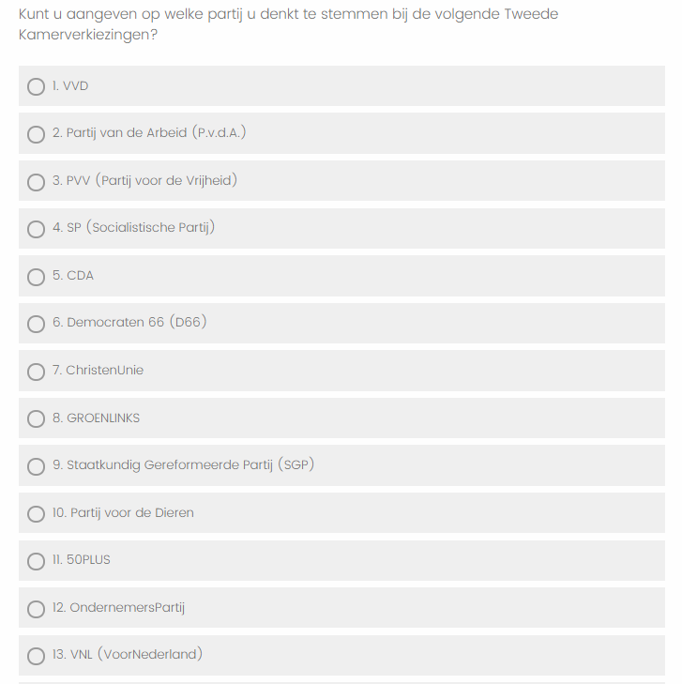

Figure A3: Screenshot of the Assembly Ballot ‘voting procedure’. (N.B.: Not all parties are shown.)

