**Online appendix**

Kerby, Matthew and Feodor Snagovsky, 2019,“Not all experience is created equal: MP Career typologies and ministerial appointments in the Canadian House of Commons, 1968-2015”  *Government and Opposition*.

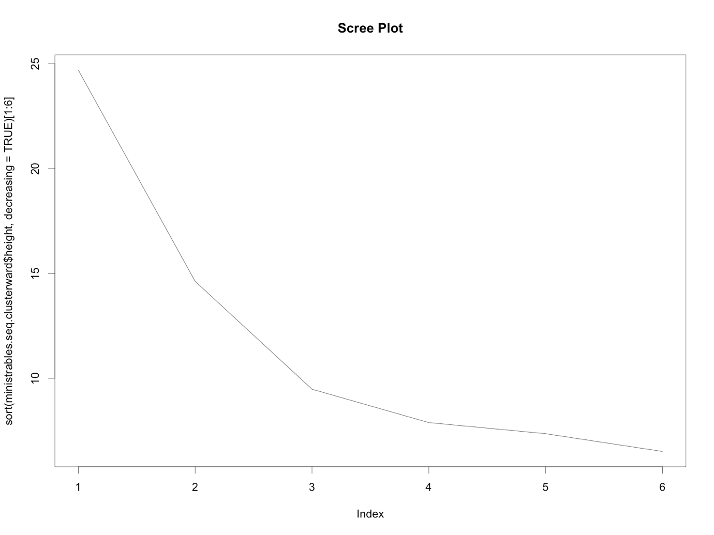



<Typesetter: please change spelling from 'Sihouette' to 'Silhouette' in top left of figure>