Appendix to “The Intensity of Government–Opposition Divide as Measured through Legislative Speeches and What We Can Learn from It: Analyses of Japanese Parliamentary Debates, 1953–2013”, by Luigi Curini, Airo Hino and Atsushi Osaka, Government & Opposition

The Wordfish algorithm
The Wordfish model, estimated through an expectation maximisation algorithm, is expressed as follows: $y_{ijt}\sim Poisson\left(λ_{ijt}\right)$, where $λ_{ijt}=exp\left(α_{it}+ψ_{j}+β_{j}*ω_{it}\right)$. In detail: y_{ijt} is the count of word j in actor i’s document (in our case: legislative speeches) at time t; α_{it} is the set of actor (i.e. party) fixed effects; $ψ_{j}$ is a set of word fixed effects; β_{j} is an estimate of a word specific weight capturing the importance of word j in discriminating between positions; and ω_{it} is the estimate of actor i’s position at time t. Words often used tend to have high ω coefficients but little distinguished positions (i.e. low β coefficients). On the contrary, relevant words are those that are not used that often but present high β coefficients. It is these words that are powerful discriminators of speeches, and therefore of speaker positions. In our case, the model was identified by fixing the mean position at 0, the standard deviation at 1, and by constraining the legislative speech by the Communist MP Kanichi Kawakami (parliamentary group leader) during Diet 50 in 1965 to have a smaller value than the speech by the LDP leader Eisaku Satō in 1968 during Diet 59. Selecting other legislative speeches as constraints on the overall identification of the model does not affect any of the results reported in the text.
Figure 1A shows a scatterplot of each word in the two dimensions of beta (on the horizontal axis) and psi (on the vertical axis) for the speeches analysed. The figure shows that some words are located on the two extremes on the horizontal axis, scoring high positive or negative beta coefficients. As discussed, these words are powerful discriminators of party positions. In Figure 1A we also show some selected words.

Figure 1A. Word estimates according to Wordfish for the Japanese legislative speeches
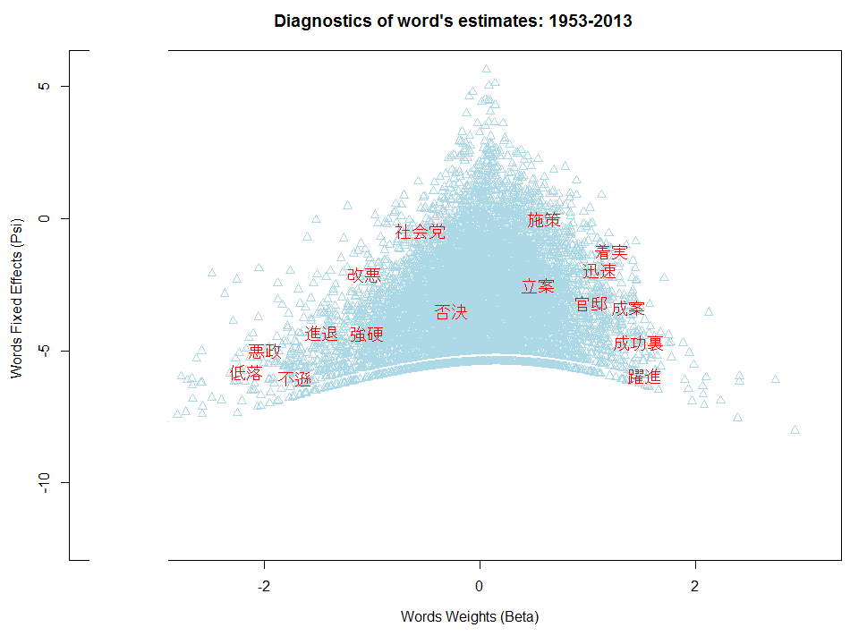

The estimated statistical models for the survival rate of Japanese cabinets and the duration of Japanese cabinet bills

Table 1A. Explanatory factors of the survival rate of Japanese cabinets
(Discrete-time survival model– Cox regression)
 | Model 1 | Model 2 | Model 3
- IGO index | 0.253* | - | 0.253*
 | (0.100) |  | (0.100)
- IP index | - | −0.046 | −0.036
 |  | (0.117) | (0.121)
- Number of parties | −0.267 | −0.307 | −0.252
 | (0.196) | (0.204) | (0.195)
- LDP strength | −5.057** | −4.499** | −5.078**
 | (1.608) | (1.395) | (1.687)
- Components of cabinet | 0.570*** | 0.475*** | 0.564***
 | (0.088) | (0.073) | (0.084)
- Different majority in the Upper House | 0.749** | 0.603* | 0.733**
 | (0.232) | (0.253) | (0.255)
- Approval rate of the cabinet | −0.036** | −0.030** | −0.036**
 | (0.013) | (0.011) | (0.013)
- Cycle of the Lower House | −0.005*** | −0.005*** | −0.006***
 | (0.002) | (0.001) | (0.002)
- Cycle of the Lower House squared | 0.000** | 0.000*** | 0.000**
 | (0.000) | (0.000) | (0.000)
Observations | 74 | 74 | 74
AIC | 285.551 | 288.473 | 287.522
Log Pseudolikelihood | −134.775 | −136.236 | −134.761
Clustered standard errors on Legislature in parentheses
⁺ p < 0.10, * p < 0.05, ** p < 0.01, *** p < 0.001

Table 2A. Determinants of the duration of Japanese cabinet bills
(Fractional Logit Model)
 | Model 4 | Model 5 | Model 6
- IGO index | 0.325* | - | 0.321*
 | (0.156) |  | (0.151)
- IP index | - | 0.097 | 0.075
 |  | (0.196) | (0.178)
- Number of parties | −0.011 | −0.017 | −0.016
 | (0.214) | (0.200) | (0.205)
- LDP strength | −1.791 | 1.337 | −1.379
 | (5.207) | (5.210) | (5.459)
- Components of cabinet | −0.220 | −0.243 | −0.199
 | (0.138) | (0.150) | (0.151)
- Majority different in the Upper House | −0.625* | −0.492 | −0.539⁺
 | (0.266) | (0.365) | (0.315)
- Cycle of the Lower House | 0.001 | 0.001 | 0.001
 | (0.001) | (0.001) | (0.001)
- Cycle of the Lower House squared | −0.000 | −0.000 | −0.000
 | (0.000) | (0.000) | (0.000)
- Constant | −0.245 | −0.297 | −0.641
 | (3.724) | (4.347) | (4.097)
Observations | 49 | 49 | 49
AIC | 60.567 | 61.149 | 62.543
Log Pseudolikelihood | −22.283 | −22.575 | −22.272
Clustered standard errors on Legislature in parentheses
⁺ p < 0.10, * p < 0.05, ** p < 0.01, *** p < 0.001

