Supplementary Text S1 – Rate and state friction model of the Slochteren base case scenario

S1.1 Rate and state friction model methodology
To simulate fault reactivation and dynamic slip, we use rate-and-state dependent friction laws in our models (Dieterich, 1979, 1981; Ruina, 1983). The rate-and-state constitutive equations relate the evolution of the friction coefficient along the fault to the slip velocity and the change in the state of the fault surface over time. These principles are based on laboratory tests, in particular velocity-stepping and slide-hold-slide experiments.
In a general form that quantifies the dependence on slip history with a single state variable, the rate and state laws can be formulated as follows
$μ=f\left(V,θ\right)$ (S1.1)
$\frac{dθ}{dt}=g(V,θ)$ (S1.2)
where $μ$ is the friction coefficient along the fault given as a function of the slip rate,$V$, and the state of the fault, $θ$. The latter parameter is associated with any parameter suitable for the characterization of the sliding surface, e.g. the average size of the asperity contacts, grain size distribution or porosity of the fault gouge (Segall, 2010).
An important observation in velocity-stepping experiments is the so called “direct effect”, which is represented in the rate-and-state laws as the condition
$\frac{∂f\left(V,θ\right)}{∂V}>0$ (S1.3)
which means that a sudden increase or decrease of the slip velocity $V$ results in an increasing or decreasing friction coefficient $μ$, respectively (Lapusta et al., 2000).
The most commonly used form of equation (S1.1) is
$μ\left(t\right)=μ_{0}+a\ln\left(\frac{V\left(t\right)}{V_{0}}\right)+b\ln\left(\frac{V_{0}θ\left(t\right)}{D_{c}}\right)$ (S1.4)
where $μ_{0}$ is a nominal coefficient of friction (usually $μ_{0}=0.6$) at the reference slip rate $V_{0}$, $a$ and $b$ are scaling parameters describing the direct effect and the evolution effect, respectively, and $D_{c}$ is the characteristic distance over which the frictional resistance develops after a sudden change in slip velocity (Segall, 2010).
The state evolution law, eq. (S1.2) has been formulated by several authors in different ways. The evolution equation we use in this study is the slip law (Ruina, 1983):
$\frac{dθ(t)}{dt}=-\frac{V\left(t\right)θ\left(t\right)}{D_{c}}ln\left(\frac{V\left(t\right)θ\left(t\right)}{D_{c}}\right)$ (S1.5)
Due to the logarithmic form of equation (S1.4), the shear stress is not defined at $V=0$ along the fault, i.e. immediately before reactivation occurs. To solve this problem, regularized rate and state equations were suggested by Rice and Ben-Zion (1996), so eq. (S1.4) can be rewritten as:
$μ\left(θ,V\right)=a ∙\operatorname{arcsinh}\left[\frac{V(t)}{2V_{0}}\exp\left(\frac{θ(t)}{a}\right)\right]$ (S1.6)
and the slip law (eq. S1.5) takes the form of
$\frac{∂θ(t)}{∂t}=-\frac{V\left(t\right)}{D_{c}}\left(μ\left(θ,V\right)-μ_{ss}\right)$ (S1.7)
where $μ_{ss}=μ_{0}+\left(a-b\right)∙ln⁡(V(t)/V_{0})$ is the static friction coefficient at $∂V/∂t=0$.

To simulate fault reactivation, stress balance along the fault is described as
$τ+ δτ_{qs} - β_{rad}V = μ(θ,V) \left(σ_{N}^{'} + δσ_{qs}\right)$ (S1.8)
where $τ$ and $σ_{N}^{'}$ are the shear stress and effective normal stress induced on the fault due to interaction with the reservoir, $δτ_{qs}$ and $δσ_{qs}$ are the quasi-static shear stress and normal stress components corresponding to the elastic stress transfer due to fault slip. $V$ is slip the velocity and $β_{rad}$ is the radiation damping factor. To obtain the shear displacement, $u_{s}$, along the fault, the system of ordinary differential equations consisting of equations (S1.6), (S1.7) and (S1.8) are solved jointly (iteratively) for the slip velocity vector that provides the displacement vector along the fault. The system of these equations is implemented in the fully-coupled, finite element numerical simulator, GOLEM(Cacace & Jacquey, 2017).

S1.2 Rate and state friction model setup
The Rate- and state friction Slochteren _Base Case model is the same as the Slip Tendency model except for the additional constitutive fault slip behavior described above. The additional model parameters are summarized in Table S1. The dynamic fault slip behavior requires a higher time step resolution. Therefore, a different time stepping algorithm was used as compared to the ST model.
Most fault gauges tested by Hunfeld et al. (2017) showed velocity-strengthening behavior except for some cases of the Basal Zechstein anhydrite-carbonate material at the top of the Slochteren reservoir, which thus shows the highest seismogenic potential. However, as indicated above, we are using the same Rate-and-state friction (RSF) parameters for the entire fault.
Table S1: Rate- and state friction parameters for the Slochteren Base Case model.
RSF a-value | 0.005 (Hunfeld et al., 2017)
RSF b-value | 0.0025 (Hunfeld et al., 2017)
RSF (a-b)-value | 0.0025 (Hunfeld et al., 2017)
RSF critical slip distance dc | 1e-5 m (Hunfeld et al., 2017)

S1.3 Rate and state friction model results
In the rate- and state friction model the dynamic fault slip behavior is additionally considered. That means that the slip velocity (Figure S1), friction coefficient (Figure S2), cumulative seismic moment (Figure S3) and cumulative slip (Figures S3 and S4) can be evaluated. The RSF parameters determined by Hunfeld et al. (2017) for Slochteren faults mainly show velocity neutral to velocity strengthening behavior. The resulting maximum slip velocities are thus extremely low and indicate aseismic creep-like behavior. That means, while the slip tendency model may indicates that the fault becomes critically stressed and may slip after ~13 years, this slip is likely to be aseismic as a result of the RSF model. Velocity weakening RSF parameters may show a decisively different behavior. If the cumulative seismic moment after 30 years shown in Figure S3 would be released in a single seismic event, this event would have a moment magnitude of 3.6.
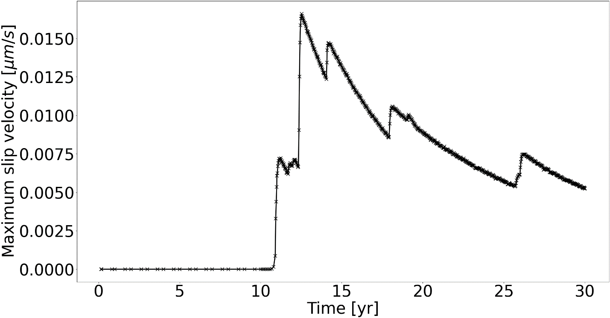
Figure S1: Maximum slip velocity on the fault in the base case Slochtern model during 30 years of fluid circulation.
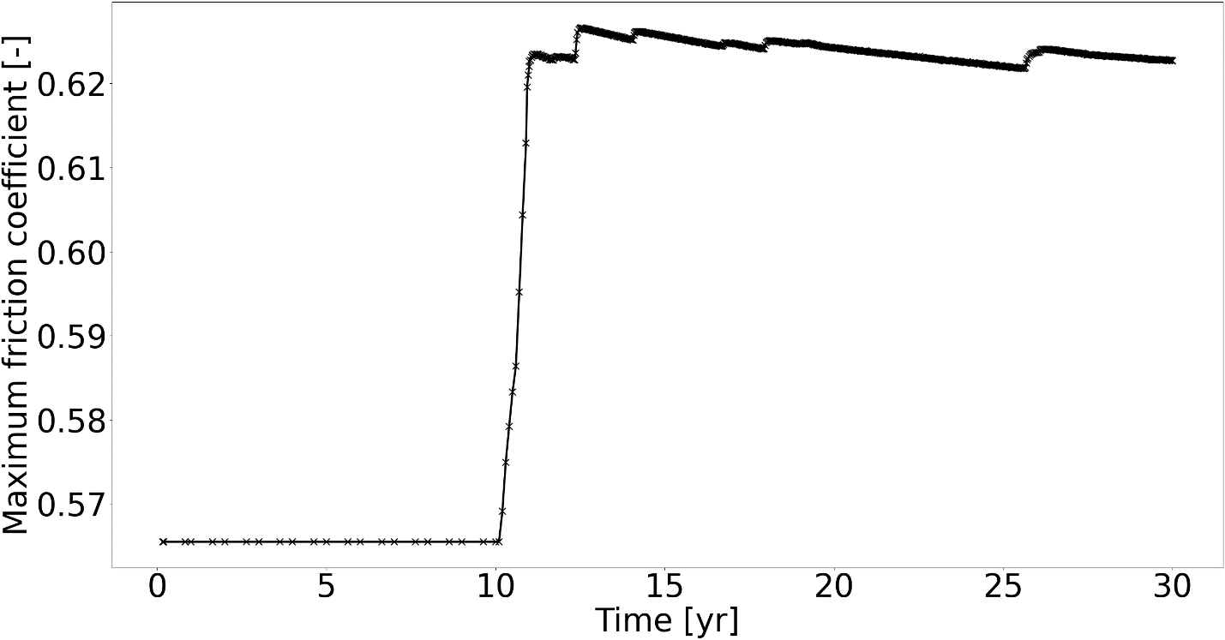
Figure S2: Maximum friction coefficient on the fault in the base case Slochteren model during 30 years of fluid circulation.
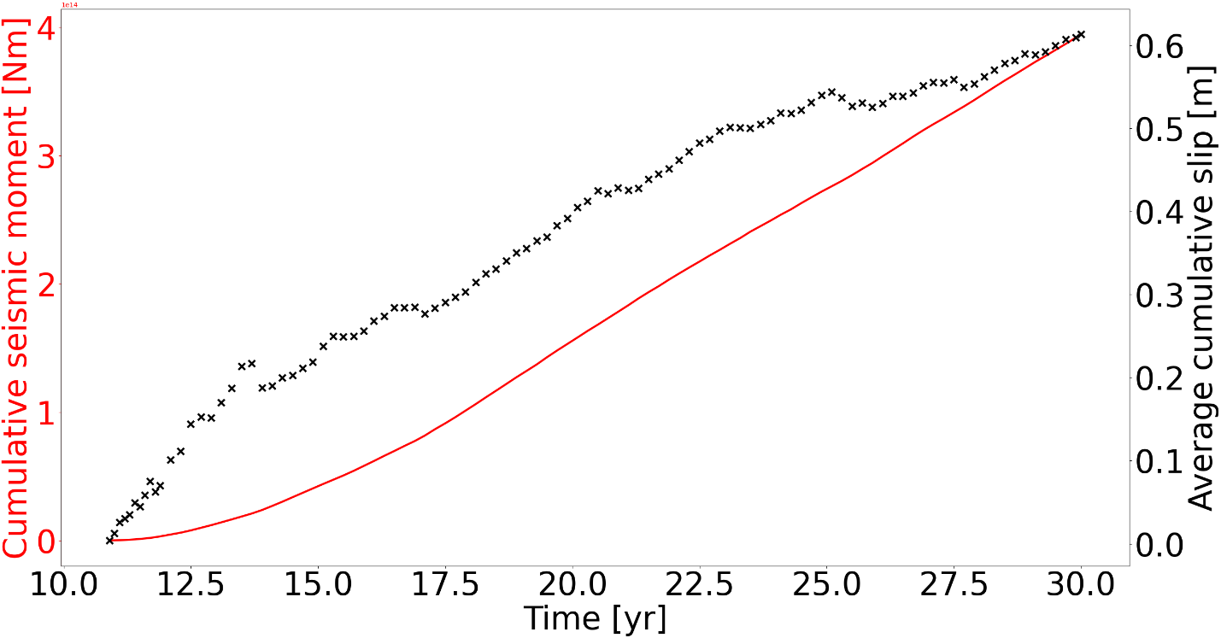
Figure S3: Cumulative seismic moment and average cumulative slip resulting from the RSF base case Slochteren model during 30 years of fluid circulation using the area of the fault where the slip tendency is above the friction coefficient of 0.6. Slip starts after 10 years. If the cumulative seismic moment would be released in a single event, this would equal to a Mw 3.6 event.
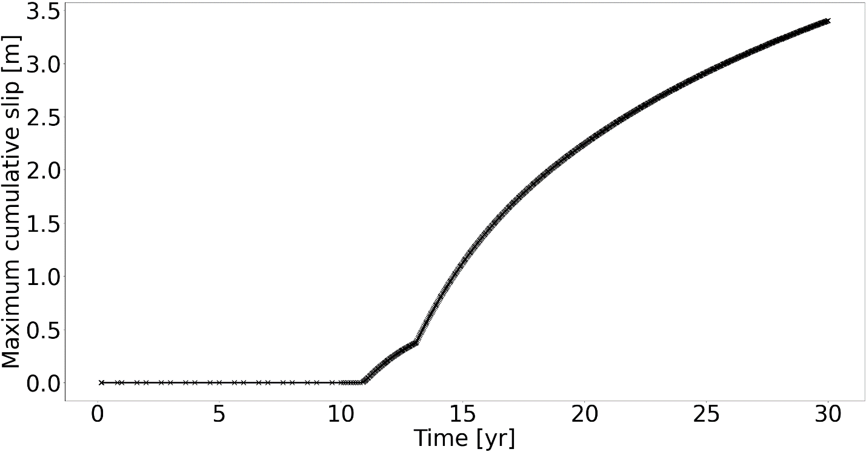
Figure S4: Maximum cumulative slip resulting from the RSF base case Slochteren model during 30 years of fluid circulation. Slip starts after 10 years and increases after ~14 years when the part of the fault intersecting the bottom layer experiences higher temperature changes and resulting thermal stresses.
References
Cacace, M. & Jacquey, A.B., 2017. Flexible parallel implicit modelling of coupled thermal–hydraulic–mechanical processes in fractured rocks. Solid Earth 8: 921–941.
Dieterich, J.H., 1979. Modeling of rock friction: 1. Experimental results and constitutive equations. Journal of Geophysical Research: Solid Earth 84(B5): 2161–2168. doi: https://doi.org/10.1029/JB084iB05p02161
Dieterich, J.H., 1981. Constitutive properties of faults with simulated gouge. Mechanical Behavior of Crustal Rocks 24: 103–120.
Hunfeld, L.B., Niemeijer, A.R. & Spiers, C.J., 2017. Frictional properties of simulated fault gouges from the seismogenic groningen gas field under in situ P–T‐chemical conditions. Journal of Geophysical Research: Solid Earth 122(11): 8969–8989.
Lapusta, N., Rice, J.R., Ben-Zion, Y. & Zheng, G., 2000. Elastodynamic analysis for slow tectonic loading with spontaneous rupture episodes on faults with rate- and state-dependent friction. Journal of Geophysical Research: Solid Earth 105(B10): 23765–23789. doi: 10.1029/2000JB900250
Rice, J.R. & Ben-Zion, Y., 1996. Slip complexity in earthquake fault models. Proceedings of the National Academy of Sciences 93(9): 3811–3818. doi: 10.1073/pnas.93.9.3811
Ruina, A., 1983. Slip instability and state variable friction laws. Journal of Geophysical Research: Solid Earth 88(B12): 10359–10370. doi: https://doi.org/10.1029/JB088iB12p10359
Segall, P., 2010. Earthquake and volcano deformation. Princeton University Press (Princeton, N.J): 432 pp.

