Supplementary Material for: Large-scale morphological changes and sediment budget of the Western Scheldt estuary 1955-2020 – The impact of large-scale sediment management.4 The Supplementary Material includes:
- Supporting text concerning the section: Dealing with uncertainty and errors details of the study area and its history
- Historical information on the estuary and its development.
- Overview of bathymetric maps used in this study.

Dealing with uncertainty and errors
The bathymetric data used in this study are not without flaws. A good understanding of the data accuracy is a prerequisite when assessing the sediment budget. Changes in survey techniques and instruments, positioning systems, variations in correction and registration methods, and changes in interpolation techniques over time make it difficult to estimate the exact accuracy of the measurements and the resulting maps.
Bed level accuracy is always crucial for a sediment budget analysis. The importance of horizontal accuracy for the sediment budget depends on the method used to assess the volume changes and the nature of the changes, and the slope of bed (greater importance for steeper slopes because the same horizontal change causes a greater vertical change when the slope is steeper). In addition to the data's accuracy, assumptions regarding the sediment budget impact its accuracy. The discussion section elaborates on these assumptions and their implications. The vertical accuracy of the Vaklodingen data was estimated by Wiegmann et al. (2005) and Perluka et al. (2006) to range between 0.11 - 0.40 m. Storm et al. (1993) indicate that errors depend on the morphologic unit surveyed. For intertidal areas, channels and flats, and channel slopes, stochastic (random) errors are 0.23, 0.19, and 0.39 m, respectively, and systematic errors (bias) are -0.20, -0.10, and -0.25 m. Marijs & Parée (2004) provide a detailed overview of possible measurement errors focusing on the Western Scheldt datasets. These authors conclude that the Vaklodingen data contains three sources of error:
(1) Stochastic errors due to individual data outliers. Improvements in instruments, measuring techniques, and protocols reduced the stochastic error from 0.48 m (1969-1983) to 0.44 m (1985-1989) and 0.36 m (1995-present). Bollebakker & Van der Male (1993) and Storm et al. (1993) prove that random errors may induce a volume error at a local scale (low data density). However, the cumulative volume errors are insignificant at higher data density or larger spatial scales (e.g., an entire Vaklodingen sheet), because stochastic errors are random and tend to cancel out in larger datasets (Anderson, 2019).
(2) Systematic error introduced by the instruments. Analysis of Vaklodingen data in the Western Scheldt identified three sources of systematic errors: squat of the survey vessel, local water level models, and false heave (Lekkerkerk et al., 2007). Both squat and false heave result from the motions of the survey vessel. Before 2001 all the survey vessels obtained data relative to the local water level. Water levels relative to NAP were obtained through correction using estimates of the tide level. These estimates were initially based on measurements of nearby stations and tidal maps (so-called reduction charts), while since 1989, tidal models have been used. These tidal corrections didn’t include the squat. As a result, all Western Scheldt measurements before 2001 have an approximate 15 cm overestimation of water depth on the shoals and up to 25 cm in the channels (Marijs & Parée, 2004). In this study, all datasets before 2001 were corrected to minimize this error. Since 2001 data have been obtained using Long Range Kinematic GPS positioning that accurately provides the ship's x, y, and z position based on satellite altimetry, effectively eliminating this error.
(3) User errors. A third source of error concerns variable systematic errors introduced by ‘user errors’ in measuring and data handling. These errors introduce volume variations in a Vakloding sheet, ranging between 0.1 and 12 million m³. In general, stochastic and systematic errors have decreased since 1993 with the introduction of more accurate echo sounders. Indications for introducing errors through data handling manifest in overrepresenting specific depths in the data. In the datasets before 1989, the decimetre values are systematically more abundant than the centimetre values. This overabundance likely originated from interpolating registered decimetre values to an entire grid in centimetre values. This flaw in the data probably has no repercussions for the sediment budget, but it does indicate that the accuracy of the data before 1989 is less than that of more recent data.
The accuracy of horizontal positioning (x, y) has increased over time with the evolution of technology. Before radio-based positioning (‘Decca’), classic techniques were used, including sighting landmarks in the nearshore and in the Western Scheldt using sextants. The accuracy of radio-based-positioning has increased over time. Eventually, satellite-based positioning (GPS) has taken over, aided by land-based support stations (DGPS-LRK). In general, positioning close to land has been more accurate than positioning further offshore because all techniques rely (in part) on land-based support (landmarks, stations). Similar to the bed level accuracy, the errors in the horizontal positioning consist of stochastic errors, systematic errors, and flaws.
The impact of the horizontal positioning accuracy on the sediment budgets depends on the choice of the sections and the characteristics of the changes in bathymetry. For example, when considering the Western Scheldt as a single section in the sediment budget, a slight shift in the position of its boundaries or shifts of the positions of the channels do not affect the water volume within the section. Determining the inverse of the water volume in the Western Scheldt over time is sufficient to determine its sediment budget.
When considering units with similar morphodynamic behaviour (areas of erosion and deposition) in the sediment budget, the spatial variations in depths and depth gradients determine whether a shift in a position significantly affects the sediment budget (Elias et al., 2016). For a large area with little spatial variations in depth, a shift in the horizontal position results in a small volume change; This is the overall situation in the Voordelta, including the mouth of the Western Scheldt. Conversely, a shift in the horizontal position results in a significant volume change for a small area with large spatial variations in water depth. In the Western Scheldt, this is the prevailing situation. Therefore, the sediment budget sections within the Western Scheldt are sufficiently large (e.g., macrocell level) to reduce the impacts of horizontal positioning (in)accuracies.
The most obvious flaws in the bathymetric data can be corrected. Without having access to the actual ship data, correction for measurement error is not a trivial task and can only be performed based on expert judgment. Elias et al. (2015) performed such correction for the mouth area based on visual inspection of the sequences of sedimentation-erosion maps. Careful inspection of these sequences allows identifying outliers and systematic inconsistencies in the data. Sounding sheets showing improbably large changes compared with preceding and following surveys in a few years were excluded from the analysis.
References.
Anderson, S.W., 2019, Uncertainty in quantitative analyses of topographic change: error propagation and the role of thresholding, Earth Surface Processes and Landforms: 44, 1015-1033.
Bollebakker, P. & van der Male, C., 1993. Invloed stochastische fout op inhoudsberekeningen. Report GWWS-93.831X, Rijkswaterstaat (Middelburg) (in Dutch).Lekkerkerk et al., 2007
Elias, E.P.L. & van der Spek, A.J.F., 2015. Uitwerking sedimentbudget van de Westerscheldemonding. Report 1210304-012, Deltares (Delft) (in Dutch).
Elias, E.P.L., van der Spek, A.J.F. & Lazar, M., 2016. The ‘Voordelta’, the contiguous ebb-tidal deltas in the SW Netherlands: large-scale morphological changes and sediment budget 1965–2013; impacts of large-scale engineering. Netherlands Journal of Geosciences 96: 233-259. https://doi.org/10.1017/njg.2016.37
Marijs, K. & Parée, E., 2004. Nauwkeurigheid vaklodingen Westerschelde en monding - “de praktijk”. Report ZLMD-04.N.004, Rijkswaterstaat (Zeeland): 46 pp. (in Dutch).
Perluka, R., Wiegmann, E.B., Jordans, R.W.L. & Swart, L.M.T., 2006. Opnametechnieken Waddenzee. Report AGI-2006-GPMP-004, Rijkswaterstaat (Delft): 47 pp. (in Dutch).
Storm, C., Bollebakker, P., de Jong, J. & Mol, G., 1993. Nauwkeurigheid zandbalans Westerschelde 1965-1990 en aanbevelingen ter optimalisatie. Report RIKZ-94.008, Rijkswaterstaat (Middelburg): 38 pp. (in Dutch).
Wiegmann, E.B., Perluka, R., Oude Elberink, S. & Vogelzang, J., 2005. Vaklodingen: De inwintechnieken en hun combinaties. Report AGI-2005-GSMH-012, Rijkswaterstaat (Delft): 47 pp. (in Dutch).

Morphological evolution of the Western Scheldt
Comprehensive overviews of the natural processes and human interferences that have influenced the morphological evolution of the Western Scheldt estuary over the past two centuries are given by, e.g., Coen (1988), Van den Berg et al. (1996) and Van der Spek (1997).
The Western Scheldt came into being between the 14th and 16th centuries as the river Scheldt connected to the tidal basin of the Honte (see Vos, 2015, p. 88-89 for a detailed account). By the 17th century, the Western Scheldt estuary had essentially formed. At this time, expansive channels, tidal flats, and marshes along the northern side of the estuary were present that connected the Western and Eastern Scheldt estuaries. On the south side the side channels with adjacent marshes of Braakman, Hellegat, and Verdronken (drowned) Land van Saeftinghe were present. These marsh areas and the connecting channels silted up naturally or were dammed in the following centuries (Van der Spek, 1997; Dam et al., 2022). In the first detailed hydrographic map, surveyed between 1799 and 1811 (Figure 1), the marshes of Braakman, Kreekrak, and Sloe are still visible.
The morphology of the estuary changed significantly between 1800 and 2021 (Figure 2 through Figure 12). The Kreekrak and Sloe channels that connected the Eastern and Western Scheldt were blocked at the end of the 19th century when dams were built across these areas to establish a railroad connection between Bergen op Zoom in the east and Vlissingen in the west (Kreekrakdam 1866-1868 and Sloedam 1871). From then on, the distributaries of Rhine and Meuse and the mouth of the Scheldt were strictly separated (Pieters et al., 1991). Only the Verdronken Land van Saeftinghe has remained a central tidal marsh area. Land reclamations decreased the intertidal storage area from 295 km² in 1650 to 196 km² in 1800 and to 104 km² in the recent Western Scheldt (Van der Spek, 1997).
In the estuary, meandering ebb channels dominate the morphological developments with annual migration rates of tens of meters from 1800 to 1930 (Figure 2 and Figure 3). This process was increasingly constrained around 1930 as the channels reached the protected embankments of the estuary (Van den Berg et al., 1996). Migration now stopped, and channel banks steepened. As a result, bank failures and slides have been observed at various locations (De Bruin & Wilderom, 1961; Mastbergen et al., 2019), prompting the further reinforcement of vulnerable channel walls with protective layers of gravel or slag.
Since the 1930s, the large-scale morphology of the Western Scheldt has been relatively stable, displaying a regular, repetitive pattern of mutually evasive meandering ebb channels and straight flood channels separated by sub- and intertidal shoals (e.g., Van Veen et al., 2005; Van den Berg et al., 1996; Jeuken, 2000; Toffolon & Crosato, 2007). Winterwerp et al. (2001) refer to this repetitive pattern as a series of meso- and macrocells. Despite stability on the macro level, large-scale dynamics of the smaller-scale channels and shoals can still occur. A significant change is the shift of the main channel in the central part of the estuary (Mc4). Untill 1982, the ebb channel along the northern embankment of the estuary (Middelgat) was the main navigation channel (Figure 6).
However, a channel bend cut-off that originated in 1951 resulted in significant natural sediment deposition in the main ebb channel and erosion of the secondary flood-dominated channel (see, e.g., Jeuken 2000). The increased dimensions of the flood channel enabled a formal relocation of the navigation channel to this channel in 1982. Continued channel migration tendencies and channel deepenings require local maintenance dredging. At the same time, the entrance of the flood channel has been a sediment disposal location since the eighties. Significant changes in the western part of the estuary resulted from the closure of the side channels Sloe and Braakman. Before closure, these side channels were connected to the main channels in the estuary and mouth. As a result of the complete closures that occurred in the 1950s, these channels are gradually infilling (Dam, 2017).
Sedimentation in the now closed-off side channels Sloe and Braakman, which were sediment sinks up to 1955, is counted as export from (the present configuration of) the estuary. Bakker & De Loof (1977) show a sediment deposition of 20.6 million m³ in Sloe and 31.1 million m³ in Braakman between 1878 and 1952 and an additional 41.9 million m³ accreted on the marsh area of Saeftinghe.
The reversal from sediment export to import likely occurred earlier as during the last century, the effect of human interventions increasingly influenced the developments. Around 1905, small-scale dredging activities to improve navigability started, while maintenance dredging started in 1925 near Bath and increased and expanded considerably since 1970, the first deepening of the navigation channel.

References
Bakker, Th.J.N.P. & De Looff, D., 1977. Onderzoek naar de mogelijkheden tot en de gevolgen van zandwinning in de Westerschelde. Report WWKZ-77.4, Rijkswaterstaat (The Hague): 58 pp. (in Dutch).
Coen, I., (1988). Ontstaan en ontwikkeling van de Westerschelde. Water 43: 157-192 (in Dutch).
Dam, G. (2017). Lange-termijn sedimentbalans van de Westerschelde. Report 1778/U16516/D/GD, Svasek Hydraulics: 64 pp. (in Dutch)
Dam, G., van der Wegen, M., Taal, M. & van der Spek, A., 2022. Contrasting behaviour of sand and mud in a long-term sediment budget of the Western Scheldt estuary. Sedimentology 69: 2267-2283. https://doi.org/10.1111/sed.12992
De Bruin, M.P. & Wilderom, M.H., 1961. Tussen Afsluitdammen en Deltadijken; Part 1; Noord-Beveland. Van Benthem & Jutting (Middelburg): 304 pp. (in Dutch)
Jeuken, M.C.J.L. & Wang, Z.B., 2010. Impact of dredging and dumping on the stability of ebb-flood channel systems. Coastal Engineering 57: 553-566. https://doi.org/10.1016/j.coastaleng.2009.12.004
Mastbergen, D.R., Beinssen, K. & Nédélec, Y., 2019. Watching the beach steadily disappearing: The evolution of understanding of retrogressive breach failures. Journal of Marine Science and Engineering 7: 368. https://doi.org/10.3390/jmse7100368
Pieters, T., Storm, C., Walhout, T. & Ysebaert, T. (eds.), 1991. Het Schelde-Estuarium, meer dan een Vaarweg. Report GWWS-91.081, Rijkswaterstaat (Middelburg): 135 pp. (in Dutch).
Toffolon, M. & Crosato, A., 2007. Developing macroscale indicators for estuarine morphology: The case of the Scheldt estuary. Journal of Coastal Research 23: 195-212.
Van den Berg, J.H., Jeuken, M.C.J.L. & van der Spek, A.J.F., 1996. Hydraulic processes affecting the morphology and evolution of the Western-Scheldt estuary. In: Nordstorm, K.F., Roman, C.T. (eds.), Estuarine Shores: Evolution, Environments and Human Alterations. John Wiley (London): 157-184.
Van der Spek, A.J.F., 1997. Tidal asymmetry and long-term evolution of Holocene tidal basins in The Netherlands: simulation of paleo-tides in the Schelde estuary. Marine Geology 141: 71-90.
Van Veen, J., van der Spek, A.J.F., Stive, M.J.F. & Zitman, T., 2005. Ebb and flood channel systems in the Netherlands tidal waters. Journal of Coastal Research 21: 1107-1120.
Vos, P.C., 2015. Origin of the Dutch coastal landscape. Long-term landscape evolution of the Netherlands during the Holocene, described and visualized in national, regional and local palaeogeographical map series. PhD thesis, Utrecht University. Barkhuis (Groningen): 359 pp.
Winterwerp, J.C., Wang, Z.B., Stive, M.J.F., Arends, A., Jeuken, M.C.J.L., Kuijper, C. & Thoolen, P.M.C., 2001. A new morphological schematisation of the Western Scheldt estuary, The Netherlands. In: Proceedings 2nd IAHR symposium on River, Coastal and Estuarine Morphodynamics, Sept 2001, Obihiro, Japan: 525-534.

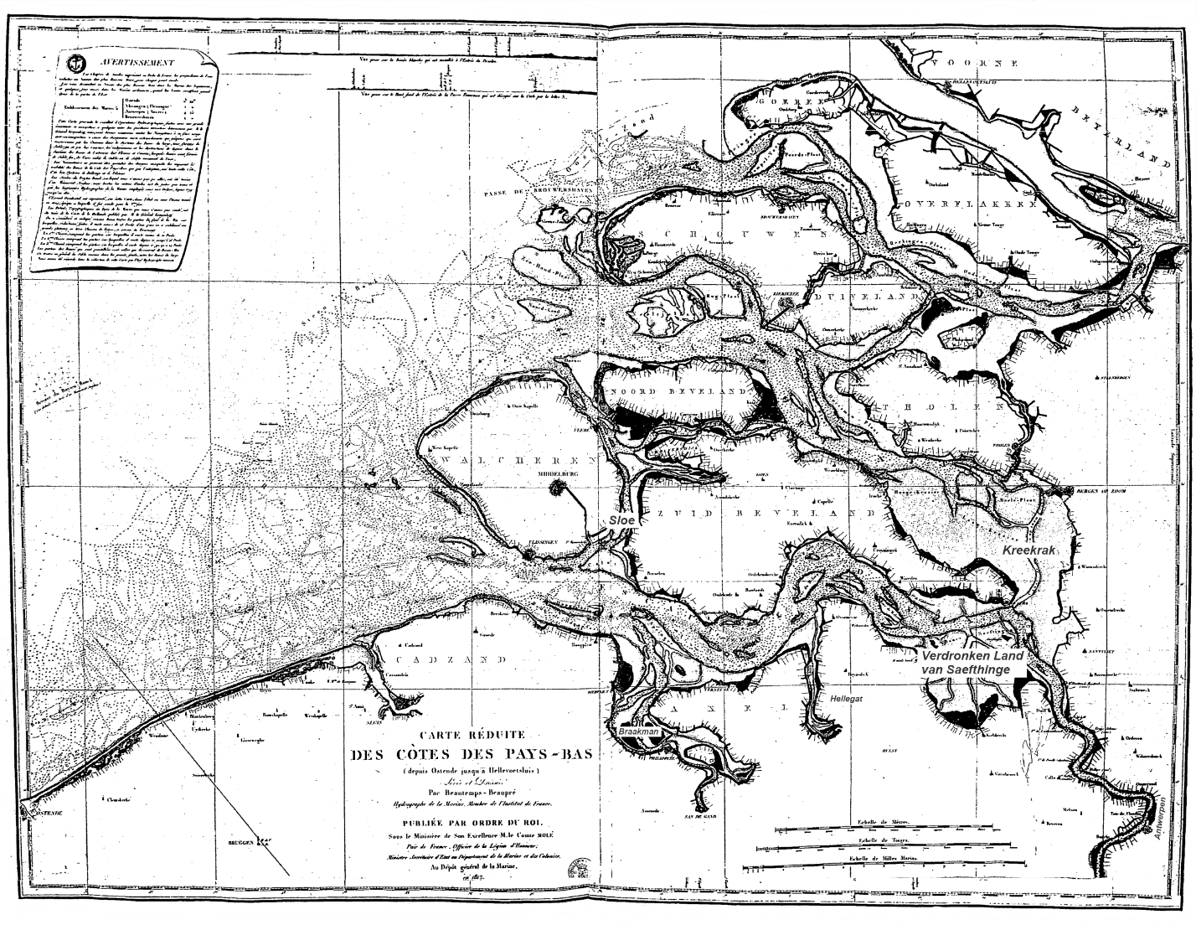
Figure 1: Historic chart “Carte réduite des Côtes des Pays-Bas (depuis Ostende jusqu’ à Hellevoetsluis), levée et dressée par Beautemps-Beaupré, hydrographe de la marine en 1817“ (Reduced chart of the coast of the Netherlands, from Ostend to Hellevoetsluis, surveyed and drawn by Beautemps-Beaupré, hydrographer of the navy in 1817), showing the Delta area, including estuaries, the islands and the Voordelta. The bathymetry in this chart is based on the Beautemps-Beaupré’s surveys starting around the year 1800. The chart was published in 1817. It gives the first reliable overview of the geomorphology of the estuaries and their ebb-tidal deltas.

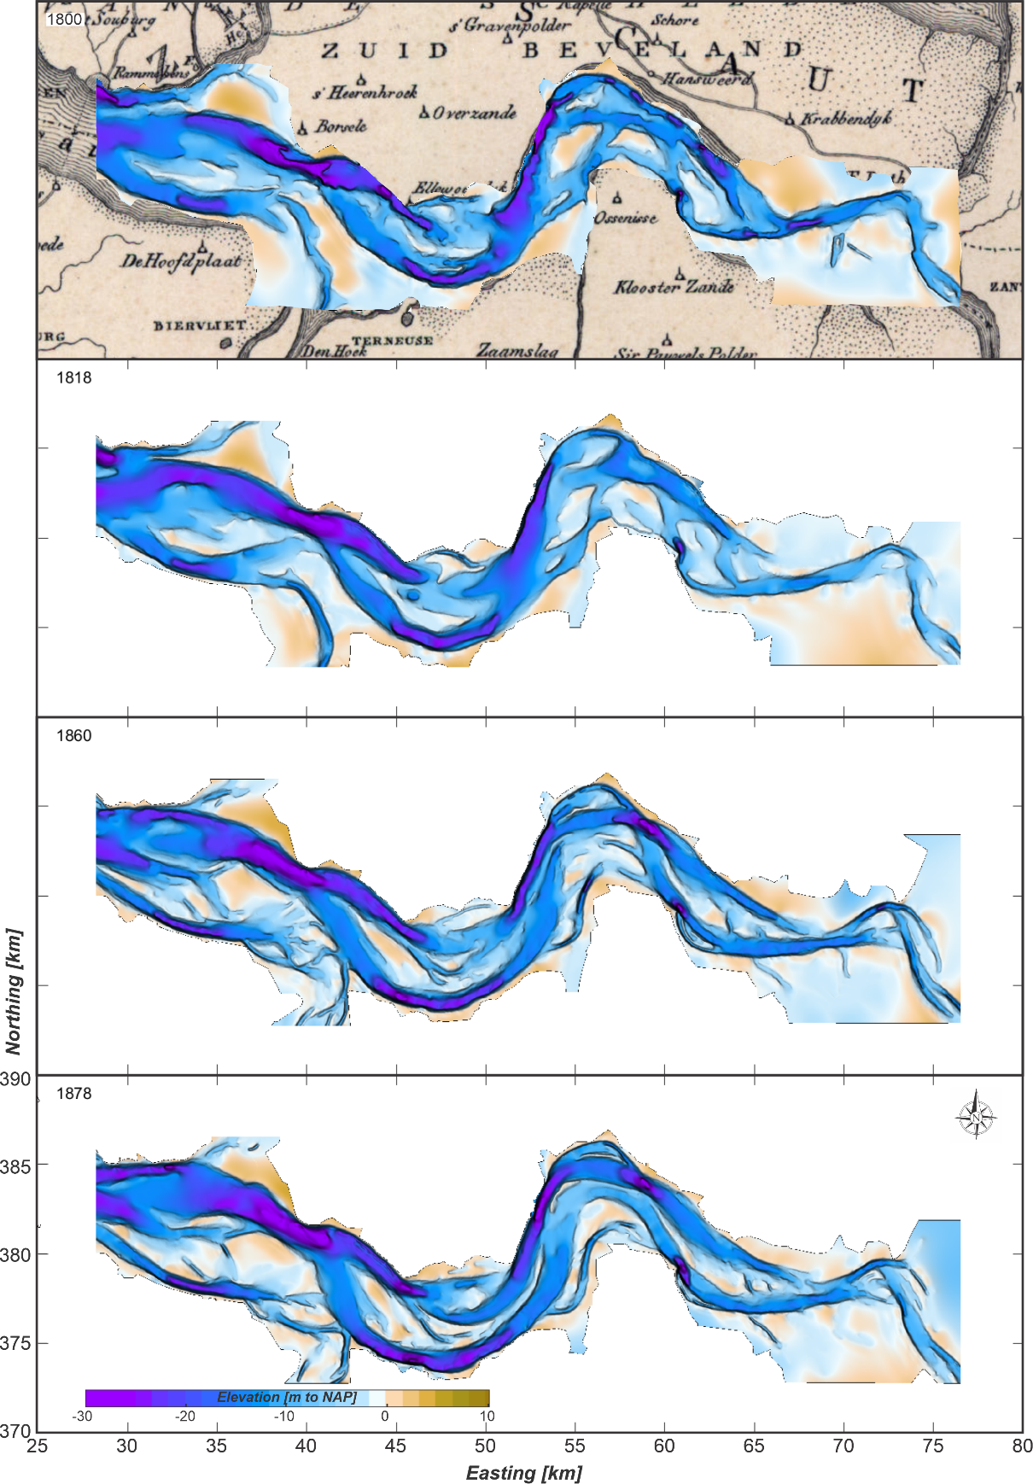
Figure 2: The bathymetry of the Western Scheldt estuary for the years 1800, 1818, 1860 and 1878. Digitized bathymetries based on Goldbach (2003).

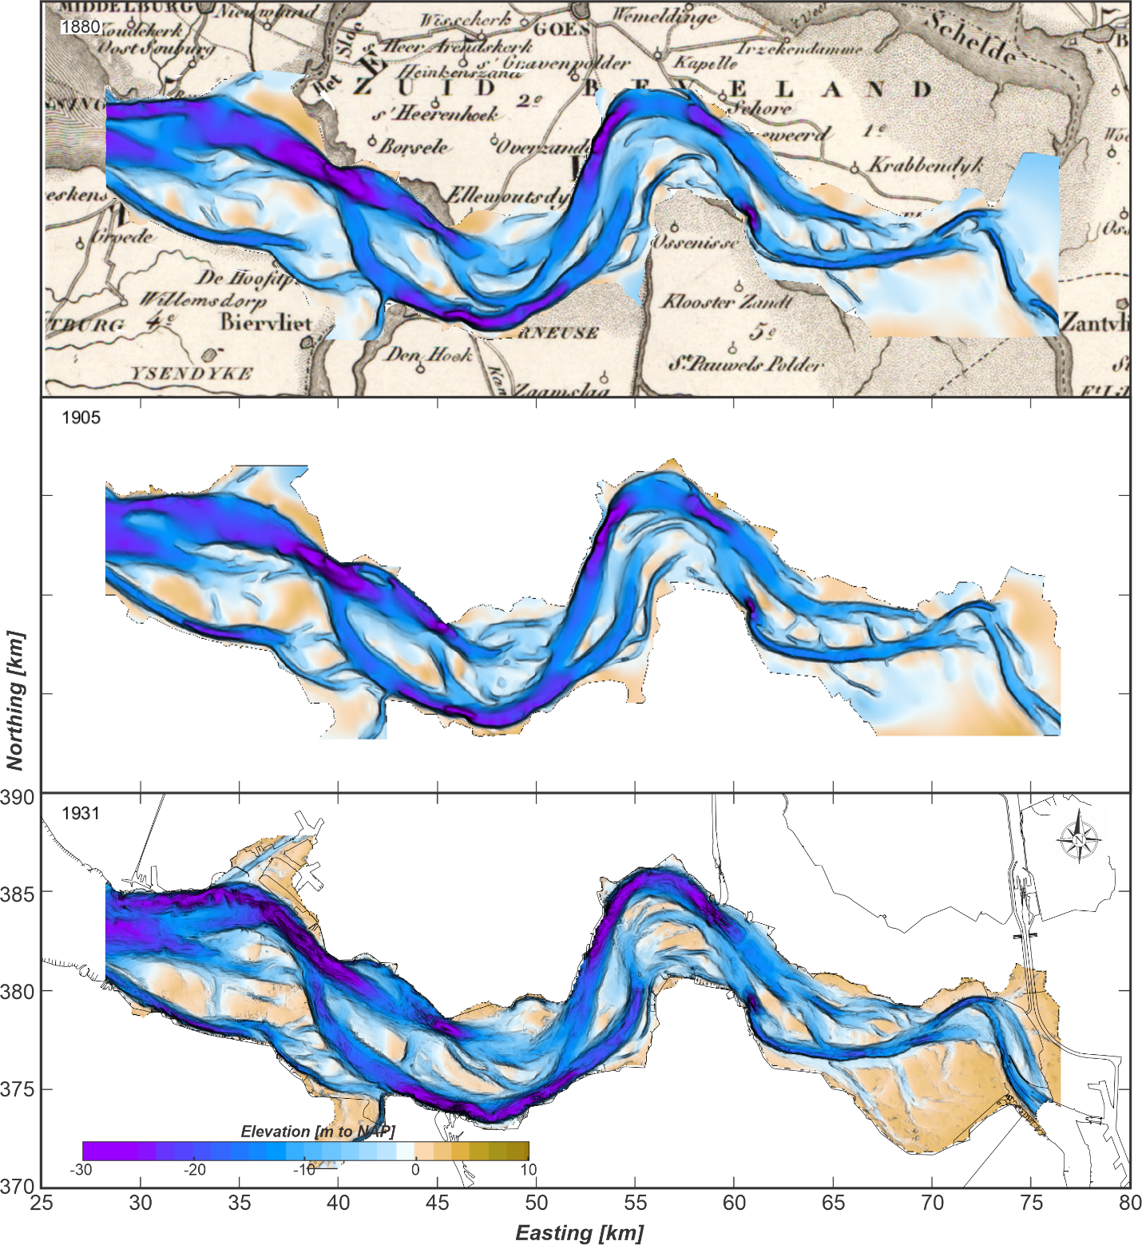
Figure 3: The bathymetry of the Western Scheldt estuary for the years 1880, 1905 and 1931. Digitized bathymetries based on Goldbach (2003).

Overview of bathymetric maps used in this study.
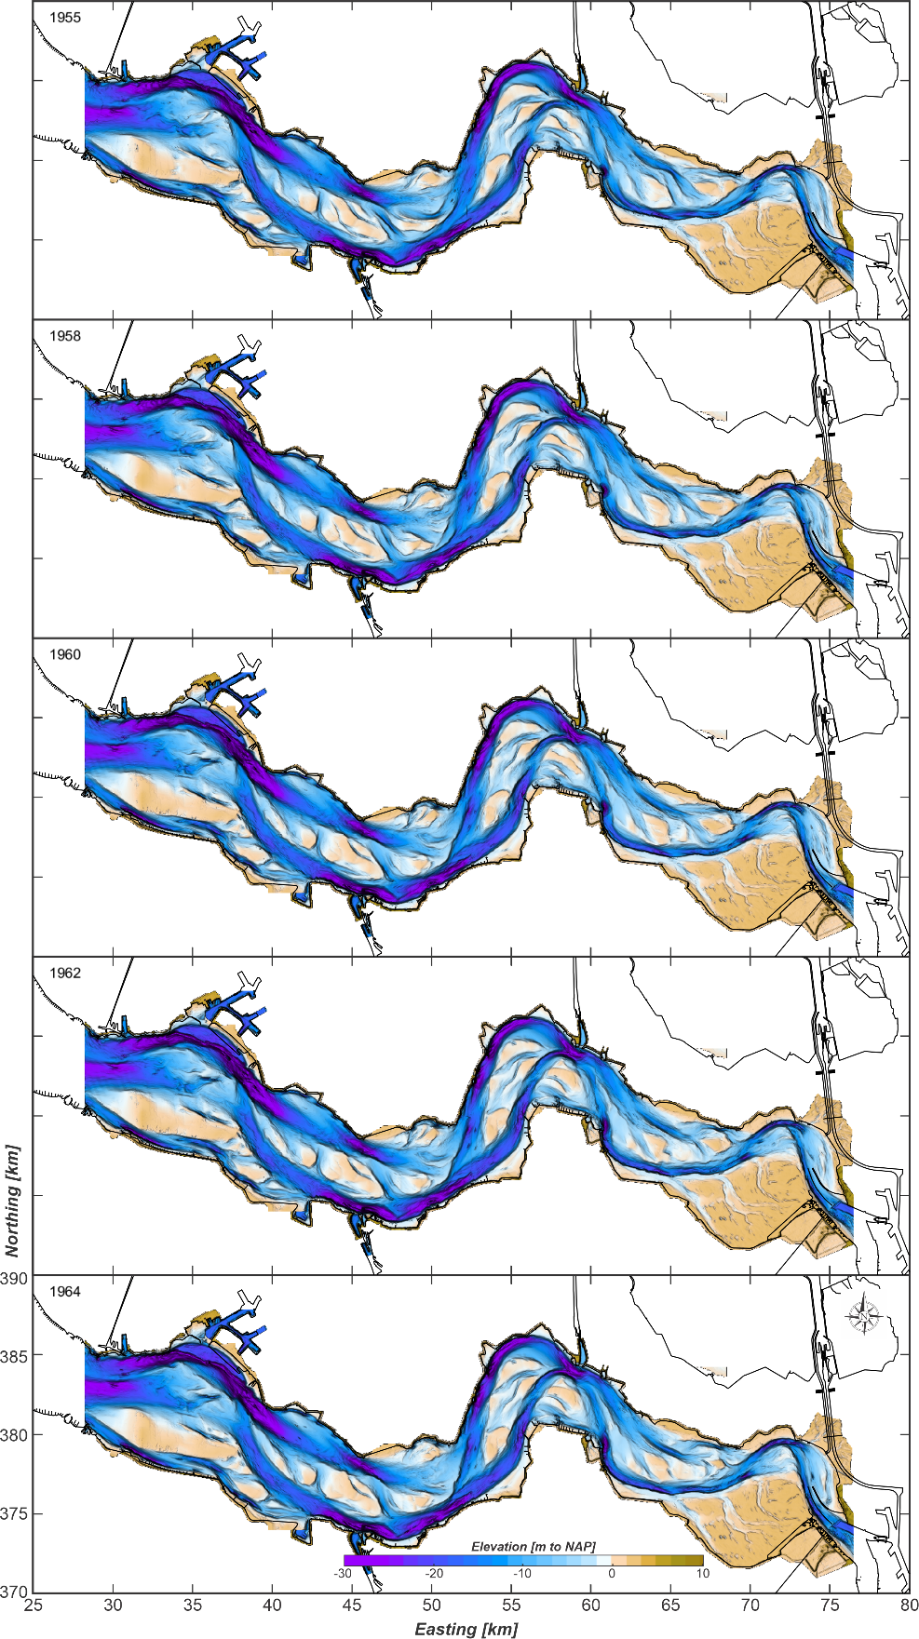
Figure 4: The bathymetry of the Western Scheldt estuary for the years 1955, 1958, 1960, 1962 and 1964.

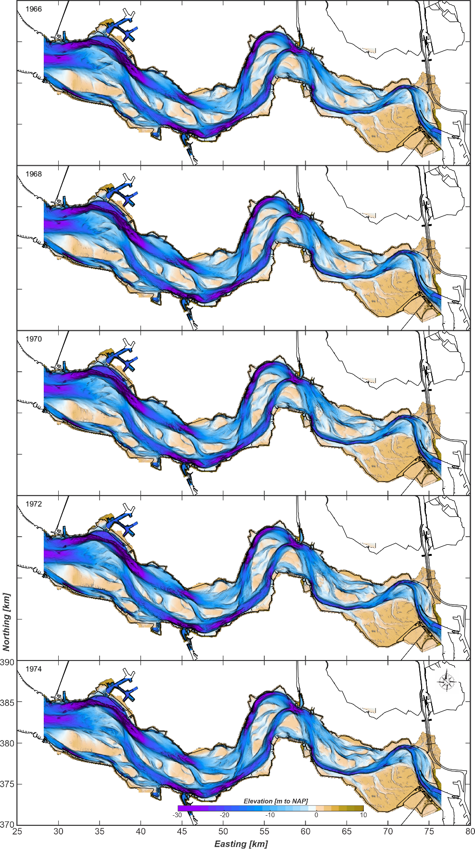
Figure 5: The bathymetry of the Western Scheldt estuary for the years 1966, 1968, 1970, 1972 and 1974.

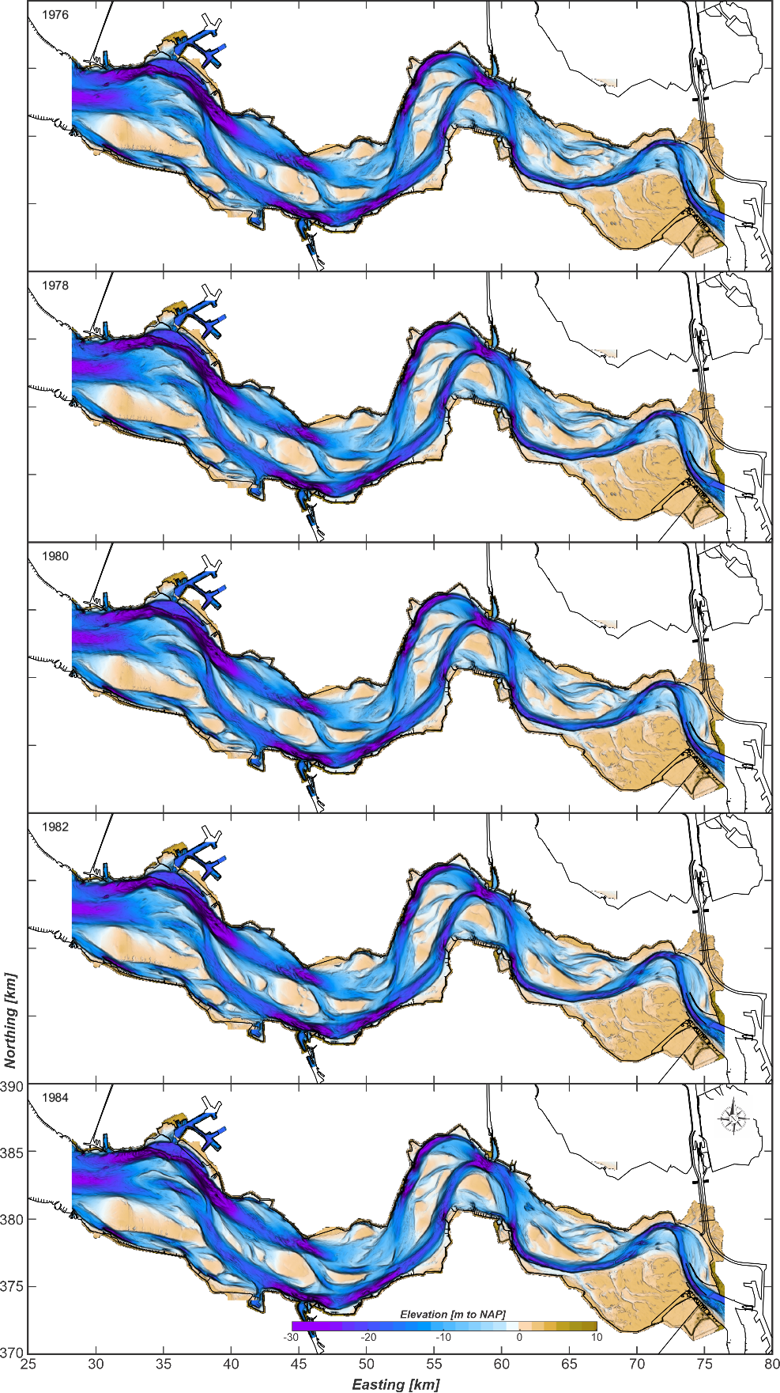
Figure 6: The bathymetry of the Western Scheldt estuary for the years 1976, 1978, 1980, 1982 and 1984.

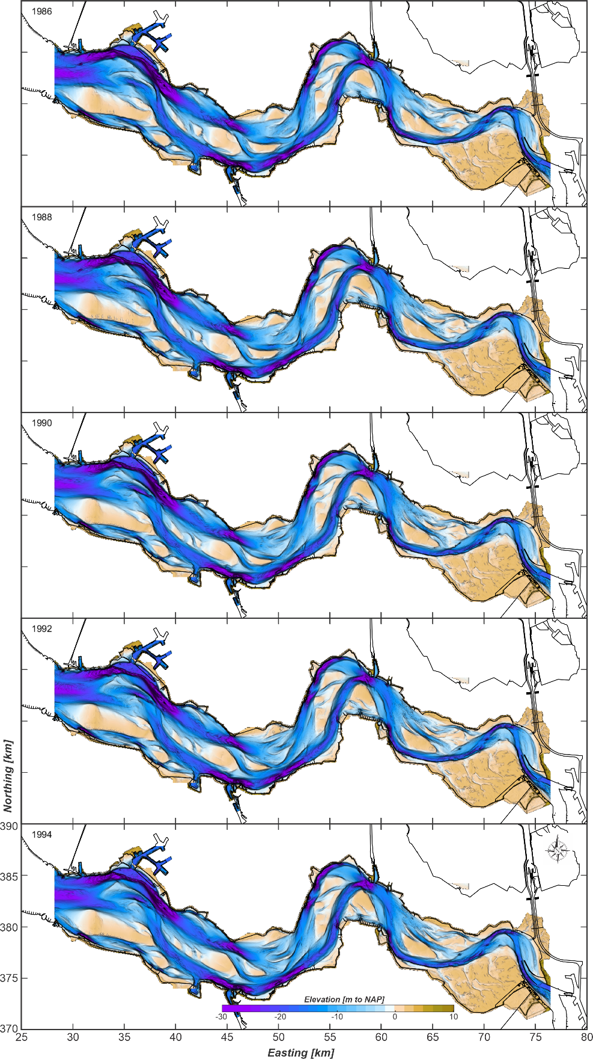
Figure 7: The bathymetry of the Western Scheldt estuary for the years 1986, 1988, 1990, 1992 and 1994.

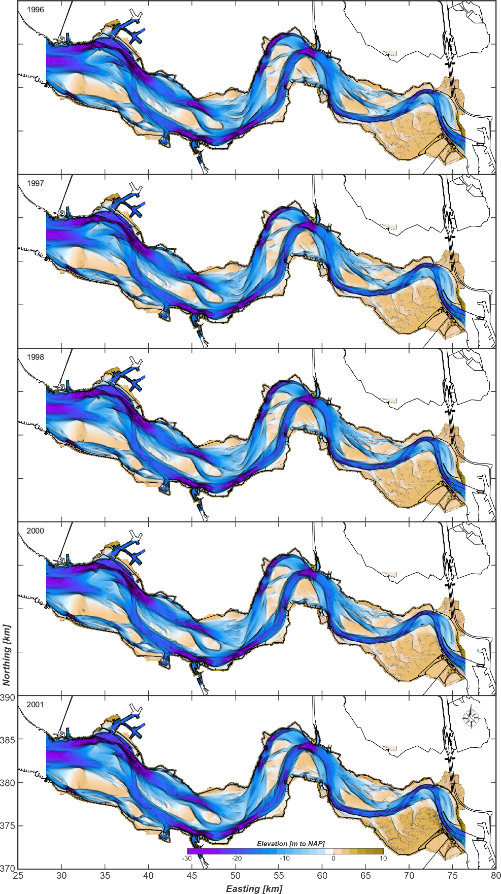
Figure 8: The bathymetry of the Western Scheldt estuary for the years 1996, 1997, 1998, 2000 and 2001.

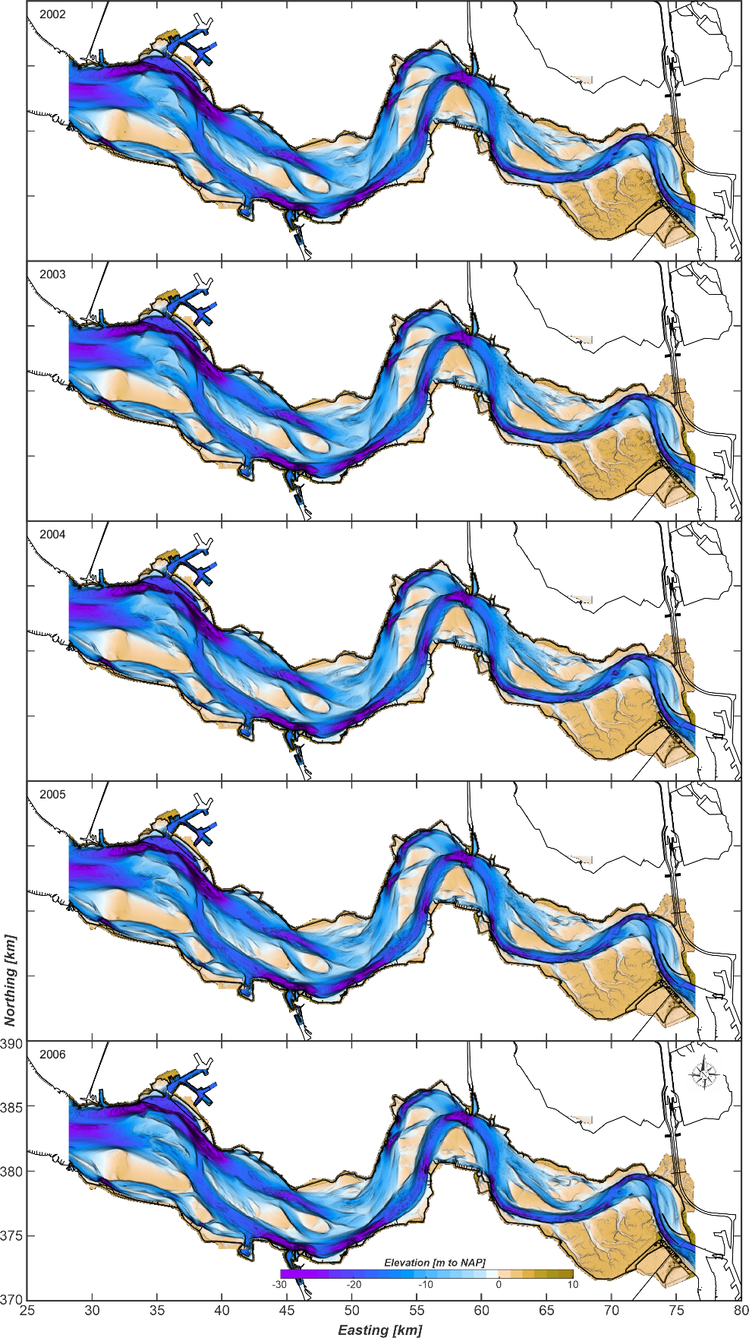
Figure 9: The bathymetry of the Western Scheldt estuary for the years 2002, 2003, 2004, 2005 and 2006.

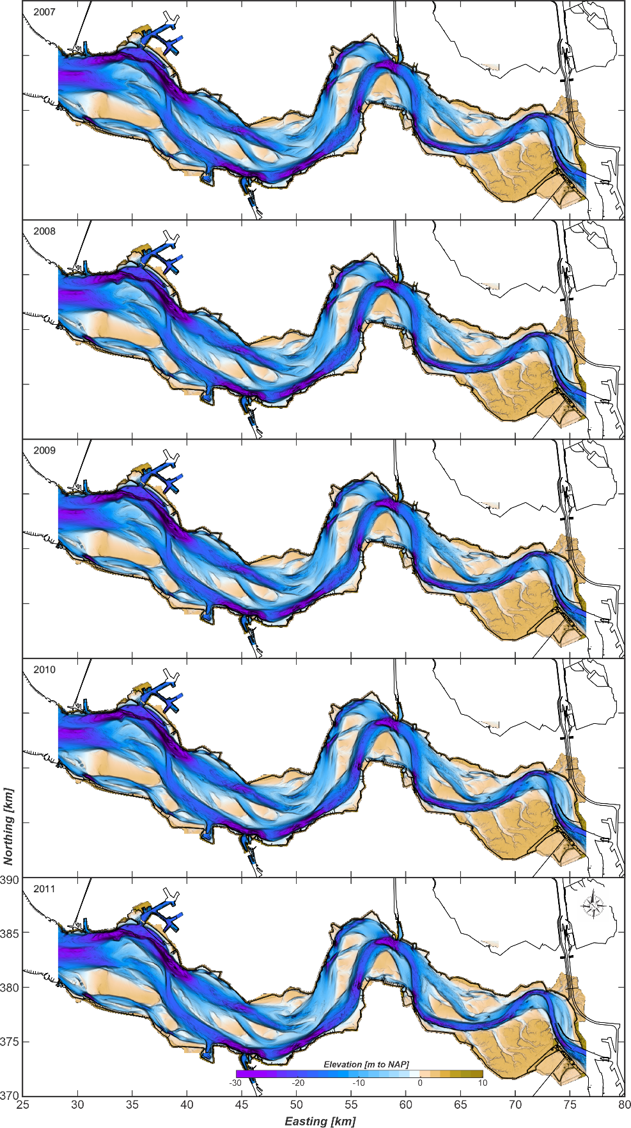
Figure 10: The bathymetry of the Western Scheldt estuary for the years 2007, 2008, 2009, 2010 and 2011.

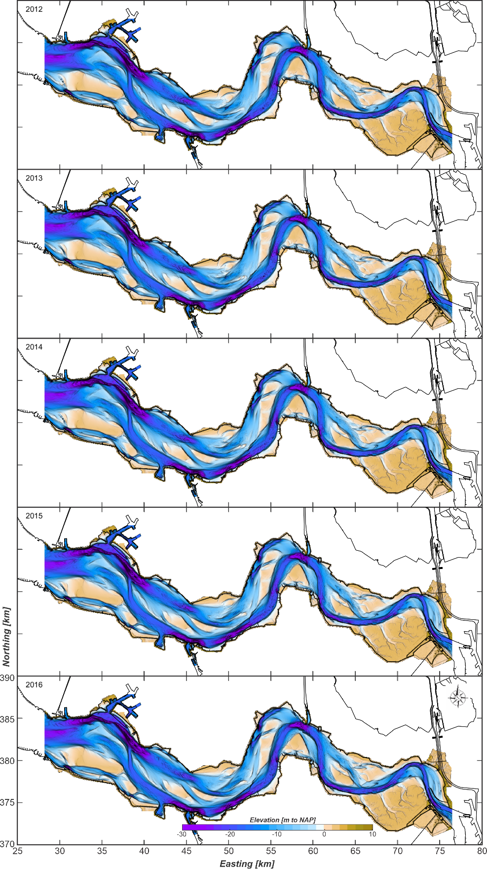
Figure 11: The bathymetry of the Western Scheldt estuary for the years 2012, 2013, 2014, 2015 and 2016.

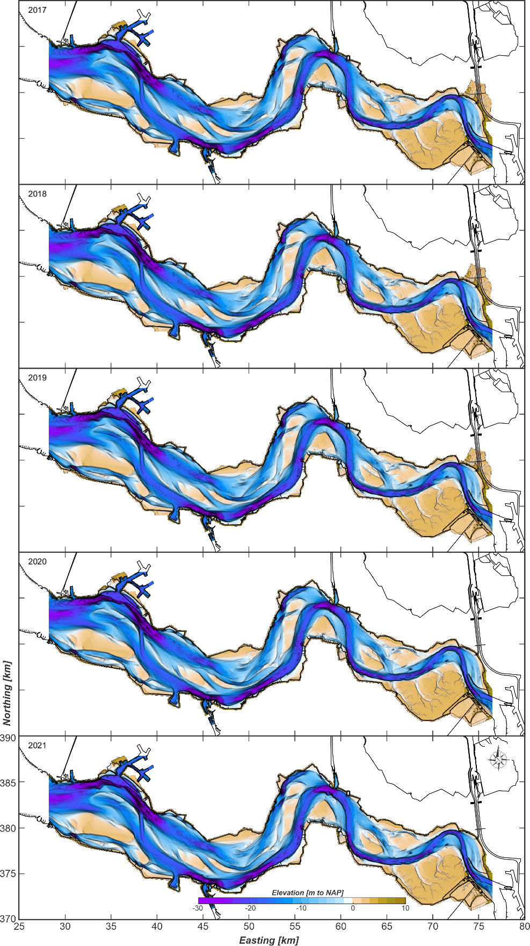
Figure 12: The bathymetry of the Western Scheldt estuary for the years 2017, 2018, 2019, 2020 and 2021.

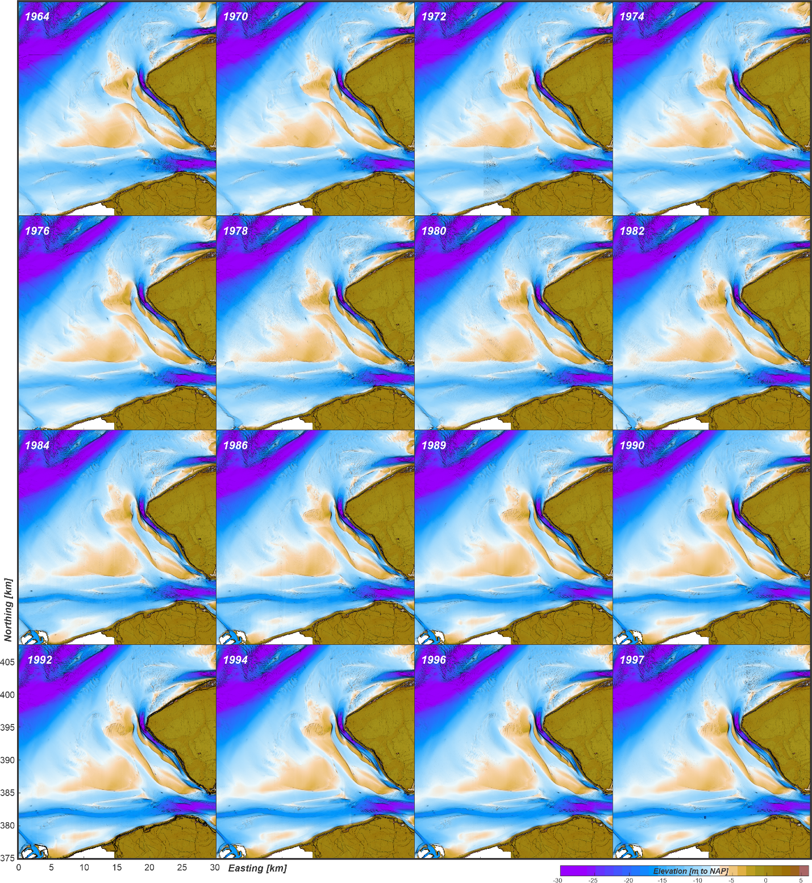
Figure 13: The bathymetry of the Western Scheldt mouth area for the years 1964 - 1997.

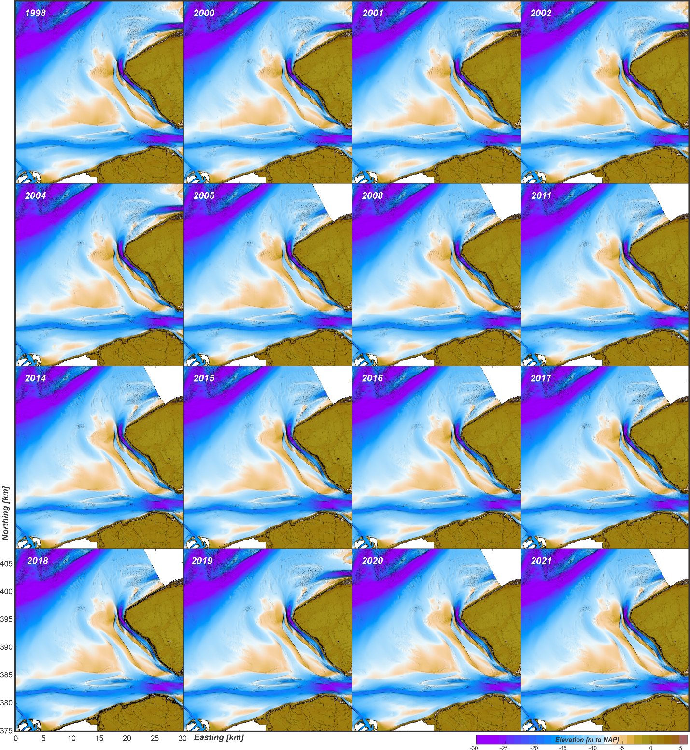
Figure 14: The bathymetry of the Western Scheldt mouth area for the years 1998 - 2021.

